How to Submit Podcast to iTunes (Apple Podcasts)

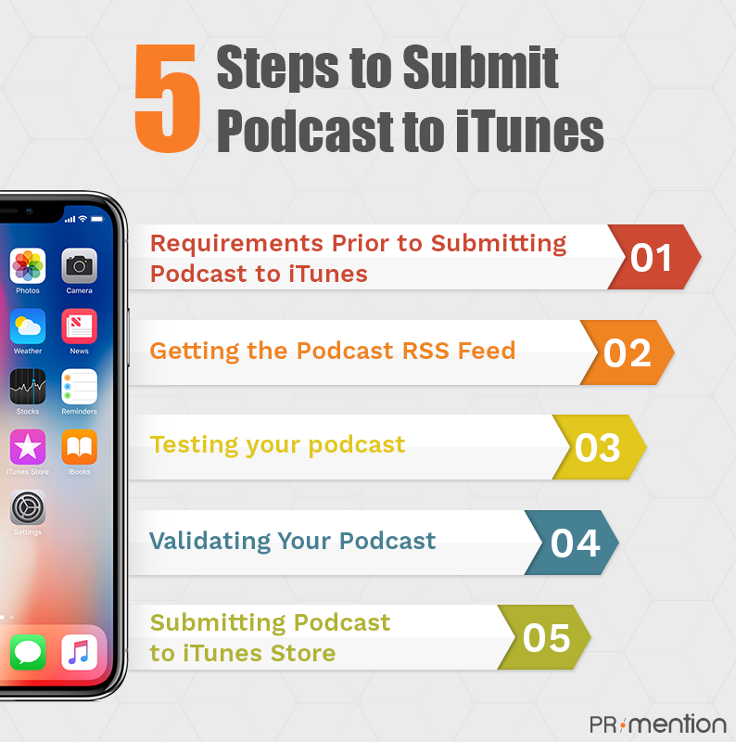

1. Requirements Prior to Submitting Podcast to iTunes

**a) Artwork Requirements:**

* The image should not be less than 1400 x 1400 pixels or more than 3000 x 3000 pixels in size. It should be either a JPEG or PNG file with appropriate extension and in RGB color space

**b) Content Requirements:**

* Your title, description, summary, categories, and contact info should be filled out completely (done through your host’s admin panel)

1. Getting the Podcast RSS Feed

If you’re using a podcast host like **Buzzsprout**, you shouldn’t run into any issues here. But if you built your own feed, you need to start by validating your RSS feed. Apple's recommended podcast validator is Podbase. Head to their website, paste your RSS feed address, and click Go!

### Testing Your Podcast

To check if your iTunes podcast upload is working correctly, subscribe to a podcast. Choose a podcast episode from your platform and enter your RSS feed in the text box. Click OK.

### Validating Your Podcast

**a) Manual Validation**

* Click on the + button.
* Copy paste or type the name of your RSS feed.
* Click the validate button.

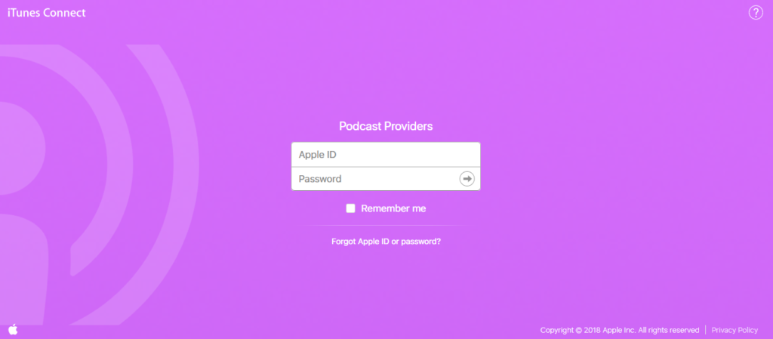

1. Submitting Podcast to iTunes Store

Now that the testing and RSS feed validation is out of the way, you are all set to submit the podcast to iTunes. Click Submit.