**SEARCH ENGINE OPTIMIZATION (SEO)**

Search Engine Optimization (SEO) is your golden ticket for better rankings in search engines’ natural results and can drive a high volume of qualified traffic to your site

Improve your ranking and visibility on Google and other search engines,

Google, Bing and Yahoo

Benchmarking

Monthly Reporting

Consultation

Website Audit

Detail on SEO

Search engine works as follow:

1. Crawling and indexing

The link structure of the web serves to bind all of the pages together. Links allow the search engines' automated robots, called "crawlers" or "spiders," to reach the many billions of interconnected documents on the web.

1. Search engines are answer machines. When a person performs an online search, the search engine scours its corpus of billions of documents and does two things: first, it returns only those results that are relevant or useful to the searcher's query; second, it ranks those results according to the popularity of the websites serving the information. It is both **relevance and popularity** that the process of SEO is meant to influence.

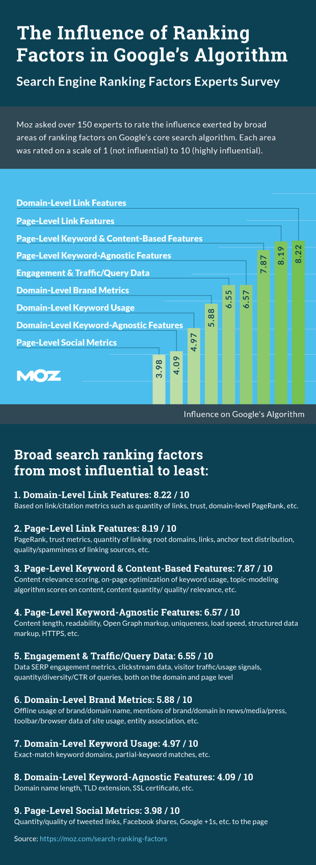

* Google recommends the following to get better rankings in their search engine:
* Make a site with a clear hierarchy and text links. Every page should be reachable from at least one static text link.
* Create a useful, information-rich site, and write pages that clearly and accurately describe your content. Make sure that your <title> elements and ALT attributes are descriptive and accurate. Use keywords to create descriptive, human-friendly URLs. Provide one version of a URL to reach a document, using 301 redirects or the rel="canonical" attribute to address duplicate content.
* Bing engineers at Microsoft recommend the following to get better rankings in their search engine:
* Ensure a clean, keyword rich URL structure is in place.
* Make sure content is not buried inside rich media (Adobe Flash Player, JavaScript, Ajax) and verify that rich media doesn't hide links from crawlers.
* Create keyword-rich content and match keywords to what users are searching for. Produce fresh content regularly.
* Don’t put the text that you want indexed inside images. For example, if you want your company name or address to be indexed, make sure it is not displayed inside a company logo.

Check always user queries

Bulid your site for users not search engines

### Problems Crawling and Indexing

* ***Online forms****: Search engines aren't good at completing online forms (such as a login), and thus any content contained behind them may remain hidden.*
* ***Duplicate pages****: Websites using a CMS (Content Management System) often create duplicate versions of the same page; this is a major problem for search engines looking for completely original content.*
* ***Blocked in the code****: Errors in a website's crawling directives (robots.txt) may lead to blocking search engines entirely.*
* ***Poor link structures****: If a*[*website's link structure*](https://moz.com/researchtools/ose/)*isn't understandable to the search engines, they may not reach all of a website's content; or, if it is crawled, the minimally-exposed content may be deemed unimportant by the engine's index.*
* ***Non-text Content****: Although the engines are getting better at reading non-HTML text, content in rich media format is still difficult for search engines to parse. This includes text in Flash files, images, photos, video, audio, and plug-in content.*

### Problems Matching Queries to Content

* ***Uncommon terms****: Text that is not written in the common terms that people use to search. For example, writing about "food cooling units" when people actually search for "refrigerators."*
* ***Language and internationalization subtleties****: For example, "color" vs. "colour." When in doubt,*[*check what people are searching for*](https://moz.com/explorer)*and use exact matches in your content.*
* ***Incongruous location targeting****: Targeting content in Polish when the majority of the people who would visit your website are from Japan.*
* ***Mixed contextual signals****: For example, the title of your blog post is "Mexico's Best Coffee" but the post itself is about a vacation resort in Canada which happens to serve great coffee. These mixed messages send confusing signals to search engines.*

### Make sure your content gets seen

Getting the technical details of search engine-friendly web development correct is important, but once the basics are covered, you must also [market your content](https://moz.com/beginners-guide-to-seo/growing-popularity-and-links). The engines by themselves have no formulas to gauge the quality of content on the web. Instead, search technology relies on the metrics of relevance and importance, and they measure those metrics by tracking what people do: what they discover, react, comment, and link to. So, you can’t just build a perfect website and write great content; you also have to get that content shared and talked about.

Focus on specific technical aspects of building (or modifying) web pages so they are structured for both search engines and human visitors alike.

## Indexable Content

|  |  |
| --- | --- |
| 1. ***Provide alt text for images****. Assign* i*mages in gif, jpg, or png format "alt attributes" in HTML to give search engines a text description of the visual content.* 2. ***Supplement search boxes****with navigation and crawlable links.* |  |
|  |  |  |
|  |  |  |
|  | 1. ***Supplement Flash or Java plug-ins****with text on the page.* 2. ***Provide a transcript for video and audio content****if the words and phrases used are meant to be indexed by the engines.* |  |

Search engines are limited in how they crawl the web and interpret content. A webpage doesn't always look the same to you and me as it looks to a search engine. In this section, we'll focus on specific technical aspects of building (or modifying) web pages so they are structured for both search engines and human visitors alike. Share this part of the guide with your programmers, information architects, and designers, so that all parties involved in a site's construction are on the same page.

## Indexable Content

To perform better in search engine listings, your most important content should be in HTML text format. Images, Flash files, Java applets, and other non-text content are often ignored or devalued by search engine crawlers, despite advances in crawling technology. The easiest way to ensure that the words and phrases you display to your visitors are visible to search engines is to place them in the HTML text on the page. However, more advanced methods are available for those who demand greater formatting or visual display styles:

|  |  |  |
| --- | --- | --- |
|  |  |  |
|  | 1. ***Provide alt text for images****. Assign images in gif, jpg, or png format "alt attributes" in HTML to give search engines a text description of the visual content.* 2. ***Supplement search boxes****with navigation and crawlable links.* |  |
|  |  |  |
|  |  |  |
|  | 1. ***Supplement Flash or Java plug-ins****with text on the page.* 2. ***Provide a transcript for video and audio content****if the words and phrases used are meant to be indexed by the engines.* |  |
|  |  |  |

### *Seeing your site as the search engines do*

Many websites have significant problems with indexable content, so double-checking is worthwhile. By using tools like Google's cache, [SEO-browser.com](http://www.seo-browser.com/), and the [MozBar](https://moz.com/mozbar/) you can see what elements of your content are visible and indexable to the engines. Take a look at [Google's text cache of this page you are reading now](http://webcache.googleusercontent.com/search?q=cache:https://moz.com/beginners-guide-to-seo/basics-of-search-engine-friendly-design-and-development&strip=1). See how different it looks?

### *Whoa! That's what we look like?*

Using the Google cache feature, we can see that to a search engine, JugglingPandas.com's homepage doesn't contain all the rich information that we see. This makes it difficult for search engines to interpret relevancy.

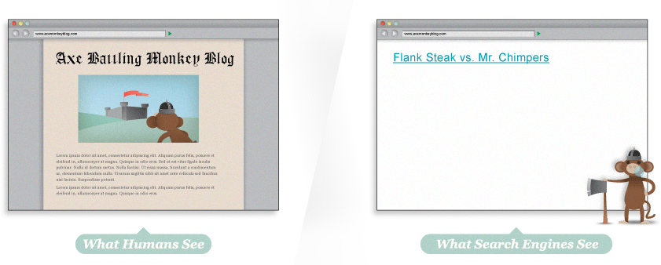

### *Hey, where did the fun go?*

Uh oh ... via Google cache, we can see that the page is a barren wasteland. There's not even text telling us that the page contains the Axe Battling Monkeys. The site is built entirely in Flash, but sadly, this means that search engines cannot index any of the text content, or even the links to the individual games. Without any HTML text, this page would have a very hard time ranking in search results.

It's wise to not only check for text content but to also use SEO tools to double-check that the pages you're building are visible to the engines. This applies to your images, and as we see below, to your links as well.

## Crawlable Link Structures

Just as search engines need to see content in order to list pages in their massive keyword-based indexes, they also need to see links in order to find the content in the first place. A crawlable [link structure](https://moz.com/researchtools/ose/)—one that lets the crawlers browse the pathways of a website—is vital to them finding all of the pages on a website. Hundreds of thousands of sites make the critical mistake of structuring their navigation in ways that search engines cannot access, hindering their ability to get pages listed in the search engines' indexes.

Below, we've illustrated how this problem can happen:

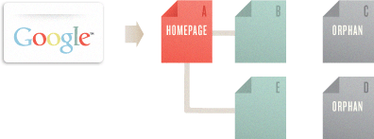

In the example above, Google's crawler has reached page A and sees links to pages B and E. However, even though C and D might be important pages on the site, the crawler has no way to reach them (or even know they exist). This is because no direct, crawlable links point pages C and D. As far as Google can see, they don't exist! Great content, good keyword targeting, and smart marketing won't make any difference if the crawlers can't reach your pages in the first place.

Common reasons why pages may not be reachable

### *Submission-required forms*

If you require users to complete an online form before accessing certain content, chances are search engines will never see those protected pages. Forms can include a password-protected login or a full-blown survey. In either case, search crawlers generally will not attempt to submit forms, so any content or links that would be accessible via a form are invisible to the engines.

### *Links in unparseable JavaScript*

If you use JavaScript for links, you may find that search engines either do not crawl or give very little weight to the links embedded within. Standard HTML links should replace JavaScript (or accompany it) on any page you'd like crawlers to crawl.

### *Links pointing to pages blocked by the Meta Robots tag or robots.txt*

The [Meta Robots tag and the robots.txt](https://moz.com/learn/seo/robotstxt) file both allow a site owner to restrict crawler access to a page. Just be warned that many a webmaster has unintentionally used these directives as an attempt to block access by rogue bots, only to discover that search engines cease their crawl.

### *Frames or iframes*

Technically, links in both frames and iframes are crawlable, but both present structural issues for the engines in terms of organization and following. Unless you're an advanced user with a good technical understanding of how search engines index and follow links in frames, it's best to stay away from them.

### *Robots don't use search forms*

Although this relates directly to the above warning on forms, it's such a common problem that it bears mentioning. Some webmasters believe if they place a search box on their site, then engines will be able to find everything that visitors search for. Unfortunately, crawlers don't perform searches to find content, leaving millions of pages inaccessible and doomed to anonymity until a crawled page links to them.

### *Links in Flash, Java, and other plug-ins*

The links embedded inside the Juggling Panda site (from our above example) are perfect illustrations of this phenomenon. Although dozens of pandas are listed and linked to on the page, no crawler can reach them through the site's link structure, rendering them invisible to the engines and hidden from users' search queries.

### *Links on pages with many hundreds or thousands of links*

Search engines will only crawl so many links on a given page. This restriction is necessary to cut down on spam and conserve rankings. Pages with hundreds of links on them are at risk of not getting all of those links crawled and indexed.

*Rel="nofollow" can be used with the following syntax:*

***<a href="https://moz.com" rel="nofollow">Lousy Punks!</a>***

Links can have lots of attributes. The engines ignore nearly all of them, with the important exception of the rel="nofollow" attribute. In the example above, adding the rel="nofollow" attribute to the link tag tells the search engines that the site owners do not want this link to be interpreted as an endorsement of the target page.

Nofollow, taken literally, instructs search engines to not follow a link (although some do). The nofollow tag came about as a method to help stop automated blog comment, guest book, and link injection spam, but has morphed over time into a way of telling the engines to discount any link value that would ordinarily be passed. Links tagged with nofollow are interpreted slightly differently by each of the engines, but it is clear they do not pass as much weight as normal links.

### *Are nofollow links bad?*

Although they don't pass as much value as their followed cousins, nofollowed links are a natural part of a diverse link profile. A website with lots of inbound links will accumulate many nofollowed links, and this isn't a bad thing. In fact, Moz's [Ranking Factors](https://moz.com/search-ranking-factors) showed that high ranking sites tended to have a higher percentage of inbound nofollow links than lower-ranking sites.

## Keyword Usage and Targeting

## Keyword Domination

Keywords dominate how we communicate our search intent and interact with the engines. When we enter words to search for, the engine matches pages to retrieve based on the words we entered. The order of the words ("pandas juggling" vs. "juggling pandas"), spelling, punctuation, and capitalization provide additional information that the engines use to help retrieve the right pages and rank them

One of the best ways to optimize a page's rankings is to ensure that the keywords you want to rank for are prominently used in titles, text, and metadata.

Generally speaking, as you make your keywords more specific, you narrow the competition for search results, and improve your chances of achieving a higher ranking. The map graphic to the left compares the relevance of the broad term "books" to the specific title Tale of Two Cities. Notice that while there are a lot of results for the broad term, there are considerably fewer results (and thus, less competition) for the specific result.

## Keyword Abuse

**The point of using keywords is not to rank highly for all keywords, but to rank highly for the keywords that people are searching for when they want what your site provides.**

## On-Page Optimization

Keyword usage and targeting are still a part of the search engines' ranking algorithms, and we can apply some effective techniques for keyword usage to help create pages that are well-optimized. Here at Moz, we engage in a lot of testing and get to see a huge number of search results and [shifts based on keyword usage tactics](https://moz.com/search-ranking-factors). When working with one of your own sites, this is the process we recommend. Use the keyword phrase:

* *In the title tag at least once. Try to keep the keyword phrase as close to the beginning of the title tag as possible. More detail on title tags follows later in this section.*
* *Once prominently near the top of the page.*
* *At least two or three times, including variations, in the body copy on the page. Perhaps a few more times if there's a lot of text content. You may find additional value in using the keyword or variations more than this, but in our experience adding more instances of a term or phrase tends to have little or no impact on rankings.*
* *At least once in the alt attribute of an image on the page. This not only helps with web search, but also image search, which can occasionally bring valuable traffic.*
* *Once in the URL. Additional rules for URLs and keywords are discussed later on in this section.*
* *At least once in the meta description tag. Note that the meta description tag does*not*get used by the engines for rankings, but rather helps to attract clicks by searchers reading the results page, as the meta description becomes the snippet of text used by the search engines.*

And you should generally not use keywords in link anchor text pointing to other pages on your site; this is known as [Keyword Cannibalization](https://moz.com/blog/how-to-solve-keyword-cannibalization).

## Title Tags

The [title element of a page](https://moz.com/learn/seo/title-tag) is meant to be an accurate, concise description of a page's content. It is critical to both user experience and search engine optimization.

### *Be mindful of length*

Search engines display only the first 65-75 characters of a title tag in the search results (after that, the engines show an ellipsis – "..." – to indicate when a title tag has been cut off).

### *Place important keywords close to the front*

### *Include branding*

### *Consider readability and emotional impact*

<head>

<title>Example Title</title>

</head>

#### Optimal format

***Primary Keyword - Secondary Keyword | Brand Name  
8-foot Green Widgets - Widgets & Tools | Widget World***

#### Optimal title length

Google typically displays the first **50–60 characters** of a title tag. If you keep

## **Why are title tags important?**

Title tags are a major factor in helping search engines understand what your page is about, and they are the first impression many people have of your page. Title tags are used in three key places:

(1) search engine results pages (SERPs),

(2) web browsers, and

(3) social networks.

#### 1. Search engine result pages

Your title tag determines (with a few exceptions) your display title in SERPs, and is a search visitor's first experience of your site. Even if your site ranks well, a good title can be the make-or-break factor in determining whether or not someone clicks on your link.

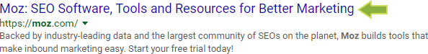

#### 2. Web browsers

Your title tag is also displayed at the top of your web browser and acts as a placeholder, especially for people who have many browser tabs open. Unique and easily recognizable titles with important keywords near the front help ensure that people don't lose track of your content.

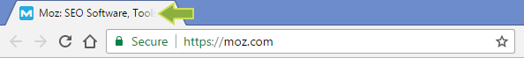

#### 3. Social networks

Some external websites — especially social networks — will use your title tag to determine what to display when you share that page. Here's a screenshot from Facebook, for example:



Keep in mind that some social networks (including Facebook and Twitter) have their own [meta tags](https://moz.com/blog/meta-data-templates-123), allowing you to specify titles that differ from your main title tag. This can allow you to optimize for each network, and provide longer titles when/where they might be beneficial.

## Meta Tags

Meta tags were originally intended as a proxy for information about a website's content. Several of the basic meta tags are listed below, along with a description of their use.

### *Meta Robots*

The [Meta Robots tag](http://www.robotstxt.org/meta.html) can be used to control search engine crawler activity (for all of the major engines) on a per-page level. There are several ways to use Meta Robots to control how search engines treat a page:

* **index/noindex** tells the engines whether the page should be crawled and kept in the engines' index for retrieval. If you opt to use "noindex," the page will be excluded from the index. By default, search engines assume they can index all pages, so using the "index" value is generally unnecessary.
* **follow/nofollow** tells the engines whether links on the page should be crawled. If you elect to employ "nofollow," the engines will disregard the links on the page for discovery, ranking purposes, or both. By default, all pages are assumed to have the "follow" attribute.  
  Example: <META NAME="ROBOTS" CONTENT="NOINDEX, NOFOLLOW">
* **noarchive** is used to restrict search engines from saving a cached copy of the page. By default, the engines will maintain visible copies of all pages they have indexed, accessible to searchers through the cached link in the search results.
* **nosnippet** informs the engines that they should refrain from displaying a descriptive block of text next to the page's title and URL in the search results.
* **noodp/noydir** are specialized tags telling the engines not to grab a descriptive snippet about a page from the Open Directory Project (DMOZ) or the Yahoo! Directory for display in the search results.

The [X-Robots-Tag](http://code.google.com/web/controlcrawlindex/docs/robots_meta_tag.html) HTTP header directive also accomplishes these same objectives. This technique works especially well for content within non-HTML files, like images.

### *Meta Description*

The [meta description](https://moz.com/learn/seo/meta-description) tag exists as a short description of a page's content. Search engines do not use the keywords or phrases in this tag for rankings, but meta descriptions are the primary source for the snippet of text displayed beneath a listing in the results.

Meta descriptions can be any length, but search engines generally will cut snippets longer than 160 characters, so it's generally wise to stay within in these limits.

## URL Structures

URLs—the addresses for documents on the web—are of great value from a search perspective. They appear in multiple important locations.

### *Employ empathy*

Place yourself in the mind of a user and look at your URL. If you can easily and accurately predict the content you'd expect to find on the page, your URL is appropriately descriptive. You don't need to spell out every last detail in the URL, but a rough idea is a good starting point.

### *Shorter is better*

### *Keyword use is important (but overuse is dangerous)*

### *Go static*

The best [URLs](https://moz.com/learn/seo/url/) are human-readable and without lots of parameters, numbers, and symbols. Using technologies like mod_rewrite for Apache and ISAPI_rewrite for Microsoft, you can easily transform dynamic URLs like this **https://moz.com/blog?id=123**into a more readable static version like this: **https://moz.com/blog/google-fresh-factor**. Even single dynamic parameters in a URL can result in lower overall ranking and indexing.

### *Use hyphens to separate words*

Not all web applications accurately interpret separators like underscores (_), plus signs (+), or spaces (%20), so instead use the hyphen character (-) to separate words in a URL, as in the "google-fresh-factor" URL example above.

## Canonical and Duplicate Versions of Content

[**Duplicate content**](https://moz.com/blog/duplicate-content-in-a-post-panda-world) is one of the most vexing and troublesome problems any website can face. Over the past few years, search engines have cracked down on pages with thin or duplicate content by assigning them lower rankings.

[**Canonicalization**](https://moz.com/learn/seo/canonicalization) happens when two or more duplicate versions of a webpage appear on different URLs. This is very common with modern Content Management Systems.

*The engines are picky about duplicate versions of a single piece of material. To provide the best searcher experience, they will rarely show multiple, duplicate pieces of content, and instead choose which version is most likely to be the original. The end result is*all*of your duplicate content could rank lower than it should.*

*Canonicalization is the practice of organizing your content in such a way that****every unique piece has one, and only one, URL****. If you leave multiple versions of content on a website (or websites), you might end up with a scenario like the one on the right: which diamond is the right one?*

*Instead, if the site owner took those three pages and*[*301-redirected*](https://moz.com/learn/seo/redirection)*them, the search engines would have only one****strong****page to show in the listings from that site.*

### *Canonical Tag to the rescue!*

A different option from the search engines, called the [Canonical URL Tag](https://moz.com/learn/seo/canonicalization), is another way to reduce instances of duplicate content on a single site and canonicalize to an individual URL. This can also be used [across different websites](https://moz.com/blog/cross-domain-canonical-the-new-301-whiteboard-friday), from one URL on one domain to a different URL on a different domain.

Use the canonical tag within the page that contains duplicate content. The target of the canonical tag points to the master URL that you want to rank for.

The Inner Workings

*<link rel="canonical" href="https://moz.com/blog"/>This tells search engines that the page in question should be treated as though it were a copy of the URL https://moz.com/blog and that all of the link and content metrics the engines apply should flow back to that URL.*

## Rich Snippets

 Rich snippets are a type of structured data that allow webmasters to mark up content in ways that provide information to the search engines.

|  |
| --- |
|  |
| *Rich Snippets in the Wild* *Let's say you announce an SEO conference on your blog. In regular HTML, your code might look like this:*  *<div> SEO Conference<br/> Learn about SEO from experts in the field.<br/> Event date:<br/> May 8, 7:30pm </div>*  *Now, by structuring the data, we can tell the search engines more specific information about the type of data. The end result might look like this:*  *<div****itemscope itemtype="http://schema.org/Event"****> <div****itemprop="name"****>SEO Conference</div>  <span****itemprop="description"****>Learn about SEO from experts in the field.</span>  Event date:* ***<time itemprop="startDate" datetime="2012-05-08T19:30">****May 8, 7:30pm****</time>****</div>* |  |
|  |  |

## Defending Your Site's Honor

### *How scrapers steal your rankings*

Unfortunately, the web is littered with unscrupulous websites whose business and traffic models depend on plucking content from other sites and re-using it (sometimes in strangely modified ways) on their own domains. This practice of fetching your content and re-publishing is called "scraping," and the scrapers perform remarkably well in search engine rankings, often outranking the original sites.

Next, you can use the scrapers' laziness against them. Most of the scrapers on the web will re-publish content without editing. So, by including links back to your site, and to the specific post you've authored, you can ensure that the search engines see most of the copies linking back to you (indicating that your source is probably the originator). To do this, you'll need to use absolute, rather that relative links in your internal linking structure. Thus, rather than linking to your home page using:

***<a href="../">Home</a>***You would instead use:***<a href="https://moz.com">Home</a>***

This way, when a scraper picks up and copies the content, the link remains pointing to your site.

Keyword Research

It all begins with words typed into a search box.

Keyword research is one of the most important, valuable, and high return activities in the search marketing field. Ranking for the right keywords can make or break your website. By researching your market's keyword demand, you can not only learn which terms and phrases to target with SEO, but also learn more about your customers as a whole.

It's not always about getting visitors to your site, **but about getting the right kind of visitors**

**A basic process for assessing a keyword’s value**

#### Ask yourself...

*Is the keyword relevant to your website's content? Will searchers find what they are looking for on your site when they search using these keywords? Will they be happy with what they find? Will this traffic result in financial rewards or other organizational goals? If the answer to all of these questions is a clear "Yes!" then proceed ...*

#### Search for the term/phrase in the major engines

*Understanding which websites already rank for your keyword gives you valuable insight into the competition, and also how hard it will be to rank for the given term. Are there search advertisements running along the top and right-hand side of the organic results? Typically, many search ads means a high-value keyword, and multiple search ads above the organic results often means a highly lucrative and directly conversion-prone keyword.*

#### Buy a sample campaign for the keyword at Google AdWords and/or Bing Adcenter

*If your website doesn't rank for the keyword, you can nonetheless buy test traffic to see how well it converts. In*[*Google Adwords*](http://adwords.google.com/)*, choose "exact match" and point the traffic to the relevant page on your website. Track impressions and conversion rate over the course of at least 200-300 clicks.*

#### Using the data you’ve collected, determine the exact value of each keyword

*For example, assume your search ad generated 5,000 impressions in one day, of which 100 visitors have come to your site, and three have converted for a total profit (not revenue!) of $300. In this case, a single visitor for that keyword is worth $3 to your business. Those 5,000 impressions in 24 hours could generate a click-through rate of between 18-36% with a #1 ranking (see the*[*Slingshot SEO study*](https://moz.com/blog/mission-imposserpble-establishing-clickthrough-rates)*for more on potential click-through rates), which would mean 900-1800 visits per day, at $3 each, or between****1 and 2 million dollars per year****. No wonder businesses love search marketing!*

## Usability and User Experience and Content affect the search engine ranking

Generally, these sites have several traits in common:

1. ***Easy to use, navigate, and understand***
2. ***Provide direct, actionable information relevant to the query***
3. ***Professionally designed and accessible to modern browsers***
4. ***Deliver high quality, legitimate, credible content***

## The Impact of Usability and User Experience

### *On search engine rankings*

Usability and user experience are second order influences on search engine ranking success. They provide an indirect but measurable benefit to a site's external popularity, which the engines can then interpret as a signal of higher quality. This is called the "**no one likes to link to a crummy site**" phenomenon.

Crafting a thoughtful, empathetic user experience helps ensure that visitors to your site perceive it positively, encouraging sharing, bookmarking, return visits, and inbound links—all signals that trickle down to the search engines and contribute to high rankings.

The search engines constantly strive to improve their performance by providing the best possible results. While "best" is subjective, the engines have a very good idea of the kinds of pages and sites that satisfy their searchers. Generally, these sites have several traits in common:

1. ***Easy to use, navigate, and understand***
2. ***Provide direct, actionable information relevant to the query***
3. ***Professionally designed and accessible to modern browsers***
4. ***Deliver high quality, legitimate, credible content***

Despite amazing technological advances, search engines can't yet understand text, view images, or watch video the same way a human can. In order to decipher and rank content they rely on meta information (not necessarily meta tags) about how people interact with sites and pages, and this gives them insight into the quality of the pages themselves.

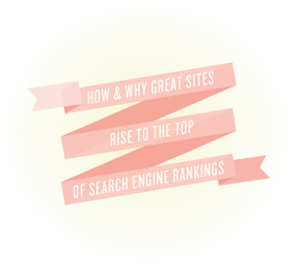

## The Impact of Usability and User Experience

### *On search engine rankings*

There are a limited number of variables that search engines can take into account directly, including keywords, links, and site structure. However, through linking patterns, user engagement metrics, and machine learning, the engines make a considerable number of intuitions about a given site. Usability and user experience are second order influences on search engine ranking success. They provide an indirect but measurable benefit to a site's external popularity, which the engines can then interpret as a signal of higher quality. This is called the "**no one likes to link to a crummy site**" phenomenon.

Crafting a thoughtful, empathetic user experience helps ensure that visitors to your site perceive it positively, encouraging sharing, bookmarking, return visits, and inbound links—all signals that trickle down to the search engines and contribute to high rankings.

## Signals of Quality Content

### *1. Engagement Metrics*

When a search engine delivers a page of results to you, it can measure the success of the rankings by observing how you engage with those results. If you click the first link, then immediately hit the back button to try the second link, this indicates that you were not satisfied with the first result. Search engines seek the "long click" – where users click a result without immediately returning to the search page to try again. Taken in aggregate over millions and millions of queries each day, the engines build up a good pool of data to judge the quality of their results.

### *2. Machine Learning*

### *3. Linking Patterns*

The engines discovered early on that the link structure of the web could serve as a proxy for votes and popularity; higher quality sites and information earned more links than their less useful, lower quality peers. Today, [link analysis](https://moz.com/researchtools/ose/) algorithms have advanced considerably, but these principles hold true.

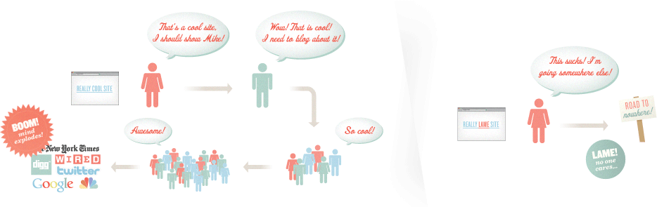

All of that positive attention and excitement around the content offered by the new site translates into a machine-parseable (and algorithmically-valuable) collection of links. The timing, source, anchor text, and number of links to the new site are all factored into its potential performance (i.e., ranking) for relevant queries at the engines.

## Common Search Engine Protocols

### *1. Sitemaps*

You can read the full details of the protocols at [Sitemaps.org](http://www.sitemaps.org/). In addition, you can build your own sitemaps at [XML-Sitemaps.com](http://www.xml-sitemaps.com/). Sitemaps come in three varieties:

### *XML*

Extensible Markup Language (recommended format)

### *RSS*

Really Simple Syndication or Rich Site Summary

### *Txt*

Text File

### *2. Robots.txt*

The following commands are available:

### *Disallow*

Prevents compliant robots from accessing specific pages or folders.

### *Sitemap*

Indicates the location of a website’s sitemap or sitemaps.

### *Crawl Delay*

Indicates the speed (in seconds) at which a robot can crawl a server.

### *3. Meta Robots*

### *4. Rel="Nofollow"*

### *5. Rel="canonical"*

## Search Engine Tools

### *Google Search Console*

[Google Search Console](https://www.google.com/webmasters/tools/home)

### *Key Features*

**Geographic Target**

**Preferred Domain** –

**URL Parameters** - You can indicate to Google information about each parameter on your site, such as "**sort=price**" and "**sessionid=2**". This helps Google crawl your site more efficiently.

**Crawl Rate** - The crawl rate affects the speed (but not the frequency) of Googlebot's requests during the crawl process.

**Malware** - Google will inform you if it has found any malware on your site. Malware creates a bad user experience, and hurts your rankings.

**Crawl Errors** - If Googlebot encounters significant errors while crawling your site, such as 404s, it will report these.

**HTML Suggestions** - Google looks for search engine-unfriendly HTML elements such as issues with meta descriptions and title tags.

### *Your Site on the Web*

Statistics provided by search engine tools offer unique insight to SEOs, like keyword impressions, click-through rates, top pages delivered in search results, and linking statistics.

### *Site Configuration*

This important section allows you to submit sitemaps, test robots.txt files, adjust [sitelinks](http://support.google.com/webmasters/bin/answer.py?hl=en&answer=47334), and submit change of address requests when you move your website from one domain to another. This area also contains the Settings and URL parameters sections discussed in the previous column.

### *+1 Metrics*

When users share your content on Google+ with the +1 button, this activity is often annotated in search results. [Watch this illuminating video on Google+](https://plus.google.com/u/0/112544075040456048636/posts/GEGKic4WGZR) to understand why this is important. In this section, Google Search Console reports the effect of +1 sharing on your site's performance in search results.

### *Labs*

The Labs section of Search Console contains reports that Google considers still in the experimental stage, but which can nonethelsss be useful to webmasters. One of the most important of these reports is Site Performance, which indicates how fast or slow your site loads for visitors.

### *Bing Webmaster Tools*

[Bing Webmaster Tools](http://www.bing.com/webmaster)

### *Key Features*

**Sites Overview** -

**Crawl Stats**

**Index** –

**Traffic** -

### *Moz Open Site Explorer*

Moz's [Open Site Explorer](https://moz.com/researchtools/ose/) provides valuable insight into your website and links.

### *Features*

**Identify Powerful Links** -

**Find the Strongest Linking Domains** –

**Analyze Link Anchor Text Distribution** –

**Head to Head Comparison View**

**Social Share Metrics** –

## RECOMMENDED METRICS TO TRACK

## 1. Search Engine Share of Referring Visits

Every month, keep track of the contribution of each traffic source for your site, including:

* ***Direct Navigation****: Typed in traffic, bookmarks, email links without tracking codes, etc.*
* ***Referral Traffic****: From links across the web or in trackable email, promotional, and branding campaign links*
* ***Search Traffic****: Queries that sent traffic from any major or minor web search engine*

**2. Search Engine Referrals**

### *Compare Performance vs. Market Share*

### *Get Visibility Into Potential Drops*

### *Uncover Strategic Value*

## 3. Visits Referred by Specific Search Engine Terms and Phrases

## 4. Conversion Rate by Search Query Term/Phrase

## 5. Number of pages receiving at least one visit from search engines

## nalytics Software

### *The right tools for the job*



* [***Moz Analytics***](https://moz.com/products/pro/)
* [***Omniture***](http://www.omniture.com/)
* [***Fireclick***](http://www.fireclick.com/)
* [***Mint***](http://www.haveamint.com/)
* [***Sawmill Analytics***](http://www.sawmill.net/)
* [***Clicktale***](http://www.clicktale.com/)
* [***Coremetrics***](http://www.coremetrics.com/)
* [***Unica NetInsight***](http://www-03.ibm.com/software/products/us/en/on-premise-web-analytics/)



* [***Yahoo! Web Analytics***](http://web.analytics.yahoo.com/)*(formerly Indextools)*
* [***Google Analytics***](http://www.google.com/analytics/)
* [***Clicky Web Analytics***](http://www.getclicky.com/)
* [***Piwik Open Source Analysis***](http://piwik.org/)
* [***Woopra Website Tracking***](http://www.woopra.com/)
* [***AWStats***](http://awstats.sourceforge.net/)

## Metrics for Measuring

### *Search Engine Optimization*

### Google Logo

### *Google Site Query*

### *Google Trends*



### *Bing Site Query*

### *Bing IP Query*

### *Bing Ads Intelligence*

## APPLYING THAT DATA

## Fluctuation

### *In search engine page and link count numbers*

## Falling

### *Search traffic from a single engine*

## Falling

### *Search traffic from multiple engines*

## Individual

### *Ranking fluctuations*

## Positive

### *Increases in link metrics without rankings increases*

<https://moz.com/beginners-guide-to-seo>

Revise chapter 8, 9, 10