Please note the following columns cannot be used directly as independent variables to predict the game of the same row in reality. **As they record the summary statistics of the games, which are only available after games finished.** But you still can use them from the historical data before the match to extract useful features, for example, calculate the historical performance of horses by their finishing time in the past.

You may also find these after understanding their meanings. I just clarify them here.

1. rfinishm

2. rm1

3. rm2

4. rm3

5. rm4

6. rm5

7. rm6

8. rank

9. runpos

10. p1

11. p2

12. p3

13. p4

14. p5

15. p6

16. m1

17. m2

18. m3

19. m4

20. m5

21. m6

22. finish

23. d1

24. d2

25. d3

26. d4

27. d5

28. d6

29. windist

30. ind_win

31. ind_pla

**Besides, we cannot use the following 2 final odds to predict the same game in reality. Because they are not available until the matches already started.**

**32. win**

**33. place**

**Yet win_t5 and place_t5 can be used as they are information of 5 minutes before matches start, which means your model needs to generate output within 5 minutes to make the bet in practice : )**

For example, the following screenshot is about the available racing information of a game on Sep 21, 2019, Sha Tin. You can check the information on <https://racing.hkjc.com/racing/Info/meeting/RaceCard/english/Local/>. This may help you to understand about available information before a horse racing game.

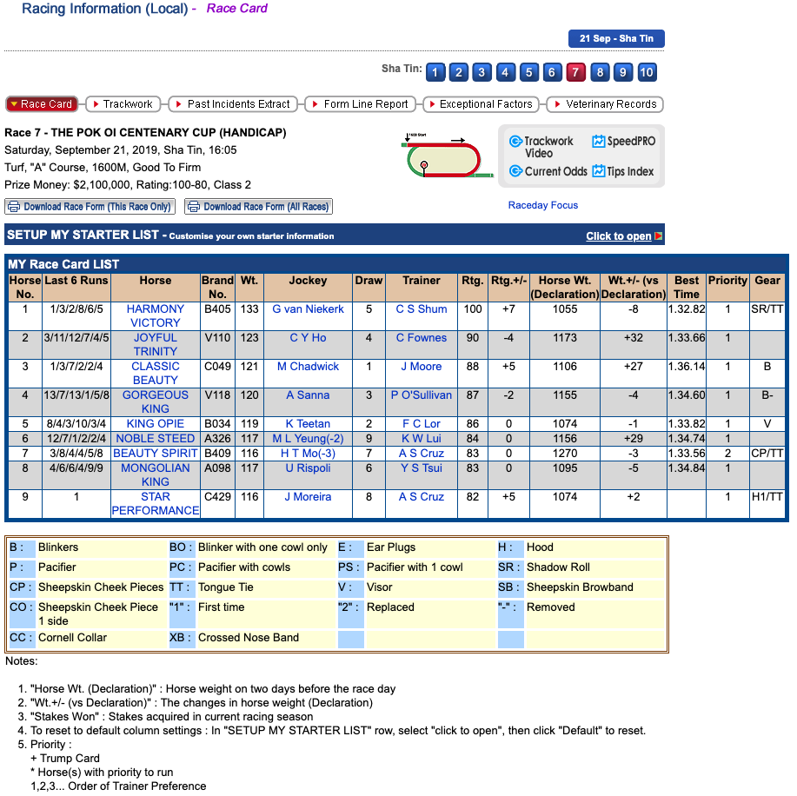

You can also find some introduction of betting at <https://special.hkjc.com/racing/info/en/betting/guide.asp>.