**1. Describe the enumerations programming constructs, which provides a human-readable form of a series of related constant values in C#.**

using System;

namespace ProgramOne

{

class Program

{

enum CollegeDays

{

MONDAY, TUESDAY, WEDNESDAY, THURSDAY, FRIDAY, SATURDAY

}

static void Main(string[] args)

{

foreach (var day in Enum.GetValues(typeof(CollegeDays)))

{

Console.WriteLine("{0} : {1}",day, (int) day);

}

Console.Read();

}

}

}

**OUTPUT:**

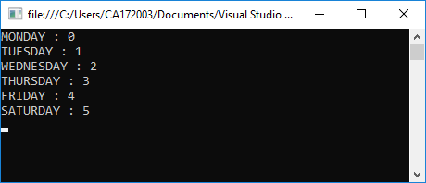

**2. Check Whether the Entered Year is a Leap Year or Not.**

using System;

using System.Windows.Forms;

namespace ProgramThreeGUI

{

public partial class Form1 : Form

{

public Form1()

{

InitializeComponent();

}

private void button1_Click(object sender, EventArgs e)

{

label2.Text = "";

long year;

try

{

year = Int64.Parse(textBox1.Text);

if (checkYear(year))

label2.Text = year + " is a Leap year";

else

label2.Text = year + " is not a Leap year";

}

catch (FormatException ex) {

label2.Text = "Please enter only numbers";

}

}

static bool checkYear(long year)

{

if (year % 400 == 0)

return true;

else if (year % 100 == 0)

return false;

else if (year % 4 == 0)

return true;

else

return false;

}

}

}

**OUTPUT:**

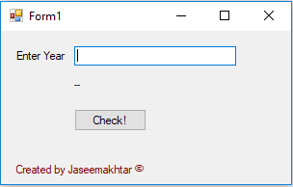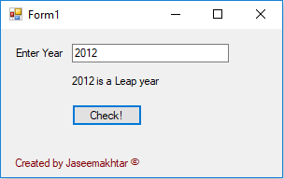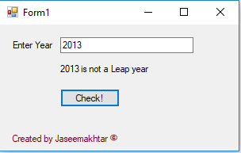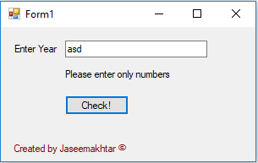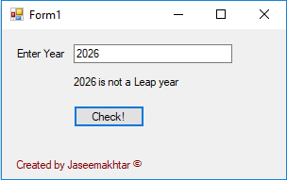

**3. Program to display the addition, subtraction, multiplication and division of two number using console applications.**

using System;

namespace ProgramFive

{

class Program

{

static void Main(string[] args)

{

double num1, num2;

double sum, sub, mul, div;

Console.WriteLine("Enter the two numbers");

num1 = Double.Parse(Console.ReadLine());

num2 = Double.Parse(Console.ReadLine());

sum = num1 + num2;

sub = num1 - num2;

mul = num1 * num2;

div = num1 / num2;

Console.WriteLine("Addition: {0}", sum);

Console.WriteLine("Substraction: {0}", sub);

Console.WriteLine("Multiplication: {0}", mul);

Console.WriteLine("Division: {0}", div);

Console.ReadLine();

}

}

}

**OUTPUT:**

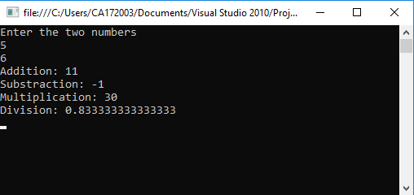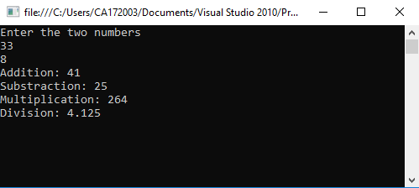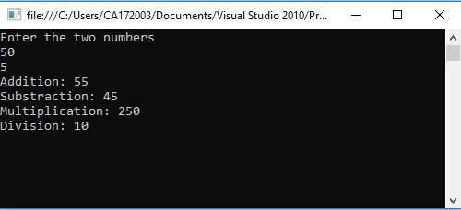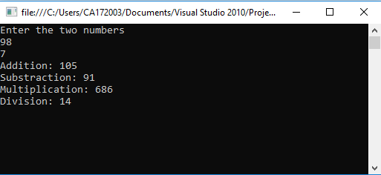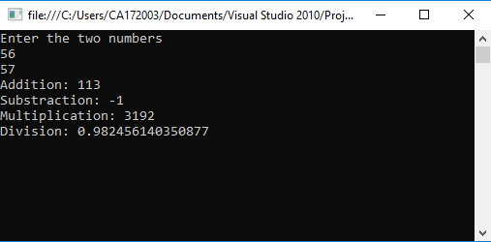

**4. Program to display the first 10 natural numbers and their sum using console application.**

using System;

namespace ProgramSix

{

class Program

{

static void Main(string[] args)

{

int sum = 0;

Console.WriteLine("First 10 natural numbers");

for (int i = 1; i <= 10; i++)

{

sum += i;

Console.WriteLine(i);

}

Console.WriteLine("Sum: {0}", sum);

Console.ReadLine();

}

}

}

**OUTPUT:**

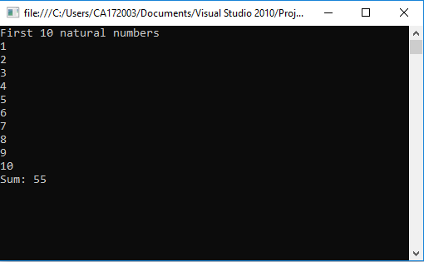

**5. Program to display the addition using the windows application.**

using System;

using System.Collections.Generic;

using System.ComponentModel;

using System.Data;

using System.Drawing;

using System.Linq;

using System.Text;

using System.Windows.Forms;

namespace ProgramSeven

{

public partial class Form1 : Form

{

public Form1()

{

InitializeComponent();

}

private void button1_Click(object sender, EventArgs e)

{

int num1 = Int16.Parse(textBox1.Text);

int num2 = Int16.Parse(textBox2.Text);

int sum = num1 + num2;

label1.Text = "Sum: " + sum;

}

}

}

**OUTPUT:**

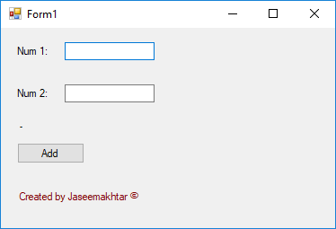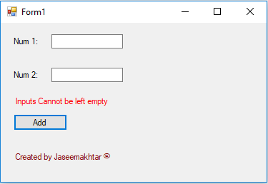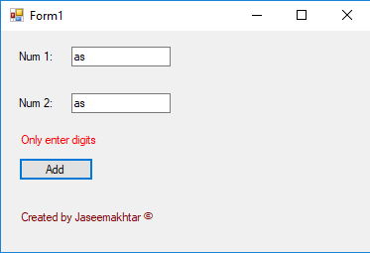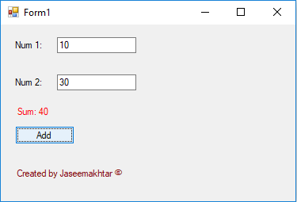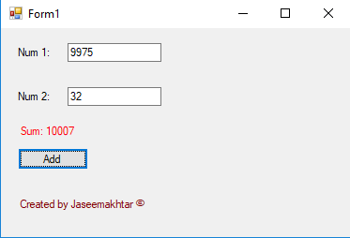

**6. Write a program to convert input string from lower to upper and upper to lower case.**

using System;

namespace ProgramNine

{

class Program

{

static void Main(string[] args)

{

string input;

Console.WriteLine("Enter any word / sentence");

input = Console.ReadLine();

Console.WriteLine("Upper case: {0}", input.ToUpper());

Console.WriteLine("Lower case: {0}", input.ToLower());

Console.ReadLine();

}

}

}

**OUTPUT:**

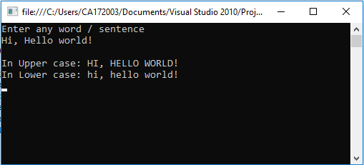

**7. Find the second largest element in a single dimensional array.**

using System;

namespace ProgramFourteen

{

class Program

{

static void Main(string[] args)

{

int n;

Console.WriteLine("Enter the size of the array");

n = Int16.Parse(Console.ReadLine());

int[] array = new int[n];

Console.WriteLine("Enter {0} elements into array", n);

for (int i = 0; i < n; i++)

array[i] = Int16.Parse(Console.ReadLine());

for (int i = 0; i < n; i++) {

int max = array[i];

for (int j = 0; j < n; j++) {

if (array[j] > max) {

int t = array[j];

array[j] = array[i];

array[i] = t;

}

}

}

Console.WriteLine("Second largest element: {0}", array[n - 2]);

Console.ReadLine();

}

}

}

**OUTPUT:**

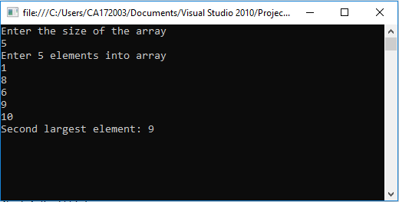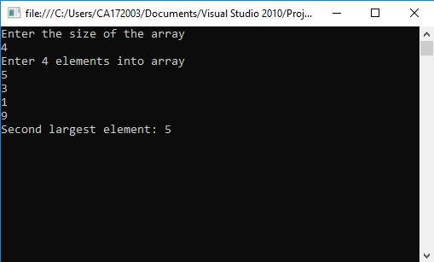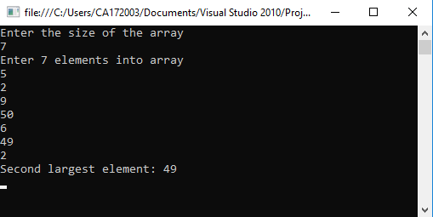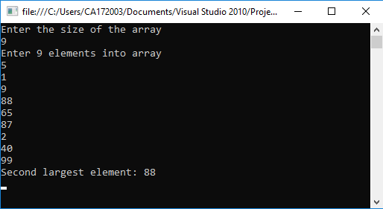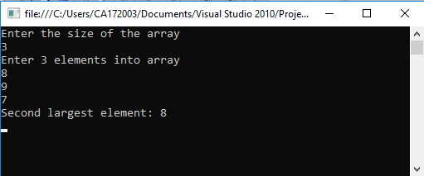

**8. Program to illustrate the use of different properties in C#.**

using System;

namespace ProgramFifteen

{

class PropertiesDemo

{

private string name;

private int age;

public string Name{

set {

name = value;

}

get {

return name;

}

}

public int Age {

set {

if (value > 0)

age = value;

}

get {

return age;

}

}

static void Main(string[] args)

{

PropertiesDemo p = new PropertiesDemo();

p.Name = "Jaseem";

p.Age = 23;

PropertiesDemo d = new PropertiesDemo();

d.Name = "Mr.X";

d.Age = -1;

Console.WriteLine("***** Properties (Getter & Setter) *****");

Console.WriteLine(" p.Name = \"Jaseem\" ");

Console.WriteLine(" p.Age = 23 ");

Console.WriteLine();

Console.WriteLine(" d.Name = \"Mr.X\" ");

Console.WriteLine(" d.Age = -1 ");

Console.WriteLine();

Console.WriteLine(" {0} : {1}", p.Name, p.Age);

Console.WriteLine(" {0} : {1}", d.Name, d.Age);

Console.ReadLine();

}

}

}

**OUTPUT:**

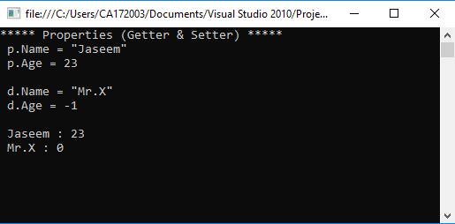

**9. Demonstrate Command line arguments processing.**

using System;

namespace ProgramSixteen

{

class Program

{

static void Main(string[] args)

{

if (args.Length >= 2)

{

int num1 = Int32.Parse(args[0]);

int num2 = Int32.Parse(args[1]);

Console.WriteLine("Addition of Command Line Arguments ({0}, {1})", num1, num2);

int sum = num1 + num2;

Console.WriteLine("{0}", sum);

}

else

{

Console.WriteLine("No command line arguments to process");

}

Console.ReadLine();

}

}

}

**OUTPUT:**

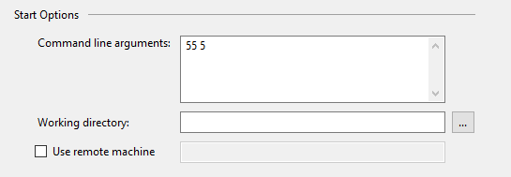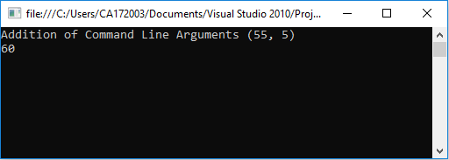

**10. Create classes, they are reference types in C# and hence are allocated on the heap. Classes provide object-oriented constructs such as encapsulation, polymorphism, and inheritance. For instance, the program should print John. Doe twice, illustrating that objects are reference types, allocated on the heap implement the same using C#.**

using System;

namespace ProgramTwo

{

class Program

{

static void Main(string[] args)

{

User user1 = new User("Tony");

Admin user2 = new Admin("Jaseem", "jaseem@gmail.com", "akhtar");

Console.WriteLine("User 1:");

Console.WriteLine("Name: {0}", user1.getName());

Console.WriteLine("Email: {0}", user1.getEmail());

Console.WriteLine();

Console.WriteLine("User 2 (Admin):");

Console.WriteLine("Name: {0}", user2.getName());

Console.WriteLine("Email: {0}", user2.getEmail());

Console.WriteLine("Password: {0}", user2.getPassword());

Console.Read();

}

}

class User {

private string name;

private string email;

public User(String name) {

this.name = name;

}

public User(String name, String email)

{

this.name = name;

this.email = email;

}

public string getName() {

return name;

}

public string getEmail()

{

return email;

}

public void setName(string name)

{

this.name = name;

}

public void setEmail(string email)

{

this.email = email;

}

}

class Admin : User {

private string password;

public Admin(string name, string email, string password): base(name, email)

{

this.password = password;

}

public void setPassword(string password) {

this.password = password;

}

public string getPassword() {

return password;

}

}

}

**OUTPUT:**

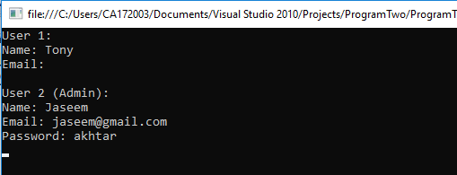

**11. Demonstrate Use of Virtual and override keyword in C# with a simple Program.**

using System;

class Animal

{

public virtual void speak() { }

}

class Dog : Animal

{

public override void speak()

{

Console.WriteLine("Woof woof...");

}

}

class Cat : Animal

{

public override void speak()

{

Console.WriteLine("Meow meow...");

}

}

class Program

{

static void Main(string[] args)

{

Console.WriteLine("#Virual & Override keywords are used in method overriding context\n");

Animal dog = new Dog();

Animal cat = new Cat();

Console.WriteLine("\nDog object:");

dog.speak();

Console.WriteLine("\nCat object:");

cat.speak();

Console.ReadLine();

}

}

**OUTPUT:**

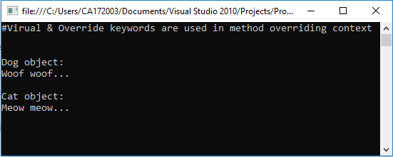

**12. Perform operator overloading.**

using System;

namespace ProgramTwelve

{

class Rectangle

{

int width;

int height;

Rectangle(int width, int height) {

this.width = width;

this.height = height;

}

public static Rectangle operator +(Rectangle a, Rectangle b)

{

int totalWidth = a.width + b.width;

int totalHeight = a.height + b.height;

return new Rectangle(totalWidth, totalHeight);

}

static void Main(string[] args)

{

Rectangle r1 = new Rectangle(60, 40);

Rectangle r2 = new Rectangle(80, 50);

Console.WriteLine("*********Operator Overloading************\n");

Console.WriteLine("Rectangle(R1)");

Console.WriteLine("Width: {0}", r1.width);

Console.WriteLine("Height: {0}", r1.height);

Console.WriteLine();

Console.WriteLine("Rectangle(R2)");

Console.WriteLine("Width: {0}", r2.width);

Console.WriteLine("Height: {0}", r2.height);

Console.WriteLine();

Rectangle r3 = r1 + r2;

Console.WriteLine("Total Width (R1 + R2): {0}", r3.width);

Console.WriteLine("Total Height (R1 + R2): {0}", r3.height);

Console.Read();

}

}

}

**OUTPUT:**

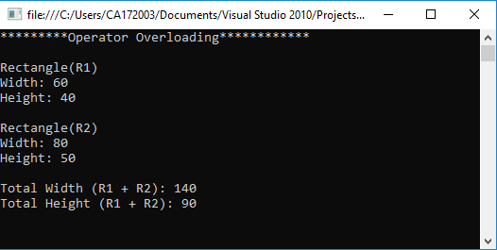

**13. Describe Arrays and Strings methods with suitable C# program.**

using System;

namespace ProgramFour

{

class Program

{

static void Main(string[] args)

{

int[] array = { 1, 4, 6, 2, 8, 9, 7 };

Console.WriteLine("Properties & Methods of an Array: ");

displayArray(array);

Console.WriteLine();

Console.WriteLine("Length: {0}", array.Length);

Console.WriteLine("Rank: {0}", array.Rank);

Console.WriteLine("Max(): {0}", array.Max());

Console.WriteLine("Min(): {0}", array.Min());

Console.WriteLine("Sum(): {0}", array.Sum());

Console.WriteLine("Array.Reverse()");

Array.Reverse(array);

displayArray(array);

Console.WriteLine("Array.Sort()");

Array.Sort(array);

displayArray(array);

Console.WriteLine();

Console.WriteLine("____________________________________");

Console.WriteLine();

Console.WriteLine("Properties & Methods of a String: ");

String str1 = "Hello World!, I am Jaseem!. ";

Console.WriteLine();

String str2 = "Full-Stack Android & Web Developer.";

Console.WriteLine("String 1: {0}", str1);

Console.WriteLine("String 2: {0}", str2);

Console.WriteLine("str1.Length: {0}", str1.Length);

Console.WriteLine("str1.IndexOf('J'): {0}", str1.IndexOf('J'));

Console.WriteLine("str2.Contains(\"Developer\"): {0}", str2.Contains("Developer"));

Console.WriteLine("str1.Insert(19 + 6, \"-Akhtar\"): {0}", str1.Insert(str1.IndexOf('J') + 6, "-Akhtar"));

Console.WriteLine("str1.Replace(\"I am\", \"This is\"): {0}", str1.Replace("I am", "This is"));

Console.WriteLine("str1.Remove(str1.IndexOf(','): {0}", str1.Remove(str1.IndexOf(',')));

Console.WriteLine("str1.Substring(str1.IndexOf(','): {0}", str1.Substring(str1.IndexOf(',') + 1));

Console.WriteLine("String.Concat(str1, str2): {0}", String.Concat(str1, str2));

Console.WriteLine("String.Equals(str1, str2): {0}", String.Equals(str1, str2));

Console.WriteLine("String.Compare(str1, str2): {0}", String.Compare(str1, str2));

Console.ReadLine();

}

static void displayArray(int[] a)

{

Console.Write("[");

for (int i = 0; i < a.Length; i++)

{

Console.Write(" {0} ", a[i]);

}

Console.WriteLine("]");

}

}

}

**OUTPUT:**

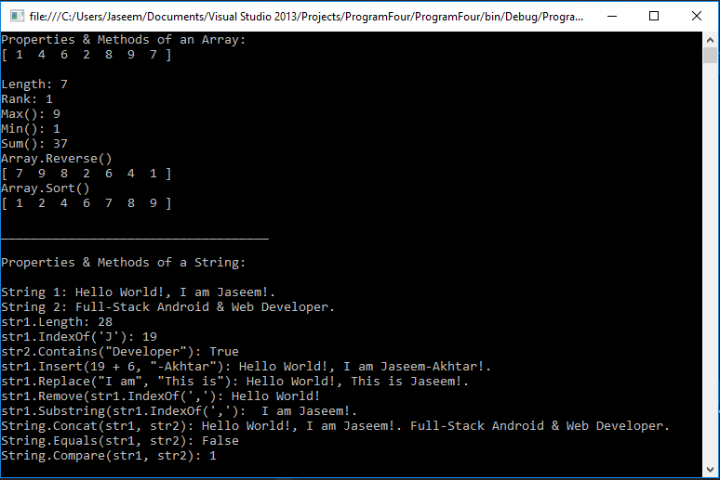

**14. Describe delegates, events, errors and exceptions.**

Program.cs

using System;

namespace ProgramThirteen

{

class Program

{

static void Main(string[] args)

{

Car car = new Car("Tesla");

car.aboutToBlowListener += new Car.EventHandler(aboutToBlow);

car.exploadListener += new Car.EventHandler(exploded);

Console.WriteLine("*****Speeding Up*******");

try

{

for (int i = 0; i < 20; i++)

{

car.accelerate(20);

}

}

catch (Exception e)

{

Console.WriteLine("Exception: Car is dead already!");

}

Console.ReadLine();

}

public static void aboutToBlow(string msg)

{

Console.WriteLine("-> Reporting: {0}", msg);

}

public static void exploded(string msg)

{

Console.WriteLine("-> Reporting: {0}", msg);

throw new Exception("Car dead");

}

}

}

Car.cs

using System;

namespace ProgramThirteen

{

class Car

{

public delegate void EventHandler(string msg);

public event EventHandler exploadListener;

public event EventHandler aboutToBlowListener;

private string name;

private bool isExhausted;

private int currentSpeed;

private const int maxSpeed = 140;

public Car(String name)

{

this.name = name;

}

public void accelerate(int delta)

{

if (isExhausted)

{

if (exploadListener != null)

exploadListener("Sorry, the car is dead!");

}

else

{

currentSpeed += delta;

if (10 >= maxSpeed - currentSpeed && aboutToBlowListener != null)

{

aboutToBlowListener("Be Careful, Gonna blow!");

}

if (currentSpeed >= maxSpeed)

isExhausted = true;

else

Console.WriteLine("-> Current Speed: {0}", currentSpeed);

}

}

}

}

**OUTPUT:**

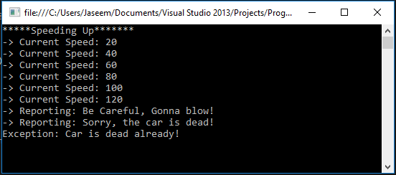

**15. Program to multiply to matrices using Rectangular arrays.**

using System;

namespace MatrixMultiplication

{

class Program

{

static void Main(string[] args)

{

int n1, n2, m1, m2;

int[,] matrixA, matrixB;

m1 = readInt("Enter the value of m, for first M x N matrix\n");

n1 = readInt("Enter the value of n, for first M x N matrix\n");

m2 = readInt("Enter the value of m, for second M x N matrix\n");

n2 = readInt("Enter the value of n, for second M x N matrix\n");

if (n1 != m2)

{

Console.WriteLine("Sorry! Matrices cannot be multiplied\n");

}

else

{

matrixA = new int[m1, n1];

matrixB = new int[m2, n2];

matrixA = readMatrix(m1, n1);

matrixB = readMatrix(m2, n2);

displayMatrix(matrixA, m1, n1);

displayMatrix(matrixB, m2, n2);

int[,] matrixC = new int[m1, n2];

for (int m = 0; m < m1; m++)

{

for (int n = 0; n < n2; n++)

{

int sum = 0;

for (int k = 0; k < m2; k++)

sum += matrixA[m, k] * matrixB[k, n];

matrixC[m, n] = sum;

}

}

Console.WriteLine("Resultant Matrix: ");

displayMatrix(matrixC, m1, n2);

}

Console.ReadLine();

}

static int readInt(String message)

{

Console.Write(message);

return Convert.ToInt16(Console.ReadLine());

}

static int[,] readMatrix(int m, int n)

{

int[,] mat = new int[m, n];

Console.WriteLine("Enter the elements of Matrix {0} x {1}", m, n);

for (int i = 0; i < m; i++)

for (int j = 0; j < n; j++)

mat[i, j] = readInt("");

return mat;

}

static void displayMatrix(int[,] mat, int m, int n)

{

Console.WriteLine("Matrix {0} x {1}", m, m);

for (int i = 0; i < m; i++)

{

for (int j = 0; j < n; j++)

Console.Write("{0} ", mat[i, j]);

Console.WriteLine("");

}

}

}

}

**OUTPUT:**

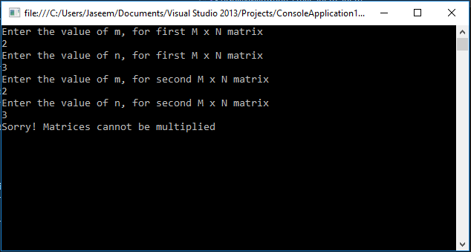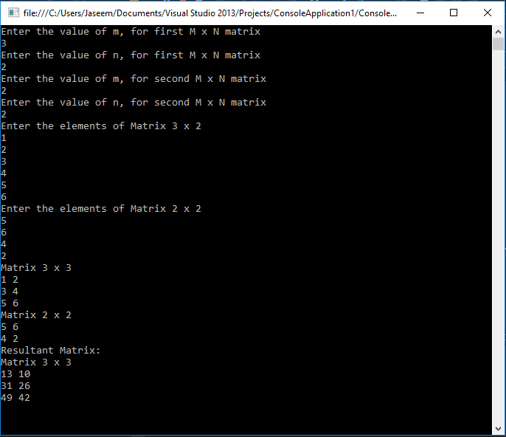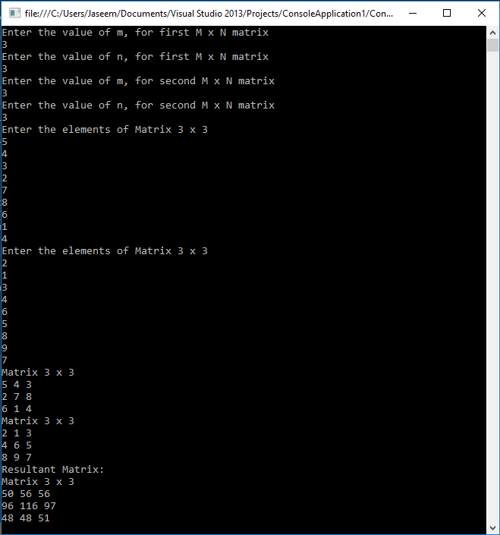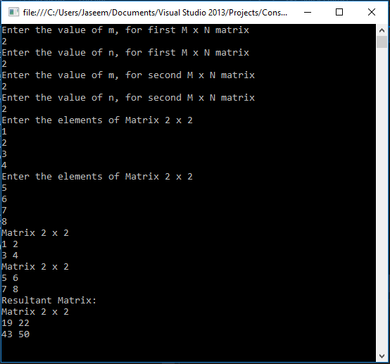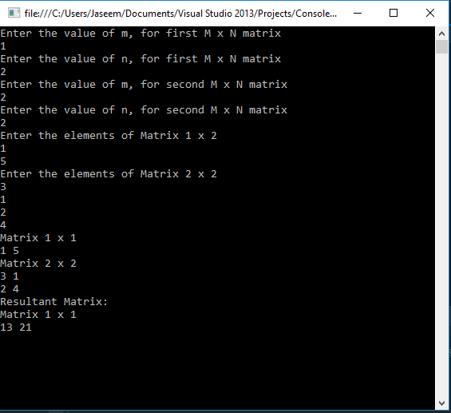

**16. Work with Page using ASP.Net.**

Default.aspx

<%@ Page Language="C#" AutoEventWireup="true" CodeFile="Default.aspx.cs" Inherits="_Default" %>

<!DOCTYPE html>

<html xmlns="http://www.w3.org/1999/xhtml">

<head runat="server">

<title>Game - Hit the button</title>

<style>

html{

height: 100%;

}

body{

min-height: 100%;

padding: 0;

margin: 0;

}

*{

font-family: Arial;

}

.container{

height: 100vh;

display: flex;

flex-direction: column;

align-items:center;

}

.space{

flex-grow: 1;

}

footer{

font-size: 0.8em;

padding: .4em;

color: gray;

}

</style>

</head>

<body>

<form id="form1" runat="server">

<div class="container">

<h1>Welcome to Game - Hit the button!</h1>

<asp:Label ID="lblOutput" Text="Your score is 0" runat="server" />

<asp:button id="clickMeButton" runat="server" text="Hit!" onClick="clickMeButton_Click" />

<div class="space"></div>

<footer>&copy; 2019 Jaseemakhtar. All Rights Reserved.</footer>

</div>

</form>

</body>

</html>

Default.aspx.cs

using System;

using System.Web;

public partial class _Default : System.Web.UI.Page

{

protected void Page_Load(object sender, EventArgs e)

{

}

protected void clickMeButton_Click(object sender, EventArgs e)

{

object value = ViewState["HitCount"];

int i = (value == null) ? 1 : (int)value + 1;

lblOutput.Text = string.Format("You score is: {0}", i);

ViewState["HitCount"] = i;

}

}

**OUTPUT:**

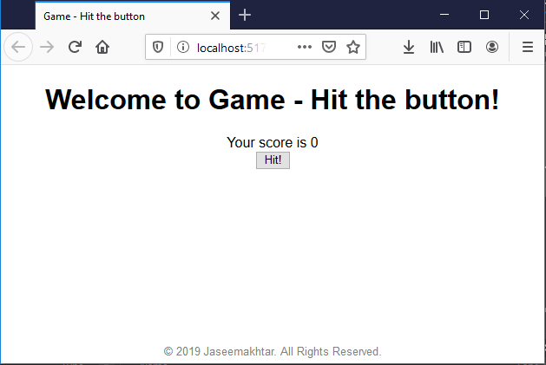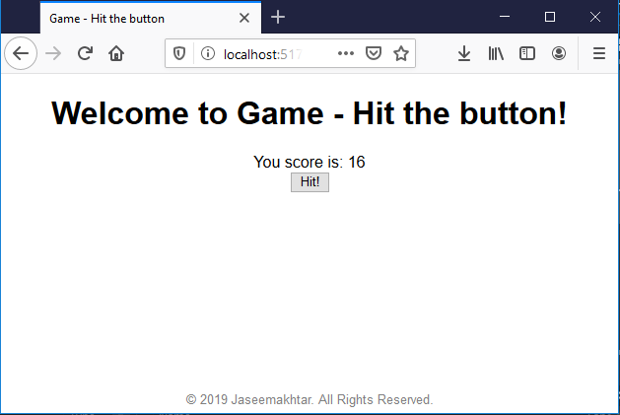

**17. Work with forms using ASP.NET.**

using System;

using System.Windows.Forms;

namespace ProgramTen

{

public partial class Form1 : Form

{

string[] names;

string[] passs;

int rows;

public Form1()

{

InitializeComponent();

names = new string[10];

passs = new string[10];

names[0] = "Jaseem";

names[1] = "Tony";

names[2] = "Morgan";

passs[0] = "sugarcane";

passs[1] = "pepper";

passs[2] = "burger";

rows = 3;

}

private void btnLogin_Click(object sender, EventArgs e)

{

string username = txtName.Text.Trim();

string password = txtPass.Text.Trim();

if (username.Equals("") || password.Equals(""))

{

MessageBox.Show("Fields cannot be empty!");

return;

}

for (int i = 0; i < rows; i++)

{

if (names[i].Equals(username) && passs[i].Equals(password))

{

MessageBox.Show("Login Successfull!");

return;

}

}

MessageBox.Show("Incorrect username/password!");

}

}

}

**OUTPUT:**

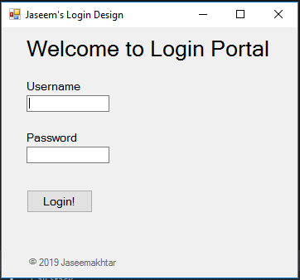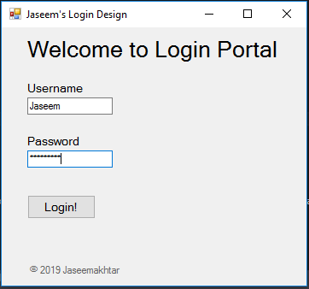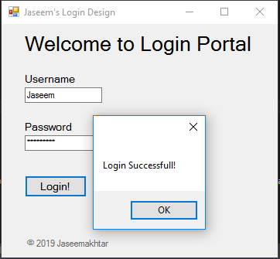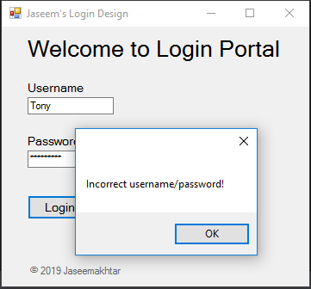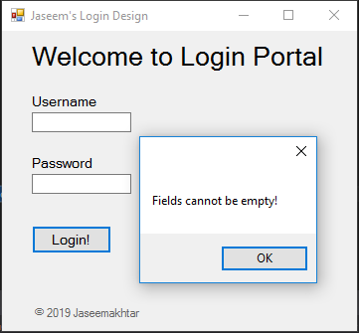

**18. Describe access data source through ADO.NET.**

User.cs

using System;

namespace ProgramEleven

{

class User

{

public int Id

{

get;

set;

}

public string UserName

{

get;

set;

}

public string RollNumber

{

get;

set;

}

public string Email

{

get;

set;

}

}

}

UserAccessLayer.cs

using System;

using System.Collections.Generic;

using System.Data;

using System.Data.SqlClient;

namespace ProgramEleven

{

class UserAccessLayer

{

private List<User> users;

private string connectionString = "Data Source=(LocalDB)\\v11.0;AttachDbFilename=\"C:\\Users\\Jaseem\\Documents\\Visual Studio 2013\\Projects\\ProgramEleven\\ProgramEleven\\myDatabase.mdf\";Integrated Security=True";

private SqlConnection connection;

private SqlCommand command;

private string query;

public List<User> getAllUsers()

{

users = new List<User>();

try

{

connection = new SqlConnection(connectionString);

connection.Open();

query = "SELECT * FROM _user";

command = new SqlCommand(query, connection);

SqlDataReader reader = command.ExecuteReader();

while (reader.Read())

{

User user = new User();

user.Id = Convert.ToInt16(reader.GetValue(0));

user.UserName = reader.GetValue(1).ToString();

user.Email = reader.GetValue(2).ToString();

user.RollNumber = reader.GetValue(3).ToString();

users.Add(user);

}

}

catch (SqlException ex)

{

Console.WriteLine("Error in fetching database!: " + ex.Message);

}

return users;

}

}

}

Form1.cs

using System;

using System.Collections.Generic;

using System.Data;

using System.Windows.Forms;

namespace ProgramEleven

{

public partial class Form1 : Form

{

public Form1()

{

InitializeComponent();

}

private void btnFetch_Click(object sender, EventArgs e)

{

UserAccessLayer uAL = new UserAccessLayer();

List<User> users = uAL.getAllUsers();

if(users.Count == 0)

lblStatus.Text = "No data!";

else

lblStatus.Text = "Data Fetched!";

dGV.DataSource = users;

}

}

}

**OUTPUT:**

