**1.Drawing the basic primitives and sierpinsky gasket using openGL*.**

#include<GL/gl.h>

#include<GL/glut.h>

#include<stdio.h> #include<math.h>

void myInit()

{

glMatrixMode(GL_PROJECTION); glLoadIdentity(); gluOrtho2D(0.0,10.0,0.0,10.0); glMatrixMode(GL_MODELVIEW); glClearColor(1.0,1.0,1.0,1.0); glColor3f(0.0,0.0,1.0);

}

void triangle(GLfloat *a,GLfloat *b,GLfloat *c)

{

glVertex2fv(a); glVertex2fv(b); glVertex2fv(c);

}

void draw_triangle(GLfloat *a,GLfloat *b,GLfloat *c,int k)

{

GLfloat ab[2],bc[2],ac[2];

int j;

if(k>1)

{

for(j=0;j<2;j++) ab[j]=(a[j]+b[j])/2.0; for(j=0;j<2;j++) bc[j]=(b[j]+c[j])/2.0; for(j=0;j<2;j++) ac[j]=(a[j]+c[j])/2.0;

draw_triangle(a,ab,ac,k-1); draw_triangle(b,bc,ab,k-1); draw_triangle(c,ac,bc,k-1);

}

else

{

triangle(a,b,c);

}

}

void display()

{ GLfloat a[2]={1.0,1.0};

GLfloat b[2]={6.0,1.0};

GLfloat c[2]={3.5,5.0};

glClear(GL_COLOR_BUFFER_BIT);

glBegin(GL_TRIANGLES);

draw_triangle(a,b,c,6);

glEnd(); glFlush();

}

int main(int argc,char **argv)

{

glutInit(&argc,argv);

glutInitDisplayMode(GLUT_RGB|GLUT_SINGLE);

glutInitWindowPosition(0,0);

glutCreateWindow("Spski Gasket");

glutDisplayFunc(display);

myInit();

glutMainLoop();

return 0;

}

**Output:**

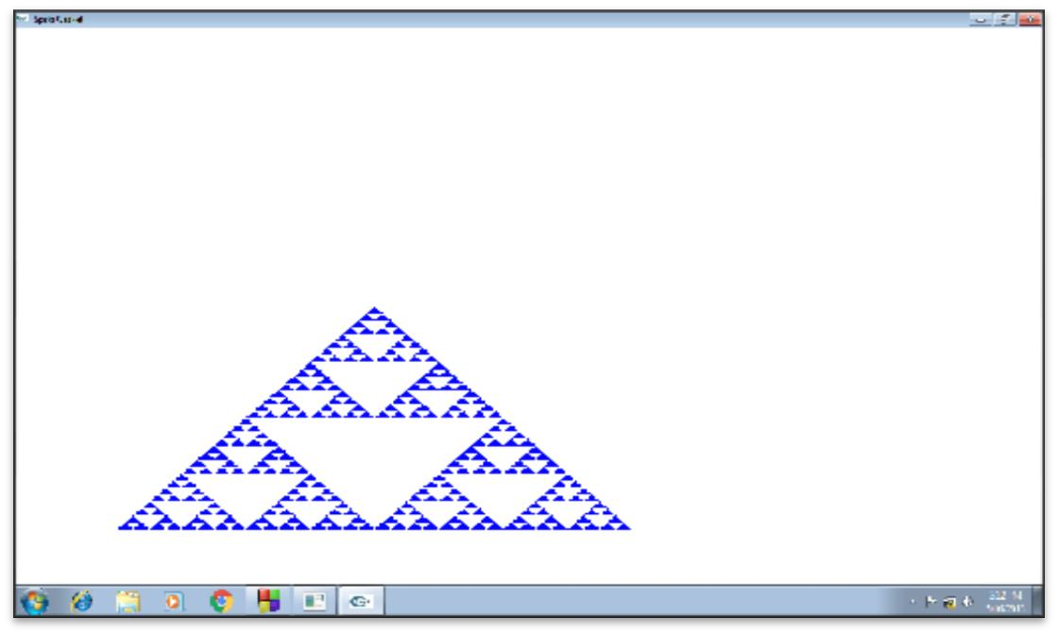

**2. Create a polyline using mouse interaction using openGL*.**

#include<GL/gl.h> #include<GL/glut.h>

struct GLintPoint

{

GLint x,y;

};

int Height=650,Width=650;

void myMouse(int button,int state,int x,int y);

void display(void)

{

glClear(GL_COLOR_BUFFET);

glFlush(); //Send all output to display

}

void myinit()

{

glClearColor(0.0,0.0,0.0,1.0); //Set background as black

glColor3f(1.0,1.0,0.0); //Draw in Yellow glMatrixMode(GL_PROJECTION); //Establish the coordinate system glLoadIdentity();

gluOrtho2D(0.0,650.0,0.0,650.0);

}

void myKeyboard(unsigned char key,int mouseX,int mouseY)

{

switch(key)

{

case 27: exit(0);

}

}

void myMouse(int button,int state,int x,int y)

{

static GLintPoint vertex[1];

static int pt=0;

if(button == GLUT_LEFT_BUTTON && state == GLUT_DOWN)

{

if(pt == 0)

{

vertex[pt].x = x;

vertex[pt].y = Height-y;

pt++;

}

Else

{

glBegin(GL_LINE_STRIP);

glVertex2i(vertex[0].x,vertex[0].y);

glVertex2i(x,Height-y);

glEnd();

vertex[0].x = x;

vertex[0].y = Height-y;

}

}

glFlush();

}

int main(int argc,char**argv)

{

glutInit(&argc,argv); //Initialize the toolkit

glutInitDisplayMode(GLUT_SINGLE|GLUT_RGB);//Set display mode

glutInitWindowSize(500,500); // Set window size

glutInitWindowPosition(100,100); //Set window position on the screen

// Open the scree window glutCreateWindow("Draw Polyline using Interaction using OpenGL");

glutDisplayFunc(display); //Register redraw function glutKeyboardFunc(myKeyboard); //Register keyboard function glutMouseFunc(myMouse); //Rigister mouse function myinit();

glutMainLoop(); //Go into a perpectual loop

return 0;

}

**Output:**

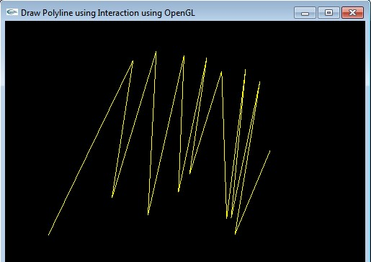

**3. Bresenham’s line drawing algorithm.**

#include<stdio.h>

#include<conio.h>

#include<math.h> #include<graphics.h> void main()

{

int xa,ya,xb,yb;

int gd = DETECT,gmode;

void bresenhm(int,int,int,int); initgraph(&gd,&gmode,"c:\\turboc3\\BGI");

printf("Enter the First end points\n");

scanf("%d %d",&xa,&ya);

printf("Enter the Second end points\n");

scanf("%d %d",&xb,&yb);

bresenhm(xa,ya,xb,yb);

}

void bresenhm(int xa,int ya,int xb, int yb)

{

int dx,dy,x,y,xend,p;

dx= abs(xa-xb);

dy= abs(ya-yb);

p2*dy-dx;

if(xa<xb)

{

x=xa;

y=yb;

}

else

{

x=xb;

y=yb;

xend=xa;

}

putpixel(x,y,7);

while(x<=xend)

{

++x;

if(p<0)

{

p+=2*dy;

}

else

{

++y;

p+=2*dy-dx;

}

putpixel(x,y,7);

}

getch();

}

**Output:**

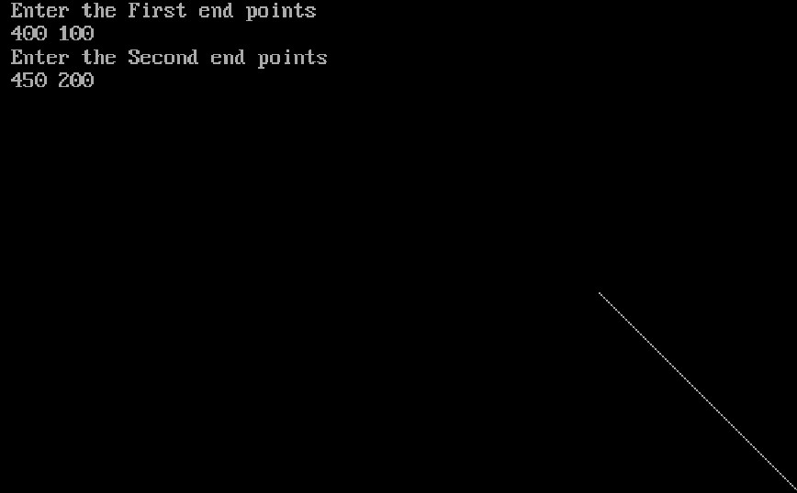

**4. Mid-Point ellipse drawing algorithm.**

#include<stdio.h>

#include<conio.h>

#include<dos.h>

#include<graphics.h>

void ellipsemidpoint(float,float,float,float); void drawellipse(float,float,float,float);

void main()

{

float xc,yc,rx,ry;

int gd=DETECT,gm; initgraph(&gd,&gm,"c:\\turboc3\\BGI");

printf("\n Enter the center co ordinates of ellipse:");

scanf("%f %f",&xc,&yc);

printf("\n Enter the x radius co ordinates:");

scanf("%f",&rx);

printf("\n Enter the y radius co ordinates:");

scanf("%f",&ry); ellipsemidpoint(xc,yc,rx,ry);

getch();

}

void ellipsemidpoint(float xc,float yc,float rx,float ry)

{

float rxsq=rx*rx;

float rysq=ry*ry;

float x=0,y=ry,p;

float px=0,py=2*rxsq*y;

drawellipse(xc,yc,x,y);

p=rysq-(rxsq*ry)+(0.25*rxsq);

while(px<py)

{

x++;

px=px+2*rysq;

if(p<0)

{

p=p+rysq+px;

}

else

{

y--;

py=py-2*rxsq;

p=p+rysq+px-py;

}

drawellipse(xc,yc,x,y);

delay(30);

}

//Region 2

p=rysq*(x+0.5)+(x+0.5)+rxsq*(y-1)*(y-1)-rxsq*rysq;

while(y>0)

{

y--;

py=py-2*rxsq;

if(p>0)

{

p=(p+rxsq-py);

}

else

{

x++;

px=px+2+rysq;

p=p+rxsq-py+px;

}

drawellipse(xc,yc,x,y);

delay(30);

}

}

void drawellipse(float xc,float yc,float x,float y)

{

putpixel(xc+x,yc+y,RED);

putpixel(xc-x,yc+y,RED); putpixel(xc+x,yc-y,RED);

putpixel(xc-x,yc-y,RED);

}

**Output:**

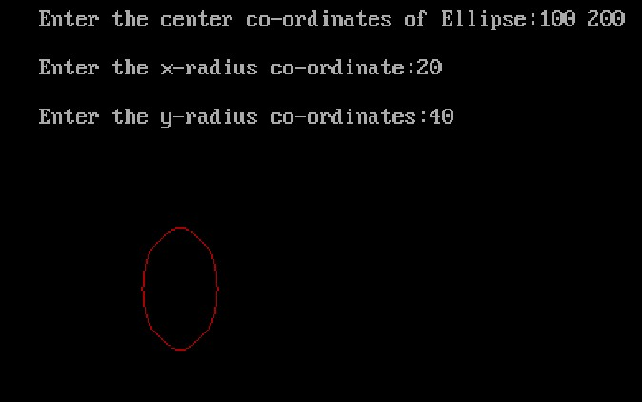

**5. Implementation of Area Filling Algorithm: Boundary Fill , Flood Fill and Scan line Polygon Fill.**

#include<stdio.h>

#include<conio.h>

#include<graphics.h> #include<math.h>

void main()

{

int gd=DETECT,gmode,i,xc,yc,tx,ty,nxc,nyc; initgraph(&gd,&gmode,"C:\\turboc3\\BGI");

xc=getmaxx()/2;

yc=getmaxy()/2;

setcolor(4);

circle(xc,yc,40);

setfillstyle(INTERLEAVE_FILL,5);

floodfill(xc,yc,4);

delay(500);

for(i=0;i<6;i++)

{

tx=80*sin(i*60*3.142/180);

ty=80*cos(i*60*3.142/180);

nxc=xc+tx;

nyc=yc+ty;

setcolor(i+1);

circle(nxc,nyc,40);

setfillstyle(SOLID_FILL,i+1);

floodfill(nxc,nyc,i+1); delay(500);

}

getch();

}

**Output:**

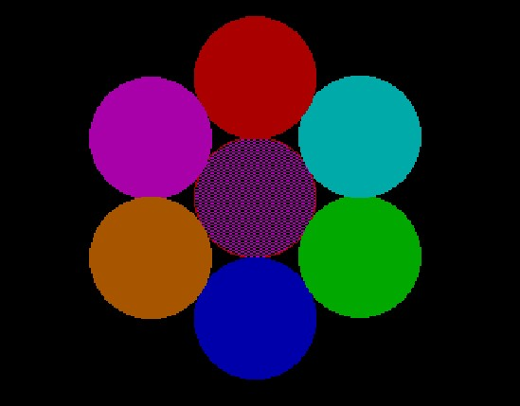

**6.Program for performing Two Dimensional Transformations Translation, Scaling, Rotation, Reflection, Shear by using a homogeneous Matrix representation,use of a function for matrix multiplication is desirable, so as to perform composite transformation**

#include<stdio.h>

#include<conio.h>

#include<math.h>

#include<graphics.h> #include<string.h>

void main()

{

int gd=DETECT,gm,ch;

initgraph(&gd,&gm,"c:\\turboc3\\BGI");

cleardevice();

printf("\t 1.Translation\n\n\t 2.rotation\n\n\t 3.Scaling\n\n\t 4.Reflection\n\n\t

5.Shearing\n\n\t 6.Exit");

printf("Enter your Choice:");

scanf("%d",&ch);

switch(ch)

{

case 1:

{

int tx=50,ty=50,x1=100,x2=230,y1=100,y2=70;

cleardevice();

printf("Rectangle before Translation:\n");

rectangle(x1,y1,x2,y2);

getch();

cleardevice();

printf("Rectangle after Translation:\n"); rectangle(x1+tx,y1+ty,x2+tx,y2+ty);

getch();

main();

}

case 2:

{

long x1=100,y1=100,x2=200,y2=200;

double d1,xt,yt;

cleardevice();

printf("n\n\n\t Enter angle of Rotation:");

scanf("%lf",&d1);

d1=((d1*3.142)/180.0);

xt=x1+((x2-x1)*cos(d1)-(y2-y1)*sin(d1));

yt=y1+((x2-x1)*sin(d1)+(y2-y1)*cos(d1));

line(x1,y1,x2,y2);

getch();

main();

}

case 3:

{

int x1=30,y1=30,x2=70,y2=70,y=2,x=2;

cleardevice();

printf("\n Rectangle before Scaling:\n");

rectangle(x1,y1,x2,y2);

getch();

cleardevice();

printf("\n\n\n rectangle after Scaling:\n");

rectangle(x1*x,y1*y,x2*x,y2*y);

getch();

main();

}

case 4:

{

\ int x1=50,y1=150,x2=75,y2=125,x3=100,y3=150,xt;

cleardevice();

printf("\n\n\n Triangle before Reflecation");

line(x1,y1,x2,y2);

line(x1,y1,x2,y2);

line(x1,y1,x2,y2);

getch();

cleardevice();

printf("\n\n\n Triangle after Reflecation\n");

line(x1,-y1+200,x2,-y2+200);

line(x1,-y1+200,x3,-y3+200);

line(x2,-y2+200,x3,-y3+200);

getch();

main();

}

case 5:

{

Int x1=100,x2=100,y1=100,y2=30,x3=170,y3=30,x4=170,y4=30,shx; cleardevice();

printf("\n\n\n Rectangle before Shearing\n");

line(x1,y1,x2,y2);

line(x1,y1,x4,y4);

line(x2,y2,x3,y3);

line(x3,y3,x4,y4);

getch();

cleardevice();

printf("\n\n\n Rectangle after Shearing:\n");

line(x1,y1,x2+shx*y2,y2);

line(x1,y1,x4,y4);

line(x2+shx*y2,y2,x3+shx*y3,y3);

line(x3+shx*y3,y3,x4,y4);

getch();

main();

}

}

closegraph();

}

**Output:**

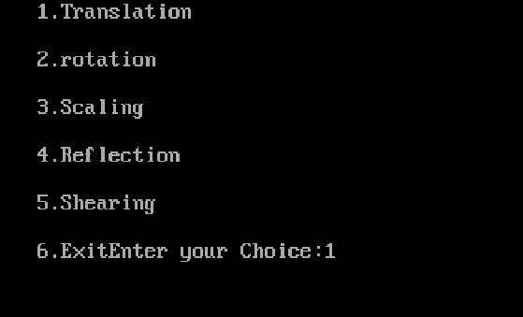

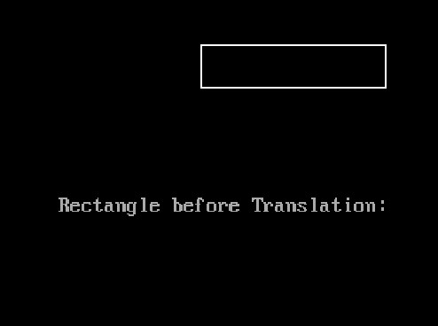

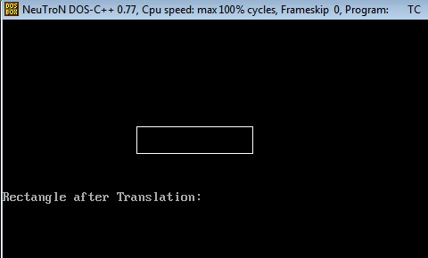

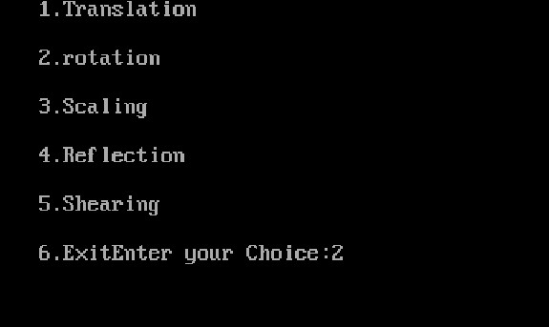

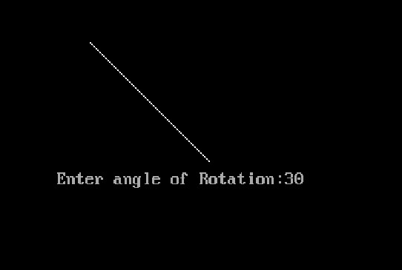

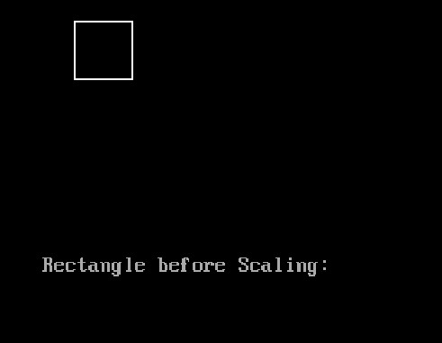

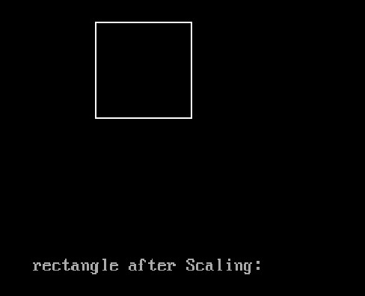

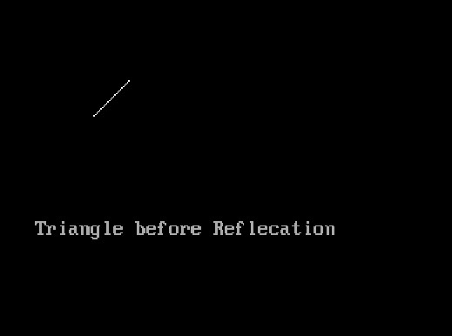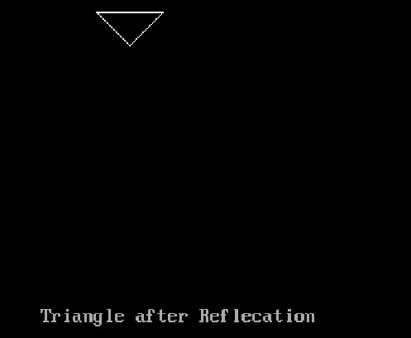

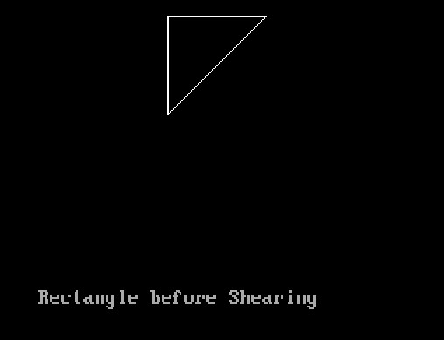

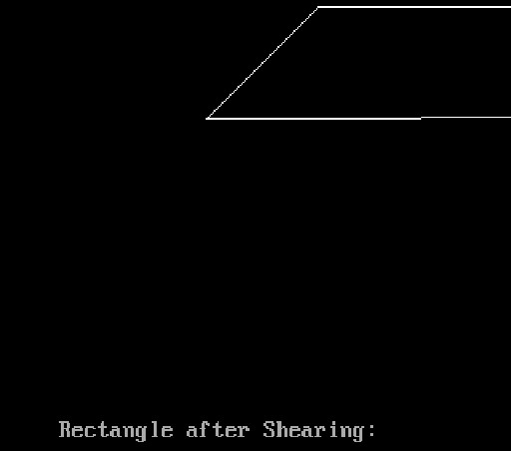

**7. Curve Generation : Bezier for n control points , B Spline (Uniform )**

#include <stdio.h>

#include <stdlib.h>

#include <graphics.h>

#include <math.h>

void bezier (int x[4], int y[4])

{

int gd = DETECT, gm;

int i;

double t;

initgraph(&gd,&gm,"c:\\turboc3\\BGI"); for (t = 0.0; t < 1.0; t += 0.0005)

{

double xt = pow (1-t, 3) * x[0] + 3 * t * pow (1-t, 2) * x[1] +

3 * pow (t, 2) * (1-t) * x[2] + pow (t, 3) * x[3];

double yt = pow (1-t, 3) * y[0] + 3 * t * pow (1-t, 2) *y[1] +

3 * pow (t, 2) * (1-t) * y[2] + pow (t, 3) * y[3];

putpixel (xt, yt, WHITE);

}

for (i=0; i<4; i++)

{

putpixel (x[i], y[i], YELLOW);

}

getch();

closegraph();

return;

}

void main()

{

int x[4], y[4];

int i;

printf ("Enter the x- and y-coordinates of the four control points.\n"); for (i=0; i<4; i++)

scanf ("%d%d", &x[i], &y[i]);

bezier (x, y);

}

**Output:**

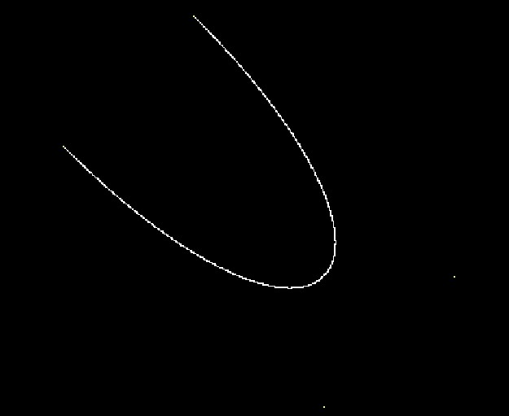

**8. Line clipping algorithm Cohen-Sutherland / liang barsky.**

#include<stdio.h>

#include<conio.h>

#include<math.h>

#include<dos.h> #include<graphics.h>

typedef struct coordinate

{

int x,y;

char code[4];

} PT;

void drawwindow();

void drawline(PT p1,PT p2);

PT setcode(PT p);

int visibility(PT p1,PT p2);

PT resetendpt(PT p1,PT p2);

void main()

{

int gd=DETECT,v,gm;

PT p1,p2,p3,p4,ptemp;

printf("\n Enter x1 and y1\n");

scanf("%d%d",&p1.x,&p1.y);

printf("\n Enter x2 and y2\n");

scanf("%d%d",&p2.x,&p2.y);

initgraph(&gd,&gm,"c:\\turboc3\\BGI");

drawwindow();

delay(500);

drawline(p1,p2);

delay(500);

cleardevice();

delay(500);

p1=setcode(p1);

p2=setcode(p2);

v=visibility(p1,p2);

delay(500);

settextstyle(DEFAULT_FONT,HORIZ_DIR,1); outtextxy(150,100,"Before Clipping");

switch(v)

{

case 0: settextstyle(DEFAULT_FONT,HORIZ_DIR,1); outtextxy(150,100,"Before Clipping");

drawwindow();

drawline(p1,p2);

delay(500);

break;

case 1: drawwindow();

delay(500);

break;

case 2: p3=resetendpt(p1,p2); p4=resetendpt(p2,p1); drawwindow();

delay(500); settextstyle(DEFAULT_FONT,HORIZ_DIR,1);

outtextxy(150,100,"After Clipping");

drawline(p3,p4);

break;

}

delay(5000);

closegraph();

}

void drawwindow()

{

line(150,100,450,100); line(450,100,450,350); line(450,350,150,350); line(150,350,150,100);

}

void drawline(PT p1,PT p2)

{

line(p1.x,p1.y,p2.x,p2.y);

}

PT setcode(PT p)

{

PT ptemp;

if(p.y<100)

ptemp.code[0]='1'; //TOP

else

ptemp.code[0]='0';

if(p.y>350)

ptemp.code[1]='1'; //BOTTOM

else

ptemp.code[1]='0';

if(p.x>450)

ptemp.code[2]='1';

else

ptemp.code[2]='0';

if(p.x<150)

ptemp.code[3]='1';

else

ptemp.code[3]='0';

ptemp.x=p.x;

ptemp.y= p.y;

return(ptemp);

}

int visibility(PT p1,PT p2)

{

int i,flag=0;

for(i=0;i<4;i++)

{

if((p1.code[i]!='0')||(p2.code[i]!='0'))

flag=1;

}

if(flag==0)

return(0);

for(i=0;i<4;i++)

{

if((p1.code[i]==p2.code[i])&&(p1.code[i]=='1'))

flag='0';

}

if(flag==0)

return(1);

return(2);

}

PT resetendpt(PT p1,PT p2)

{

PT temp;

int x,y,i;

float m,k;

if(p1.code[3]=='1')

x=150;

if(p1.code[2]=='1')

x=450;

if((p1.code[3]=='1')||(p1.code[2]=='1'))

{

m=(float)(p2.y-p1.y)/(p2.x-p1.x);

k=(p1.y+(m*(x-p1.x)));

temp.y=k;

temp.x=x;

for(i=0;i<4;i++)

{

temp.code[i]=p1.code[i];

If(temp.y<=350 && temp.y>=100)

return(temp);

}

}

if(p1.code[0]=='1')

y=100; if(p1.code[1]=='1')

y=350;

if((p1.code[0]=='1')||(p1.code[1]=='1'))

{

m=(float)(p2.y-p1.y)/(p2.x-p1.x;

k=(float)p1.x+(float)(y-p1.y)/m;

temp.x=k;

temp.y=y;

for(i=0;i<4;i++)

temp.code[i]=p1.code[i];

return(temp);

}

else return(p1);

}

**Output:**

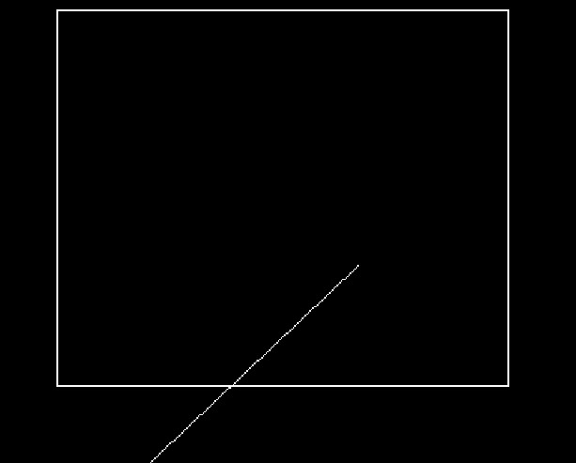

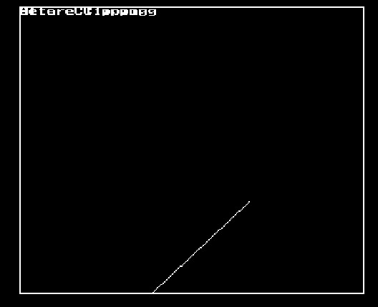

**9. Polygon Clipping algorithm Sutherland Hodgeman.**

#include <stdio.h>

#include <graphics.h>

#include <conio.h>

#include <math.h>

#include <process.h>

#define TRUE 1

#define FALSE 0

typedef unsigned int outcode;

outcode CompOutCode(float x,float y);

enum

{

TOP = 0x1,

BOTTOM = 0x2,

RIGHT = 0x4,

LEFT = 0x8

};

float xmin,xmax,ymin,ymax;

void clip(float x0,float y0,float x1,float y1)

{

Outcode outcode0,outcode1,outcodeOut;

int accept = FALSE,done = FALSE;

outcode0 = CompOutCode(x0,y0);

outcode1 = CompOutCode(x1,y1);

do

{

if(!(outcode0|outcode1))

{

accept = TRUE;

done = TRUE;

}

else

{

if(outcode0 & outcode1)

{

done = TRUE;

}

else

{

float x,y;

outcodeOut = outcode0?outcode0:outcode1;

}

if(outcodeOut & TOP)

{

x= x0+(x1-x0)*(ymax-y0)/(y1-y0);

x= ymax;

}

elseif(outcodeOut &BOTTOM)

{

x= x0+(x1-x0)*(ymin-y0)/(y1-y0);

x= ymin;

}

elseif(outcodeOut & RIGHT)

{

y = y0+(y1-y0)*(xmax-x0)/(x1-x0);

x= xmax;

}

else

{

x= y0+(y1-y0)*(xmin-x0)/(x1-x0);

x = xmin;

}

if(outcodeOut==outcode0)

{

x0 = x;

y0 = y;

outcode0 = CompOutCode(x0,y0);

}

else

{

x1 = x;

y1 = y;

outcode1 = CompOutCode(x1,y1);

}

}

}

while(done==FALSE);

if(accept)

{

line(x0,y0,x1,y1);

outtextxy(150,20,"POLYGONAFTER CLIPPING"); rectangle(xmin,ymin,xmax,yx);

}

outcode CompOutCode(float x, float y)

{

Outcode code = 0; if(y>ymax) code|=TOP;

elseif(y<ymin)

code|=BOTTOM;

if(x>xmax)

code|=RIGHT;

else if(x<xmin)

code|=LEFT;

return code;

}

void main( )

{

float x1,y1,x2,y2; /* request auto detection */

int gdriver = DETECT, gmode, n,poly[14],i;

clrscr( );

printf("Enter the no of sidespolygon:"); scanf("%d",&n);

printf("\nEnter the coordinates of polygon\n"); for(i=0;i<2*n;i++)

{

scanf("%d",&poly[i]);

}

poly[2*n]=poly[0];

poly[2*n+1]=poly[1];

printf("Enter the rectangular coordinates of clipping window\n"); scanf("%f%f%f%f",&xmin,&ymin,&xmax,&ymax);

initgraph(&gdriver, &gmode, "c:\\turboc3\\bgi");

outtextxy(150,20,"POLYGON BEFORE CLIPPING");

drawpoly(n+1,poly);

rectanglee(xmin,ymin,xmax,ymax);

getch( );

cleardevice( );

for(i=0;i<n;i++)

clip(poly[2*i],poly[(2*i)+1],poly[(2*i)+2],poly[(2*i)+3]);

getch( );

restorecrtmode( );

}

**Output:**

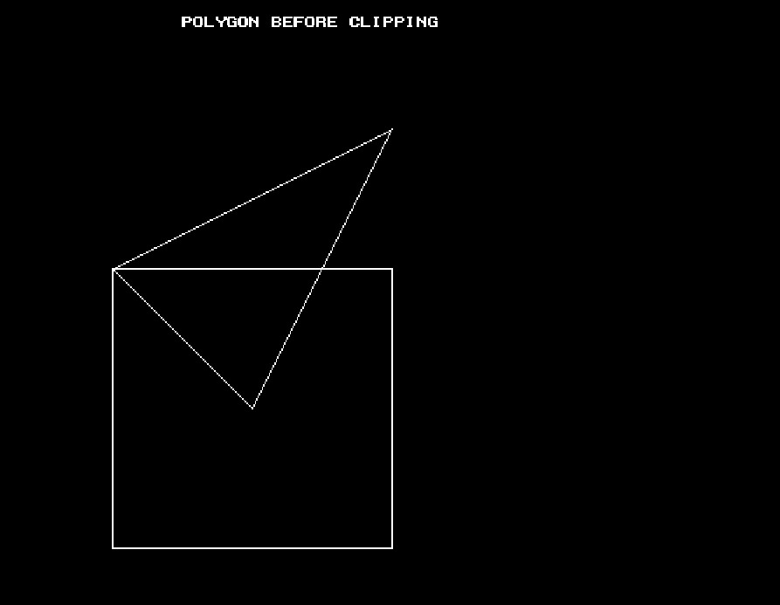

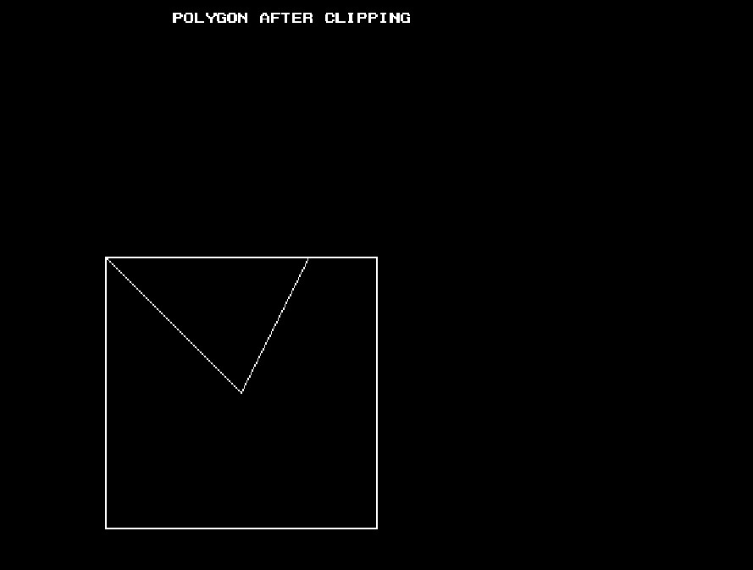

**10. Program to represent a 3D object using polygon surfaces and then perform 3D transformation**

#include<stdio.h>

#include<conio.h>

#include<graphics.h>

#include<math.h>

int maxx,maxy,midx,midy;

void axis()

{

getch();

cleardevice();

line(midx,0,midx,maxy);

line(0,midy,maxx,midy);

}

void main()

{

int gd,gm,x,y,z,ang,x1,x2,y1,y2;

detectgraph(&gd,&gm);

initgraph(&gd,&gm,"C:\\turboc3\\BGI");

setfillstyle(3,25);

maxx=getmaxx();

maxy=getmaxy();

midx=maxx/2;

midy=maxy/2;

outtextxy(100,100,"ORIGINAL OBJECT");

bar3d(midx+100,midy-20,midx+60,midy-90,20,5);

axis();

outtextxy(100,20,"TRANSLATION");

printf("\n\n Enter the Translation vector: ");

scanf("%d%d",&x,&y);

bar3d(midx+100,midy-20,midx+60,midy-90,20,5);

bar3d(midx+(x+100),midy-(y+20),midx+(x+60),midy-(y+90),20,5);

axis();

outtextxy(100,20,"SCALING");

printf("\n Enter the Scaling Factor: ");

scanf("%d%d%d",&x,&y,&z);

bar3d(midx+100,midy-20,midx+60,midy-90,20,5);

bar3d(midx+(x*100),midy-(y*20),midx+(x*60),midy-(y*90),20*z,5);

axis();

outtextxy(100,20,"ROTATION");

printf("\n Enter the Rotation angle: ");

scanf("%d",&ang);

x1=100*cos(ang*3.14/180)-20*sin(ang*3.14/180);

y1=100*sin(ang*3.14/180)+20*sin(ang*3.14/180);

x2=60*cos(ang*3.14/180)-90*sin(ang*3.14/180);

y2=60*sin(ang*3.14/180)+90*sin(ang*3.14/180);

axis();

printf("\n After rotating about z-axis\n");

bar3d(midx+100,midy-20,midx+60,midy-90,20,5);

bar3d(midx+x1,midy-y1,midx+x2,midy-y2,20,5);

axis();

printf("\n After rotating about x-axis\n");

bar3d(midx+100,midy-20,midx+60,midy-90,20,5);

bar3d(midx+100,midy-x1,midx+60,midy-x2,20,5);

axis();

printf("\n After rotating about y-axis\n");

bar3d(midx+100,midy-20,midx+60,midy-90,20,5);

bar3d(midx+x1,midy-20,midx+x2,midy-90,20,5);

axis();

closegraph();

}

**Output:**

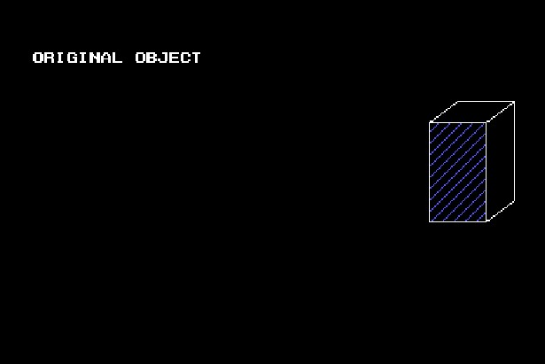

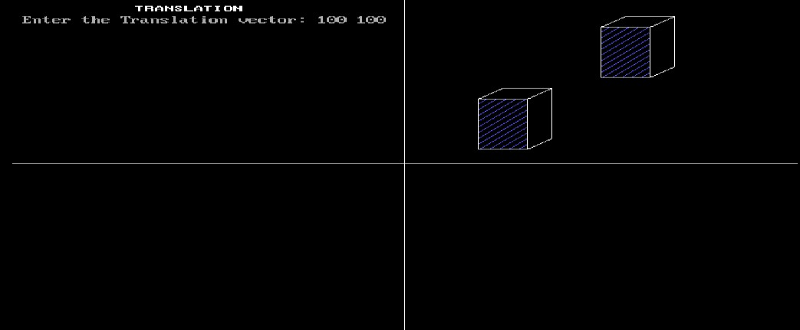

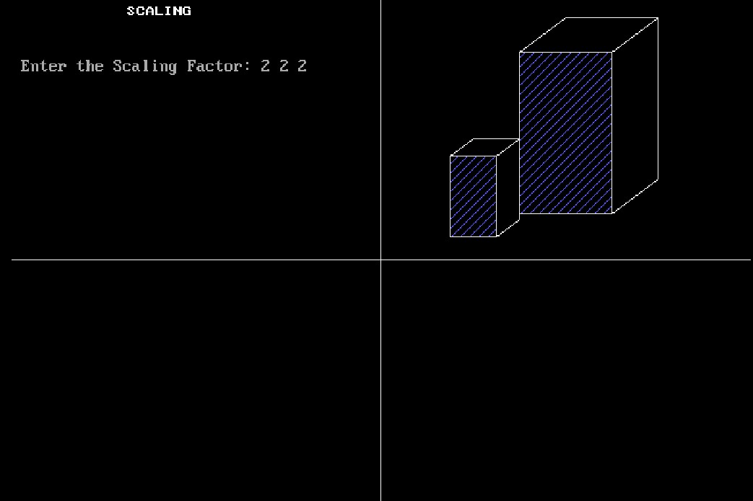

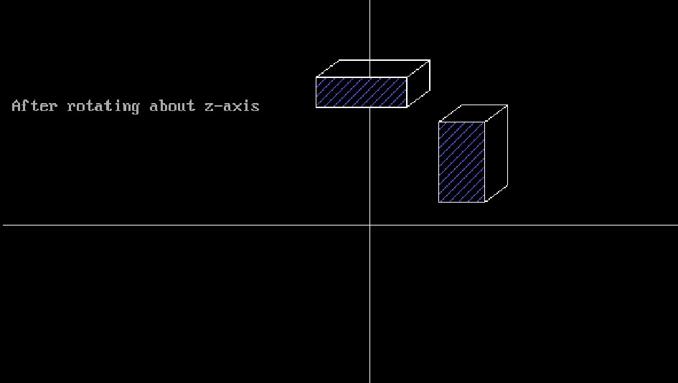

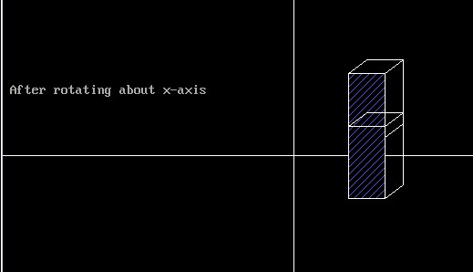

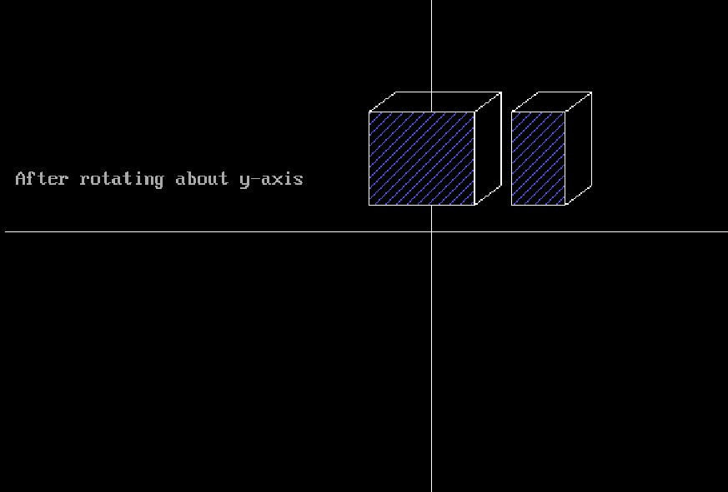

**11. Fractal generation ( Koch curve / Hilbert curve / peano curves using string production )**

#include<graphics.h>

#include<conio.h>

#include<math.h>

void koch(int x1, int y1, int x2, int y2, int it)

{

float angle = 60*M_PI/180;

int x3 = (2*x1+x2)/3;

int y3 = (2*y1+y2)/3;

int x4 = (x1+2*x2)/3;

int y4 = (y1+2*y2)/3;

int x = x3 + (x4-x3)*cos(angle)+(y4-y3)*sin(angle);

int y = y3 - (x4-x3)*sin(angle)+(y4-y3)*cos(angle);

if(it >0)

{

koch(x1, y1, x3, y3, it-1);

koch(x3, y3, x, y, it-1);

koch(x, y, x4, y4, it-1);

koch(x4, y4, x2, y2, it-1);

}

else

{

line(x1, y1, x3, y3);

line(x3, y3, x, y);

line(x, y, x4, y4);

line(x4, y4, x2, y2);

}

}

int main(void)

{

int gd = DETECT, gm;

int x1=100,y1=100, x2=400, y2=400;

initgraph(&gd, &gm, "C:\\Turboc3\\BGI");

koch(x1, y1, x2, y2, 4);

getch();

return 0;

}

**Output:**

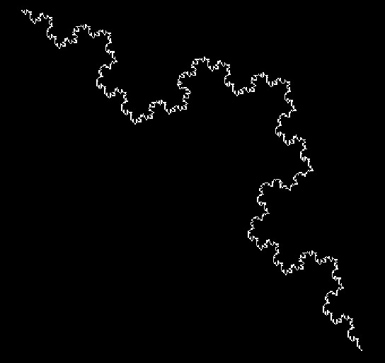

**12. Program for Animation (eg. moving wheel, moving car, man walking with umbrella, flying flag, etc.)**

**12a. Moving Wheel**

#include<stdio.h>

#include<conio.h>

#include<math.h>

#include<graphics.h>

#include<dos.h>

#define PI=3.142;

int xc=50,yc=200,r=35; int x[15], y[15];

void drawCircles()

{

setcolor(BLUE);

circle(xc,yc,r);

circle(xc,yc,r+5);

}

void main()

{

double angle=0,theta;

int i,a;

int gd=DETECT,gm;

initgraph(&gd,&gm,"c:\\turboc3\\BGI");

a=xc+r;

while(!kbhit())

{

while(a<=630)

{

theta=M_PI*angle/180;

cleardevice();

drawCircles();

for(i=0;i<18;i++)

{

theta=M_PI*angle/180;

x[i]=xc+r*cos(theta);

y[i]=yc+r*sin(theta);

angle+=20;

line(xc,yc,x[i],y[i]);

}

angle+=2; xc+=2; a=xc+r;

delay(50);

}

xc=50; r=35; a=xc+r;

}

getch();

closegraph();

}

**Output:**

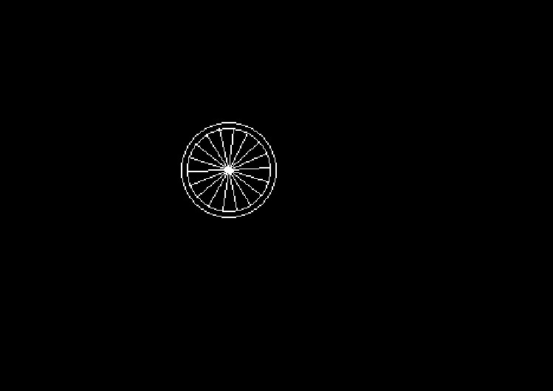

**12b. MovingCar**

#include<graphics.h>

#include<conio.h> #include<dos.h>

main()

{

int i,j=0,gd=DETECT,gm; initgraph(&gd,&gm,"c:\\turboc3\\BGI"); settextstyle(DEFAULT_FONT,HORIZ_DIR,2);

outtextxy(25,240,"Press any key to view the moving car");

getch();

setviewport(0,0,639,440,1);

for(i=0;i<=420;i=i+10,j++)

{

rectangle(50+i,275,150+i,400);

rectangle(150+i,350,200+i,400);

circle(75+i,410,10);

circle(175+i,410,10);

setcolor(j);

delay(100);

if(i==420)

break;

clearviewport();

}

getch();

closegraph();

return 0;

}

**Output:**

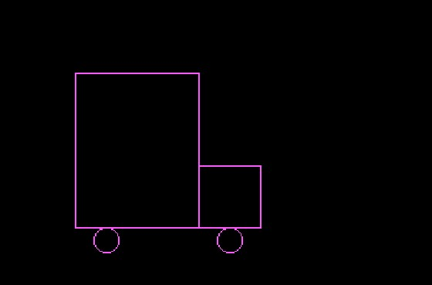

**12c.Man Walking with umbrella.**

#include<stdio.h>

#include<conio.h> #include<graphics.h>

void displayman(int x, int y)

{

setcolor(7);

circle(x,y,10);

line(x,y+10, x,y+30);

line(x,y+30,x-20,y+40);

line(x,y+30,x+20,y+40);

line(x+20,y+40,x+30,y+30);

line(x,y+30,x,y+70);

line(x+30,y+30,x+30,y-90);

pieslice(x+30,y-30,0,180,55);

}

void main()

{

int gd=DETECT,gm,i,d=0,j,x=50,y=340,shouldMove=1;

int rx,ry,a=1;

initgraph(&gd,&gm,"c:\\turboc3\\bgi");

while(!kbhit())

{

cleardevice();

setcolor(3);

outtextxy(100,140,"Rajanikant enjoying his first Rain ");

displayman(x,340);

line(0,430,639,430);

for(i=0; i<500; i++)

{

rx=rand()%639;

ry=rand()%439;

if(rx>=(x-40)&&rx<=(x+110))

if(ry>=(y-50)&&ry<=579)

//setcolor(2);

continue;

line(rx-10,ry+10,rx,ry);

}

if(shouldMove)

{

if(d<20)

d+=4;

else

shouldMove=0;

line(x,y+70,x-d,y+90);

line(x,y+70,x+d,y+90);

}

else

{

if(d>0) d-=4;

else

shouldMove=1;

line(x,y+70,x-d,y+90);

line(x,y+70,x+d,y+90);

}

delay(250);

x=(x+10)%639;

}

getch();

}

**Output:**

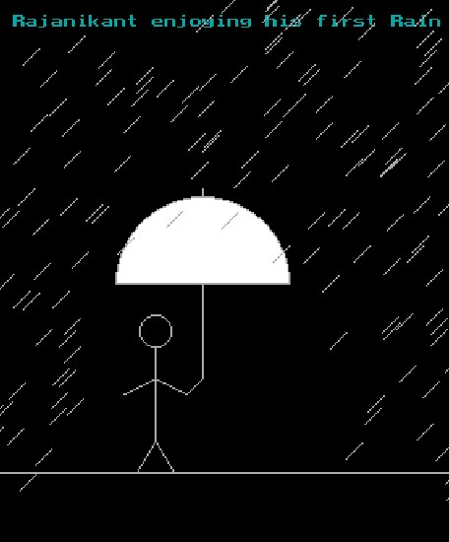

**12d.flying flag**

#include<stdio.h>

#include<conio.h>

#include<graphics.h>

#include<math.h>

#include<dos.h>

void dda(float x1,float y1,float x2,float y2,int z)

{

float dx,dy,x=x1,y=y1,m;

int i;

dx=x2-x1;

dy=y2-y1;

if(abs(dx)>=abs(dy))

m=abs(dx);

else

m=abs(dy);

putpixel((int)x,(int)y,z);

for(i=1;i<=m;i++)

{

x=x+dx/m; y=y+dy/m;

putpixel((int)x,(int)y,z);

}

}

void main()

{

float l1=250,l2=350,l3=50,l4=80,l5=120,l6=150,i,i1,i2,i3,b,a1,a2,a3,e;

int gd=DETECT,gm=DETECT;

initgraph(&gd,&gm,"c:\\turboc3\\BGI"); printf(" Algorithm DDA");

a1=(l2-l1)/3;

a2=(l2-l1)/2;

a3=(l5-l4)/2;

i1=l1+a1;

i2=i1-l1;

i3=i1+i2;

setbkcolor(0);

while(!kbhit())

{

i=1; e=0;

while(((i<=i1)||(i<=i3)||(i<=l2))&&(i<=8))

{

circle(245,47,4);

dda(240,50,240,350,8);

dda(250,50,250,350,8);

dda(350,50-i,350,150-i,7);

outtextxy(getmaxx()-150,(((getmaxy()/2)-50)+(10*i)),"JAIHIND !!!!"); outtextxy(getmaxx()-170,getmaxy()-40,"DONE BY SEENIVASAN.P"); setfillstyle(11,3);

fillellipse(l1+a2,l4+a3-i,13,13-e);

dda(l1,l3,i1,l3-i,6);

dda(l1,l4,i1,l4-i,15);

dda(l1,l5,i1,l5-i,15);

dda(l1,l6,i1,l6-i,2);

dda(i1,l3-i,i3,l3,6);

dda(i1,l4-i,i3,l4,15);

dda(i1,l5-i,i3,l5,15);

dda(i1,l6-i,i3,l6,2);

dda(i3,l3,l2,l3-i,6); dda(i3,l4,l2,l4-i,15); dda(i3,l5,l2,l5-i,15);

dda(i3,l6,l2,l6-i,2);

bar3d(l1-50, 355, l1+50,350+55, 10, 3);

i=i+1;

e=e+0.25;

delay(200);

cleardevice();

}

i=8;

b=0;

while(((i<=i1)||(i<=i3)||(i<=l1))&&(i>=1))

{

circle(245,47,4); dda(240,50,240,350,8); dda(250,50,250,350,8); dda(350,50-i,350,150-i,7);

outtextxy(getmaxx()-150,(((getmaxy()/2))-50+(10*i)),"JAIHIND !!!!"); outtextxy(getmaxx()-170,getmaxy()-40,"DONE BY SEENIVASAN.P"); setfillstyle(11,4);

fillellipse(l1+a2,l4+a3-i,13,13-e);

dda(l1,l3,i1,l3-i,6);

dda(l1,l4,i1,l4-i,15); dda(l1,l5,i1,l5-i,15); dda(l1,l6,i1,l6-i,2); dda(i1,l3-i,i3,l3,6); dda(i1,l4-i,i3,l4,15); dda(i1,l5-i,i3,l5,15); dda(i1,l6-i,i3,l6,2); dda(i3,l3,l2,l3-i,6); dda(i3,l4,l2,l4-i,15); dda(i3,l5,l2,l5-i,15); dda(i3,l6,l2,l6-i,2);

bar3d(l1-50, 355, l1+50,350+55, 10, 3);

i=i-1;

e=e-0.25;

delay(200);

cleardevice();

}

}

getch();

}

**Output :**

