**1. Insurance database.**

**PERSON( driver_id:string , name:string , address:string )**

**CAR( regno:string , model:string , year:int )**

**ACCIDENT( report_number:int , accd_date:date , location:string )**

**OWNS( driver_id:string , regno:string )**

**PARTICIPATED( driver_id:string , regno:string , report_number:int,**

**damage_amount:int)**

1) Create the above tables by properly specifying the primary keys and foreign keys.

2) Enter at least five tuples for each relation.

3) Demonstrate updating of data value, insertion of new record.

4) Write queries

a. Find the total number of people who owned cars that were involved in accidents in a specific year.

b. Find the number of accidents in which cars belonging to a specific model were involved.

c. List the details of the cars not involved in accident for a specific year.

PERSON TABLE

----------------------

CREATE TABLE PERSON(

DRIVER_ID VARCHAR2(10),

NAME VARCHAR2(10),

ADDRESS VARCHAR2(50));

ALTER TABLE PERSON ADD CONSTRAINT DRVR_ID_PK PRIMARY KEY(DRIVER_ID);

INSERT INTO PERSON VALUES( 11 , 'KRISHNAN','GURGOAN');

INSERT INTO PERSON VALUES( 22 , 'NAVATHE','DELHI');

INSERT INTO PERSON VALUES( 33 , 'GERKHE','CALCUTTA');

INSERT INTO PERSON VALUES( 44 , 'ELMARSEE','BANGALORE');

INSERT INTO PERSON VALUES( 55 , 'LEVINTIN','NEWYORK');

CAR TABLE

-----------------

CREATE TABLE CAR(

REGNO VARCHAR2(10),

MODEL VARCHAR2(10),

YEAR DATE);

ALTER TABLE CAR ADD CONSTRAINT REGNO_PK PRIMARY KEY(REGNO);

INSERT INTO CAR VALUES(110,'HONDA',TO_DATE('2002','YYYY'));

INSERT INTO CAR VALUES(112,'LAMBO',TO_DATE('2003','YYYY'));

INSERT INTO CAR VALUES(113,'AUDI',TO_DATE('2004','YYYY'));

INSERT INTO CAR VALUES(114,'MARUTI',TO_DATE('2005','YYYY'));

INSERT INTO CAR VALUES(115,'SUZUKI',TO_DATE('2006','YYYY'));

-------------------------

ACCIDENT TABLE

-------------------------

CREATE TABLE ACCIDENT(

REPORT_NUMBER NUMBER(10),

ACCD_DATE DATE,

LOCATION VARCHAR2(10));

ALTER TABLE ACCIDENT ADD CONSTRAINT RPT_NO PRIMARY KEY(REPORT_NUMBER);

INSERT INTO SYSTEM.ACCIDENT VALUES(11,TO_DATE('10-06-2001','DD-MM-YYYY'),'BELGAVI');

INSERT INTO SYSTEM.ACCIDENT VALUES(12,TO_DATE('12-08-2003','DD-MM-YYYY'),'BELGAVI');

INSERT INTO SYSTEM.ACCIDENT VALUES(13,TO_DATE('14-10-2015','DD-MM-YYYY'),'BELGAVI');

INSERT INTO SYSTEM.ACCIDENT VALUES(14,TO_DATE('16-12-2010','DD-MM-YYYY'),'BELGAVI');

INSERT INTO SYSTEM.ACCIDENT VALUES(15,TO_DATE('18-02-2013','DD-MM-YYYY'),'BELGAVI');

OWNS TABLE

----------

CREATE TABLE OWNS(

DRIVER_ID VARCHAR2(10),

REGNO VARCHAR2(10));

ALTER TABLE OWNS ADD CONSTRAINT FK_DRVR_ID FOREIGN KEY (DRIVER_ID) REFERENCES PERSON((DRIVER_ID);

ALTER TABLE OWNS ADD CONSTRAINT FK_REGNO_ID FOREIGN KEY (REGNO) REFERENCES CAR(REGNO);

INSERT INTO SYSTEM.OWNS VALUES(11,110);

INSERT INTO SYSTEM.OWNS VALUES(22,112);

INSERT INTO SYSTEM.OWNS VALUES(33,113);

INSERT INTO SYSTEM.OWNS VALUES(44,114);

INSERT INTO SYSTEM.OWNS VALUES(55,115);

PARTICIPATED TABLE

--------------------------------

CREATE TABLE PARTICIPATED(

DRIVER_ID VARCHAR2(10),

REGNO VARCHAR2(10),

REPORT_NUMBER NUMBER(10),

DAMAGE_AMOUNT NUMBER(10));

ALTER TABLE PARTICIPATED ADD CONSTRAINT FK_DRVR1_ID FOREIGN KEY (DRIVER_ID) REFERENCES PERSON((DRIVER_ID);

ALTER TABLE PARTICIPATED ADD CONSTRAINT FK_REGNO1_ID FOREIGN KEY (REGNO) REFERENCES CAR(REGNO);

ALTER TABLE PARTICIPATED ADD CONSTRAINT FK_RPTNO_ID FOREIGN KEY REPORT_NUMBER) REFERENCES ACCIDENT(REPORT_NUMBER);

INSERT INTO SYSTEM.PARTICIPATED VALUES('11','110',11,5000);

INSERT INTO SYSTEM.PARTICIPATED VALUES('22','112',12,6000);

INSERT INTO SYSTEM.PARTICIPATED VALUES('33','113',13,7000);

INSERT INTO SYSTEM.PARTICIPATED VALUES('44','114',14,8000);

INSERT INTO SYSTEM.PARTICIPATED VALUES('55','115',15,9000);

FIND TOTAL NUMBER OF PEOPLE WHO OWNED CARS THAT ARE INVOLVED IN ACCIDENT IN SPECIFIC YEAR.

**Output**

**Find The Total Number Of People Who Owned Cars That Were Involved In Accidents In A Specific Year.**

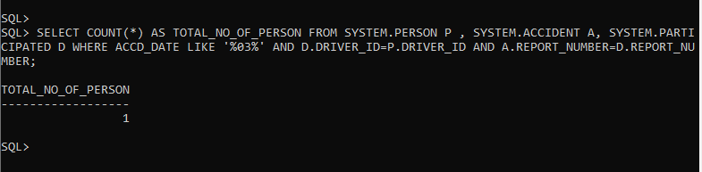

**Find the Number of Accidents In Which Cars Belonging To A Specific Model Were Involved.**

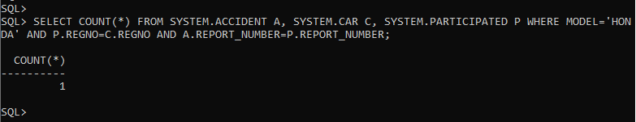

**List the Details of The Cars Not Involved In Accident For A Specific Year.**

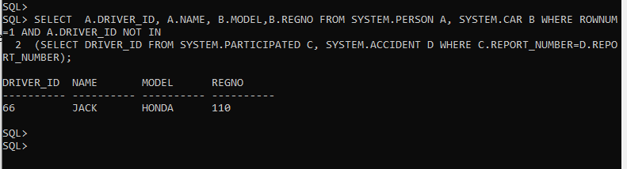

**Demonstrate Updating Of Data Value.**

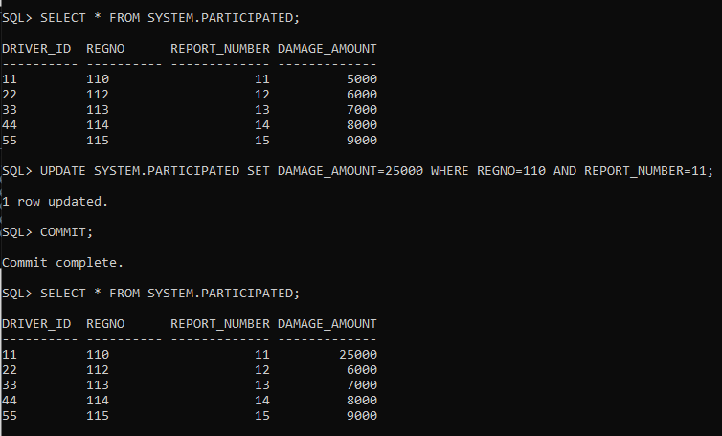

**2. Order processing database application in a company.**

**CUSTOMER( custno:int , cname:string , city:string )**

**ORDER( orderno:int , odate:date , custno:int , ord_amt:int )**

**ORDER_ITEM( orderno:int , itemno:int , quantity:int )**

**ITEM( itemno:int , unitprice:int )**

**SHIPMENT( orderno:int , warehouseno:int , ship_date:date )**

**WAREHOUSE( warehouseno:int , city:string )**

1) Create the above tables by properly specifying the primary keys and foreign keys.

2) Enter at least five tuples for each relation.

3) Produce a listing: custname , No_of_orders , Avg_order_amount , where the middle column is

the total number of orders by the customer and the last column is the average order amount for

that customer.

4) List the orderno for orders that were shipped from all the warehouses that the company has in a

specific city.

5) Demonstrate the deletion of an item from the ITEM table and demonstrate a method of handling the rows in the ORDER_ITEM table that contains this particular item.

CUSTOMER TABLE

---------------------------

CREATE TABLE CUSTOMER(

CUSTNO NUMBER(20),

CNAME VARCHAR2(50),

CITY VARCHAR2(50));

ALTER TABLE CUSTOMER ADD CONSTRAINT CUSTNO_PK PRIMARY KEY(CUSTNO);

INSERT INTO CUSTOMER VALUES('22','NAVATHE','DELHI');

INSERT INTO CUSTOMER VALUES('11','KRISHNAN','GURGOAN');

INSERT INTO CUSTOMER VALUES('33','GERKHE','CALCUTTA');

INSERT INTO CUSTOMER VALUES('44','ELMARSEE','BANGALORE');

INSERT INTO CUSTOMER VALUES('55','LEVINTIN','NEWYORK');

ORDERS TABLE

----------------------

CREATE TABLE ORDERS(

ORDERNO NUMBER(20),

ODATE DATE,

CUSTNO NUMBER(20),

ORD_AMT NUMBER(20));

ALTER TABLE ORDERS ADD CONSTRAINT ORDERNO_PAK PRIMARY KEY(ORDERNO);

ALTER TABLE ORDERS ADD CONSTRAINT FK_CUSTNO FOREIGN KEY (CUSTNO) REFERENCES CUSTOMER(CUSTNO);

INSERT INTO ORDERS VALUES(11,TO_DATE('12-12-2002','DD-MM-YYYY'),'22','2000');

INSERT INTO ORDERS VALUES(12,TO_DATE('12-12-2003','DD-MM-YYYY'),'11','5000');

INSERT INTO ORDERS VALUES(13,TO_DATE('12-12-2004','DD-MM-YYYY'),'33','6000');

INSERT INTO ORDERS VALUES(14,TO_DATE('12-12-2005','DD-MM-YYYY'),'44','7000');

INSERT INTO ORDERS VALUES(15,TO_DATE('12-12-2006','DD-MM-YYYY'),'55','8500');

ITEM TABLE

------------------

CREATE TABLE ITEM(

ITEMNO NUMBER(20),

UNITPRICE NUMBER(20));ORDERS TABLE

----------------------

CREATE TABLE ORDERS(

ORDERNO NUMBER(20),

ODATE DATE,

CUSTNO NUMBER(20),

ORD_AMT NUMBER(20));

ALTER TABLE ORDERS ADD CONSTRAINT ORDERNO_PAK PRIMARY KEY(ORDERNO);

ALTER TABLE ORDERS ADD CONSTRAINT FK_CUSTNO FOREIGN KEY (CUSTNO) REFERENCES CUSTOMER(CUSTNO);

INSERT INTO ORDERS VALUES(11,TO_DATE('12-12-2002','DD-MM-YYYY'),'22','2000');

INSERT INTO ORDERS VALUES(12,TO_DATE('12-12-2003','DD-MM-YYYY'),'11','5000');

INSERT INTO ORDERS VALUES(13,TO_DATE('12-12-2004','DD-MM-YYYY'),'33','6000');

INSERT INTO ORDERS VALUES(14,TO_DATE('12-12-2005','DD-MM-YYYY'),'44','7000');

INSERT INTO ORDERS VALUES(15,TO_DATE('12-12-2006','DD-MM-YYYY'),'55','8500');

ITEM TABLE

------------------

CREATE TABLE ITEM(

ITEMNO NUMBER(20),

UNITPRICE NUMBER(20));

ALTER TABLE ITEM ADD CONSTRAINT ITEMNO_PK PRIMARY KEY(ITEMNO);

INSERT INTO ITEM VALUES('456','15000');

INSERT INTO ITEM VALUES('123','20000');

INSERT INTO ITEM VALUES('789','12000');

INSERT INTO ITEM VALUES('654','18000');

INSERT INTO ITEM VALUES('321','25000');

ORDERITEM TABLE

----------------------------

CREATE TABLE ORDERITEM(

ORDERNO NUMBER(20),

ITEMNO NUMBER(20),

QTY SNUMBER(20));

ALTER TABLE ORDERITEM ADD CONSTRAINT FK_ORDERNO FOREIGN KEY (ORDERNO) REFERENCES ORDERS(ORDERNO);

ALTER TABLE ORDERITEM ADD CONSTRAINT FK_ITEMNO FOREIGN KEY (ITEMNO) REFERENCES ITEM(ITEMNO);

INSERT INTO ORDERITEM VALUES('11','123','2');

INSERT INTO ORDERITEM VALUES('12','456','5');

INSERT INTO ORDERITEM VALUES('13','789','4');

INSERT INTO ORDERITEM VALUES('14','654','1');

INSERT INTO ORDERITEM VALUES('15','321','6');

WAREHOUSE TABLE

-----------------------------

CREATE TABLE WAREHOUSE(

WAREHOUSENO NUMBER(20),

CITY VARCHAR2(50));

ALTER TABLE WAREHOUSE ADD CONSTRAINT WAREHOUSENO_PK PRIMARY KEY(WAREHOUSENO);

INSERT INTO WAREHOUSE VALUES('01','JENSHEDPUR');

INSERT INTO WAREHOUSE VALUES('02','MUMBAI');

INSERT INTO WAREHOUSE VALUES('03','LAHORE');

INSERT INTO WAREHOUSE VALUES('04','SIDNEY');

INSERT INTO WAREHOUSE VALUES('05','CANADA');

SHIPMENT TABLE

-------------------------

CREATE TABLE SHIPMENT(

ORDERNO NUMBER(20),

WAREHOUSENO NUMBER(20),

SHIPDATE DATE);

ALTER TABLE SHIPMENT ADD CONSTRAINT FAK_ORDERNO FOREIGN KEY (ORDERNO) REFERENCES ORDERS(ORDERNO);

ALTER TABLE SHIPMENT ADD CONSTRAINT FK_WAREHOUSENO FOREIGN KEY (WAREHOUSENO) REFERENCES WAREHOUSE(WAREHOUSENO);

INSERT INTO SHIPMENT VALUES('11','01',TO_DATE('15-12-2002','DD-MM-YYYY'));

INSERT INTO SHIPMENT VALUES('12','02',TO_DATE('15-01-2004','DD-MM-YYYY'));

INSERT INTO SHIPMENT VALUES('13','03',TO_DATE('05-02-2005','DD-MM-YYYY'));

INSERT INTO SHIPMENT VALUES('14','04',TO_DATE('12-03-2006','DD-MM-YYYY'));

INSERT INTO SHIPMENT VALUES('15','05',TO_DATE('15-04-2007','DD-MM-YYYY'));

**Output:**

**Produce a listing: custname , No_of_orders , Avg_order_amount , where the middle column is the total number of orders by the customer and the last column is the average order amount for that customer.**

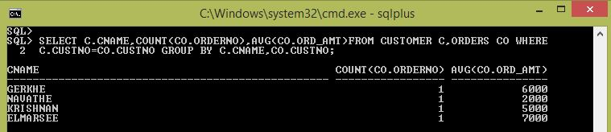

**List the orderno for orders that were shipped from all the warehouses that the company has in a specific city.**

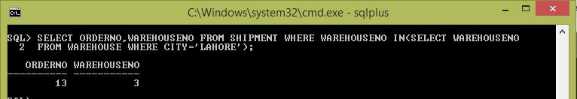

**List the orderno for orders that were shipped from all the warehouses that the company has in a specific city.**

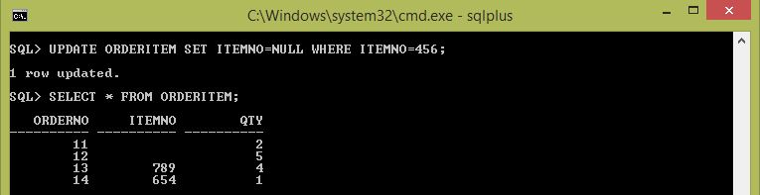

**Demonstrate the deletion of an item from the ITEM table and demonstrate a method of handling the rows in the ORDER_ITEM table that contains this particular item.**

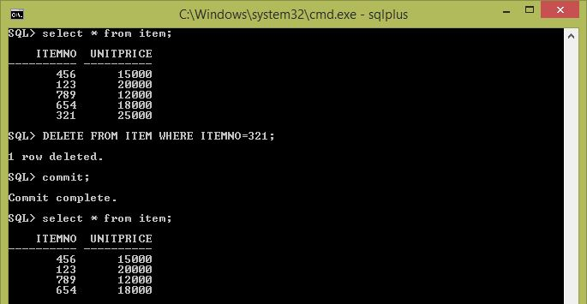

**3. Book dealer information database.**

**AUTHOR( author_id:int , name:string , city:string , country:string )**

**PUBLISHER( publisher_id:int , name:string , city:string , country:string )**

**CATALOG( book_id:int , title:string , author_id:int , publisher_id:int , category_id:int , year:int ,**

**price:int)**

**CATEGORY( category_id:int , description:string )**

**ORDER_DETAILS( order_no:int , book_id:int , quantity:int )**

1) Create the above tables by properly specifying the primary keys and foreign keys.

2) Enter at least five tuples for each relation.

3) Give the details of the authors who have 2 or more books in the catalog and the price of the books

is greater than the average price of the books in the catalog and the year of publication is after

2000.

4) Find the author of the book that has maximum sales.

5) Demonstrate how you increase the price of books published by a specific publisher by 10%

AUTHOR TABLE

-----------------------

CREATE TABLE AUTHOR(

AUTHORID NUMBER(10),

NAME VARCHAR2(12),

CITY VARCHAR2(20),

COUNTRY VARCHAR2(12));

ALTER TABLE AUTHOR ADD CONSTRAINT AUTHORID_PK PRIMARY KEY(AUTHORID);

INSERT INTO AUTHOR VALUES('11','KRISHNAN','GURGOAN','INDIA');

INSERT INTO AUTHOR VALUES('22','NAVATHE','DELHI','INDIA');

INSERT INTO AUTHOR VALUES('33','GERKHE','CALCUTTA','INDIA');

INSERT INTO AUTHOR VALUES('44','ELMARSEE','BANGALORE','INDIA');

INSERT INTO AUTHOR VALUES('55','LEVINTIN','NEWYORK','US');

PUBLISHER TABLE

--------------------------

CREATE TABLE PUBLISHER(

PUBLISHERID NUMBER(5),

NAME VARCHAR2(12),

CITY VARCHAR2(20),

COUNTRY VARCHAR2(12));

ALTER TABLE PUBLISHER ADD CONSTRAINT PUBLISHERID_PK PRIMARY KEY(PUBLISHERID);

INSERT INTO PUBLISHER VALUES('110','PEARSON','MUMBAI','INDIA');

INSERT INTO PUBLISHER VALUES('120','WILEY','LAHORE','PAKISTAN');

INSERT INTO PUBLISHER VALUES('130','PRENTICE','SIDNEY','AUSTRALIA');

INSERT INTO PUBLISHER VALUES('140','TATA','JENSHEDPUR','INDIA');

INSERT INTO PUBLISHER VALUES('150','MCGRAW','CANADA','US');

CATEGORY TABLE

--------------------------

CREATE TABLE CATEGORY(

CATEGORYID NUMBER(6),

DECRIPTION sVARCHAR2(12));

ALTER TABLE CATEGORY ADD CONSTRAINT CATEGORYID_PK PRIMARY KEY(CATEGORYID);

INSERT INTO CATEGORY VALUES('201','WEB PROG');

INSERT INTO CATEGORY VALUES('202','DATABASE');

INSERT INTO CATEGORY VALUES('203','UNIX');

INSERT INTO CATEGORY VALUES('204','DESIGN');

INSERT INTO CATEGORY VALUES('205','SOFTWARE');

CATLOG TABLE

------------

CREATE TABLE CATLOG(

CBOOKID NUMBER(5),

TITLE VARCHAR2(12),

AUTHORID NUMBER(6),

PUBLISHERID NUMBER(5),

CATEGORYID NUMBER(6),

YEAR NUMBER(5),

PRICE NUMBER(6,2));

ALTER TABLE CATLOG ADD CONSTRAINT CBOOKID_PK PRIMARY KEY(CBOOKID);

ALTER TABLE CATLOG ADD CONSTRAINT FK_AUTHORID FOREIGN KEY (AUTHORID) REFERENCES AUTHOR(AUTHORID);

ALTER TABLE CATLOG ADD CONSTRAINT FK_PUBLISHERID FOREIGN KEY (PUBLISHERID) REFERENCES PUBLISHER(PUBLISHERID);

ALTER TABLE CATLOG ADD CONSTRAINT FK_CATEGORYID FOREIGN KEY (CATEGORYID) REFERENCES CATEGORY(CATEGORYID);

**8. Write a program to demonstrate use of user defined package by importing the package and access the member variable of classes contained in the package.**

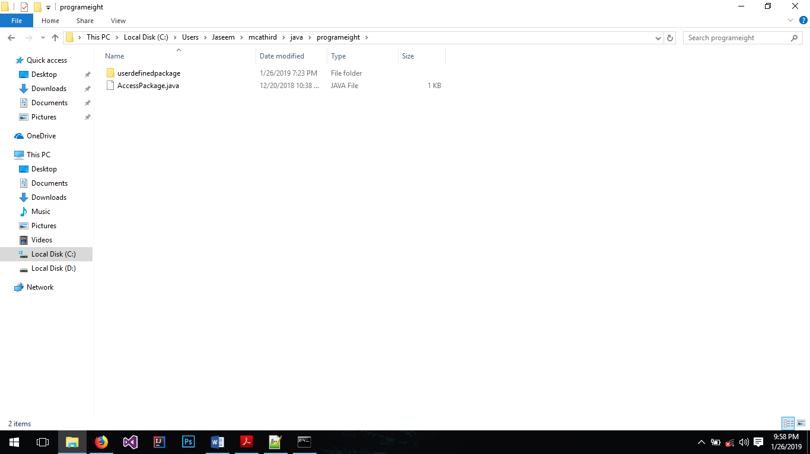

Create a folder “userdefinedpackage” and inside it create a java file “Demo.java” & compile.

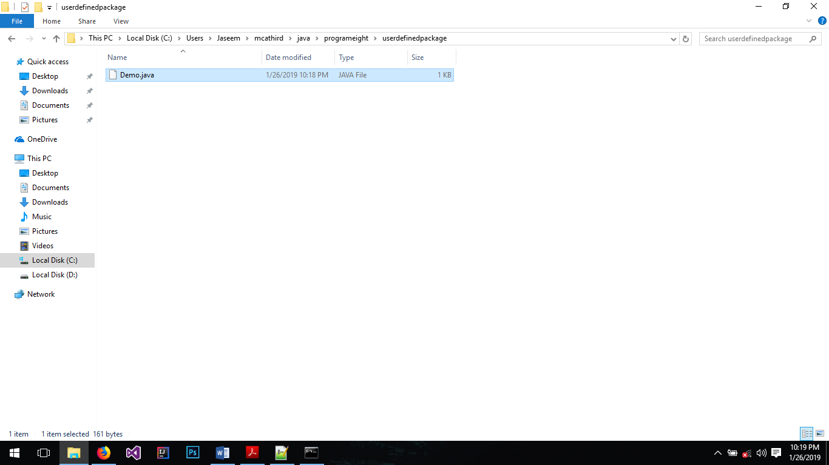

INSERT INTO CATLOG VALUES('101','INTRO_DBMS','22','110','202','2000','375.5');

INSERT INTO CATLOG VALUES('102','DBMS','11','120','202','2002','495');

INSERT INTO CATLOG VALUES('104','ADA','55','140','204','2003','275.75');

INSERT INTO CATLOG VALUES('105','SE','44','150','205','2003','400');

INSERT INTO CATLOG VALUES('106','UNIX','11','110','203','1999','450');

INSERT INTO CATLOG VALUES('107','CPROG','11','140','205','2001','425');

ORDERDETAILS TABLE

---------------------------------

CREATE TABLE ORDERDETAILS(

ORDERNO NUMBER(5),

BOOKID NUMBER(5),

QTY NUMBER(4));

ALTER TABLE ORDERDETAILS ADD CONSTRAINT ORDERNO_PK PRIMARY KEY(ORDERNO);

ALTER TABLE ORDERDETAILS ADD CONSTRAINT FK_BOOKID FOREIGN KEY (BOOKID) REFERENCES CATLOG(CBOOKID);

INSERT INTO ORDERDETAILS VALUES('1111','101','25');

INSERT INTO ORDERDETAILS VALUES('1112','102','15');

INSERT INTO ORDERDETAILS VALUES('1113','102','15');

INSERT INTO ORDERDETAILS VALUES('1114','104','30');

INSERT INTO ORDERDETAILS VALUES('1115','105','20');

**Output:**

**Give the details of the authors who have 2 or more books in the catalog and the price of the books is greater than the average price of the books in the catalog and the year of publication is after 2000.**

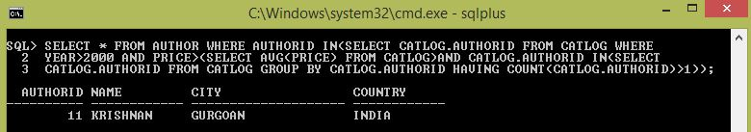

**Find the author of the book that has maximum sales.**

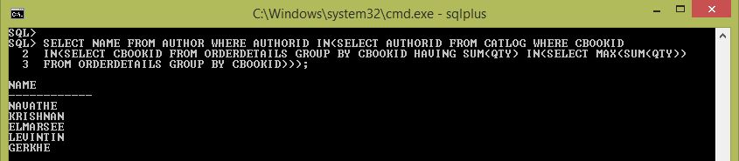

**Demonstrate how you increase the price of books published by a specific publisher by 10%**

