**Interactive prototype:** [**https://projects.invisionapp.com/prototype/BIT707-A2-JasonNorton-5001428-UIDesign-cl2bygxry001j9k01jclgyuhd/inspect/c4c848dc**](https://projects.invisionapp.com/prototype/BIT707-A2-JasonNorton-5001428-UIDesign-cl2bygxry001j9k01jclgyuhd/inspect/c4c848dc)

**UI.1: List View (default screen displayed when the application starts)**

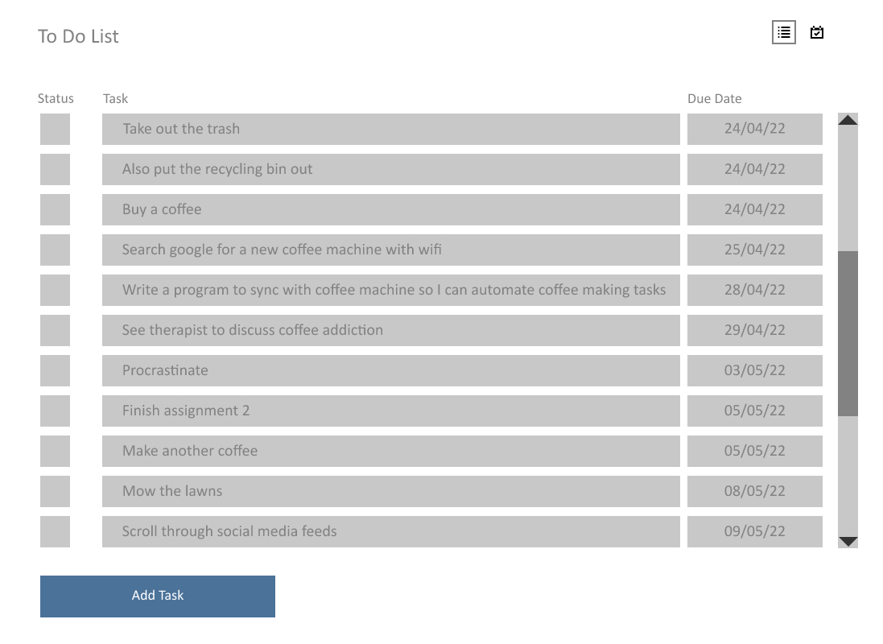

Single click on a task to select it, or double click to see further details about the task

Click the status box to mark the task as completed (puts a tick in the box and a line through the text)

Click here to switch between list view and calendar view

**UI.2: List View – Add Task**

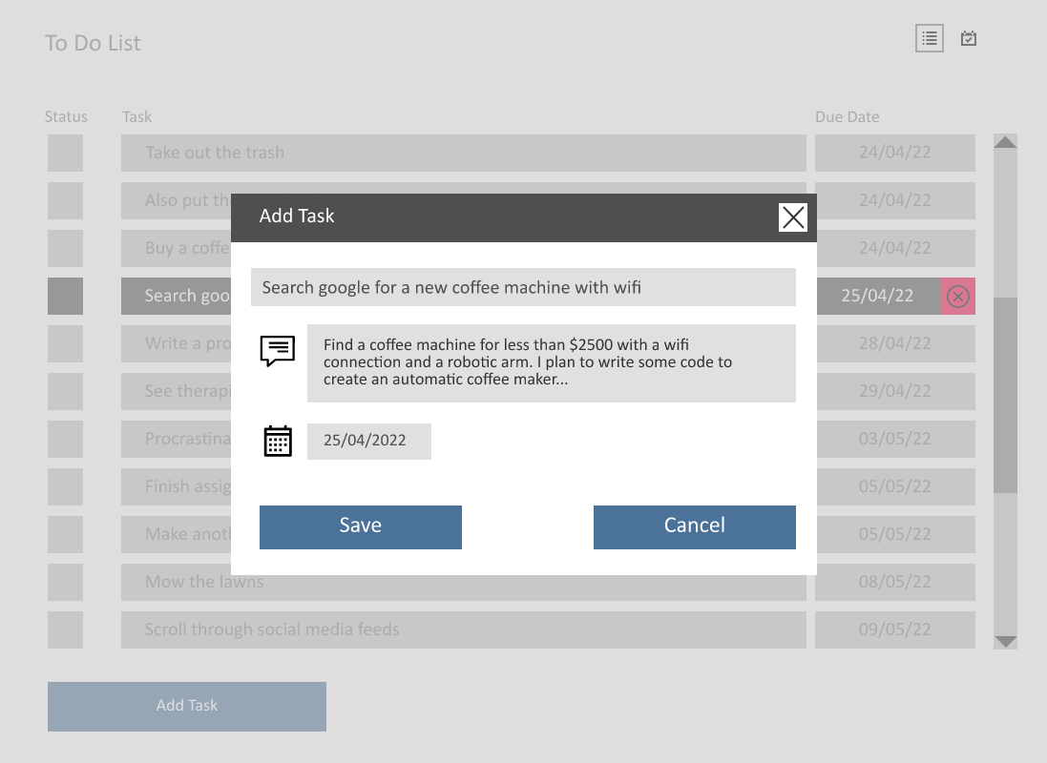

Editable text fields. Task name has max length 50 characters. Description max length 250 characters.

This would display a date picker when the field is clicked

**UI.3: List View – Task Selected**

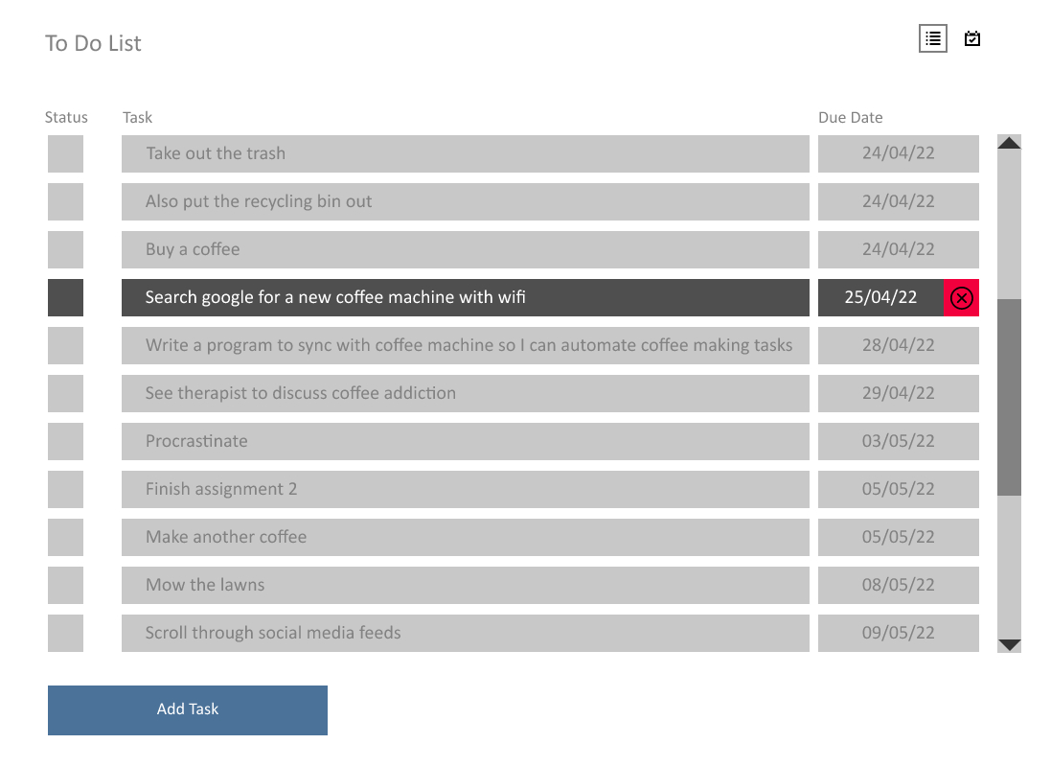

Once a task is selected, the task delete button is displayed

Single click on a task to select/deselect it, or double click to see further details about the task

**UI.4: List View – Task Details**

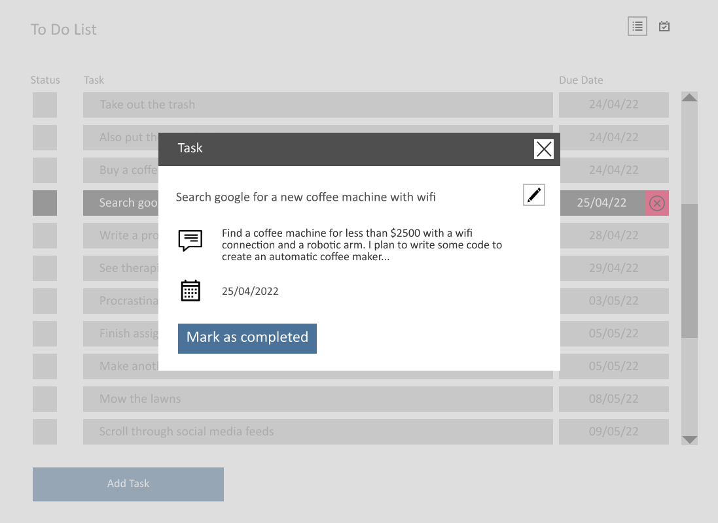

Showing detailed view of task

Updating the status from here does the same thing as ticking the status box on the List View (see next image)

Click here to edit the task details (task name, description, due date)

**UI.5: List View – Task Status**

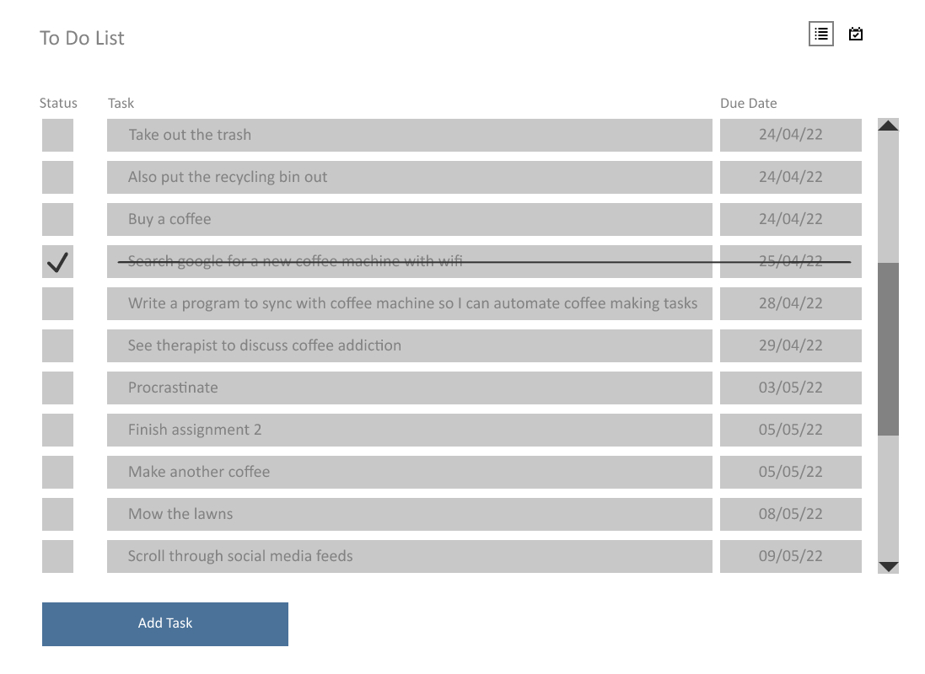

Task status can be toggled by clicking the status box

**UI.6: List View – Edit Task**

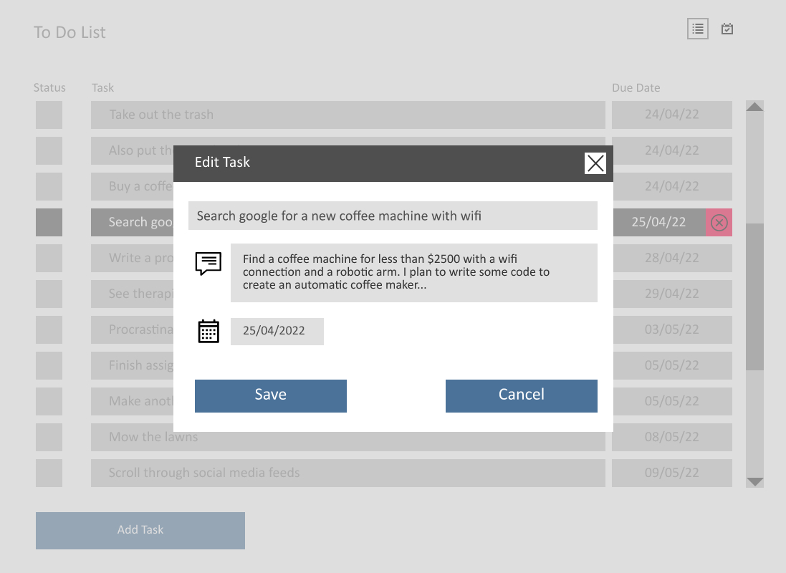

This would display a date picker when the field is clicked

Editable text fields. Task name max length 50 characters. Description max length 250 characters

**UI.7: List View – Delete Task (Confirmation Dialog)**

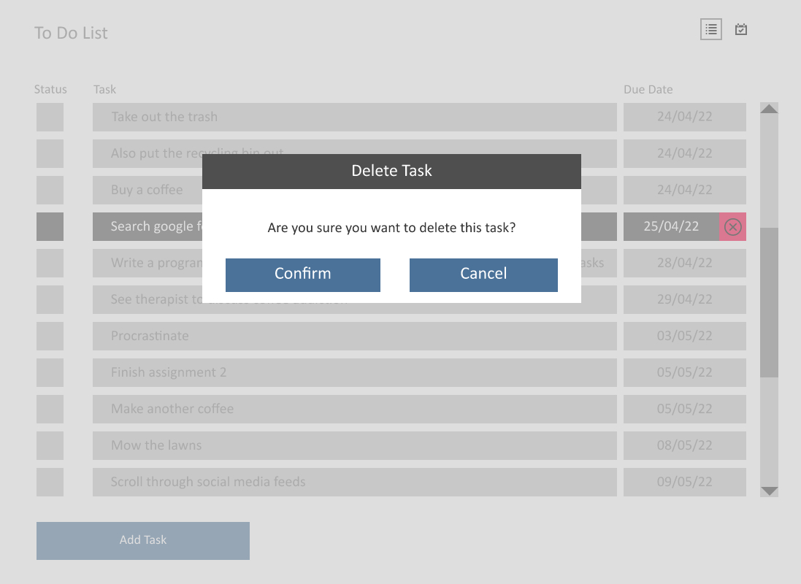

Two step deletion process to minimise risk of user deleting a task by mistake

**UI.8: List View – Task Deleted**

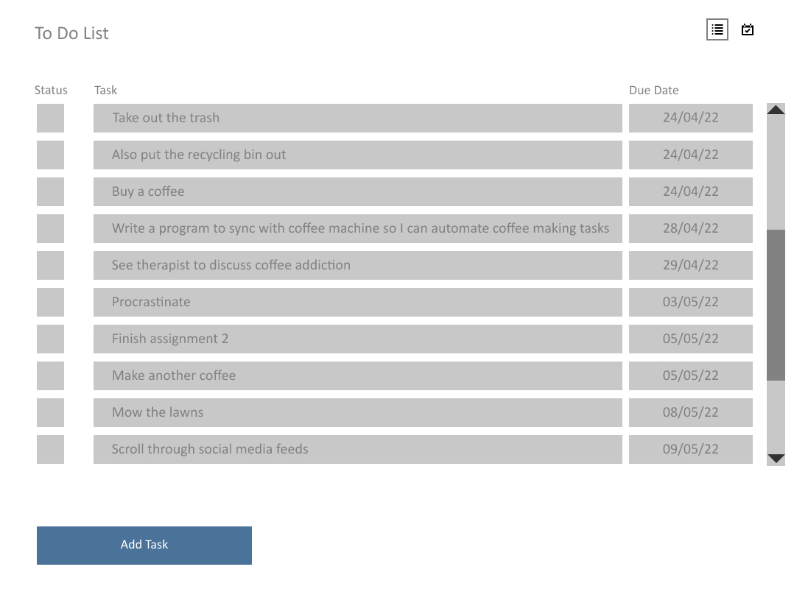

Task has been removed from the list. No undo/recovery option available – Thus two step deletion process is necessary

**UI.9: List View – Error Adding Task**

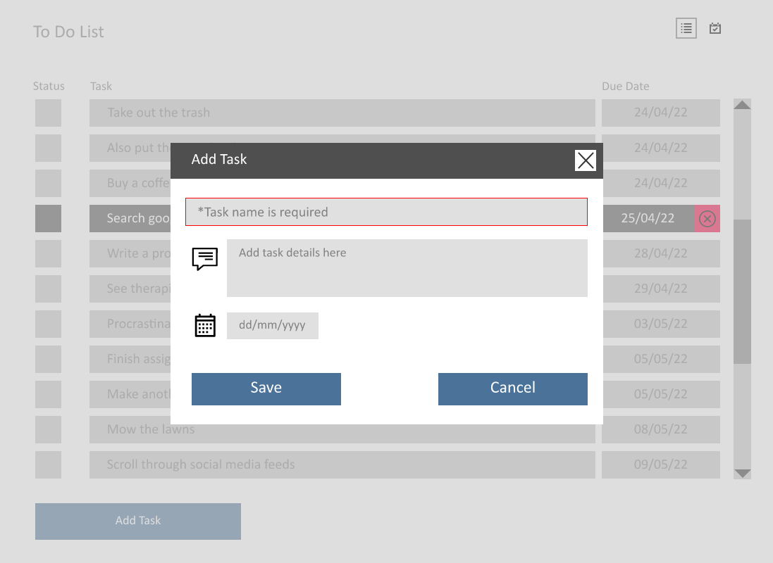

If required fields are not filled in when user clicks save button the fields are highlighted in red and hint text displays error message

**UI.10: Calendar View**

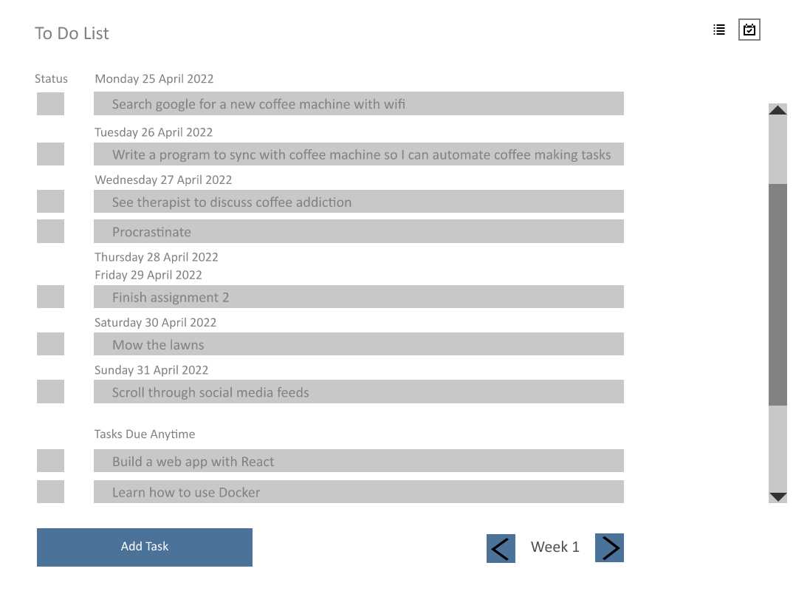

Calendar view selected. The current week is displayed by default

Some tasks may have no scheduled completion date

Task completion status can be toggled. When marked as complete this box has a tick and the task title has a strike through

Some days may have no tasks scheduled

Click a task to select it, or double click to view further details for the task

Navigate to next or previous week

**UI.11: Calendar View – Add Task**

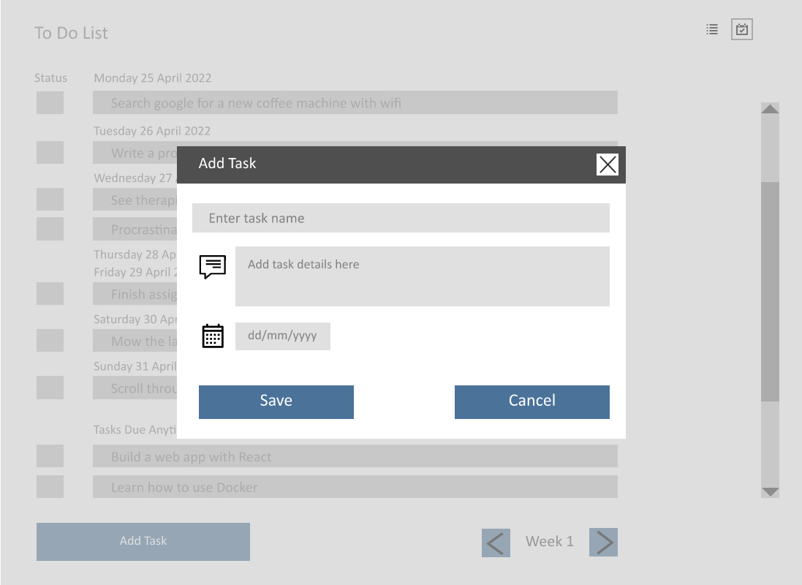

Editable text fields. Task name has max length 50 characters. Description max length 250 characters.

This would display a date picker when the field is clicked

**UI.12: Calendar View – Task Selected**

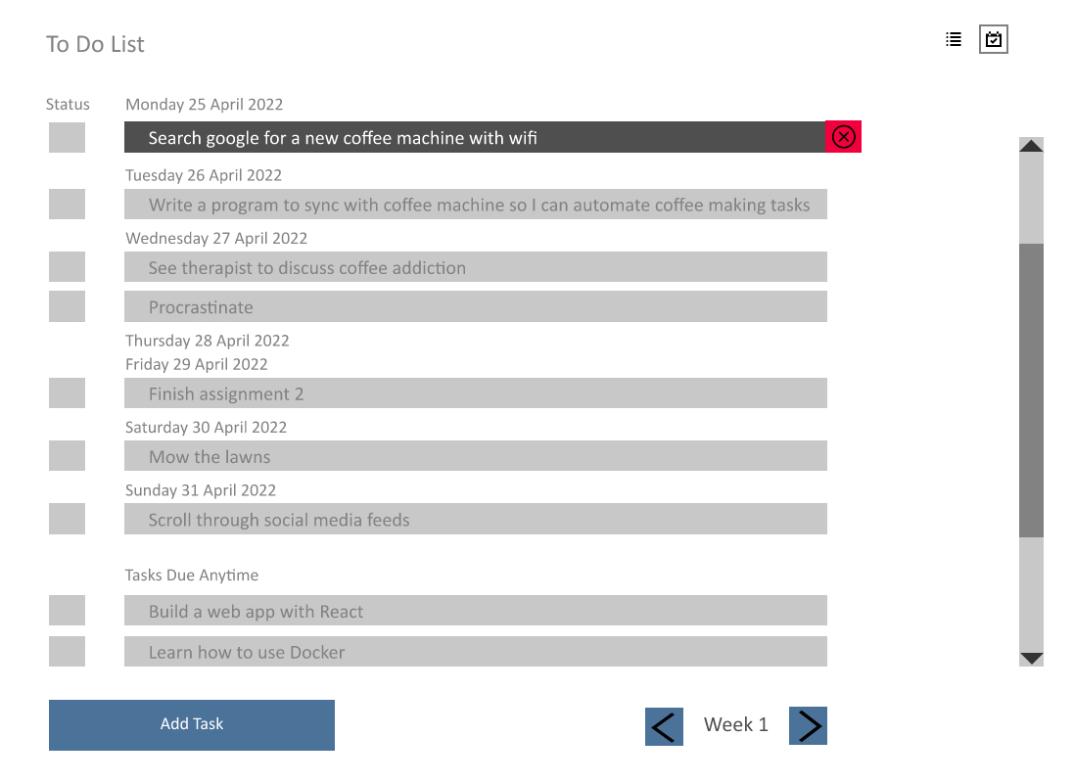

Single click on a task to select/deselect it, or double click to see further details about the task

Once a task is selected, the task delete button is displayed

**UI.13: Calendar View – Task Details**

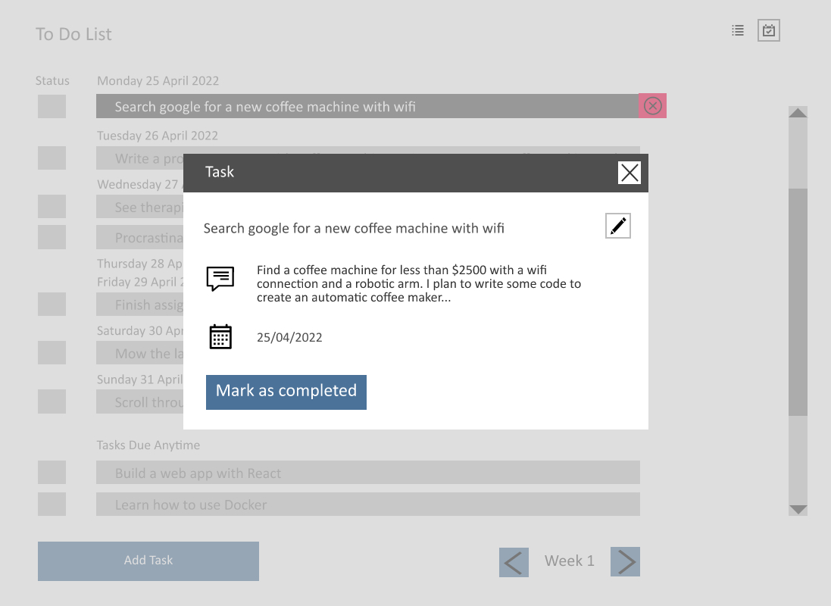

Updating the status from here does the same thing as ticking the status box on the List View (see next image)

Click here to edit the task details (task name, description, due date)

Showing detailed view of task

**UI.14: Calendar View – Task Status**

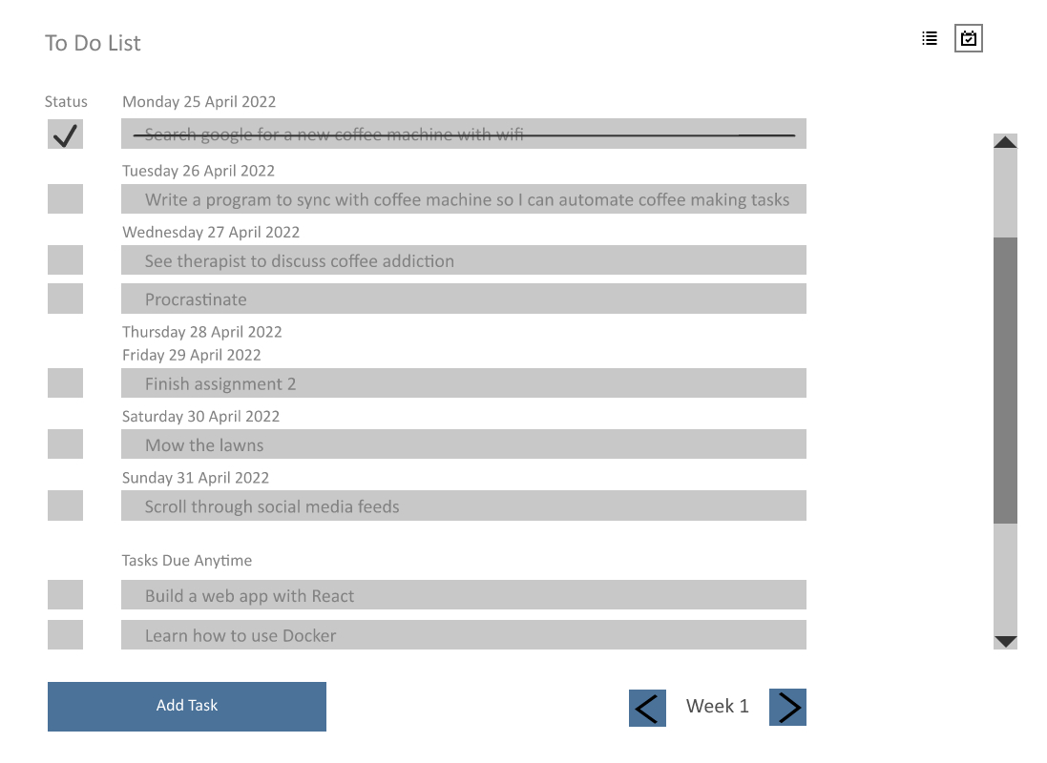

Task status can be toggled by clicking the status box

**UI.15: Calendar View – Edit Task**

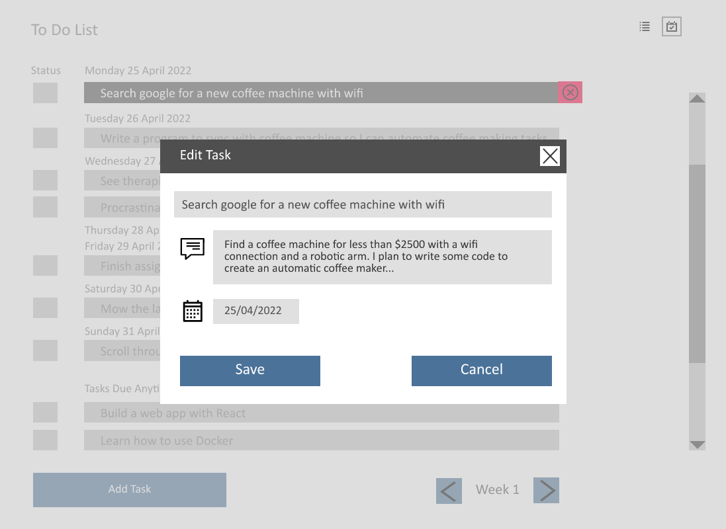

This would display a date picker when the field is clicked

Editable text fields. Task name max length 50 characters. Description max length 250 characters

**UI.16: Calendar View – Delete Task (Confirmation Dialog)**

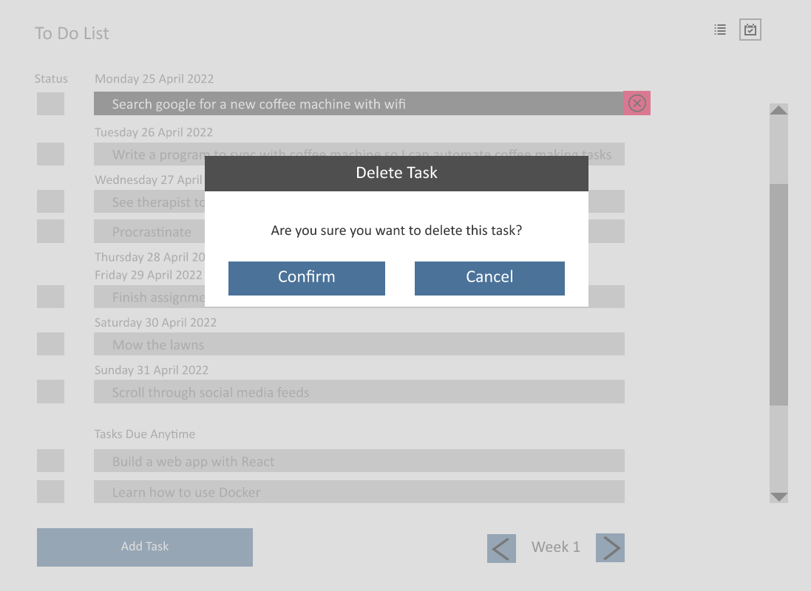

Two step deletion process to minimise risk of user deleting a task by mistake

**UI.17: Calendar View – Task Deleted**

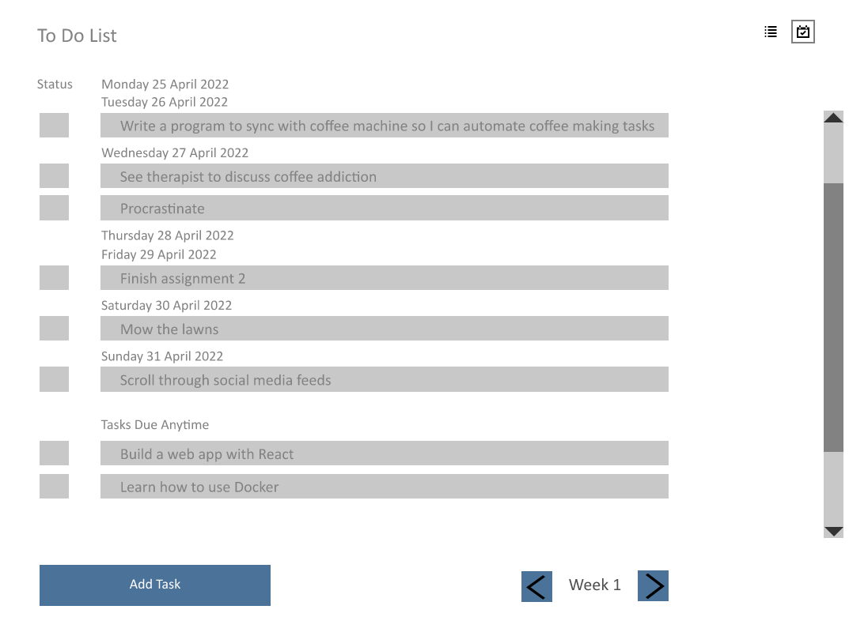

Task has been removed from the list. No undo/recovery option available – Thus two step deletion process is necessary

**UI.18: Calendar View – Error Adding Task**

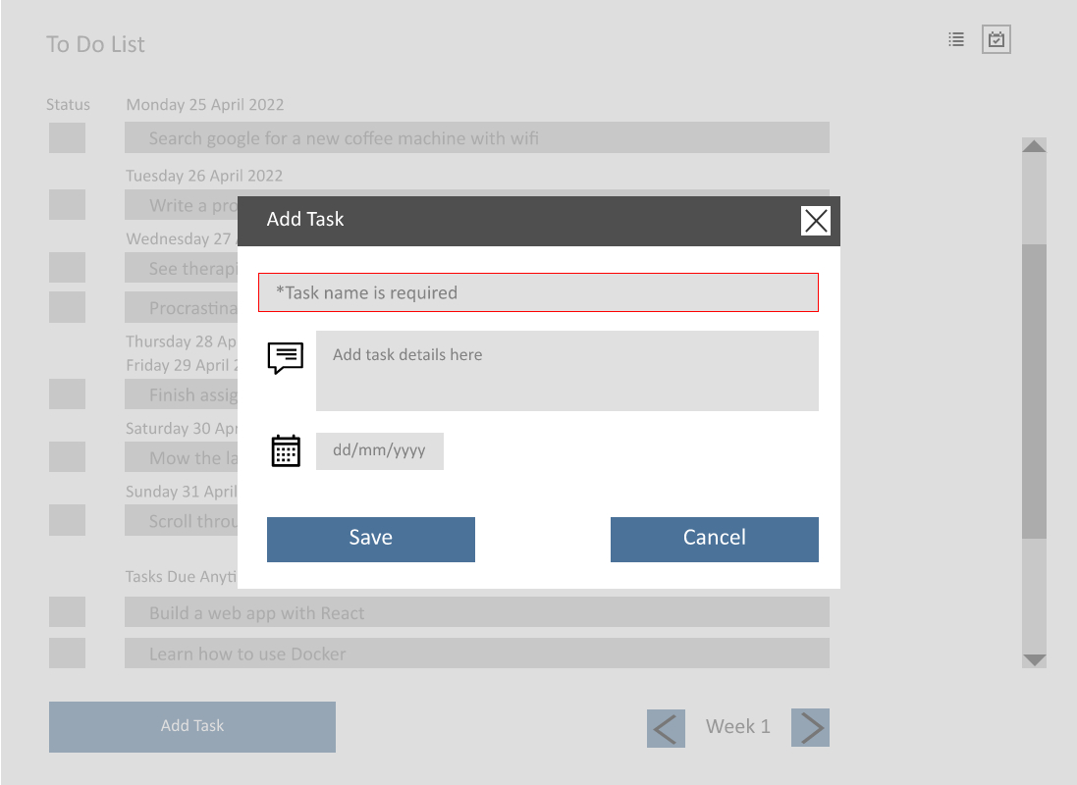

If required fields are not filled in when user clicks save button the fields are highlighted in red and hint text displays error message