**UI.1: List View (default screen displayed when the application starts)**

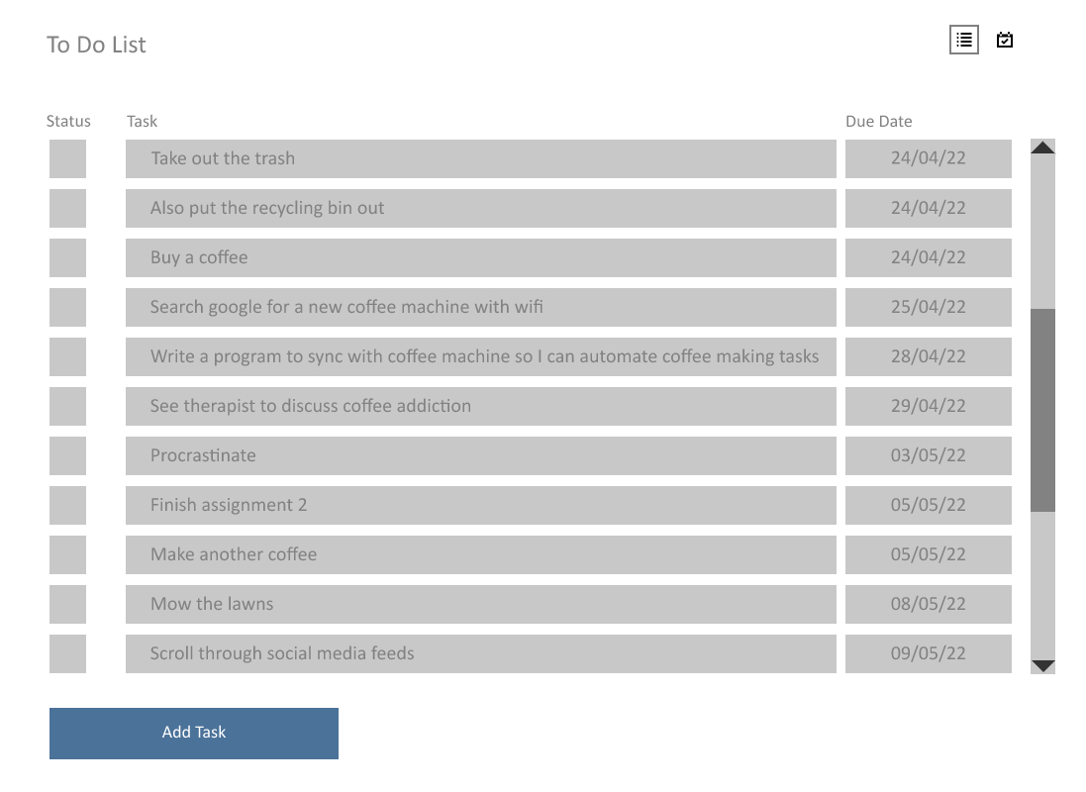

Single click on a task to select it, or double click to see further details about the task

Click the status box to mark the task as completed (puts a tick in the box and a line through the text)

Click here to switch between list view and calendar view

**UI.2: List View – Add Task**

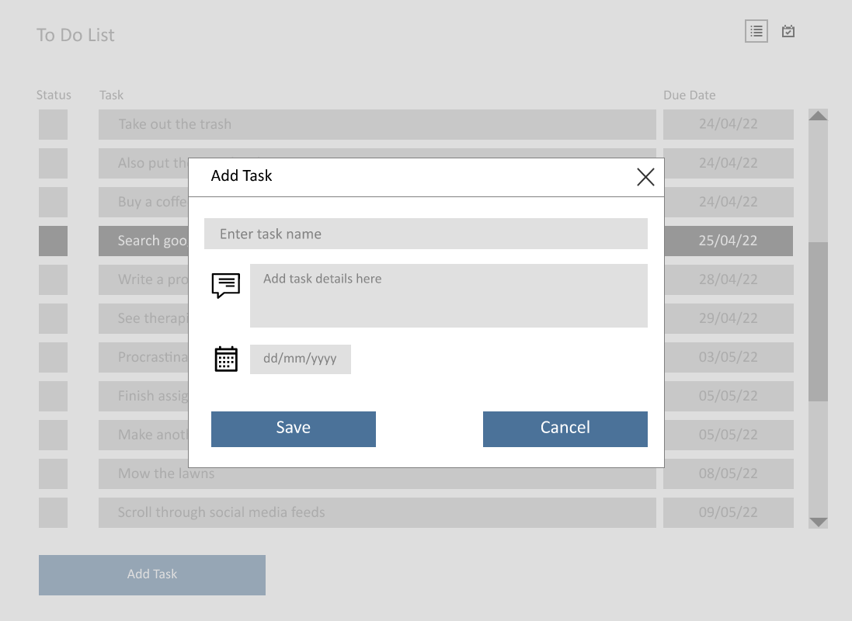

Editable text fields. Task name has max length 50 characters. Description max length 250 characters.

Editable text field with constraints to ensure only valid dates are entered

**UI.3: List View – Task Selected**

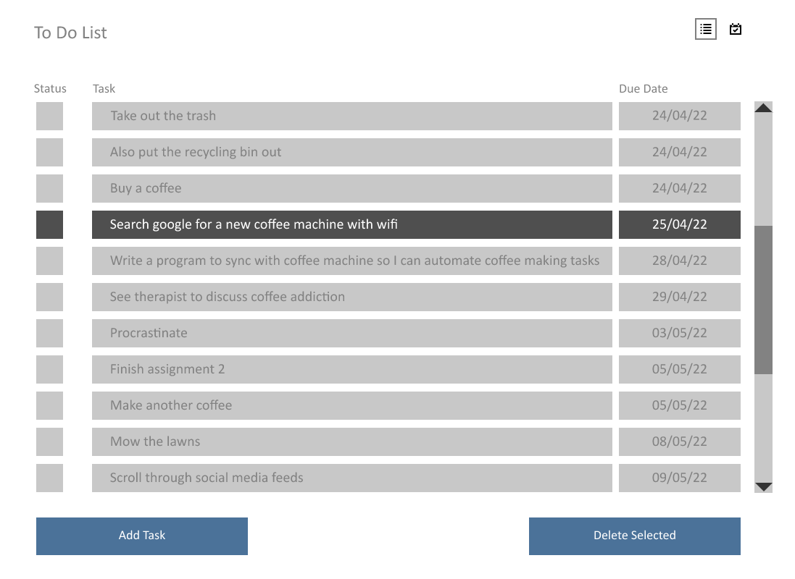

Once a task is selected, the task delete button is displayed

Single click on a task to select/deselect it, or double click to see further details about the task

**UI.4: List View – Task Details**

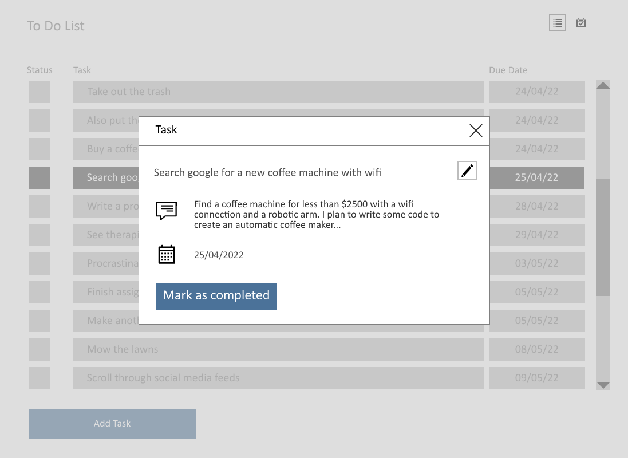

Showing detailed view of task

Updating the status from here does the same thing as ticking the status box on the List View (see next image)

Click here to edit the task details (task name, description, due date)

**UI.5: List View – Task Status**

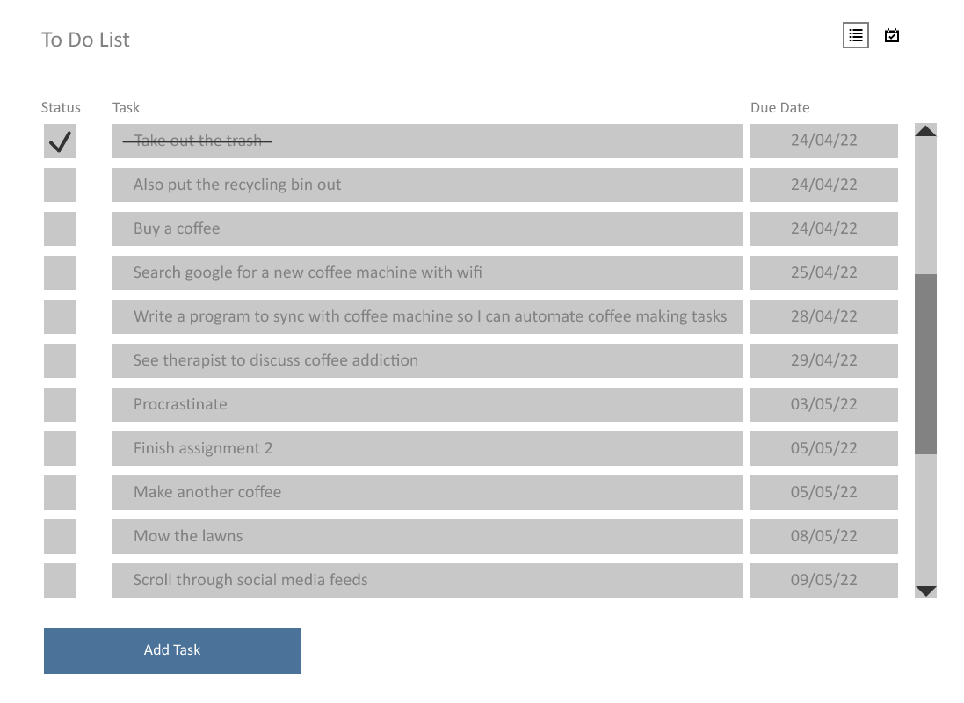

Task status can be toggled by clicking the status box

**UI.6: List View – Edit Task**

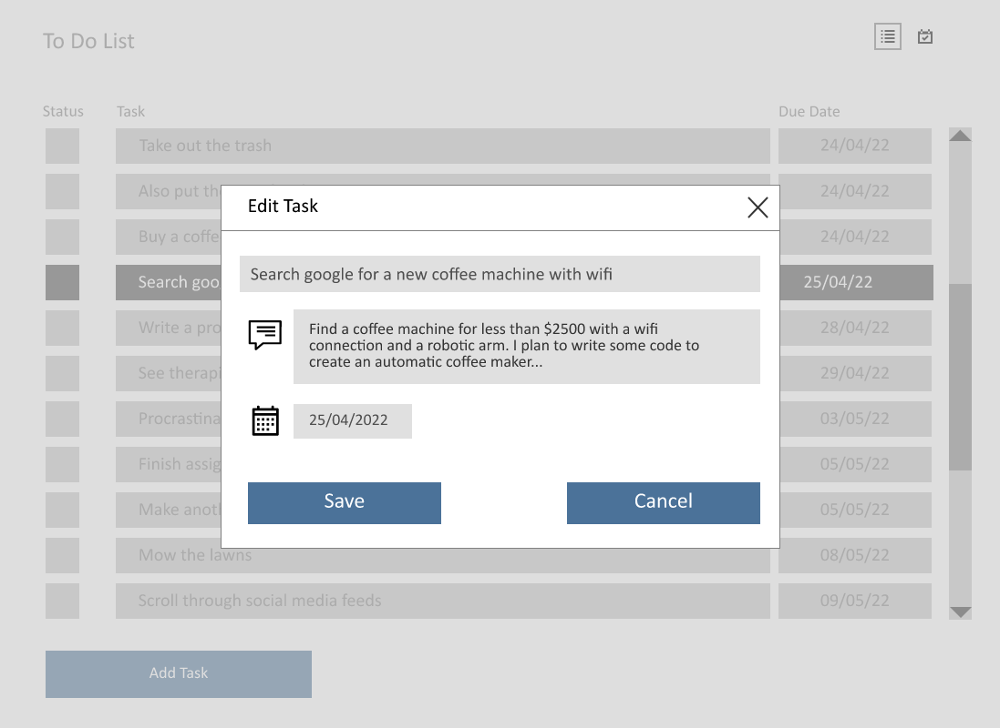

Editable text field with constraints to ensure only valid dates are entered

Editable text fields for task name and description

**UI.7: List View – Delete Task**



Delete button is displayed when a task is selected. Two step deletion process to minimise risk of user deleting a task by mistake

**UI.8: List View – Task Deleted**

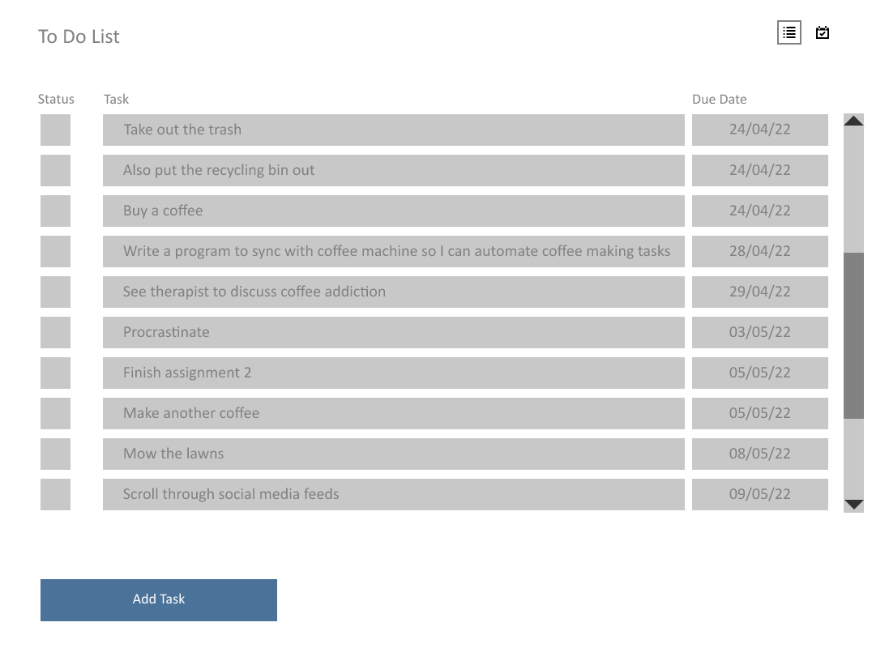

Task has been removed from the list. No undo/recovery option available – Thus two step deletion process is necessary

**UI.9: List View – Error Adding Task**

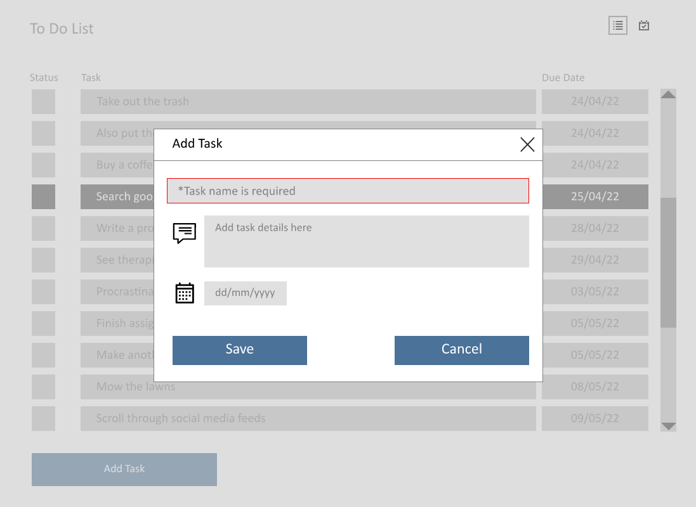

If required fields are not filled in when user clicks save button the fields are highlighted in red and hint text displays error message

**UI.10: Calendar View**

Calendar view selected.

Navigate to next or previous week. The current week is displayed by default

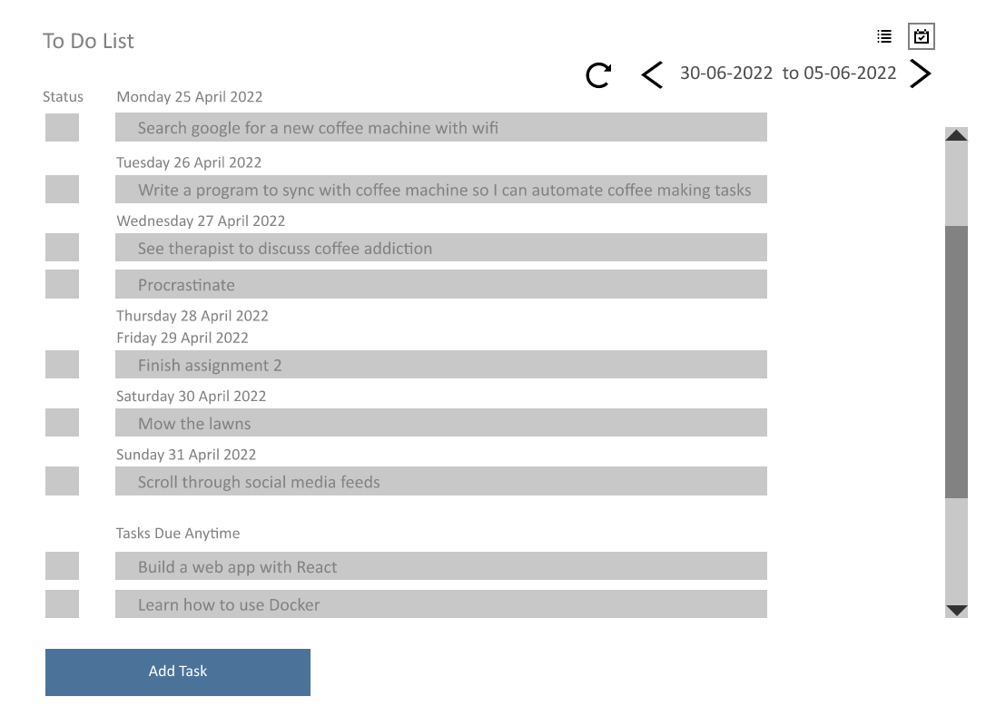

Click a task to select it, or double click to view further details for the task

Task completion status can be toggled. When marked as complete this box has a tick and the task title has a strike through

Some days may have no tasks scheduled

**UI.11: Calendar View – Add Task**

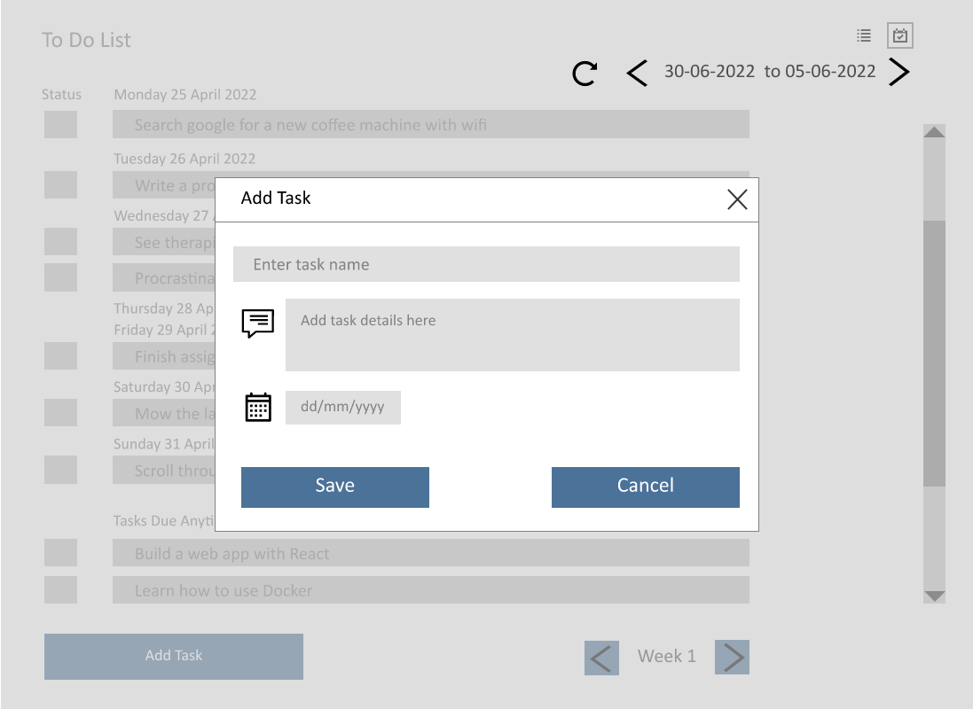

Editable text fields for task name and description

Editable text field with constraints to ensure only valid dates are entered

**UI.12: Calendar View – Task Selected**

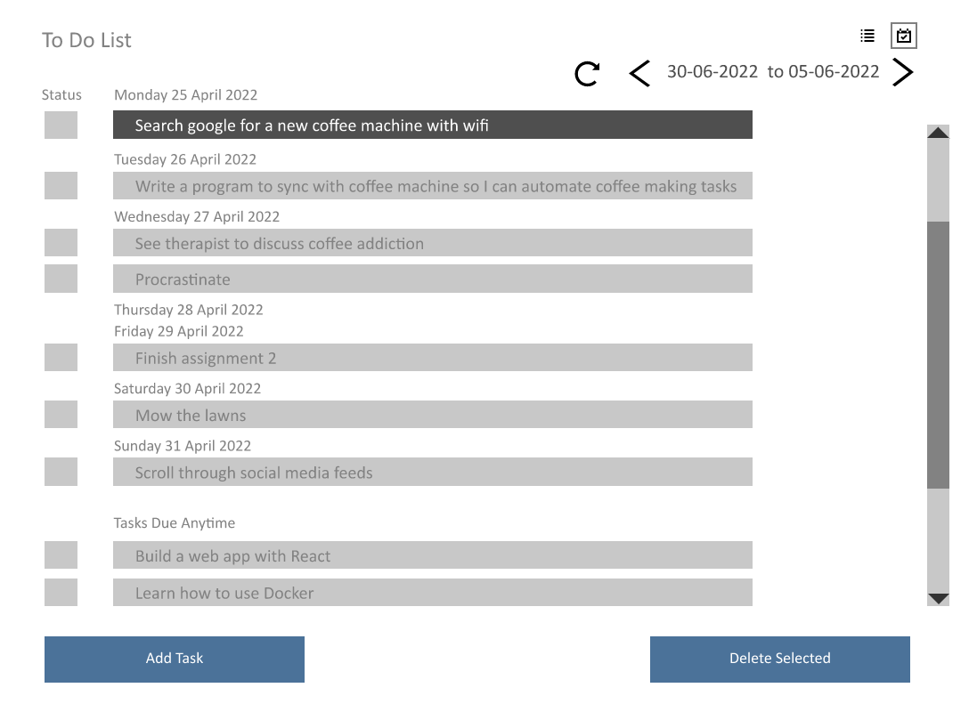

Single click on a task to select/deselect it, or double click to see further details about the task

Once a task is selected, the task delete button is displayed

**UI.13: Calendar View – Task Details**

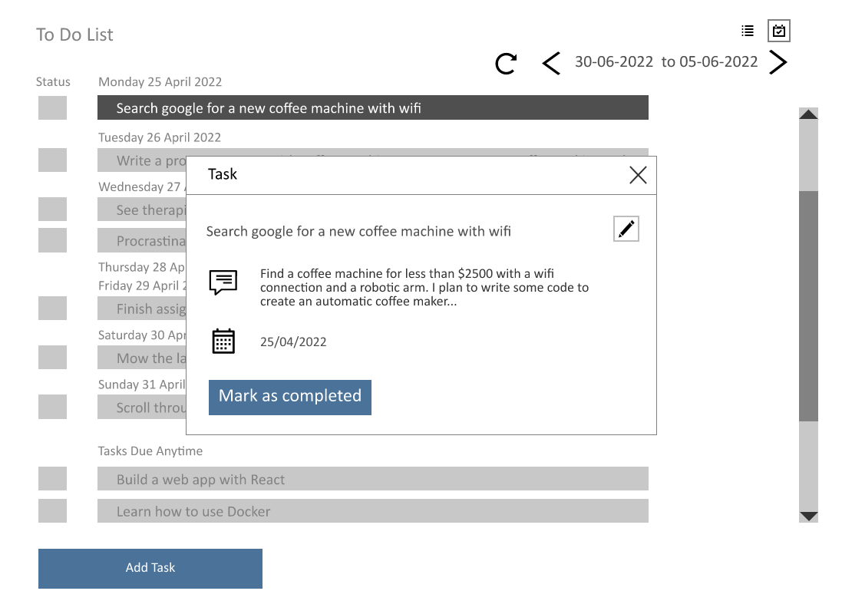

Updating the status from here does the same thing as ticking the status box on the List View (see next image)

Click here to edit the task details (task name, description, due date)

Showing detailed view of task

**UI.14: Calendar View – Task Status**

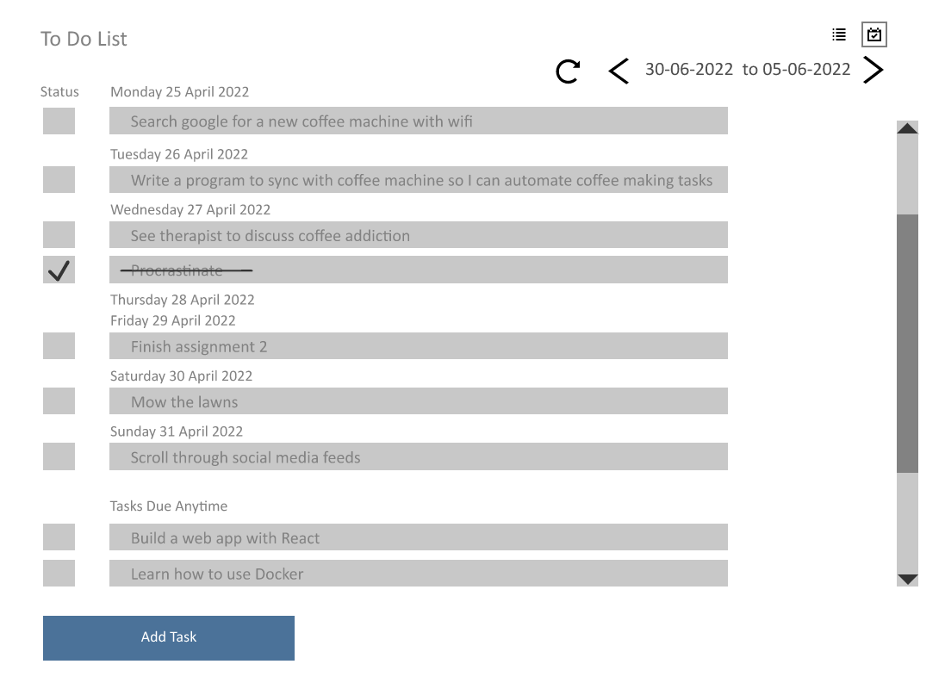

Task status can be toggled by clicking the status box.

Task text is then crossed out with a strikethrough

**UI.15: Calendar View – Edit Task**

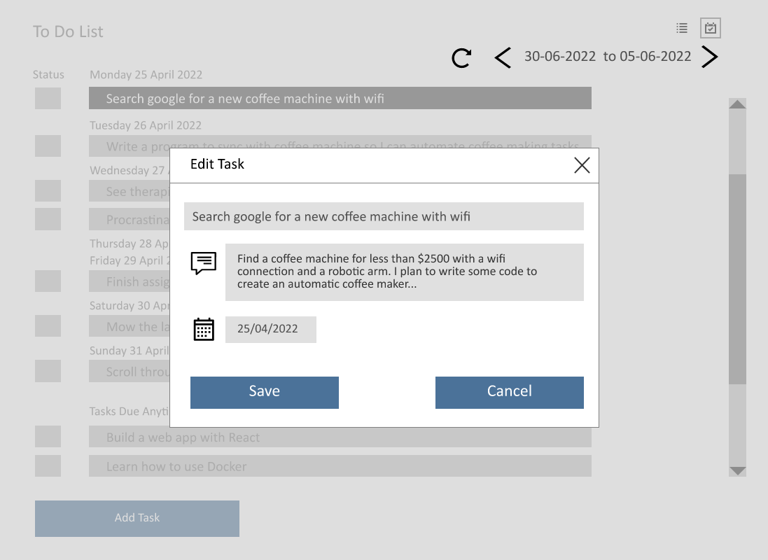

Editable text field with constraints to only accept valid dates

Editable text fields for task name and description.

**UI.16: Calendar View – Delete Task**



Delete button appears when user selects a task. Two step deletion process to minimise risk of user deleting a task by mistake

**UI.17: Calendar View – Task Deleted**

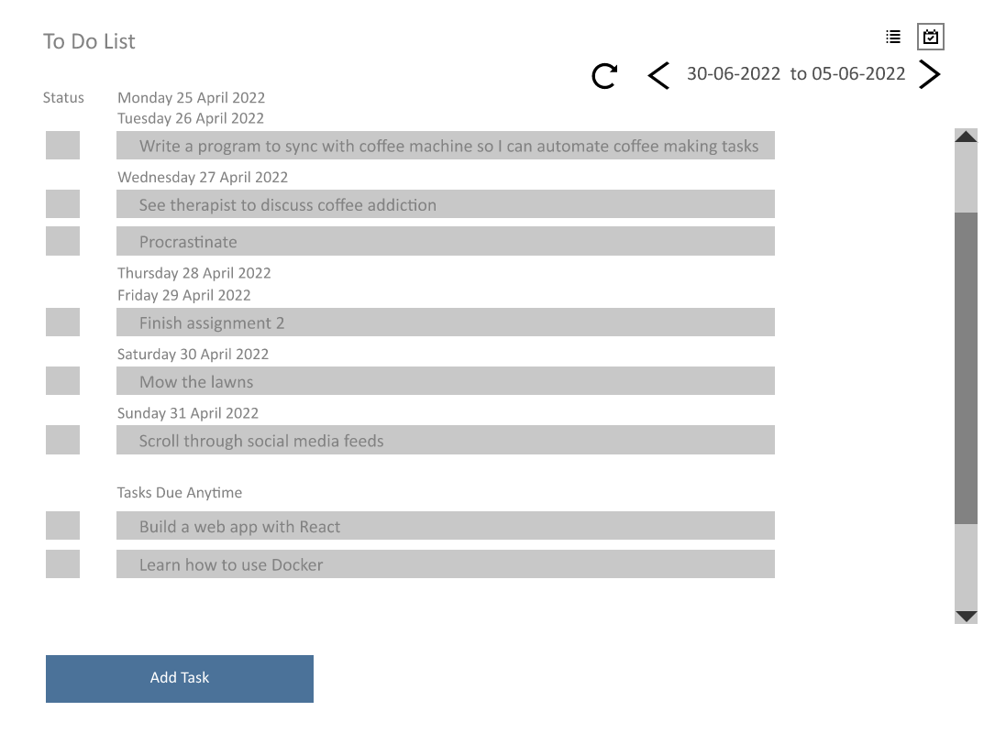

Task has been removed from the list. No undo/recovery option available – Thus two step deletion process is necessary

**UI.18: Calendar View – Error Adding Task**

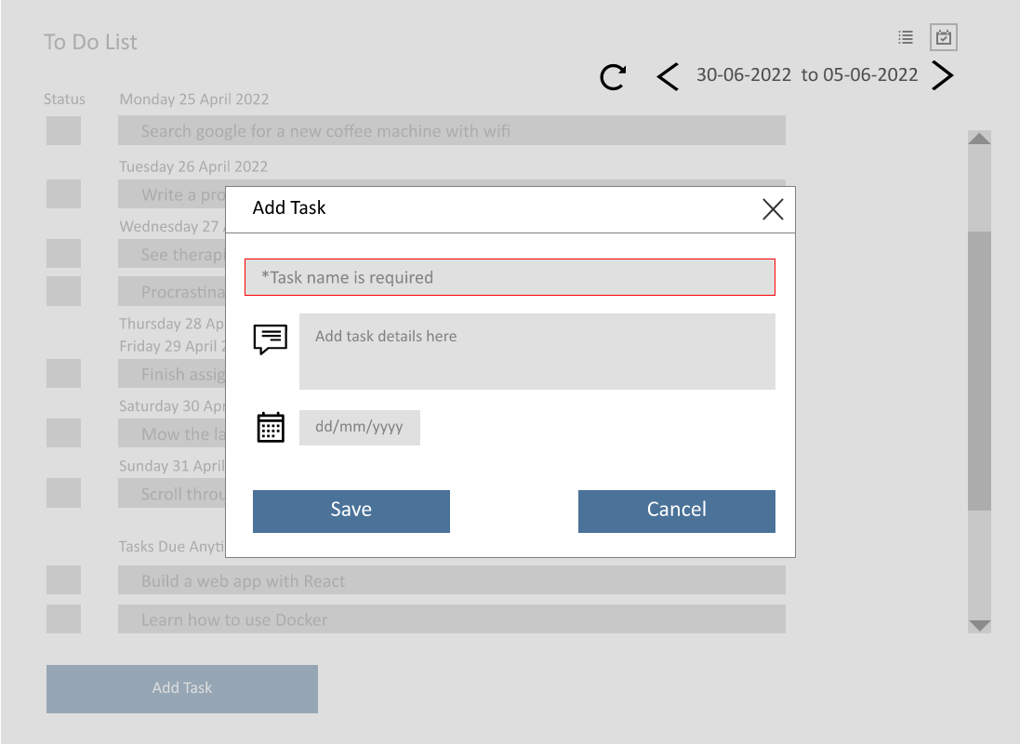

If required fields are not filled in when user clicks save button the fields are highlighted in red and hint text displays error message