Architecture — said-wat
Purpose: Stack, flows, and API facts for building said-wat.
Status: Current
Verified against: Alignment interview + Kimi API docs (platform.kimi.ai), 2026-08-09
Primary code: not yet created — greenfield

Stack
- Electron 35 + TypeScript (strict, ES2024, ESM) + React 19, rspack bundling, oxlint/eslint, vitest — mirroring Multi-Code (docs/knowledge/tech-conventions.md).
- Single LLM provider: Kimi (Moonshot), OpenAI-compatible.
- Zero native dependencies; tray-resident; global hotkeys.

LLM integration
- Base URL: https://api.moonshot.cn/v1 (Chinese platform — verified live 2026-08-10; the builder's key does NOT authenticate against api.moonshot.ai). Official openai Node SDK.
- API key: env var MOONSHOT_API_KEY (or repo-root .env in dev); never in repo, never hardcoded.
- v1 default model: kimi-k2.6 in non-thinking mode (vision + text, thinking switchable).
- Fallback: kimi-k2.7-code (builder's "Kimi 2.7") — thinking always on; reserved for hard screenshot interpretation.
- Vision input: content array with type: "image_url" + base64 data URL (png/jpeg/webp/gif; keep ≤4K).
- Image tokens count dynamically by resolution — hundreds to low thousands per screenshot; output/thinking tokens dominate cost, so thinking stays off.

Flows
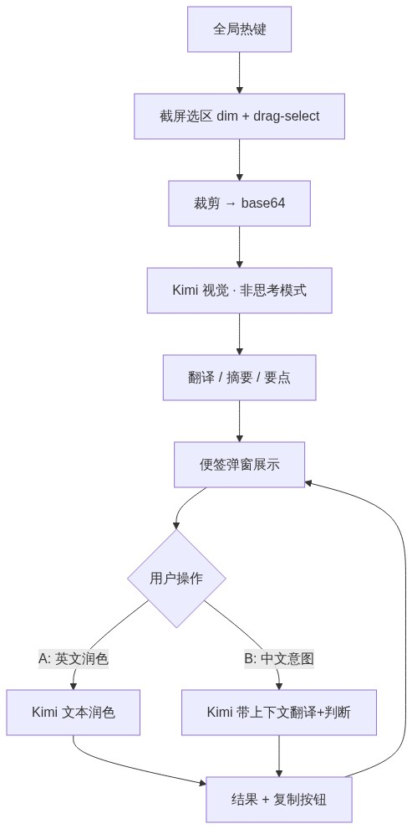
Fig: said-wat 核心流程 (mermaid flowchart)

Part 1 — screenshot interpret
- Global hotkey → screen-capture overlay (WeChat desktop UX clone: dim + drag-select; Electron fullscreen overlay + desktopCapturer, requires Screen Recording permission).
- Crop region → base64 → Kimi (vision, non-thinking) with a 3-section output prompt: full translation (untranslatable parts kept as-is) / one-line summary / notable points.
- Result rendered in a sticky-note popup (always-on-top, frameless, compact).

Part 2 — reply workspace (same note)
- Multi-line draft box below the analysis.
- Flow A: user writes English → copies → polish hotkey → Kimi (text) → idiomatic English. Pure text polish, no context check.
- Flow B: user writes Chinese intent → send → Kimi with context = note analysis + full accumulated conversation → judge whether the screenshot's questions are answered → translate to English; if not answered, translate anyway + append a warning line. Result + copy button.
- Multi-turn: every send includes the note's conversation history.

Config & storage
- Hotkeys configurable (placeholders Cmd+W / Cmd+E conflict with universal close-window — 3-key combos recommended).
- Config persisted under the user config dir (mirror Multi-Code settings-store.ts pattern, ~/.config/<app>/…).

