Sunshine's Todo
Business Proposal & Software Requirement Overview

Project Name
Sunshine's Todo
Tagline
"Organize your days, preserve your memories, and always leave room for a little sunshine."

Executive Summary
Sunshine's Todo is a personalized productivity and journaling web application designed to help users organize their daily lives while creating an emotionally meaningful digital space.
Unlike traditional to-do list applications that focus solely on task management, Sunshine's Todo combines productivity tools with thoughtful personal features, allowing users to plan their schedules, maintain journals, improve focus, and receive daily encouragement through carefully curated literature and personalized messages.
The application aims to provide a clean, elegant, and distraction-free environment where productivity meets emotional connection.

Vision
To create a productivity platform that feels personal rather than mechanical—one that not only helps users complete tasks but also motivates, inspires, and reminds them that someone believes in them every single day.

Project Objectives
The platform is designed to help users:
- Organize daily tasks efficiently.
- Break large goals into smaller manageable subtasks.
- Schedule and manage important events.
- Maintain a personal journal.
- Improve concentration through structured focus sessions.
- Track productivity and study hours.
- Preserve memories through calendar-linked notes.
- Receive daily literature, poems, and heartfelt messages.

Core Features
1. Authentication System
The application begins with a secure authentication system ensuring every user's personal information remains private.
Features
- User Registration
- Login
- Logout
- Forgot Password
- Email Verification
- Secure User Sessions
- Protected Routes
Security
- Firebase Authentication
- Password Encryption
- HTTPS
- User-specific data isolation

2. Dashboard
After signing in, users arrive at a personalized dashboard displaying an overview of their productivity.
Dashboard Components:
- Welcome Message
- Today's Date
- Daily Progress
- Today's Tasks
- Upcoming Events
- Focus Time Summary
- Quick Add Task
- Calendar Preview

3. Smart To-Do Management
The application provides complete CRUD functionality for task management.
Users can:
- Create Tasks
- Edit Tasks
- Delete Tasks
- Mark Tasks as Completed
- Set Priorities
- Assign Due Dates
- Track Completion Status
Each task includes:
- Title
- Description
- Due Date
- Priority
- Status
- Creation Date
- Last Updated Date

4. Task Subdivision
Large tasks can be divided into unlimited subtasks.
Example:
Complete Semester Project
▼ Research
• Literature Review
• Requirement Analysis
▼ Development
• Backend
• Frontend
▼ Testing
• Final Deployment
Each parent task automatically displays completion progress based on its subtasks.

5. Calendar & Event Management
A fully interactive calendar enables users to organize their schedules.
Features include:
- Monthly Calendar
- Weekly Calendar
- Add Events
- Edit Events
- Delete Events
- Event Categories
- Event Colors
- Event Reminders

6. Calendar Notes Timeline
Every event created within the calendar is automatically recorded inside a dedicated Notes Timeline.
Each entry contains:
- Event Title
- Event Description
- Scheduled Event Date
- Date Created
- Time Created
- Last Updated
This timeline functions as a chronological history of all planned activities and serves as a digital record of important moments.

7. Focus Mode
A dedicated distraction-free workspace designed to maximize concentration.
Features:
- Minimal Interface
- Full Screen Mode
- Ambient Background
- Session Timer
- Today's Goal
- Session Notes

8. Pomodoro Productivity System
The platform integrates the Pomodoro Technique to encourage structured work sessions.
Available Modes:
- 25/5
- 50/10
- 90/20
- Custom Session
Productivity Analytics:
- Today's Focus Time
- Weekly Focus Hours
- Monthly Focus Hours
- Total Sessions Completed
- Longest Focus Session
- Productivity Trends

9. Journal
A private journaling space allows users to record thoughts, experiences, and reflections.
Features:
- Create Journal Entry
- Edit Entry
- Delete Entry
- Search Entries
- Rich Text Support
- Mood Selection
- Automatic Timestamp
- Chronological Timeline

10. What Jazzy Has to Say to You Today
This page is simple, personal, and made for someone special.
Every day, it brings a small reminder that you are not alone.

Daily Message (Automated)
Each day, a new message is generated through an API and changes every 24 hours.
These messages are gentle reminders that:
- You are loved
- You are not alone
- You are strong
- You are enough
- You are not wrong
The goal is to give comfort, reassurance, and a little warmth every single day.

A Note from Jazzy ❤️
This section is controlled by the admin through the dashboard.
Jazzy can write personal notes whenever she wants, making it feel real and meaningful.
If no note is added, the section will still show something every day, such as a soft love poem or a heartfelt message.
This ensures that there is always something waiting for you—something kind, something warm, something just for you.

11. Admin Dashboard (Jazzy)
A secure administrator panel allows Jazzy to manage personalized content.
Admin Features:
- Create Daily Notes
- Edit Notes
- Delete Notes
- Schedule Messages
- Upload Original Poems
- Add Literature
- Manage Daily Quotes
- Archive Published Content
This enables Sunshine's Todo to blend automated inspiration with authentic personal communication.

User Interface Design
The application follows a modern dark aesthetic inspired by premium productivity platforms while maintaining a warm and welcoming atmosphere.
Dark Theme
Primary Background:
Deep Charcoal Black
Cards:
Soft Dark Gray
Accent Color:
Golden Yellow
Secondary Accent:
Warm Orange
Typography:
Clean, minimal, and highly readable
Animations:
Smooth page transitions and subtle micro-interactions using Framer Motion.

Proposed Pages
- Login
- Sign Up
- Dashboard
- To-Do List
- Calendar
- Event Timeline
- Focus Mode
- Journal
- What Jazzy Has to Say to You Today
- Profile & Settings
- Admin Dashboard (Restricted)

Technology Stack
Frontend
- React.js
- Vite
- TypeScript
- Tailwind CSS
- ShadCN UI
- Framer Motion
- React Router DOM
- React Hook Form

Backend
- Node.js
- Express.js
Responsibilities:
- REST API Development
- Business Logic
- Authentication Middleware
- Daily Content APIs
- Admin Panel APIs

Database
Firebase Firestore
Collections:
- Users
- Tasks
- Subtasks
- Calendar Events
- Event Timeline
- Journal Entries
- Focus Sessions
- Daily Statistics
- Poems
- Literature
- Quotes
- Admin Notes

Authentication
Firebase Authentication
Supports:
- Email & Password Login
- Google Sign-In
- Secure Sessions

Storage
Firebase Storage
Used for:
- Profile Pictures
- Future Media Uploads

Deployment
Frontend:
Vercel
Backend:
Render
Database:
Firebase Firestore

Future Enhancements
- AI-generated productivity suggestions
- Voice-to-task conversion
- Push notifications
- Shared task lists
- Habit tracking
- Mobile application using React Native
- Progressive Web App (PWA) support
- Export journals and reports as PDF

Estimated Development Timeline
Phase | Duration
UI/UX Design | 2 Weeks
Frontend Development | 4 Weeks
Backend Development | 3 Weeks
Firebase Integration | 1 Week
Testing & Quality Assurance | 2 Weeks
Deployment | 1 Week
Total Estimated Duration: 10–13 Weeks

UI design to implement
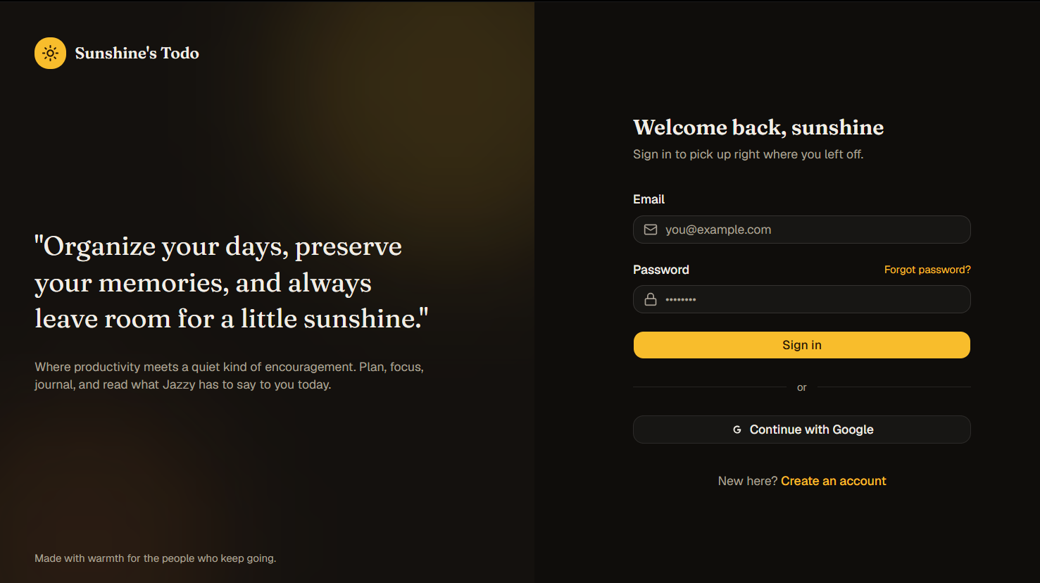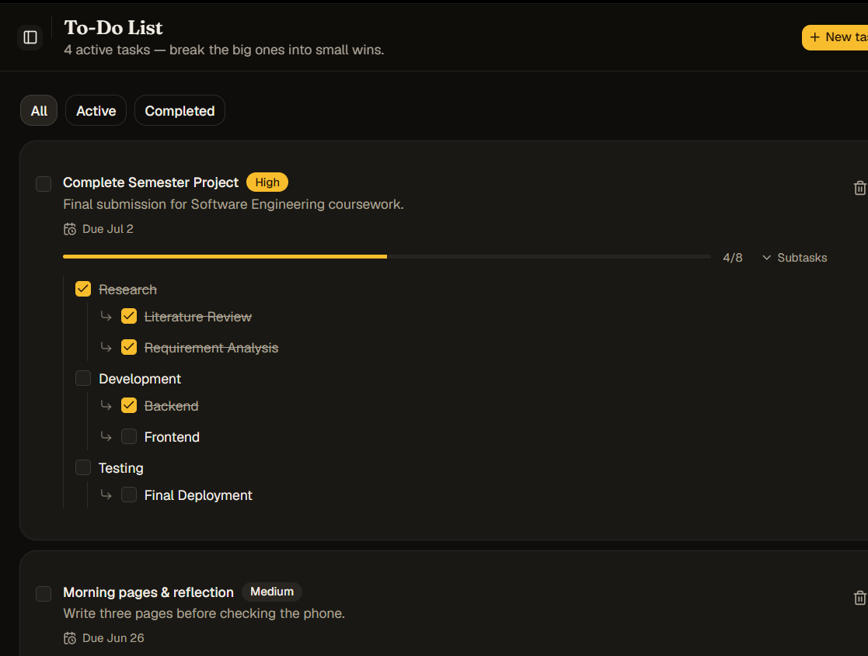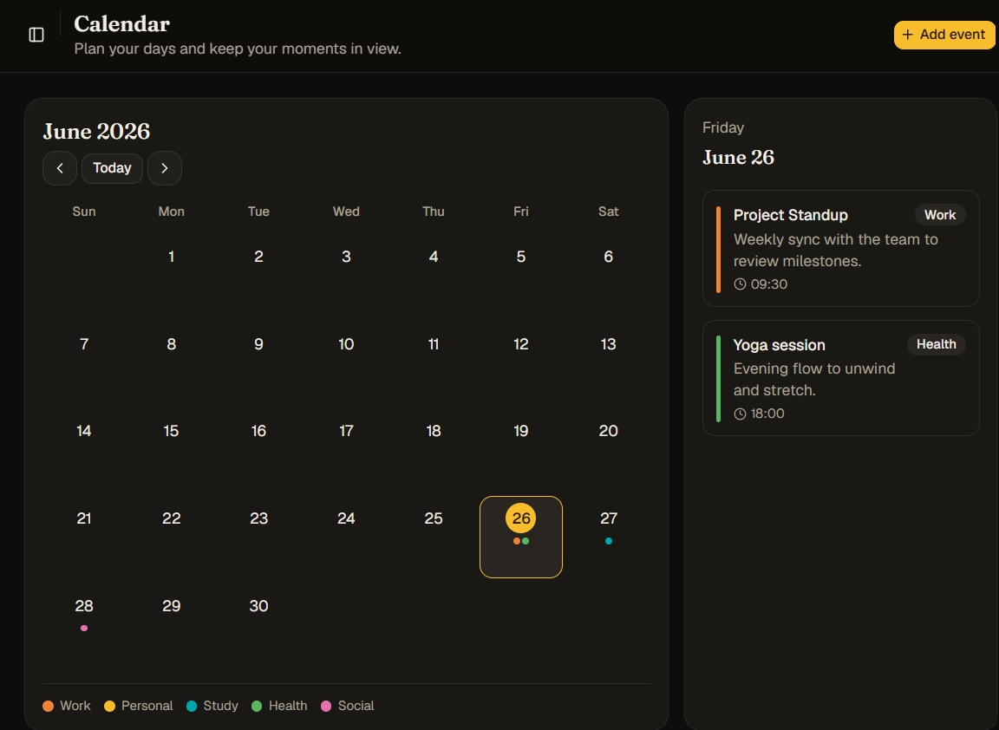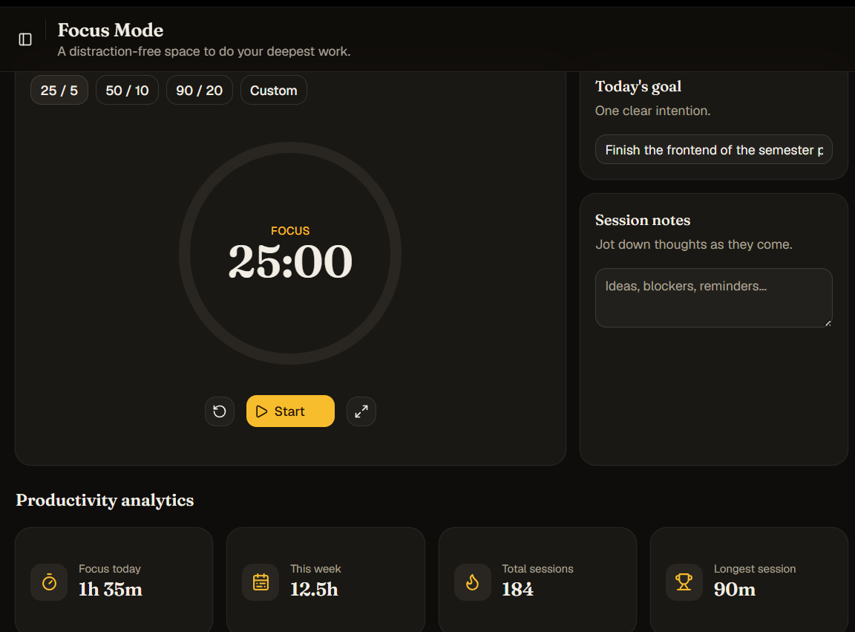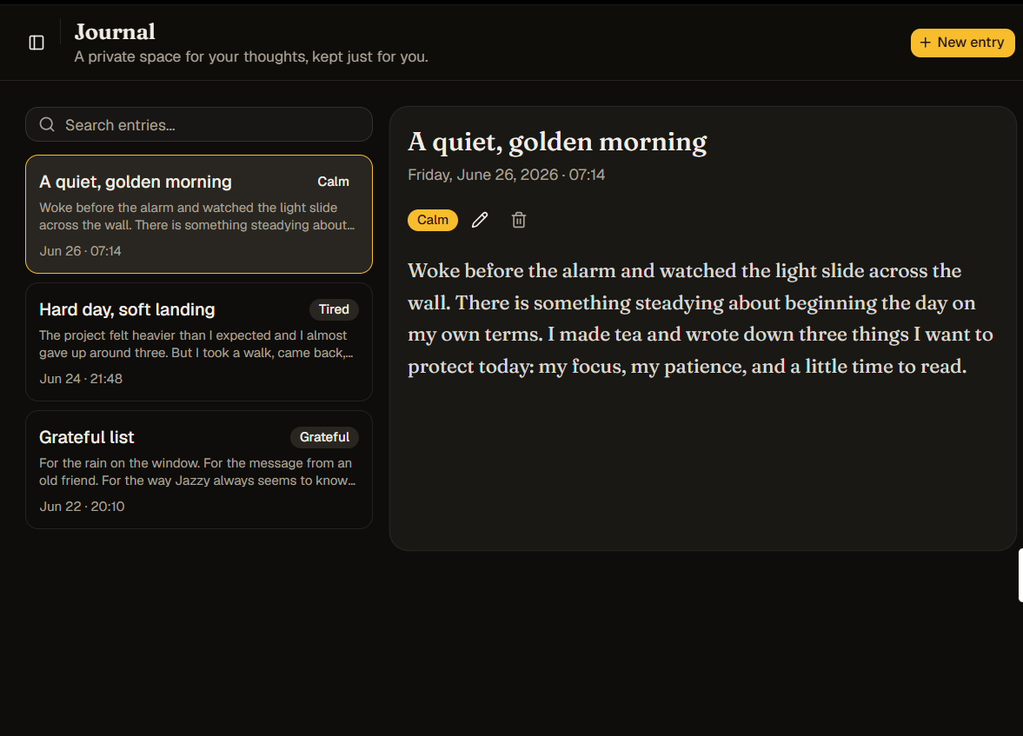

Dash board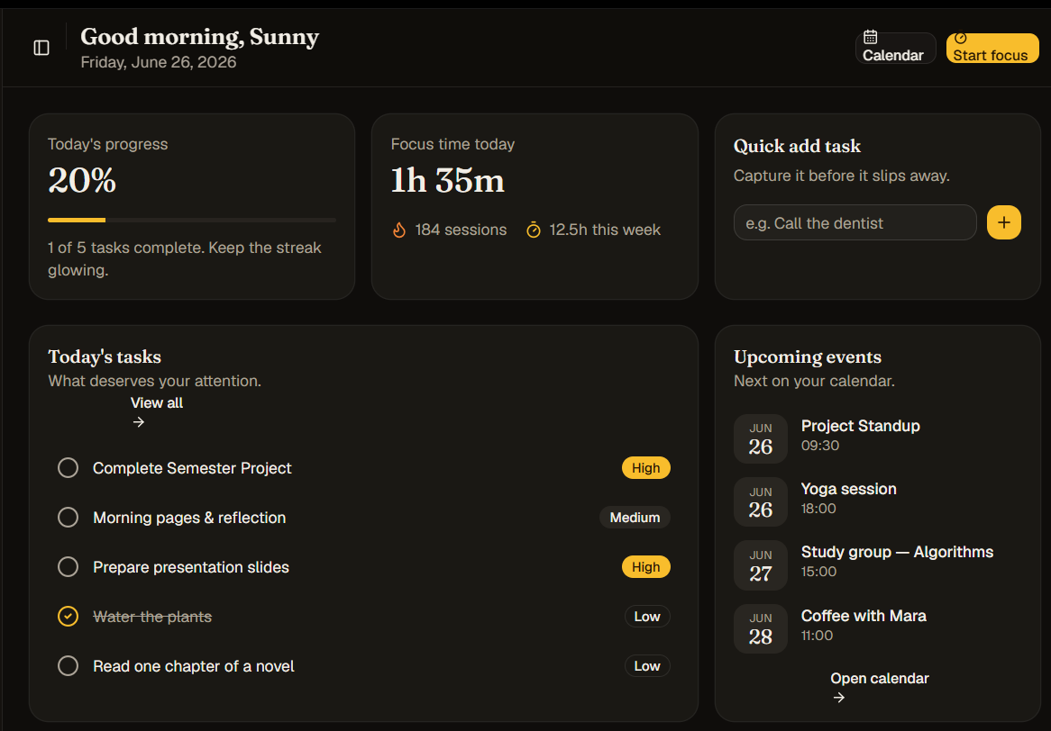

- Conclusion
Sunshine's Todo is more than a task management website. It is a personalized digital companion that combines organization, productivity, focus, journaling, and heartfelt communication within a single elegant platform.
By integrating secure task management, calendar planning, focus tools, personal journaling, and the exclusive "What Jazzy Has to Say to You Today" experience, the platform transforms everyday planning into a meaningful and memorable journey.
The result is a modern productivity application that not only helps users accomplish more but also offers encouragement, reflection, and genuine human connection every day.

