

Carnegie Mellon University

The Robotics Institute, School of Computer Science

16681 - MRSD Project 1

**PDS Conceptual Design**

**Telepresence Mobile Manipulator for Virtual Tour**

**Team H**

Jashkumar Diyora (jdiyora)

Shruti Gangopadhyay (sgangopa)

Jigarkumar Patel (jkpatel)

Prakhar Pradeep (ppradee2)

Shivani Sivakumar (ssivaku3)

**Sponsors**

Zackory Erikson, RCHI Lab, RI, SCS, CMU

Yonaton Bisk CLAW, LTI, SCS, CMU

Date: February 23, 2022

Contents

1 Conceptual Design 1

1.1 Problem Statement 1

1.2 Proposed Idea 1

1.3 PCB Usage 1

1.4 Design Requirements 2

1.5 Block Diagram of the system 3

# Conceptual Design

Team H is assigned [Hello Robot Stretch RE1](https://hello-robot.com/product) platform to develop MRSD project and since Hello Robot Stretch RE1 is a commercial robotics platform, they have internal power distribution system for all subsystems already. Therefore, our team decided to make a PCB for wireless kill switch system.

## Problem Statement

Since the kill switch on Hello Robot Stretch RE1 is physically present on robot and as it is a mobile robot there are fair chances of robot to be far away from operator. Most of the operation of robot is done using an app developed by team H that works on apple devices. In an unlikely situation where the robot must be shut down/suspended it would be too late for the operator to be physically there and avoid damages caused to/by the robot.

## 1.2 Proposed Idea

To develop a PCB which helps the remote user activate the kill switch in a situation of emergency using an app interface that has an emergency button on it. As the emergency button is pressed on the app, it updates the database that is being monitored by microcontroller and Wi-Fi chip on the PCB. As an emergency event is triggered, the servo motor is given an actuation signal that will press the kill switch on robot thus enabling a remote user present thousand miles away to stop the robot before any causalities.

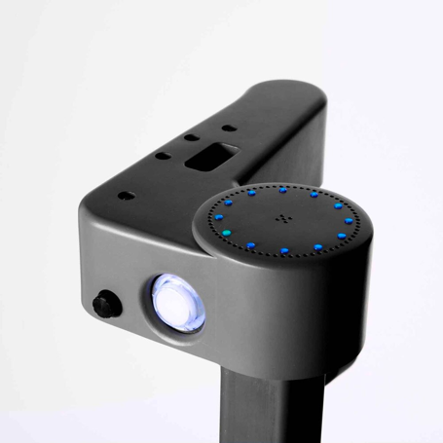

Figure 1: Kill switch illuminated in white on robot

## 1.3 PCB Usage

PCB will have a microcontroller on it that can control actuation of a servo motor. A 3D printed mount will house the servo such that it can press the button. Ideally, we can over pull-out wires from kill switch and put a relay to trigger kill action, but our team prefers to not change anything from internally system of the robot since the robot is property of sponsors and any fault could cause damages to robot, or potentially delays further project plans. For the power distribution, right next to kill switch there is a developer port given that can be accessed for USB serial connection to the robot’s central computer and next port has a 12V/3A power supply point. We plan step down the 12V/3A to 5V/1A using a voltage regulator with over voltage, reverse voltage protection. We will also have an indicator LED to verify the functioning of PCB. The 5V/1A supply will be used to power MCU, Wi-Fi chip, LEDs, and servo motor. The PCB will have few through hole RCL components as voltage dividers are required powering Wi-Fi chip like ESP-01.

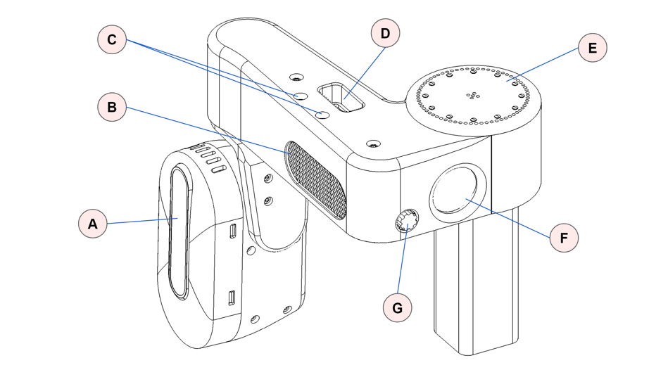

Figure 2: Point D is developer box, Point F is kill switch location

## 1.4 Design Requirements

**Subsystem wise power requirements:**

* Microcontroller: Mostly our team plans to use an Arduino nano which has operated at 5V, it has current draw of 100mA.
* Servo Motor: SG90 is a tiny blue servo which is good enough for the simple task like this, it is operated at 3~6V and has max current draw of 550mA.
* Wi-Fi chip: ESP-01 is operated at 3.3v which can be easily fetched from 3.3V line of microcontroller. Normally current from 50~80mA is required.

**Analysis:**

1. Number of connectors and current capacity of the connector

Answer: 3 connectors, 1A current capacity.

1. For each source, detail if you plan to monitor input voltage, if you require a manual switch,

and what the main overvoltage/reverse voltage protection will be.

Answer: Only one 12V/3A source is fetched from robotics developer box. For OVP/RVP diodes and fuse will be used.

3. If a subsystem requires a voltage regulating circuit, set a desired efficiency/cost,

output voltage, and peak output current.

Answer: No such critical subsystem.

4. If a subsystem requires more advanced control, like FETs or H-bridges, provide the peak output current and minimum/maximum required operating voltage.

Answer: No such advance control subsystem.

5. Detail any reverse voltage/overvoltage protection for the subsystem.

Answer: Reverse voltage: Specific diode number or MOSFET isn’t decided yet but for reverse voltage protection our team plans to deploy diode or p channel MOSFET across the power input for RVP.

Overvoltage Protection: Using a 1.5A rating fuse on the mains of DC input and a Zener diode limit to 5V. As this limit is reached the diode will shunt the excessive power to ground and save the PCB from major damage.

6. Detail if you need to be able to control power to the subsystem (does your

controllers need to be able to enable/disable power to a given subsystem)

Answer: No every subsystem is already powered by internal electronics of robot.

7. Detail if you plan to monitor the input or output voltages with the system controller, and whether you intend to provide visual indication (i.e., an LED) that power to a given subsystem is on.

Answer: Yes, visual indication with an LED will be provided on PCB to determine the PCB status.

## 1.5 Block Diagram of the system

Here is a high-level idea of how we plan to develop the schematic of PCB.

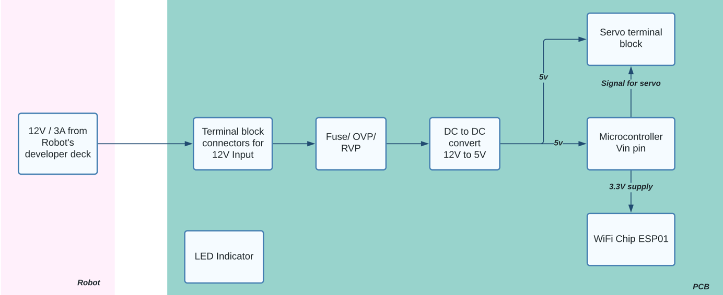

Figure 3: Block diagram of PCB