**16681: MRSD Project 1 / Task 11 PDS – SCH Submission**

Team: **H**

Team Members:

* Jashkumar Diyora (**jdiyora**)
* Shruti Gangopadhyay (**sgangopa**)
* Jigarkumar Patel (**jkpatel**)
* Prakhar Pradeep (**ppradee2**)
* Shivani Sivakumar (**ssivaku3**)

**Analysis**

**State the efficiency regulators**

* Formula for Efficiency: **[1 – ((Vin - Vout)/(Vin))] x 100%**

|  |  |  |  |
| --- | --- | --- | --- |
| **Part** | **Vin** | **Vout** | **Efficiency** |
| **LM2596T-5.0/LF03** | 12V | 5V | 41.67% |

**Updates to concept**

* Change Arduino Uno to NodeMCU
* Removed ESP-01 since NodeMCU has inbuilt Wi-Fi chip
* Added 12V supply for Dynamixel.

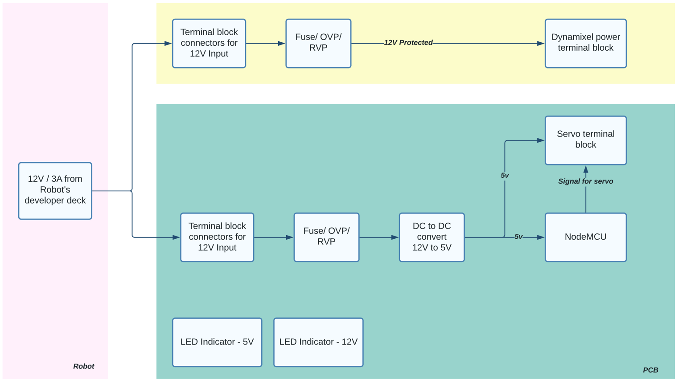

Figure: Updated PCB concept with RVP 12V for Dynamixel