How to run the code?

• Run the following commands to generate the N-bit Wallace tree multiplier circuit (with isolation register stage after every K stages) in Verilog from the C++ code.

• The code will ask the user to input the value of N and K when the user runs ./a.out. For N, you can enter any value in the power of 2. For K (>0), enter any value greater than zero, not necessarily in the powers of 2.

unzip CS19S018.zip ; cd CS19S018
g++ Multiplier_gen_pipeline.cpp
./a.out
8 2

• After running the above commands, the multiplier.v file will be generated in the current
directory, which is the Verilog file for the N-bit Wallace tree multiplier circuit (with isolation register stage after every K stages). N is 8, and K is 2 in this case.

• In order to run the generated Verilog files using the test benches to see the multiplication results, use the following commands.

iverilog multiplier.v
iverilog multiplier_tb.v
./a.out

- Note: Carry Lookahead Adder is not pipelined while adding the pipeline stages. The pipeline stages are only added to the CSA tree.
- Note: There will be many warnings generated when the user compiles the code using the commands -> iverilog multiplier.v or iverilog multiplier_tb.v. Please ignore those warnings that will not affect the final results.

- Note: The Multiplier_gen_pipeline.cpp is the multiplier generation code, while the multiplier.v is the self-generated Verilog code generated by Multiplier_gen_pipeline.cpp. The multiplier_tb.v is the testbench file, which is written manually and is not generated by Multiplier_gen_pipeline.cpp.

- Note: The time period of the clock (clk input) has to be changed manually. This can be done from multiplier_tb.v.

Block Diagram and Output for N=8 and K=2

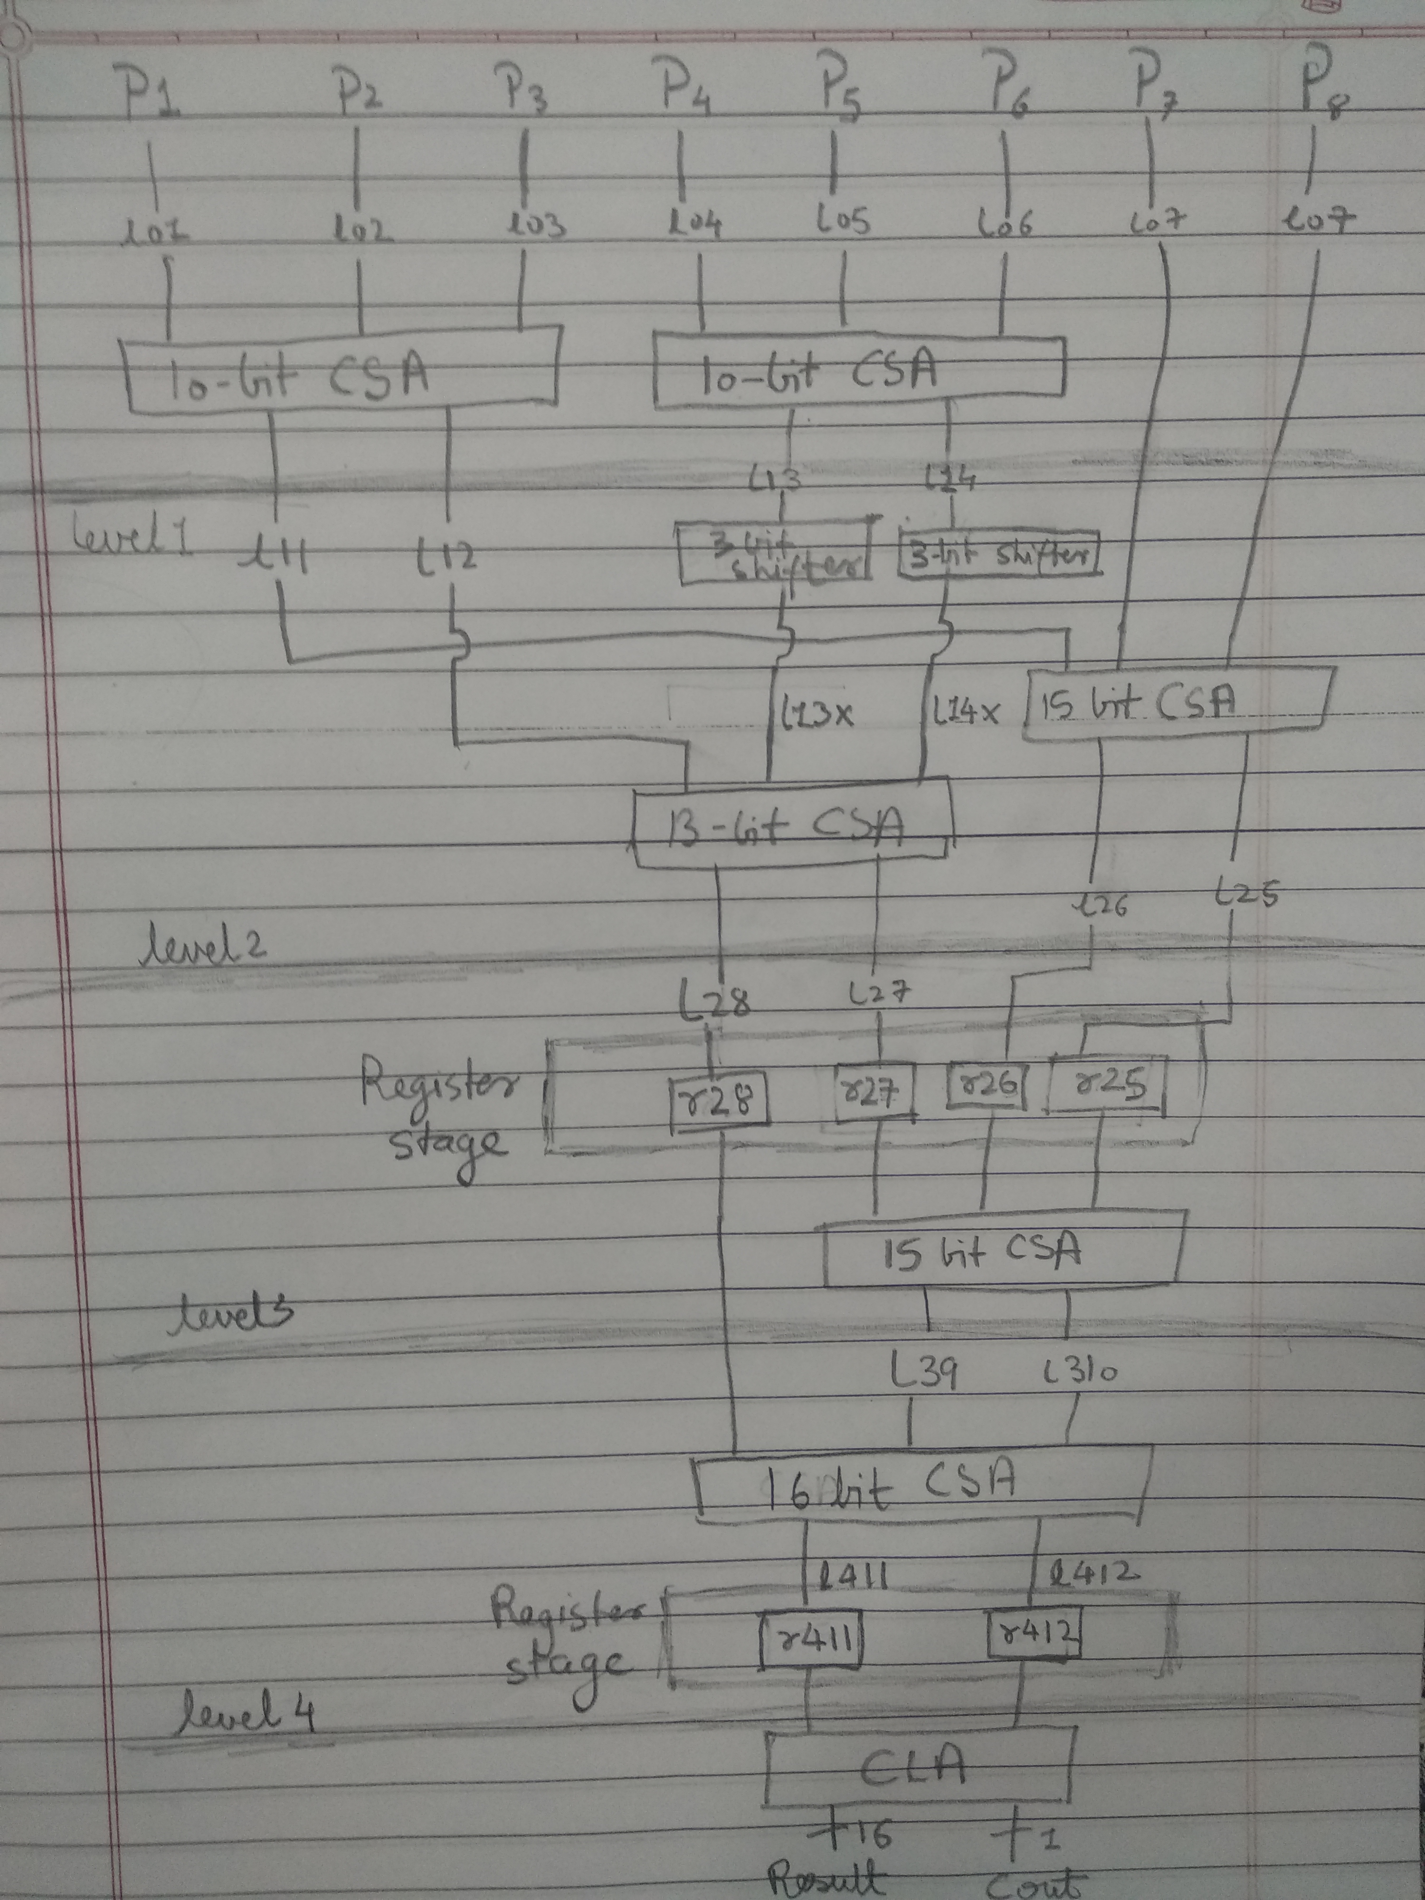
Figure(1)

- The above figure shows the resulting block diagram of pipelined Wallace Tree Multiplier generated by HLL code-named Multiplier_gen_pipeline.cpp with N=8 and K=2.
- Note that code does not generate 16-bit CSA at every stage in the CSA tree. Instead, it generates less bit size CSA wherever possible. This is done in order to optimize the area of the circuit.
- P1, P2 .. P8 are the partial products that are generated from multiplicand and multiplier.
- Register stage generated by the code is shown in the figure above.
- 3-bit left Shifter are used to shift the CSA inputs appropriately. This is needed when CSA has input values with different shifts in it.
- Way the CSAs are connected, and the structure of the CSA tree, which is generated by the HLL code is clearly shown in the above figure.

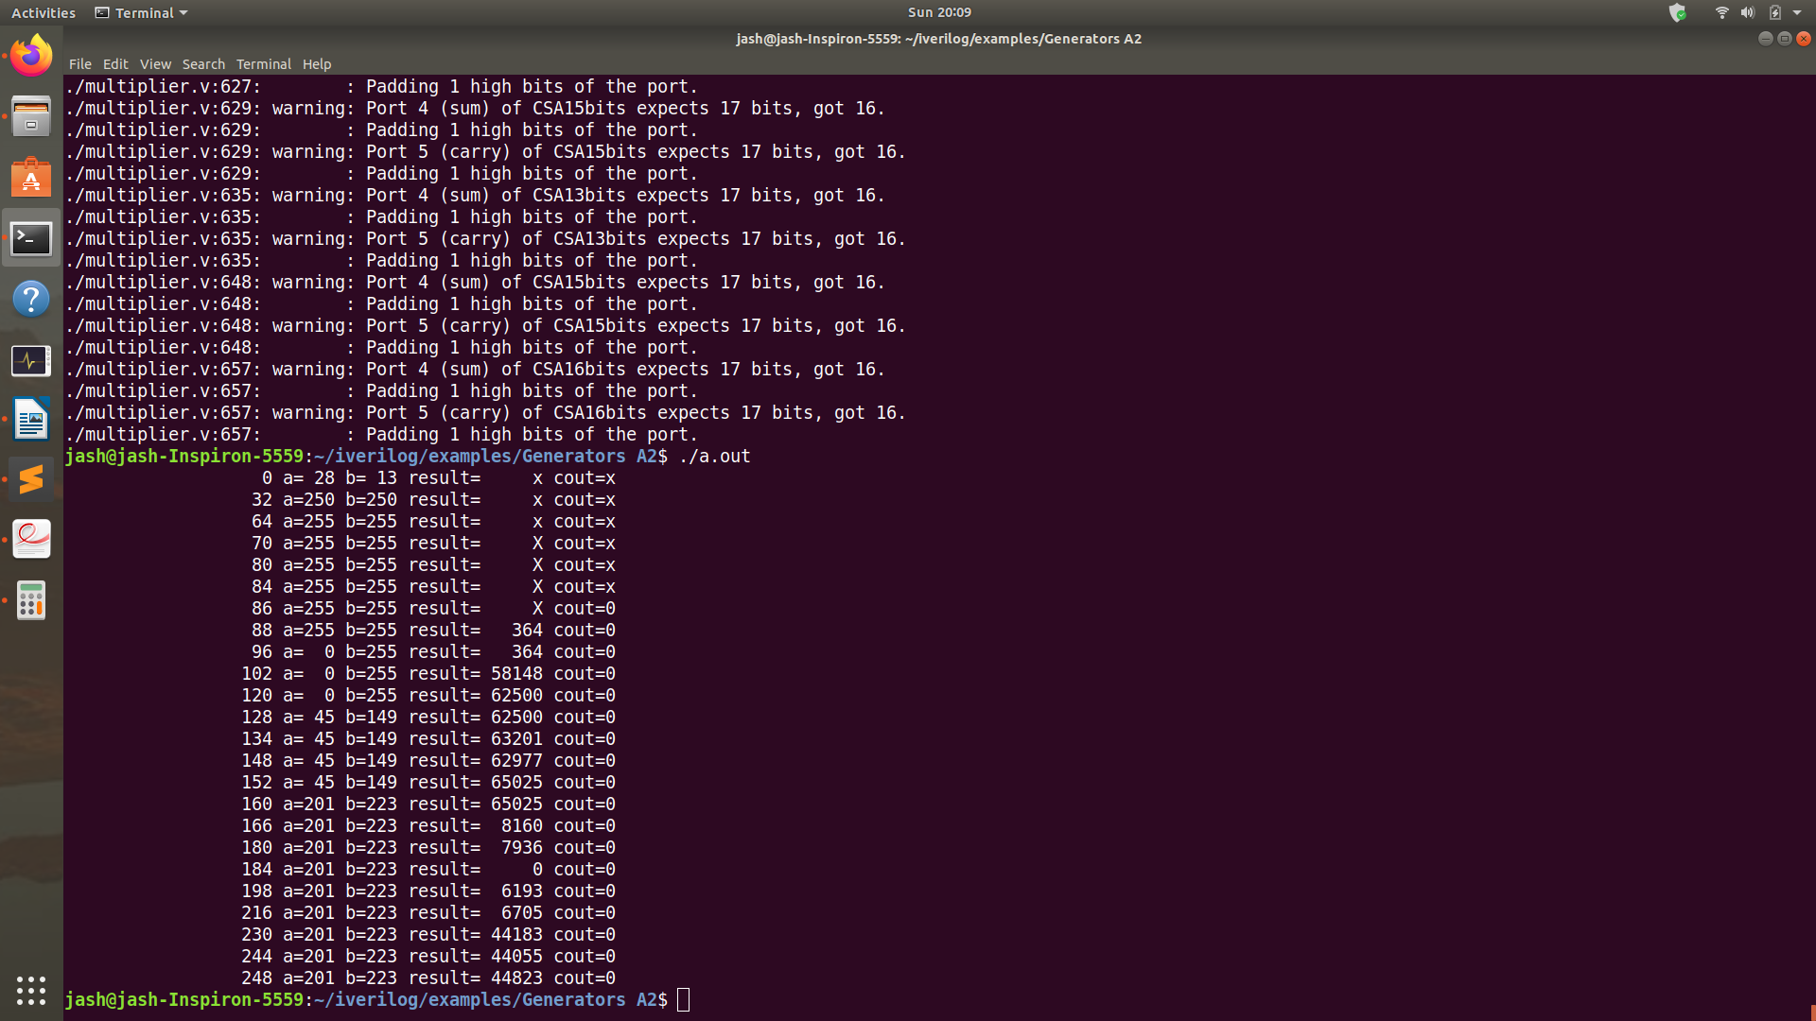
Figure(2)

- The above figure shows the result of executing the generated verilog code by HLL with N=8 and K=2. The time period of the clock is set to 32 units. Same results can be replicated by running the submitted testbench file(multiplier_tb).
- The ‘a’ and ‘b’ represent multiplicand and multiplier, respectively.
- The result shows the actual multiplication result while cout is the carry out of the CLA which can be ignored.
- Total of 6 inputs are feed to the pipelined multiplier circuit at each clock cycle i.e. at t=0,32,64,96,128,160 respectively.
- The result of the first input is available at t=88. (28*13 =364).
- After this point, results for all the successive inputs are getting available at the successive clock cycles.
- So, 250*250 will be available at 88 + 32(time period) = 120 time unit.
- 255*255 will be available at 88 + 2*32 = 152 time unit.
- 0*255 will be available at 88 + 3*32 = 184 time unit.
- 45*149 will be available at 88 + 4*32 = 216 time unit.
- 201*223 will be available at 88 + 5*32 = 248 time unit.

Results

- The following table summarizes the results for the 8-bit pipelined Wallace tree multiplier with K=1,2,3,4,5.
- Note that new input is pushed into the 8-bit pipelined Wallace tree multiplier in each clock cycle. A total of 11 inputs are feed to the pipelined multiplier. The derived results from it are tabulated below.
- Note that output for the first input will be available after t time units. After that in each clock cycle we will get the results for the rest of the inputs. Execution time given below is the time taken to get outputs for all the inputs.

- Note that 8-bit Wallace tree multiplier has only 4 levels of the CSA tree. So K=5 will not add any register stage at all in the CSA tree (i.e. Non-pipelined implementation of multiplier).

- The 11 inputs that we feed to the pipeline were (a,b) = (28,13) , (255,255) , (250,250) , (0,255) , (45,149) , (201,223) , (21,23) , (90,100) , (200,50) , (255,155) , (1,223). The result tabulated below can be replicated by setting values of a,b as mentioned above and adjusting clock as given in the table.

N | K | Number of 1-bit registers used for pipelining | Time period of the clock (clk)  in units | Execution time(in units) to finish all the 11 inputs
8 | 1 | 240 | 24 units | 360 units
8 | 2 | 96 | 24 units | 312 units
8 | 3 | 48 | 24 units | 294 units
8 | 4 | 32 | 30 units | 334 units
8 | 5 | 0 | unclocked/Non-pipelined | 660 units

Comparative Analysis for different values of K

Register needed for different values of K.
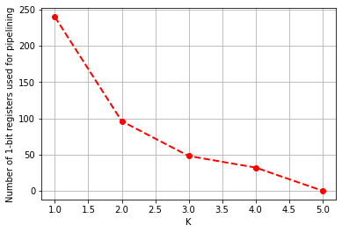
Figure(3)

- The above figure tells us that as the value of K (from 1 to 5 in this case) increases, the number of 1-bit registers needed to implement the pipeline reduces.
- This is intuitive because for K=1, we add the register stage after every CSA stage, while for K=4 we add the register stage only after every four register stages. Hence the number of the register should decrease as K increases.

Time period of the Clock for different values of K.

- For K=1,2,3 CLA with the delay of 24 units will become the bottleneck for the pipelined multiplier. Hence, the time period of the clock is set to 24 units.
- For K=4, CLA, and all 4 stages of the CSA tree are separated by the register stage. In this case, the delay in processing the input from the CSA tree(30 units) will be more than the delay of CLA (24 units). Hence, the clock is set to 30 units.

- For K=5 or above, we will not have any register stage as the K value exceeds the number of CSA stages. So, in this case we do not need to set the time period of the clock. In this cases, each multiplication operation may take as much as 60 units in worst case.
Execution time analysis for different values of K and
speedup vs area trade-off

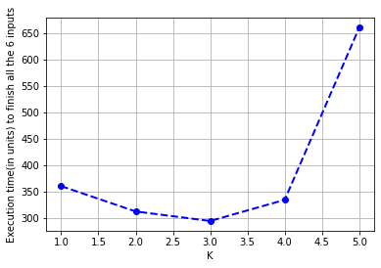
Figure(4)

- For K=5, Since there are no register stages that have been added. Hence the execution is completely sequential (Non-pipelined). In this case, each multiplication may take takes 60 units in the worst case. Hence 11 multiplication operations will take 660 units of time. However, the advantage here is we are not using any 1-bit register at all since there is no pipeline

- For K=1, the execution time obtained is 360. Out of these 120 units of time are needed to compute the first output. After that, we will get one output in each clock cycle(24 units) for the rest of the 10 inputs. Hence total delay = 120 + 10*24 = 360. For a large number of inputs, the time to compute the first output will be less significant. Hence, in general, we can say for N=8, K=1, and a large number of inputs, the time taken to compute each output is 24 units (that is the time period of the clock). So, speed-up over the sequential circuit is 60/24 = 2.5, and the total number of 1-bit register needed is 240.
- Similarly for K=2, the execution time obtained is 312. Out of these 72 units of time are needed to compute the first output. After that, we will get one output in each clock cycle(24 units) for the rest of the 10 inputs. Hence total delay = 72 + 10*24 = 312. For a large number of inputs, the time to compute the first output will be less significant. Hence, in general, we can say for N=8, K=2, and a large number of inputs, the time taken to compute each output is 24 units (that is the time period of the clock). So, speed-up over the sequential circuit is 60/24 = 2.5, and the total number of 1-bit register needed is 96.
- Similarly for K=3, the execution time obtained is 294. Out of these 54 units of time are needed to compute the first output. After that, we will get one output in each clock cycle(24 units) for the rest of the 10 inputs. Hence total delay = 54 + 10*24 = 294. For a large number of inputs, the time to compute the first output will be less significant. Hence, in general, we can say for N=8, K=3, and a large number of inputs, the time taken to compute each output is 24 units (that is the time period of the clock). So, speed-up over the sequential circuit is 60/24 = 2.5, and the total number of 1-bit register needed is 48.
- Finally for K=4, the execution time obtained is 354. Out of these 54 units of time are needed to compute the first output. After that, we will get one output in each clock cycle(30 units) for the rest of the 10 inputs. Hence total delay = 54 + 10*30 = 354. For a large number of inputs, the time to compute the first output will be less significant. Hence, in general, we can say for N=8, K=4, and a large number of inputs, the time taken to compute each output is 30 units (that is the time period of the clock). So, speed-up over the sequential circuit is 60/30 = 2, and the total number of 1-bit register needed is 32.

N | K | Speed-up over the sequential execution (if provided large number of input values) | Number of 1-bit registers used for pipelining
8 | 1 | 2.5 | 240
8 | 2 | 2.5 | 96
8 | 3 | 2.5 | 48
8 | 4 | 2 | 32
8 | 5 (or above) | 1 | 0

Conclusion

- From these experiments, we can conclude that for N=8; the K=3 may give us the best achievable speed-up while using an optimal number of registers for implementing the 8-bit pipelined Wallace tree multiplier.

