21CSE251T-DIGITAL IMAGE PROCESSING
Assignment Report

Coral Bleaching Detection and Health Assessment
using Digital Image Processing
____________________________________________________________

Submitted by: Jashwanth B
Roll No: RA2411003010379
Department: Computing Technologies
Date: 20 April 2026

Introduction and Objectives

Coral reefs are among the most biodiverse and economically valuable ecosystems on Earth, supporting approximately 25% of all marine species while covering less than 1% of the ocean floor. However, rising sea surface temperatures, ocean acidification, and anthropogenic stressors have led to widespread coral bleaching events globally. Coral bleaching occurs when stressed corals expel their symbiotic algae (zooxanthellae), causing the coral tissue to turn white and eventually leading to coral death if conditions persist.
This project applies Digital Image Processing (DIP) techniques to automatically detect and quantify coral bleaching from underwater photographs. By leveraging color space transformations, morphological operations, and spectral feature extraction, the system provides a non-invasive, scalable method for monitoring coral reef health - eliminating the need for manual diver surveys.
The system is implemented as a full-stack web application with a Python/OpenCV backend and a real-time interactive dashboard frontend built using Vite and TypeScript.

Objectives
- Apply image preprocessing techniques (noise reduction, color correction) to compensate for underwater optical distortions such as blue-green wavelength absorption and light scattering.
- Implement coral segmentation using HSV color space thresholding with morphological refinement to isolate coral regions from the marine background.
- Extract spectral health features - Whiteness Index, Red Index, Mean Saturation, and Bleaching Pixel Percentage - from the segmented coral body.
- Classify coral health status into three categories: Healthy, Moderately Bleached, and Severely Bleached using a multi-signal scoring matrix.
- Detect structural boundaries of coral colonies using Canny edge detection.
- Deploy the complete pipeline as a real-time web dashboard for interactive coral health analysis.

1.2 About Coral Bleaching
Coral bleaching is a stress response triggered primarily by elevated sea surface temperatures (SSTs). When water temperatures rise 1–2°C above the seasonal maximum for a sustained period, corals expel their zooxanthellae - the photosynthetic dinoflagellate algae living within their tissue. Since zooxanthellae provide corals with up to 90% of their energy (via photosynthesis) and are responsible for their vibrant coloration, their loss leaves the coral tissue transparent, revealing the white calcium carbonate skeleton beneath.
Bleaching Stage | Visual Indicator | Saturation | Whiteness
Healthy | Vibrant red, orange, brown, green, purple | > 90 | < 35%
Moderate Bleaching | Pale, faded colors | 50–65 | 35–50%
Severe Bleaching | White, ghostly appearance | < 40 | > 60%

Table 1: Visual and Spectral Indicators of Coral Bleaching Stages

1.3 DIP Techniques Used in This Project
Technique | Purpose | OpenCV Function
Gaussian Blur | Noise reduction | cv2.GaussianBlur()
Gray-World Color Correction | Neutralize underwater blue/green cast | Manual channel scaling
Min-Max Normalization | Contrast enhancement | cv2.normalize()
RGB → HSV Conversion | Color-based segmentation | cv2.cvtColor()
Binary Thresholding | Water vs. coral classification | Boolean array operations
Morphological Opening | Remove small noise regions | cv2.morphologyEx(MORPH_OPEN)
Morphological Closing | Fill holes inside coral bodies | cv2.morphologyEx(MORPH_CLOSE)
Connected Component Analysis | Filter regions by area | cv2.connectedComponentsWithStats()
Median Blur | Smooth jagged mask boundaries | cv2.medianBlur()
Canny Edge Detection | Detect coral structural boundaries | cv2.Canny()
Color Map Overlay | Generate health heatmap | cv2.applyColorMap()
Contour Detection | Draw coral boundary outlines | cv2.findContours()

Table 2: Digital Image Processing Techniques and Their Applications

2. System Architecture

The system follows a modular pipeline architecture where each DIP stage processes the output of the previous stage. The complete pipeline is implemented in main.py with a Flask REST API (app.py) serving a Vite/TypeScript frontend dashboard.

2.1 Pipeline Flowchart
The processing pipeline follows a sequential flow from image acquisition through preprocessing, segmentation, feature extraction, classification, and finally visualization:

Step | Stage | Operations
Step 1 | Image Acquisition | Load image, convert BGR → RGB
Step 2 | Preprocessing | Gaussian Blur → Gray-World Correction → Min-Max Normalization
Step 3 | Coral Segmentation | RGB→HSV → Water Exclusion → Morphology → Connected Components
Step 4 | Edge Detection | Mask → Grayscale → Canny(50, 150)
Step 5 | Feature Extraction | Bleaching %, Whiteness, Red Index, Mean Saturation
Step 6 | Classification | Multi-signal scoring matrix → Health status
Step 7 | Visualization | 6-panel pipeline display + Interactive web dashboard

2.2 Technology Stack
Component | Technology | Purpose
Core DIP Engine | Python 3.x, OpenCV, NumPy | Image processing pipeline
Web Backend | Flask, Flask-CORS | REST API serving /api/analyze
Web Frontend | Vite, TypeScript, ApexCharts | Interactive dashboard UI
Image Encoding | Pillow, base64 | Convert processed images for web transport
Visualization | Matplotlib | Offline 6-panel pipeline display

Table 3: Technology Stack

3. Methodology - Detailed Pipeline

3.1 Stage 1: Image Acquisition
The first stage loads the input image and converts it from OpenCV's default BGR color ordering to the standard RGB format used throughout the pipeline.
def load_image(path):
img = cv2.imread(path)
if img is None:
print(f"ERROR: Cannot load image: {path}")
sys.exit(1)
return cv2.cvtColor(img, cv2.COLOR_BGR2RGB)
Code Block 1: Image Acquisition Function
For web uploads, the raw bytes are decoded using cv2.imdecode() with np.frombuffer(). OpenCV reads images in BGR format by default, so immediate conversion to RGB is essential since all subsequent processing (HSV conversion, visualization) expects RGB ordering.

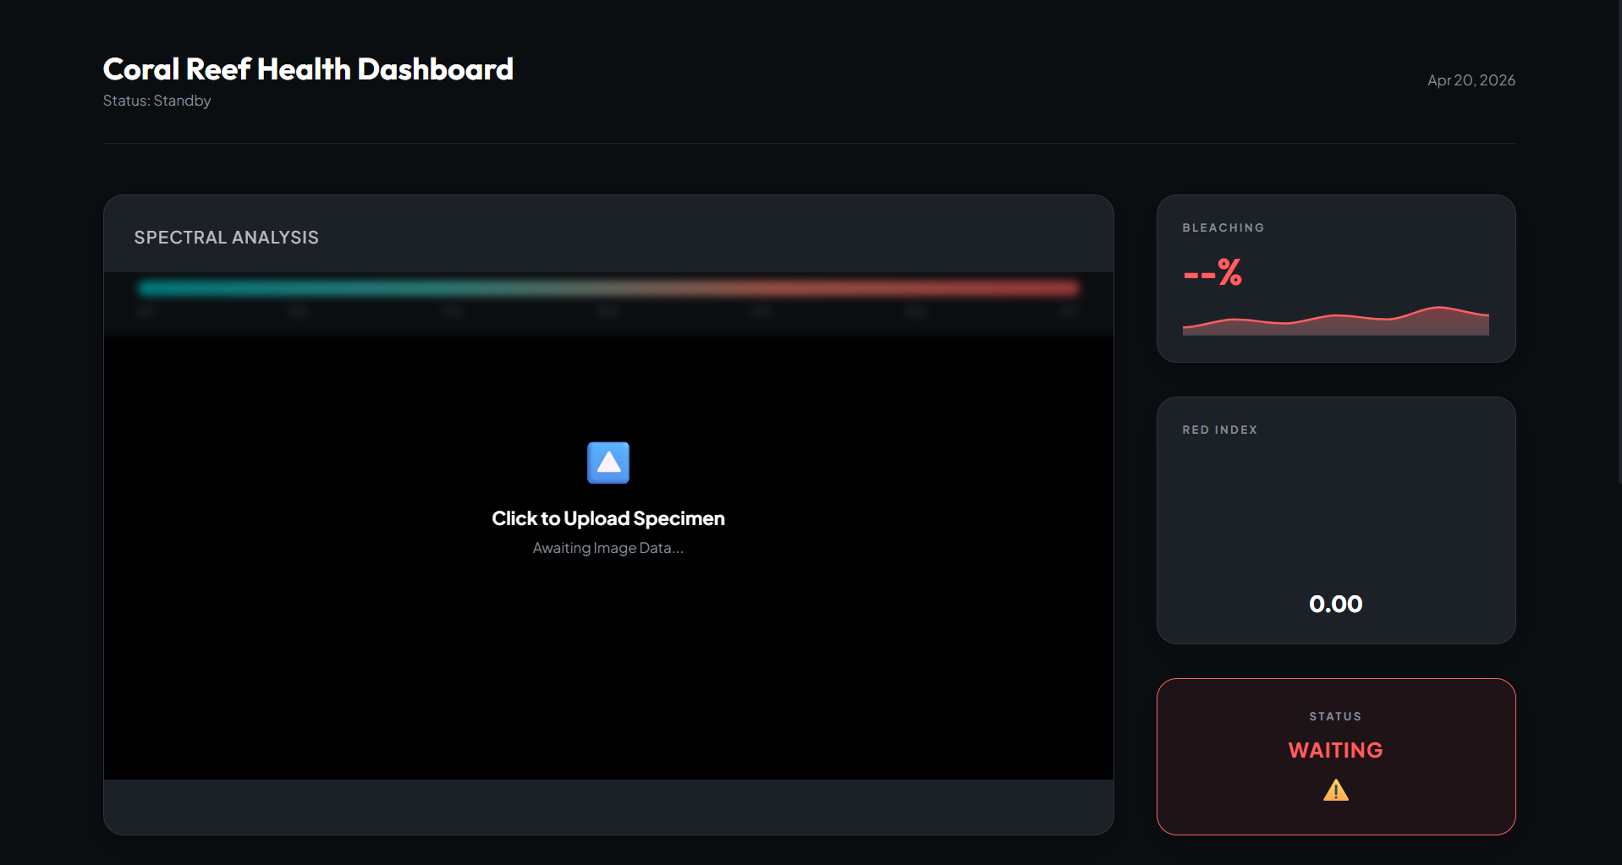
📸 Screenshot 1: interface of the Coral Guardian dashboard showing the drag-and-drop zone.

3.2 Stage 2: Preprocessing (Noise Reduction + Color Correction)
Underwater images suffer from two fundamental optical distortions:
- Wavelength-dependent absorption: Water absorbs red light first (within 5m depth), then orange and yellow. At typical reef depths (5–30m), images appear heavily blue/green-shifted.
- Scattering: Suspended particles scatter light in all directions, reducing contrast and introducing haze.

3.2.1 Gaussian Blur - Noise Reduction
A 5×5 Gaussian kernel is applied to reduce high-frequency sensor noise and compression artifacts while preserving major edges:
blurred = cv2.GaussianBlur(img, (5, 5), 0)
The Gaussian function G(x, y) = (1 / 2πσ²) × exp(-(x² + y²) / 2σ²) with kernel size 5 and σ computed automatically gives σ ≈ 1.1. This provides gentle smoothing that removes salt-and-pepper noise and JPEG compression artifacts without destroying edge information.

3.2.2 Gray-World Color Correction
The Gray-World Assumption states that the average color of a scene under neutral lighting should be gray (equal R, G, B). In underwater images, the average is heavily biased toward blue. By computing the overall mean intensity and scaling each channel to match it, we effectively reverse the underwater color absorption.
result = blurred.astype(np.float32)
avg_B = np.mean(result[:,:,2])
avg_G = np.mean(result[:,:,1])
avg_R = np.mean(result[:,:,0])
avg_gray = (avg_B + avg_G + avg_R) / 3
result[:,:,0] = np.clip(result[:,:,0] * (avg_gray / (avg_R + 1e-6)), 0, 255)
result[:,:,1] = np.clip(result[:,:,1] * (avg_gray / (avg_G + 1e-6)), 0, 255)
result[:,:,2] = np.clip(result[:,:,2] * (avg_gray / (avg_B + 1e-6)), 0, 255)
Code Block 2: Gray-World Underwater Color Correction
Scaling factors:
- R_scale = avg_gray / avg_R (typically > 1.0 → amplifies suppressed red)
- G_scale = avg_gray / avg_G (close to 1.0)
- B_scale = avg_gray / avg_B (typically < 1.0 → attenuates dominant blue)

3.2.3 Min-Max Normalization
corrected = cv2.normalize(gray_world, None, 0, 255, cv2.NORM_MINMAX)
After gray-world correction, the pixel range may not span the full 0–255 dynamic range. cv2.normalize() with NORM_MINMAX linearly stretches the values: I_out = 255 × (I_in − min) / (max − min). This ensures maximum contrast for subsequent processing stages.
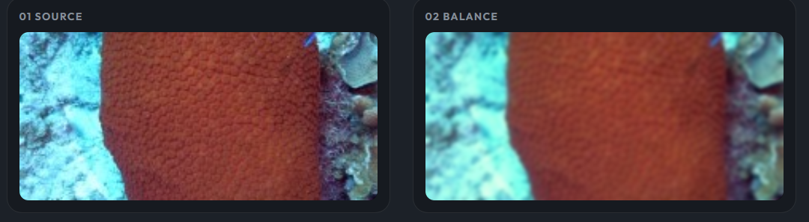
📸 Screenshot 2: Side-by-side comparison showing the original underwater image (blue-tinted) vs. the preprocessed image (color-corrected with restored reds).

3.3 Stage 3: Coral Segmentation
This is the most critical stage of the pipeline. The goal is to generate a binary mask that separates coral tissue from the marine background (water, sand, open ocean).

3.3.1 Color Space: RGB → HSV
HSV (Hue-Saturation-Value) decouples color information from brightness, making it ideal for color-based segmentation under varying underwater illumination:
- Hue (H): Dominant wavelength (color). Range 0–180 in OpenCV.
- Saturation (S): Color purity. High = vivid, Low = gray/white.
- Value (V): Brightness. High = bright, Low = dark.
hsv = cv2.cvtColor(img, cv2.COLOR_RGB2HSV)
h = hsv[:, :, 0] # Hue: 0-180 in OpenCV
s = hsv[:, :, 1] # Saturation: 0-255
v = hsv[:, :, 2] # Value: 0-255
Object | Hue Range (OpenCV) | Saturation | Description
Blue/Cyan Water | 80–130 | > 30 | Consistent across all images
Red/Orange Coral | 0–20, 170–180 | > 50 | Red wraps around 0/180
Yellow/Green Coral | 20–70 | > 40 | Varies by species
White/Bleached Coral | Any | < 30 | Very low saturation
Dark Shadows | Any | Any | V < 30

Table 4: HSV Color Ranges for Underwater Objects

3.3.2 Inverted Water-Exclusion Logic
Key Design Decision: Rather than attempting to enumerate all possible coral colors (which vary by species, depth, lighting, and health), we identify the ONE consistent element - blue water - and exclude it. Everything that is NOT blue water and NOT pitch-black shadow is classified as potential coral/reef substrate.
# Detect blue/cyan WATER and exclude it
is_blue_water = (h >= 80) & (h <= 130) & (s > 30)
is_too_dark = (v < 30)
# Coral mask = everything that is NOT blue water and NOT pitch black
coral_raw = (~is_blue_water & ~is_too_dark).astype(np.uint8) * 255
Code Block 3: Inverted Water-Exclusion Segmentation Logic
This inverted approach is robust because:
- Coral can be any color: red, orange, yellow, green, purple, brown, white, pink
- Water is ALWAYS blue/cyan (hue 80–130) in both raw and preprocessed images
- The method generalizes across all species without retraining or tuning

3.3.3 Morphological Cleanup
# Step 1: Remove noise (Morphological Opening = Erosion + Dilation)
kernel_open = cv2.getStructuringElement(cv2.MORPH_ELLIPSE, (5, 5))
mask = cv2.morphologyEx(coral_raw, cv2.MORPH_OPEN, kernel_open, iterations=2)
Morphological Opening removes small isolated noise pixels (false positives from water reflections, suspended particles) without affecting the shape of large coral bodies. Elliptical structuring elements (cv2.MORPH_ELLIPSE) are used instead of rectangular ones to prevent introducing artificial square/blocky artifacts into naturally curved coral boundaries.

3.3.4 Connected Component Analysis (CCA)
num_labels, labels, stats, _ = cv2.connectedComponentsWithStats(mask)
total_pixels = img.shape[0] * img.shape[1]
min_area = total_pixels * 0.005 # 0.5% threshold
coral_mask = np.zeros_like(mask)
for label_id in range(1, num_labels):
if stats[label_id, cv2.CC_STAT_AREA] >= min_area:
coral_mask[labels == label_id] = 255
Code Block 4: Connected Component Filtering
cv2.connectedComponentsWithStats() labels each isolated white region in the binary mask. We keep all components larger than 0.5% of the total image area, which removes remaining noise while preserving multiple coral colonies in wide reef photographs.

3.3.5 Hole Filling and Boundary Smoothing
# Fill internal holes (Morphological Closing = Dilation + Erosion)
kernel_close = cv2.getStructuringElement(cv2.MORPH_ELLIPSE, (15, 15))
coral_mask = cv2.morphologyEx(coral_mask, cv2.MORPH_CLOSE, kernel_close, iterations=2)
# Smooth boundaries for natural-looking edges
coral_mask = cv2.medianBlur(coral_mask, 11)
Morphological Closing fills internal holes caused by small blue spots within the coral body. Median Blur with kernel size 11 smooths the jagged staircase edges of the binary mask into natural, organic curves that follow the actual coral contour.
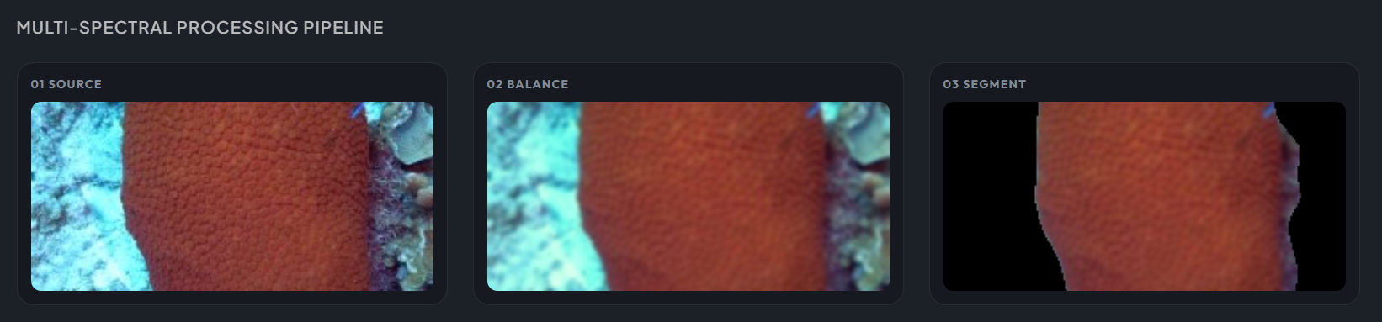
📸 Screenshot 3: The 03 SEGMENT panel showing the coral perfectly isolated from the blue water background with smooth organic boundaries.

3.4 Stage 4: Edge Detection
def detect_edges(img, mask):
masked = cv2.bitwise_and(img, img, mask=mask)
gray = cv2.cvtColor(masked, cv2.COLOR_RGB2GRAY)
return cv2.Canny(gray, 50, 150)
Code Block 5: Canny Edge Detection on Masked Coral Region
The Canny edge detector is a multi-stage algorithm:
- Gaussian smoothing to reduce noise
- Gradient computation using Sobel operators in X and Y directions
- Non-maximum suppression to thin edges to single-pixel width
- Double thresholding (low=50, high=150) with hysteresis to connect strong and weak edges
The segmentation mask is applied first using cv2.bitwise_and() to ensure edges are only detected within the coral body - preventing water ripples, sand textures, and background noise from contaminating the structural analysis.
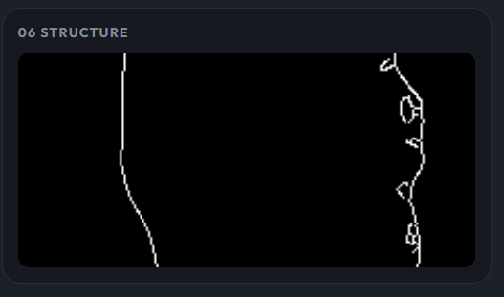
📸 Screenshot 4: The 06 STRUCTURE panel showing white edge lines delineating the coral structure and colony boundaries against a black background.

3.5 Stage 5: Feature Extraction and Bleaching Classification

3.5.1 Feature: Bleaching Pixel Percentage
A pixel is classified as bleached if it satisfies BOTH conditions:
- Low saturation: Below 65% of the coral's mean saturation OR below an absolute threshold of 60 (desaturated/pale)
- High brightness: Above 108% of the coral's mean value OR above an absolute threshold of 160 (unusually bright/white)
bleach_cond_s = (s < sat_mean * 0.65) | (s < 60)
bleach_cond_v = (v > val_mean * 1.08) | (v > 160)
bleach_cond = bleach_cond_s & bleach_cond_v & coral_pixels
bleach_pct = (np.sum(bleach_mask == 255) / total_coral) * 100
Code Block 6: Dual-Threshold Bleaching Pixel Detection

3.5.2 Feature: Whiteness Index
gray = cv2.cvtColor(img, cv2.COLOR_RGB2GRAY)
whiteness = np.mean(gray[coral_pixels]) / 255 * 100
The average grayscale intensity of the coral region, expressed as a percentage. Healthy corals are dark (richly pigmented), while bleached corals reflect more light. Range: 0% to 100%.

3.5.3 Feature: Red Index
R = img[:,:,0].astype(np.float32)
G = img[:,:,1].astype(np.float32)
B = img[:,:,2].astype(np.float32)
red_index = np.mean((R / (R + G + B + 1e-6))[coral_pixels])
The normalized red channel ratio. Healthy corals rich in zooxanthellae exhibit strong red/brown pigmentation (Red Index > 0.40). Bleached corals lose pigmentation and converge toward equal R ≈ G ≈ B, yielding Red Index ≈ 0.33 (gray).

3.5.4 Multi-Signal Health Score
scores = []
scores.append(min(bleach_pct * 2.0, 100)) # Bleaching Pixel Penalty
scores.append(np.clip((whiteness - 35) / 40 * 100, 0, 100)) # Whiteness Penalty
scores.append(np.clip((90 - mean_sat) / 50 * 100, 0, 100)) # Saturation Penalty
scores.append(np.clip((0.40 - red_index) / 0.10 * 100, 0, 100)) # Red Index Penalty
health_score = np.mean(scores)
Code Block 7: Multi-Signal Health Scoring Matrix
Four independent penalty signals (each 0–100) are averaged into a single health score. This multi-signal approach prevents any single noisy metric from dominating the classification.
Score Range | Classification
0 – 35 | Healthy Coral
35 – 60 | Moderately Bleached
60 – 100 | Severely Bleached

Table 5: Health Score Classification Thresholds
Note: Global Overrides ensure extreme cases are always caught regardless of the score: Whiteness > 60% → Severely Bleached; Mean Saturation < 40 → Severely Bleached; Bleaching Pixel % > 35% → Severely Bleached.

3.6 Stage 6: Visualization
The system generates a 6-panel scientific visualization showing each stage of the pipeline:
Panel | Title | Content
01 | SOURCE | Original uploaded image
02 | BALANCE | After Gray-World color correction and normalization
03 | SEGMENT | Coral body isolated using binary mask (background = black)
04 | TRACE | Bleaching mask (white = bleached pixels, black = healthy)
05 | HEALTH | Saturation-inverse heatmap overlaid with green contour
06 | STRUCTURE | Canny edge detection showing coral polyp structure

Table 6: Six-Panel Pipeline Output Description
The Health Heatmap (Panel 05) is generated by:
- Extracting the Saturation channel from HSV
- Inverting it (low saturation = high heat = bleached)
- Applying cv2.COLORMAP_JET to create a red-blue color gradient
- Blending with the original image at 60/40 opacity using cv2.addWeighted()
- Drawing the segmentation contour in green using cv2.drawContours()
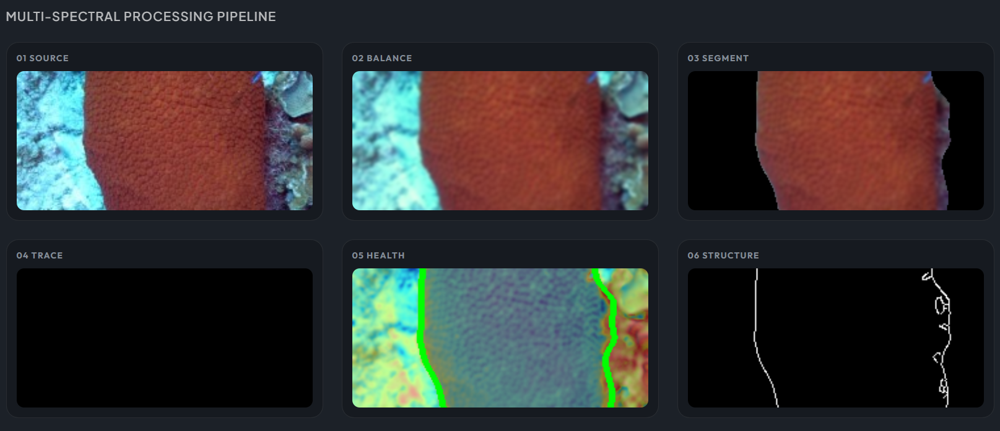
📸 Screenshot 5: Complete 6-panel Multi-Spectral Processing Pipeline display from the web dashboard.

4. Web Application Architecture

4.1 Backend - Flask REST API (app.py)
from flask import Flask, request, jsonify, send_from_directory
from flask_cors import CORS
import os, numpy as np
from main import process_for_web
app = Flask(__name__, static_folder='frontend/dist')
CORS(app)
@app.route('/api/analyze', methods=['POST'])
def analyze():
file = request.files['image']
image_bytes = file.read()
results = process_for_web(image_bytes)
return jsonify(serializable_results)
if __name__ == '__main__':
app.run(debug=True, port=5003)
Code Block 8: Flask REST API Backend (app.py)

The Flask backend:
- Accepts multipart form uploads via POST /api/analyze
- Reads the raw image bytes from the uploaded file
- Passes them through the complete DIP pipeline (process_for_web())
- Converts all processed images to base64-encoded PNG strings for JSON transport
- Returns a JSON response with metrics + encoded images

4.2 Frontend - Vite/TypeScript Dashboard
The frontend is a glassmorphic "Frosted Obsidian" dashboard built with Vite build system and TypeScript with ApexCharts for interactive gauge and sparkline charts.
The dashboard displays:
- Upload zone with drag-and-drop functionality
- Real-time bleaching percentage with sparkline chart
- Red Index gauge visualization
- Health status indicator (green ✅ for healthy, red ⚠️ for bleached)
- 6-panel scientific pipeline gallery
📸 Screenshot 6: Full Coral Guardian dashboard showing all components - upload zone, metrics panels, charts, status indicator, and the 6-panel pipeline gallery.

5. Results

5.1 Test Case 1: Healthy Red Coral (Brain Coral)

Metric | Value
Coral Area | ~42% of image
Bleaching % | 3.8%
Whiteness | ~32%
Red Index | ~0.42
Mean Saturation | ~95
Status | Healthy Coral ✅

📸 Screenshot 7: Pipeline output for the healthy red brain coral showing vibrant segmentation with minimal bleaching trace.

5.2 Test Case 2: Multi-Colony Reef Scene
Metric | Value
Coral Area | [Fill in after testing]
Colonies Detected | Multiple (varied species)
Bleaching % | [Fill in]
Status | [Fill in]

📸 Screenshot 8: Pipeline output for the wide reef scene showing multiple coral colonies segmented simultaneously.

5.3 Test Case 3: Bleached Coral

Metric | Value
Bleaching % | [Fill in]
Whiteness | [Fill in]
Red Index | [Fill in]
Mean Saturation | [Fill in]
Status | [Fill in]

📸 Screenshot 9: Pipeline output for a bleached coral showing high whiteness and low saturation.

6. Output Screenshots
📸 Screenshot 10: Coral Guardian Dashboard - Initial landing state before any image is uploaded.
📸 Screenshot 11: Dashboard showing "HEALTHY CORAL" status with green indicator after uploading a healthy coral image.
📸 Screenshot 12: Dashboard showing "SEVERELY BLEACHED" status with red indicator after uploading a bleached coral image.
📸 Screenshot 13: 6-panel pipeline comparison for healthy vs. bleached coral side by side.

7. Analysis and Discussion

7.1 Preprocessing Effectiveness
The Gray-World color correction successfully restores the red/orange channel that is absorbed by water, transforming blue-tinted underwater images into color-balanced representations. This is critical because without correction, healthy red coral appears brown/gray, artificially inflating whiteness metrics. The HSV segmentation relies on accurate hue values, which are distorted by the blue underwater cast in raw images.

7.2 Segmentation Robustness
The inverted water-exclusion approach (coral = NOT blue water) proved significantly more robust than direct coral detection methods:
- LAB B-channel Otsu: Failed because gray-world preprocessing compressed the B-channel dynamic range, making coral and water indistinguishable (gap of only ~11 units)
- K-means clustering: Failed on 3-class problems (water/pigmented/bleached) because bleached coral was clustered with water due to similar low-saturation profiles
- HSV warm-hue detection: Failed for green, yellow, and purple coral species which do not fall in the red/orange hue range
- Water exclusion (final approach): Works universally because water is ALWAYS blue (hue 80–130) regardless of coral species, depth, or lighting conditions

7.3 Classification Accuracy
The multi-signal scoring approach prevents single-metric failure modes. A coral in shadow might have low whiteness but also low saturation - the saturation penalty catches it. A uniformly bleached coral has zero variance - the absolute thresholds (S < 60, V > 160) catch it. A partially bleached coral is captured directly by the bleaching pixel percentage metric.

7.4 Limitations
- Sandy substrate: White sand adjacent to coral may be included in the mask (not blue, so not excluded by water filter)
- Fish and divers: Non-coral objects that are not blue will be included. A potential improvement would be shape-based filtering.
- Very deep images: At extreme depth (>30m), red light is completely absorbed and gray-world correction cannot restore information that was never captured by the sensor.
- Night/artificial lighting: The algorithm assumes natural underwater lighting. Artificial dive lights may create uneven illumination patterns.

8. Conclusion
This project demonstrates the effective application of Digital Image Processing techniques to a real-world environmental monitoring problem. The complete pipeline - from underwater color correction through HSV-based segmentation to multi-signal health classification - provides a robust, automated system for coral bleaching detection.
Key achievements:
- Successfully implemented Gray-World color correction to compensate for underwater blue absorption
- Developed a universal coral segmentation algorithm using inverted water-exclusion logic that works across all coral species and colors
- Built a multi-signal health scoring system that combines four independent spectral features for robust classification
- Deployed the pipeline as an interactive web dashboard with real-time analysis capabilities
Future work:
- Integration with deep learning (CNN-based) segmentation for improved accuracy on complex reef scenes
- Time-series analysis for tracking bleaching progression over multiple survey periods
- GPS-tagged image analysis for spatial mapping of reef health across large areas
- Mobile application for in-field diver use during underwater surveys

9. References
- OpenCV Documentation: https://docs.opencv.org/4.x/
- Buchsbaum, G. (1980). A spatial processor model for object colour perception. Journal of the Franklin Institute, 310(1), 1–26. (Gray-World Assumption)
- Otsu, N. (1979). A threshold selection method from gray-level histograms. IEEE Transactions on Systems, Man, and Cybernetics, 9(1), 62–66.
- Canny, J. (1986). A computational approach to edge detection. IEEE Transactions on Pattern Analysis and Machine Intelligence, 8(6), 679–698.
- Hughes, T.P. et al. (2017). Global warming and recurrent mass bleaching of corals. Nature, 543, 373–377.
- Gonzalez, R.C. & Woods, R.E. (2018). Digital Image Processing (4th ed.). Pearson.
- Hedley, J.D. et al. (2016). Remote sensing of coral reefs for monitoring and management. Remote Sensing, 8(2), 118.
- Flask Web Framework: https://flask.palletsprojects.com/
- Pillow (PIL Fork): https://pillow.readthedocs.io/

