Group number : 3

Assignment 1

Prof – prem Parashar

Group members –
Jash patel
Jashkumar patel
Navjot kaur
Caleb Harrison

Introduction to Mobile Applications -
A mobile application, commonly known as an app, is a specific type of software designed to run on handheld wireless devices such as smartphones and tablets. Unlike traditional desktop software that runs on powerful computers with large monitors, mobile apps must be built to handle the unique constraints of mobile hardware.

- Types of Mobile Applications –
- Native Applications –
Native apps are built specifically for one single operating system using that platform’s official language. For Apple iOS, developers use Swift or Objective-C inside Xcode. For Google Android, developers use Kotlin or Java inside Android Studio.

Usability –
- Use when building high-end graphics software like 3D mobile games.
- Use when your app depends heavily on continuous background data, like a fitness app tracking real-time GPS step metrics or a secure banking application using biometric fingerprint scanners.

Avoid when: Your project has a tight deadline, a low budget, or you need to launch on both iOS and Android quickly.

- Mobile Web Applications-
Mobile web apps are not actually installed on the phone from an app store. Instead, they are highly responsive websites designed to look and feel exactly like an app when opened inside a mobile browser like Safari or Chrome. They are built using basic web languages: HTML, CSS, and JavaScript.

Usability –
Use for content-delivery platforms, such as news websites, blogs, or simple informational catalogs where users just need to read text.
Avoid when: The application needs to work completely offline or requires the use of the phone’s built-in hardware like the camera.

- Hybrid Applications –
Hybrid apps combine elements of both Native and Web apps. They are written using a single codebase (typically using web technologies or frameworks like React Native) but are packaged inside a native container. This allows them to be downloaded directly from the Apple App Store or Google Play Store just like a native app

Usability –
1.Use when you are building standard data-driven applications like social media networks, e-commerce stores, or productivity dashboards.

2.Use when you want to launch on both iOS and Android simultaneously using a single codebase to save time and money.

Avoid when: The app requires heavy, pixel-perfect layout animations or massive multi-threaded processing power.

- Core Concept – React Native Props –

1. Introduction to Props
In hybrid mobile development using React Native, Props are the standard mechanism used to pass data from a parent component down to a child component. Think of props exactly like arguments passed into a regular JavaScript function, or attributes assigned to an HTML tag. They tell a component what it should display or how it should behave.

- Advantages of Using Props –

1. Reusable Components -
Props help us reuse the same component with different data.
Example: A StudentCard component can display different student names using props.

2. Easy Data Passing
Props allow data to move from a parent component to a child component easily.

3. Makes Code Organized
Using props keeps code cleaner and separates different parts of the application.

4. Dynamic User Interface
Props help create dynamic webpages where content changes based on the values passed.

5. Saves Development Time
Instead of creating many similar components, developers can use one component with different props.

- Disadvantages of Props in React –

- Props Are Read-Only –

Props cannot be changed inside the component.
A component can only use the data it receives.

- Too Many Props Can Be Confusing –
When many props are passed, the code becomes harder to read and manage.

- Limited for Large Applications-
In big projects, managing props across many components can become difficult.

- Components Depend on Parent Data –
A child component relies on the parent component to send correct props.

• Program example
App.tsx

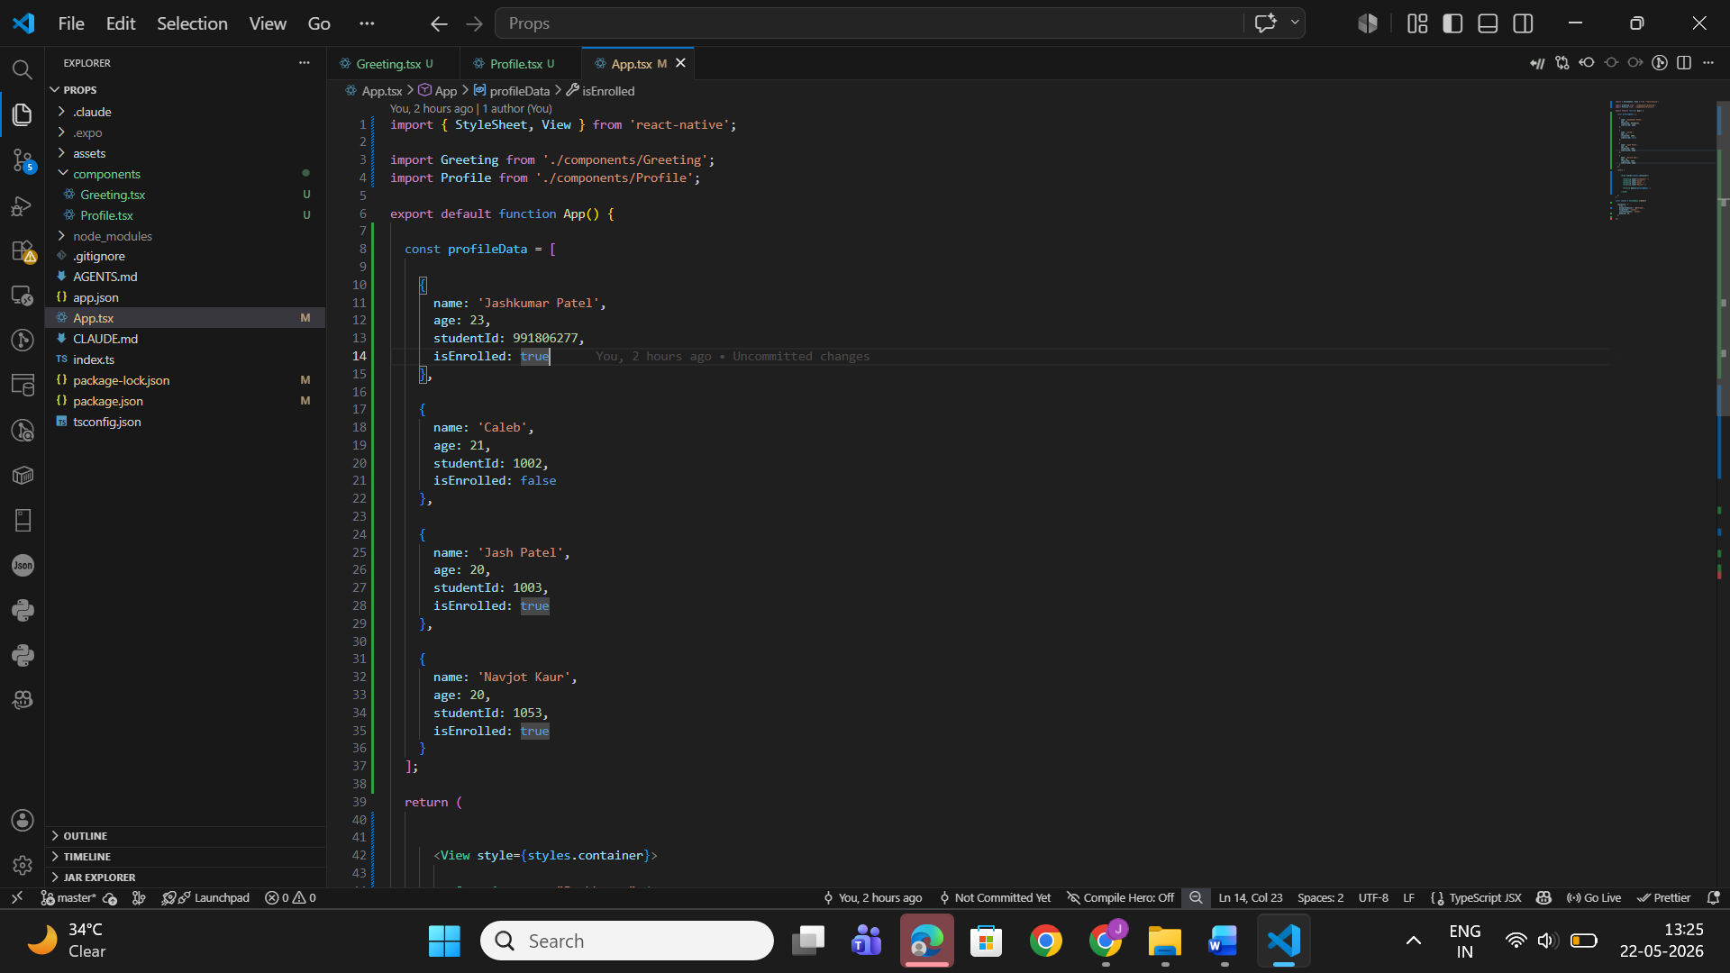

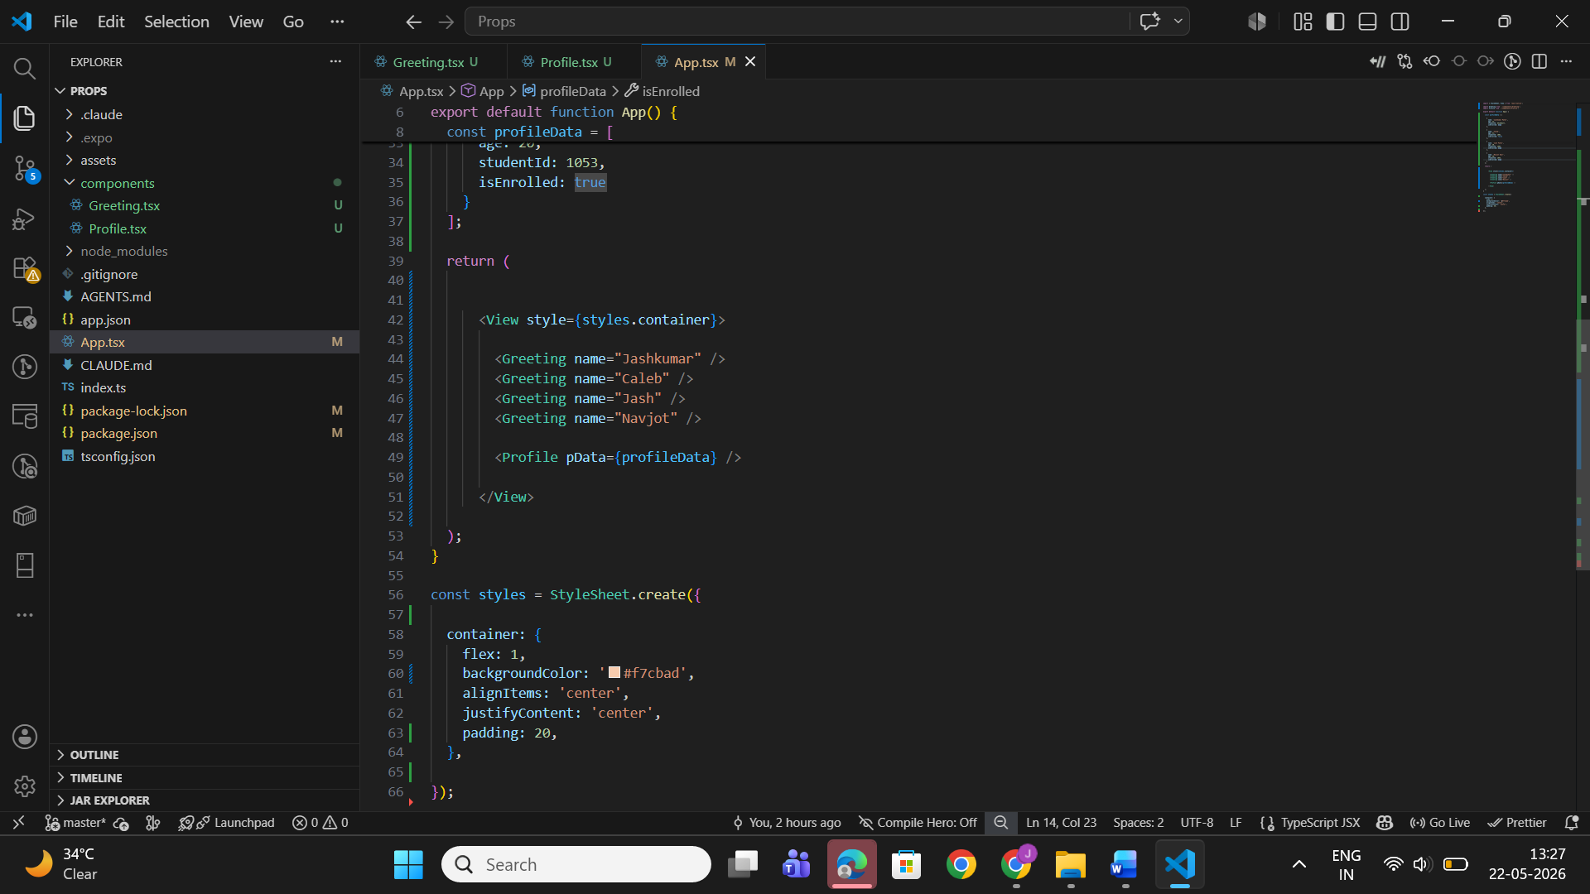
Greeting.tsx
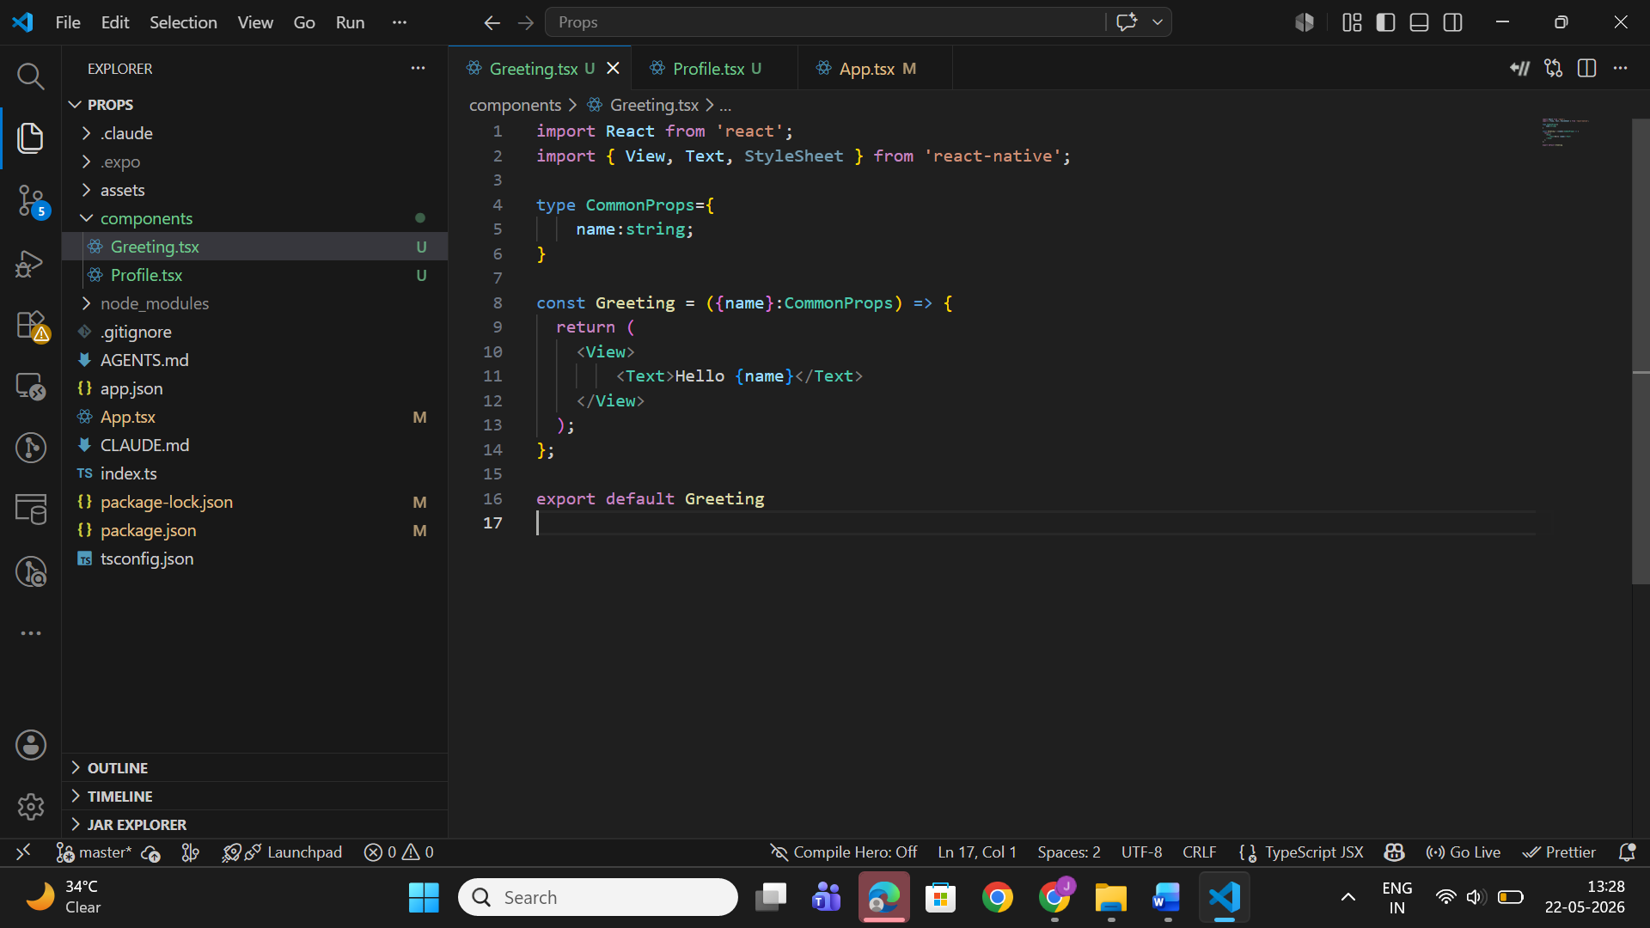

Profile.tsx
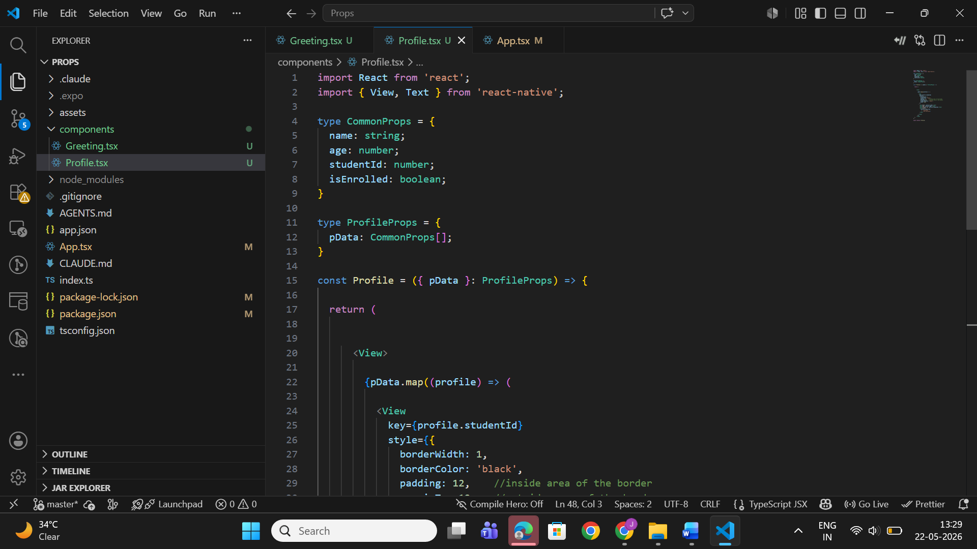

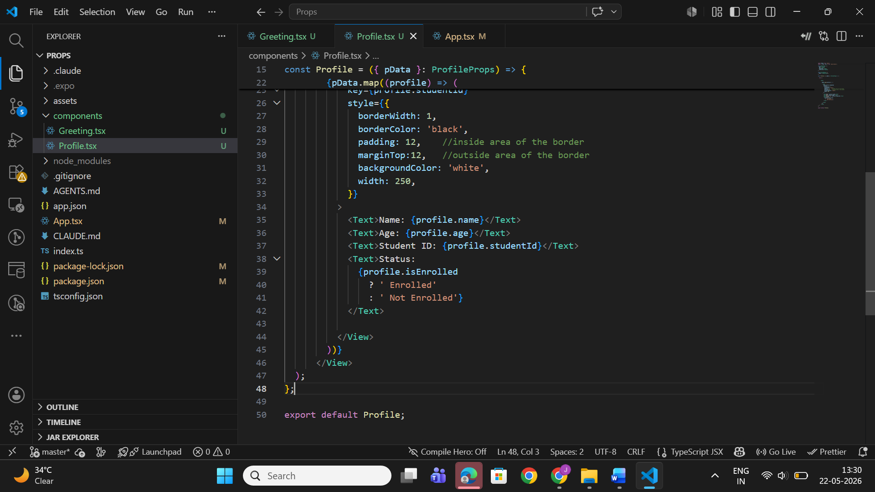

• Explanation of the code
- App.tsx
Import statements:
import { StyleSheet, View } from 'react-native';
StyleSheet is used to create styles.
View is a container component used to organize layout elements.
Impact if this statement fails
- The application layout will break.
- Styles cannot be applied to the interface.

import Greeting from './components/Greeting';
import Profile from './components/Profile';
These statements import custom child components.
- Greeting displays greeting messages.
- Profile displays student profile cards.
Impact if this statement fails
- React Native cannot find the components.
- The application will show module import errors.

Profile Data Array:
const profileData = [
This creates an array containing multiple student profile objects.
Each object contains:
- name
- age
- studentId
- isEnrolled
For example:
{
name: 'Jashkumar Patel',
age: 23,
studentId: 991806277,
isEnrolled: true
}
Purpose
This data is passed to the Profile component using props.
Impact if this statement fails
- No student information will be available.
- The Profile component cannot display any records.

Passing Props to Greeting Component
<Greeting name="Jashkumar" />
This passing a prop named name to the Greeting component.
How Props Work Here
- name is the prop name.
- "Jashkumar" is the value passed.
The same component is reused multiple times with different values like:
<Greeting name="Caleb" />
<Greeting name="Jash" />
<Greeting name="Navjot" />
Impact if this statement fails
- Greeting messages will not display.
- Dynamic rendering will stop working.
Passing Array Props
<Profile pData={profileData} />
This passes the entire profileData array to the Profile component.
Purpose
Allows the child component to access all student records.
Impact if this statement fails
- No profile cards will appear.
- The .map() function inside Profile component may generate errors because data is undefined.

- Greeting.tsx
Import Statements
import React from 'react';
import { View, Text, StyleSheet } from 'react-native';
Imports required React Native components.
Impact if removed
- The component cannot render text or layout.

Type Definition:
type CommonProps={
name:string;
}
Defines the expected type of props.
Purpose
We need to make sure that:
- name must be a string.
- If it’s number so it will saw Typescript error

Receiving Props:
const Greeting = ({name}:CommonProps)
Receives and destructures props.
Purpose
Allows direct access to the name value.

Rendering Output
<Text>Hello {name}</Text>
It displays dynamic text.
For example:
<Greeting name="Jash" />
Output:
Hello Jash
Impact if {name} is removed
- Only “Hello” appears.
- Dynamic behavior is lost.

- Profile.tsx
Type Definitions:
type CommonProps = {
name: string;
age: number;
studentId: number;
isEnrolled: boolean;
}
Defines the structure of each student object.
Purpose
Ensures data consistency.
type ProfileProps = {
pData: CommonProps[];
}
Defines that pData must be an array of objects.
Impact if invalid data is passed
- TypeScript generates errors.
- Data rendering may fail.

Receiving Array Props
const Profile = ({ pData }: ProfileProps)
Receives student profile data from App.tsx.

Displaying Student Information
<Text>Name: {profile.name}</Text>
Displays dynamic student names.
Similar statements display:
- Age
- Student ID
- Enrollment status

Conditional Rendering
{profile.isEnrolled
? ' Enrolled'
: ' Not Enrolled'}
Uses a ternary operator to check enrollment status.

• Explanation of the outcome
Program Output
When the application runs, the following greeting messages appear:
Hello Jashkumar
Hello Caleb
Hello Jash
Hello Navjot
Below the greetings, multiple profile cards are displayed.
Each card contains:
- Student Name
- Age
- Student ID
- Enrollment Status
Example output:



Why This Output Appears
Greeting Component
The Greeting component receives different name props from App.tsx.
React dynamically replaces:
{name}
with the passed value.
Example:
<Greeting name="Caleb" />
becomes:
Hello Caleb
Profile Component
The Profile component receives the entire array through the pData prop.
The .map() function loops through every student object and creates a profile card for each record.

Conditional Rendering
This statement:
profile.isEnrolled
? ' Enrolled'
: ' Not Enrolled'
checks the boolean value.
- true → Enrolled
- false → Not Enrolled
This creates dynamic output based on the data.

- Usability

When Props Should Be Used
Parent-to-Child Communication
- Props should be used when a parent component needs to send data to child components.

Reusable Components
- The same Greeting component displays different names using different props.
- Benefits: Reduces code duplication and Improves maintainability

Dynamic Applications
- Student management systems
- Shopping applications
- Dashboard applications
- Social media applications

Organized code structure
- Props separate Data logic and UI rendering
- Benefits: Easier debugging, Better readability and Cleaner project structure

When Props Should Be Avoided
Deeply Nested Components
- This becomes difficult to manage.
Frequently Changing Data
- Props are not ideal for data that changes inside the same component.
- Example: Counter values and Form input changes
Large Scale Application
- In large projects, managing many props becomes complex.

