CLIMATE-BASED FLOOD RISK ANALYSIS AND PREDICTION
IBM SKILLSBUILD ACADEMIC INTERNSHIP – DATA ANALYTICS WITH AI
Author: JASHASWI SAHA

Executive Summary
This IBM SkillsBuild Academic Internship – Data Analytics with AI project analyzes the supplied India_Flood_Inventory_v3.csv event inventory. The file contains 6,876 records and 23 source columns spanning 1967-07-02 to 2023-09-12. The analysis inspects data types, missingness, duplicates, mixed numeric fields, dates, geography fields, outliers, temporal patterns, regional mentions, and recorded impacts.
Scope boundary
The file is an event inventory, not a sensor time series. Rainfall, temperature, humidity, river/water level, latitude, longitude, severity, and area-affected measurements are not available in the provided dataset. The report therefore does not fabricate climate KPIs or physical flood-causation results.

A binary impact_event target was derived from positive parsed values in the recorded human fatality, human injured, human displaced, or animal fatality fields. This target is an indicator of recorded impact, not a complete measure of real-world harm. Recorded impact is present in 62.3% of rows. July is the most common event-start month, with 1,709 records (24.9% of valid dated events).
Four classification models were compared using a stratified 80/20 split and five-fold ROC-AUC cross-validation. Gradient Boosting achieved the highest holdout ROC-AUC in the saved evaluation, 0.810, with recall 0.917, F1-score 0.825, and false-negative rate 8.3%. These results are model-based estimates for this dataset and split, not guaranteed warnings.
Table 1. Project KPI summary
Project KPI | Actual result
Records | 6,876
Source columns | 23
Exact duplicate rows | 0
Recorded-impact rate | 62.3%
Date coverage | 1967-07-02 to 2023-09-12
Best model | Gradient Boosting
Best holdout ROC-AUC | 0.810
Best false-negative rate | 8.3%

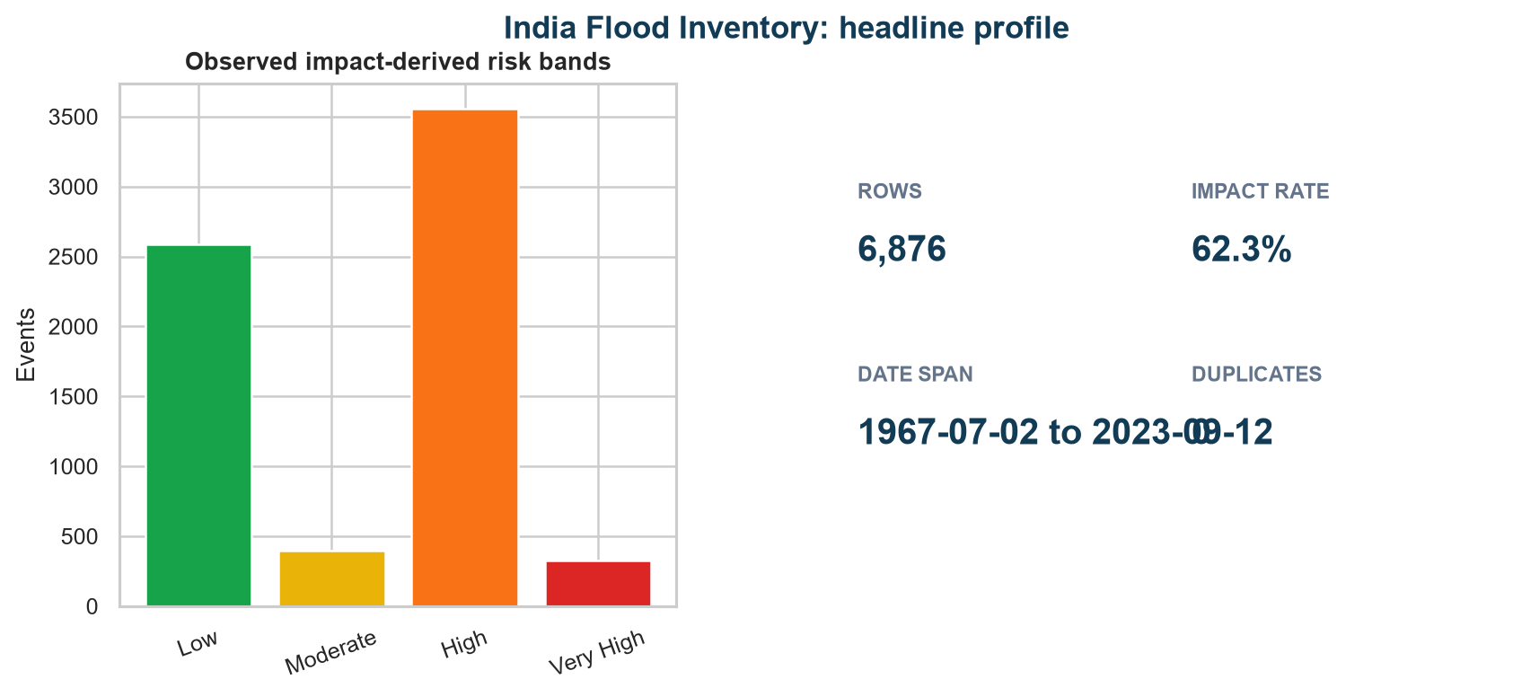
Figure 1. Dataset profile and headline KPIs derived from the provided inventory.

Contents and Visual Index
The report is organized as a research-oriented internship deliverable. The principal figures and tables are embedded in the relevant sections; page numbers can be refreshed in Microsoft Word if a dynamic table of contents is required.
- 1. Introduction and Background
- 2. Problem Statement
- 3. Project Aim and Objectives
- 4. Research Questions
- 5. Research Hypotheses
- 6. Dataset Description and Variables
- 7. Data Preprocessing and Cleaning
- 8. Exploratory Data Analysis (EDA)
- 9. Statistical Analysis
- 10. Feature Engineering
- 11. Machine Learning Methodology
- 12. Model Development and Training
- 13. Model Evaluation and Comparison
- 14. Feature Importance and Model Interpretability
- 15. Flood Risk Analysis
- 16. Key Insights and Findings
- 17. SDG 13 – Climate Action Alignment
- 18. Project Contribution
- 19. Potential Impact
- 20. Data-Driven Recommendations
- 21. Limitations
- 22. Future Scope
- 23. Conclusion
- 24. References
- 25. Appendix
Figures: dataset profile; missing values; seasonal trends; correlation heatmap; diagnostic distributions; state analysis; risk composition; model comparison; confusion matrix; ROC curve; feature importance. Tables: project KPIs; missing-value profile; engineered variables; statistical tests; model results; SDG 13 contribution; appendix data dictionary.

1. Introduction and Background
Floods are high-impact hazards that can affect communities, animals, infrastructure, agriculture, and public services. Data analytics can help organize historical records, reveal when events are reported most often, identify data-quality gaps, and support repeatable screening of records likely to contain documented impacts.
This project adopts an event-inventory perspective. Each row represents a reported flood-related event rather than a continuous observation of rainfall, temperature, river discharge, or soil conditions. The analytical objective is therefore historical understanding and impact-risk screening, not real-time hydrological forecasting.

2. Problem Statement
The source combines dates, durations, free-text causes, multi-state geography, mixed numeric and text impact fields, and substantial missingness. Without preprocessing, direct analysis can confuse unknown values with zero, treat text as numeric, overstate regional differences, or leak impact outcomes into a model. The project addresses how to clean and analyze the inventory while preserving the distinction between recorded evidence and physical flood causation.
The practical problem is to estimate whether an inventory-style event contains a positive recorded human or animal impact using attributes that are not themselves the impact outcomes, while communicating uncertainty and unsupported variables clearly.

3. Project Aim and Objectives
Aim: to develop a reproducible data analytics and AI workflow for historical flood-impact analysis using the supplied Indian flood event inventory.
- Inspect the actual file structure, row count, columns, types, dates, categories, geography fields, missing values, duplicates, and outlier-prone variables.
- Correct data types, parse mixed numeric fields, clean categorical text, document missing-value decisions, and preserve the source evidence.
- Perform descriptive, temporal, regional, casualty, outlier, correlation, and statistical analysis supported by the available fields.
- Engineer a transparent impact-event target and non-leaky event-level predictors.
- Compare classification models with cross-validation and false-negative-rate emphasis.
- Translate results into explainable flood-risk awareness, SDG 13 alignment, and responsible recommendations.

4. Research Questions
Table 2. Research questions and operational analyses
Question | Operational analysis
RQ1. What is the structure and quality of the inventory? | Profile rows, columns, types, missingness, duplicates, dates, and fully missing fields.
RQ2. When and where are events represented most often? | Analyze year, month, season, state mentions, and multi-state records.
RQ3. Which available attributes are associated with recorded impact? | Use descriptive statistics, Pearson/Spearman association, and categorical cross-tabulation.
RQ4. Which classification approach is most useful for impact screening? | Compare four models using holdout and cross-validated metrics.
RQ5. How can the output support climate resilience? | Separate demonstrated inventory results from possible future SDG 13 applications.

5. Research Hypotheses
The hypotheses below are testable statements about this inventory and its constructed target; they are not claims about physical flood causation.
Table 3. Research hypotheses and evidence
ID | Hypothesis | Evidence used
H1 | Event-start records are not uniformly distributed across calendar months. | Monthly event counts and seasonal chart.
H2 | At least one engineered numeric or categorical feature is associated with impact_event. | Correlations, rank tests, and cross-tabulation.
H3 | A nonlinear ensemble can outperform a linear baseline on holdout ROC-AUC. | Model comparison table.
H4 | The selected model can identify a substantial share of recorded-impact cases. | Recall and false-negative rate.

6. Dataset Description and Variables
The actual file contains 6,876 rows and 23 source columns. It has 0 exact duplicate rows. Start Date ranges from 1967-07-02 to 2023-09-12 after day-first parsing, with 20 invalid or missing start dates and 20 invalid or missing end dates. Event Source is populated as IMD in the supplied file.
Table 4. Dataset variable classes and treatment
Variable class | Actual fields / examples | Treatment or availability
Identifiers | Unnamed: 0, UEI | Identity fields; not used as predictors.
Dates and duration | Start Date, End Date, Duration(Days) | Dates parsed; year, month, season and numeric duration derived.
Categorical/text | Main Cause, Districts, State, Event Source, descriptions | Whitespace/case normalized where used; one-hot encoding for model categories.
Geographical | Location, Districts, State, Latitude, Longitude, codes | State and district text available; Location, Latitude, Longitude are fully missing; codes are incomplete.
Impact/damage | Human fatality, Human injured, Human Displaced, Animal Fatality, Area Affected, damage text | Mixed impact fields parsed for target; impact outcomes excluded from predictors; Area Affected fully missing.
Climate measurements | Rainfall, temperature, humidity, water/river level | Not available in the provided dataset.

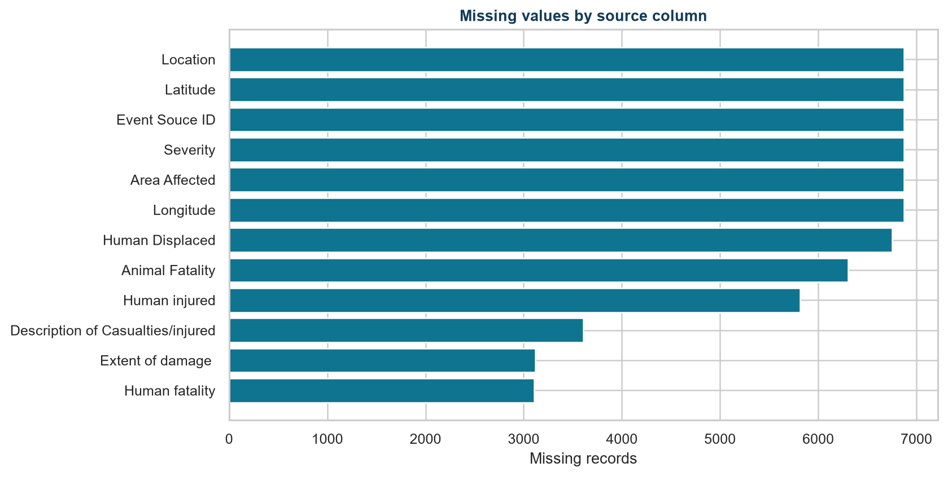
Figure 2. Missing values by source column. Fully missing fields are reported rather than imputed as measurements.

7. Data Preprocessing and Cleaning
Column-name whitespace was stripped and dates were parsed with day-first handling. Mixed fields were converted into numeric helper columns by extracting numeric values from strings after removing comma separators. Original values were retained for traceability. Main Cause and state text were normalized for modeling, while unknown categories were retained as explicit categories where needed.
No exact duplicate rows were found, so duplicate removal changed the row count by zero. Missing numeric predictors are handled within the model preprocessing pipeline using median imputation; categorical predictors use most-frequent imputation and one-hot encoding. Fully missing columns are excluded because imputation would fabricate information. Positive recorded impact fields define impact_event; missing impact values are not asserted to be true zero outside that operational definition.
Outliers were reviewed using distribution summaries, histograms, and boxplots. Extreme duration or casualty values were retained because they may represent genuine severe events; deleting them without source verification would risk removing the very events a flood-impact analysis should examine.
Table 5. Data-quality checks and preprocessing decisions
Quality check | Actual result / decision
Exact duplicates | 0 rows; no duplicate removal required.
Fully missing columns | Location, Latitude, Longitude, Severity, Area Affected, Event Souce ID
Invalid start/end dates | 20 / 20
Categorical cleaning | Whitespace and lower-case normalization for cause features; unknown values retained.
Outliers | Reviewed and retained; no unsupported deletion rule applied.

8. Exploratory Data Analysis (EDA)
The EDA uses Matplotlib and Seaborn charts generated from the cleaned data. The Streamlit application in app.py additionally provides Plotly versions of the interactive views. Available analyses include event volume, seasonal trends, durations, recorded casualty distributions, state mentions, observed risk bands, and engineered-feature associations.
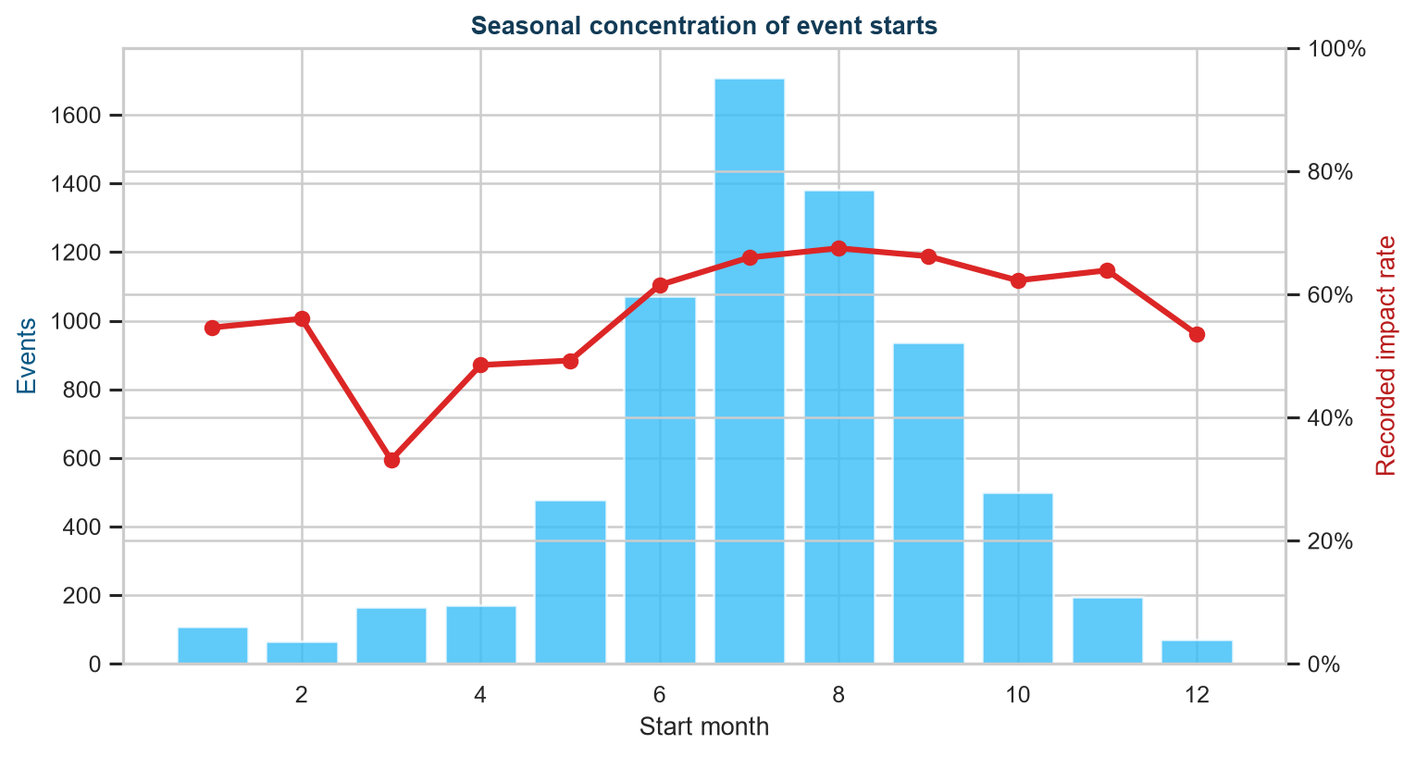
Figure 3. Monthly event-start volume and recorded-impact rate. July is the most common start month in the provided records.
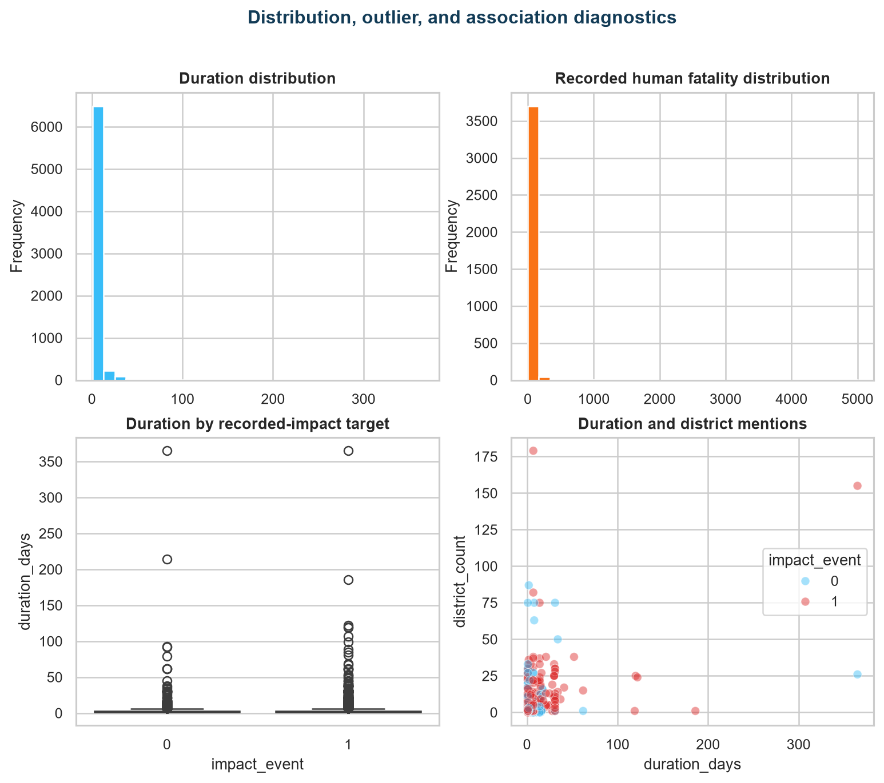
Figure 4. Histograms, boxplot, and scatter plot for available duration, recorded fatality, and geography-count fields.
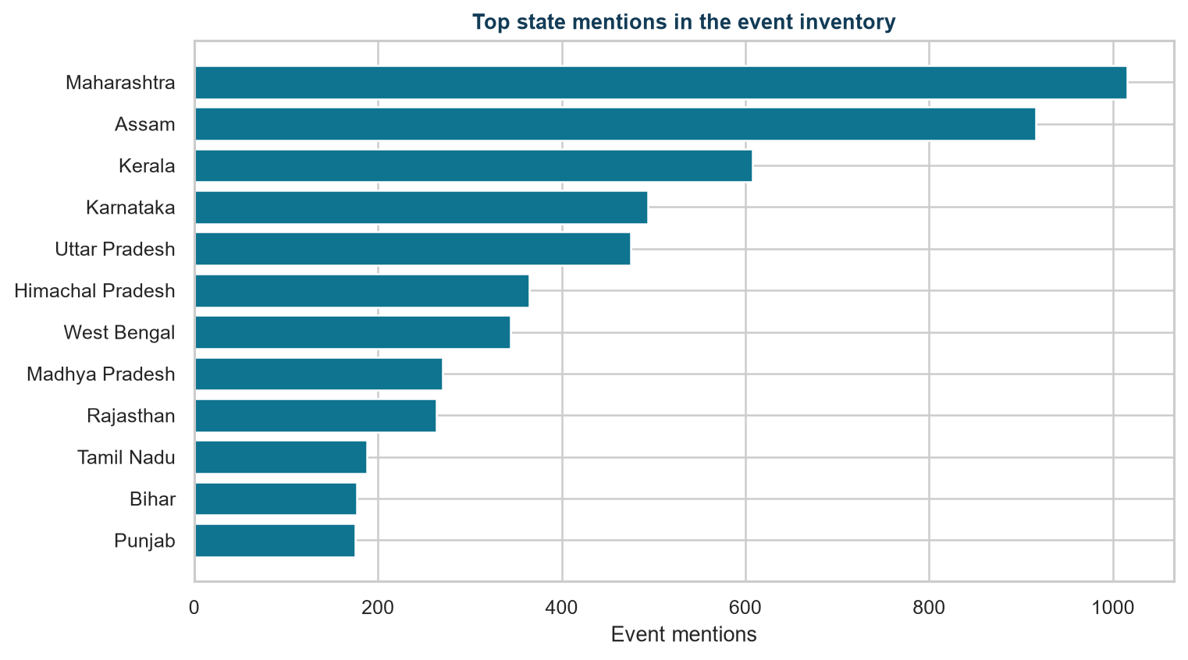
Figure 5. Top state mentions. These are inventory mentions and can include multi-state event records.
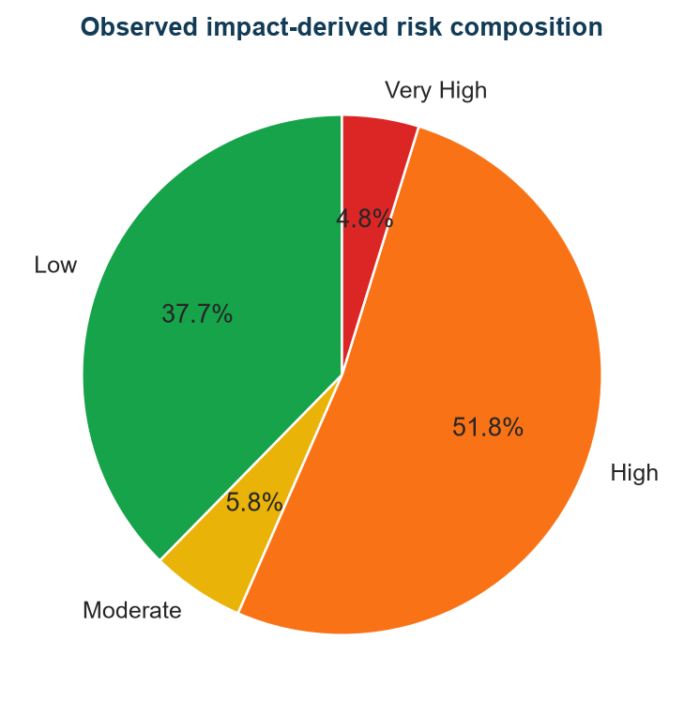
Figure 6. Observed impact-derived risk composition. These bands summarize recorded impacts and are not official hazard classes.
Measured rainfall/flood scatter plots, climate distributions, water-level analysis, coordinate maps, and physical regional hazard maps are not available in the provided dataset because the required measurements or coordinates are absent.

9. Statistical Analysis
Descriptive analysis is appropriate for this irregular event inventory. Pearson correlations quantify linear association among engineered numeric variables; Spearman rank tests check monotonic association. A chi-square test examines the association between season and impact_event. These tests describe the constructed target and do not establish causation. Tests requiring absent rainfall, temperature, humidity, water-level, damage-area, or coordinate values are not available in the provided dataset.
Table 6. Pearson correlation results
Feature | Pearson r with impact_event
month | 0.090
district_count | 0.055
rain_related_flag | -0.052
duration_days | 0.042
year | -0.032

Table 7. Spearman rank association results
Feature | Spearman rho | p-value | n
duration_days | 0.029 | 0.0159384 | 6857
district_count | 0.184 | 2.40793e-53 | 6876
state_count | -0.005 | 0.705964 | 6876
year | -0.082 | 8.60699e-12 | 6856
month | 0.087 | 7.21675e-13 | 6856

Table 7. Statistical test results
Test | Statistic | p-value | df
Season vs impact_event chi-square | 146.025 | 1.44705e-30 | 4

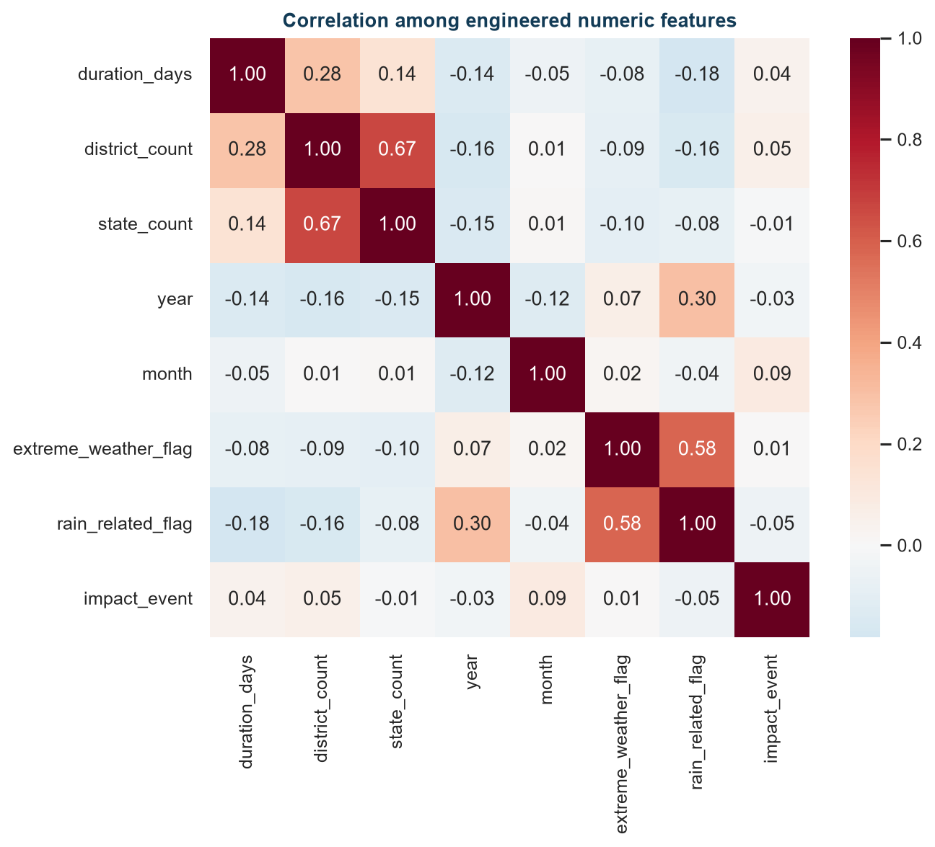
Figure 7. Correlation heatmap for engineered numeric fields. Correlation is association, not causation.
A t-test or ANOVA for climate measurements is not available in the provided dataset. The chi-square and p-values above should be interpreted cautiously because event records may be dependent, the target reflects reporting, and multiple comparisons were not the primary design objective.

10. Feature Engineering
Table 8. Engineered feature definitions
Feature | Definition and purpose
impact_event | 1 when any parsed human/animal impact field is positive; operational target.
year, month, season | Temporal features derived from Start Date.
duration_days | Numeric Duration(Days) after mixed-value parsing.
district_count / state_count | Counts of comma-separated geographic mentions.
cause_clean | Lowercase, whitespace-normalized Main Cause text.
rain_related_flag | Text mention of rain, monsoon, or precipitation; not measured rainfall.
extreme_weather_flag | Text mention of severe, flash, cloud burst, cyclone, storm, or related terms.
risk_band_observed | Descriptive band from recorded impact magnitudes; not used as an independent physical hazard label.

11. Machine Learning Methodology
Classification is the appropriate primary ML problem because the file supports a defensible binary recorded-impact target, whereas continuous damage and climate measurements are incomplete or unavailable. Regression, physical time-series forecasting, and spatial prediction are not supported by the supplied fields alone.
Predictors exclude human fatality, human injured, human displaced, animal fatality, casualty descriptions, and damage text to reduce direct target leakage. The retained predictors are duration, year, month, season, district_count, state_count, normalized Main Cause, State, and text indicators. A stratified 80/20 train-test split with random state 42 was used, together with five-fold stratified cross-validation for ROC-AUC.
The implemented comparison uses Logistic Regression, Decision Tree, Random Forest, and Gradient Boosting. Their configurations are documented in src/flood_analysis.py. The saved run uses constrained, reproducible parameters; an exhaustive grid search, XGBoost, SHAP package analysis, KNN, SVM, Naive Bayes, Extra Trees, and regression models were not required by the supported target and are not claimed as executed results.

12. Model Development and Training
Each model is wrapped in a preprocessing pipeline. Numeric predictors receive median imputation and standardization where appropriate. Categorical predictors receive most-frequent imputation and one-hot encoding with unknown-category handling. Models are fitted on the training portion and evaluated on the untouched test portion. Cross-validation is performed on the full feature matrix using stratified folds for a comparable ROC-AUC estimate.
Model selection prioritizes holdout ROC-AUC together with recall and false-negative rate because missed recorded-impact cases are important in a screening context. The final output is a probability estimate for recorded impact, not a physical probability of flooding.

13. Model Evaluation and Comparison
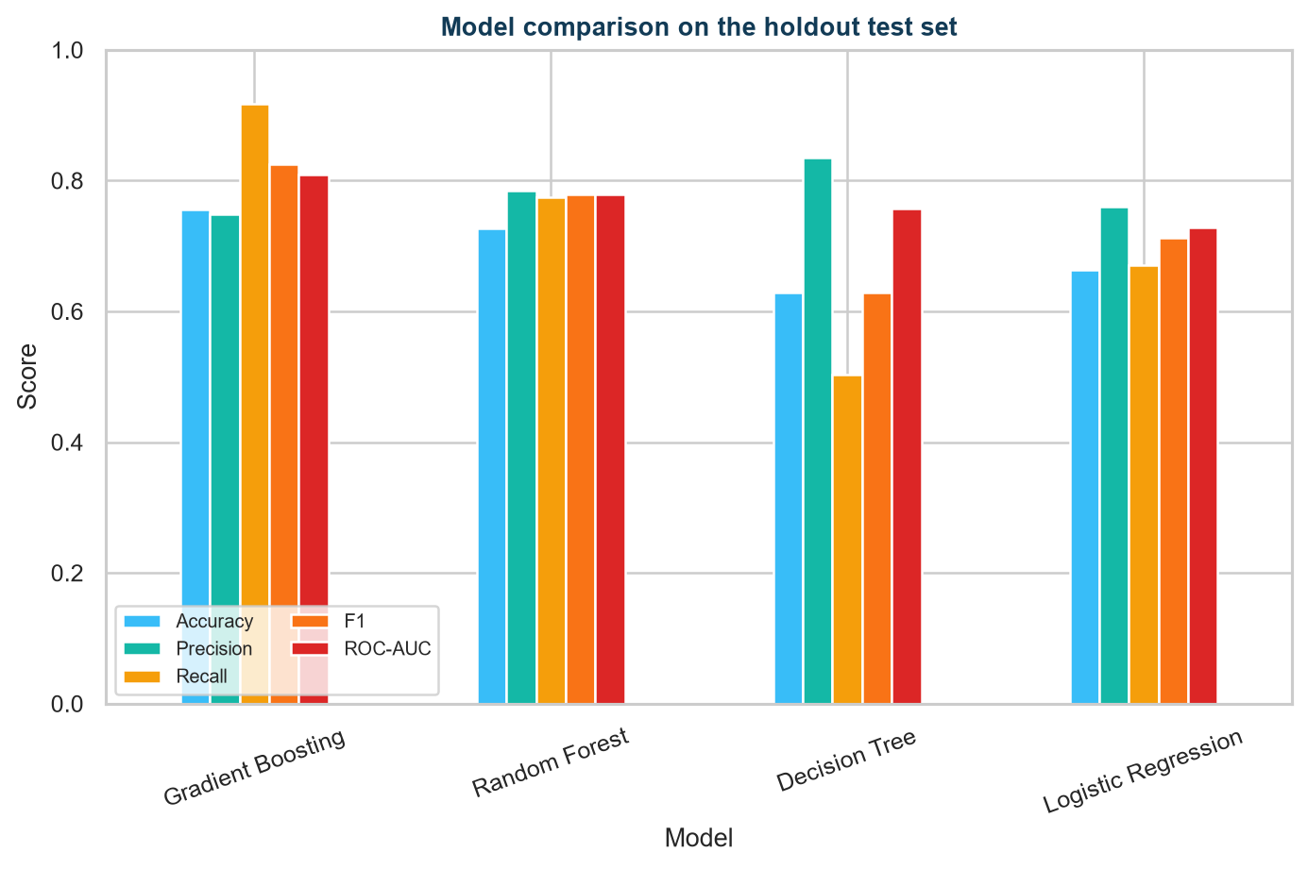
Figure 8. Accuracy, precision, recall, F1, and ROC-AUC comparison on the holdout test set.
Table 9. Model evaluation and comparison
Model | Accuracy | Precision | Recall | F1 | ROC-AUC | FNR | 5-fold CV AUC
Gradient Boosting | 0.757 | 0.749 | 0.917 | 0.825 | 0.810 | 8.3% | 0.792
Random Forest | 0.727 | 0.784 | 0.775 | 0.780 | 0.779 | 22.5% | 0.767
Decision Tree | 0.629 | 0.836 | 0.503 | 0.628 | 0.758 | 49.7% | 0.753
Logistic Regression | 0.663 | 0.761 | 0.670 | 0.713 | 0.728 | 33.0% | 0.735

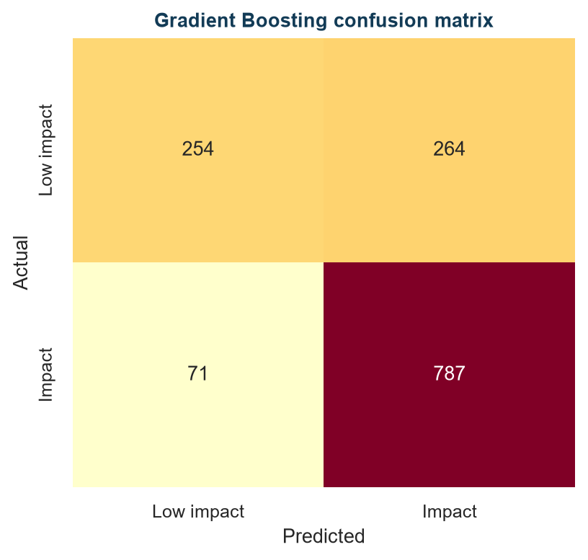
Figure 9. Confusion matrix for the selected model at the default 0.50 threshold.
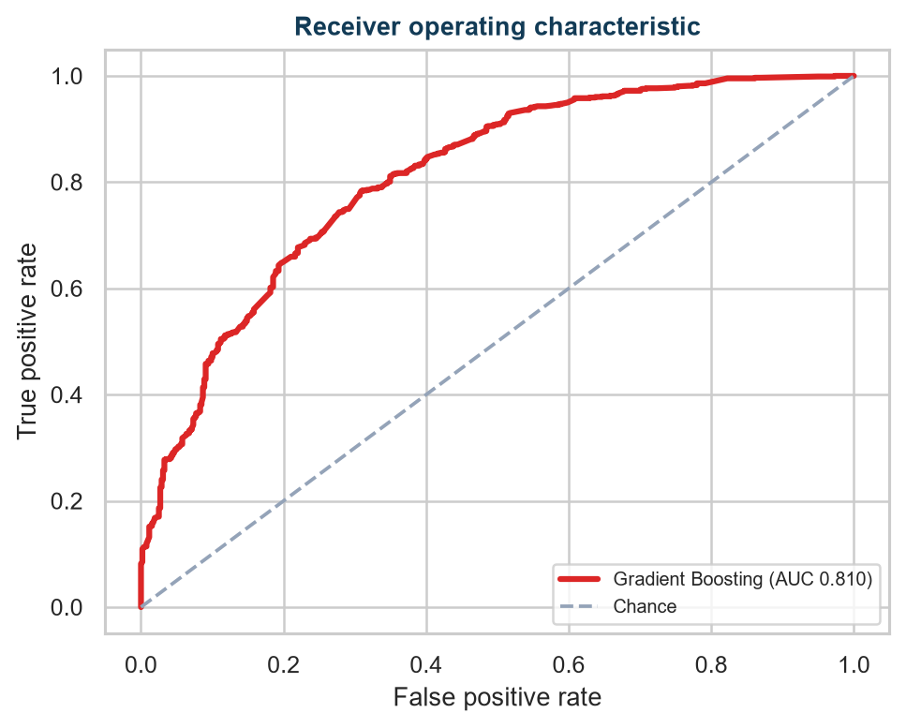
Figure 10. ROC curve for the selected model on the holdout test set.
MAE, RMSE, and R² are regression metrics and are not applicable to this binary classification target. They are therefore not reported as model scores. The most important operational metric for missed impact screening is false-negative rate, which is reported directly.

14. Feature Importance and Model Interpretability
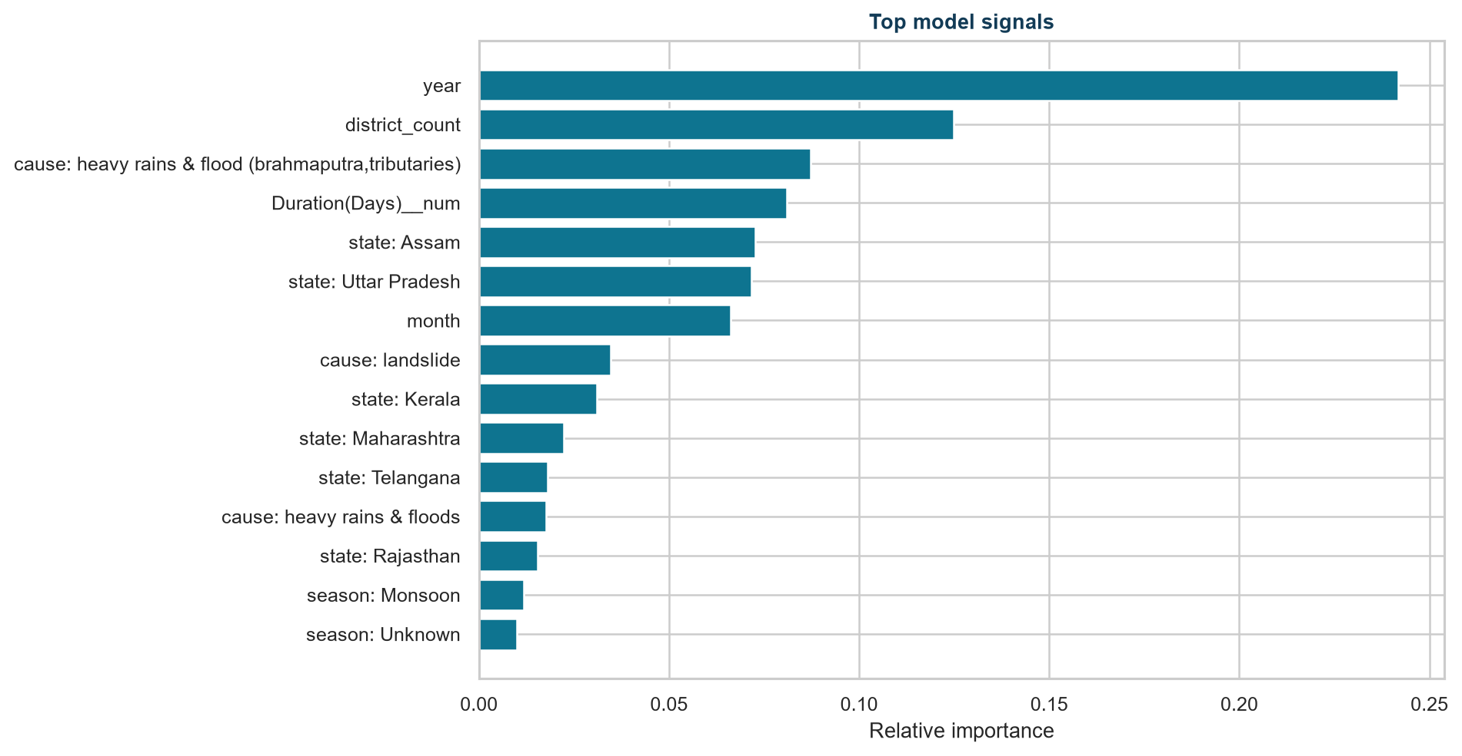
Figure 11. Relative feature importance from the selected Gradient Boosting model.
The saved model shows year, district_count, a heavy-rain/flood cause category, duration, and selected states among the strongest predictive signals. Importance indicates predictive utility within this dataset and model; it does not prove that any signal caused a flood or impact. The strong year signal may reflect changing reporting coverage or event composition.
SHAP values are not reported because a SHAP computation artifact was not generated in the supplied analysis run. Feature importance is therefore the demonstrated interpretability method. Future work can add SHAP explanations after installing and validating a compatible SHAP workflow, using the same leakage controls.

15. Flood Risk Analysis
The project uses four communication bands for predicted recorded-impact probability: Low below 0.25, Moderate from 0.25 to below 0.50, High from 0.50 to below 0.75, and Very High at or above 0.75. These are analytical labels for the dashboard and report, not official emergency categories.
- The most common event-start month is 7 with 1,709 records (24.9% of valid dated events).
- Maharashtra has the largest number of state mentions (1,016); this describes inventory representation, not causal risk.
- Rain-related wording appears in 78.1% of records; text mentions are not measured rainfall observations.
- Recorded human or animal impact is present in 62.3% of records under the project's operational target definition.
- The best holdout ROC-AUC is 0.810 from Gradient Boosting; its false-negative rate is 8.3% on the fixed test split.
- The dataset is an event inventory; it cannot establish that rainfall, temperature, humidity, or river level caused an event because those measurements are absent.
Responsible decision support
Use high predicted-impact cases to prioritize human review and data-quality checks. Combine this historical estimate with official forecasts, live gauges, vulnerability information, and local emergency procedures before acting.

16. Key Insights and Findings
- The inventory contains 6,876 rows, 23 source columns, and zero exact duplicate rows.
- Recorded human or animal impact is positive in 62.3% of rows under the operational target definition.
- July is the most common event-start month in the valid dated records.
- Rain-related wording is a text indicator only; measured rainfall is not available.
- Location, latitude, longitude, severity, area affected, and event source ID are fully missing in the supplied file.
- Gradient Boosting has the strongest holdout ROC-AUC among the executed models.
These findings describe the inventory and the analysis run. They do not establish population-wide state rankings, physical causation, climate change trends, or guaranteed future performance.

17. SDG 13 – Climate Action Alignment
SDG 13 calls for urgent action on climate change and its impacts. Flood-risk analytics can support climate-risk assessment and adaptation planning by organizing evidence about historical hazards, impacts, timing, and exposure. Climate-related changes may influence precipitation extremes, runoff, river conditions, and vulnerability, but this specific dataset does not measure those mechanisms directly.
The project aligns conceptually with SDG 13.1 on resilience and adaptive capacity, SDG 13.2 on integrating climate measures into planning, and SDG 13.3 on awareness and capacity-building. This is a potential alignment, not a claim that the project achieves any SDG target.
Table 10. SDG 13 alignment and potential application
SDG 13 area | Demonstrated result vs potential application
Climate-risk assessment | Demonstrated: historical event and recorded-impact summaries. Potential: combine with rainfall, river, exposure, and vulnerability layers.
Preparedness and resilience | Demonstrated: seasonal patterns and false-negative analysis. Potential: prioritize review and preparedness exercises.
Adaptation planning | Demonstrated: reproducible evidence layer. Potential: inform regional and infrastructure planning with stronger geospatial data.
Early-warning systems | Demonstrated: no real-time warning capability. Potential: integrate live gauges, forecasts, satellite, GIS, and calibrated thresholds.
Awareness and capacity | Demonstrated: explainable charts and limitations. Potential: support training and community risk communication.

18. Project Contribution
The demonstrated contribution is a reproducible analytics workflow: actual dataset inspection, transparent cleaning, feature engineering, supported EDA, statistical association analysis, model comparison, false-negative evaluation, and an explainable recorded-impact screening system. The project also makes unavailable variables visible instead of replacing them with assumptions.
Its potential contribution to climate resilience is as an evidence layer for researchers, planners, disaster-management authorities, and communities. It can support informed questions about historical timing, regional representation, reporting gaps, and which records merit further review. It does not directly achieve SDG 13 or replace official systems.

19. Potential Impact
Potential impact areas include disaster preparedness, flood-risk awareness, early-warning support, climate adaptation, regional planning, infrastructure planning, community protection, data-driven decision-making, and future integration with real-time weather, satellite, and GIS data.
The dataset and model do not demonstrate actual reductions in casualties, economic losses, or flood frequency. Any future benefit would depend on improved data, validated operational integration, appropriate thresholds, institutional processes, and community use. The strongest immediate impact is improved transparency about historical event evidence and its limitations.
Table 11. Potential users and decision-support applications
Potential user | Potential use
Communities | Improve awareness of historical timing and documented impact patterns alongside official guidance.
Disaster-management teams | Prioritize review of high predicted-impact records and inspect false-negative trade-offs.
Regional planners | Use historical event representation as one input to planning, subject to better exposure and geospatial data.
Infrastructure planners | Combine event history with engineering, elevation, drainage, asset, and hydrological studies.
Researchers and policymakers | Identify data gaps and design future integrated climate-risk monitoring systems.

20. Data-Driven Recommendations
- Add measured rainfall, temperature, humidity, river level, soil moisture, elevation, land use, exposure, and vulnerability variables.
- Standardize cause, state, district, spelling, codes, and multi-state event representation.
- Separate unknown, not reported, and confirmed-zero impact values.
- Use time-based and region-aware validation before operational deployment.
- Calibrate probabilities and set thresholds with disaster-management stakeholders, explicitly considering false-negative costs.
- Integrate official weather forecasts, river gauges, satellite observations, GIS layers, and local knowledge for any future early-warning use.

21. Limitations
- The event inventory has no non-flood control observations and is not a physical flood/no-flood sensor dataset.
- Rainfall, temperature, humidity, river level, coordinates, severity, and area affected are not available in the provided dataset.
- Missing impact values may represent unknown or underreported consequences rather than confirmed zero.
- Cause, state, district, and description fields contain inconsistent spelling, aggregation, and reporting detail.
- Random splitting can be optimistic where events are temporally or regionally dependent; time-based validation remains future work.
- Model probabilities and risk categories are analytical estimates, not guaranteed flood warnings.
- Correlation, p-values, feature importance, and predictive metrics do not establish causation.

22. Future Scope
Future work should join this inventory with daily or hourly meteorological data, river-gauge observations, satellite products, GIS boundaries, elevation, drainage, land use, population exposure, infrastructure, and vulnerability indicators. This would enable spatial mapping, calibrated early-warning research, time-aware validation, and possibly regression of verified damage or casualty totals.
Future modeling can add validated hyperparameter search, probability calibration, SHAP explanations, KNN/SVM/Naive Bayes/Extra Trees comparisons where justified, and time-series or geospatial methods once the data structure supports them. Any extension should preserve target-leakage controls and report unsupported values as unavailable.

23. Conclusion
Conclusion
The project provides a transparent historical flood-impact analytics workflow for 6,876 records. Gradient Boosting is the leading executed classifier on the saved holdout evaluation, but the result is bounded by the event-inventory design, reporting quality, and absence of measured climate and hydrological variables.

The strongest responsible conclusion is that this project can support flood-risk awareness, historical preparedness analysis, and future climate-resilience planning as one evidence layer. It cannot independently forecast floods, prove climate causation, claim SDG achievement, or guarantee reductions in harm.

24. References
- Provided dataset: India_Flood_Inventory_v3.csv. Local project input supplied for this analysis.
- IBM SkillsBuild. Academic Internship – Data Analytics with AI. Project context supplied by the author.
- Pedregosa, F. et al. Scikit-learn: Machine Learning in Python. Journal of Machine Learning Research, 12, 2825–2830.
- McKinney, W. Python for Data Analysis. O'Reilly Media. Referenced for pandas data preparation concepts.
- Hunter, J. D. Matplotlib: A 2D Graphics Environment. Computing in Science & Engineering, 9(3), 90–95.
- Waskom, M. Seaborn: Statistical Data Visualization. Journal of Open Source Software, 6(60), 3021.
- United Nations. Sustainable Development Goal 13: Climate Action. Used as conceptual context; no target achievement is claimed.

25. Appendix
Appendix A: Data dictionary and analytical treatment. The cleaned dataset, model metrics, feature importance, predictions, and summary JSON are generated in the outputs directory by the project pipeline.
Table 12. Appendix data dictionary
Field/group | Meaning | Analytical treatment
UEI | Event identifier | Retained for inventory identity; excluded from predictors.
Start Date / End Date | Event dates | Parsed; year, month, and season derived.
Duration(Days) | Reported event duration | Numeric conversion; median imputation inside preprocessing.
Main Cause | Cause description | Normalized and one-hot encoded for models.
Districts / State | Geographical text | Counts and categorical features engineered.
Human fatality / injured / displaced / Animal Fatality | Recorded impact fields | Parsed for impact_event; excluded from predictors.
Latitude / Longitude / Severity / Area Affected | Geography/severity | Not available in the provided dataset; excluded.
Rainfall / temperature / humidity / water level | Climate measurements | Not available in the provided dataset.

Appendix B: Reproducibility. Run python src/flood_analysis.py to regenerate analysis artifacts. Run python internship_report_generator.py to regenerate this DOCX. The Streamlit dashboard is app.py and uses Plotly for interactive views.

