**TextZ - A Real Time Chating MERN Stack project**

the Real-time Chat Application is a platform designed to facilitate instant communication between users. Leveraging technologies such as Socket.IO for real-time messaging, Node.js for the backend, MongoDB for data storage, and JWT along with Google Auth for user authentication, this application offers a seamless and secure chatting experience.

**Design Document**

**Technology Stack**

**Frontend**

* **React.js**: The front end of the chat app website will be built using React.js, leveraging its component-based architecture for creating dynamic user interfaces.
* **React Router**: React Router will handle client-side routing, enabling navigation between different pages of the website without full page reloads.
* **Redux:** Redux will be used for state management, providing a predictable and centralized state container for the application. This will facilitate data sharing and communication between React components.
* **Tailwind CSS**: Tailwind CSS will be used for styling the website. Its utility-first approach allows for rapid development and customization of the user interface.
* **Axios**: Axios will handle HTTP requests from the frontend to the backend API, facilitating data fetching and interaction with the server.

**Backend**

* **Node.js**: The backend of the website will be powered by Node.js, allowing for the development of scalable and efficient server-side applications using JavaScript.
* **Express.js**: Express.js will handle routing, middleware, and HTTP requests on the server side, providing a robust foundation for building RESTful APIs.
* **MongoDB**: MongoDB will store data for the real estate website. Its flexibility and scalability make it suitable for storing various types of data, including user profiles, property listings, and related information.
* **Mongoose**: Mongoose will simplify interactions with the MongoDB database, providing schema validation and modeling capabilities.

**Authentication and Authorization**

* **Google OAuth**: User authentication will be implemented using Google OAuth for secure login and registration.
* **JWT (JSON Web Tokens)**: JSON Web Tokens will be used for authentication and authorization purposes, enabling access to protected routes and resources.

**Image Storage**

* **Cloudinary:** Cloudinary will be used for storing and serving property images. Its cloud-based infrastructure provides scalability and performance benefits for handling image uploads and storage.

**Deployment**

* **Render**: The real estate website will be deployed on Render, leveraging its seamless integration with the MERN stack, continuous deployment capabilities, and serverless architecture.
* **GitHub**: The website's source code will be hosted on GitHub for version control and collaboration, enabling automated deployments to Render.

**Database Schemas**

Using MongoDB for storing data on the website.

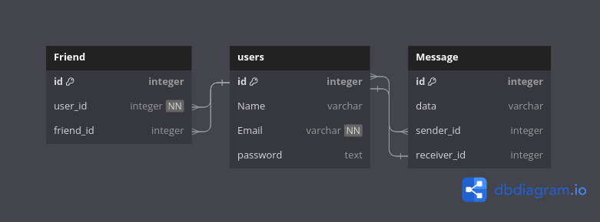

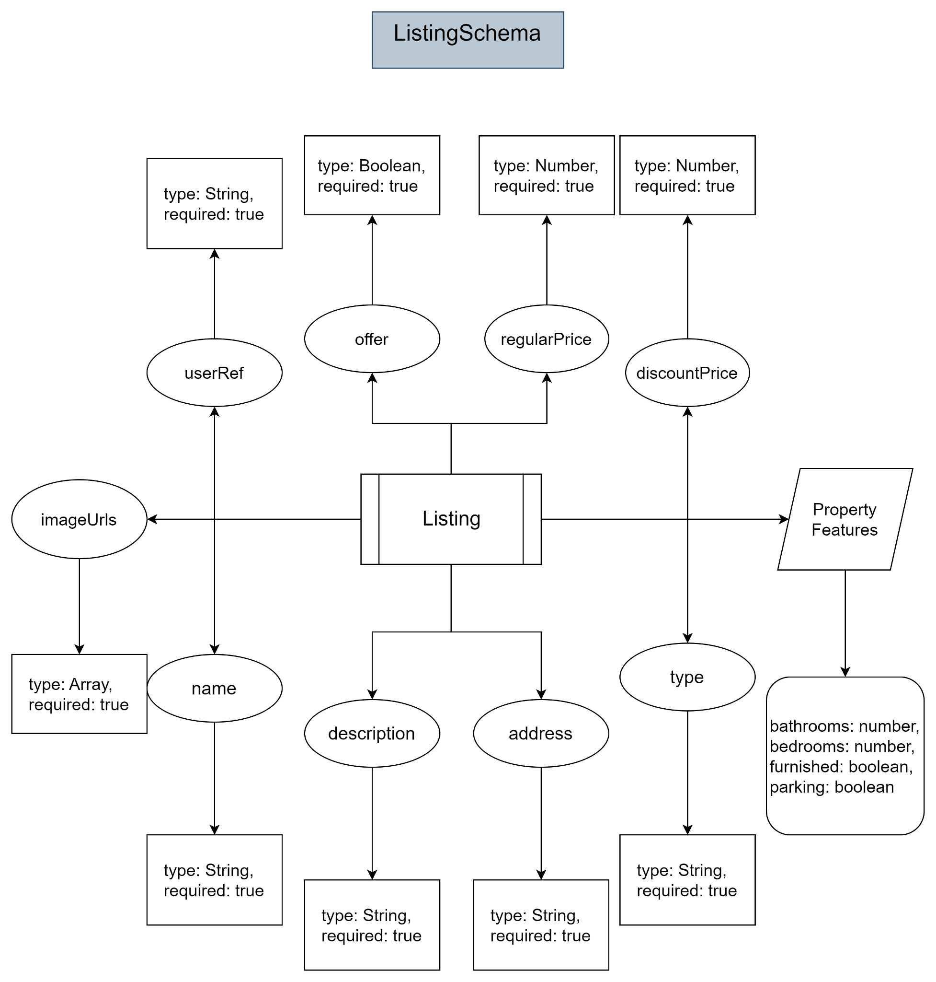

**API Design**

1Auth

* `post/signup` → to signup a new account
* `post/signin` → to signin a existing account
* `post/google` → to signin/signup with Google
* `get/signout` → to signout from the accoun

1. Listing

* `post/create` → to create a new listing of chat group
* `delete/delete/:id` → to delete an existing chat group
* `post/update/:id` → to update an existing chat group
* `get/get/:id` → to get chat from listing according to ID
* `get/get` → to get all chats from listing

1. User

* `post/update/:id` → to update user info
* `delete/delete/:id` → to delete user
* `get/listing/:id` → to get the user’s listing of chats
* `get/:id` → to get user

FEATURES