EMG-Controlled VR Football
Comparing smoothing filters for real-time biceps and triceps control
ES244 Signals, Systems and Random Processes (SSRP) – Project 14
Final report, 10 November 2026
Team member | Roll number | Part of the project
Bhavya Chaudhary | 25110075 | Butterworth low-pass (F3); game development, real-time integration and game testing
Jashan Saini | 25110144 | Kalman filter on RMS (F5)
Dhruval Naik | 25110104 | Chebyshev I band-pass and alternative processing pipeline
Shreyas Jadhav | 25110137 | Chebyshev II low-pass (F7)

1 Objective
The aim of the project is to control a football game in Unity with surface EMG from two muscles: the biceps makes the player run and the triceps makes the player kick. The signal processing chain has to turn the raw EMG into a stable control signal that separates contraction from rest, reacts quickly, and does not trigger the game by accident.
Each team member proposed one smoothing filter for the envelope of the muscle activity, and the team compared them on the EMG of all four subjects and in the game. The specific goals are to:
- identify the noise in the raw EMG (DC offset, drift, mains hum, movement artefacts) and remove it with filtering, checked with the power spectrum;
- extract the envelope of muscle activity (MAV and RMS features, followed by a smoothing filter) and normalise it to each person’s calibration;
- compare the members’ filters – Butterworth, Kalman, the Chebyshev I pipeline and Chebyshev II – on delay, smoothness and false triggers, and compare raw against processed signals;
- evaluate how the processing affects movement, response time, accuracy and overall game performance.

2 Experimental Design

2.1 Set-up and acquisition
Surface EMG was recorded with a BioRadio wireless device at 1000 Hz and read in Python (bioradio_emg.py) through the BioRadio SDK. The biceps electrodes were on the left arm (channel 1) and the triceps electrodes on the right arm (channel 2), so running and kicking are controlled independently. Electrodes were placed on bicep of one arm and tricep of another arm.
Python filters the signal live and sends the biceps and triceps levels to Unity over UDP, 100 times per second. It also saves the raw biceps and triceps signals of every session to CSV, so every filter can be applied afterwards to every recording, whatever filter was running live.
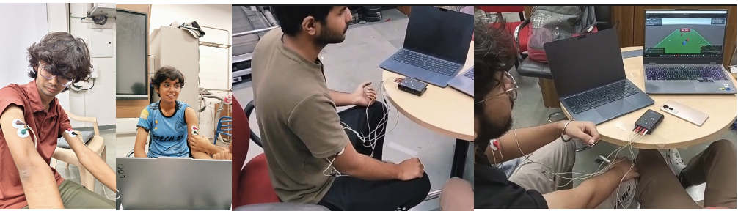
Fig E1 – Set-up: BioRadio electrodes on the biceps and triceps, with the game running

2.2 Subjects and recordings
Four subjects (S1–S4, one per team member) were recorded. The game was tested on one subject only (S2), as instructed.
Subject | Recording | Length
S1 | one game round with F2 (data collection) | 5.6 min
S2 | game tester: five rounds F2 → F3 → F5 → F6 → F7, plus one reaction test (F2) | 28.9 min
S3 | one game round with F2 (data collection) | 5.6 min
S4 | earlier recording (30 Oct) with F2 | 1.7 min

The game’s filter box is only a label, so the filter actually running was read from the Python recording. S2’s first round and the S1 and S3 rounds were labelled F0 but ran F2; the reaction test was labelled F7 but ran F2. S2 also played a round with F6, a Chebyshev I low-pass set up by the team; it is no member’s design, so that round is not used in the results. No round was played with raw EMG; raw and processed signals are compared offline on the same recordings (Section 3.5).

2.3 Calibration
Before playing, each subject did 5 s of complete rest, 3 s of maximum biceps contraction and 3 s of maximum triceps contraction. For each filter, the rest level is the median of the envelope at rest and the MVC is its 95th percentile during the maximum contraction. S4’s calibration file is older than the current filter list and has valid values only for Butterworth; for the other filters its Butterworth calibration is scaled by the mean ratio of that filter’s levels to Butterworth’s in S1–S3 (Kalman: F2 levels, Section 3.2).

2.4 Processing pipeline
All filters share the same chain; only the smoothing step (step 4) differs. All filters are causal (MATLAB filter, not filtfilt), as in real time.
Step | Operation | Settings
1 | Band-pass | Butterworth, order 4, 20–450 Hz
2 | Notch | 50 Hz, Q = 30
3 | Rectify | full-wave, |x|
4 | Smoothing | the filter being compared (Section 2.5)
5 | Normalise | (env − rest) / (MVC − rest), clipped to 0–1.5 (fraction of MVC)
6 | Game command | run and kick rules (Section 2.6)

2.5 Smoothing filters compared
The three low-pass filters are all order 2 with their −3 dB point at 4 Hz, so they compare fairly. Two reference envelopes are also used: F0, the rectified signal with no smoothing, and F2, a 100 ms moving RMS (the simplest envelope; it is not raw).
ID | Smoothing filter | Design (MATLAB) | Proposed by
F0 | Raw (rectified, no smoothing) | – | reference
F2 | 100 ms moving RMS | sqrt(filter(ones(100,1)/100, 1, x.^2)) | reference
F3 | Butterworth low-pass | butter(2, 4/(fs/2)) | Bhavya Chaudhary
F5 | Kalman filter on 100 ms RMS | random-walk Kalman, Q/R = 0.01 (settled gain K ≈ 0.095) | Jashan Saini
F7 | Chebyshev type II low-pass | cheby2(2, 40, 28.35/(fs/2)), 40 dB stopband | Shreyas Jadhav

Dhruval Naik used the Chebyshev I filter at the band-pass stage (step 1) rather than the smoothing stage, as part of an alternative processing chain: Chebyshev I band-pass, multi-harmonic comb notch, Hamming-window RMS, soft clipping and a Schmitt trigger. It was evaluated offline on S1, S3 and S4 (Section 3.3) and was not played in the game. To compare it with the other filters under the game’s rules, it was run with his own code on all of S2’s recorded EMG (Section 3.5).

2.6 Game and real-time integration
The game is a Unity football game. The player carries the ball upfield past four defenders and shoots past a keeper; the defenders move the same way every round, so rounds are comparable across filters. UdpEmgControl.cs receives the two levels from Python and applies these rules:
Control | Rule
Run (biceps) | stands still below 10% MVC; speed rises linearly to full speed at 60% MVC
Kick (triceps) | fires above 30% MVC; re-arms only after falling below 20% MVC; 0.7 s lockout
Kick power | from the triceps peak in the first 0.3 s
Defenders | move the same way every round

S2 played one 5-minute round per smoothing filter, in the order F2 → F3 → F5 → F6 → F7 (the F6 round is not used, Section 2.2), followed by a reaction test of 20 cues (FLEX, RELAX, KICK). The game logged every goal, shot, save, miss and tackle, and the run command in every frame.

2.7 Offline analysis and measures
The analysis was done in MATLAB (Signal Processing Toolbox). Each member’s script applies one filter to every subject’s data-collection recording (for S2, its first 5.6 min file); S2’s game rounds are used only in the game analysis (Section 3.5). Figures that zoom in show a 10 s segment chosen automatically as the most active part of each recording, the same segment for every filter; all values are computed on the full recordings.
Measure | Definition
Delay | lag (ms) that maximises the cross-correlation between the envelope and a zero-phase reference envelope (4 Hz Butterworth, filtfilt)
Ripple | standard deviation of the envelope’s content above 3 Hz during contractions, as % of the envelope’s mean
False triggers at rest | % of rest time above the run threshold (biceps, 0.10) or kick threshold (triceps, 0.30); rest = quietest 10% of 500 ms windows
SNR raw → cleaned | activity-to-rest power ratio before and after the band-pass and notch
RMS/MAV ratio | median RMS/MAV during the 25% most active samples (≈ 1.25 expected for Gaussian-like EMG)
Step test | muscle level 0 → 0.5 MVC for 1 s → 0: time to cross 0.10 after onset and after release, and peak overshoot

2.8 SSRP concepts used
Concept | Where it is used
LTI systems, difference equations, poles and zeros | band-pass, notch and smoothing filters; pole and zero placement of Butterworth, Chebyshev I and II, comb notch
Frequency response and group delay | filter design figures (Fig B1, C1); link between group delay and measured delay
Power spectral density (Welch) | noise identification before and after cleaning (Fig B6, D1)
Random processes | EMG as a zero-mean, Gaussian-like process: MAV, RMS and their ratio; short-time power
Cross-correlation | measuring the delay of each envelope
State estimation | Kalman filter on the RMS envelope (F5), steady-state gain and time constant (Section 4.2)
Convolution and window functions | moving RMS, Hamming window
Hysteresis | kick re-arm rule; Schmitt trigger in the alternative pipeline

3 Results
Results are given separately for each member. Subject-level figures use the same 10 s segment for every filter.

3.1 Butterworth low-pass, F3 (Bhavya Chaudhary)

Butterworth filter design (Fig B1)
The Butterworth filter reacts in 30 ms when a muscle turns on and 89 ms when it relaxes, with only 4.3% overshoot. It is a 2nd-order low-pass with its −3 dB point at 4 Hz, applied to the rectified EMG after the band-pass (20–450 Hz) and the 50 Hz notch.
Property | Value
Gain below 2 Hz | about 0 dB (flat, no ripple)
Gain at 4 Hz | −3 dB
Gain at 10 Hz / 100 Hz | −16 dB / −56 dB (−40 dB per decade)
Delay below 1 Hz | about 56 ms
Highest delay | about 68 ms, near 2.5 Hz
Step test: crosses run threshold after onset | 30 ms
Step test: drops below run threshold after release | 89 ms
Overshoot | 4.3% (small dip below zero after release)
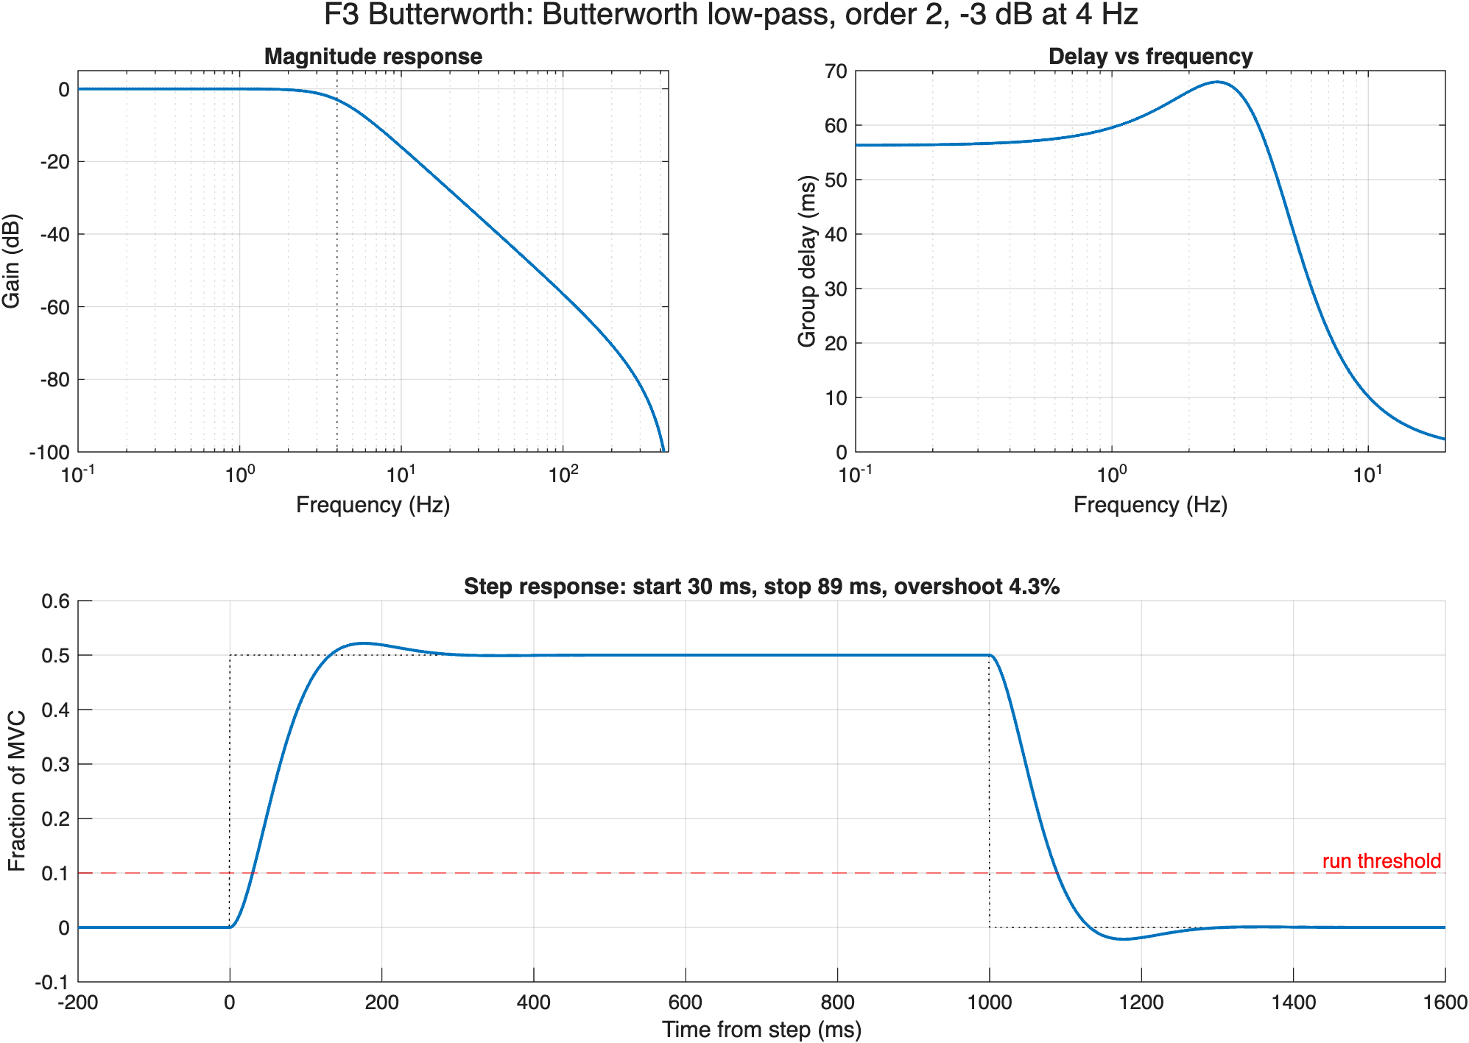
Fig B1 – Butterworth low-pass (order 2, −3 dB at 4 Hz): magnitude response, group delay, and step response (0 → 0.5 MVC → 0) with the run threshold.

Butterworth on every subject’s EMG (Fig B2–B8)
On real data the Butterworth envelope lagged by 65–72 ms for every subject and muscle. It almost never triggered while the arm was relaxed, except for S4’s biceps, whose calibration was too weak.
Recording | Delay (ms) | Ripple (%) | False triggers at rest (%) | SNR raw → cleaned (dB)
S1 biceps | 65 | 12.5 | 0 | −0.3 → 38.1
S1 triceps | 66 | 17.9 | 0 | −0.4 → 30.2
S2 biceps | 68 | 13.2 | 0.39 | 2.9 → 31.4
S2 triceps | 71 | 28.4 | 0 | 4.0 → 33.6
S3 biceps | 69 | 13.7 | 0 | 4.9 → 27.0
S3 triceps | 72 | 13.5 | 0 | 0.2 → 23.4
S4 biceps | 69 | 22.7 | 89.6 | 9.0 → 21.9
S4 triceps | 66 | 10.1 | 0 | 1.6 → 14.8

- Spectra (Fig B6): the large DC and drift content below 20 Hz and everything above 450 Hz are removed. The notch leaves a narrow dip at 50 Hz. S2’s and S3’s raw triceps show a small 50 Hz peak, which confirms mains hum.
- Signal chain (Fig B2, S3): around 95 s a slow 3.5–4 mV movement artefact appears in the raw signal. It is gone after the band-pass, while the muscle bursts remain.
- Before vs after (Fig B7): the raw rectified signal jumps between 0 and 1.5 MVC many times per second. The Butterworth envelope follows each contraction smoothly and crosses the threshold once per burst.
S3’s triceps was tense during the first ~20 s and last ~15 s of the recording (Fig B4); this comes from the subject, not the filter. S4’s numbers come from a weak calibration: its biceps maximum was only 0.07 mV, so even at rest the biceps read about 0.19 MVC, above the run threshold.
S4’s figures show this directly. In the 10 s zoom (Fig B3, from 31 s) the biceps envelope never falls below about 0.15 MVC, and between bursts the triceps stays close to the kick line. S4’s overview (Fig B5) shows the same raised baseline for the whole recording.
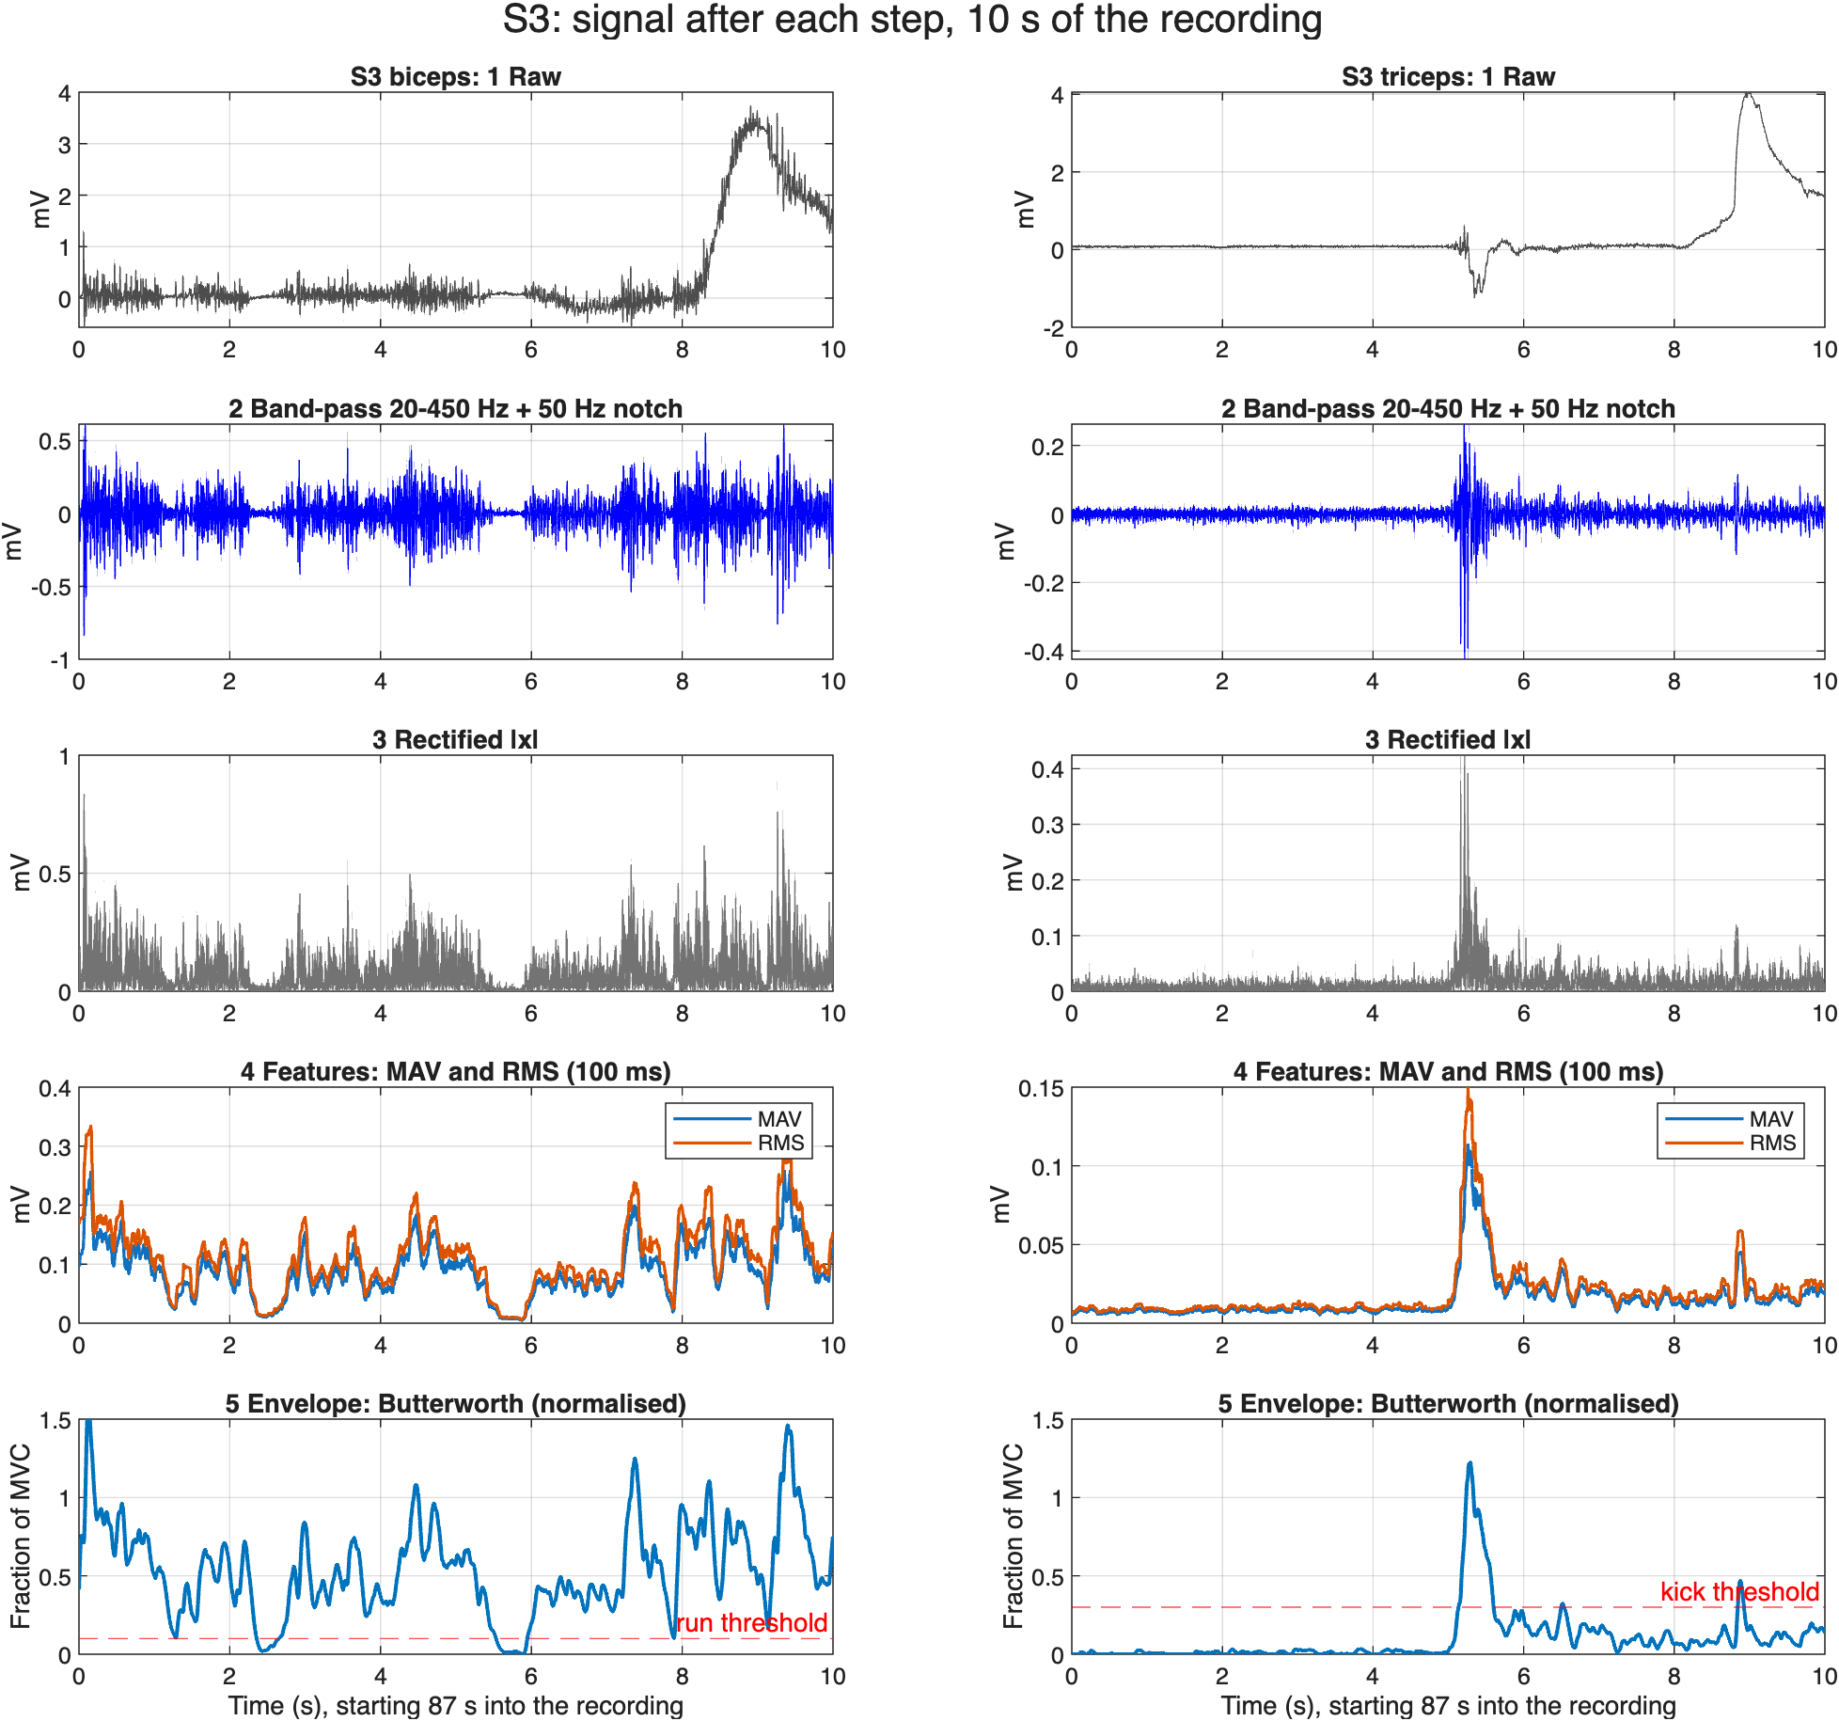
Fig B2 – 10 s of S3’s recording after each step: raw, band-pass + notch, rectified, MAV/RMS features, normalised Butterworth envelope. The band-pass removes a 3.5–4 mV movement artefact.
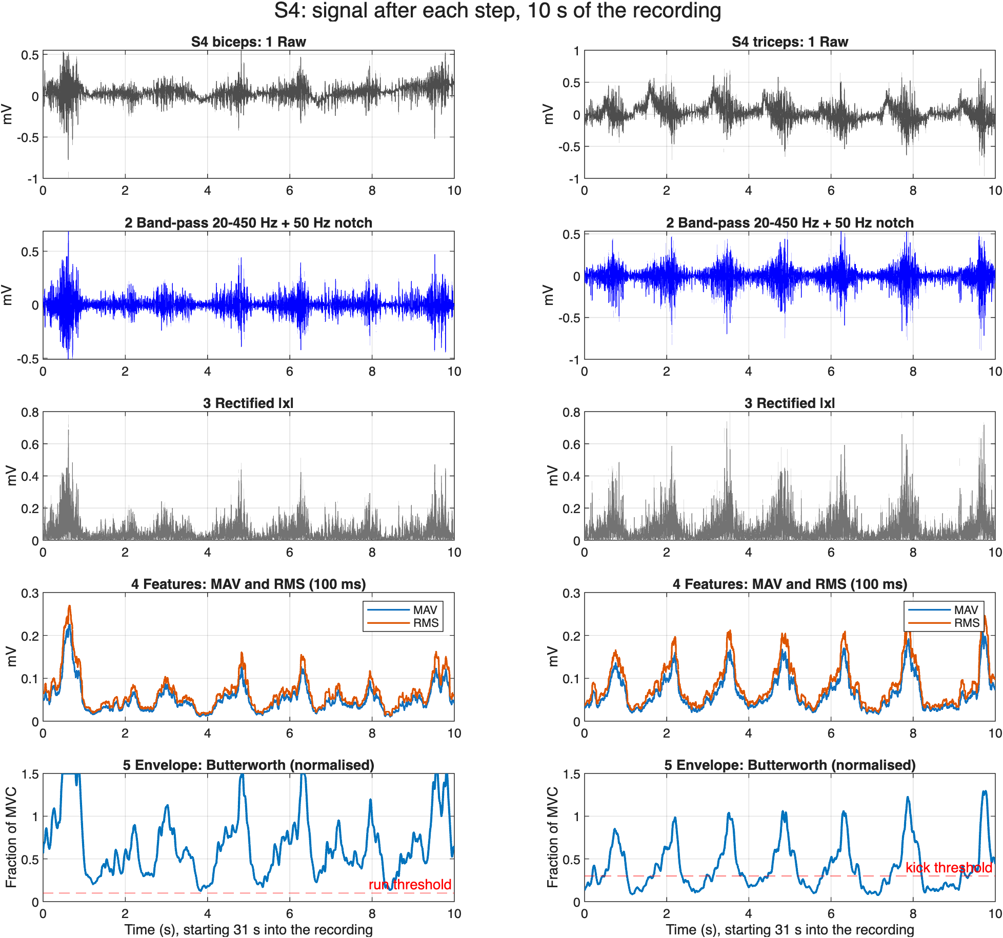
Fig B3 – the same steps for S4: the envelope never returns below the run threshold because of S4’s weak calibration.
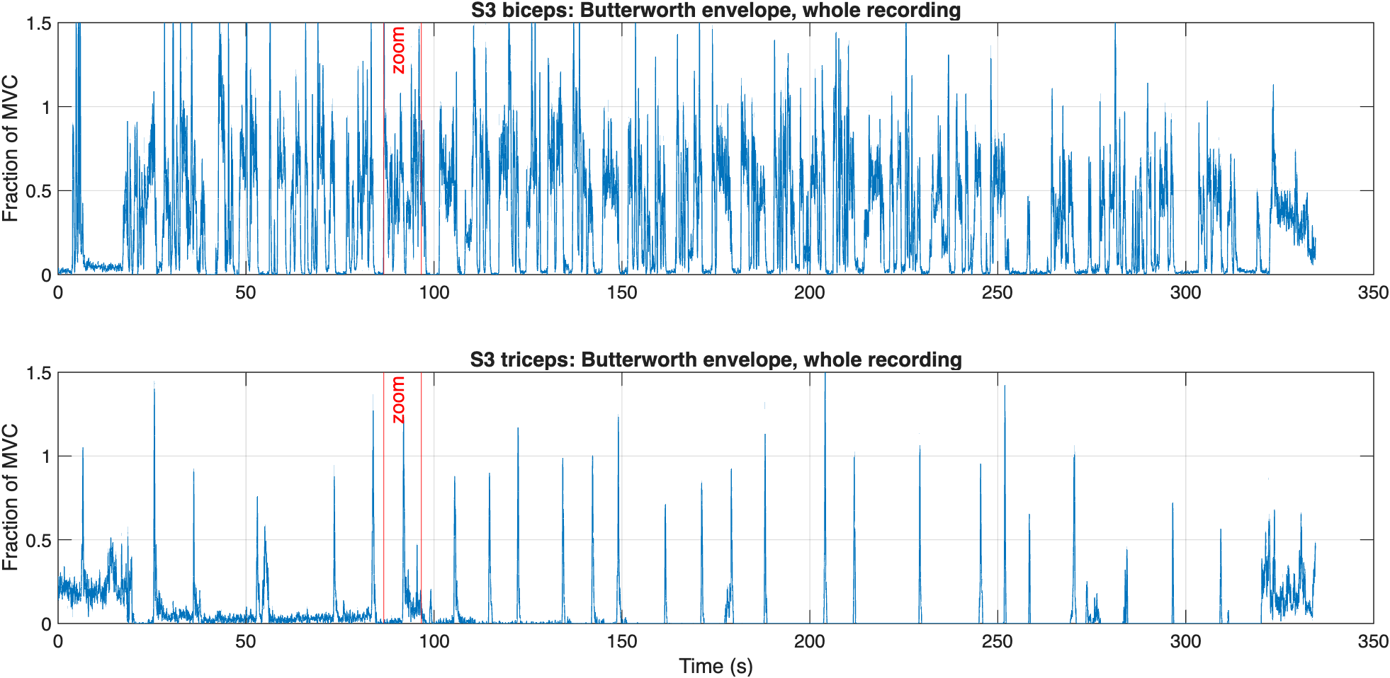
Fig B4 – S3’s Butterworth envelope over the whole recording, with the 10 s zoom marked: the triceps is tense during the first ~20 s and the last ~15 s.
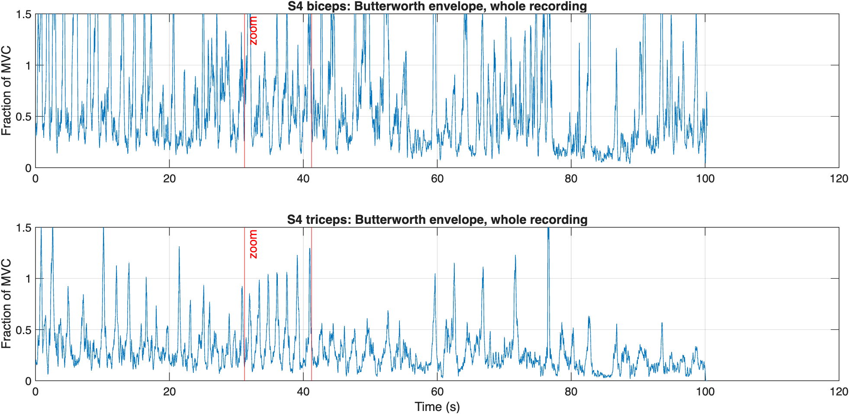
Fig B5 – S4’s Butterworth envelope over the whole recording: the biceps baseline stays raised for the whole recording.
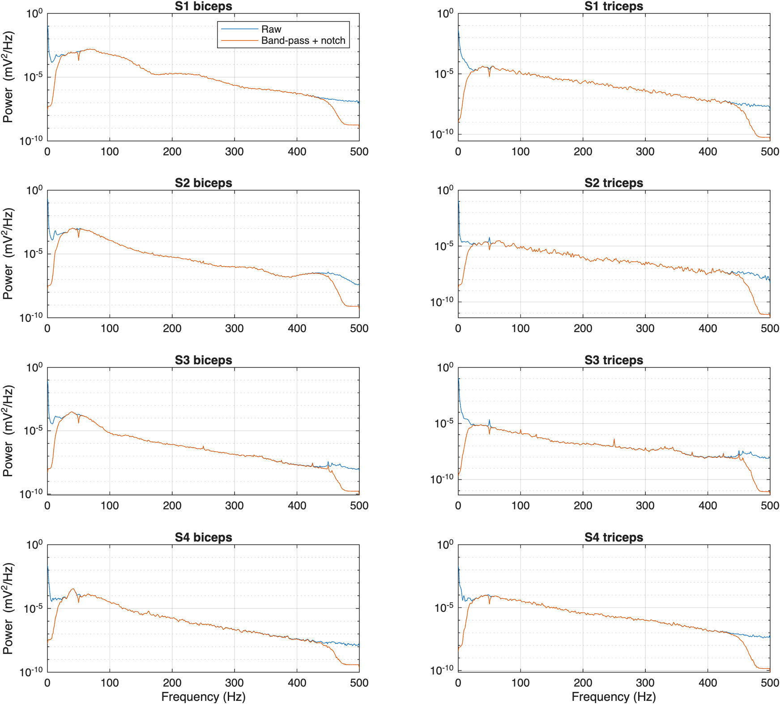
Fig B6 – power spectra of the raw vs band-passed + notched EMG for all subjects and muscles. This step is the same for every smoothing filter.
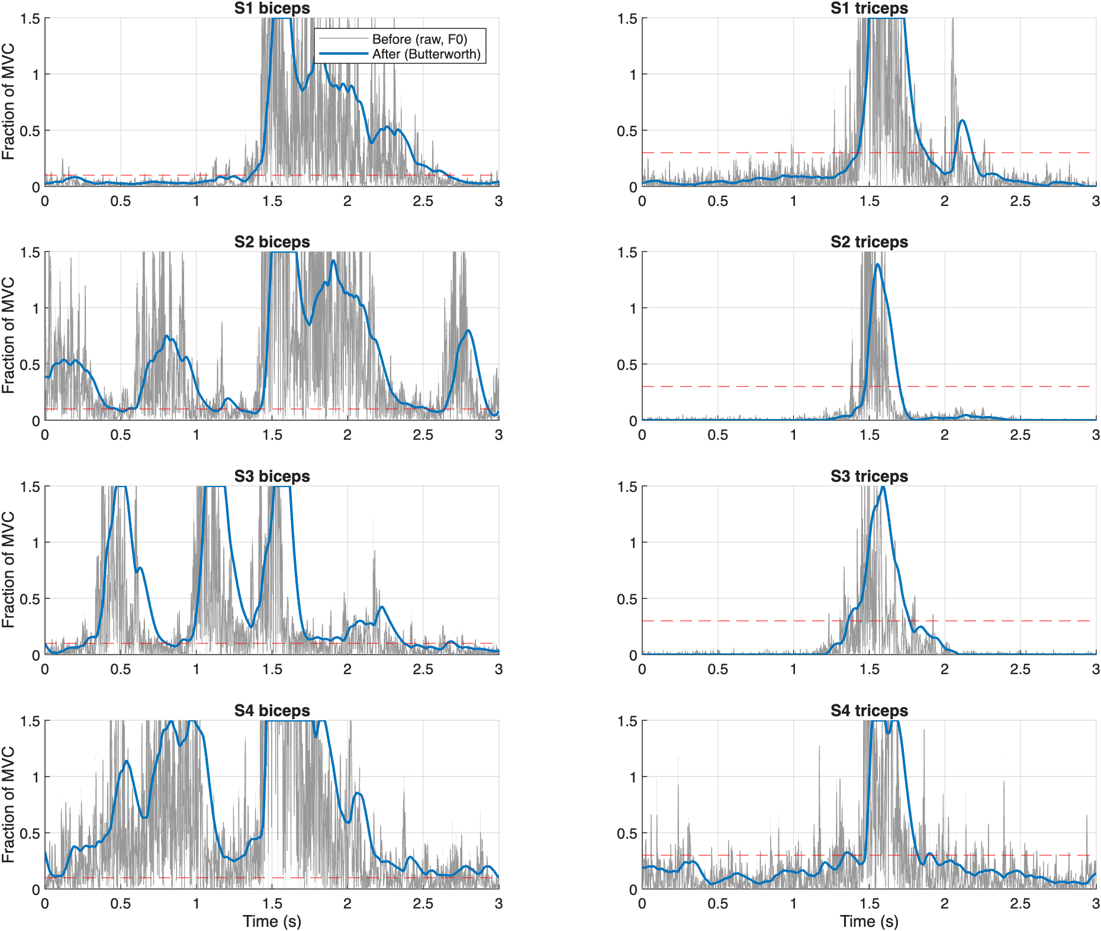
Fig B7 – each subject’s strongest burst: raw rectified signal (grey) vs Butterworth envelope (blue), with the run or kick threshold.
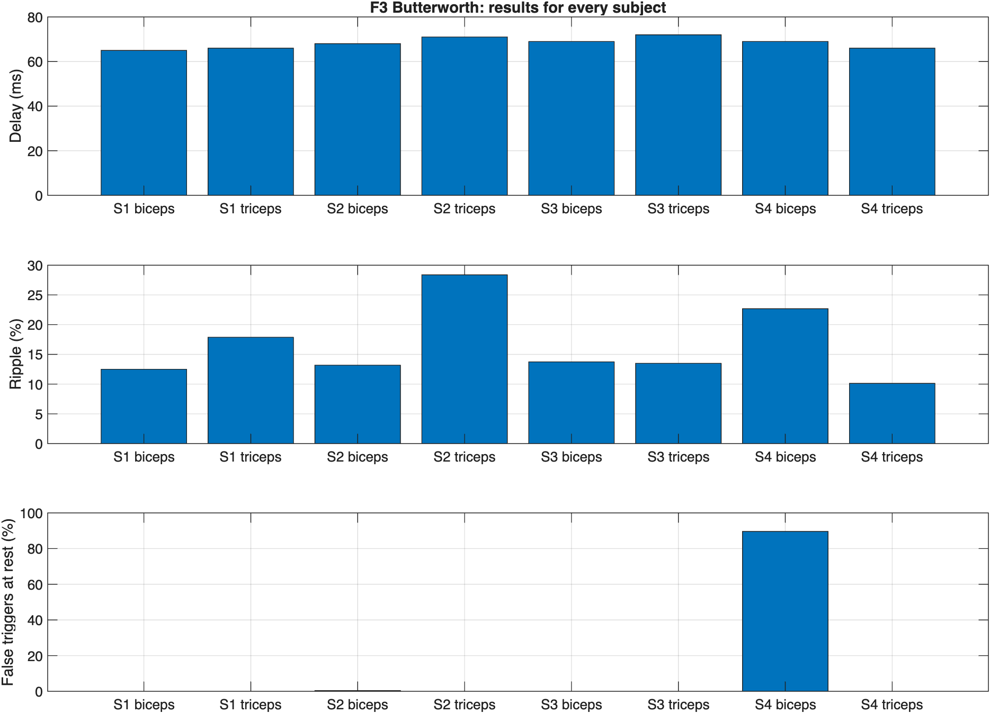
Fig B8 – delay, ripple and false triggers at rest for every subject and muscle.
Figs B2–B3 show a 10 s segment chosen automatically as the most active part of each recording, marked on Figs B4–B5; all values are computed on the full recordings.

3.2 Kalman filter on RMS, F5 (Jashan Saini)
F5 passes the 100 ms moving-RMS envelope through a scalar Kalman filter. This part describes the F5 design, tunes its single parameter q/r, and compares it with F2 (RMS only), F3 (Butterworth) and F7 (Chebyshev II), on S1–S3 (9 Nov) and S4 (30 Oct).

Recordings and calibration
Each CSV file holds two surface-EMG channels (biceps of the left arm on channel 1, triceps of the right arm on channel 2) in millivolts, sampled at 1000 Hz, together with the envelope that the game received live (filter F2). The sampling rate was confirmed from the timestamps. The 9 Nov recordings are single continuous files of about 5.6 minutes per subject. S4’s 30 Oct session lasts 1.7 minutes over three contiguous files, which were joined in time order.
Subject | Session | Files | Duration (s) | Calibration
S1 | 9 Nov | 1 | 336.7 | v3
S2 | 9 Nov | 1 | 335.3 | v3
S3 | 9 Nov | 1 | 335.5 | v3
S4 | 30 Oct | 3 | 103.3 | old
Table K1 – Recordings used in this part.
For each subject the calibration file stores a rest level and an MVC level for every filter. In the 9 Nov files (version v3) the F5 levels agree with the F2 levels to within 1.5%, as expected: a Kalman filter with unity DC gain keeps the scale of the RMS it smooths. S4’s file predates v3, and its F5 levels are only 0.76 to 0.83 times the F2 levels, so they were produced by a different F5 definition; the F2 levels were therefore used to normalise S4’s F5 envelope. Table K2 compares each calibration with what the muscles actually did during the game.
Channel | Rest (µV) | MVC (µV) | MVC / rest (dB) | Quiet in game (% MVC) | Peak in game (% MVC)
S1 biceps | 3.8 | 663 | 45 | 1.8 | 146
S1 triceps | 9.0 | 186 | 26 | 2.7 | 151
S2 biceps | 1.6 | 459 | 49 | 3.6 | 143
S2 triceps | 9.2 | 459 | 34 | 0.6 | 49
S3 biceps | 6.6 | 199 | 30 | 4.3 | 131
S3 triceps | 9.7 | 113 | 21 | 3.6 | 74
S4 biceps | 2.8 | 91 | 30 | 20.4 | 310
S4 triceps | 9.3 | 194 | 26 | 14.1 | 115
Table K2 – F5 calibration levels and a check against the game data (quiet = 10th percentile, peak = 99th percentile of the F5 envelope).
Two calibrations do not fit the game data. For S4 the biceps reached 310% of its recorded MVC and its quiet level was 20%, above the 10% run threshold, so that player ran almost all the time. For S2 the triceps peaked at only 49% of MVC, so its MVC was set too high and kicks needed extra effort. Both are calibration problems, not filter problems.

Processing pipeline
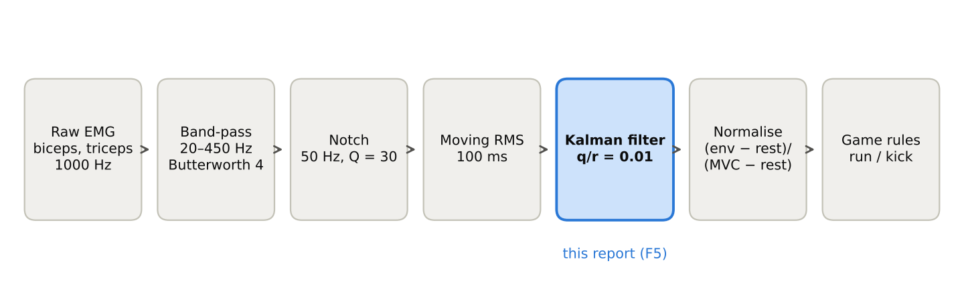
Fig K1 – Processing chain. Only the smoothing stage differs between the team’s filters; F5 uses moving RMS followed by a Kalman filter.
Band-pass filter, Nyquist frequency and causality. A 4th-order Butterworth band-pass (8th order overall) with cut-offs at 20 and 450 Hz removes the DC offset, baseline drift and motion artefacts, and keeps the EMG band. All its poles lie inside the unit circle, so it is stable. With fs = 1000 Hz the Nyquist frequency is 500 Hz, above the 450 Hz edge, and less than 0.05% of the raw power lies above 450 Hz, so no aliasing occurs. The game runs in real time, so every filter is applied causally (MATLAB filter, which uses only present and past samples); zero-phase filtering (filtfilt) is used only for the offline reference envelope. The F2 envelope rebuilt offline with this chain matches the envelope logged by the game with correlation 1.00000 on every 9 Nov channel, so the offline F5 results carry over to the game.
50 Hz notch filter. The 50 Hz mains frequency lies inside the 20–450 Hz passband, so the band-pass cannot remove mains interference. A second-order IIR notch with Q = 30 (−3 dB width 1.7 Hz) places zeros on the unit circle at ±50 Hz and poles just inside it. The Welch power spectral density (Table K3, Fig K2) shows no mains peak in S4’s 30 Oct recording, but on 9 Nov the triceps channels of S2 and S3 had peaks of +4.8 dB and +5.8 dB, and S3 also had a +3.5 dB peak at 100 Hz. On those two channels the notch lowered the 49–51 Hz power by 8.4 and 9.6 dB, against about 5 dB where only EMG was present. Its cost is 2.7 to 8.3% of the signal variance. The notch is kept because the 9 Nov data shows that it is needed.
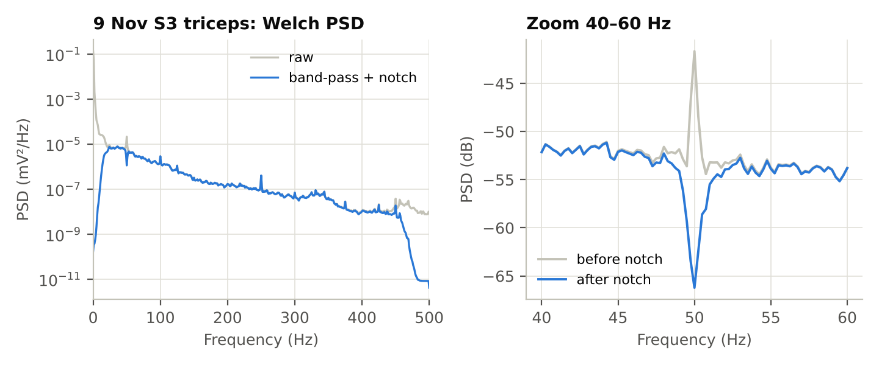
Fig K2 – 9 Nov S3 triceps: Welch PSD of the raw and filtered signal (left) and the 40–60 Hz region before and after the notch (right, 0.25 Hz resolution).
Moving RMS envelope. RMS[n] = √[(1/N) · Σ x²[n − k]], k = 0 … N − 1, N = 100 (100 ms). Squaring removes the sign, so no separate rectification is needed. The RMS follows the short-time power of the signal, which rises with muscle force because surface EMG behaves like a zero-mean random process whose variance grows with activation. The trailing 100 ms window delays the envelope by about 50 ms.
Kalman filter (F5). The RMS still fluctuates, because it is estimated from a random signal. The Kalman filter treats the true activation x as a slowly changing hidden state and each RMS sample z as a noisy measurement of it (random-walk model):
- State: x[n] = x[n − 1] + w[n], w ~ N(0, Q)
- Measurement: z[n] = x[n] + v[n], v ~ N(0, R)
- Predict: x̂⁻[n] = x̂[n − 1], P⁻[n] = P[n − 1] + Q
- Gain: K[n] = P⁻[n] / (P⁻[n] + R)
- Update: x̂[n] = x̂⁻[n] + K[n] (z[n] − x̂⁻[n]), P[n] = (1 − K[n]) P⁻[n]
Only the ratio q/r = Q/R affects the output (here R = 1, P[0] = 1 and x̂[0] = 0). With q/r = 0.01 the gain settles within about 30 samples to its steady value K∞ = (−q + √(q² + 4q))/2 = 0.095 (Fig K3). In steady state the filter is therefore a first-order low-pass, x̂[n] = 0.905 x̂[n − 1] + 0.095 z[n], with a time constant of about 10 ms. Its DC gain is 1, so it keeps the RMS scale, and its single real pole means its step response never overshoots. A larger q/r makes it follow the RMS more closely; a smaller q/r smooths more but adds delay. The state and covariance are carried from sample to sample and never reset, as required for real-time use.
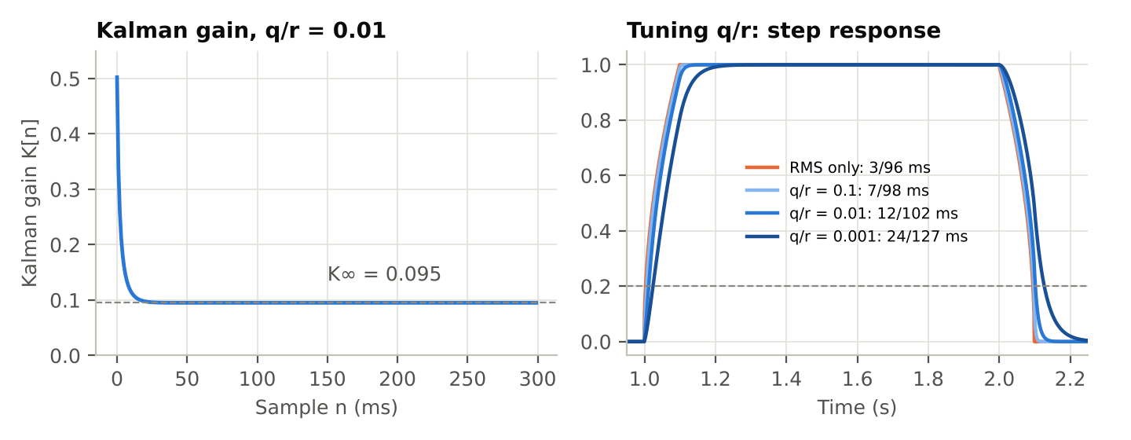
Fig K3 – Left: the Kalman gain converges to K∞ = 0.095 in about 30 ms. Right: step responses for three values of q/r (start/stop times at 20%).
Normalisation and game rules. u[n] = (x̂[n] − rest) / (MVC − rest), clipped to 0 … 1.5, so 0 is rest and 1 is MVC for every player. The game rules are those of Section 2.6; there is no biceps/triceps ratio check, because the two electrodes are on different arms and the player may run and kick at the same time.

Effect of filtering
The raw signals are dominated by drift and motion artefacts: 67 to 100% of their power lies below 20 Hz (Table K3). After the band-pass and notch, the bursts of muscle activity stand out clearly (Fig K4), and the contraction-to-rest power ratio rose from between −0.7 and 4.9 dB to between 15.4 and 38.5 dB. The ratio is computed as 10 log10(P_contraction / P_rest), with rest and contraction taken as the quietest and loudest 10% of 0.5 s windows and the same windows used before and after filtering; the mean of the whole recording is subtracted first. The Butterworth and Chebyshev II sections give −0.3 → 38.1 dB for S1 (here −0.7 → 38.5 dB) mainly because they remove the DC offset differently.
Channel | DC (mV) | Power < 20 Hz (%) | 50 Hz peak (dB) | 100 Hz peak (dB) | Notch: 49–51 Hz drop (dB) | Notch: variance removed (%) | SNR raw (dB) | SNR filtered (dB)
S1 biceps | −0.10 | 67 | −0.4 | −0.1 | 5.1 | 2.8 | −0.7 | 38.5
S1 triceps | −1.51 | 97 | −1.8 | +1.1 | 5.0 | 2.7 | −0.4 | 30.2
S2 biceps | −3.86 | 88 | −0.3 | −0.2 | 5.2 | 4.8 | 2.9 | 31.4
S2 triceps | 3.19 | 99 | +4.8 | +1.2 | 8.4 | 6.0 | 4.0 | 33.6
S3 biceps | 3.53 | 94 | +0.5 | +0.1 | 5.2 | 5.2 | 4.9 | 27.0
S3 triceps | 2.30 | 100 | +5.8 | +3.5 | 9.6 | 8.3 | 0.1 | 23.5
S4 biceps | 0.08 | 90 | +0.3 | +0.0 | 5.0 | 3.3 | 4.2 | 22.0
S4 triceps | −0.27 | 93 | +0.3 | +0.9 | 5.3 | 3.5 | −0.3 | 15.4
Table K3 – Noise identification and filtering effect per channel.
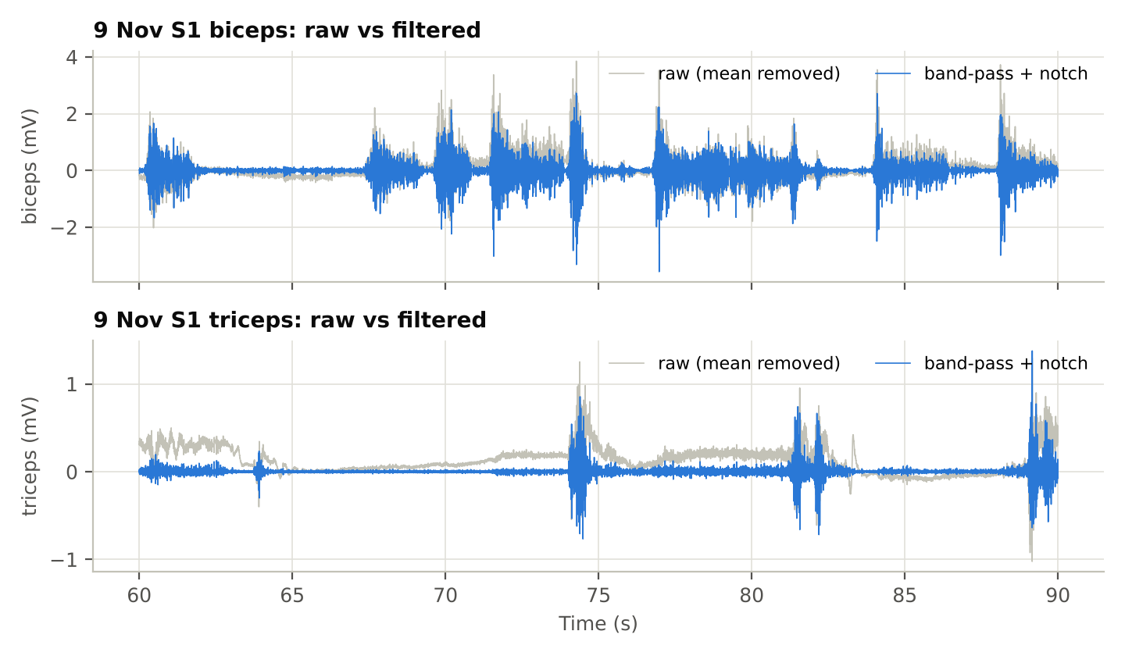
Fig K4 – S1, 60–90 s: raw signal (grey, mean removed) and the band-pass + notch output (blue).

Step test
The step test feeds a unit step lasting 1 s into each smoother: start is the time to rise above 20%, stop is the time to fall below 20% after the step ends, and overshoot is the peak above 1. F5 gives 12 ms / 102 ms / 0%. Compared with F3 and F7 it starts 18 ms earlier but releases 13 ms later, and it has no overshoot (F3 4.3%, F7 4.4%), so it never reports more effort than the muscle produced. For F2, Section 3.5 gives 4 / 95 ms instead of 3 / 96 ms: the RMS of a step lands exactly on the 20% threshold (√(4/100) = 0.2), so floating-point rounding decides which sample counts and moves the crossing by one sample; the low-pass filters never land exactly on the threshold, so their values agree.
Smoother | Start (ms) | Stop (ms) | Overshoot (%)
F2 RMS 100 ms | 3 | 96 | 0.0
RMS + Kalman, q/r = 0.1 | 7 | 98 | 0.0
F5: RMS + Kalman, q/r = 0.01 | 12 | 102 | 0.0
RMS + Kalman, q/r = 0.001 | 24 | 127 | 0.0
F3 Butterworth LP 4 Hz | 30 | 89 | 4.3
F7 Chebyshev II LP 4 Hz | 30 | 89 | 4.4
Table K4 – Step test (unit step for 1 s; thresholds at 20%).
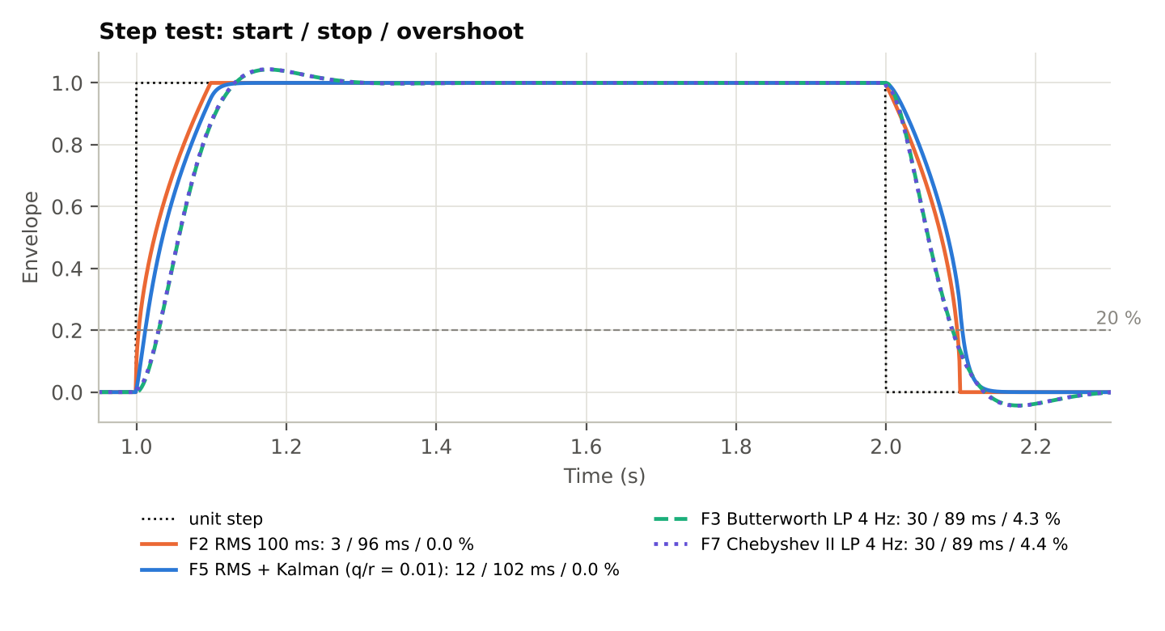
Fig K5 – Step responses of the four smoothers with their start / stop / overshoot values.

Delay and ripple on real data
Each causal envelope was compared with a zero-phase reference: the rectified, band-passed signal smoothed by a 4 Hz Butterworth low-pass run forwards and backwards, which has no delay. Delay is the lag at the peak of the cross-correlation between an envelope and the reference. Ripple is the standard deviation of the envelope’s content above 3 Hz divided by its mean, measured while the muscle is active.
Smoother | Delay (ms) | Ripple (%)
F2 RMS 100 ms | 57 | 16.5
RMS + Kalman, q/r = 0.1 | 60 | 16.4
F5: RMS + Kalman, q/r = 0.01 | 66 | 15.8
RMS + Kalman, q/r = 0.001 | 86 | 13.3
F3 Butterworth LP 4 Hz | 68 | 16.1
F7 Chebyshev II LP 4 Hz | 68 | 15.9
Table K5 – Delay and ripple, mean of the six 9 Nov channels (S1–S3).
The Kalman filter adds 9 ms to the RMS (66 ms against 57 ms) and lowers the ripple from 16.5% to 15.8%. That places F5 at about the same point of the delay–ripple trade-off as F3 and F7 (68 ms; 16.1% and 15.9%). Changing q/r moves F5 along the trade-off curve: q/r = 0.1 behaves almost like plain RMS (60 ms, 16.4%), while q/r = 0.001 smooths most (13.3%) but lags by 86 ms, about 20 ms more than F5. The F3 and F7 ripple values here (16.1% and 15.9%) are slightly lower than the means in Sections 3.1 and 3.4 (16.5% and 16.4%) for the same reason as the SNR: the DC offset is removed differently (the first sample here, the mean there). The ranking of the filters is unchanged.
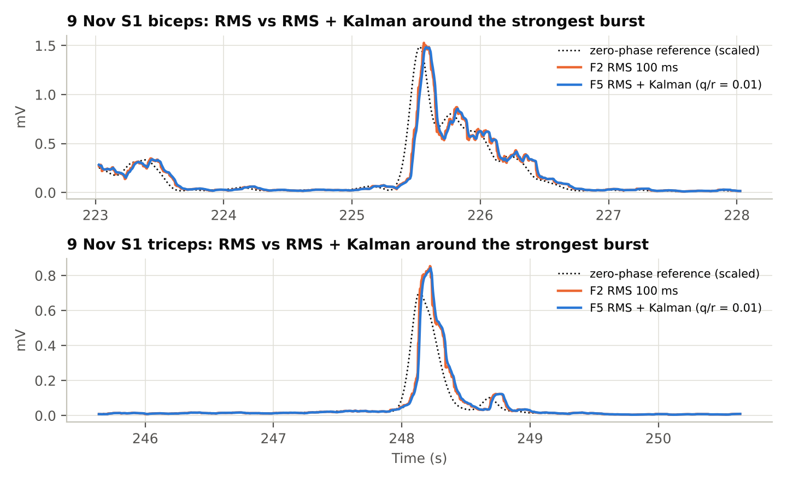
Fig K6 – S1: RMS and RMS + Kalman around the strongest biceps and triceps bursts, with the scaled zero-phase reference.
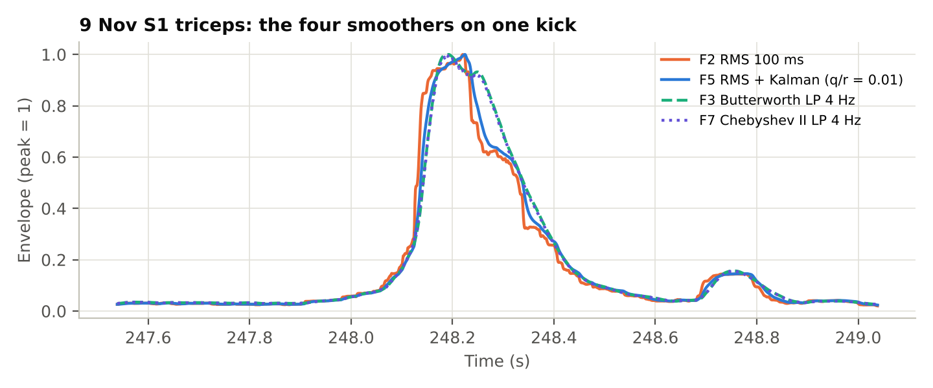
Fig K7 – S1 triceps: the four smoothers on a single kick (each scaled to its peak).

Game command performance (offline estimate)
This is an offline estimate, not a measurement in the game. The recordings have no manual labels, so reference kicks were found by applying the same game rule to the zero-phase reference envelope. A detected kick counts as correct if it falls between 0.1 s before and 0.5 s after a reference kick; unmatched detections are false kicks, and unmatched reference kicks are missed. Because the reference comes from our own zero-phase envelope and not from real labels, small differences in false kicks (for example 17 against 20) are weak evidence; the in-game F5 result is in Section 3.5.
Subject | Reference kicks | F2 RMS | F5 Kalman | F3 Butterworth | F7 Chebyshev II | Running, F5 (%)
S1 | 29 | 28/1/5 | 28/1/3 | 28/1/4 | 28/1/4 | 48
S2 | 24 | 24/0/1 | 24/0/1 | 24/0/1 | 24/0/1 | 66
S3 | 38 | 35/3/17 | 36/2/13 | 35/3/15 | 35/3/15 | 58
S4 | 51 | 47/4/26 | 46/5/19 | 48/3/11 | 48/3/12 | 98
All | 142 | 134/8/49 | 134/8/36 | 135/7/31 | 135/7/32
Table K6 – Offline estimate: kick detection per subject (correct / missed / false) and time spent running with F5.
Smoother | Correct | Missed | False | Precision (%) | Recall (%)
F2 RMS 100 ms | 134 | 8 | 49 | 73.2 | 94.4
F5: RMS + Kalman, q/r = 0.01 | 134 | 8 | 36 | 78.8 | 94.4
F3 Butterworth LP 4 Hz | 135 | 7 | 31 | 81.3 | 95.1
F7 Chebyshev II LP 4 Hz | 135 | 7 | 32 | 80.8 | 95.1
Table K7 – Offline estimate: kick detection over S1–S4 (142 reference kicks). Precision = correct / (correct + false); recall = correct / reference.
Over the 142 reference kicks, F5 detected 134, missed 8 and fired 36 false kicks, against 134, 8 and 49 for plain RMS: about a quarter fewer false kicks. F3 and F7 did slightly better overall (135 correct, 31 and 32 false). The whole gap comes from S4, whose calibration was wrong (F5 19 false kicks against 11 for F3); without S4, F5 fired the fewest false kicks (17, against 20 for F3 and F7). On S1, the cleanest recording, F5 also fired the fewest (3, against 4 for F3 and F7 and 5 for RMS). Most false kicks come from two subjects with known problems: S4 (wrong calibration) and S3, whose triceps had the weakest signal (MVC/rest only 21 dB) and the strongest mains interference.
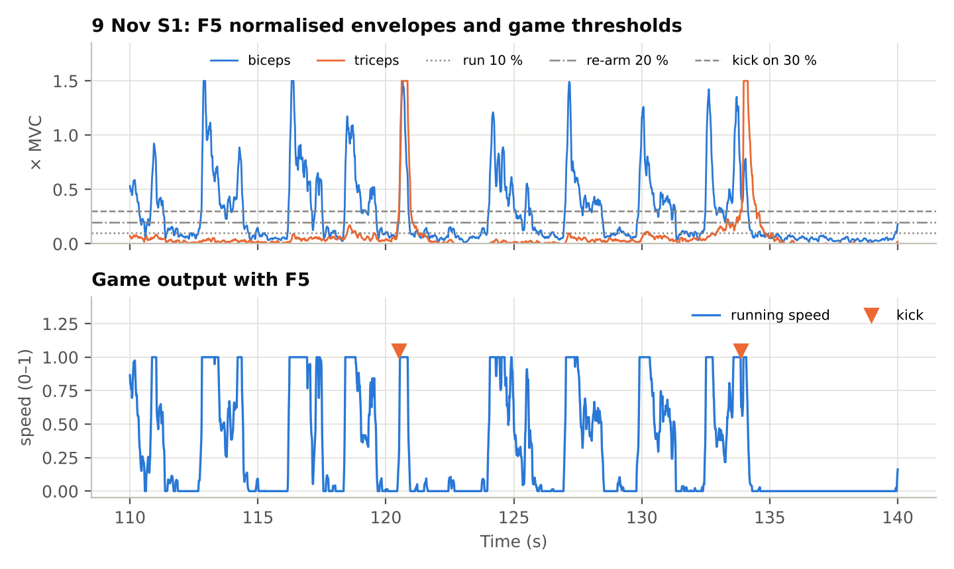
Fig K8 – Offline estimate, S1, 110–140 s: F5 normalised envelopes with the game thresholds (top) and the resulting running speed and kicks (bottom).

Normalisation across subjects
Before normalisation the biceps MVC differs 3.3 times between S1–S3 (0.20 to 0.66 mV) and 7.3 times including S4 (0.09 to 0.66 mV; these are the Kalman/RMS calibration levels, while Section 3.1 gives 0.07 mV for S4 because each filter has its own calibration level). Dividing by each subject’s levels maps every player onto the same 0–1.5 scale (Fig K9), which is what allows one set of game thresholds to work for everyone.
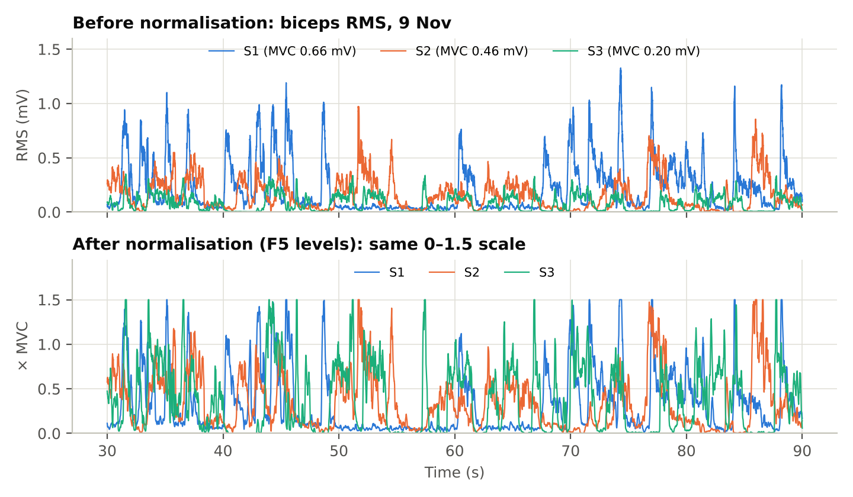
Fig K9 – Biceps envelopes of S1–S3 before normalisation (top) and after F5 normalisation (bottom), 30–90 s.

3.3 Chebyshev I band-pass and alternative pipeline (Dhruval Naik)
Pipeline: Chebyshev Type I band-pass filter → comb notch filter → Hamming RMS → soft-knee normalisation → Schmitt trigger.
My version of the signal processing pipeline was tested across the recorded CSV files and compared against a pipeline that would use a Butterworth filter, a rectangular RMS and a single threshold at 0.25.
Metric | Subject 1 | Subject 3 | Subject 4 | Average improvement
Low f (≤ 15 Hz) drift removal, Butterworth filter | −23.65 dB | −28.68 dB | −30.35 dB | −27.56 dB
Low f (≤ 15 Hz) drift removal, my Chebyshev type I filter | −27.26 dB | −32.48 dB | −34.34 dB | −31.36 dB (better by 3.80 dB)
Command switches in game, single 0.25 threshold | 408 | 556 | 366 | 443.3 switches
Command switches in game, my Schmitt trigger | 212 | 369 | 119 | 233.3 switches (47.4% fewer, so flicker is reduced)

Command switches are counted offline on the recorded EMG with the thresholds named in each row; this pipeline was not played in the game. S2 is not in this table because S2’s recordings are the game rounds; the pipeline is evaluated on all of S2’s EMG in Section 3.5.
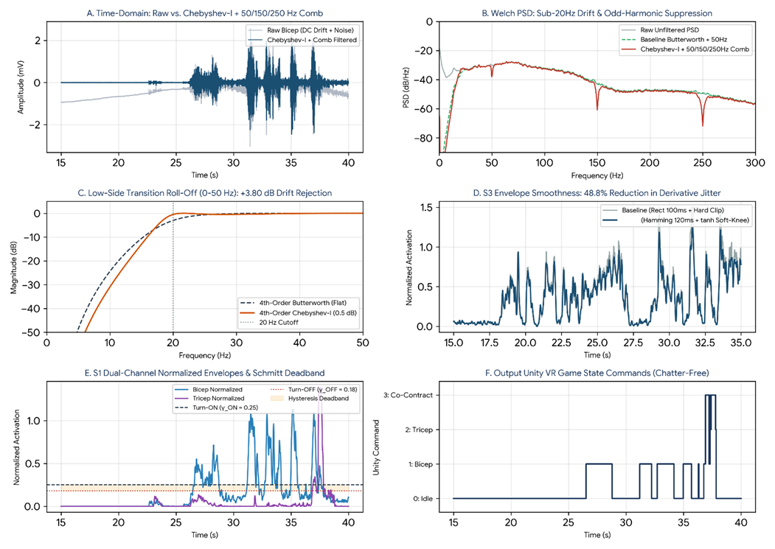
Fig D1 – My signal processing results on data from subjects 1 and 3. A: filtering of the biceps signal to remove the DC offset; B: Welch PSD with notches at 50, 150 and 250 Hz after filtering; C: comparison of Butterworth and Chebyshev Type I (the low-frequency cut-off of Chebyshev Type I is steeper); D: the Hamming RMS envelope is smoother than a rectangular window; E: biceps and triceps envelopes, normalised, with the Schmitt trigger band (0.18 to 0.25); F: final clean game commands for Unity.
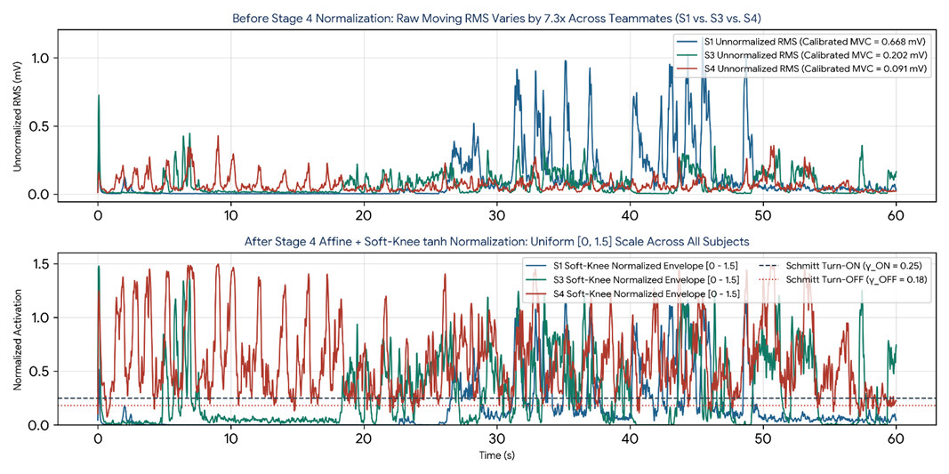
Fig D2 – Effect of normalisation on the signals of subjects 1, 3 and 4. Before normalisation, subject 1’s signal is much larger in amplitude than subject 4’s, so a single threshold for everyone would make the game unfair from person to person.

3.4 Chebyshev II low-pass, F7 (Shreyas Jadhav)

Chebyshev II filter design (Fig C1)
The Chebyshev II filter reacts in 30 ms when a muscle turns on and 89 ms when it relaxes, with only 4.4% overshoot. It is a 2nd-order low-pass with a 40 dB stopband and its −3 dB point at 4 Hz, applied to the rectified EMG after the band-pass (20–450 Hz) and the 50 Hz notch.
Property | Value
Gain below 2 Hz | about 0 dB (flat, no ripple)
Gain at 4 Hz | −3 dB
Gain at 10 Hz | −16.5 dB
Stopband | −40 dB from 28.35 Hz, a null at 40 Hz, then a flat −40 dB floor (−41 dB at 100 Hz)
Delay below 1 Hz | about 56 ms
Highest delay | about 68 ms, near 2.6 Hz
Step test: crosses run threshold after onset | 30 ms
Step test: drops below run threshold after release | 89 ms
Overshoot | 4.4% (small dip below zero after release)
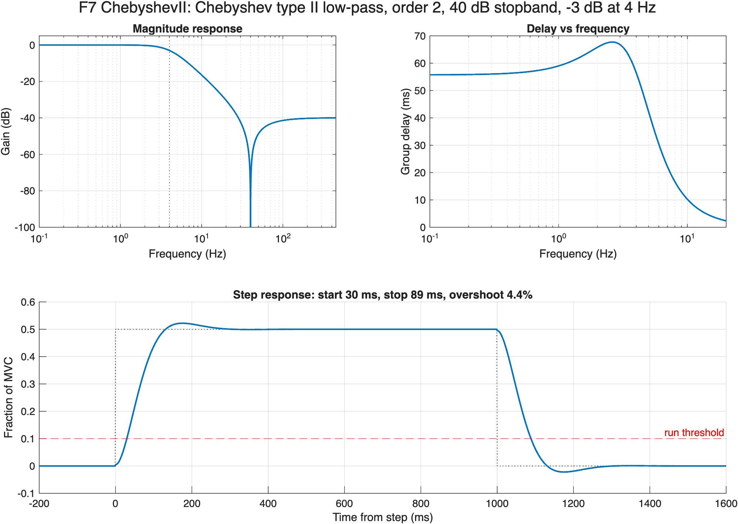
Fig C1 – Chebyshev II low-pass (order 2, 40 dB stopband, −3 dB at 4 Hz): magnitude response, group delay, and step response (0 → 0.5 MVC → 0) with the run threshold.

Chebyshev II on every subject’s EMG (Fig C2–C7)
On real data the Chebyshev II envelope lagged by 64–72 ms for every subject and muscle. It almost never triggered while the arm was relaxed, except for S4’s biceps, whose calibration was too weak.
Recording | Delay (ms) | Ripple (%) | False triggers at rest (%) | SNR raw → cleaned (dB)
S1 biceps | 64 | 12.4 | 0 | −0.3 → 38.1
S1 triceps | 65 | 17.8 | 0 | −0.4 → 30.2
S2 biceps | 68 | 13.0 | 0.39 | 2.9 → 31.4
S2 triceps | 70 | 28.2 | 0 | 4.0 → 33.6
S3 biceps | 69 | 13.6 | 0 | 4.9 → 27.0
S3 triceps | 72 | 13.4 | 0 | 0.2 → 23.4
S4 biceps | 69 | 22.6 | 89.6 | 9.0 → 21.9
S4 triceps | 65 | 10.0 | 0 | 1.6 → 14.8

- Spectra (Fig B6): the cleaning steps are the same for every filter, so the spectra are those of Fig B6. A small 250 Hz harmonic also remains in S3.
- Signal chain (Fig C2, S3): around 95 s a slow 3.5–4 mV movement artefact appears in the raw signal. It is gone after the band-pass, while the muscle bursts remain.
- Before vs after (Fig C6): the raw rectified signal jumps between 0 and 1.5 MVC many times per second. The Chebyshev II envelope follows each contraction smoothly and crosses the threshold once per burst.
S3’s triceps was tense during the first ~20 s and last ~15 s of the recording (Fig C4); this comes from the subject, not the filter. S4’s numbers come from a weak calibration: its biceps maximum was only 0.07 mV, so even at rest the biceps read about 0.19 MVC, above the run threshold.
S4’s figures show this directly. In the 10 s zoom (Fig C3, from 31 s) the biceps envelope never falls below about 0.15 MVC, and between bursts the triceps stays close to the kick line. S4’s overview (Fig C5) shows the same raised baseline for the whole recording. S4’s Butterworth calibration is transferred to Chebyshev II (rest ×1.000, MVC ×0.999).
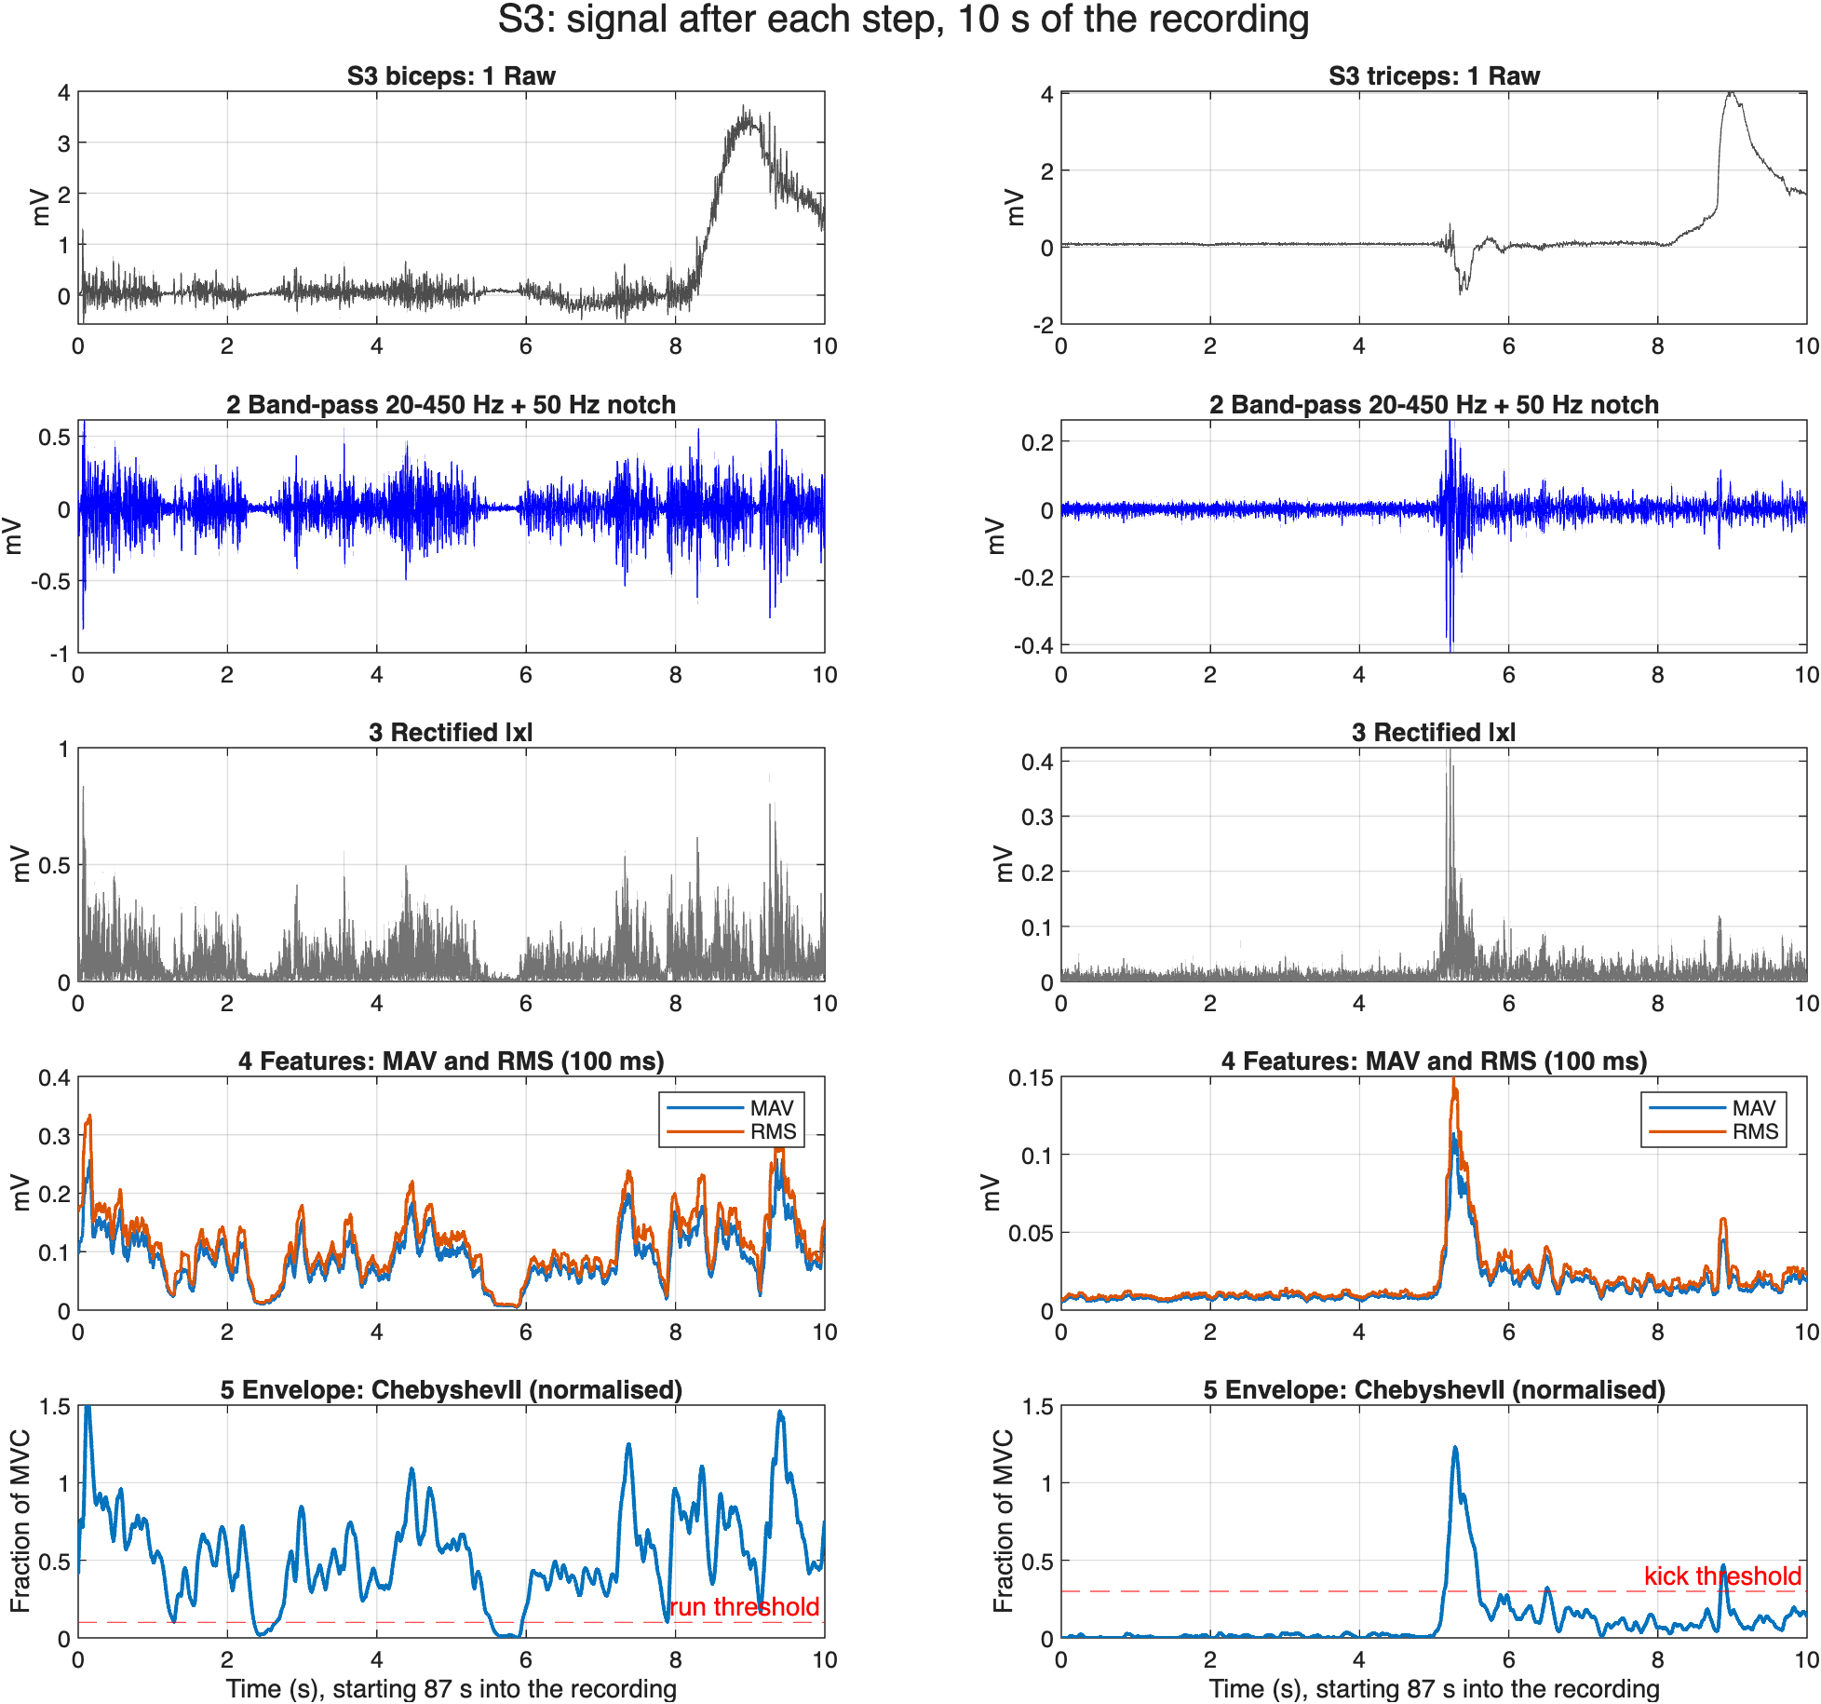
Fig C2 – 10 s of S3’s recording after each step: raw, band-pass + notch, rectified, MAV/RMS features, normalised Chebyshev II envelope. The band-pass removes a 3.5–4 mV movement artefact.
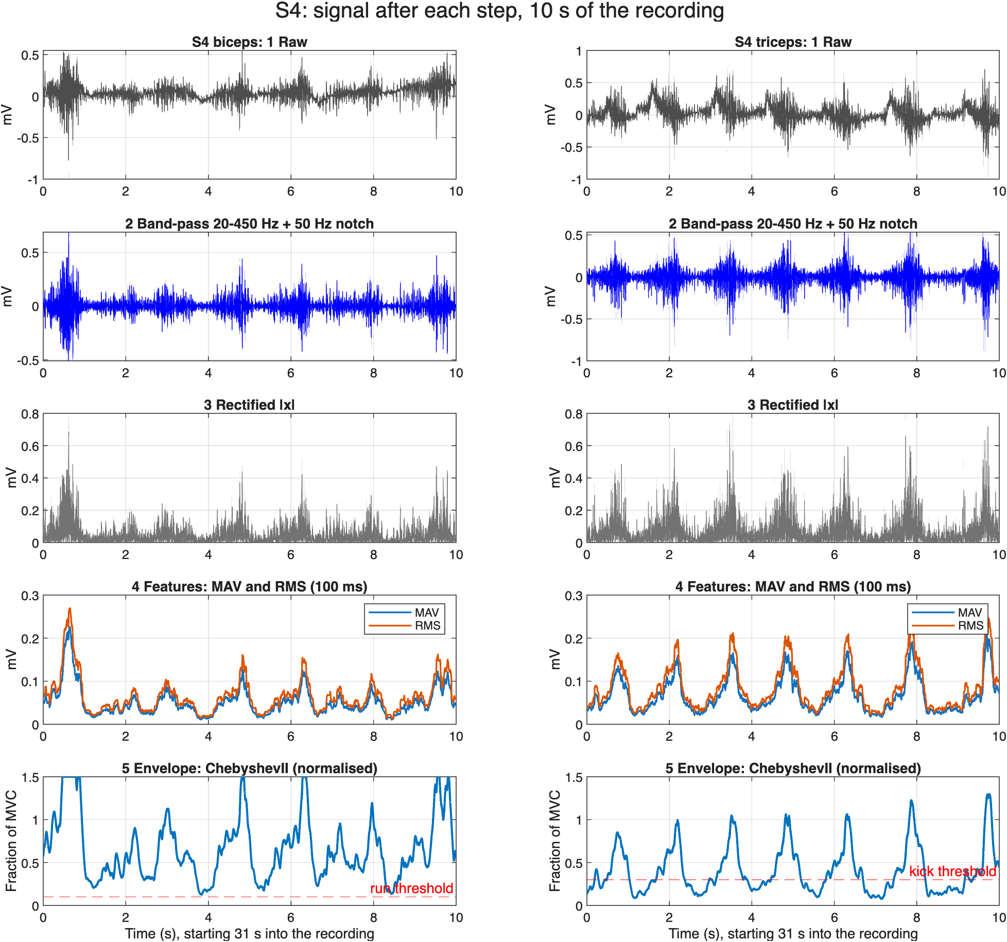
Fig C3 – the same steps for S4: the envelope never returns below the run threshold because of S4’s weak calibration.
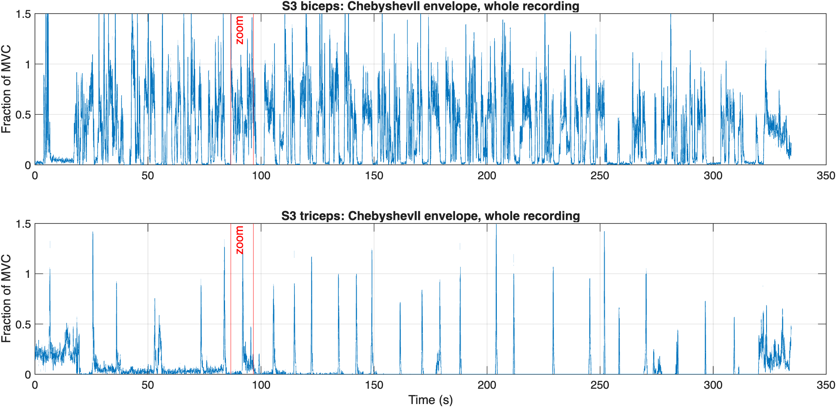
Fig C4 – S3’s whole recording through Chebyshev II, with the 10 s zoom marked. The triceps is tense during the first ~20 s and last ~15 s.
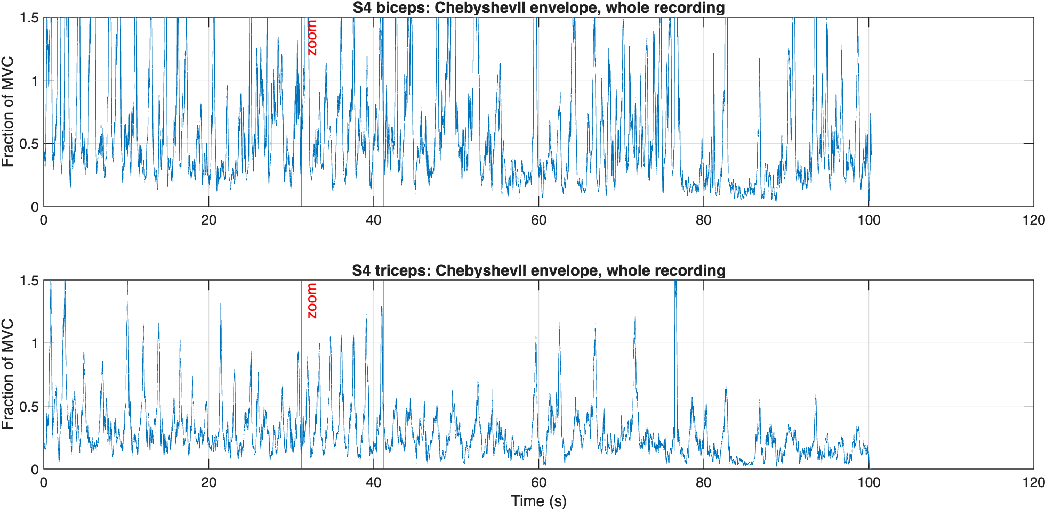
Fig C5 – S4’s whole recording through Chebyshev II, with the 10 s zoom marked. The biceps baseline stays raised for the whole recording.
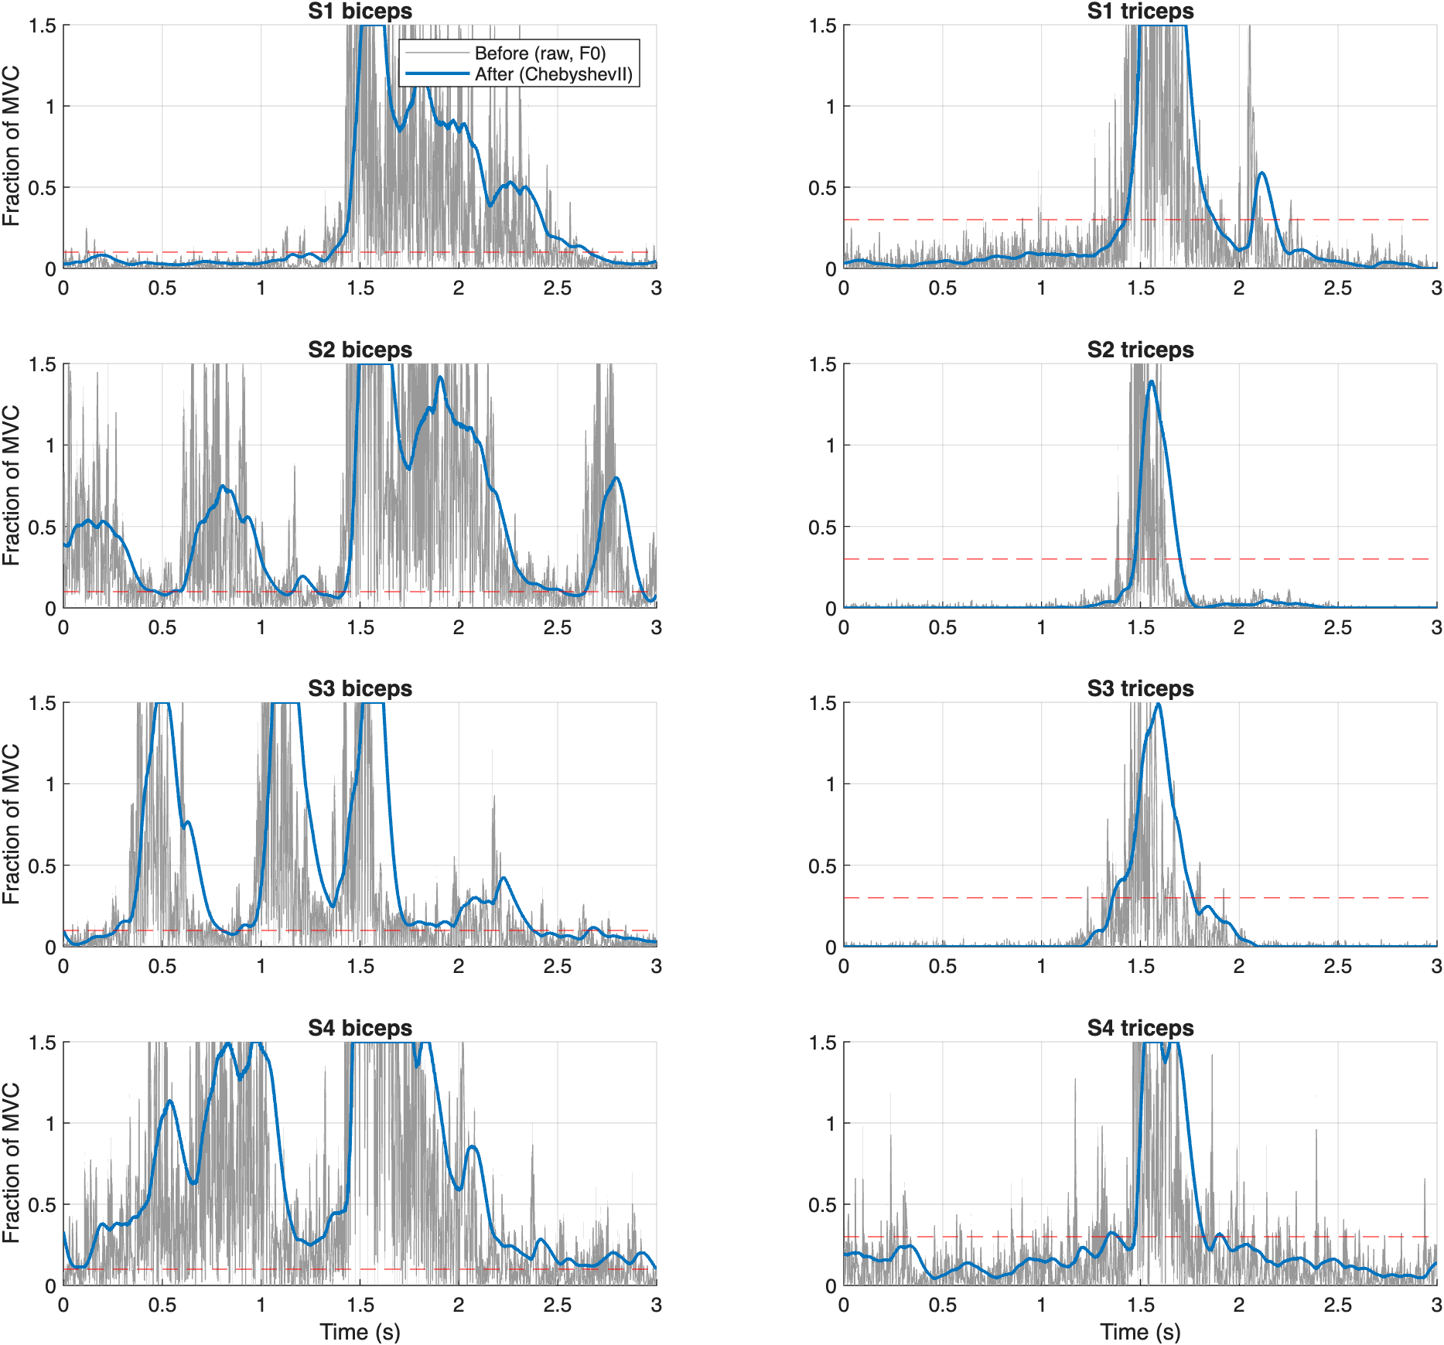
Fig C6 – each subject’s strongest burst: raw rectified signal (grey) vs Chebyshev II envelope (blue), with the run or kick threshold.
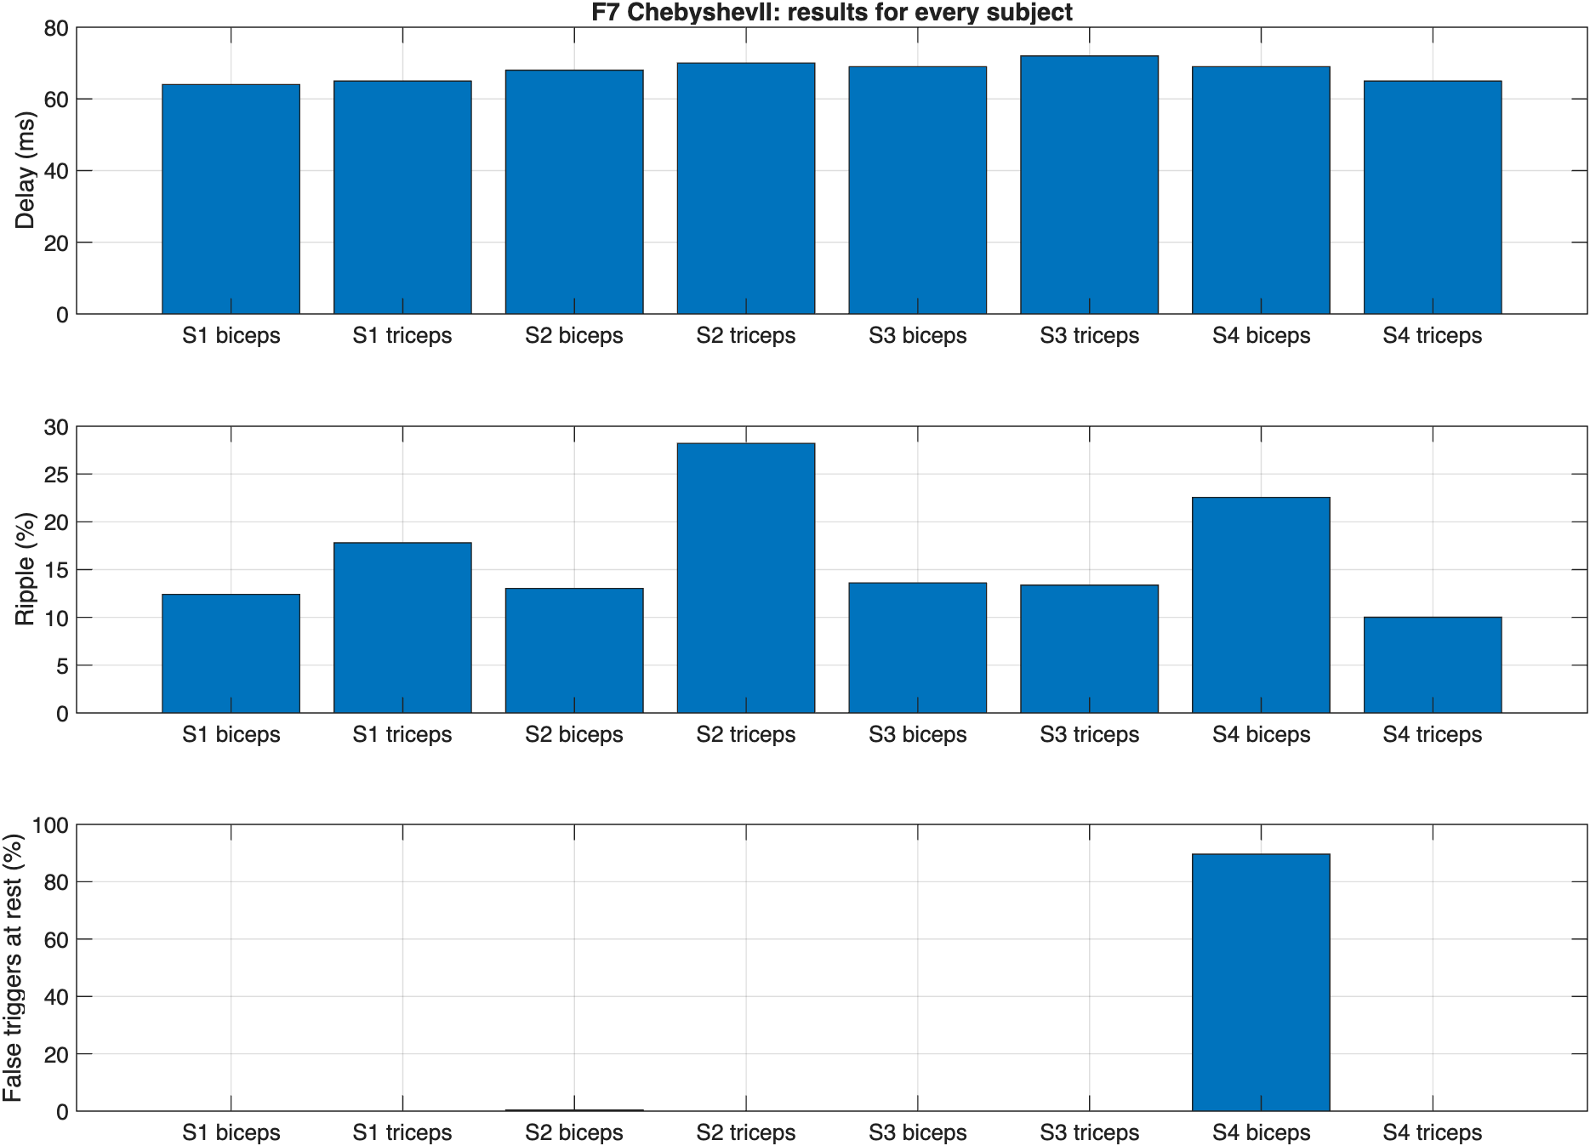
Fig C7 – delay, ripple and false triggers at rest for every subject and muscle. S2’s biceps bar (0.39%) is too small to see at this scale.
Figs C2–C3 show a 10 s segment (marked on Figs C4–C5) chosen automatically as the most active part of each recording; all values are computed on the full recordings.

3.5 Game testing and real-time integration (Bhavya Chaudhary)

What was tested in the game
S2, the game tester, played 5-minute rounds with F2, F3, F5 and F7, in that order with an F6 round between F5 and F7 (not used, Section 2.2), followed by one reaction test. All game results below are S2’s. Dhruval Naik’s Chebyshev I pipeline was not played; it is compared with the others offline on S2’s recorded EMG, with his own code. The filter running in each round was read from the Python recording; the first round, labelled F0 in the game, was played with F2, and the reaction test was also run with F2. The game rules were the same in every round (Section 2.6).

Game performance per filter (Fig G1)
With Butterworth (F3), S2 was tackled once in 5 minutes and scored 21 goals; Chebyshev II (F7) scored the most goals (22) with the highest shooting accuracy (79%).
Filter (order played) | Goals | Shots | Acc. (%) | Saves | Misses | Tackles | Time to score (s) | Kick power
F2 Moving RMS (1st) | 12 | 23 | 52 | 13 | 11 | 9 | 8.3 | 0.76
F3 Butterworth (2nd) | 21 | 30 | 70 | 18 | 8 | 1 | 8.2 | 0.60
F5 Kalman on RMS (3rd) | 12 | 23 | 52 | 18 | 10 | 7 | 10.1 | 0.48
F7 Chebyshev II (5th) | 22 | 28 | 79 | 16 | 6 | 6 | 7.7 | 0.76

All rounds: S2, 5 minutes each. A tackle means the player ran into a defender while carrying the ball. Kicks without the ball: 1 with F2, 0 with the others.
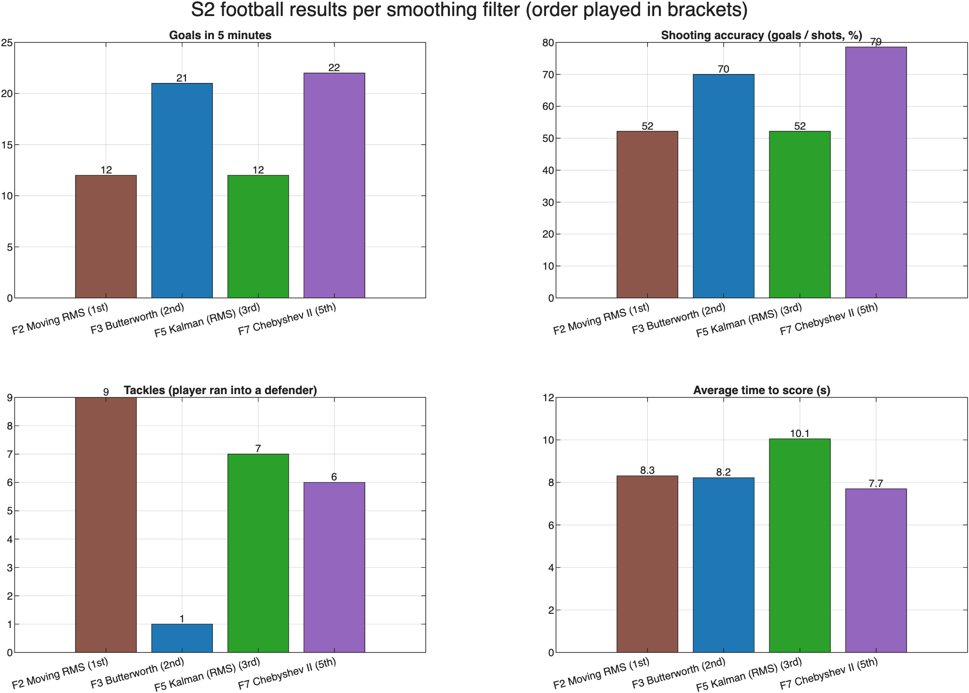
Fig G1 – S2’s goals, shooting accuracy, tackles and average time to score for each smoothing filter (order played in brackets).

Smoothness of movement (Fig G2)
Butterworth gave the steadiest run command (11.9% ripple); Chebyshev II had the fewest short stops (14.6 per minute), and Kalman the most.
Filter | Run starts / min | Flickers / min (stops shorter than 0.2 s) | Run-command ripple (%)
F2 Moving RMS | 31.2 | 21.2 | 13.8
F3 Butterworth | 32.4 | 19.6 | 11.9
F5 Kalman on RMS | 40.2 | 25.4 | 15.5
F7 Chebyshev II | 30.0 | 14.6 | 12.2

Measured from the game’s per-frame log of S2’s run command, only while the player had the ball. Ripple is the fast wobble above 3 Hz as % of the command’s mean.
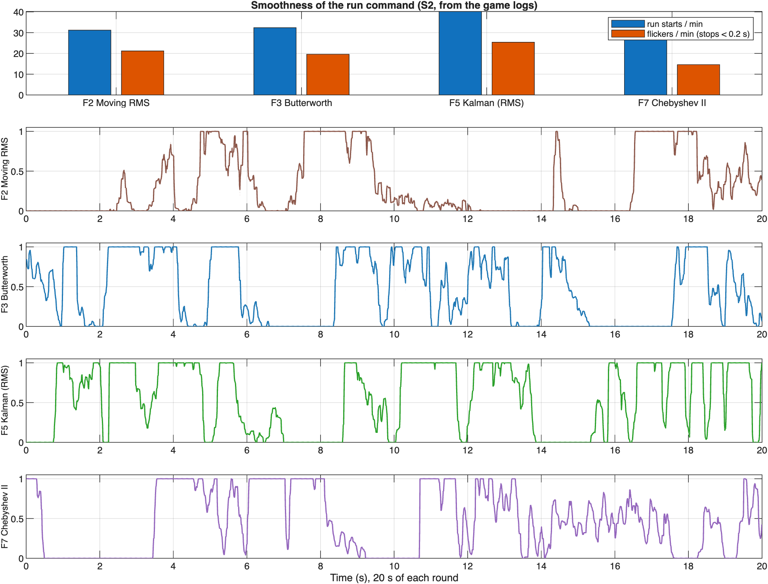
Fig G2 – run starts and short stops per minute (top) and 20 s of S2’s run command in each round (0 = stand still, 1 = full speed).

Response time (Fig G3, Fig G4)
S2’s own reaction time was about 390 ms; the filters added 4–30 ms when starting to run and 89–102 ms when stopping.
Reaction test (S2, with F2, 20 cues). Median times were 393 ms to start running after FLEX, 426 ms to stop after RELAX and 870 ms to kick after KICK (this includes the 0.3 s kick window). There were no misses, 4 false starts and 1 false kick. Subtracting F2’s own delay gives S2’s reaction: about 390 ms to start, 331 ms to stop and 535 ms to kick.
Response time per filter = S2’s reaction + the filter’s delay. The filter delays come from the step test (0 → 0.5 MVC → 0). Only F2 was measured in the game; the other reaction times are estimates. The Chebyshev I pipeline was not played, so its row uses the same step test on its 120 ms Hamming RMS.
Filter | Filter delay: start (ms) | Filter delay: stop (ms) | Start reaction (ms) | Stop reaction (ms) | Kick reaction (ms)
F2 Moving RMS | 4 | 95 | 393 (measured) | 426 (measured) | 870 (measured)
F3 Butterworth | 30 | 89 | 419 (est.) | 420 (est.) | 902 (est.)
F5 Kalman on RMS | 12 | 102 | 401 (est.) | 433 (est.) | 881 (est.)
Chebyshev I pipeline | 18 | 101 | 407 (est.) | 432 (est.) | 885 (est.)
F7 Chebyshev II | 30 | 89 | 419 (est.) | 420 (est.) | 901 (est.)
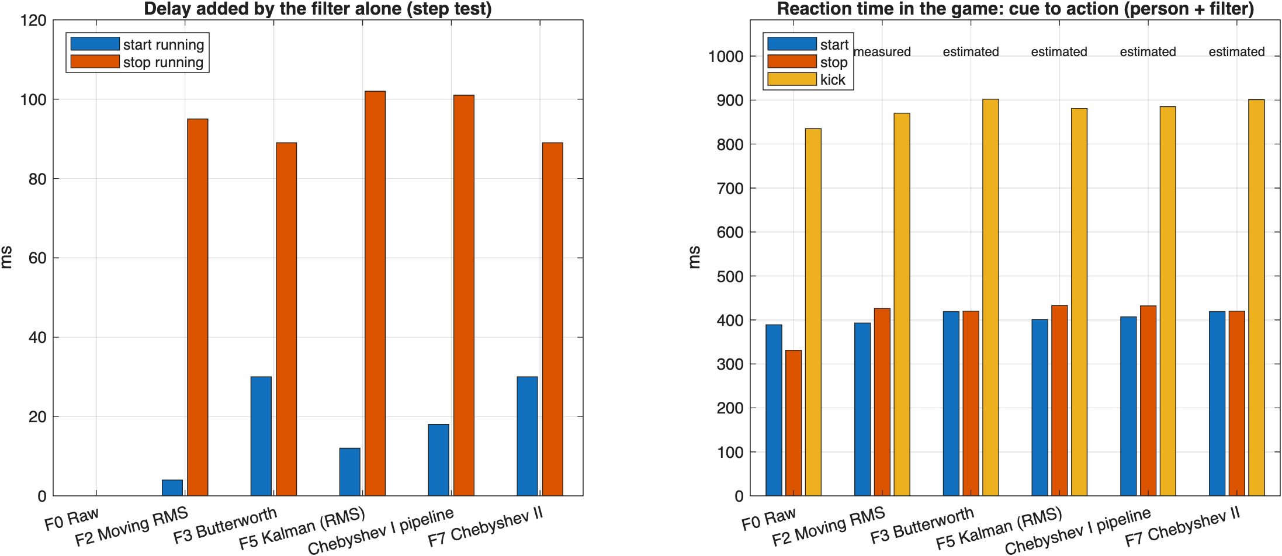
Fig G3 – delay added by each filter alone in the step test (left) and the resulting reaction time in the game, measured for F2 and estimated for the others (right).
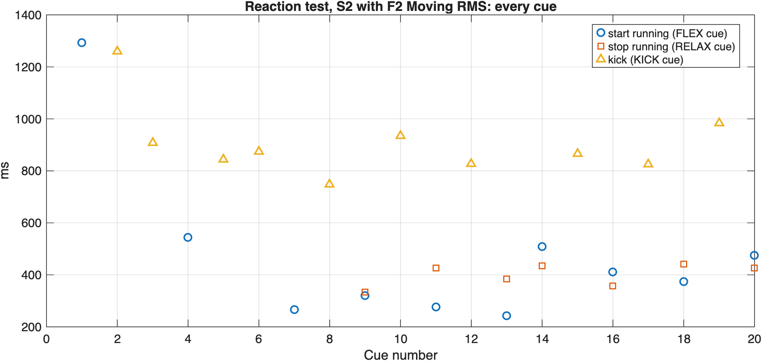
Fig G4 – S2’s reaction test with F2: time from each cue to starting, stopping or kicking.

Raw vs processed in the game (Fig G5, Fig G6)
With raw (unsmoothed) EMG the player would start and stop about 64 times per second; every smoothing filter brings this down to under one stop per second.
No round was played with raw EMG. Instead, all of S2’s recorded EMG (28.9 min) was passed through every filter, including F0 Raw and the Chebyshev I pipeline (run with his own code), and then through the game’s run and kick rules, so every filter sees exactly the same muscle activity.
Filter | Flickers / min | Run starts / min | Kicks / min | Biceps ripple (%)
F0 Raw | 3851 | 3859 | 6.0 | 63.5
F2 Moving RMS | 41.1 | 58.7 | 5.1 | 16.3
F3 Butterworth | 25.2 | 42.4 | 5.0 | 14.0
F5 Kalman on RMS | 25.6 | 43.1 | 5.1 | 15.0
Chebyshev I pipeline | 31.1 | 48.7 | 5.1 | 15.4
F7 Chebyshev II | 31.3 | 48.4 | 5.0 | 13.9

Fig G6 shows the same 8 s of S2’s biceps through each filter: F0 crosses the run threshold hundreds of times, while each smoothed envelope crosses it about once per contraction.
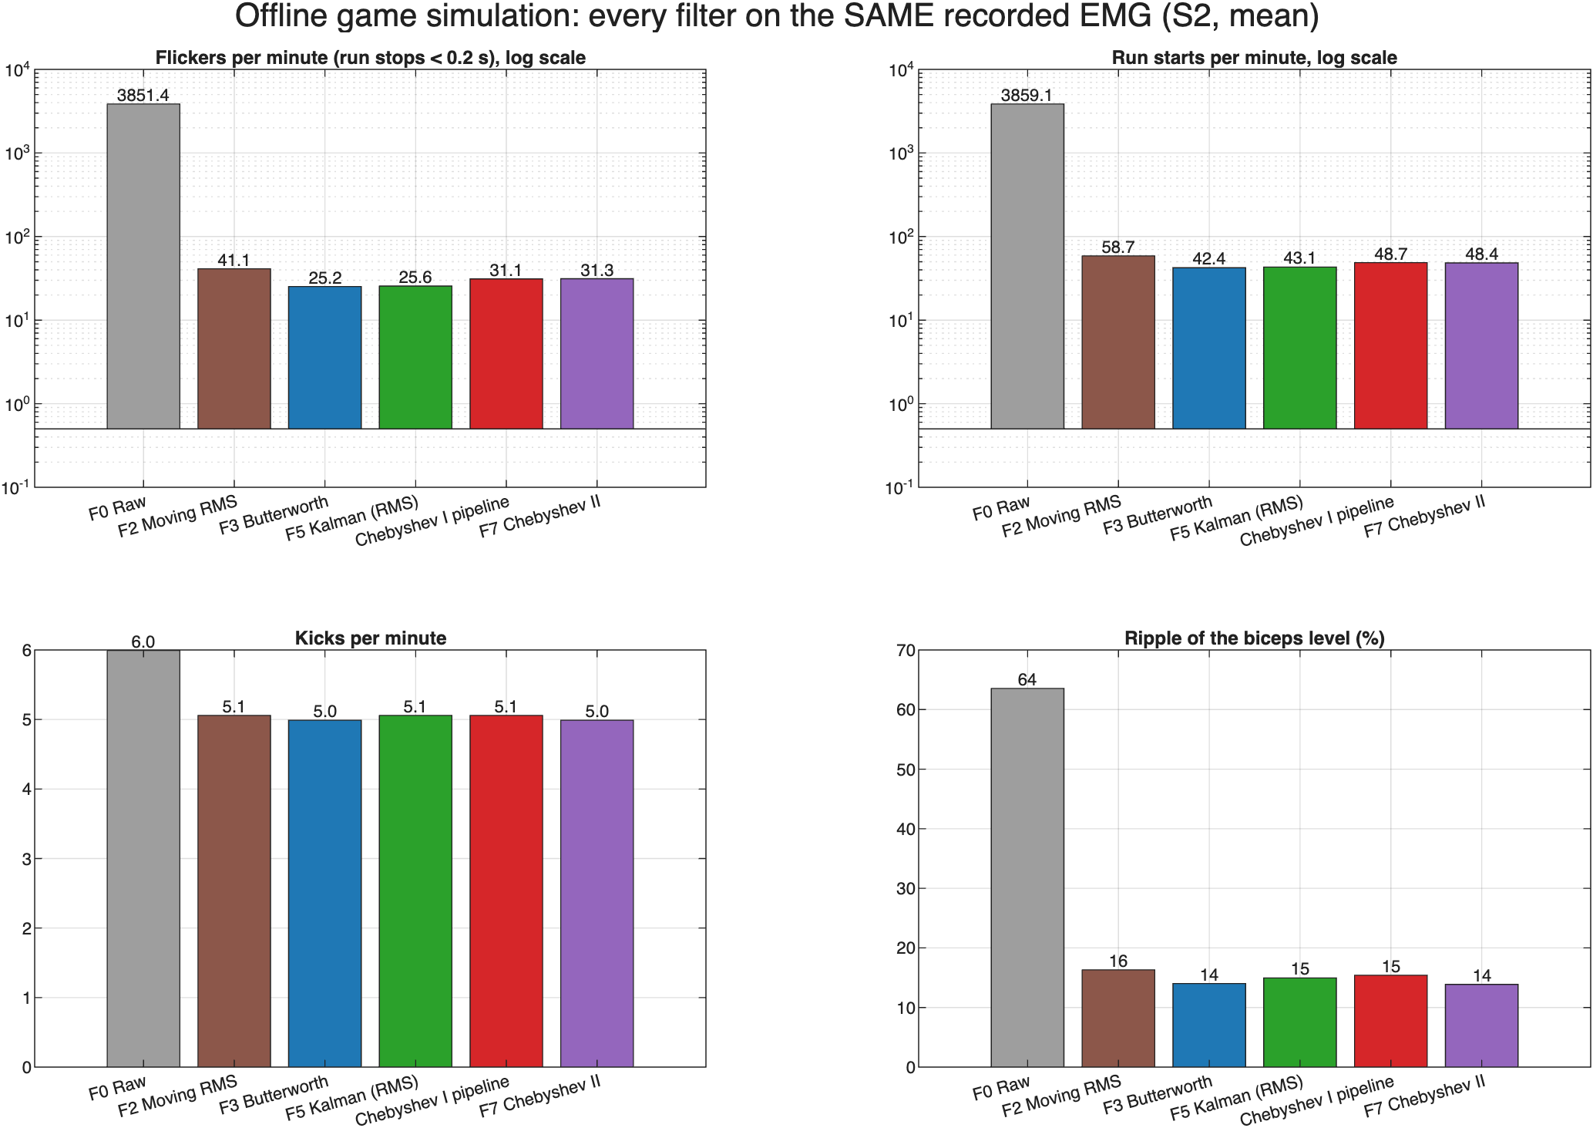
Fig G5 – every filter applied offline to the same 28.9 min of S2’s EMG and passed through the game’s rules: short stops, run starts, kicks and biceps ripple (top panels on a log scale).
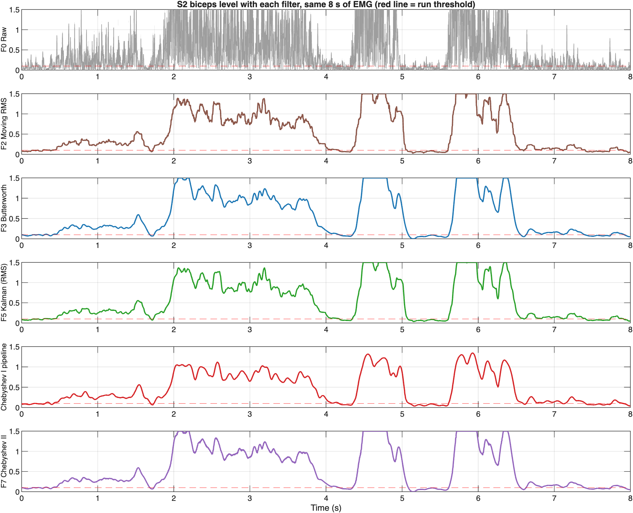
Fig G6 – the same 8 s of S2’s biceps through each filter, with the run threshold (red).

Alternative pipeline in the game simulation
On the same 28.9 min of S2’s EMG, Dhruval Naik’s Chebyshev I pipeline gave 31.1 short stops per minute under the game’s run rule, against 25.2 for Butterworth; adding hysteresis cut short stops by 46–50% for both.
Dhruval’s pipeline (Section 3.3) was not played, so it was simulated in the same way as raw EMG, using his own MATLAB code: S2’s recorded EMG was passed through his Chebyshev I band-pass (order 4, 0.5 dB ripple, 20–450 Hz), his comb notch at 50, 150 and 250 Hz (pole radius r = 1 − ω₀/70, i.e. 0.996, 0.987 and 0.978), his 120 ms Hamming RMS, and his normalisation with S2’s F2 calibration levels and tanh soft clipping, and then through the game’s rules. Butterworth is taken from the same simulation (Section 3.5, raw vs processed). Each envelope was also tested with two hysteresis rules for running: the game’s 0.10 threshold with a release at 0.072 (the same 72% ratio as Dhruval’s trigger), and his own Schmitt trigger (on at 0.25, off at 0.18).
Envelope | Run rule | Short stops / min | Run starts / min | Kicks / min | Biceps ripple (%)
F3 Butterworth | game: on/off at 0.10 | 25.2 | 42.4 | 5.0 | 14.0
Chebyshev I pipeline | game: on/off at 0.10 | 31.1 | 48.7 | 5.1 | 15.4
F3 Butterworth | hysteresis: on 0.10, off 0.072 | 13.6 | 28.1 | 5.0 | 14.0
Chebyshev I pipeline | hysteresis: on 0.10, off 0.072 | 15.7 | 31.0 | 5.1 | 15.4
F3 Butterworth | Schmitt: on 0.25, off 0.18 | 7.6 | 28.9 | 5.0 | 14.0
Chebyshev I pipeline | Schmitt: on 0.25, off 0.18 | 10.0 | 31.7 | 5.1 | 15.4

In the step test (0 → 0.5 MVC → 0) Dhruval’s Hamming RMS crosses the run threshold after 18 ms and drops below it 101 ms after release, with no overshoot (Butterworth: 30 ms, 89 ms, 4.3%). Kicks are the same in every row because the kick rule already has hysteresis and does not depend on the run rule.

4 Analysis
Each member analyses their own results.

4.1 Butterworth low-pass, F3 (Bhavya Chaudhary)
The cleaning steps make the muscle activity stand out, and the Butterworth filter turns it into a smooth level at the cost of a fixed delay of about 65–72 ms.
1. Why the raw signal needs cleaning. In the raw signal, the DC offset and slow drift (below 20 Hz) are larger than the muscle activity itself. They are present during both rest and contraction, so the raw activity-to-rest ratio is only −0.4 to 9 dB. Removing them with the band-pass, and the 50 Hz hum with the notch, raises it to 15–38 dB. The same step removed a 3.5–4 mV movement artefact in S3 (Fig B2), which would otherwise look like a strong contraction.
2. Why a smoothing filter is needed. After rectification the EMG still jumps between 0 and 1.5 MVC within milliseconds (Fig B7), because it is made of many random motor-unit spikes. The information about how hard the muscle works lies in its slow changes, below a few hertz. A 4 Hz low-pass keeps those and removes the rest (Fig B1, Fig B6).
3. Why the delay is the same for everyone. Butterworth delays the 0–4 Hz band by 56–68 ms (Fig B1). That matches the 65–72 ms measured on real data. The delay is a property of the filter, not of the person, so it stays almost constant across subjects and muscles (Fig B8).
4. Why ripple differs between recordings. Ripple was 12–14% for S1–S3’s biceps, 18% and 28.4% for S1’s and S2’s triceps, and 22.7% for S4’s biceps (Fig B8). A likely reason, not measured directly: biceps contractions during running were long and steady, while triceps contractions for kicks were short bursts of under a second (Fig B2), so their envelope contains relatively more fast change. S4’s biceps signal was very weak, so noise probably made up a larger share of its envelope.
5. Why there are almost no false triggers. Butterworth is maximally flat in the passband, with no ripple, so after a contraction it overshoots by only 4.3% and then settles. For S1–S3 the resting envelope stays well below the run (0.10) and kick (0.30) thresholds, giving 0% false triggers except 0.39% for S2’s biceps. S4’s biceps is the exception (89.6%), explained in point 8.
6. MAV and RMS features. Both track the contractions in the same way (Fig B2). During activity, RMS was 1.23–1.32 times MAV for every subject and muscle (RMS/MAV ratio in the MATLAB results table), close to the 1.25 expected for a random, Gaussian-like signal such as surface EMG.
7. Smoothness vs delay. A lower cutoff would give a smoother envelope but more delay; a higher cutoff the reverse. At 4 Hz the envelope crosses the thresholds once per contraction (Fig B7), while adding only about 0.1 s when the muscle relaxes.
8. Why S4 behaves differently. S4’s calibrated biceps maximum was only 0.07 mV, against 0.16–0.54 mV for S1–S3. Dividing by such a small maximum inflates every level, so S4’s relaxed biceps read about 0.19 MVC and stayed above the run threshold for 89.6% of rest time. The filter itself behaved normally (66–69 ms delay), so this is a calibration and electrode problem, not a filter problem. It shows that controlling the game depends on a good calibration as much as on the filter.

4.2 Kalman filter on RMS, F5 (Jashan Saini)
F5 (100 ms moving RMS followed by a scalar Kalman filter with q/r = 0.01) gives a 12 ms start, a 102 ms stop and no overshoot in the step test, about 66 ms delay behind the ideal envelope and 16% ripple on real data. In the offline kick estimate over 142 kicks from S1–S4 it reached 94.4% recall and 78.8% precision, with about a quarter fewer false kicks than the plain RMS envelope. Butterworth and Chebyshev II were slightly more precise overall (81%), but only because of S4’s bad calibration; without S4, F5 fired the fewest false kicks.
1. What the Kalman filter does here. With constant Q and R the gain settles to 0.095 within 30 ms, so in steady state F5 is a first-order low-pass with a 10 ms time constant applied to the RMS. It is the optimal estimator only if the activation really is a random walk measured with constant noise. EMG noise grows with activation, so a constant R is a simplification; an adaptive R would be the next step.
2. Trade-off. F5 reaches the same delay and ripple as F3 and F7 and similar kick accuracy. Its advantages are a faster start (12 against 30 ms), no overshoot, unity gain on the RMS scale (so the calibration stays consistent) and very low cost: one multiply-add per sample once the gain has settled. Its disadvantage is a slower release (102 against 89 ms), so the player keeps running about 13 ms longer after the biceps relaxes.
3. Choice of q/r. q/r = 0.01 gives the same delay and ripple as F3 and F7 and about a quarter fewer false kicks than plain RMS. A smaller q/r (0.001) smooths more (13.3% ripple) but adds about 20 ms of delay, which would make the game feel slower (Table K4, Table K5).
4. Notch. Whether the notch is needed depends on the recording conditions: S4’s 30 Oct recording had no mains peak, but the notch removed real mains peaks on 9 Nov. Keeping it costs a few per cent of EMG power and makes the pipeline robust to both conditions.
5. Calibration matters more than the filter. The largest errors came from S4 (MVC too low) and S2’s triceps (MVC too high), not from the choice of smoother. A check of the game peak against 100% MVC should be part of every session, and a subject whose game peak is far from 100% MVC should be recalibrated.

4.3 Chebyshev I band-pass and alternative pipeline (Dhruval Naik)

Stage 1: Chebyshev Type I band-pass filter (20–450 Hz)
(Frequency band-pass filtering of LTI signals, placement of poles)
Our raw CSV data had large DC offsets (peaking at about 7 mV for subject 3), as well as slow movement drift below 20 Hz. It also had noise above 450 Hz. We therefore used a band-pass filter to remove these frequencies and confine the EMG to 20–450 Hz. Although a Butterworth filter’s passband is flat, its cutoff slope is gentle. I used a Chebyshev Type I filter instead, with a much steeper cutoff at around 20 Hz, which blocks 3.80 dB more noise than a Butterworth. The Chebyshev I filter does have a small 0.5 dB passband ripple, but it does not harm the signal because the RMS stage sums the total signal power.

Stage 2: Multi-harmonic comb notch filter (50, 150, 250 Hz)
(Pole-zero placement in the z-plane, Fourier harmonics)
Transfer function of the notch:
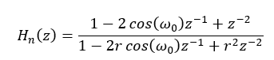
There is 50 Hz interference from the mains inside the band of muscle frequencies. Non-linear loads such as laptop chargers also create odd harmonics of 50 Hz at 150 Hz (3rd harmonic) and 250 Hz (5th harmonic). I placed zeros on the unit circle (z = e^(±jω)) to make the gain zero at 50, 150 and 250 Hz, and placed poles just inside the unit circle at about r = 0.99 to keep each notch very narrow, so that useful frequencies are not removed. The comb targets the odd harmonics only, so the small even-harmonic peak at 100 Hz in S3’s triceps (+3.5 dB, Table K3) is not removed; its power is small.

Stage 3: Moving RMS with a Hamming window
(Convolution in discrete time, short-time average power, window functions)
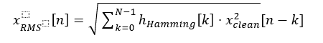
The filtered EMG has zero mean, with positive and negative spikes, so its direct average would be zero. I therefore took its root mean square over a sliding Hamming window to track the short-time power of the muscle. Full-wave rectification is not needed, because squaring already makes the whole signal positive. Instead of a flat rectangular window, I used a 120 ms Hamming window, w(n) = 0.54 − 0.46 cos(2πn/(N−1)). Its tapered sides attenuate the frequency sidelobes to −43 dB, making the envelope much smoother than the sharp edges of a rectangular window, which leak high-frequency ripple into the envelope. The Hamming window adds less than 60 ms of delay.

Stage 4: Normalisation with soft clipping (tanh)
(Removing offsets, scaling amplitude, non-linear compression)
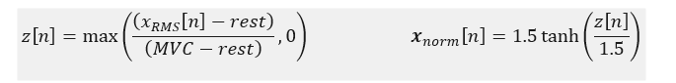
In our dataset, subject 1’s biceps MVC was 7.3 times as strong as subject 4’s. I subtracted each player’s rest level and divided by MVC − rest, which removes the offset and maps all four players to the same scale, where 0 means rest and 1 means 100% MVC (Fig D2). Instead of hard-clipping values above 1.5, I soft-clipped them with tanh, which rounds off peaks smoothly instead of creating a sudden flat ceiling when subjects 3 and 4 flex harder than during calibration.

Stages 5 and 6: Schmitt trigger hysteresis and PSD verification
(Hysteresis in dynamic systems, Welch PSD)
With a single threshold at 0.25, whenever a player’s muscle level stays around 0.25, small noise fluctuations make the game command flicker between 0 and 1 (in subject 4’s data there are nearly 360 switches between 0 and 1 around 0.25). My Schmitt trigger uses two thresholds: the muscle level must rise above 0.25 to turn on and fall below 0.18 to turn off. This cut unwanted flickering by about 47.4%. Finally, the Welch power spectral density before and after filtering (Fig D1, B) confirms that the drift below 20 Hz and the harmonic spikes at 50, 150 and 250 Hz have been removed, while the useful 20–450 Hz spectrum is preserved.

4.4 Chebyshev II low-pass, F7 (Shreyas Jadhav)
The cleaning steps make the muscle activity stand out, and the Chebyshev II filter turns it into a smooth level at the cost of a fixed delay of about 64–72 ms, behaving almost exactly like Butterworth.
1. Why the raw signal needs cleaning. In the raw signal, the DC offset and slow drift (below 20 Hz) are larger than the muscle activity itself. They are present during both rest and contraction, so the raw activity-to-rest ratio is only −0.4 to 9 dB. Removing them with the band-pass, and the 50 Hz hum with the notch, raises it to 15–38 dB. The same step removed a 3.5–4 mV movement artefact in S3 (Fig C2), which would otherwise look like a strong contraction.
2. Why a smoothing filter is needed. After rectification the EMG still jumps between 0 and 1.5 MVC within milliseconds (Fig C6), because it is made of many random motor-unit spikes. The information about how hard the muscle works lies in its slow changes, below a few hertz. A 4 Hz low-pass keeps those and removes the rest (Fig C1, Fig B6).
3. Why the delay is the same for everyone. Chebyshev II delays the 0–4 Hz band by 56–68 ms (Fig C1). That matches the 64–72 ms measured on real data. The delay is a property of the filter, not of the person, so it stays almost constant across subjects and muscles (Fig C7). The step test’s start delay (30 ms) is shorter, because the envelope reaches 0.10, only a fifth of the 0.5 step, early in its rise.
4. Why ripple differs between recordings. Ripple was 12–14% for S1–S3’s biceps, 17.8% and 28.2% for S1’s and S2’s triceps, and 22.6% for S4’s biceps (Fig C7). A likely reason, not measured directly: biceps contractions during running were long and steady, while triceps contractions for kicks were short bursts of under a second (Fig C2), so their envelope contains relatively more fast change. S4’s biceps signal was very weak, so noise probably made up a larger share of its envelope.
5. Why there are almost no false triggers. Chebyshev II is flat in the passband, with no ripple, so after a contraction it overshoots by only 4.4% and then settles. For S1–S3 the resting envelope stays well below the run (0.10) and kick (0.30) thresholds, giving 0% false triggers except 0.39% for S2’s biceps. The small dip below zero after release is clipped to 0 by the normalisation, so it cannot trigger anything. S4’s biceps is the exception (89.6%), explained in point 8.
6. MAV and RMS features. Both track the contractions in the same way (Fig C2). During activity, RMS was 1.23–1.32 times MAV for every subject and muscle (RMS/MAV ratio in the MATLAB results table), close to the 1.25 expected for a random, Gaussian-like signal such as surface EMG. These features are computed before smoothing, so they are the same for every filter.
7. Smoothness vs delay. A lower cutoff would give a smoother envelope but more delay; a higher cutoff the reverse. For a filter of this shape the delay scales with 1/cutoff, so a 2 Hz cutoff would roughly double the 56–68 ms group delay (Fig C1). At 4 Hz the envelope crosses the thresholds once per contraction (Fig C6), while adding only 89 ms when the muscle relaxes, small next to S2’s reaction time of about 390 ms.
8. Why S4 behaves differently. S4’s calibrated biceps maximum was only 0.07 mV, against 0.16–0.54 mV for S1–S3. Dividing by such a small maximum inflates every level, so S4’s relaxed biceps read about 0.19 MVC and stayed above the run threshold for 89.6% of rest time. The filter itself behaved normally (65–69 ms delay), so this is a calibration and electrode problem, not a filter problem. The transferred Butterworth calibration is almost exact for Chebyshev II, because their levels agree within 0.3% for every subject.
9. What makes Chebyshev II different from Butterworth. Both filters have their poles at almost the same place, so their delay and step response match. They differ only in the stopband: Chebyshev II puts its zeros at 40 Hz, so it is steeper just above the cutoff but stops at a −40 dB floor, while Butterworth keeps falling (Fig C1).
Property | F7 Chebyshev II | F3 Butterworth
Step test: start / stop delay | 30 / 89 ms | 30 / 89 ms
Overshoot | 4.4% | 4.3%
Gain at 28 Hz | −40 dB | −34 dB
Gain at 100 Hz | −41 dB | −56 dB
Delay on real data | 64–72 ms | 65–72 ms
Ripple on real data | 10.0–28.2% | 10.1–28.4%
Short stops per minute, game test (S2’s EMG, offline) | 31.3 | 25.2

On real data the steeper roll-off between 5 and 28 Hz gives 0.1–0.2 points less ripple and 0–1 ms less delay than Butterworth in every recording; these differences are far smaller than those between subjects. The −40 dB floor lets about 1% of the fast fluctuation through, visible as a tiny jump (0.005 MVC) at the first sample of the step (Fig C1). This is a possible reason why, on the same EMG, Chebyshev II gave more short stops in the game test, when the envelope hovers near the run threshold.

4.5 Game testing and real-time integration (Bhavya Chaudhary)
Smoothing decides whether the game is playable at all; between the smoothing filters the differences in play are smaller, and Butterworth and Chebyshev II performed best.
1. Raw vs processed. Without smoothing, the spikes of the rectified EMG cross the run threshold constantly, so the player would stutter about 3,850 times per minute (Section 3.5). Every smoothing filter cuts this by about 99%, to 25–41 per minute, and lowers the biceps ripple from 64% to 14–16%. Kicks change much less (6.0 vs about 5.0 per minute), likely because a kick needs the triceps to drop below 20% and wait 0.7 s before the next one. Compared with raw, the differences between the smoothing filters are small.
2. Response time is dominated by the person. The filters add 4–30 ms when starting and 89–102 ms when stopping, while S2’s own reaction was about 390 ms. S2’s reaction also varied from cue to cue: the mean start time (471 ms) was 78 ms above the median (393 ms). The estimated reaction times of the filters differ by at most 30 ms, which is smaller than this variation (Fig G3, Fig G4).
3. Butterworth and Chebyshev II behave alike. Both reach the run threshold in 30 ms, drop below it in 89 ms and overshoot by about 4%. In play they gave the best results: 21 and 22 goals, 70% and 79% accuracy, 1 and 6 tackles. Chebyshev II was played last, so part of its higher accuracy may come from practice.
4. Kalman on RMS scored slowest. It took the longest to score (10.1 s), scored the fewest goals (12, equal with F2) and had the weakest kicks (mean power 0.48). It also had the most short stops in play (25.4 per minute). In the offline simulation on S2’s recorded EMG, however, it stuttered about as much as Butterworth (25.6 vs 25.2 per minute), so the extra stops in play probably came from how S2 played that round rather than from the filter.
5. Order and practice. The filters were played in a fixed order, and the first round (F2) together with F5 gave the fewest goals. Results from one player and one round per filter are therefore trends. The filter-only measures (step test and offline simulation) separate the filters’ own behaviour from the player’s.
6. Hysteresis helps more than any change of envelope. In the simulation, Dhruval’s Chebyshev I pipeline gave 23% more short stops than Butterworth (31.1 vs 25.2 per minute) and slightly more ripple (15.4% vs 14.0%), so its envelope does not beat Butterworth under the game’s rules. A likely reason is that its envelope is a moving RMS, which keeps more fast fluctuation than a 4 Hz low-pass, like F2 (41.1 per minute). Adding hysteresis to the run threshold, however, cut short stops by 46% for Butterworth (25.2 → 13.6) and 50% for Dhruval’s pipeline (31.1 → 15.7), much more than any difference between envelopes. The hysteresis in his design is therefore its most useful part for the game, and it works with any smoothing filter.

5 Conclusion
Cleaning and smoothing are both essential. The band-pass and notch remove drift, movement artefacts and mains hum, raising the activity-to-rest SNR from about 0–9 dB to 15–38 dB on every recording. Without smoothing the game is unplayable: raw EMG would make the player stop and start about 3,850 times per minute, and every smoothing filter cuts this by about 99%.
The smoothing filters behave similarly on real data. Butterworth and Chebyshev II give 64–72 ms of delay and Kalman 66 ms on average, 10–29% ripple and almost no false triggers at rest. In the step test the smoothing stages add 12–30 ms when a contraction starts and 89–102 ms when it stops, small next to the player’s reaction time of about 390 ms.
Filter | Step test start / stop (ms) | Overshoot | Delay on real data (ms) | Short stops / min (offline, S2) | Goals / tackles (S2, in play)
F3 Butterworth | 30 / 89 | 4.3% | 65–72 | 25.2 | 21 / 1
F5 Kalman on RMS | 12 / 102 | 0% | 66 (9 Nov mean) | 25.6 | 12 / 7
F7 Chebyshev II | 30 / 89 | 4.4% | 64–72 | 31.3 | 22 / 6
Chebyshev I pipeline (simulated) | 18 / 101 | 0% | – | 31.1 | not played

Butterworth is the best smoothing filter for the game; Chebyshev II comes close in play, and Kalman on the same recorded EMG. Butterworth gave the fewest short stops on the same EMG, the steadiest run command in play (11.9% ripple) and only one tackle in five minutes. Chebyshev II has the same timing and scored the most goals with the highest accuracy, but its −40 dB stopband floor is a possible reason for its extra short stops, and it was played last. Kalman never overshoots and starts fastest (12 ms) but stops slowest (102 ms); in the offline kick estimate over 142 kicks from S1–S4 it fired 36 false kicks against 31 for Butterworth, a gap that comes entirely from S4’s bad calibration. On the same recorded EMG Kalman was almost as smooth as Butterworth (25.6 against 25.2 short stops per minute) but did worse in play. Dhruval Naik’s Chebyshev I pipeline was not tested in the game, but the offline simulation on the same 28.9 min of S2’s EMG showed that Butterworth was better: 25.2 against 31.1 short stops per minute, 42.4 against 48.7 run starts per minute and 14.0% against 15.4% biceps ripple.
Hysteresis is the biggest improvement still available. Dhruval Naik’s Chebyshev I pipeline shows that a steeper Chebyshev I band-pass removes 3.8 dB more drift and a Schmitt trigger cuts command switches by 47.4% compared with a single threshold. In the game simulation on S2’s EMG his envelope gave more short stops than Butterworth (31.1 vs 25.2 per minute), but adding hysteresis to the run threshold cut short stops by 46% for Butterworth (to 13.6 per minute). The best combination found is therefore the Butterworth envelope with a hysteresis run threshold; the game’s kick already uses hysteresis (30% on, 20% off).
Calibration matters as much as the filter. S4’s weak biceps calibration (MVC 0.07 mV) gave about 90% false triggers at rest with both Butterworth and Chebyshev II. Because the game was tested on one player with one round per filter, in a fixed order, the game results are trends; the filter-only measures (step test and offline simulation) support the same ranking.

