**PIZZA SALES SQL QUERIES**

**A. KPI’s**

**1. Total Revenue:**

SELECT SUM(total_price) AS total_revenue FROM pizza_sales;

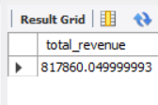

**2. Average Order Value**

SELECT SUM(total_price) / COUNT(DISTINCT order_id) AS average_order_value FROM pizza_sales;

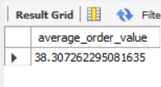

**3. Total Pizzas Sold**

SELECT SUM(quantity) AS total_pizza_sold FROM pizza_sales;

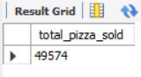

**4. Total Orders**

SELECT COUNT(distinct order_id) AS total_orders FROM pizza_sales; 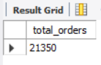

**5. Average Pizzas Per Order**

SELECT CAST(SUM(quantity)/COUNT(distinct order_id) AS DECIMAL (10,2)) AS avg_pizza_per_order

FROM pizza_sales;

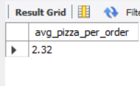

1. **Weekly Trend For Orders**

SELECT DAYNAME(order_date) AS order_day, COUNT(DISTINCT order_id) AS total_orders

FROM pizza_sales

GROUP BY DAYNAME(order_date);

***Output:***

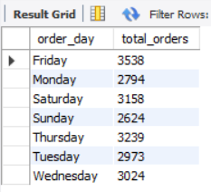

1. **Hourly Trend For Orders**

SELECT HOUR(order_time) AS order_hour, COUNT(DISTINCT order_id) AS total_orders

FROM pizza_sales

GROUP BY HOUR(order_time)

ORDER BY order_hour;

***Output***

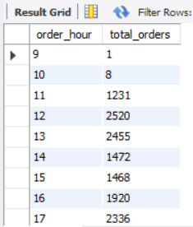

1. **% of sales by pizza category**

SELECT pizza_category , SUM(total_price) AS total_revenue, CAST(SUM(total_price)*100 / (SELECT SUM(total_price) FROM pizza_sales) AS DECIMAL (10,2)) AS PCT

FROM pizza_sales

GROUP BY pizza_category;

***Output***

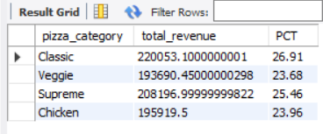

**E.% of sales by pizza size**

SELECT pizza_size , SUM(total_price) AS total_sales, CAST(SUM(total_price)*100 / (SELECT SUM(total_price) FROM pizza_sales) AS DECIMAL (10,2)) AS sales_percentage

FROM pizza_sales

GROUP BY pizza_size

ORDER BY sales_percentage DESC;

***Output***

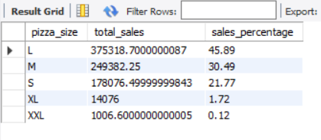

**F. Total Pizzas Sold by Pizza Category**

SELECT pizza_category , SUM(quantity) AS total_pizza_sold

FROM pizza_sales

GROUP BY pizza_category;

***Output***

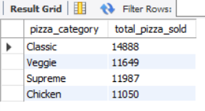

**G.Top 5 Best Sellers by Total Pizzas Sold**

SELECT pizza_name , SUM(quantity) AS total_pizzas_sold

FROM pizza_sales

GROUP BY pizza_name

ORDER BY total_pizzas_sold DESC

LIMIT 5;

***Output***

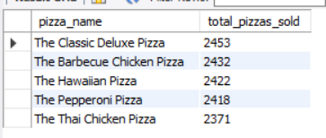

**H.Bottom 5 Best Sellers by Total Pizzas Sold**

SELECT pizza_name , SUM(quantity) AS total_pizzas_sold

FROM pizza_sales

GROUP BY pizza_name

ORDER BY total_pizzas_sold

LIMIT 5;

***Output***

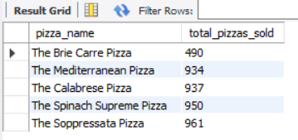

***NOTE***

If we want to apply the Month, Quarter, or Week filters to the below queries in **MySQL**, we can use the WHERE clause. Follow some of the examples below:

SELECT DAYNAME(order_date) AS order_day, COUNT(DISTINCT order_id) AS total_orders FROM pizza_sales WHERE MONTH(order_date) = 1GROUP BY DAYNAME(order_date);

Here MONTH(order_date) = 1 indicates that the output is for the month of January. MONTH(order_date) = 4 indicates output for the month of April.

SELECT DAYNAME(order_date) AS order_day, COUNT(DISTINCT order_id) AS total_orders FROM pizza_sales WHERE QUARTER(order_date) = 1GROUP BY DAYNAME(order_date);

Here QUARTER(order_date) = 1 indicates that the output is for Quarter 1. QUARTER(order_date) = 3 indicates output for Quarter 3.