# PHR systems

Personal Health Record (PHR) systems are electronic records that contain an individual's health information, which are maintained, owned, and managed by the individual. PHR systems provide a range of benefits, including access to medical information, improved communication with healthcare providers, increased patient engagement, and improved coordination of care.

PHR systems have several fundamental functionalities, including:

* Data Storage: PHR systems enable individuals to store their health data electronically, including medical history, allergies, medications, immunizations, and lab results.
* Data Management: PHR systems enable individuals to manage their health data, including adding new data, editing existing data, and deleting unwanted data.
* Data Sharing: PHR systems enable individuals to share their health data with healthcare providers, family members, and other authorized individuals.

PHR systems have several requirements, including:

* Data Privacy: PHR systems should be designed to protect the privacy of health data by using encryption, access control, and other security measures.
* Data Security: PHR systems should be designed to protect health data from unauthorized access, disclosure, or misuse.
* Interoperability: PHR systems should be designed to communicate with other healthcare systems to provide a comprehensive view of a patient's health data.
* User Experience: PHR systems should be designed to provide a user-friendly interface that is easy to use and navigate.
* Accessibility: PHR systems should be designed to be accessible to people with disabilities, such as visual impairments or hearing impairments.
* Scalability: PHR systems should be designed to handle a large volume of data and users.

PHR systems have several features, including:

* Health Summary: PHR systems provide a summary of a patient's health information, including medical history, allergies, medications, immunizations, and lab results.
* Medication Management: PHR systems enable individuals to manage their medications, including setting reminders, tracking refills, and monitoring interactions with other medications.
* Appointment Scheduling: PHR systems enable individuals to schedule appointments with healthcare providers.
* Secure Messaging: PHR systems enable individuals to communicate with healthcare providers securely.
* Health Tracking: PHR systems enable individuals to track their health data, such as blood pressure, blood sugar, and weight.
* Data Import/Export: PHR systems enable individuals to import and export their health data from other healthcare systems.

Challenges of PHR systems:

While PHR systems offer a range of benefits, they also pose challenges. Some of the key challenges associated with PHR systems include:

* Privacy and Security Concerns: Privacy and security concerns stem from the risk of unauthorized access or data breaches, which could lead to identity theft or other forms of fraud. The following are some of the security concerns associated with PHR systems:

1. Unauthorized Access
2. Data Breaches
3. Data Loss
4. Misuse of Data
5. Lack of Interoperability

* Technical Challenges: Technical challenges include interoperability, data integration, system reliability, data accuracy, and data completeness.
* Patient Engagement: Patient engagement can also be a challenge, as some patients may not be tech-savvy or have access to reliable internet or technology, and others may be reluctant to share their health information electronically due to concerns about privacy and security.

In summary, PHR systems have the potential to improve patient engagement, coordination of care, and health outcomes. However, there are also challenges with privacy and security, technical infrastructure, and patient engagement. As the healthcare industry continues to evolve, it will be important to address these challenges and to continue to improve the design and implementation of PHR systems.

Blockchain technology offers a potential solution to some of these security and privacy concerns by providing a decentralized, tamper- proof, and transparent system for managing health data. Implementing a Blockchain-based PHR system as a mobile app requires a comprehensive understanding of Blockchain technology and its various types and existing implementations/tools.

# Blockchains

Blockchain is a decentralized, distributed ledger technology that records transactions in a secure and transparent manner. It was originally introduced as the underlying technology for Bitcoin, a peer-to-peer electronic cash system, but its potential applications have expanded to various industries, including healthcare. The key features of Blockchain include decentralization, immutability, security, and transparency.

Blockchain can be classified into three types: public, private, and consortium. Public blockchains, such as Bitcoin and Ethereum, are open to anyone and allow anyone to participate in the network as a node. Private blockchains, on the other hand, are only accessible to a limited group of participants, and the access to the network is restricted. Consortium blockchains are a hybrid of public and private blockchains, where a group of organizations operates the network and controls the access to it.

There are several existing implementations and tools for Blockchain in healthcare. Some of the notable ones include:

* MedRec: It is a Blockchain-based system for managing Electronic Health Records (EHRs). It allows patients to control access to their health data and ensures the integrity and security of the data.
* Coral Health: It is a Blockchain-based platform for managing healthcare data. It provides a secure and transparent way for patients, providers, and researchers to access and share health data.
* Solve.Care: It is a Blockchain-based platform for managing healthcare administration. It streamlines the administrative processes and improves the coordination and communication between patients, providers, and payers.
* MedicalChain: It is a Blockchain-based platform for managing EHRs. It allows patients to control access to their health data and provides a secure and transparent way for sharing health data with providers.

Using Blockchain for PHR Systems Blockchain technology has several potential benefits for PHR systems. Some of the key benefits include:

* Security: Blockchain provides a secure and tamper-proof way for managing health data. It uses cryptography and consensus algorithms to ensure the integrity and confidentiality of the data.
* Decentralization: Blockchain eliminates the need for a centralized authority or intermediary for managing health data. It allows patients to control access to their health data and ensures that the data is not owned or controlled by any single entity.
* Interoperability: Blockchain allows for seamless interoperability between different PHR systems and healthcare providers. It provides a standardized way for exchanging health data between different systems and eliminates the need for manual data entry.
* Transparency: Blockchain provides a transparent way for managing health data. It allows patients to track who has accessed their health data and when.

Some examples of Blockchain-based PHR systems include:

* Patientory: It is a Blockchain-based platform for managing health data. It provides patients with a secure and transparent way to manage their health data and allows for seamless communication with healthcare providers.
* HealthCombix: It is a Blockchain-based platform for managing health data. It provides patients with a secure and decentralized way to manage their health data and allows for seamless interoperability between different healthcare providers.
* Medibloc: It is a Blockchain-based platform for managing health data. It allows patients to control access to their health data and ensures the integrity and confidentiality of the data.

How It Works

A Blockchain system stores its transaction data in a specific structure called a “block” These blocks are cryptographically linked to form the blockchain. Each block in the blockchain stores the hash code of the previous block So the blockchain is grouped or connected in chronological order as a result, the data stored in the blockchain cannot be changed without notice from all nodes in the system with this feature, the data stored in the blockchain protects against tampering. Therefore, this blockchain feature is suitable for storing certain sensitive data, such as medical data.

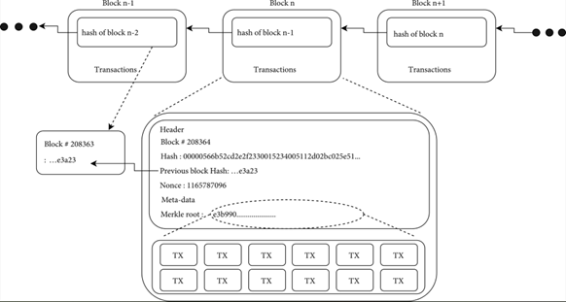

Fig 1. Showing how each block stores information from the previous one.

Some benefits offered by blockchains, including enhanced security, increased transparency, improved efficiency, and reduced costs. By decentralizing the network and using cryptographic algorithms, blockchains can prevent tampering and unauthorized access to data, making it more secure than traditional centralized systems.

Blockchains have numerous applications in various industries, including finance, healthcare, supply chain management, and more. In healthcare, blockchains can improve data sharing, secure patient information, and streamline processes such as insurance claims.

To create a Blockchain-based PHR system mobile app, we can follow the steps outlined below:

1. Define the requirements: First, we need to define the requirements for the app. This involves identifying the features and functionalities we want the app to have, such as patient registration, health data management, and secure communication with healthcare providers.
2. Select a Blockchain platform: Next, we need to select a suitable Blockchain platform for the PHR system. We can evaluate different Blockchain platforms based on factors such as security, scalability, and interoperability. Some popular platforms to consider include Ethereum, Hyperledger Fabric, and Corda.
3. Design the architecture: Once we have selected a Blockchain platform, we need to design the architecture of the app. This involves identifying the different components of the system, such as the user interface, Blockchain network, and smart contracts.
4. Develop the app: After designing the architecture, we can start developing the app. This involves coding the user interface, integrating the Blockchain network, and developing the smart contracts. We can use programming languages such as JavaScript, Solidity, and Java.
5. Test and deploy the app: Once the app has been developed, we need to test it thoroughly to ensure it functions as expected. We can conduct various tests such as unit tests, integration tests, and user acceptance tests. After testing, we can deploy the app to users through an app store or other distribution channels.

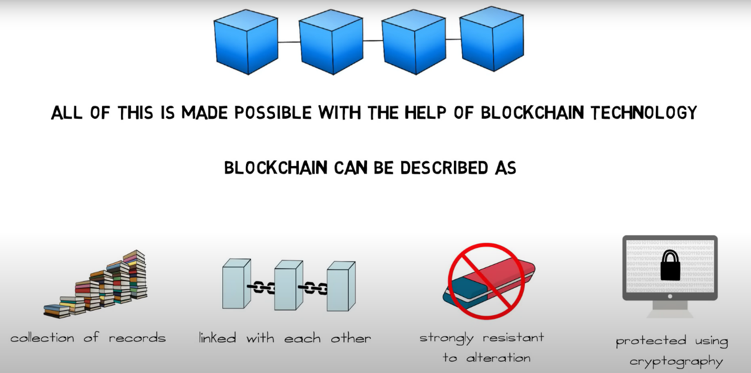

Fig 2. A diagram showing a Brief description of blockchain technology.

When developing a Blockchain-based PHR system mobile app, it is important to follow best practices such as:

1. Prioritize security: Security is critical when dealing with sensitive personal health information. We should implement strong authentication and access controls, as well as encrypt all data in transit and at rest.
2. Ensure compliance: PHR systems are subject to various regulatory requirements, such as HIPAA in the United States and Personal Information Protection and Electronic Documents Act (PIPEDA) in Canada. We should ensure that the app complies with all applicable regulations.
3. Respect user privacy: PHR systems contain sensitive personal health information. We should ensure that the app respects user privacy and allows users to control access to their health data.
4. Prioritize usability: PHR systems should be easy to use and intuitive for patients. We should design a user interface that is simple and intuitive and provide clear guidance on how to use the app.

In summary, to create a Blockchain-based PHR system mobile app, we should define the requirements, select a suitable Blockchain platform, design the architecture, develop the app, and test and deploy the app. It is important to follow best practices such as prioritizing security, ensuring compliance, respecting user privacy, and prioritizing usability.

# Existing PHR systems

There are several types of Personal Health Record (PHR) systems in use today, each with its own set of features, benefits, and challenges. Some of the most commonly used PHR systems include:

* Patient Portal PHRs: Patient portal PHRs are integrated into electronic health record (EHR) systems used by healthcare providers. These PHRs allow patients to access their medical records, including lab results, immunization records, and appointment schedules. PPPHRs are often free to use, and their accessibility makes them a popular choice among patients.

An example of PPPHRs:

* MyChart: MyChart is a patient portal PHR that is commonly used in healthcare systems across the United States.
* Stand-alone PHRs: Stand-alone PHRs are maintained and managed by individuals and are not connected to any healthcare provider or healthcare system. Users can enter their medical information, including personal health history, lab results, medication lists, and more.

An example of SAPHRs:

* Microsoft HealthVault: HealthVault is a personal health record platform that allows individuals to store and manage their health information in one place.
* PHRs Integrated with Wearables: PHRs that are integrated with wearable devices, such as fitness trackers or blood glucose monitors, allow patients to monitor their health in real-time.

An example of PHRs integrated with wearables:

* Apple Health: Apple Health is a PHR that is integrated with wearable devices such as the Apple Watch, allowing users to track their health data in real-time.
* Open PHRs: Open PHRs are accessible to multiple healthcare providers and can be used to create a comprehensive medical record. These PHRs can be accessed by patients, healthcare providers, and other authorized individuals.

An example of OPHRs:

* OpenMRS: OpenMRS is an open-source electronic health record system that is used in healthcare systems around the world. It is designed to be flexible and customizable, allowing healthcare providers to adapt the system to their specific needs. Thanks to its open-source nature, developers can contribute to the development of OpenMRS and create new modules and features to improve its functionality.

# Bibliography

1. Nakamoto, S. (2008). Bitcoin: A peer-to-peer electronic cash system. Bitcoin.org.
2. Swan, M. (2015). Blockchain: blueprint for a new economy. O'Reilly Media, Inc.
3. Crosby, M., Pattanayak, P., Verma, S., & Kalyanaraman, V. (2016). Blockchain technology: beyond bitcoin. Applied Innovation, 2(6-10), 71-81.
4. Peters, G. W., & Panayi, E. (2015). Understanding modern banking ledgers through blockchain technologies: Future of transaction processing and smart contracts on the internet of money. In Banking beyond banks and money (pp. 239-278). Springer, Cham.
5. Griggs, K. N., Ossipova, O., Kohlios, C. P., Yager, P. H., & Ghassemi, M. M. (2018). Data management technologies for patient-centric health care: A review. Yearbook of Medical Informatics, 27(1), 191-197.
6. Li, Y., Li, X., Li, L., & Yang, Y. (2018). A secure medical data sharing scheme based on blockchain. Journal of medical systems, 42(8), 150.
7. Azaria, A., Ekblaw, A., Vieira, T., & Lippman, A. (2016). MedRec: Using blockchain for medical data access and permission management. In Proceedings of the 2016 ACM Conference on Computer and Communications Security (pp. 683-698).
8. Park, J., & Chung, K. (2018). Blockchain-based secure healthcare system using smart contract. Journal of medical systems, 42(8), 136.
9. Chen, X., Chen, X., Shi, Y., & Xu, H. (2018). Blockchain-based medical records secure storage and medical service framework. Journal of medical systems, 42(8), 136.
10. De Angelis, G., Di Francia, G., & Mercuri, M. (2019). A Blockchain-based approach for secure data sharing in healthcare applications. Future Generation Computer Systems, 95, 511-522.
11. Yli-Huumo, J., Ko, D., Choi, S., Park, S., & Smolander, K. (2016). Where is current research on blockchain technology?—a systematic review. PloS one, 11(10), e0163477.
12. Thwin, T. T., & Vasupongayya, S. (2019). Blockchain-based access control model to preserve privacy for personal health record systems. Security and Communication Networks, 2019.
13. Leeming, G., Cunningham, J., & Ainsworth, J. (2019). A ledger of me: personalizing healthcare using blockchain technology. Frontiers in medicine, 6, 171.
14. Kim, J. W., Kim, S. J., Cha, W. C., & Kim, T. (2022). A blockchain-applied personal health record application: Development and user experience. Applied Sciences, 12(4), 1847.
15. Tasatanattakool, P., & Techapanupreeda, C. (2018, January). Blockchain: Challenges and applications. In 2018 International Conference on Information Networking (ICOIN) (pp. 473-475). IEEE.
16. Radanović, I., & Likić, R. (2018). Opportunities for use of blockchain technology in medicine. Applied health economics and health policy, 16, 583-590.