**Space Coronagraph Retardance and Polarization in Python (SCRAPPy): A Compact, Full Mueller Polarimeter for Measuring Polarization Aberrations in Astronomical Telescopes**

Jaren N. Ashcraft

James C. Wyant College of Optical Sciences, University of Arizona



*Scrappy-Doo, nephew of Scooby-Doo, the namesake of our coronagraph testbed.*

**Introduction**

High-contrast imaging has advanced to the point where the scalar diffraction assumption is no longer sufficient. Space telescopes aiming to achieve 10^-10 contrast are limited by polarization aberrations [1,2] when trying to detect earthlike exoplanets. Polarization differential imaging from the ground [3] can be affected by uncharacterized sources of polarization-dependent behavior in the point-spread function (PSF). Several investigators have characterized polarization aberrations through a model-based approach [4, 5, 6], but there is little data of the on-sky performance of these systems. Over time, the coatings of the optics (reflective, dichroic, etc.) degrade and by doing so depart from the performance predicted by models. To accurately assess the response of astronomical observatories to the polarization of the optical field, we must measure the response on-sky.

An ideal data set that characterizes this response to polarization is to measure the Mueller Matrix of the optical system across the exit pupil of the telescope. The irradiance pattern across the beam at the pupil plane does not vary considerably, so it is easy to perform polarimetry on. We can also spatially sample the pupil to understand how the Mueller matrix differs across it with high granularity. The full Mueller polarimetry process is straightforward.

1. Place a narrow bandwidth source behind the instrument under test. In front of it, fix a linear polarizer in a collimated space and record the angle. In front of the polarizer, place a retarder in a motorized rotation mount and record the angle.
2. Align the beam to the entrance pupil of the instrument under test, and verify that the beam at the output produces the expected image
3. Collimate the beam and place a rotating retarder and fixed polarizer and record the initial angles.
4. Place a detector in the collimated space near the location of the real exit pupil

Instrument Modes

*Full Stokes Polarimetry*

*Full Mueller Polarimetry*

Data-informed Mueller Matrix Measurements

We have the option

Boulder Vision Optical Retarders

Meadowlark Polarizers

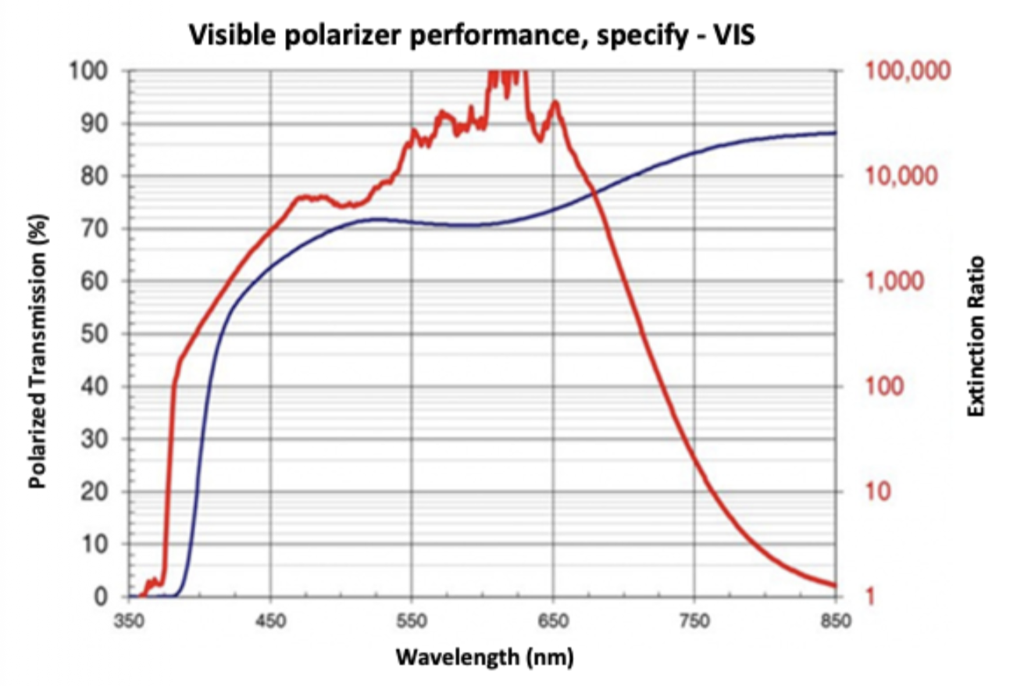

Rotation Mounts

References

[1] Breckinridge, James B. and Lam, Wai Sze T. and Chipman, Russell A. (2015) *Polarization Aberrations in Astronomical Telescopes: The Point Spread Function.* Publications of the Astronomical Society of the Pacific, 127 (951). pp. 445-468. ISSN 0004-6280. doi:10.1086/681280.

[2] Scott D. Will, James R. Fienup, "Effects and mitigation of polarization aberrations in LUVOIR coronagraph," Proc. SPIE 11117, Techniques and Instrumentation for Detection of Exoplanets IX, 1111710 (9 September 2019);<https://doi.org/10.1117/12.2525377>

[3] Norris, Barnaby, et al. "The VAMPIRES instrument: imaging the innermost regions of protoplanetary discs with polarimetric interferometry." *Monthly Notices of the Royal Astronomical Society* 447.3 (2015): 2894-2906.

[4] Anche, Ramya M. and Anupama, G. C. and Sriram, S. and Sankarasubramanian, K. and Skidmore, Warren (2018) *Estimation of polarization aberrations and its effect on the point spread function of the Thirty Meter Telescope.* In: Adaptive Optics Systems VI. Proceedings of SPIE. No.10703. Society of Photo-optical Instrumentation Engineers (SPIE) , Bellingham, WA, Art. No. 107034K. ISBN 9781510619593.

[5] Chipman, R.A., Lam, W.-S.T., & Young, G. (2018). Polarized Light and Optical Systems (1st ed.). CRC Press. https://doi.org/10.1201/9781351129121

[6] José Sasián, "Polarization fields and wavefronts of two sheets for understanding polarization aberrations in optical imaging systems," Opt. Eng. 53(3) 035102 (17 March 2014)<https://doi.org/10.1117/1.OE.53.3.035102>