**Roll number – 19BCE123**

**Name – Jash Mavani**

**Subject – Blockchain Technology**

**Practical – 10**

**Aim :** To write a contract code to implement a two player game Tic Tac Toe

**Screenshots :**

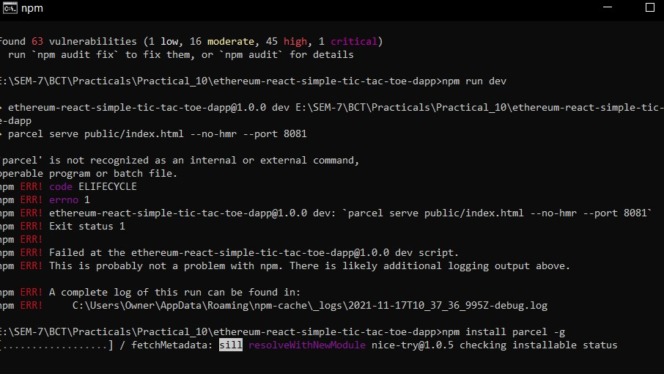

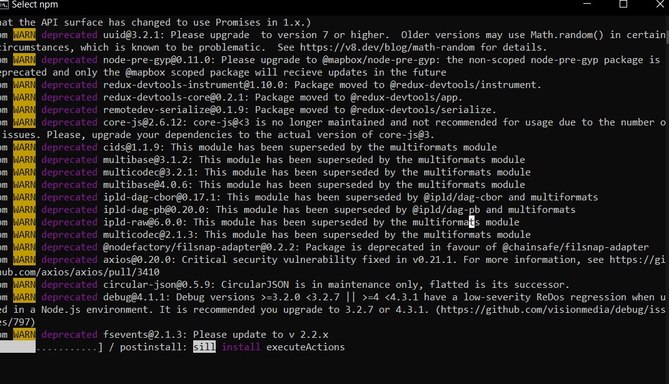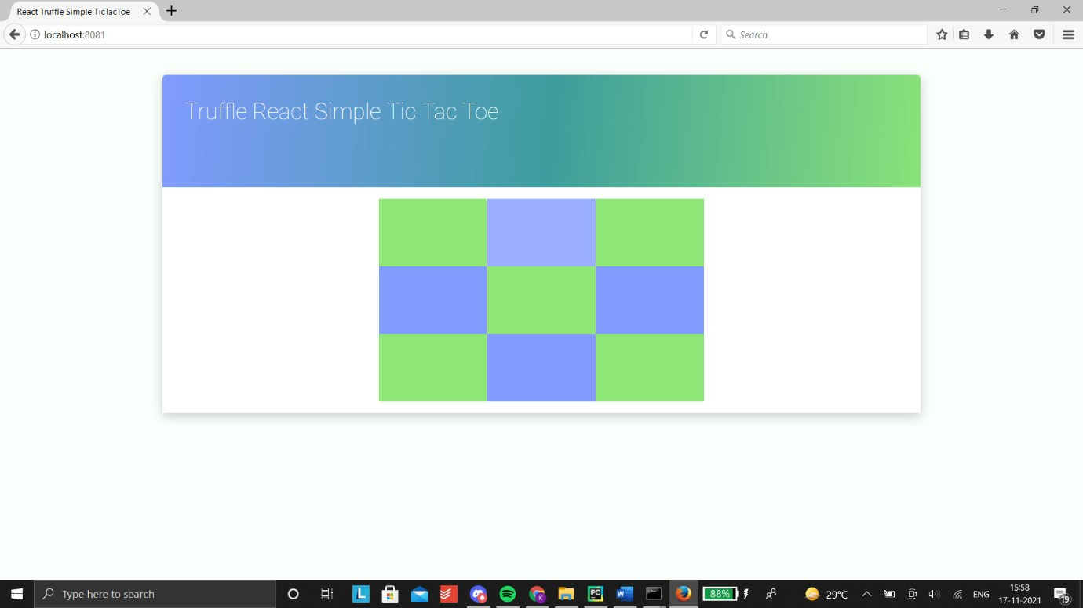

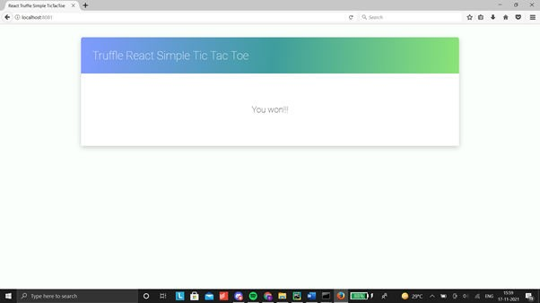

**Conclusion**

After completion of this practical I learnt how to make Tic Tae To app using Truffle IDE.