**Roll number – 19BCE123**

**Name – Jash Mavani**

**Batch - EL2**

**Course Code & Name – 2CSDE93 & Blockchain Technology**

**Practical – 5**

**Aim :** To perform thorough study and installation of Remix IDE and Truffle IDE for deploying Smart Contracts and Decentralized Applications (dapps) and create and deploy a Smart Contract for any application such as finance, healthcare etc.

**Solidity Code :**

pragma solidity ^0.4.21;

contract AVTax

{

struct Owner

{

string name_of_owner;

int tax_amount;

int have_amount;

}

mapping(address => Owner) public owners;

function add(string _name_of_owner, int _have_amount) public

{

owners[msg.sender] = Owner(_name_of_owner, 0, _have_amount);

}

function add_tax(int x) public {

if(owners[msg.sender].have_amount >= x)

owners[msg.sender].have_amount = owners[msg.sender].have_amount -

x;

else owners[msg.sender].tax_amount = owners[msg.sender].have_amount +

x;

}

}

**Input and Output:**

I have used remixIDE for compiling the solidity file and then made one person and taken the tax input from user and as a result we will see the updated amount from user.

**ScreenShots**

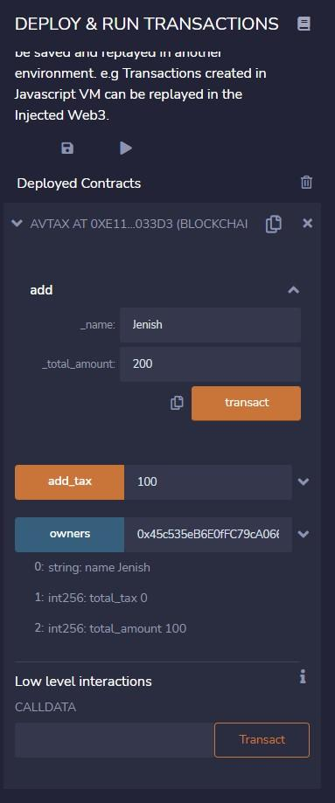

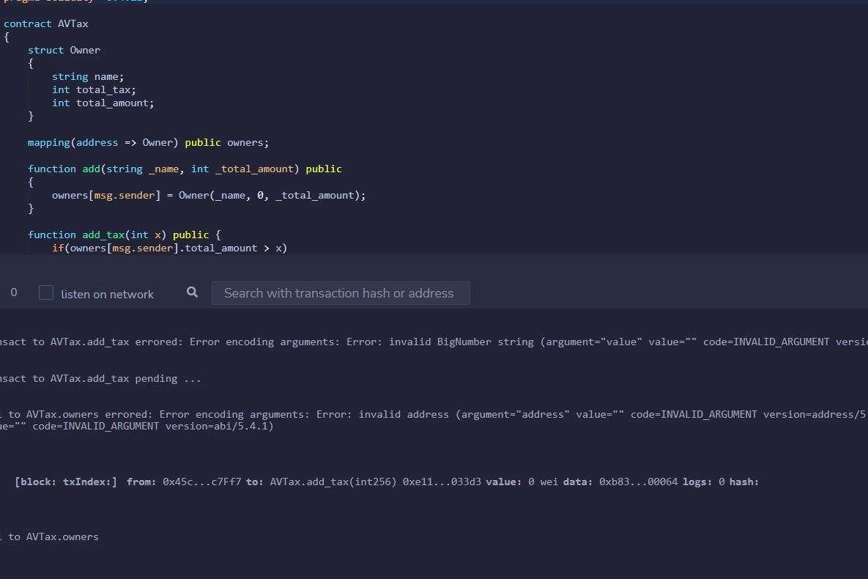

**Conclusion :**

After completion of this practical, I learnt how to deploy smart contracts using RemixIDE.