PHISHING EMAIL DETECTION & AWARENESS REPORT

Submitted By:
Chintham Jashnavi

Internship:
Cyber Security Intern

Organization:
Future Interns

Task:
Task 2 – Phishing Email Detection & Awareness System

Date:
17 June 2026

Objective:

The objective of this report is to analyze phishing email samples, identify phishing indicators, classify email threats, and provide security awareness guidelines to help users recognize and avoid phishing attacks.

Introduction: -
Phishing is a cyber attack method used to steal sensitive information such as usernames, passwords, and banking details through fake emails and malicious websites.
This report analyzes phishing email examples and identifies suspicious indicators used by attackers.

Screenshot: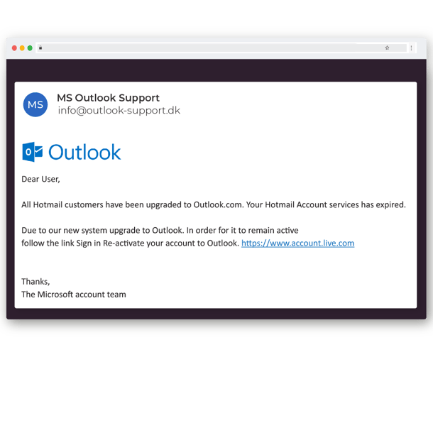

Phishing Email Analysis:-
1. Outlook Email Upgrade Scam
Indicators Found:
- Suspicious sender email
- Urgent warning message
- Fake login request
- Generic greeting
Risk Level:
High
Classification:
Phishing
Explanation:
This email attempts to scare users into clicking a malicious link and entering login credentials.

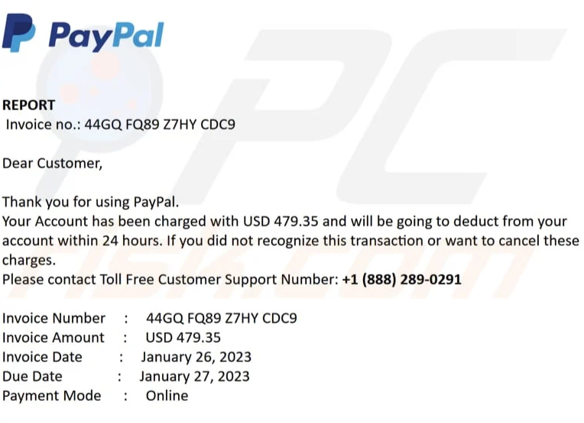

2. PayPal Invoice Scam

Indicators Found:
- Fake payment warning
- Urgent request to contact support
- Suspicious invoice details
- Fear tactic used to scare the user
- Generic greeting “Dear Customer”

Risk Level:
High

Classification:
Phishing

Explanation:
This phishing email attempts to frighten users by claiming that money will be deducted from their PayPal account. The attacker tries to make the victim call a fake support number or provide sensitive information.

Tools Used:
• Phishing Email Samples
• Browser Tools
• Email Header Analysis
• Microsoft Word
• PDF Documentation

Email Sample | Risk Level | Classification
Outlook Email Upgrade Scam | High | Phishing
PayPal Invoice Scam | High | Phishing

Prevention Guidelines:
1. Verify sender email addresses carefully.
2. Avoid clicking on suspicious links.
3. Do not download unexpected attachments.
4. Enable Multi-Factor Authentication (MFA).
5. Never share passwords or banking details through email.
6. Report suspicious emails to the IT or security team.

Conclusion:-
This project analyzed different phishing email examples and identified common phishing indicators such as fake sender addresses, urgent warning messages, suspicious links, and social engineering techniques.
The analysis showed how attackers attempt to trick users into revealing sensitive information like passwords and banking details. Proper awareness, careful email verification, and safe browsing practices can help users protect themselves from phishing attacks and improve overall cyber security.

