PROJECT REPORT
1. Executive Summary / Overview
The File Data Analyzer System is an interactive, web-based Exploratory Data Analysis (EDA) and data analytics platform. Designed to simplify data exploration for non-technical users and analysts alike, the application automates data loading, cleaning, statistical summary generation, visual insight creation, and automated reporting.
Built entirely in Python, the application transforms raw tabular data (CSV and Excel formats) into clear, visual, and actionable insights with zero code required from the end user.
2. Accessing and Running the Application
A. Web Access (Live Streamlit Cloud Deployment)
- URL: https://file-data-analyzer.streamlit.app/
- Requirements: Any modern web browser (Google Chrome, Mozilla Firefox, Microsoft Edge, Safari) on desktop, tablet, or mobile.
- No Installation Required: Users can access the app directly via the URL, upload .csv or .xlsx files, and explore insights immediately.
B. Local Execution (Development & Offline Access)
- Clone the Repository:
git clone https://github.com/JashuaGummalla/FileDataAnalyzer.git
cd FileDataAnalyzer
- Install Dependencies:
pip install -r requirements.txt
- Run the Streamlit Dashboard:
streamlit run app.py
- Local URL: Access locally at http://localhost:8501.
3. Tech Stack & Library Justifications
Tech / Library | Version | Purpose & Function in the Project
Streamlit | >=1.30.0 | Frontend & Web Framework: Converts raw Python scripts into an interactive, reactive web user interface. Handles file uploads, interactive sidebars, data tables, and dynamic visual layouts without requiring traditional HTML/CSS/JavaScript.
Pandas | >=2.0.0 | Data Manipulation Engine: Provides high-performance data structures (DataFrame, Series). Handles dataset ingestion, filtering, handling missing values, structural transformations, aggregations, and exporting cleaned outputs.
NumPy | >=1.24.0 | Numerical & Mathematical Computation: Underpins matrix operations, vectorized calculations, missing value indicators (np.nan), standard deviations, and array manipulations supporting Pandas computations.
Matplotlib | >=3.8.0 | Core Plotting Engine: Serves as the base visualization library. Customizes plot figures, axes layout, chart sizing, color maps, labels, and exports static figures to rendering backends.
Seaborn | >=0.13.0 | High-Level Statistical Data Visualization: Works on top of Matplotlib to create attractive statistical charts, including distribution plots, correlation heatmaps, box plots, and categorical comparisons.
OpenPyXL | >=3.1.0 | Excel File Handling Engine: Enables Pandas to read, parse, process, and write native .xlsx Excel spreadsheet formats seamlessly alongside standard .csv files.

4. System Architecture & Modular Structure
The project follows a clean, modular architecture separating the user interface layer from core business and data processing logic:
FileDataAnalyzer/
│
├── app.py # Main application entry point & Streamlit UI layout
├── requirements.txt # Dependency configuration file
├── Dockerfile # Containerization specification
├── Procfile # Deployment execution instructions
│
├── modules/ # Modular Python backend engines
│ ├── __init__.py # Package initializer
│ ├── data_loader.py # File reader (CSV, Excel parsing & validation)
│ ├── data_cleaner.py # Missing value handler, type casting, duplicate removal
│ ├── statistics.py # Descriptive & summary statistics engine
│ ├── visualizations.py # Matplotlib & Seaborn chart generator
│ └── insights.py # Automated text insight & anomaly detection logic
│
├── data/ # Sample datasets for testing
│ └── sample_sales_data.csv
├── outputs/ # Export directory for generated artifacts
│ ├── charts/ # Downloadable PNG chart exports
│ └── reports/ # Summarized analytical reports
└── screenshots/ # Application UI documentation previews
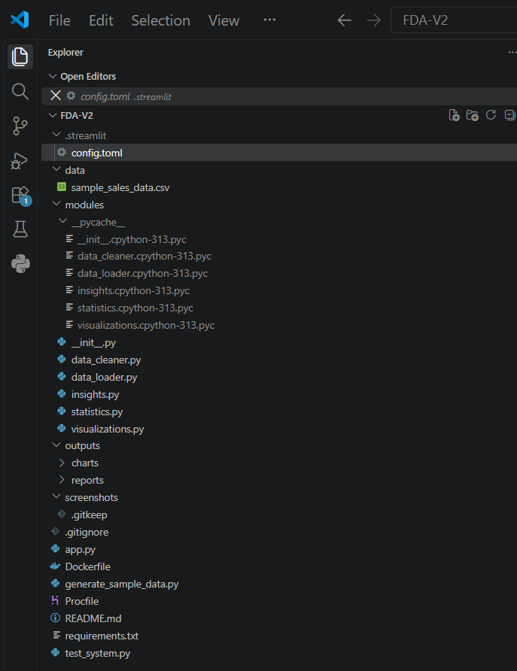

5. Key System Capabilities & Modules
- Data Ingestion Module (data_loader.py):
  - Supports multi-format dataset uploading (.csv, .xlsx).
  - Validates dataset integrity and memory footprint.
- Data Preprocessing & Cleaning (data_cleaner.py):
  - Automatic detection and handling of missing/null values (imputation or removal).
  - Column renaming, data type detection, and duplicate record elimination.
- Statistical Analytics (statistics.py):
  - Descriptive statistics (Mean, Median, Mode, Standard Deviation, Skewness, Kurtosis).
  - Correlation matrix computation across numerical features.
- Visual Analytics Engine (visualizations.py):
  - Interactive chart selection: Histograms, Box Plots, Scatter Plots, Heatmaps, and Bar Charts.
  - Responsive chart rendering inside the Streamlit UI.
- Automated Insights (insights.py):
  - Automated key takeaway generation, highlight of extremal values (min/max), and structural summaries.

