|  |  |  |  |  |  |  |
| --- | --- | --- | --- | --- | --- | --- |
| **Project Name : Predicting Boat Accidents** | | | | | | |
| **Test case Id :** ID_1 **Test Designed By** **:** Kundana  **Test Priority :**high **Test Designed Date** **:** 01-12-2020  **Module Name :** Danger Zones Page **Test Executed By :** Kundana  **Test Title :** Verifying Danger Zones  **Test Executed Date:**01-12-2020  **Description :** Testing Danger Zones Page | | | | | | |
| **Pre Conditions:** User should provide location details | | | | | | |
| **Stage** | **Test Steps** | **Test Data** | **Expected Result** | **Actual Result** | **Status(Pass/Fail)** | **Remarks** |
| 1 | Verify Danger Zones Page | Location:  Vijayawada | Nearby danger zones are displayed | Nearby danger zones are displayed | Pass | Nil |
| 2 | Browse locations details |
| 3 | Upload location details |
| **Post Conditions :**Danger zones based on location are verified successfully | | | | | | |

**TASK 1:**

**Aim:** To design a test case template for login page validation.

**Test case-1:**

**Output:**

**Case 1**: Pass

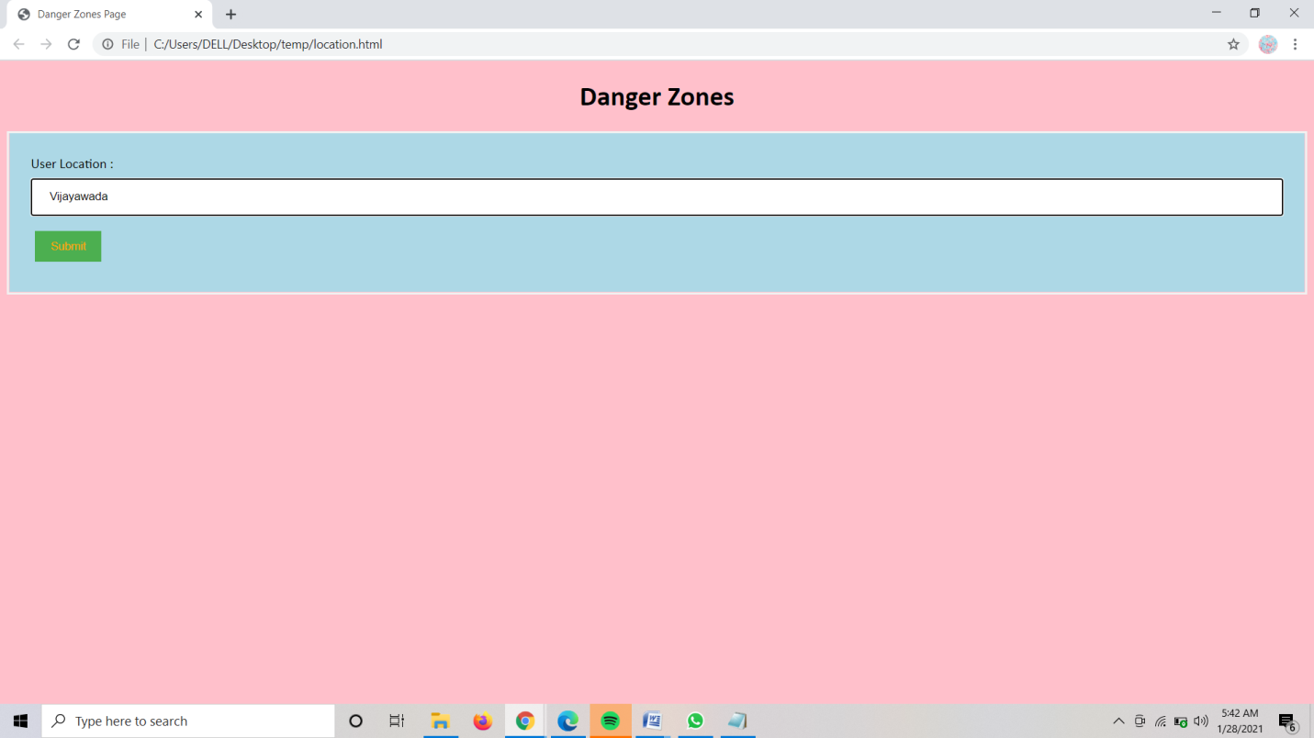

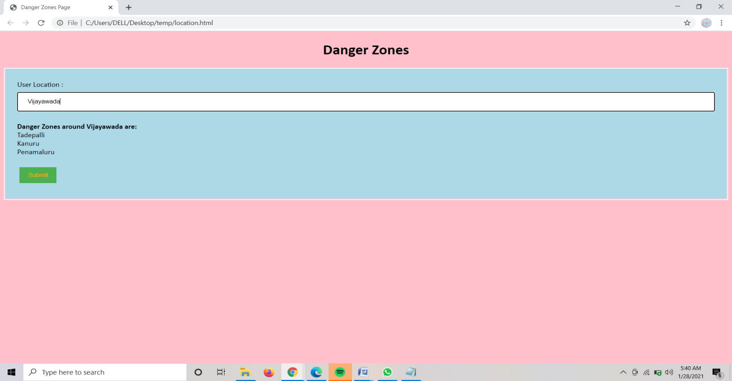

**Case 2:** Fail

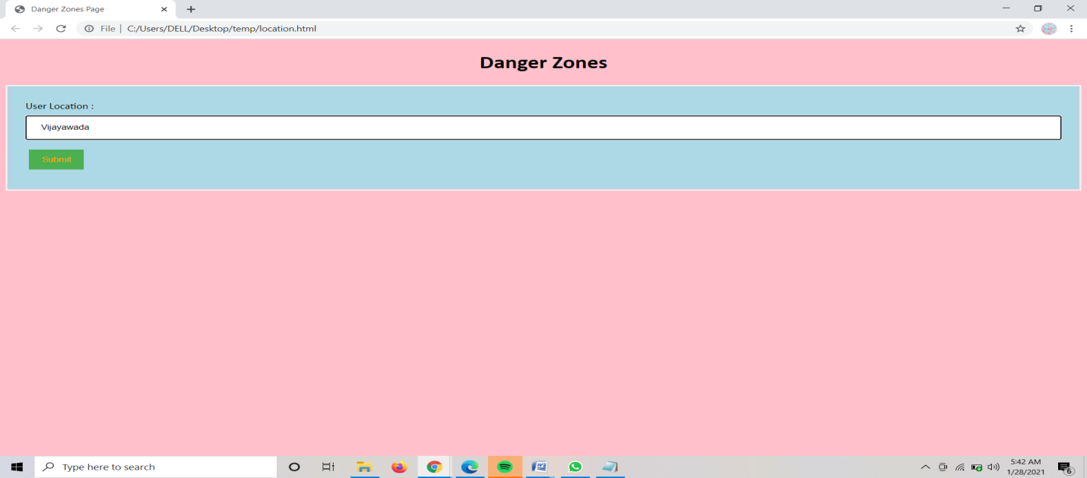

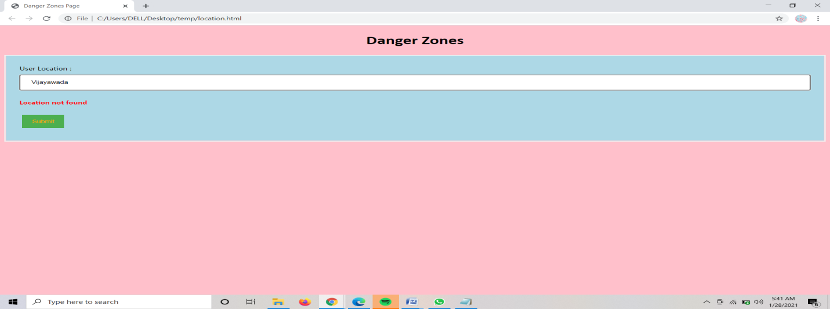

|  |  |  |  |  |  |  |
| --- | --- | --- | --- | --- | --- | --- |
| **Project Name :Predicting Boat Accidents** | | | | | | |
| **Test case Id :** ID_2 **Test Designed By** **:** Kundana  **Test Priority :**low **Test Designed Date** **:** 01-12-2020  **Module Name :** Feedback Page **Test Executed By :** Kundana  **Test Title :** Verifying Feedback Page  **Test Executed Date:**01-12-2020  **Description :** Testing Feedback Page | | | | | | |
| **Pre Conditions:** User should provide login details and feedback | | | | | | |
| **Stage** | **Test Steps** | **Test Data** | **Expected Result** | **Actual Result** | **Status(Pass/Fail)** | **Remarks** |
| 1 | Verify Feedback Page | User Name:  leela  Password:  Abc@123  Feedback:  Need to be more user friendly | User navigated to next page displaying feedback is submitted successfully | User navigated to next page displaying feedback is submitted successfully | Pass | Nil |
| 2 | Provide login details |
| 3 | Upload feedback and submit |
| **Post Conditions :**Feedback Page is verified successfully | | | | | | |

**Test Case-2:**

**Output:**

**Case 1:** Pass

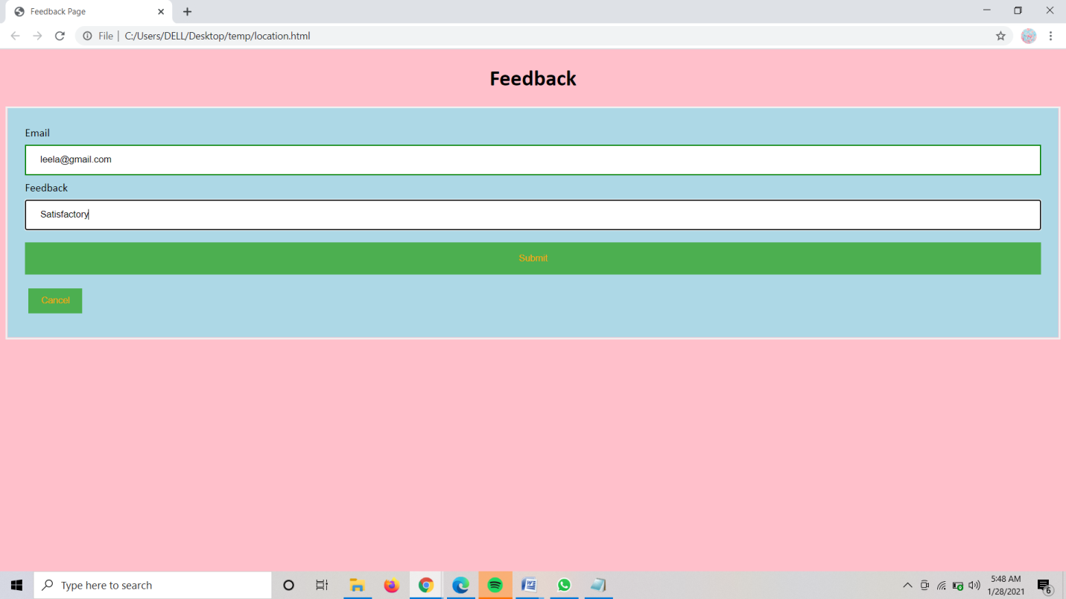

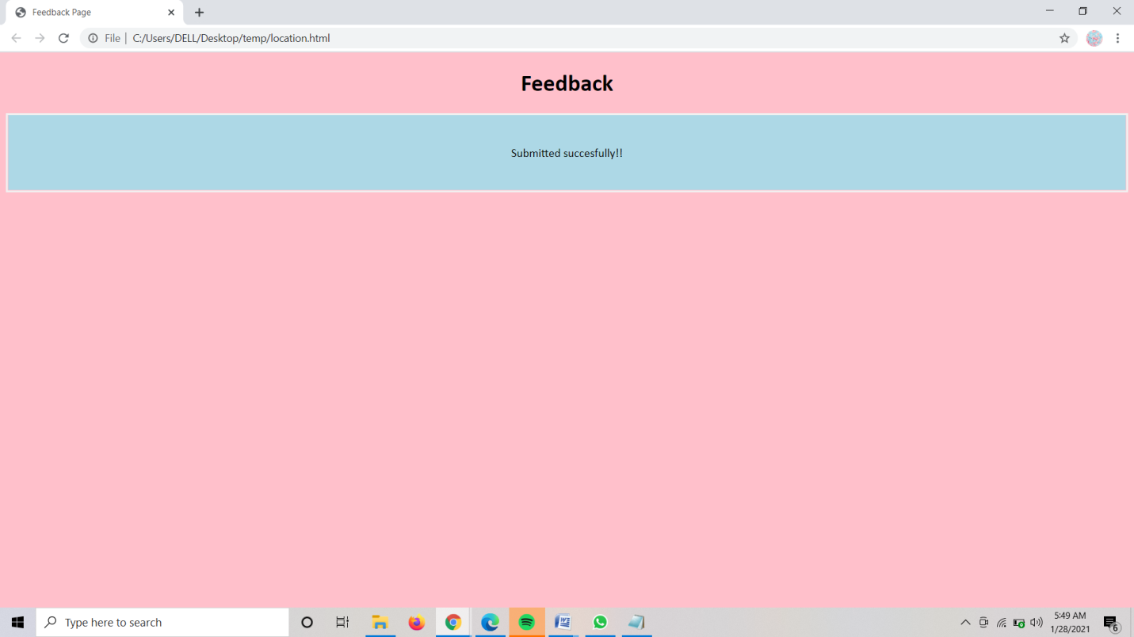

**Case 2:** Fail

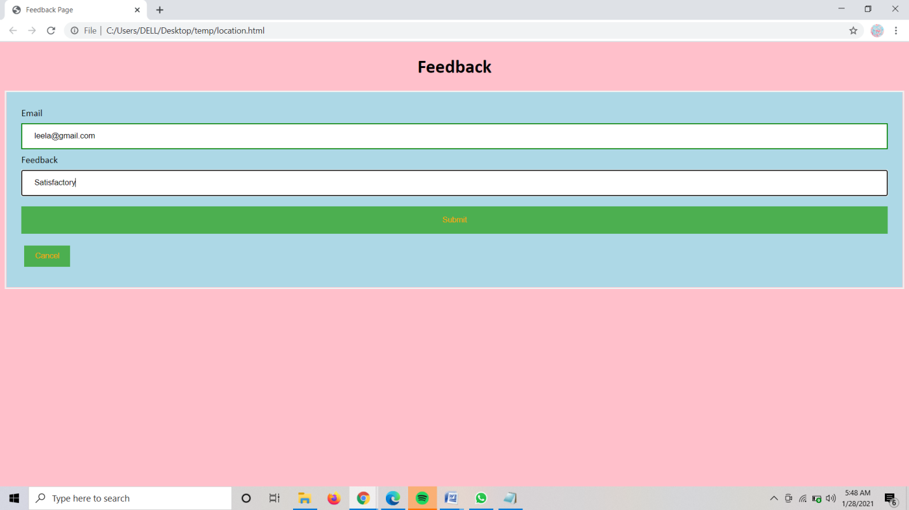

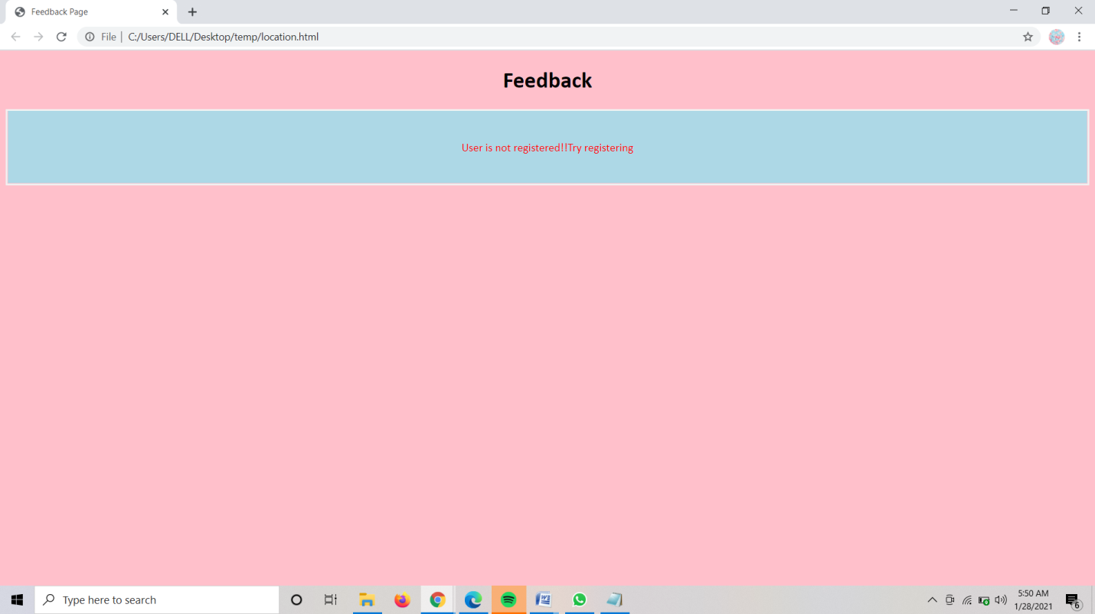

**Result:** Designing a test case template for login page validation is done successfully.