RETAIL SALES ANALYSIS PROJECT DOCUMENTATION

1. Introduction
Retail Sales Analysis is a business intelligence project developed using Power BI to analyze retail transaction data. The project focuses on understanding sales performance, profit trends, discount impact, and customer segmentation. The goal is to transform raw retail data into actionable insights for better decision-making.

2. Objectives
- Analyze total sales, profit, and quantity performance.
- Evaluate the impact of discounts on profitability.
- Identify high-performing customer age groups.
- Develop an interactive dashboard using Power BI.
- Provide data-driven business recommendations.

3. Dataset Description
The dataset contains 9000 retail transaction records with the following key fields:
• Order_ID – Unique order identifier
• Age – Customer age
• Quantity – Number of units purchased
• Unit_Price – Price per unit
• Discount – Discount applied on transaction
• Sales_Amount – Total revenue generated
• Profit – Profit earned per transaction

4. Tools & Technologies Used
- Power BI Desktop
- DAX (Data Analysis Expressions)
- Power Query Editor
- Microsoft Excel
- Python (optional advanced visualizations)

5. Data Preprocessing
• Removed null and duplicate values.
• Converted Sales_Amount and Profit columns to decimal numbers.
• Created calculated columns such as Age Group and Discount Band.
• Created DAX measures for KPI calculations.

6. DAX Measures Created
Total Sales = SUM([Sales_Amount])
Total Profit = SUM([Profit])
Total Quantity = SUM([Quantity])
Profit Margin % = DIVIDE([Total Profit], [Total Sales], 0) * 100
Average Discount = AVERAGE([Discount])

7. Dashboard Visualizations
• KPI Cards – Total Sales, Profit, Quantity, Profit Margin
• Scatter Chart – Sales vs Profit relationship
• Line Chart – Discount impact on Profit
• Column Chart – Sales by Age Group
• Pie Chart – Sales Contribution by Segment
• Decomposition Tree – Sales breakdown analysis
• Matrix Heatmap – Correlation insights

8. Key Insights
• Strong positive relationship between Sales and Profit.
• High discounts negatively affect Profit Margin.
• Certain age groups contribute higher revenue.
• Quantity significantly impacts Sales performance.

9. Business Recommendations
• Optimize discount strategies to improve profitability.
• Focus marketing efforts on high-performing age segments.
• Monitor profit margin regularly.
• Encourage bulk purchases with controlled discounting.

10. Conclusion
The Retail Sales Analysis dashboard successfully converts transactional data into meaningful insights. The interactive Power BI report helps stakeholders monitor performance, analyze trends, and make informed business decisions.

11. Future Scope
• Implement time-series analysis for year-over-year growth.
• Add predictive analytics using machine learning.
• Deploy dashboard to Power BI Service for real-time reporting.
• Integrate additional datasets such as customer demographics or regional data.

RETAIL SALES ANALYSIS PROJECT DASHBOARDS
1 . RETAIL BUSINESS INSIGHTS WITH PYTHON VISUALIZATION
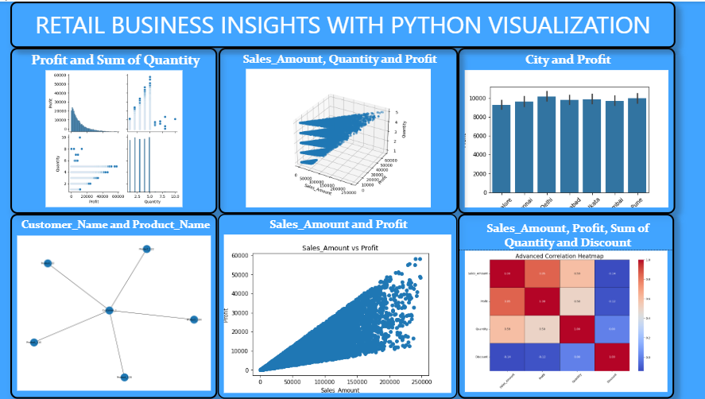
2. RETAIL SALES ANALYSIS DASHBOARD
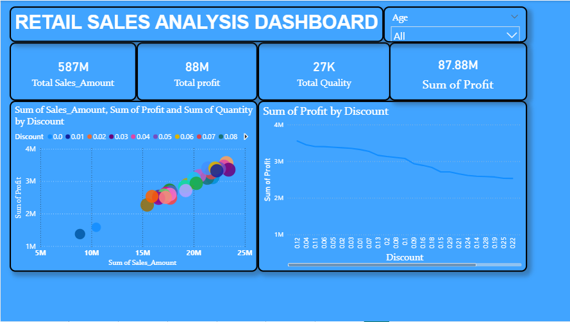
3. AGE-WISE SALES PERFORMANCE ANALYSIS
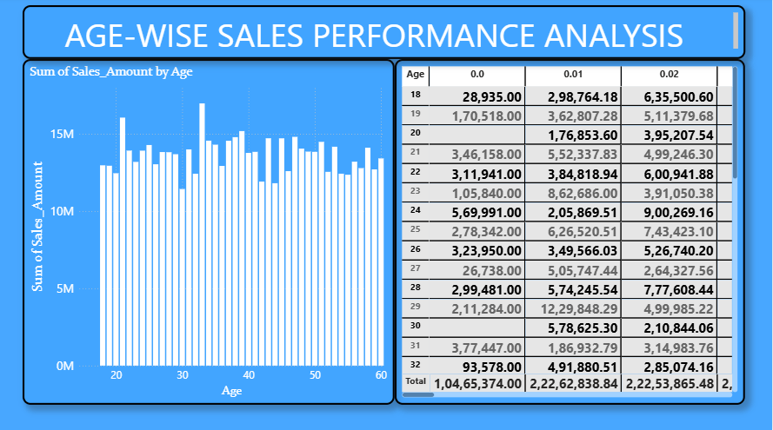
4. SALES AND PROFIT ANALYSIS REPORT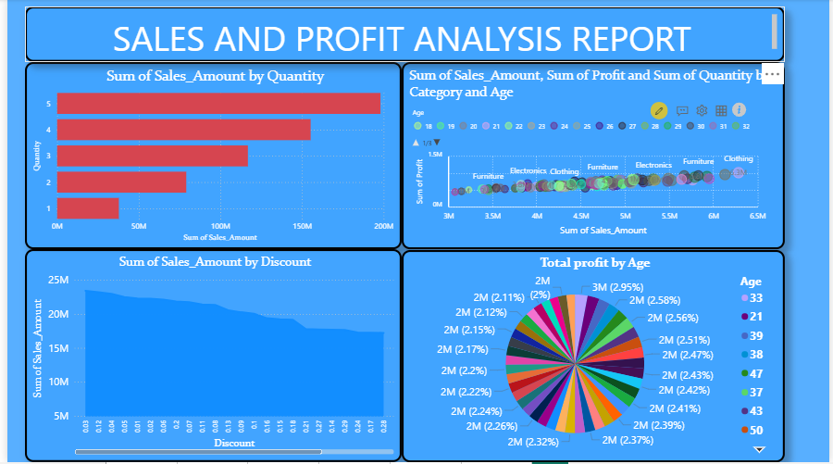

5. TOTAL PROFIT AND GOAL TRACKING
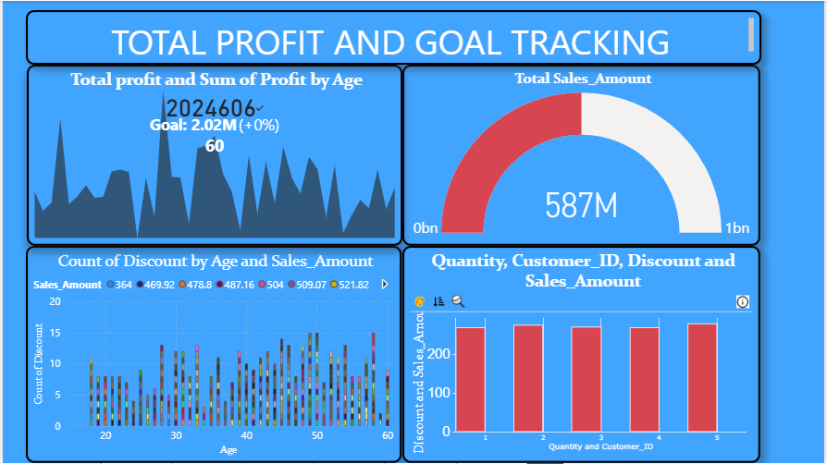
6. GEOGRAPHICAL SALES DISTRIBUTION
