

**School of Information Technology & Engineering**

**Department of Smart Computing**

**Code-a-thon**

**Covid-19 Cases**

**Team Name -BCS**

**Team Members:**

1.Yogaprasath M-20BCS0162

2.Jashwanth Kumar S-20BCS0139

3.Mudassir Khan G-20BCS0130

4.Jerin Jebaraj J-20BCS0152

**Abstract**

Covid-19 cases website in this website we show the affected cases and dead count according to the day count. we can see the number of infected and dead count in particular day.

**Phase- I Planning**

We plan to do the website like we use the form and some html tags to create the website.

**Phase -II Desing**

**Phase – III Implementation**

1 Snapshot of your code

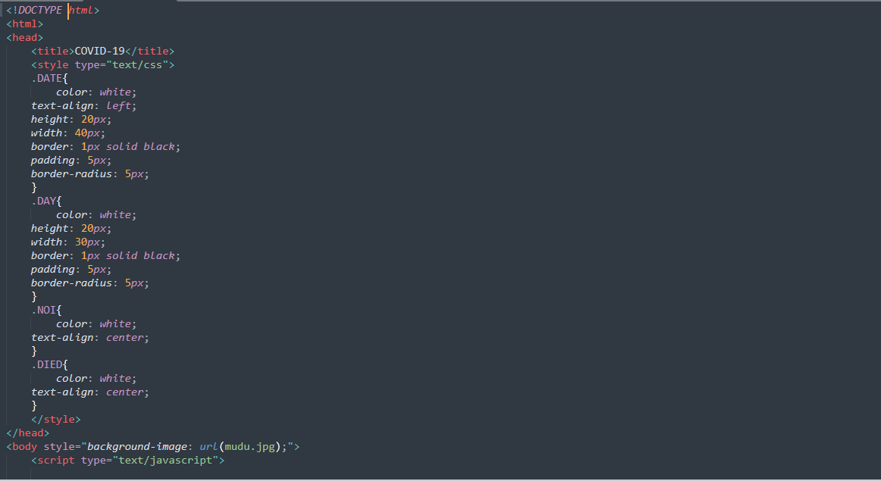

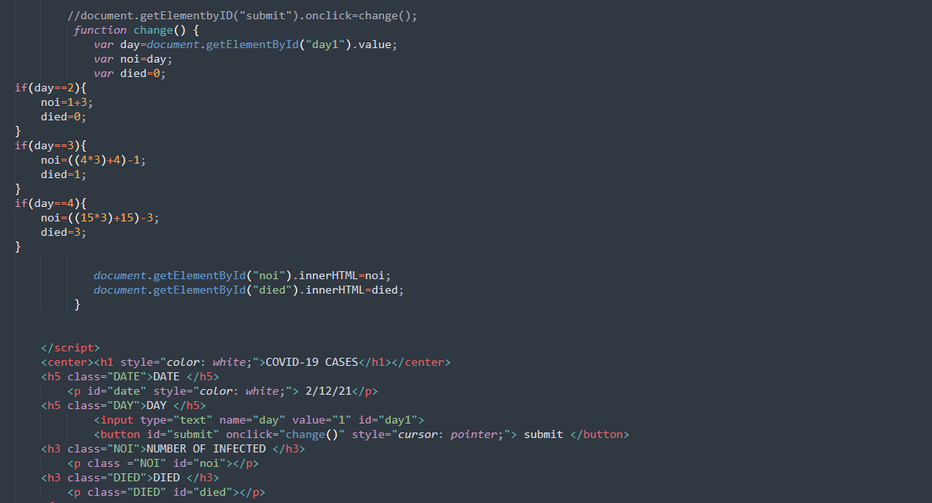

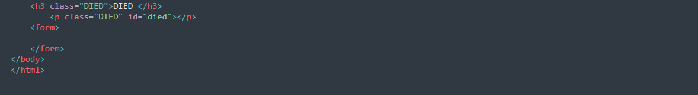

**Phase -IV Testing**

