**Fall Semester 2021-2022**

**Lab Cyclesheet-02**

Name: Jashwanth Kumar S

Reg No: 20BCS0139

Subject: Web Development

Slot: L43+L44

Course Code: CSC4002

Faculty Name: Dr Rathi

1. Design a web page which display digital clock as shown below.

**Code:**

<!DOCTYPE html>

<html>

<head>

<meta charset="utf-8">

<meta name="viewport" content="width=device-width, initial-scale=1">

<title>20BCS0139</title>

<style type="text/css">

.clock {

background-color:#FCFF33;

color: #808080;

font-size: 20px;

letter-spacing: 2px;

width: 130px;

padding: 2px 10px;

border-radius:0.5px;

}

.fot{

font-size: 30px;

}

</style>

</head>

<body>

<div class="fot"><h2><b>Digital Clock</b></h2></div>

<div id="MyClockDisplay" class="clock" onload="showTime()"></div>

<script type="text/javascript">

function showTime(){

var date = new Date();

var h = date.getHours(); // 0 - 23

var m = date.getMinutes(); // 0 - 59

var s = date.getSeconds(); // 0 - 59

var session = "AM";

if(h == 0){

h = 12;

}

if(h > 12){

h = h - 12;

session = "PM";

}

h = (h < 10) ? "0" + h : h;

m = (m < 10) ? "0" + m : m;

s = (s < 10) ? "0" + s : s;

var time = h + ":" + m + ":" + s + " " + session;

document.getElementById("MyClockDisplay").innerText = time;

document.getElementById("MyClockDisplay").textContent = time;

setTimeout(showTime, 1000);

}

showTime();

</script>

</body>

</html>

**Output:**

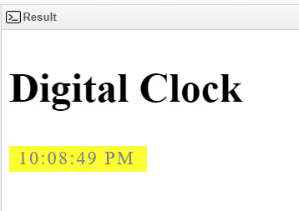

1. Design a scientific calculator using JavaScript.

**Code:**

<!DOCTYPE html>

<html>

<head>

<title>20BCS0139</title>

<style>

.title {

margin-bottom: 10px;

padding: 5px 0px;

font-size: 25px;

font-weight:bold;

text-align:center;

width: 458px;

color:Black;

border: solid black 2px;

}

#btn {

width: 100%;

height: 40px;

font-size: 30px;

}

input[type="button"] {

background-color:white;

color: black;

border: solid black 1px;

width:100%

}

input[type="text"] {

background-color:white;

border: solid black 2px;

width:100%

}

</style>

<script>

function backspace(calc) {

size = calc.display.value.length;

calc.display.value = calc.display.value.substring(0, size-1);

}

function calculate(calc) {

if(calc.display.value.includes("!"))

{

size = calc.display.value.length;

n = Number(calc.display.value.substring(0, size-1));

f = 1;

for(i = 2; i <= n; i++)

f = f*i;

calc.display.value = f;

}

else if(calc.display.value.includes("%")) {

size = calc.display.value.length;

n = Number(calc.display.value.substring(0, size-1));

calc.display.value = n/100;

}

else

calc.display.value = eval(calc.display.value);

}

</script>

</head>

<body>

<div class = title >

Scientific Calculator

</div>

<form name = "calc">

<table id = "calc" border = 2>

<tr>

<td colspan=5><input id="btn" name="display"

onkeypress="return event.charCode >= 48

&& event.charCode <= 57" type="text">

</td>

</tr>

<tr>

<td><input id="btn" type="button" value="1"

OnClick="calc.display.value+='1'">

</td>

<td><input id="btn" type="button" value="2"

OnClick="calc.display.value+='2'">

</td>

<td><input id="btn" type="button" value="3"

OnClick="calc.display.value+='3'">

</td>

<td><input id="btn" type="button" value="C"

OnClick="calc.display.value=''">

</td>

<td><input id="btn" type="button" value="<-"

OnClick="backspace(this.form)">

</td>

<td><input id="btn" type="button" value="="

OnClick="calculate(this.form)">

</td>

</tr>

<tr>

<td><input id="btn" type="button" value="4"

OnClick="calc.display.value+='4'">

</td>

<td><input id="btn" type="button" value="5"

OnClick="calc.display.value+='5'">

</td>

<td><input id="btn" type="button" value="6"

OnClick="calc.display.value+='6'">

</td>

<td><input id="btn" type="button" value="-"

OnClick="calc.display.value='-'">

</td>

<td><input id="btn" type="button" value="%"

OnClick="calc.display.value+='%'">

</td>

<td><input id="btn" type="button" value="cos"

OnClick="calc.display.value='Math.cos('">

</td>

</tr>

<tr>

<td><input id="btn" type="button" value="7"

OnClick="calc.display.value+='7'">

</td>

<td><input id="btn" type="button" value="8"

OnClick="calc.display.value+='8'">

</td>

<td><input id="btn" type="button" value="9"

OnClick="calc.display.value+='9'">

</td>

<td><input id="btn" type="button" value="*"

OnClick="calc.display.value+='*'">

</td>

<td><input id="btn" type="button" value="n!"

OnClick="calc.display.value+='!'">

</td>

<td><input id="btn" type="button" value="sin"

OnClick="calc.display.value='Math.sin('">

</td>

</tr>

<tr>

<td><input id="btn" type="button" value="."

OnClick="calc.display.value+='.'">

</td>

<td><input id="btn" type="button" value="0"

OnClick="calc.display.value+='0'">

</td>

<td><input id="btn" type="button" value=","

OnClick="calc.display.value+=','">

</td>

<td><input id="btn" type="button" value="+"

OnClick="calc.display.value+='+'">

</td>

<td><input id="btn" type="button" value="/"

OnClick="calc.display.value+='/'">

</td>

<td><input id="btn" type="button" value="tan"

OnClick="calc.display.value='Math.tan('">

</td>

</tr>

<tr>

<td><input id="btn" type="button" value="E"

OnClick="calc.display.value+='Math.E'">

</td>

<td><input id="btn" type="button" value="pi"

OnClick="calc.display.value+='Math.PI'">

</td>

<td><input id="btn" type="button" value="^"

OnClick="calc.display.value+='Math.pow('">

</td>

<td><input id="btn" type="button" value="("

OnClick="calc.display.value+='('">

</td>

<td><input id="btn" type="button" value=")"

OnClick="calc.display.value+=')'">

</td>

<td><input id="btn" type="button" value="log"

OnClick="calc.display.value='Math.log('">

</td>

</tr>

<tr>

<td><input id="btn" type="button" value="sqrt"

OnClick="calc.display.value+='Math.sqrt('">

</td>

<td><input id="btn" type="button" value="ln2"

OnClick="calc.display.value+='Math.LN2'">

</td>

<td><input id="btn" type="button" value="ln10"

OnClick="calc.display.value+='Math.Log10'">

</td>

<td><input id="btn" type="button" value="l2e"

OnClick="calc.display.value+='Math.LOG2E'">

</td>

<td><input id="btn" type="button" value="l10e"

OnClick="calc.display.value+='Math.log10'">

</td>

<td><input id="btn" type="button" value="exp"

OnClick="calc.display.value='Math.exp('">

</td>

</tr>

</table>

</form>

</body>

</html>

**Output:**

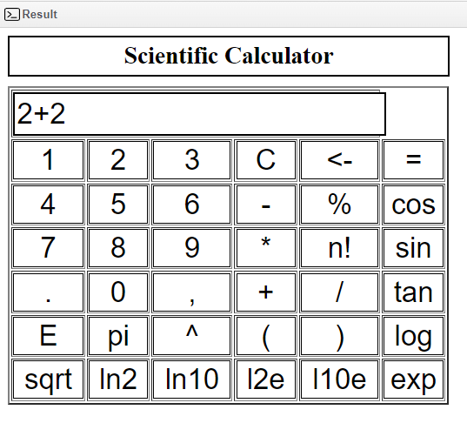

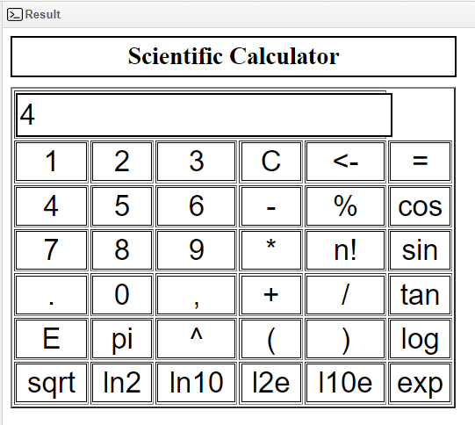

1. Design a web page which contains three buttons with labelled as red, blue and green. On clicking the button the respective color should displayed as background color.

**Code:**

<!DOCTYPE html>

<html lang="en">

<head>

<meta charset="utf-8">

<title>20BCS0139</title>

<script>

function changeBodyBg(color)

{

document.body.style.background = color;

}

</script>

</head>

<body>

<h2>Choose The Color You Want</h2>

<hr>

<div>

<label></label>

<button type="button"

onclick="changeBodyBg('red');">Red</button>

<button type="button"

onclick="changeBodyBg('blue');">Blue</button>

<button type="button"

onclick="changeBodyBg('Green');">Green</button>

</div>

</body>

</html>

**Output:**

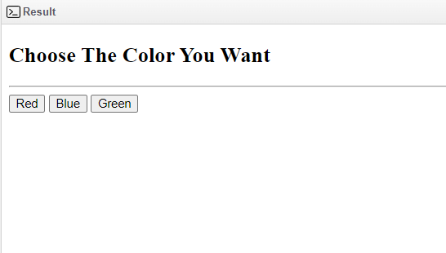

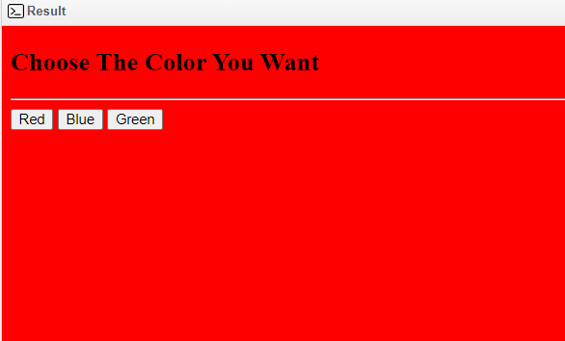

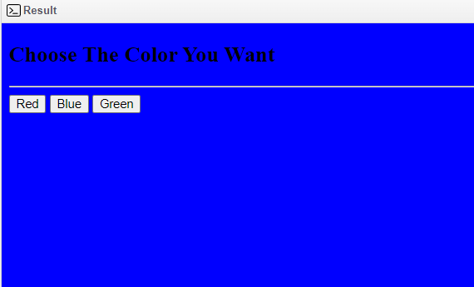

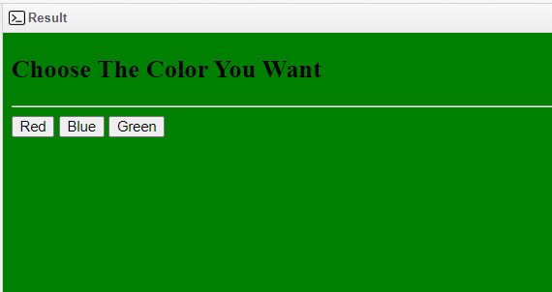

1. Implement the following using JavaScript:

a. Find factorial of the given number.

**Code:**

<!DOCTYPE html>

<html>

<head>

<title>20BCS0139</title>

</head>

<body style = "text-align: center; font-size: 20px;">

<h1>Factorial of the given number</h1>

Enter a number: <input id = "num">

<br><br>

<button onclick = "fact()"> Factorial </button>

<p id = "res"></p>

<script>

function fact(){

var i, num, f;

f = 1;

num = document.getElementById("num").value;

for(i = 1; i <= num; i++)

{

f= f * i;

}

i= i - 1;

document.getElementById("res").innerHTML = "The factorial of the

number " + i + " is: " + f ;

}

</script>

</body>

</html>

**Output:**

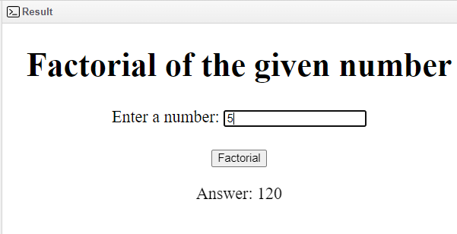

b. Find if a given number is an Armstrong number

**Code:**

<!DOCTYPE html>

<html lang="en">

<head>

<meta charset="UTF-8" />

<meta http-equiv="X-UA-Compatible" content="IE=edge" />

<meta name="viewport" content="width=device-width, initial-scale=1.0" />

<title>20BCS0139</title>

<style> body {

background-color: rgb(233, 227, 227);

color: rgb(97, 91, 91); text-align: center; font-size: 20px;

}

.b1 {

border: none;

background-color: green; padding: 10px 30px;

cursor: pointer; border-radius: 10px; margin-top: 30px;

}

</style>

<script>

function Armstrong() { var flag,

number, remainder, addition = 0;

number = Number(document.getElementById("Num").value); flag = number;

while (number > 0) { remainder = number % 10;

addition = addition + remainder * remainder * remainder; number = parseInt(number / 10);

}

if (addition == flag) {

document.getElementById("result").innerHTML = "Number is Armstrong";

} else {

document.getElementById("result").innerHTML = "Number is Not a Armstrong";

}

}

</script>

</head>

<body>

<br>

<h1>Check a number is Armstrong or not</h1>

Enter The Number :<input type="text" name="number" id = "Num"/>

<br>

<center><button class="b1" onClick="Armstrong()">CHECK</button>

<p id="result"></p>

</body>

</html>

**Output:**

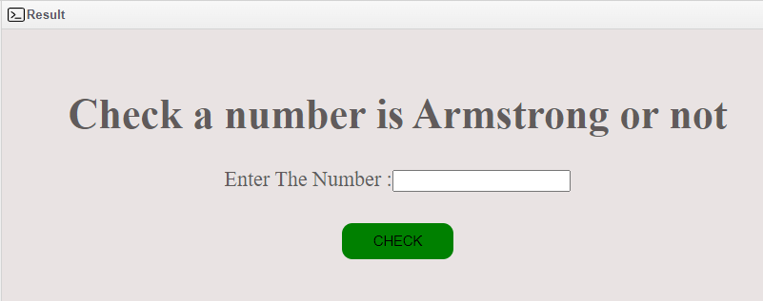

c. Find if a given number is Automorphic

**Code:**

<!DOCTYPE html>

<html lang="en">

<head>

<meta charset="UTF-8" />

<meta http-equiv="X-UA-Compatible" content="IE=edge" />

<meta name="viewport" content="width=device-width, initial-scale=1.0" />

<title>20BCS0139</title>

<style> body {

background-color: rgb(215, 207, 207);

color: rgb(65, 60, 60); text-align: center; font-size: 20px;

}

.b1 {

border: none;

background-color: green;

padding: 10px 30px; cursor: pointer; border-radius: 10px; margin-top: 30px; margin-bottom: 20px;

}

</style>

<script>

function automorphic() { var a, b;

a = parseInt(document.getElementById("first").value); b = a * a;

document.getElementById("num").innerHTML = "Square of a number is: " + b;

if (a % 10 != b % 10) {

document.getElementById("num1").innerHTML = a + " is not an automorphic number";

a = a / 10; b = b / 10;

} else {

document.getElementById("num1").innerHTML = a + " is an automorphic number";

}

}

</script>

</head>

<body>

<h1>Check the number is automorphic or not</h1> Enter the number:

<input type="text" name="a" id="first" placeholder="Enter a number" />

<br />

<button class="b1" onclick="automorphic ()">Submit</button>

<div id="num"></div>

<div id="num1"></div>

</body>

</html>

**Output:**

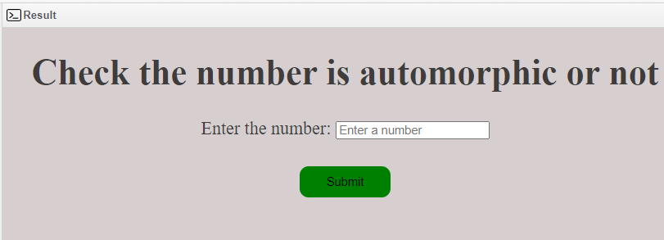

1. Design a HTML page to generate an image slide show using Javascript. First input all the images(minimum of 5 images) you want to add to the slideshow. Add a button to start the slideshow. Repeatedly starting from the first to last, display each image for 5 seconds and then display the next image. Add two buttons to view the previous and next image.

**Code:**

<!DOCTYPE html>

<html lang="en">

<head>

<meta charset="UTF-8" />

<meta http-equiv="X-UA-Compatible" content="IE=edge" />

<meta name="viewport" content="width=device-width, initial-scale=1.0" />

<title>20BCS0139</title>

<style> body {

background-color: rgb(255, 222, 173); color: black;

font-size: 22px;

}

button {

padding: 10px 30px; color: white;

background-color: green; border: none;

border-radius: 10px;

}

</style>

<script>

var images = new Array(); function startSideShow() { var i = 0; setInterval(function () {

var img = images[i]; document.getElementById("gtimage").setAttribute("src", img); document.getElementById("slideimgnum").innerHTML = i + 1;

document.getElementById("slideimgnumlength").innerHTML =images.length; if (i < images.length) {

if (i == images.length - 1) { i = 0;

} else { i++;

}

} else { i = 0;

}

}, 5000);

}

function addImage() {

if (images.length == 0) {

i = 0;

images[i] = document.getElementById("imgpaths").value;

} else {

var len = images.length; if (images.length < 5) {

images[len] = document.getElementById("imgpaths").value;

}

}

}

function prevoiusImage() {

if (i == 0) {

i = images.length - 1; var img = images[i];

document.getElementById("gtimage").setAttribute("src", img); document.getElementById("slideimgnum").innerHTML = i + 1; document.getElementById("slideimgnumlength").innerHTML = images.length;

} else { i--;

var img = images[i]; document.getElementById("gtimage").setAttribute("src", img); document.getElementById("slideimgnum").innerHTML = i + 1; document.getElementById("slideimgnumlength").innerHTML = images.length;

}

}

function nextImage() {

if (i == images.length - 1) { i = 0;

var img = images[i]; document.getElementById("gtimage").setAttribute("src", img); document.getElementById("slideimgnum").innerHTML = i + 1;

document.getElementById("slideimgnumlength").innerHTML = images.length;

} else { i++;

var img = images[i]; document.getElementById("gtimage").setAttribute("src", img); document.getElementById("slideimgnum").innerHTML = i + 1; document.getElementById("slideimgnumlength").innerHTML = images.length;

}

}

</script>

</head>

<body id="bodybg">

<center>

<h1>IMAGE SLIDE SHOW</h1>

<div>

<h5>

Image Path Url: <input type="text" id="imgpaths" />

<br />

<br />

<button type="text" onclick="addImage()">Add Image</button>

<button type="text" onclick="startSideShow()">Start Side Show</button>

</h5>

</div>

<div>

<img src="D:\html\htmll\img\image1.jpg" id="gtimage" />

<p style="text-align: center">

<span id="slideimgnum"></span>/<span id="slideimgnumlength"></span>

</p>

</div>

<button type="button" onclick="prevoiusImage()">&lt;&lt;</button>

<button type="button" onclick="nextImage()">&gt;&gt;</button>

</center>

</body>

</html>

**Output:**

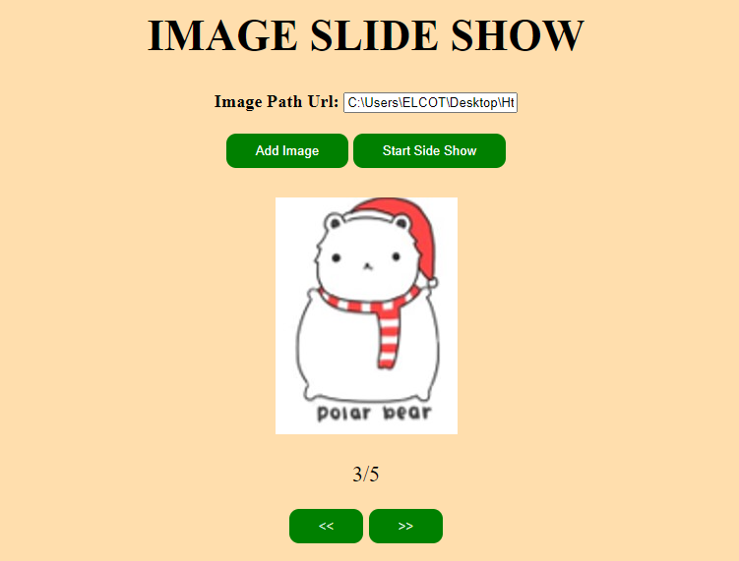

6. Develop an Online Greetings Designer using Javascript and CSS.

Add options to

i) change the image

ii) Position the image (left, background, right)

iii) Edit text

iv) Change font size

v) Change font color

**Code:**

<!DOCTYPE html>

<html lang="en">

<head>

<title>20BCS0139</title>

<title>Document</title>

<style> body{

width: 700px; margin: 0px auto;

background-color:green;

}

#container{ margin-top: 100px; text-align: center; width: 500px; height: 450px;

background-color: black; margin-bottom: 40px;

/* position: relative; */

}

#image{

width: 100%;

height: 50%;

/* background-color: black; */

/* margin-left: 26px; */

}

img{ width:500px ; height: 100%; overflow: hidden; object-fit: cover; overflow: hidden;

}

#content{ width: 500px;

overflow: hidden;

background-color:red; height:100%;

}

p{

color: white;

}

</style>

</head>

<body>

<div id="container">

<div id="image">

<img src="birthday.PNG" id="pic" alt="Happy Married Life">

<div id="content">

<p id="hb"><h2>Choose your own ceremony</h2>

<br><span>A Ceremony is a strict observance of formalities or etiquette,A formal act or set of formal acts established by custom or authority as proper to a special

occasion, such as a wedding, birthday, etc.</span>

</p>

</p>

</div>

</div>

</div>

<label for="">Enter celebration:</label>

<input type="text" id="text1">

<input type="button" value="Submit" onclick="content()"><br><br>

<label for="">Font size(in px):</label>

<input type="text" id="text2" >

<input type="button" value="Submit" onclick="f_size()"><br><br>

<label for="">Font color:</label>

<input type="color" id="text3" >

<input type="button" value="Submit" onclick="f_color()"><br><br>

<label for="">Background Image:</label><br>

<input type="radio" id="birthday" name="image" value="birth" onclick="img_change()">Birthday <br>

<input type="radio" id="wedding" name="image" value="wed" onclick="img_change()">Wedding <br>

<input type="radio" id="house" name="image" value="home" onclick="img_change()">House Warming <br>

<input type="radio" id="baby shower" name="image" value="sport" onclick="img_change()">Baby Shower<br>

<script>

function content(){

var txt= document.getElementById("text1").value;

document.getElementById("hb").innerHTML=txt;

}

function f_size(){

let font=document.getElementById("text2").value; document.getElementById("hb").style.fontSize = font+"px";

}

function f_color(){

let fcolor=document.getElementById("text3").value; document.getElementById("hb").style.color=fcolor;

}

function img_change(){ if(document.getElementById("sports").checked){ document.getElementById("pic").src="img/sports.JPG"

}

if(document.getElementById("birthday").checked){ document.getElementById("pic").src="img/birthdayimg.JPG"

}

if(document.getElementById("wedding").checked){ document.getElementById("pic").src="img/weddingimg.JPG"

}

if(document.getElementById("house").checked){ document.getElementById("pic").src="img/horse.JPG"

}

}

</script>

</body>

</html>

**Output:**

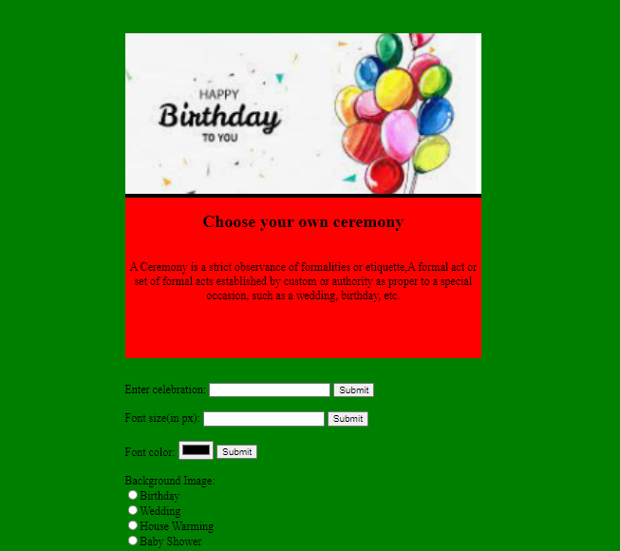

7.Design an online Resume Generator using HTML and Javascript. Design a HTML page where the user can input his personal, academic and experience details. Using Javascript generate the formatted resume.

**Code:**

<!Doctype html>

<html>

<head>

<title>20BCS0139</title>

<script>

function createResume(){

var fullnamme= document.getElementById('name').value;

var mobnumber= document.getElementById('number').value;

var address= document.getElementById('address').value;

document.getElementById('fullname').innerHTML=fullnamme;

document.getElementById('mobnumber').innerHTML=mobnumber;

document.getElementById('fulladdress').innerHTML=address;

var b10= document.getElementById('10b').value;

var s10= document.getElementById('10s').value;

var p10= document.getElementById('10p').value;

var c10= document.getElementById('10c').value;

document.getElementById('10thboard').innerHTML=b10;

document.getElementById('10school').innerHTML=s10;

document.getElementById('10year').innerHTML=p10;

document.getElementById('10cgpa').innerHTML=c10;

var b12= document.getElementById('12b').value;

var s12= document.getElementById('12s').value;

var p12= document.getElementById('12p').value;

var c12= document.getElementById('12c').value;

document.getElementById('12thboard').innerHTML=b12;

document.getElementById('12thschool').innerHTML=s12;

document.getElementById('12thyear').innerHTML=p12;

document.getElementById('12thcgpa').innerHTML=c12;

}

</script>

<style>

table,th,td{

border:1px solid black;

width:100%;

}

</style>

</head>

<body>

<fieldset>

<legend>Personal Info</legend>

Enter Your Name: <input type="text" id="name"><br>

Enter Mobile Number: <input type="text" id="number"><br>

Enter Address: <input type="text" id="address"><br>

</fieldset>

<br>

<fieldset>

<legend>Academic Info</legend>

Enter 10th Board: <input type="text" id="10b"><br>

Enter 10th School: <input type="text" id="10s"><br>

Enter 10th Passing Year: <input type="text" id="10p"><br>

Enter 10th CGPA: <input type="text" id="10c"><br><br>

Enter 12th Board: <input type="text" id="12b"><br>

Enter 12th School: <input type="text" id="12s"><br>

Enter 12th Passing Year: <input type="text" id="12p"><br>

Enter 12th CGPA: <input type="text" id="12c"><br>

</fieldset>

<button type="button"

onclick="createResume()">Submit</button><br><br>

<div id="resume" style="border:2px solid

#ddd;margin:5px;padding:5px">

<h4 style="text-align:center;text-decoration:underline">My

Resume</h4>

<div style="border:1px dashed black">

<div style="background:#333;color:white;padding:5px

10px">Personal Inforation</div>

<h1 style="margin:5px 0px 5px 10px"

id="fullname"></h1>

<h4 style="margin:5px 0px 5px 10px"

id="mobnumber"></h4>

<h5 style="margin:5px 0px 5px 10px"

id="fulladdress"></h5>

</div>

<div style="border:1px dashed black">

<div style="background:#333;color:white;margin:5px

0px ;padding:5px 10px">Academic Inforation</div>

<table>

<tr>

<th>Class</th>

<th>Board</th>

<th>School / University</th>

<th>Passing Year</th>

<th>CGPA</th>

</tr>

<tr>

<td>10<sup>th</sup></td>

<td id="10thboard"></td>

<td id="10school"></td>

<td id="10year"></td>

<td id="10cgpa"></td>

</tr>

<tr>

<td>12<sup>th</sup></td>

<td id="12thboard"></td>

<td id="12thschool"></td>

<td id="12thyear"></td>

<td id="12thcgpa"></td>

</tr>

</table>

<h1 style="margin:5px 0px 5px 10px"

id="fullname"></h1>

<h4 style="margin:5px 0px 5px 10px"

id="mobnumber"></h4>

<h5 style="margin:5px 0px 5px 10px"

id="fulladdress"></h5>

</div>

</div>

</body>

</html>

**Output:**

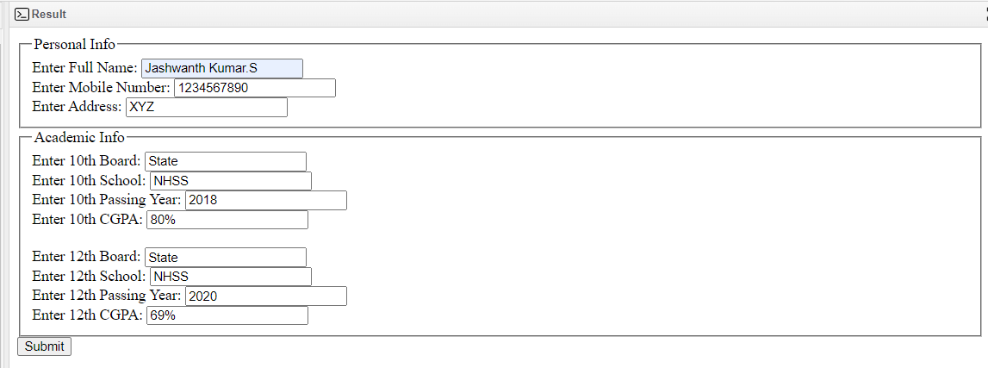

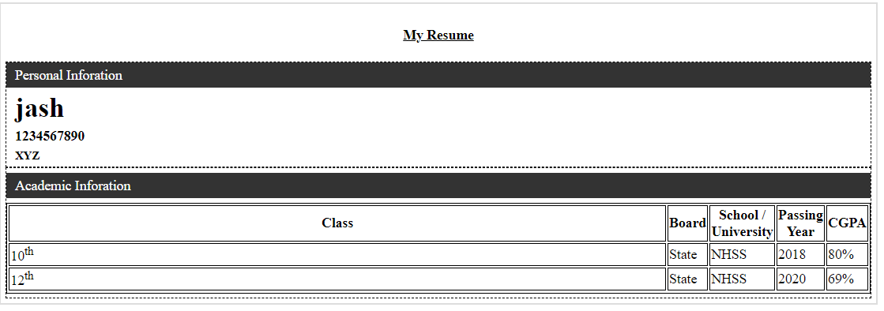

1. A parking garage charges a $2.00 minimum fee to park for up to three hours. The garage charges an additional $0.50 per hour for each hour or part thereof in excess of three hours. The maximum charge for any given 24-hour period is $10.00. Assume that no car parks for longer than 24 hours at a time. Write a script that calculates and displays the parking charges for each customer who parked a car in this garage yesterday. You should input from the user the hours parked for each customer. The program should display the charge for the current customer and should calculate and display the running total of yesterday's receipts. The program should use the function calculate-Charges to determine the charge for each customer. Use a text input field to obtain the input from the user.

**Code:**

<!DOCTYPE html>

<html lang="en">

<head>

<meta charset="UTF-8" />

<meta http-equiv="X-UA-Compatible" content="IE=edge" />

<meta name="viewport" content="width=device-width, initial-scale=1.0" />

<title>20BCS0139</title>

<style> body {

background-color: ;

}

h1 {

font-size: 40px;

font-family: sans-serif; font-weight: 600;

color:;

}

.data {

margin-left: 500px;

}

.b1,

.b2 {

padding: 10px 30px; color: white;

background-color:red; border-radius: 10px;

cursor: pointer;

}

.b3 {

padding: 10px 30px; color: white;

background-color:red; cursor: pointer;

border-radius: 10px;

}

.b1 {

margin-top: 20px;

}

.b2,

.b3 {

margin-left: 500px;

}

.answer,

.all_Data {

margin-left: 500px;

}

#lat {

margin-left: 500px;

}

</style>

<script>

var arr = [];

var hrs = [];

var total_amt = []; var count = 0;

function enter_data() {

var hrs_place = parseFloat(document.getElementById("hrs").value); var name = document.getElementById("nam").value; arr.push(name);

hrs.push(hrs_place);

if (hrs_place <= 3) { total_amnt = parseFloat("2"); total_amt.push(total_amnt);

} else if (hrs_place > 3 && hrs_place < 24) { total_amnt = 2 + (hrs_place - 3) * 0.5;

if (total_amnt > 10) { total_amnt = 10; total_amt.push(total_amnt);

} else { total_amt.push(total_amnt);

}

} else { total_amt.push(parseFloat("10"));

}

}

function show_data() { var sum = 0;

for (var j = 0; j < total_amt.length; j++) { sum = sum + total_amt[j];

}

document.getElementById("total").innerHTML = sum; for (var i = 0; i < arr.length - 1; i++) {

var data = "Name=" + arr[i] + " " + "hours=" +hrs[i] + " " + "Total amount=" +

total_amt[i];

var c = i.toString(); document.getElementById(c).innerHTML = data;

}

document.getElementById();

}

function show_latest_data() { var n = arr.length;

var data = "Name=" +arr[n - 1] +"Hours=" + hrs[n - 1] + "Total amount=" + total_amt[n - 1];

document.getElementById("lat").innerHTML = data;

}

</script>

</head>

<body>

<h1 align="center">Parking Garage</h1>

<div class="data">

Enter name:&nbsp;<input type="text" id="nam" /><br /><br /> Enter hrs: &nbsp; &nbsp;<input type="text" id="hrs" /><br />

<button class="b1" onclick="enter_data()">Add Data</button>

</div>

<br />

<button class="b2" onclick="show_data()">Show data</button><br /><br />

<button class="b3" onclick="show_latest_data()">Show Latest data</button

><br /><br />

<div class="answer">Total Collection=<span id="total"></span></div>

<h3 align="center">Yesterday:-</h3>

<div class="all_Data">

<span id="0"></span><br />

<span id="1"></span><br />

<span id="2"></span><br />

<span id="3"></span><br />

<span id="4"></span><br />

</div>

<h3 align="Center">Latest:-</h3>

<span id="lat"> </span>

<script src="script.js"></script>

</body>

</html>

**Output:**

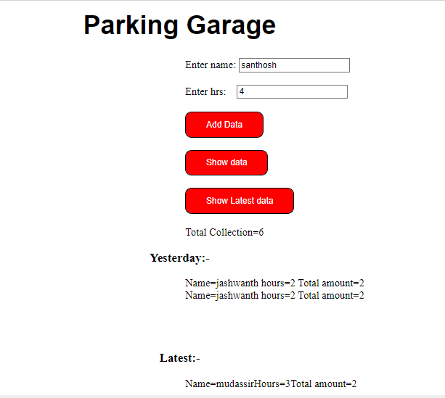

1. BSNL has designed a grievance registration form in HTML with name of customer, address, telecom circle, email and grievance nature in a list box containing huge bills for limited mobile usage, roaming charges and frequent service disruption and a submit button.

ii) Write a Javascript DOM event to be enabled when the user submits the form and display the complaint details in a tabular format.

iii) If no grievance is selected, then invoke another DOM event to display “ No grievances”.

**Code:**

<!DOCTYPE html>

<html lang="en">

<head>

<meta charset="UTF-8" />

<meta http-equiv="X-UA-Compatible" content="IE=edge" />

<meta name="viewport" content="width=device-width, initial-scale=1.0" />

<title>20BCS0139</title>

<style> body {

background-color: red;

color: rgb(63, 60, 60); font-family: sans-serif;

}

.card {

background-color: rgba(175, 178, 180, 0.888); width: fit-content;

border-radius: 5px;

color: black;

}

h3 {

text-decoration: underline; text-align: center;

background-color: rgb(255, 255, 255); border-radius: inherit;

}

.tab2 {

border-radius: 5px;

border-style: groove; border: 1;

border-color: rgb(245, 245, 245);

}

input {

border-radius: 1rem;

}

button {

border-radius: 10px; padding: 10px 30px; color: white;

background-color: rgb(215, 24, 24);

}

.form1 {

color: rgb(77, 75, 75);

}

</style>

<script>

function dataentry() {

var fname = document.getElementById("namef").value; var lname = document.getElementById("namel").value; var address = document.getElementById("add").value;

var telecomcircle = document.getElementById("telecom").value;

var emailadd = document.getElementById("email").value; var feedback = document.getElementById("fdback").value; document.getElementById("fstname").innerHTML = fname; document.getElementById("lstname").innerHTML = lname; document.getElementById("adds").innerHTML = address;

document.getElementById("telcom").innerHTML = telecomcircle; document.getElementById("emailid").innerHTML = emailadd; document.getElementById("feedbk").innerHTML = feedback;

}

</script>

</head>

<body>

<h1 align="center">BSNL Grievance Registration</h1>

<form class="form1">

<fieldset>

<legend>Customer Details</legend>

Enter First Name : <input type="text" id="namef" /> <br /><br /> Enter Last Name : <input type="text" id="namel" /> <br /><br /> Enter Address : <input type="text" id="add" /> <br /><br />

Enter Telecom Circle : <input type="text" id="telecom" /> <br /><br />

Enter E-mail :

<input type="email" id="email" placeholder="www.@gmail.com" />

<br />

<div class="card">

<h3>Roming Charges</h3>

<table class="tab1">

<tr>

<th>ISD Pack :</th>

<th>$23</th>

<td>| ISD SMS @Rs.3.0/sms.(Price per day : Rs.0.8)</td>

</tr>

<tr>

<th>STV VAS :</th>

<th>$36</th>

<td>

| Get unlimited SMS score alerts for on-going Cricket match along with News Jokes Love and Shayari sms content for 30 days.

</td>

</tr>

<tr>

<th>2GB Pack :</th>

<th>$13</th>

<td>

| This pack applies to North East 1 Telecom Region. 2G-3G Data: 2 GB, extra @Rs.0.03/10KB. (price per day: Rs. 13.0).

</td>

</tr>

</table>

</div>

<br />

Enter Roming Pack :

<input type="text" id="fdback"

placeholder="pack name or $"

/>

<br />

<button class="btn" type="button" onclick="dataentry()">Submit</button>

</fieldset>

</form>

<form>

<fieldset>

<legend>Customer Complaint Details :</legend>

<table border="1px" class="tab2">

<tr>

<th>First Name</th>

<th>Last Name</th>

<th>Address</th>

<th>Telecom Circle</th>

<th>E-mail</th>

<th>Romig Pack</th>

</tr>

<tr>

<td id="fstname"></td>

<td id="lstname"></td>

<td id="adds"></td>

<td id="telcom"></td>

<td id="emailid"></td>

<td id="feedbk"></td>

</tr>

</table>

</fieldset>

</form>

</body>

</html>

**Output:**

