Intrusion Detection System for Internet of Vehicles Using Optimized CNN

# Mohamed Faheej N

*Department of Computer Application*

*Vellore Institute of Technology* Vellore, India. mohamedfaheej.n2023@vitstudent.ac.in

# Mudassir Khan G

*Department of Computer Application*

*Vellore Institute of Technology* Vellore, India.

mudassirkhan.g2023@vitstudent.ac.in

# Jashwanth Kumar S

*Department of Computer*

*Application*

*Vellore Institute of Technology* Vellore, India.

jashwanthkumar.s2023@vitstudent.ac.in

***Abstract*—** **In today's world rapidly evolving technological landscape, various advancements such as electric vehicles, autonomous vehicles, and connected vehicles have emerged. It highlights the vulnerability of modern vehicles, interconnected with the external world, to cyber threats, necessitating the deployment of Intrusion Detection Systems (IDSs) to enhance security in vehicular networks. The paper proposes a novel approach utilizing Transfer Learning, machine learning, and ensemble learning techniques to implement IDS in the Internet of Vehicles (IoV). It employs Recurrent Neural Network (RNN) and hyper-parameter optimization techniques and demonstrates the effectiveness of the proposed IDS in detecting cyber-attacks using datasets such as Car-Hacking and CICIDS2017. The research aims to emphasize the efficacy of the IDS in bolstering cybersecurity in modern vehicle systems**

***Index Terms*—Intrusion Detection System, RNN, Transfer learning, Ensemble learning, Internet of Vehicles.**

1. Introduction

Modern vehicles, driven by advancements in Internet of Things (IoT) and Internet of Vehicles (IoV) technologies, have become network-controlled, with intra-vehicle communications predominantly facilitated by the Controller Area Network (CAN) bus. However, the increased identity and accessibility of automotive networks have expanded the cyber-attack surface of contemporary automobiles, making them vulnerable to various attacks such as DoS, fuzzy, and spoofing attacks. The absence of fundamental security safeguards in processing CAN packets heightens the risk of cyber threats. Leveraging advancements in machine learning (ML) and deep learning (DL), this research proposes an intelligent IDS model based on enhanced Convolutional Neural Networks (CNNs), transfer learning, and ensemble learning techniques. By training base learners using state-of-the-art CNN models on car network traffic data and employing Particle Swarm Optimization (PSO) for hyper-parameter optimization, the proposed IDS aims to provide optimal learning models. Evaluation using open-source vehicle network datasets demonstrates the efficacy and efficiency of the proposed IDS system.

The study's main contributions include:

1. Introducing a novel framework using CNN, transfer learning, ensemble learning, and HPO for efficient cyber-attack detection in both internal and external networks.
2. Proposing a data transformation technique to convert car network traffic data into visuals, aiding in the identification of various cyber-attack patterns.
3. Comparing the performance of the proposed method with state-of-the-art approaches using benchmark cyber-security datasets reflecting data from both internal and external networks.

II.Proposed Framework

This effort aims to defend both internal and external vehicular networks by creating an IDS capable of identifying various threats. The IDS is designed to protect vehicles from both internal attacks via the On-Board Diagnostics II (OBD II) interface and external assaults through wireless interfaces. It is proposed to be implemented in both intra-vehicle networks (IVNs) and external networks. The IDS can be installed on the CAN-bus in IVNs to detect unusual CAN messages and generate alarms. Additionally, it can be integrated into gateways in external networks to detect and filter malicious packets aimed at breaching vehicles.

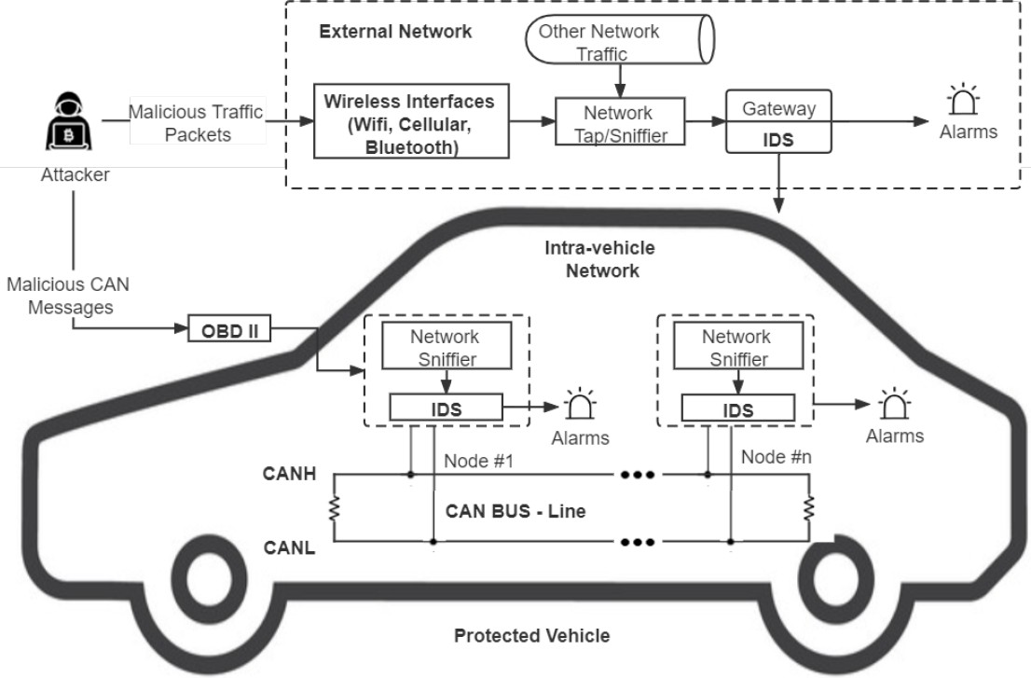

Fig. 1. Architecture of IDS-Protected Vehicle

This research proposes a unique optimized CNN and transfer learning-based IDS to identify different types of attacks in IoV systems. The proposed IDS framework utilizes quantile transform to convert time-based chunked network data into images, which are then used to train five cutting-edge CNN models (VGG16, VGG19, Xception, Inception, and InceptionResnet). Hyper-parameter optimization using Particle Swarm Optimization (PSO) is employed to optimize the CNN models, and ensemble techniques such as confidence averaging and concatenation are used to construct final detection models.

III. Data Description and Transformation

In this study, two datasets are utilized to develop the proposed IDS for both intra-vehicle networks (IVNs) and external vehicular networks. The Car-Hacking dataset provides intra-vehicle data, including CAN identification (ID) and 8-bit data field of CAN packets, covering attacks like DoS, fuzzy, gear spoofing, and RPM spoofing. The CICIDS2017 dataset offers external network data, showcasing attack patterns such as DoS assaults, port-scan attacks, brute-force attacks, web attacks, and botnets. Data preprocessing involves converting original network data into image forms, with normalization techniques applied for consistency.

Quantile normalization is employed in the proposed architecture due to its resilience against outliers, unlike min-max normalization, which often yields excessively low values in the majority of data samples. This technique recalibrates all feature values based on a normal distribution, resulting in most variable values being within a few standard deviations of the median, effectively managing outliers. The data samples are transformed following data normalization. de- pending on the timestamps and size of the features of datasets for network traffic. As it has done for the Car-Hacking dataset 9 key characteristics (CAN ID and DATA[0]–DATA[7]), each of which block of 9 characteristics and 27 consecutive samples (279 = 243) feature values combined) are converted into a shape picture. 9x9x3.

Each modified picture is a square color as a result a three-channel picture (red, green, and blue). Similarly, the CICIDS2017 dataset that produced 20 significant characteristics Each image from is converted to 20203 color images. This dataset’s chunk has 203 = 60 consecutive data. samples. Since the timestamps are used to produce the photos the initial time-series correlations of the data samples, network data can be retained.

IV. CNN and Transfer Learning

CNN models excel at image classification and recognition tasks by directly processing images, avoiding the need for additional feature extraction. They comprise convolutional, pooling, and fully-connected layers, which automatically extract feature patterns, reduce data complexity, and generate output.

Transfer Learning (TL) involves transferring a DNN model's weights from one dataset to another, leveraging learned feature patterns.

TL has been successful in various picture classification tasks, utilizing specific characteristics from the top layers of CNN models and generic patterns from the bottom layers. Fine-tuning involves freezing most pre-trained model layers while unfreezing a few top layers to adapt to new data. In this work, VGG16, VGG19, Xception, Inception, and InceptionResnet are chosen as base models. These models have shown outstanding performance in image classification tasks, especially after pre-training on the ImageNet dataset, which consists of over a million photos in 1,000 classes. VGG16 and VGG19 models achieved decreased error rates in the ImageNet Challenge, with VGG19 having three additional convolutional layers compared to VGG16's five blocks of convolutional layers and three fully connected layers.

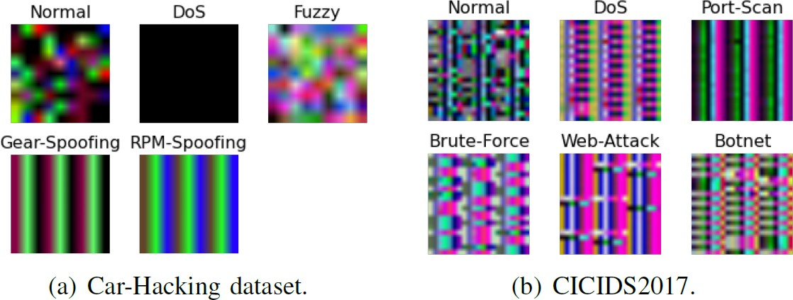

Fig. 3. Sample images of each class in two datasets: a) Car-Hacking dataset;

b) CICIDS2017.

V. Proposed Ensemble Learning Model

Ensemble learning combines multiple learning models to create an ensemble model, boosting efficiency. It's widely used in data analytics because ensembles often outperform individual learners. One technique, confidence averaging, combines learners' categorization probability values to identify the most confident group. In this approach, softmax layers in DL models produce posterior probabilities for each class, and the class with the highest average confidence is chosen as the final categorization outcome.

VI. Performance and Evaluation

To enhance the performance of CNN models on the chosen datasets, hyperparameters must be adjusted and optimized. These hyperparameters include those related to model creation, such as frozen layer proportion, learning rate, and dropout rate, as well as those for model training, such as early stopping, number of epochs, and batch size. Hyperparameter Optimization (HPO) is an automated process that fine-tunes these parameters using optimization techniques. Particle Swarm Optimization (PSO) is a popular metaheuristic optimization method used for HPO, where particles in a swarm exchange information to determine optimal hyperparameter values. Each particle in PSO is initialized with a position and velocity, and their velocities are updated based on their own best position and the global best position.



Fig. 4. softmax formula

VII. Performance and Evaluation

1. *Experimental setup*

The experiments were conducted using Python libraries, specifically Scikit-learn and Keras. The DL models were evaluated on a Raspberry Pi 3 and trained on a Dell Precision 3630, representing an IoV central server machine and a vehicle-level local machine, respectively. The proposed architecture was tested using the benchmark CICIDS2017 and Car-Hacking datasets, with performance assessed using fivefold cross-validation to prevent biased and over-fitted findings.

1. *Experiments and Results*

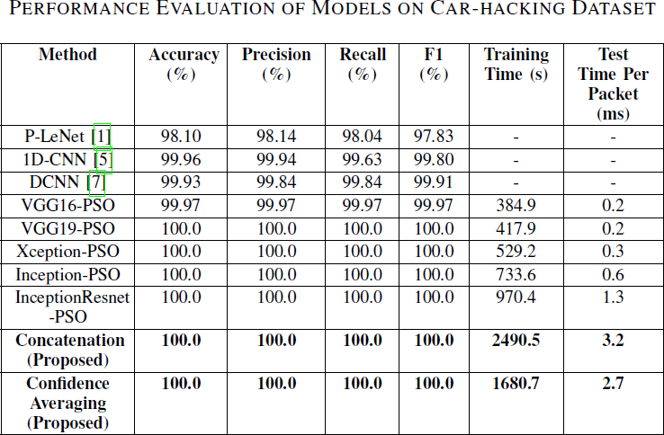The primary hyperparameters of each basic CNN model were optimized using PSO to achieve the best performance. HPO was specifically applied to the CICIDS2017 dataset, given that CNN models with default settings already achieved close to 100% accuracy on the Car-Hacking dataset. Following HPO, ensemble models were constructed using the optimized CNN models as base learners. Tables II and III present the results of testing the enhanced CNN models and the suggested ensemble models on the Car-Hacking and CICIDS2017 datasets. Except for VGG16, all improved basic CNN models achieved 100% accuracy and F1-scores, facilitated by distinct patterns in the modified pictures. Concatenation and confidence averaging procedures, two ensemble methodologies, were also utilized.

Fig. 5. Evaluation of models on Car Hacking Dataset.

Following data transformation and PSO, the optimized base CNN models for the CICIDS2017 dataset attained high F1-scores ranging from 99.674% to 99.850%. Additionally, the confidence averaging ensemble model slightly outperformed the concatenation model, achieving an F1-score of 99.925%. These ensemble models exhibited better performance than recent approaches in the literature. Notably, the confidence averaging method required significantly less training time overall than the concatenation strategy. The efficacy of CNN, TL, and HPO approaches was evident in the superior performance of the proposed models compared to other cutting-edge IDSs. Additionally, the average prediction times of the proposed ensemble models demonstrated their suitability for real-time implementation in IoV systems.

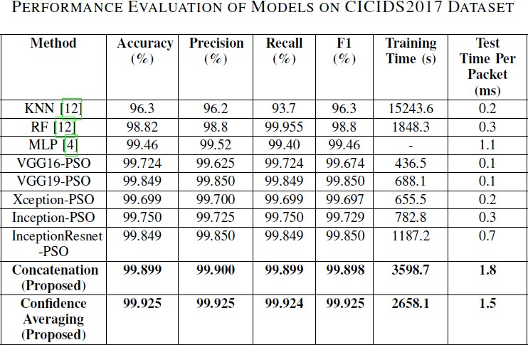

Fig. 6. Evaluation Of Models On CICIDS2017 Dataset

VIII. Conclusion

This paper introduces a transfer learning and ensemble learning-based IDS framework to protect IoV systems from cyberthreats. It utilizes optimal CNN models to detect various attacks and proposes a chunk-based data transformation technique for processing car network traffic data. Experimental results using Car-Hacking and CICIDS2017 datasets show superior performance compared to existing approaches, with F1-scores reaching 100% and 99.925%. Testing on vehicle-level machines

confirms the effectiveness of the IDS in real-time networks. Future work aims to develop an online adaptive model to address concept drift in car network data and enable online learning.

References

1. Yang, L., and Shami, A., "A Transfer Learning and Optimized CNN Based Intrusion Detection System for Internet of Vehicles," arXiv preprint arXiv: pp. 2201.11812 (2022).
2. S. T. Mehedi, A. Anwar, Z. Rahman, and K. Ahmed, “Deep Transfer Learning Based Intrusion Detection System for Electric Vehicular Networks,” Sensors, vol. 21, no. 14, 2021.
3. L. Yang, A. Moubayed, and A. Shami, “MTH-IDS: A Multi-Tiered Hybrid Intrusion Detection System for Internet of Vehicles,” IEEE Internet Things J., 2021.
4. L. Yang et al., ”Multi-Perspective Content Delivery Networks Security Framework Using Optimized Unsupervised Anomaly Detection,” IEEE Trans. Netw. Serv. Manag., 2021.
5. L. Yang and A. Shami, “A Lightweight Concept Drift Detection and Adaptation Framework for IoT Data Streams,” IEEE Internet Things Mag., vol. 4, no. 2, pp. 96–101, 2021.
6. Thakkar, A., and Lohiya, R., "A review on machine learning and deep learning perspectives of IDS for IoT: recent updates, security issues, and challenges," Archives of Computational Methods in Engineering, 28(4), 3211-3243 (2021).
7. Mehedi, S. T., Anwar, A., Rahman, Z., and Ahmed, K., "Deep transfer learning based intrusion detection system for electric vehicular networks," Sensors, 21(14): pp. 4736 (2021).
8. Kim, D.Y.; Jung, M.; Kim, S. An internet of vehicles (IoV) access gateway design considering the efficiency of the in-vehicle ethernet backbone. *Sensors* 2021, *21*, 98.
9. Yang, L.; Moubayed, A.; Shami, A. MTH-IDS: A Multi-Tiered Hybrid Intrusion Detection System for Internet of Vehicles. *IEEE Internet Things J.* 2021, *9*, 616–632.
10. Latif, S.; e Huma, Z.; Jamal, S.S.; Ahmed, F.; Ahmad, J.; Zahid, A.; Dashtipour, K.; Muhmmad, U.A.; Ahmad, M.; Abbasi, Q.H. Intrusion Detection Framework for the Internet of Things using a Dense Random Neural Network. *IEEE Trans. Ind. Inform.* 2021.