**AIM:** To develop or design an app or web application to change the background color and menu.

**PROCEDURE:**

1.Create a canvas for the app.

2. Add all the wedgets.

3.Change the background color.

4.Add menu.

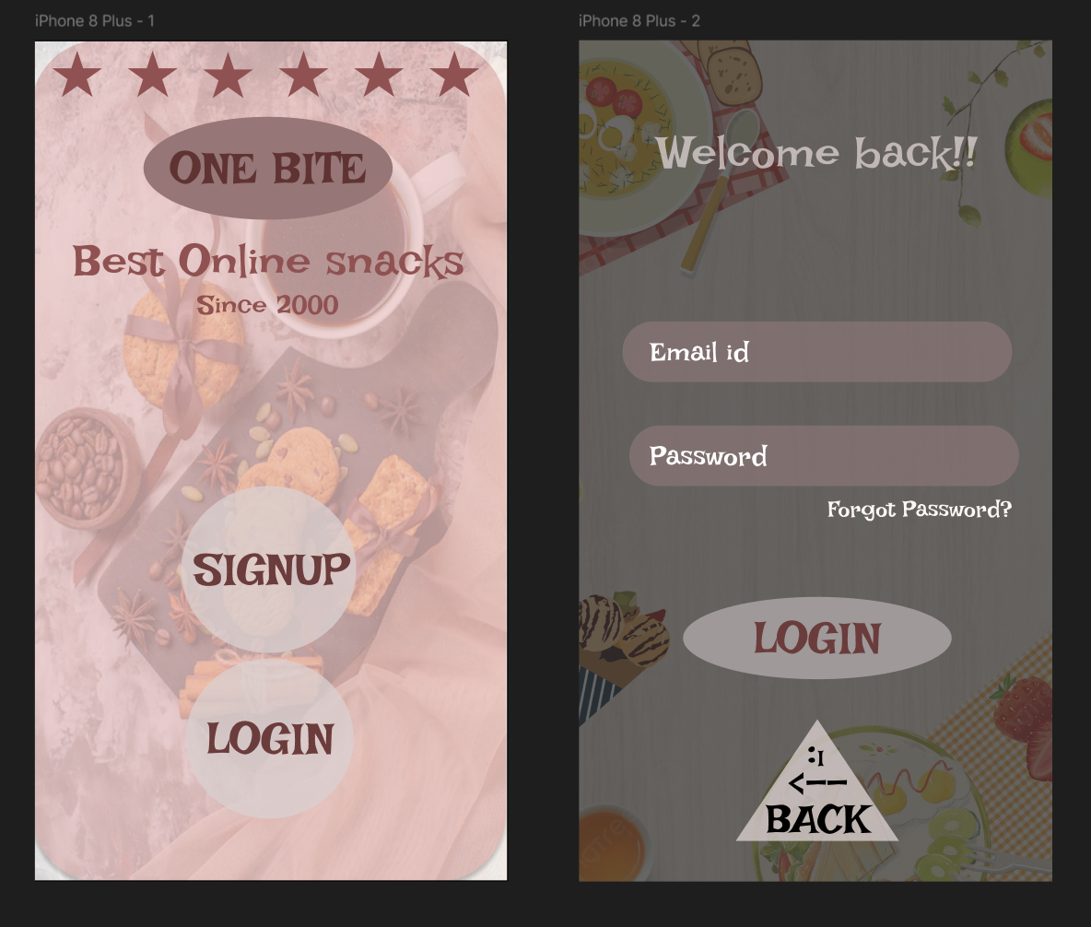

**RESULT:** Hence the design is completed and output is verified.