TACTILE VIRTUALIZATION: RENDERING FABRIC TEXTURE AS SMARTPHONE VIBRATION

A PROJECT REPORT SUBMITTED IN PARTIAL FULFILLMENT OF THE REQUIREMENTS FOR THE AWARD OF THE DEGREE OF

BACHELOR OF TECHNOLOGY
IN
COMPUTER SCIENCE AND ENGINEERING

BY

NAME OF THE STUDENT 1 22071A0301

NAME OF THE STUDENT 2 22071A0302

NAME OF THE STUDENT 3 22071A0303

NAME OF THE STUDENT 4 22071A0304

UNDER THE GUIDANCE OF

Ms. G. LAXMI DEEPTHI

Assistant Professor



DEPARTMENT OF COMPUTER SCIENCE AND ENGINEERING

VALLURUPALLI NAGESWARA RAO

VIGNANA JYOTHI INSTITUTE OF ENGINEERING & TECHNOLOGY
Vignana Jyothi Nagar, Bachupally, Hyderabad 500118, Telangana, India

NOVEMBER 2026


DEPARTMENT OF COMPUTER SCIENCE AND ENGINEERING
CERTIFICATE
This is to certify that the Major Project Phase-I titled “TACTILE VIRTUALIZATION: RENDERING FABRIC TEXTURE AS SMARTPHONE VIBRATION” is a record of bona fide work submitted by:
- NAME OF THE STUDENT 1 22071A0301
- NAME OF THE STUDENT 2 22071A0302
- NAME OF THE STUDENT 3 22071A0303
- NAME OF THE STUDENT 4 22071A0304
in partial fulfillment of the requirements for the award of the degree of Bachelor of Technology (B.Tech.) in COMPUTER SCIENCE AND ENGINEERING of Jawaharlal Nehru Technological University Hyderabad (JNTUH), under VNRVJIET B.Tech. R22 Academic Regulations. The work has been carried out under our guidance and supervision at Vallurupalli Nageswara Rao Vignana Jyothi Institute of Engineering & Technology, Hyderabad.
The report is original, free from plagiarism, and complies with the Institute guidelines, including those related to academic ethics and AI-generated content.

Signature of Supervisor  Ms. G. Laxmi Deepthi  Assistant Professor  Dept. of CSE | Signature of HOD  Dr. Vadlana Baby  Associate Professor & HOD  Dept. of CSE
VNR VJIET, Hyderabad | VNR VJIET, Hyderabad

PLAGIARISM CERTIFICATE

APPROVAL CERTIFICATE

The Major Project Phase–I evaluation for the project titled “TACTILE VIRTUALIZATION: RENDERING FABRIC TEXTURE AS SMARTPHONE VIBRATION,” being submitted by
Mr./Ms. NAME OF THE STUDENT 1, Regd. No. 22071A0301, Mr./Ms. NAME OF THE STUDENT 2, Regd. No. 22071A0302, Mr./Ms. NAME OF THE STUDENT 3, Regd. No. 22071A0303, Mr./Ms. NAME OF THE STUDENT 4, Regd. No. 22071A0304,
was conducted on ____________. The project has been evaluated in accordance with the applicable requirements of the VNRVJIET B.Tech. R22 Academic Regulations for the BACHELOR OF TECHNOLOGY (B.Tech.) programme in COMPUTER SCIENCE AND ENGINEERING.

INTERNAL EXAMINER EXTERNAL EXAMINER

DEPARTMENT OF COMPUTER SCIENCE AND ENGINEERING
DECLARATION
We, the undersigned, declare that the Major Project Phase-I titled “TACTILE VIRTUALIZATION: RENDERING FABRIC TEXTURE AS SMARTPHONE VIBRATION” has been carried out by us in partial fulfillment of the requirements for the award of the degree of Bachelor of Technology (B.Tech.) in COMPUTER SCIENCE AND ENGINEERING of Jawaharlal Nehru Technological University Hyderabad (JNTUH), under VNRVJIET B.Tech. R22 Academic Regulations, at Vallurupalli Nageswara Rao Vignana Jyothi Institute of Engineering & Technology, Hyderabad.
We further declare that this work is original, has not been submitted previously for any degree or similar title, and complies with the Institute’s plagiarism and academic ethics guidelines, including AI-generated content. The contributions of all team members are clearly indicated in the report.
PLACE: HYDERABAD
DATE: ____________
Signature of the Student(s)

NAME OF THE STUDENT 1 22071A0301

NAME OF THE STUDENT 2 22071A0302

NAME OF THE STUDENT 3 22071A0303
NAME OF THE STUDENT 4 22071A0304

ABSTRACT

Online shoppers cannot touch the fabric of a garment before buying it, so they cannot judge how it feels. This project asks how much of a fabric's feel can be carried from a product photograph to the vibration motor of an ordinary Android smartphone, using software and public data only. The work is organised into five objectives: a haptic descriptor database with a pre-registered separability gate, visual fabric classification with a measurement of the gap between laboratory scans and product photographs, image-to-vibration association, a web rendering interface, and a perceptual user study. The literature shows that visual-to-tactile mapping, contrastive visual-tactile embeddings and velocity-conditioned rendering are already well studied. What remains open is whether models trained on laboratory surface scans transfer to real product photography, whether vibration descriptors stay stable across sliding speed, and what survives a phone's on/off vibration channel. Phase I used the Cluster Haptic Texture Dataset (118 materials, 16 of them cloth). The four-number vibration descriptor failed the pre-registered gate (silhouette −0.164, one effective class of 16), while a convolutional network on the spectrogram identified the fabric 37.8% of the time against 6.25% chance. A photo-trained material classifier recognised 75.6% of photographed fabric but only 3.3% of the dataset's fabric scans. After the vibration shared by every surface is removed, cloth alone shifts upward with sliding speed, which replicated on 2,240 held-out recordings. All results are saved, re-run from committed code and covered by 459 automated tests. Phase II will complete the product-photo transfer set, run the user study once ethics clearance is obtained, and submit the findings for publication.
Keywords: Haptic rendering, Vibrotactile feedback, Fabric texture, Domain transfer, E-commerce
TABLE OF CONTENTS

CERTIFICATE |  | i
PLAGIARISM CERTIFICATE |  | ii
APPROVAL CERTIFICATE |  | iii
DECLARATION |  | iv
ABSTRACT |  | v
TABLE OF CONTENTS |  | vi
LIST OF FIGURES |  | viii
LIST OF TABLES |  | ix
NOMENCLATURE |  | x
ACKNOWLEDGEMENT |  | xi
CHAPTER 1 – INTRODUCTION |  | 1
1.1 | Background of the Problem | 1
1.2 | Need and Relevance | 1
1.3 | Problem Statement | 1
1.4 | Aim and Objectives | 2
1.5 | Scope of Work | 3
1.6 | Engineering, Environmental, Societal, and Cost Considerations | 3
1.7 | Organization of the Report | 3
CHAPTER 2 – LITERATURE REVIEW |  | 4
2.1 | Overview of Existing Work | 4
2.2 | Comparison of Methods / Approaches | 5
2.3 | Critical Analysis of Literature and Inferences | 7
2.4 | Research Gaps Identified | 7
CHAPTER 3 – PROPOSED DESIGN / SOLUTION APPROACH |  | 8
3.1 | Requirements and Constraints | 8
3.2 | Possible Approaches Considered | 9
3.3 | Proposed Approach / Methodology | 9
3.4 | Technical Justification and Supporting Analysis | 14
3.5 | Assumptions and Benchmarks | 14
3.6 | Tools / Techniques Proposed | 15
3.7 | Feasibility and Sustainability Considerations | 15
CHAPTER 4 – PRELIMINARY DESIGN, ANALYSIS AND PHASE–I PROGRESS |  | 16
4.1 | Phase–I Activities and Progress | 16
4.2 | Preliminary Design / Model / Calculations / Simulation | 17
4.3 | Preliminary Implementation or Proof of Concept (where applicable) | 18
4.4 | Preliminary Checks, Tests and Observations (where applicable) | 21
4.5 | Challenges and Decisions | 27
CHAPTER 5 – EXPECTED OUTCOMES AND PHASE–II PLAN |  | 29
5.1 | Expected Outcomes Linked to Objectives | 29
5.2 | Project Plan, Milestones and Timeline | 29
5.3 | Work Planned for Phase–II | 29
5.4 | Conclusions from Phase–I | 30
REFERENCES |  | 31
APPENDICES |  | 34
APPENDIX A: Contribution of Team Members |  | 35
APPENDIX B: Relevance to Sustainable Development Goals (SDGs) |  | 36
APPENDIX C: Descriptor Extraction Code |  | 37
APPENDIX D: Source of Every Result |  | 38
LIST OF FIGURES

Fig. No. | Title | Page No.
3.1 | System architecture | 10
3.2 | Activity diagram of the image-to-vibration pipeline | 11
3.3 | Use case diagram | 12
3.4 | Class diagram of the main modules | 13
3.5 | Sequence diagram for “feel this fabric” | 13
3.6 | State diagram of a rendering session | 14
4.1 | The web interface after analysing a sample image (desktop browser) | 20
4.2 | Share of variance in each descriptor | 22
4.3 | Sixteen-way fabric identification from acceleration | 22
4.4 | Confusion matrix of the DTD texture classifier on the 12 textile classes | 23
4.5 | A photo-trained classifier does not recognise flatbed scans of fabric | 24
4.6 | Velocity exponents for all 118 materials | 25
4.7 | Identification accuracy for every input and model tried in Phase I | 27
LIST OF TABLES

Table No. | Title | Page No.
1.1 | Objectives, how each is measured, and Phase I status | 2
2.1 | Literature survey of related work | 5
2.2 | Rendering technologies for consumer use | 6
2.3 | Research gaps and how this project addresses them | 7
3.1 | Principal requirements and design controls | 8
3.2 | Approaches considered and the decision taken | 9
3.3 | Tools and techniques | 15
4.1 | Status of each objective at the end of Phase I | 16
4.2 | Phase I timeline | 16
4.3 | The 16 cloth materials and their usable recordings | 17
4.4 | Haptic descriptor definitions | 17
4.5 | Main data stores | 20
4.6 | O1 separability gate on the 16 cloth materials | 21
4.7 | Registered predictions in rounds 2–6 and their outcomes | 25
5.1 | Expected outcomes | 29
5.2 | Phase II timeline (16 weeks) | 29
A.1 | Contribution of team members | 35
D.1 | Saved runs behind the reported results | 38
NOMENCLATURE
Symbol | Meaning
API | Application Programming Interface
CLIP | Contrastive Language–Image Pre-training (image–text model)
CNN | Convolutional Neural Network
CV | Coefficient of Variation
DTD | Describable Textures Dataset
ERM / LRA | Eccentric Rotating Mass / Linear Resonant Actuator (phone motors)
F1 | Harmonic mean of precision and recall
FFT | Fast Fourier Transform
GPU | Graphics Processing Unit
ICC | Intraclass Correlation Coefficient
MAE | Mean Absolute Error
MINC | Materials in Context Database (MINC-2500 subset)
RMS | Root Mean Square
UML | Unified Modeling Language
f | Spectral centroid of acceleration (Hz)
v | Sliding velocity of the probe (mm/s)
λ | Spatial wavelength of a surface texture (mm)
ω² | Omega-squared, an unbiased effect size for ANOVA
p | Probability value of a statistical test
ACKNOWLEDGEMENT
We express our sincere gratitude to our project supervisor, Ms. G. Laxmi Deepthi, Assistant Professor, Department of Computer Science and Engineering, for her guidance, technical direction and regular review of our work, and for helping us settle the scope of the project early.
We thank Dr. Vadlana Baby, Associate Professor and Head of the Department of Computer Science and Engineering, for providing the facilities and encouragement needed to carry out this work, and the faculty and staff of the department for their support.
We thank the management and Principal of VNR Vignana Jyothi Institute of Engineering and Technology for the infrastructure and environment provided.
We acknowledge the authors of the Cluster Haptic Texture Dataset, MINC-2500, the Describable Textures Dataset and DeepFashion-MultiModal for making their data public, and Kaggle for the GPU time used to train our models.

NAME OF THE STUDENT 1 22071A0301

NAME OF THE STUDENT 2 22071A0302

NAME OF THE STUDENT 3 22071A0303
NAME OF THE STUDENT 4 22071A0304

CHAPTER 1

INTRODUCTION

1.1 Background of the Problem
When a shopper buys a garment online, they judge its fabric from a photograph and a short text description. Touch, which is how people normally judge softness, roughness and drape, is missing. Haptics research has shown that much of what is felt when a finger or a tool slides over a textured surface is carried by small vibrations [1], [2]. Nearly every smartphone already contains a vibration motor, and Android browsers can drive it from a web page through the W3C Vibration API [3]. This suggests a software-only path to giving a shopper a rough sense of a fabric: map the product photograph to a vibration pattern and play it on the phone.
Doing this needs three things that do not yet exist together: recordings of how real fabrics vibrate when touched, a way to recognise the fabric from an ordinary product photograph, and a way to turn a recorded vibration into a pattern that a phone motor can play. Public datasets now provide the first. The Cluster Haptic Texture Dataset [4] records contact sound, probe acceleration, force and position for 118 materials, including 16 fabrics, at five sliding speeds, eight directions and two forces.
1.2 Need and Relevance
Experiments on mobile shopping show that adding vibrotactile feedback raises shoppers' anticipated satisfaction with a product [5], and that the value of haptic feedback depends on how much a shopper relies on touch [6]. A feature that lets a shopper feel even a coarse difference between, for example, corduroy and silk would add information that photographs cannot give. Because the method uses only a web page and the phone's existing motor, it needs no extra hardware and could reach any Android user. The work is also relevant to haptics research, because it measures how far laboratory haptic data can be reused for consumer devices.
1.3 Problem Statement
Given a photograph of a garment, produce a vibration pattern that a standard Android smartphone can play and that conveys the texture of the garment's fabric, using only public datasets and no custom hardware. Measure, at each stage, how much fabric-specific information survives: from the surface to the recorded vibration, from the laboratory scan to the product photograph, and from the recorded vibration to the phone's on/off motor.
1.4 Aim and Objectives
The aim is to build and evaluate a pipeline that renders fabric texture as smartphone vibration from a product image, and to report honestly where information is lost. The objectives are listed below, and Table 1.1 gives how each one is measured and where it stands at the end of Phase I.
- O1 – Build a haptic descriptor database for the 16 cloth materials (frequency, intensity, pattern and duration) and test, with thresholds fixed in advance, whether the materials can be told apart.
- O2 – Train ImageNet-pretrained ResNet-50 classifiers for material (MINC-2500) and texture (DTD), and measure the accuracy gap between the dataset's 300 dpi scans and real product photographs.
- O3 – Compare two image-to-vibration association strategies (class-pair lookup and embedding similarity) on held-out materials, and test whether descriptors are invariant to sliding velocity.
- O4 – Build a web interface that goes from image to classifier to descriptor to waveform, spectrum and phone vibration, with a two-fabric comparison view.
- O5 – Validate the result perceptually with a user study (40 participants recruited, at least 30 usable, Android only), including mismatched control pairs.
Table 1.1 Objectives, how each is measured, and Phase I status
Objective | Measured by | Status at end of Phase I
O1 Haptic database | Coverage; ANOVA effect size; silhouette ≥ 0.30 and ≥ 8 of 16 materials separable (fixed in advance) | Done; gate failed (silhouette −0.164)
O2 Visual classification | Top-1 accuracy and macro F1; accuracy on scans vs ≥ 50 labelled product photos | Models trained (80.3%, 80.7%); photo set pending
O3 Association and velocity | Top-1/top-3 retrieval; descriptor error vs the mean; variation across 20–60 mm/s | Done; no strategy beats the mean; cloth-specific speed shift
O4 Interface | End-to-end latency; rendering on ≥ 3 Android models | Working prototype; device tests pending
O5 User study | Ratings against mismatched controls; ≥ 30 usable participants | Instrument ready; awaiting ethics clearance

1.5 Scope of Work
The project is software only; no hardware is built or bought. It uses public datasets only: the Cluster Haptic Texture Dataset [4], MINC-2500 [7], the Describable Textures Dataset (DTD) [8] and DeepFashion-MultiModal [9]. Rendering targets Android phones, because iOS browsers do not implement the Vibration API. The study is limited to the 16 fabrics in the Cluster dataset, with the other 102 materials used as a reference for what all surfaces share. Patent protection is out of scope, since software as such is excluded under Section 3(k) of the Indian Patents Act; software copyright registration is the appropriate route if needed.
1.6 Engineering, Environmental, Societal and Cost Considerations
Complexity: complex. The problem combines signal processing, deep learning on images, cross-domain transfer, statistics with pre-registered hypotheses, web development and human-subject evaluation.
Cost: low. All data is public, all software is open source, and model training uses free Kaggle GPU time (about 30 hours per week is available; 3.9 hours have been used so far). The user study needs only participants' own Android phones.
Environment and sustainability: if shoppers can judge fabric better before buying, fewer garments may be returned, which would reduce return shipping and waste. This is a possible benefit, not something this project measures. Compute use is kept small by running everything that does not need a GPU on a CPU.
Society: the feature could help shoppers who rely heavily on touch to judge clothing. The user study will follow the institute's ethics process and collect no identifying data beyond the phone model.
1.7 Organization of the Report
Chapter 2 reviews existing work and identifies the gaps. Chapter 3 describes the requirements, the approaches considered, the chosen pipeline and its design in UML. Chapter 4, the main chapter, reports the work completed in Phase I and its results. Chapter 5 lists the expected outcomes and the plan for Phase II. The appendices give each member's contribution and the project's relevance to the Sustainable Development Goals.

CHAPTER 2

LITERATURE REVIEW

This review builds on the team's survey of tactile virtualization, which classifies the field into measurement-driven and inference-driven approaches and compares consumer rendering technologies.
2.1 Overview of Existing Work
Why touch matters in online shopping. Li et al. found in several experiments that adding vibrotactile feedback to mobile shopping raised shoppers' anticipated satisfaction with a product, though not their purchase confidence [5]. Racat et al. show that the effect of haptic feedback in augmented-reality shopping apps depends on the shopper's need for touch [6], so haptic feedback cannot be treated as uniformly helpful.
Texture as vibration. Sliding over a fine texture produces vibrations whose content depends on both the surface and the scanning speed [2], and data-driven rendering reproduces texture by recording and replaying such vibrations [1].
Measurement-driven approaches. These record a physical surface directly. The Cluster Haptic Texture Dataset uses a 3-axis machine with a Shore A15 urethane rubber tip, sized to the contact area of an index finger, to slide over 118 surfaces at five speeds (20–60 mm/s), eight directions and two normal forces (0.5 and 1.0 N). With two repetitions this gives 160 recordings per surface and 18,880 in total, each with contact sound, acceleration, force and position [4]. Cao et al. instead press a GelSight optical tactile sensor onto 50 fabrics without sliding, producing the FabricVST dataset [10]. Lee et al. predict perceived smoothness and roughness of synthetic fibres from standardised mechanical measurements [11]. Braune et al. test whether an ordinary smartphone can imitate the roughness and friction of a textile [12]. Measurement gives accurate descriptors but needs specialised equipment for every new surface.
Inference-driven approaches. These predict touch from non-contact inputs. Discriminative models classify into material or texture classes: Zandonati et al. adapt vision foundation models to tactile data from four different sensors [13], and Park et al. improve visual texture classification with a feature retention module [14]. Generative models synthesise tactile signals: Ujitoko and Ban generate vibrotactile signals from texture images or attributes with a conditional GAN [15]; Cao et al. generate tactile features from images and semantic attributes to recognise fabrics never touched before, reporting 83.06% accuracy on unseen materials [10]; TexSenseGAN lets a user steer a GAN's vibration output with a slider [16]; and Sound2Hap converts sound to vibration with a CNN autoencoder trained from human ratings [17]. Heravi et al. render texture vibration in real time from a surface image and the user's action [18]. Shared embedding spaces such as UniTouch align touch with vision, language and sound [19]. Retrieval approaches look up stored signals by nearest-neighbour search; FAISS and Annoy have been benchmarked for this on ResNet-50 image features [20].
Rendering technologies. Smartphone linear resonant actuators are widespread but narrowband [12]. Mid-air ultrasound can render clothing textures without contact; Lim and Yap built a mock clothing store with an Ultrahaptics array and found that it improved shoppers' satisfaction [21]. Wearable haptic textiles offer much finer spatial resolution [22]. Only the first is in every consumer's pocket.
Related surveys. Earlier reviews cover AI prediction of fabric properties and handfeel [23], deep learning for textile manufacturing [24], and tactile sensing for robot texture perception [25]. None connects sensing, consumer rendering and human evaluation, which is the gap the team's survey addresses.
Visual recognition. MINC-2500 [7] and DTD [8] provide labelled material and texture photographs; ResNet-50 [26] pretrained on ImageNet [27] is the standard starting point, and CLIP [28] classifies images without task-specific training.
2.2 Comparison of Methods / Approaches
Table 2.1 summarises the studies reviewed, in order of year, with the method, the key finding and the limitation that matters for this project.
Table 2.1 Literature survey of related work
No. | Study | Method | Key finding | Limitation for this project
1 | Bensmaïa and Hollins, 2003 [2] | Texture vibration study | Skin vibrations depend on surface and scanning speed | Not a rendering method
2 | Culbertson et al., 2014 [1] | Data-driven texture models | Records and replays tool–surface vibrations | Needs recordings of every surface
3 | Ujitoko and Ban, 2018 [15] | Conditional GAN | Vibration generated from texture images or attributes | Texture images, not product photos
4 | Braune et al., 2021 [12] | Smartphone rendering | Tests whether a phone can imitate textile roughness and friction | Narrowband phone actuator
5 | Zandonati et al., 2023 [13] | Vision models on tactile data | Learns across four tactile sensors | Needs a tactile sensor
6 | Cao et al., 2024 [10] | Zero-shot visual–tactile generation | 83.06% on fabrics never touched; FabricVST (50 fabrics) | Static GelSight press, not vibration
7 | Heravi et al., 2024 [18] | Learning-based real-time rendering | Texture vibration rendered in real time | Dedicated haptic device
8 | Yang et al., 2024 [19] | Multimodal embedding (UniTouch) | Aligns touch with vision, language and sound | Vision-based tactile sensors
9 | Zhang et al., 2024 [16] | GAN with user slider (TexSenseGAN) | Users steer generated vibration | Needs tuning by each user
10 | Li et al., 2024 [5] | Shopping experiments | Vibration raises anticipated satisfaction, not purchase confidence | Not fabric-specific
11 | Lim and Yap, 2024 [21] | Mid-air ultrasound store | Improved shopper satisfaction | Specialist hardware
12 | Rahman et al., 2024 [20] | FAISS and Annoy benchmark | Fast nearest-neighbour search on ResNet-50 features | Not haptic
13 | Eguchi et al., 2026 [4] | Machine-controlled sliding dataset | 118 surfaces at 5 speeds, 8 directions, 2 forces | Laboratory scans, not product photos
14 | Racat et al., 2026 [6] | AR shopping experiment | Effect depends on the shopper's need for touch | Not fabric rendering
15 | Li and Seifi, 2026 [17] | CNN autoencoder (Sound2Hap) | Sound converted to vibration, learned from ratings | Audio input, not images

Table 2.2 Rendering technologies for consumer use
Technology | Example | Spatial detail | Consumer availability
Phone linear resonant actuator | Braune et al. [12] | Whole device vibrates | In almost every phone
Mid-air ultrasound | Lim and Yap [21] | Focal points in mid-air | Specialist hardware
Breathable haptic textile | Yao et al. [22] | Multi-site array on the hand | Wearable prototype
Dedicated haptic device | Heravi et al. [18] | Single point | Research hardware

2.3 Critical Analysis of Literature and Inferences
- Visual-to-tactile generation, shared vision–touch embeddings and action-conditioned rendering are all established [15], [19], [18]; none of them is a new contribution here.
- Most rendering work uses dedicated hardware [18], [21], [22]. A phone motor is a far narrower channel [12], and how much texture survives it is rarely measured.
- Measurement-driven data is accurate but tied to laboratory rigs [4], [10]; inference-driven models depend on large labelled sets and are rarely tested on real product photography.
- Consumer benefit is real but uneven: vibration raises anticipated satisfaction [5], but its value depends on the shopper's need for touch [6], so user evaluation must be part of the design.
- Speed matters for vibration [2], [18], yet few datasets vary it; the Cluster dataset's five speeds make velocity effects testable [4].
2.4 Research Gaps Identified
Table 2.3 lists the three gaps this project addresses, how it addresses each, and what Phase I found.
Table 2.3 Research gaps and how this project addresses them
Gap | Description | How this project addresses it | Phase I result
G1 Scan to photo | Do models built on laboratory scans transfer to e-commerce photos? (headline question) | Accuracy on scans vs labelled product photos (O2) | Gap runs both ways: 0.675 vs 0.287; CLIP 0.635 vs 0.460
G2 Velocity | Are fabric descriptors stable across sliding speed? | Descriptor variation across 5 speeds (O3) | Centroid ignores speed; cloth shifts by about a third of v/λ
G3 Binary channel | What survives a motor that can only switch on and off? | 10 ms on/off encoding and fidelity (O4) | 9 of 80 envelopes playable; identity above chance

CHAPTER 3
PROPOSED DESIGN / SOLUTION APPROACH
3.1 Requirements and Constraints
Functional requirements:
- Accept a garment image from the user's phone or computer.
- Classify the fabric's material and texture from the image.
- Retrieve or predict a vibration descriptor for that fabric.
- Show the waveform and spectrum, and play the pattern on the phone's vibration motor.
- Compare two fabrics side by side, and log the device model and latency of each session.
Non-functional requirements and constraints: software only; public datasets only; about six months and four people; runs in an Android browser (iOS cannot vibrate from a web page); end-to-end latency must be short enough for interactive use; every result must be reproducible from saved code and data; training must fit within the free Kaggle GPU quota.
Table 3.1 links each main requirement to the design control that meets it and to how it is checked.
Table 3.1 Principal requirements and design controls
Requirement | Design control | How it is checked
Reproducibility | Every run saved with its configuration, metrics, Git commit and source hash | Quoted results re-run from committed code (Appendix D)
Honest evaluation | Thresholds and predictions written down and committed before data is analysed | Registration file in the repository
Generalisation | One sliding direction held out in every identification test | 8-fold cross-validation
Phone playback | On/off patterns on a 10 ms tick through the Vibration API | Fidelity scores now; device tests in Phase II
Compute budget | CPU for everything except CNN training; resumable Kaggle jobs | 3.9 GPU-hours used of about 30 per week
Correctness | Automated tests designed to fail on bad data | 459 tests

3.2 Possible Approaches Considered
Table 3.2 Approaches considered and the decision taken
Approach | Decision | Reason
Improve a published generative model (e.g. a texture GAN) | Rejected | Depends on weights that may not be public, and would need to beat the original
Collect a new dataset (including phone-microphone capture) | Rejected | Team decided to use public data only
Build or buy haptic hardware | Rejected | Software-only scope agreed with the guide
Measure transfer and information loss with public data, phone rendering | Chosen | Feasible, testable, and addresses open questions

3.3 Proposed Approach / Methodology
The pipeline has five stages, each matching one objective. Fig. 3.1 shows the system architecture: the public datasets, the modules for each objective, and the run log that stores every result.
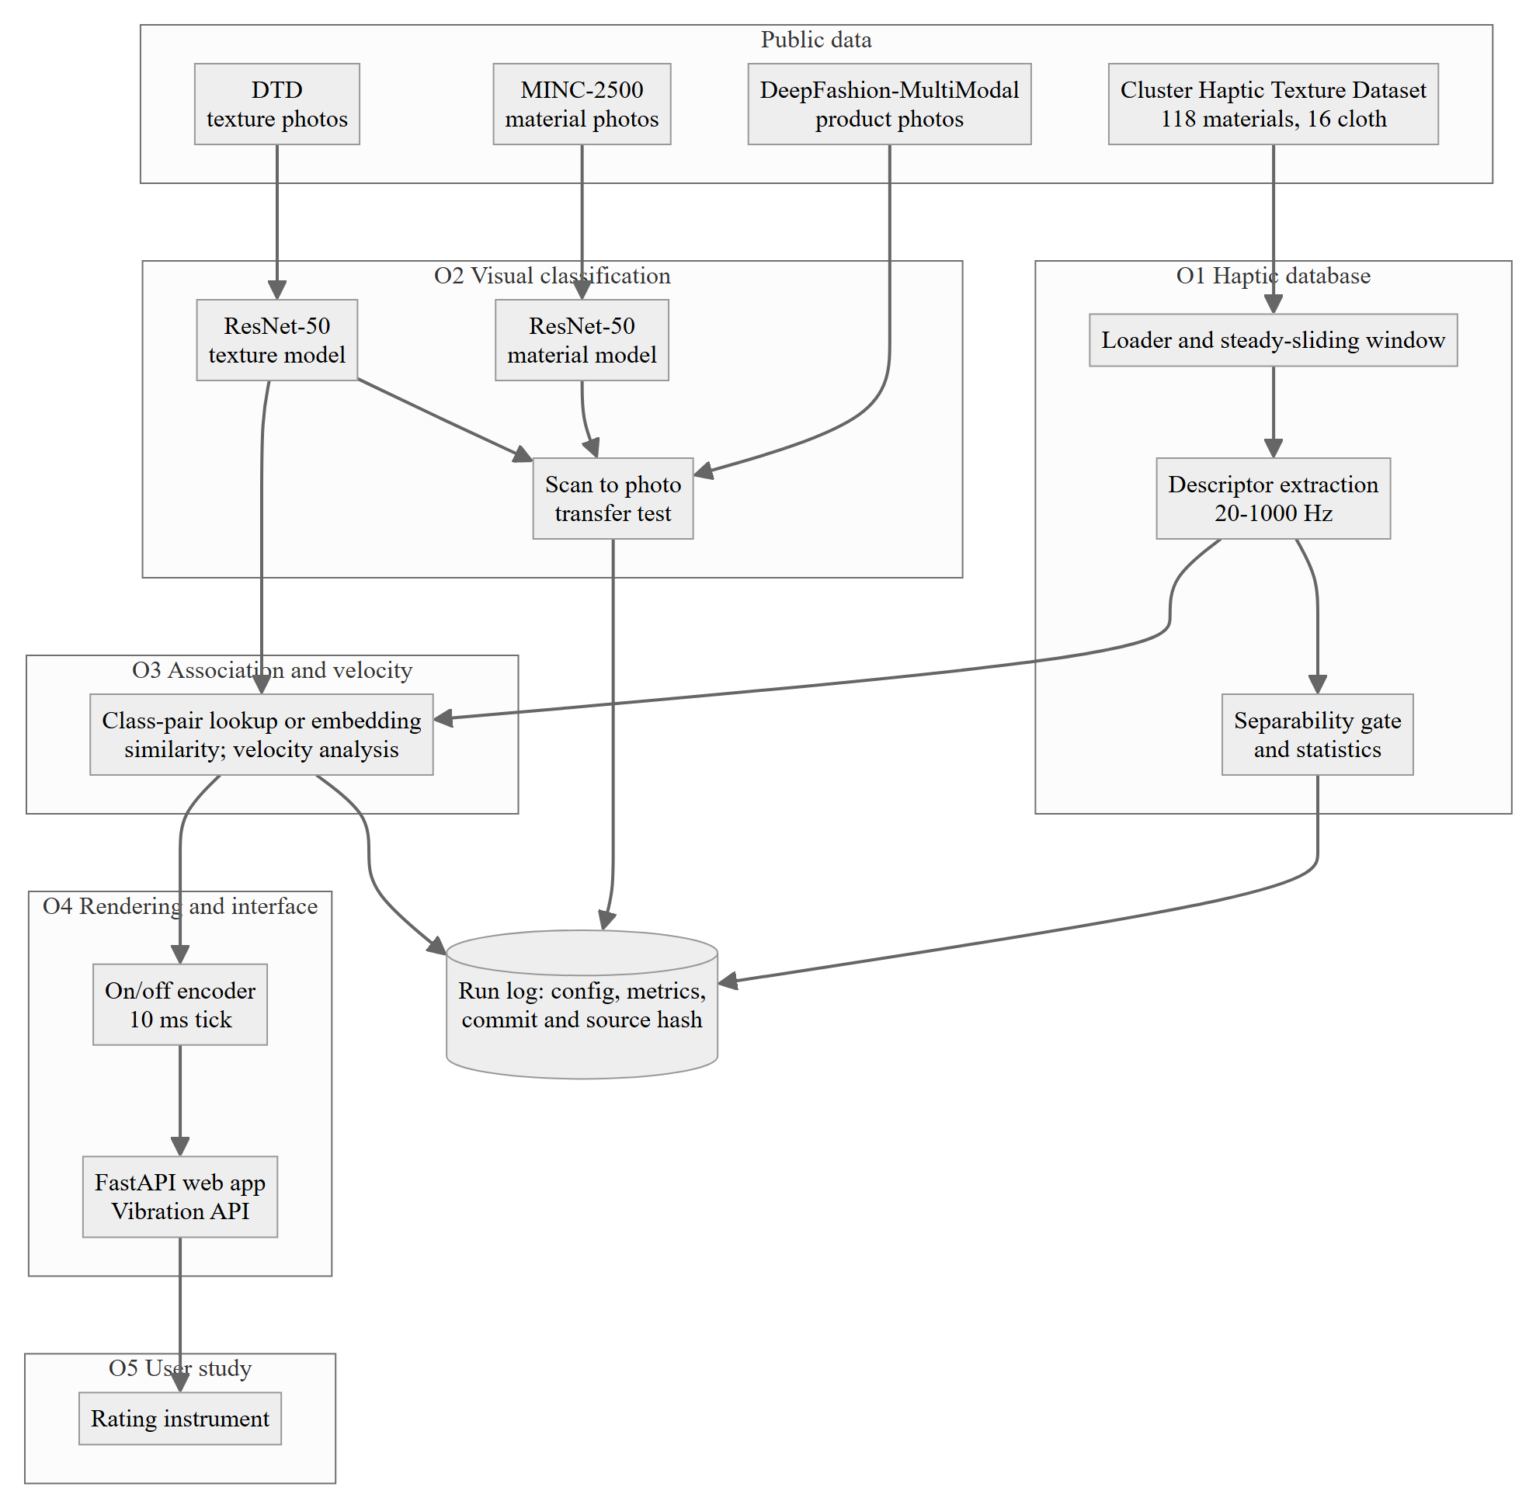
Fig. 3.1 System architecture
- Haptic database (O1): load the cloth recordings, band-pass the acceleration to 20–1000 Hz, and compute four descriptors – spectral centroid (frequency), RMS (intensity), normalised spectral entropy (pattern) and dominant envelope period (duration). Recordings whose energy falls below the band are flagged and excluded.
- Visual classification (O2): fine-tune two ResNet-50 models [26] pretrained on ImageNet [27], one on MINC-2500 [7] for material and one on DTD [8] for texture, restricted to 12 textile classes.
- Association (O3): map an image to a descriptor either by class-pair lookup or by cosine similarity of image embeddings.
- Rendering (O4): convert the descriptor into an on/off pattern with a 10 ms tick and play it with the Vibration API [3] through a FastAPI web service.
- Perceptual validation (O5): participants rate the match between images and vibrations, including mismatched controls.
Fig. 3.2 shows the same pipeline as an activity diagram, from upload to playback.
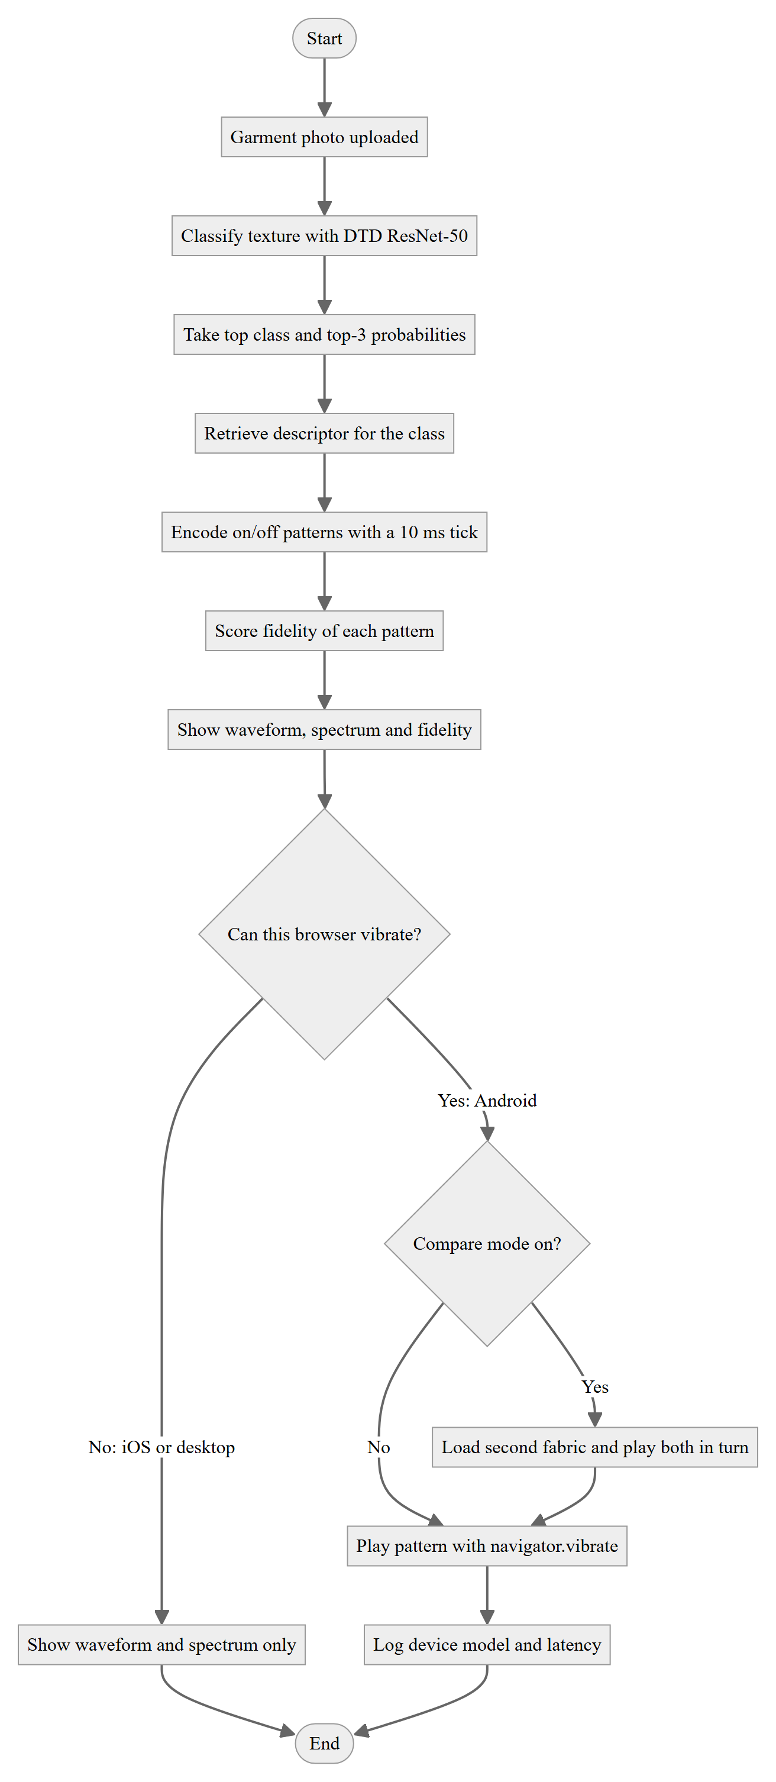
Fig. 3.2 Activity diagram of the image-to-vibration pipeline
The diagrams in this section are generated from the same sources that StarUML imports (report/uml/). Use case view. The shopper uploads an image, views the predicted fabric and vibration, plays it, and compares two fabrics. The researcher runs the descriptor gate, trains the classifiers and evaluates transfer (Fig. 3.3).
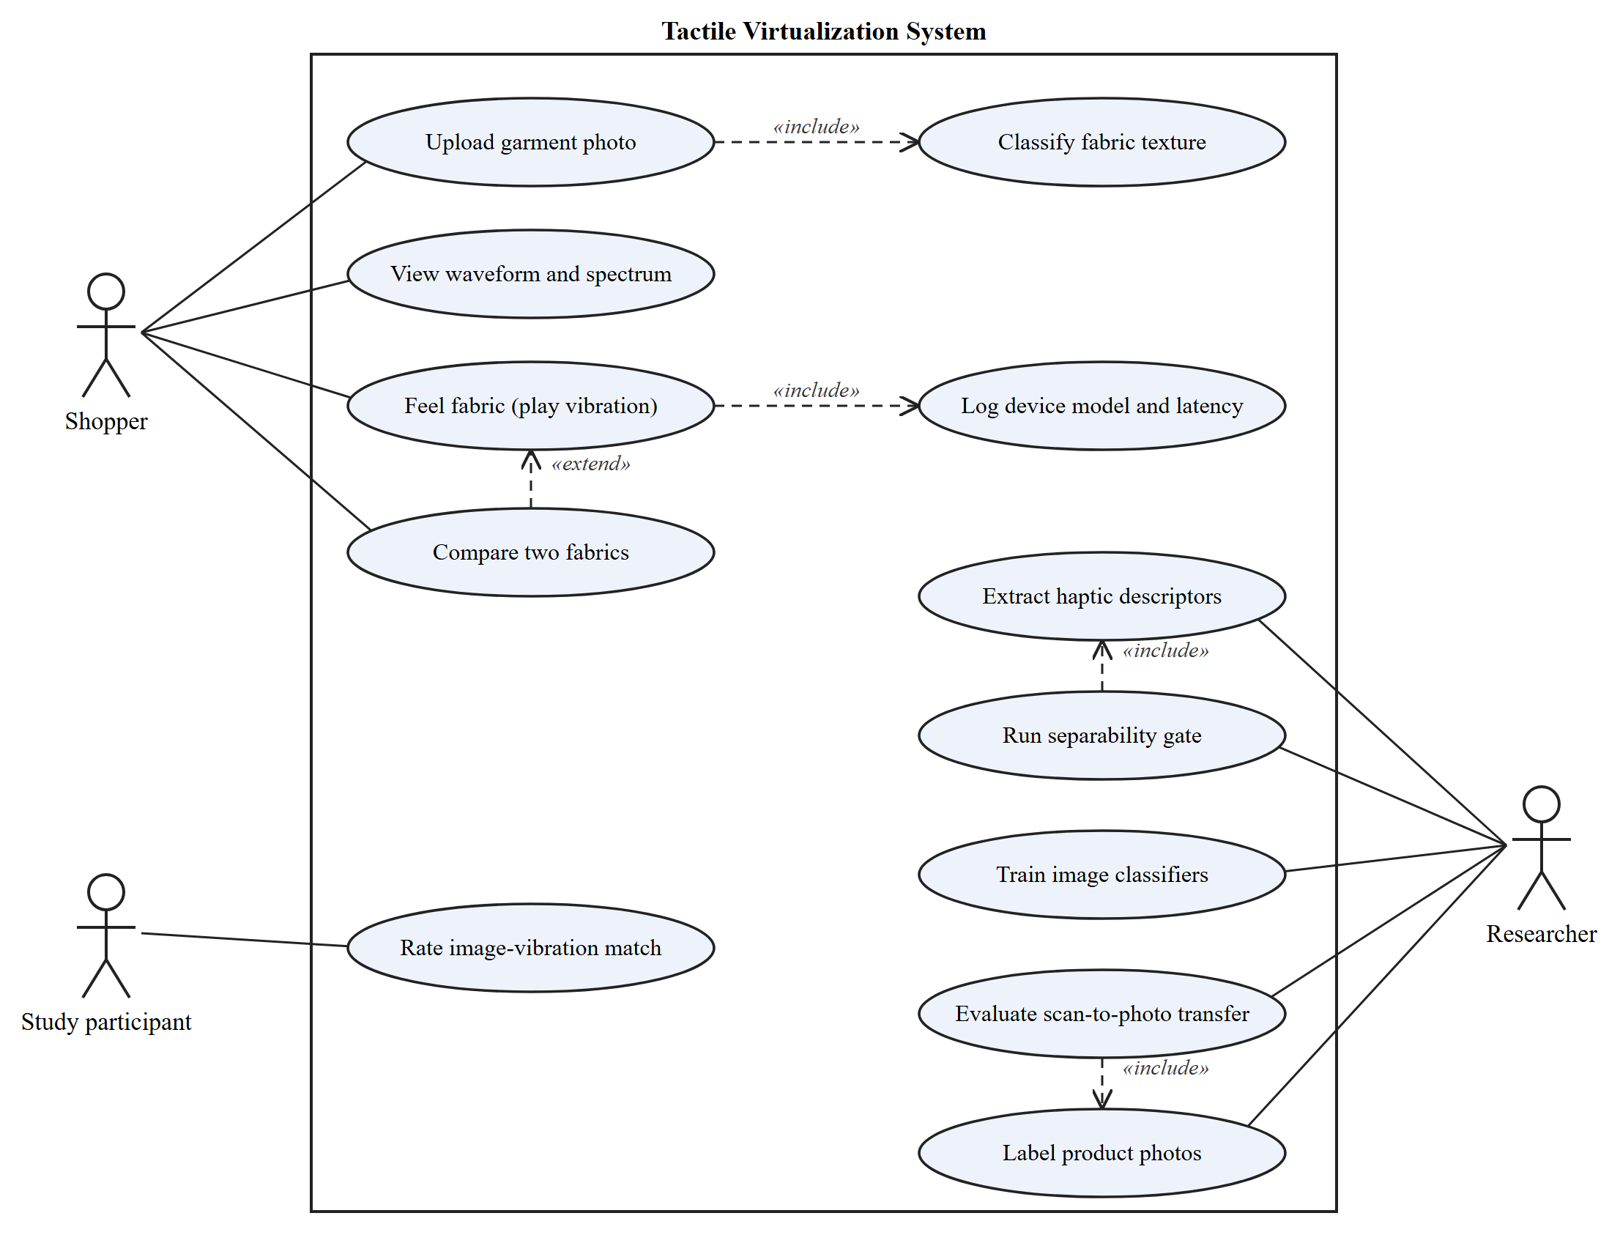
Fig. 3.3 Use case diagram
Structure. The implementation is organised into Python packages: haptic (descriptors, loader, statistics, rendering), vision (classifiers and transfer), webapp (the interface) and runlog (saved, versioned results). Fig. 3.4 shows the main classes.
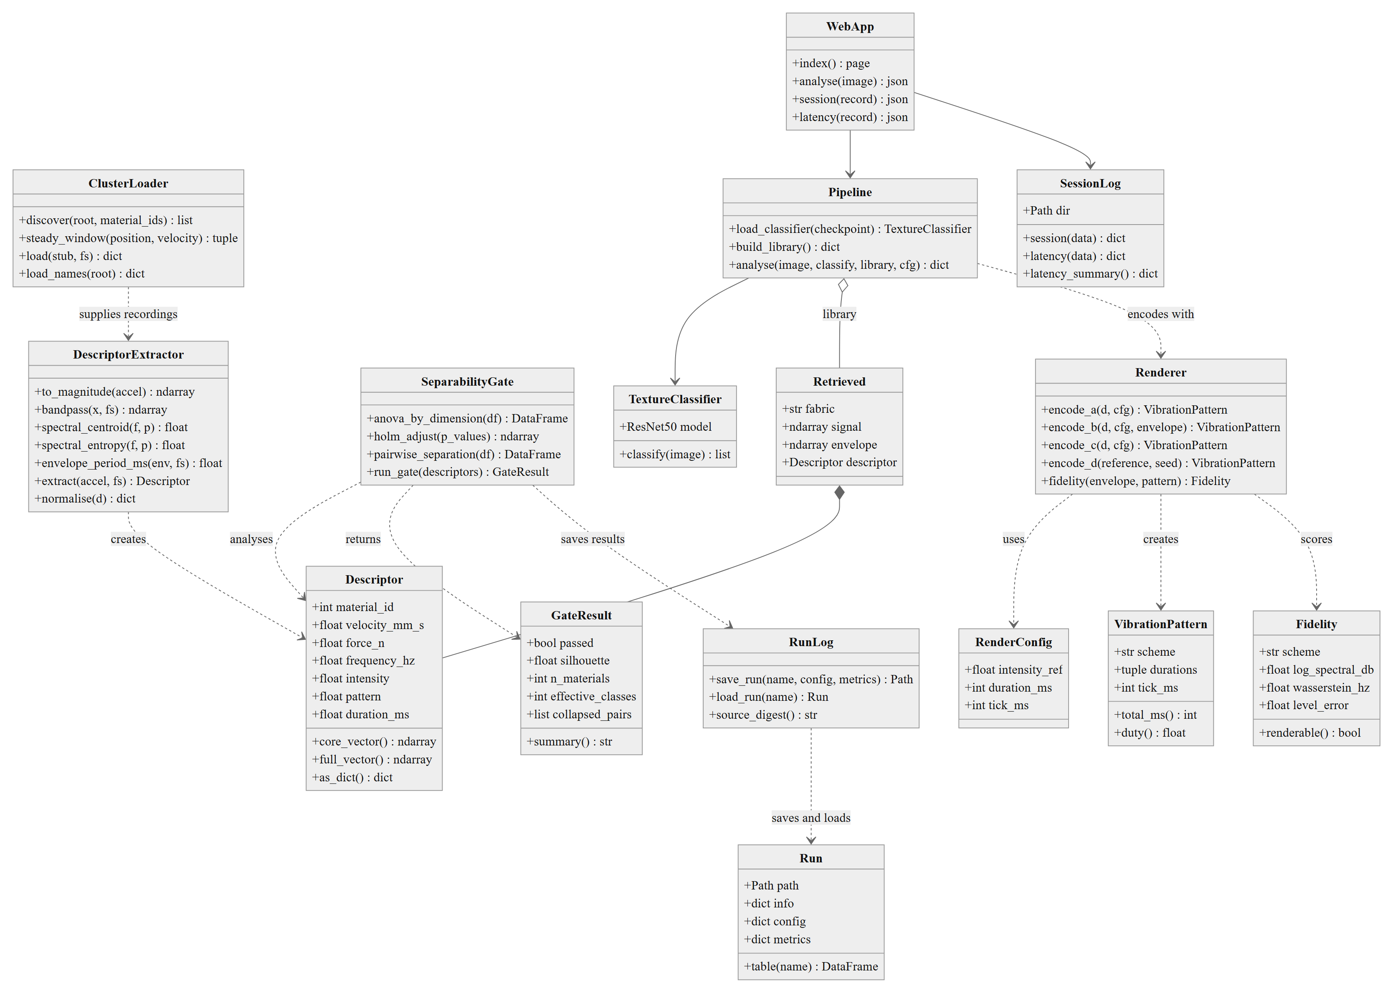
Fig. 3.4 Class diagram of the main modules
Interaction. Fig. 3.5 shows the sequence of calls when a shopper asks to feel a fabric.
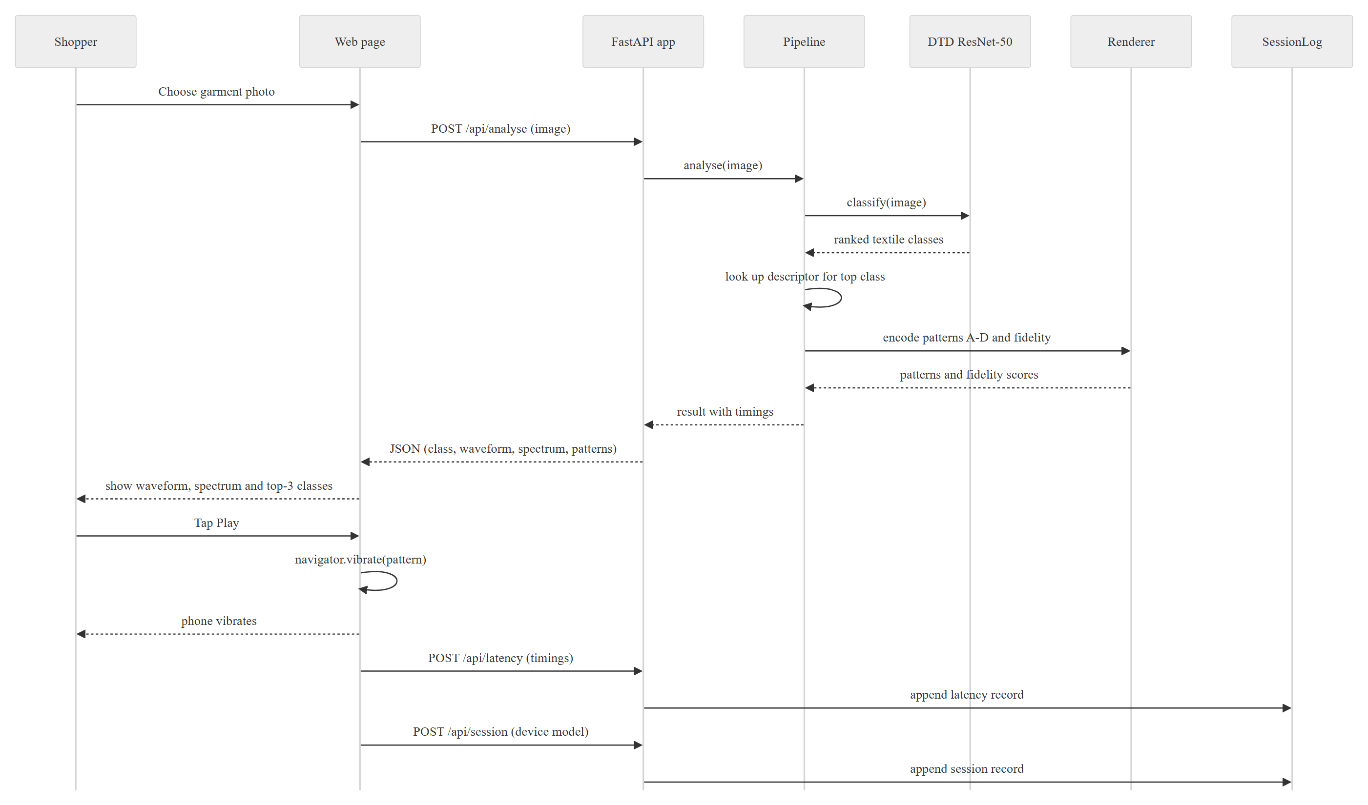
Fig. 3.5 Sequence diagram for “feel this fabric”
States. Fig. 3.6 shows the states of a rendering session in the web interface.
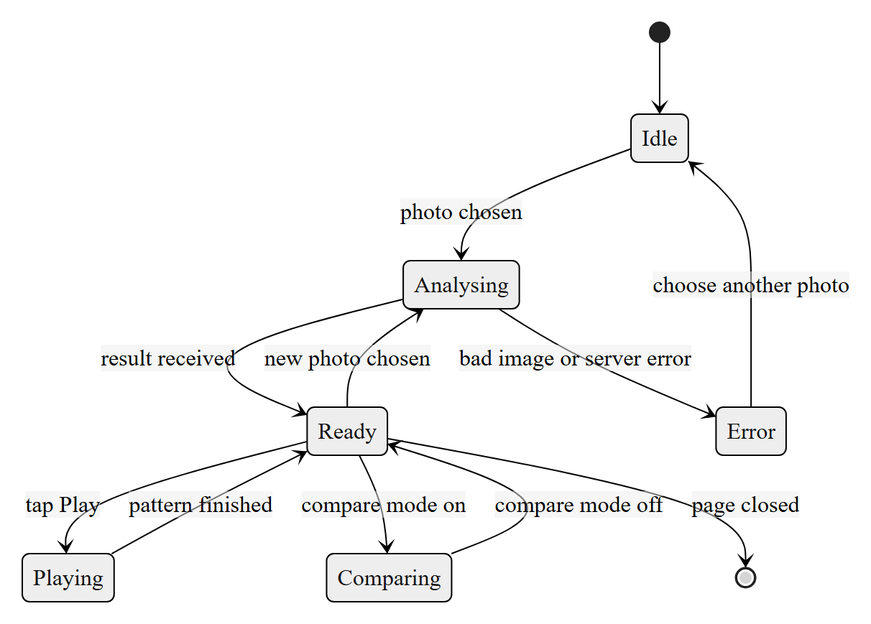
Fig. 3.6 State diagram of a rendering session
3.4 Technical Justification and Supporting Analysis
- Four descriptors match the perceptual dimensions most often used for vibrotactile texture (frequency, intensity, regularity and rhythm) and fit what a phone can render.
- Normalised spectral entropy replaced spectral flatness, because flatness returned about zero for every material on these narrow-band signals.
- Omega-squared replaced eta-squared as the effect size, because eta-squared is biased upward with small samples. Holm correction [29] controls false positives across the four dimensions.
- The envelope is decimated to about 500 Hz before its period is estimated; at the raw 6 kHz rate the frequency resolution was too coarse and periods came out three times too long.
- Results are validated with sliding direction held out, so a model cannot succeed by memorising one stroke.
3.5 Assumptions and Benchmarks
- Assumption: the probe's acceleration in the Cluster dataset reflects what a finger would feel well enough to compare fabrics. Phase I tested part of this (Chapter 4).
- Benchmark for O1, fixed before any real data was analysed: pooled silhouette of at least 0.30 and at least 8 of the 16 materials separable. If fewer than 8 separate, the class list is coarsened and the grouping reported.
- Benchmarks for identification: chance is 1/16 = 6.25% for the 16 fabrics and 1/118 = 0.85% for all materials.
- Benchmark for O2: accuracy on the dataset's scans versus at least 50 product photographs labelled by two people.
3.6 Tools / Techniques Proposed
Table 3.3 Tools and techniques
Category | Tools
Language and libraries | Python 3.13, NumPy, SciPy, pandas, scikit-learn
Deep learning | PyTorch, torchvision (ResNet-50), Hugging Face transformers (CLIP)
Compute | Local CPU; Kaggle notebooks with an NVIDIA T4 GPU for training
Web interface | FastAPI, HTML/JavaScript, W3C Vibration API
Testing and versioning | pytest (459 tests), Git and GitHub, run logs with source hashes
Design | StarUML (UML diagrams), Matplotlib (figures)

3.7 Feasibility and Sustainability Considerations
Technical feasibility is shown by the Phase I implementation, which runs end to end on public data. Economic feasibility follows from the zero hardware and data cost. Operational feasibility is limited by two factors: iOS phones cannot be used, and the user study depends on ethics clearance, whose date the team does not control. The plan therefore keeps the publishable results independent of the study (Chapter 5). The code is modular, tested and versioned, so it can be maintained and extended after the project.

CHAPTER 4
PRELIMINARY DESIGN, ANALYSIS AND PHASE–I PROGRESS
4.1 Phase I Activities and Progress
After the team's literature survey, the implementation work recorded in the project repository ran from 31 October to 8 November 2026. In that period the team set up the data pipeline for the Cluster Haptic Texture Dataset [4], fixed the success thresholds in writing before touching real data, built the descriptor database, trained the image classifiers, prototyped the web interface, and then ran six further rounds of analyses. Table 4.1 gives the status of each objective and Table 4.2 the order of work. Alongside the code, the team wrote a survey paper, “A Survey of Tactile Virtualization: Taxonomy, Analysis, Evaluation, and Future Directions”, which classifies the field into measurement-driven and inference-driven work and compares consumer rendering technologies. Its 17 references were checked against publisher and arXiv records; the text is being revised for submission. Chapter 2 is built on it.
Table 4.1 Status of each objective at the end of Phase I
Objective | Work completed | Status | Where reported
O1 Haptic database and gate | Descriptors for 2,493 cloth recordings; gate; variance analysis; group test; CNN baseline | Complete | Sec. 4.4.1
O2 Visual classification | MINC-2500 model; 10 DTD folds; tested on 1,600 scan crops; first product-photo transfer test | Mostly complete; labelled photo set pending | Sec. 4.4.2
O3 Association and velocity | Two strategies on held-out materials; velocity analysis on all 118 materials; replication | Complete for Phase I | Sec. 4.4.3
O4 Interface | FastAPI web service with waveform, spectrum, four vibration schemes, comparison view and logging | Prototype; retrieval still a placeholder | Sec. 4.3, 4.4.4
O5 User study | Rating instrument, reliability and analysis code; labelling tool | Waiting for ethics clearance | Sec. 5.3
Survey paper | Literature survey written; 17 references checked | Under revision | Chapter 2

Table 4.2 Phase I timeline
Period (2026) | Work done
Before 31 Oct | Literature survey; survey paper drafted (A Survey of Tactile Virtualization: Taxonomy, Analysis, Evaluation, and Future Directions, 17 references), now under revision
31 Oct | Objective 1 descriptor extraction and gate; ResNet-50 training on MINC-2500 and DTD; gate thresholds registered
1–4 Nov | All 10 DTD folds; cloth group assignment registered; O1 gate, O2 scan test, O3 and O4 on real data
5–6 Nov | Velocity analysis on all 118 materials; held-out replication; CNN baseline on Kaggle GPU
7 Nov | Rounds 2–5: 15 registered analyses (A–O) on 18,614 recordings of all 118 materials
7–8 Nov | Round 6 (whitened CNN, GPU); provenance corrections; all quoted results re-run from committed code

4.2 Preliminary Design / Model / Calculations / Simulation
Data. The 16 cloth materials of the Cluster dataset (IDs 102–117) are listed in Table 4.3 with the number of usable recordings of each. Every material was recorded at 5 speeds, 8 directions and 2 forces, twice (160 recordings); recordings with less than 0.5 s of steady sliding or with energy below the analysis band were excluded, leaving 2,493 [4].
Table 4.3 The 16 cloth materials and their usable recordings
ID | Material | Recordings | ID | Material | Recordings
102 | Velvet | 145 | 110 | Organdy | 157
103 | Corduroy | 153 | 111 | Mesh | 158
104 | Cotton | 152 | 112 | Wool | 157
105 | Cotton broadcloth | 157 | 113 | Nylon | 154
106 | Cotton gauze | 159 | 114 | Polyester | 156
107 | Chiffon | 158 | 115 | Silk | 157
108 | Lace | 158 | 116 | Linen | 156
109 | Georgette | 157 | 117 | Cotton linen | 159

Descriptor definitions. Acceleration is band-passed to 20–1000 Hz, and four numbers are computed for each recording (Table 4.4). Recordings whose energy falls below the band, which happens for coarse fabrics at low speed, are flagged and excluded rather than averaged in.
Table 4.4 Haptic descriptor definitions
Descriptor | Definition
frequency_hz | Spectral centroid of the band-passed acceleration
intensity | RMS acceleration in the band
pattern | Normalised spectral entropy, 0–1 (low = periodic, high = random)
duration_ms | Dominant period of the envelope modulation (envelope decimated to about 500 Hz first)
wavelength_mm | v / f (velocity-normalised form)
roughness_index | intensity / (force × √(v/40))

The four descriptors and the derived quantities are defined by Eqs. (4.1)–(4.5), where P_{k} is the Welch power at frequency f_{k} inside 20–1000 Hz, x_{b} is the band-passed acceleration of N samples, v the sliding speed (mm/s) and F the normal force (N).
f_{c} = ∑_{k} f_{k} P_{k} / ∑_{k} P_{k} (4.1)
I = √( (1/N) ∑_{n} x_{b}[n]² ) (4.2)
H = −∑_{k} q_{k} ln q_{k} / ln K, q_{k} = P_{k} / ∑_{j} P_{j} (4.3)
T = 1000 / f_{env} ms, f_{env} = peak of the envelope spectrum (4.4)
λ = v / f_{c}, R = I / (F √(v / 40)) (4.5)
Separability and effect size use Eqs. (4.6) and (4.7), where a(i) is the mean distance from recording i to its own material and b(i) the mean distance to the nearest other material. Whitening, Eq. (4.8), subtracts from each feature its median over all 118 materials at the same speed, force and direction c.
ω² = (SS_{b} − (k − 1) MS_{w}) / (SS_{t} + MS_{w}) (4.6)
s(i) = (b(i) − a(i)) / max{a(i), b(i)} (4.7)
x̃_{m}(c) = x_{m}(c) − median_{m′} x_{m′}(c), c = (v, F, θ) (4.8)
Statistical design. Every confirmatory test was written into a registration file and committed to Git before it was run, with its prediction and threshold. Effects across materials use one-way ANOVA with omega-squared and Holm correction [29]. Separability uses the silhouette score and a pairwise distance matrix with a collapse threshold of 1.0 standard deviation. Identification is tested with logistic regression and with a small CNN on the spectrogram, always with one sliding direction held out (8 folds), so that a model cannot succeed by memorising one stroke. Comparisons between methods use one-sided Wilcoxon tests over folds.
Rendering model. A phone's vibration motor can only be switched on and off, and the Vibration API takes a list of on/off durations. The project fixes a 10 ms tick, which means the fastest pattern a phone can play repeats at 25 Hz. Four schemes turn a descriptor into an on/off pattern (A–C) and a random pattern of the same length serves as a control (D). A 25 ms motor lag is assumed when comparing what was intended with what a phone can play.
4.3 Preliminary Implementation or Proof of Concept
All code is in a single Git repository with 48 commits and 459 automated tests. The main parts are:
- A dataset loader that reads the Cluster files, cuts each recording to its steady sliding stretch using the position data, and fails clearly if the file layout is not as expected.
- Descriptor extraction, the separability gate and the statistics, with tests that are designed to fail on bad data.
- ResNet-50 [26] training scripts packaged for Kaggle, with resumable checkpoints; 3.9 GPU-hours used in total.
- A transfer evaluation for product photographs, and an offline labelling page so that two people can label photographs independently.
- A FastAPI web service and page: the user uploads an image, sees the predicted texture class with its top-3 probabilities, the waveform, spectrum and fidelity of four vibration schemes, plays the pattern on an Android phone, compares two fabrics, and the page logs device model and latency.
- A run log that saves every result with its configuration, Git commit and a hash of the source code, so every number in this report can be traced to the exact code that produced it.
Fig. 4.1 shows the interface after it has analysed one of its sample images: the predicted texture class with its top-3 probabilities, the descriptor, the waveform and its spectrum, with the band that a 10 ms tick can play shaded.
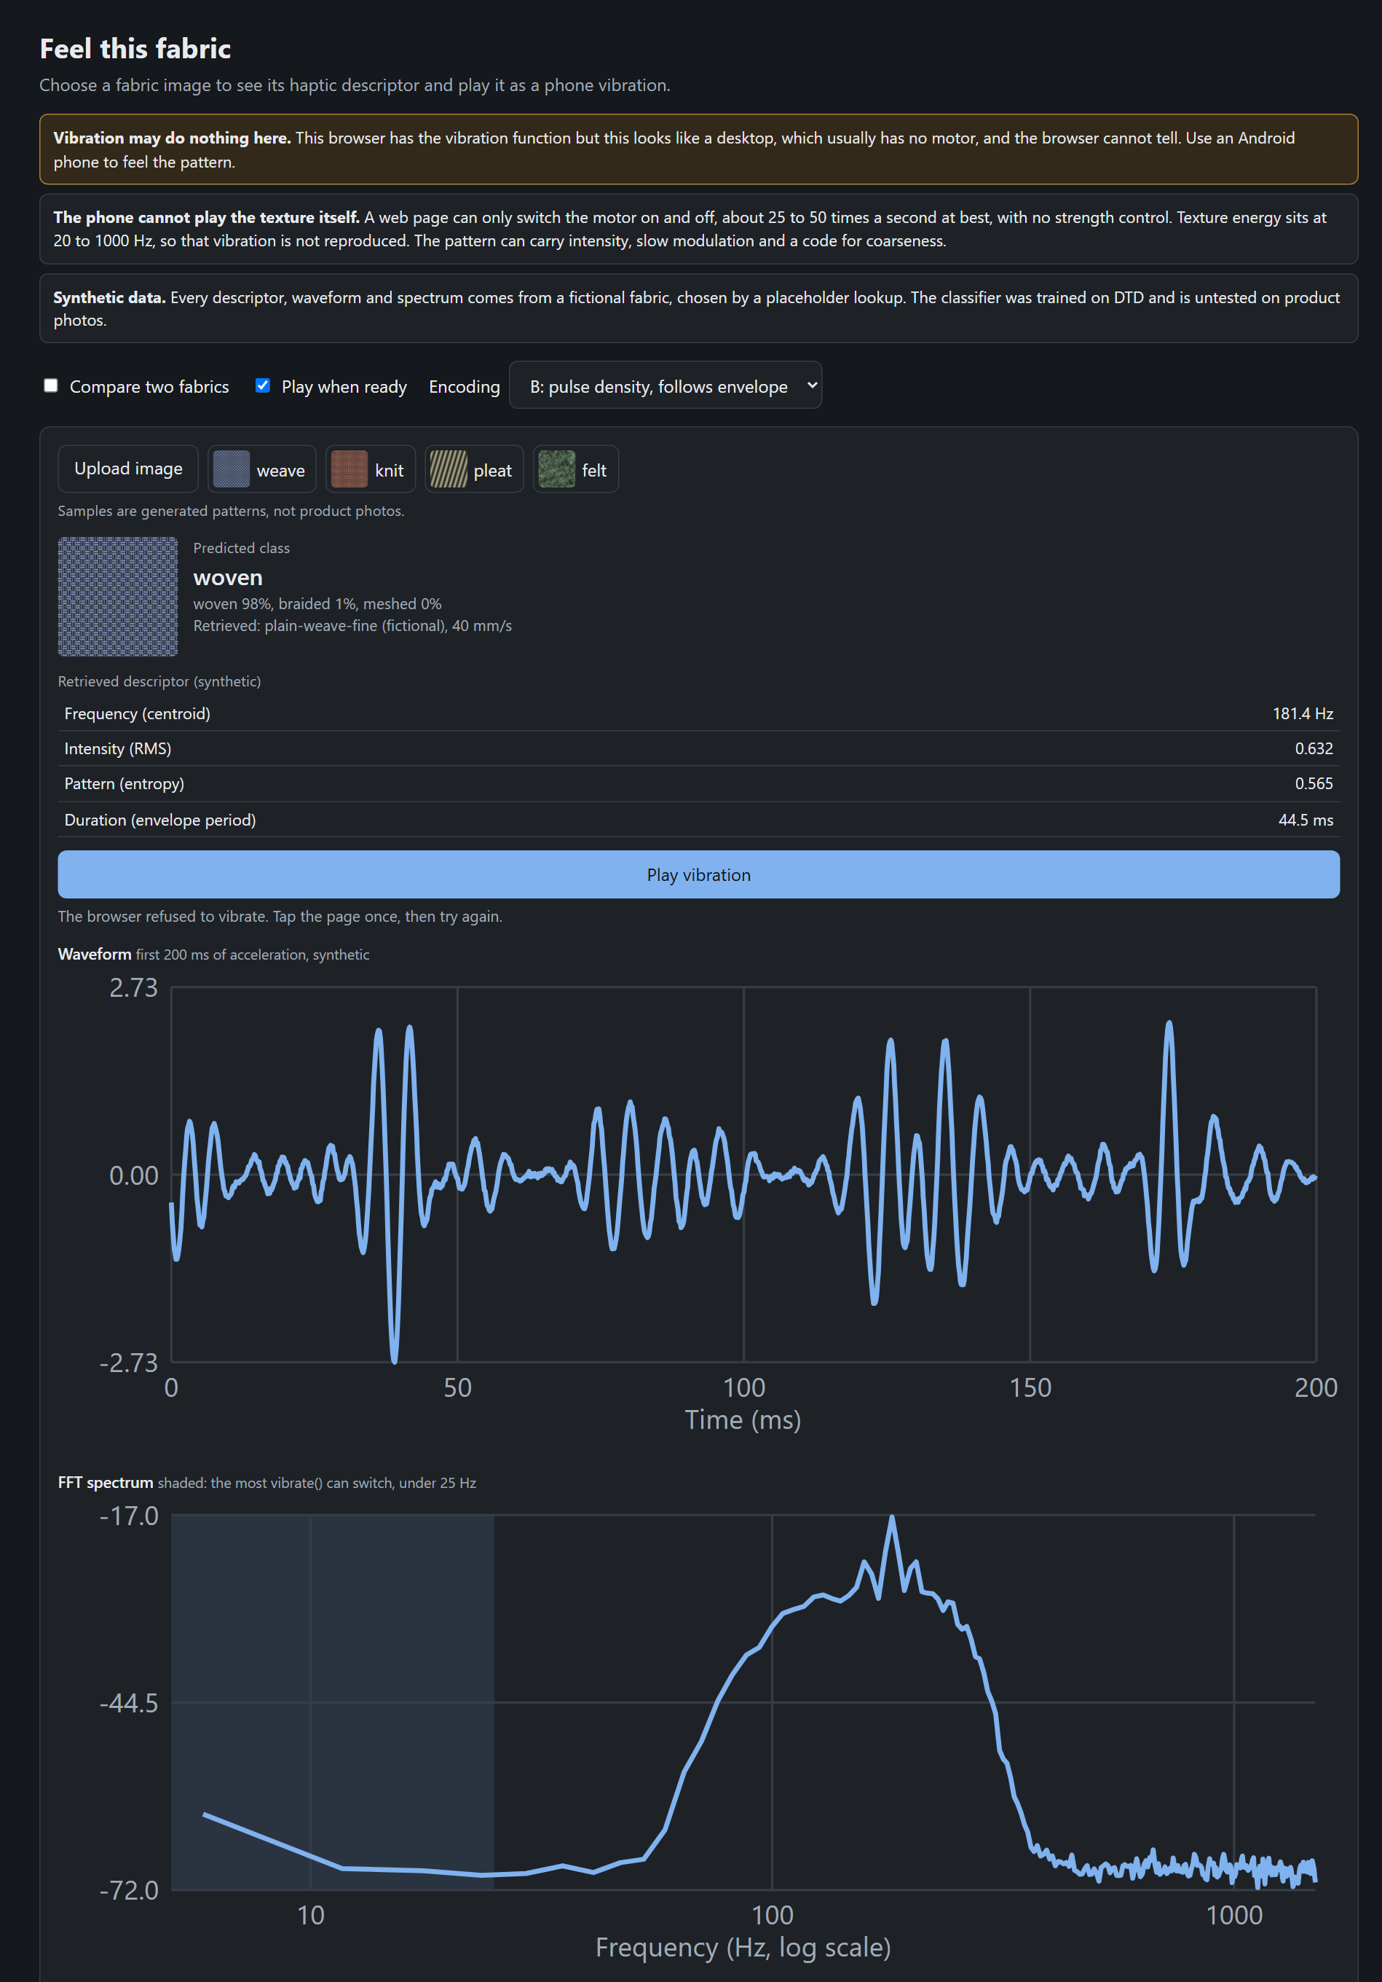
Fig. 4.1 The web interface after analysing a sample image (desktop browser)
Data design. Table 4.5 lists the main data stores. Raw data stays outside version control; everything derived from it is saved with enough information to regenerate it.
Table 4.5 Main data stores
Store | Contents | Format
Cluster mirror (local) | Cloth recordings (acceleration, sound, force, position) and 300 dpi scans | CSV, FLAC, JPEG; not in Git
Feature table | One row per recording: material, speed, force, direction, repeat, descriptors, 16 band powers, in-band flag | CSV, 18,614 rows
Run log (results/) | Per run: run.json (time, commit, source hash), config.json, metrics.json and tables | JSON and CSV
Models | ResNet-50 checkpoints: MINC-2500 fold 1, DTD folds 1–10 | PyTorch .pt
Interface logs | Session records (device model) and latency records | JSON lines
Registration file | Predictions and thresholds, committed before each analysis | Markdown in Git

Limitation of the prototype: the step from texture class to vibration descriptor in the web interface is still a hand-made placeholder, and the page marks its output as synthetic until the real retrieval is connected in Phase II.
4.4 Preliminary Checks, Tests and Observations
4.4.1 Objective 1: can the four descriptors tell 16 fabrics apart?
Of 2,560 cloth recordings, 47 had less than 0.5 s of steady sliding and 20 fell below the analysis band, leaving 2,493. Table 4.6 shows the gate result; the thresholds were fixed before the data was used.
Table 4.6 O1 separability gate on the 16 cloth materials
Measure | Raw descriptors | Velocity-normalised | Threshold
Pooled silhouette | −0.164 | −0.124 | ≥ 0.30
Collapsed pairs | 120 of 120 | 120 of 120 | —
Effective classes | 1 | 1 | ≥ 8
Verdict | FAIL | FAIL

Every descriptor differs significantly across materials (Holm p < 10⁻¹⁵), but material explains only 8–15% of each one, and sliding direction and recording-to-recording variation explain most of the rest (Fig. 4.2). Because every pair of fabrics overlaps, coarsening the class list, the plan's fallback, cannot rescue the gate. The registered group test also failed: the seven woven fabrics do not cluster (Holm p = 0.23), and the pile group had too few members to test.
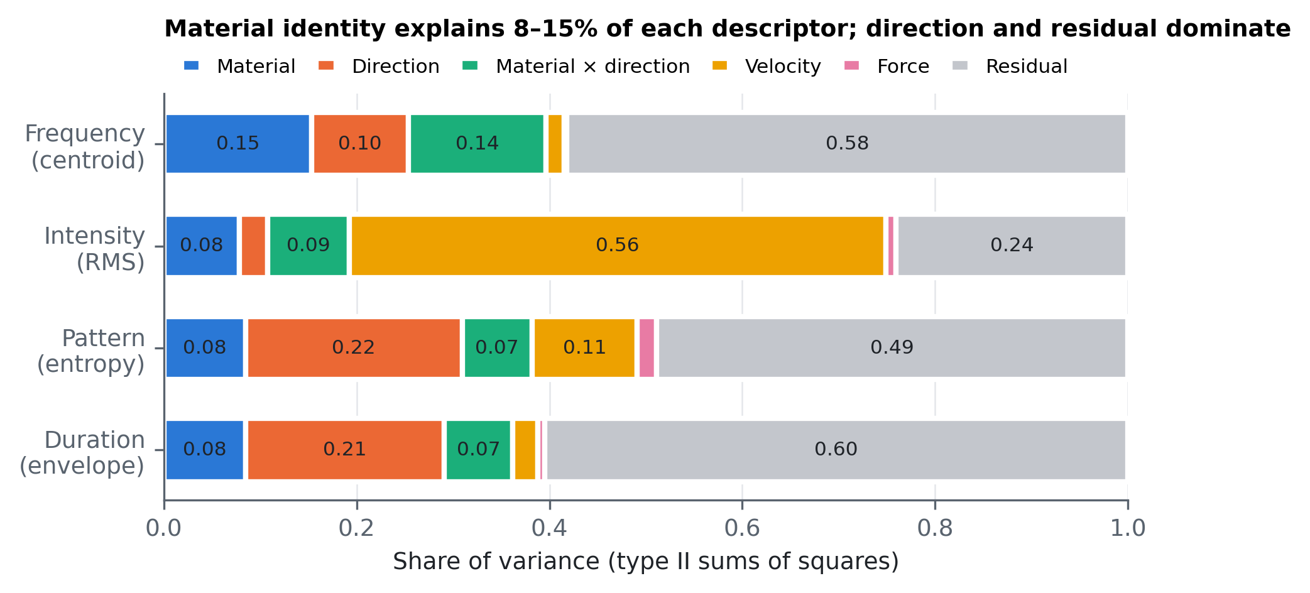
Fig. 4.2 Share of variance in each descriptor
To find out whether the problem is the descriptor or the signal, the same task was run with richer inputs (Fig. 4.3). With direction held out, the four descriptors identify the fabric 13.8% of the time, a 16-band spectrum 21.8%, and a CNN on the spectrogram 37.8%, against 6.25% chance. So the signal carries much more identity than four numbers keep. Two repeats of the same stroke agree closely (19 of 21 features have an intraclass correlation of at least 0.75), so the overlap is not measurement noise.
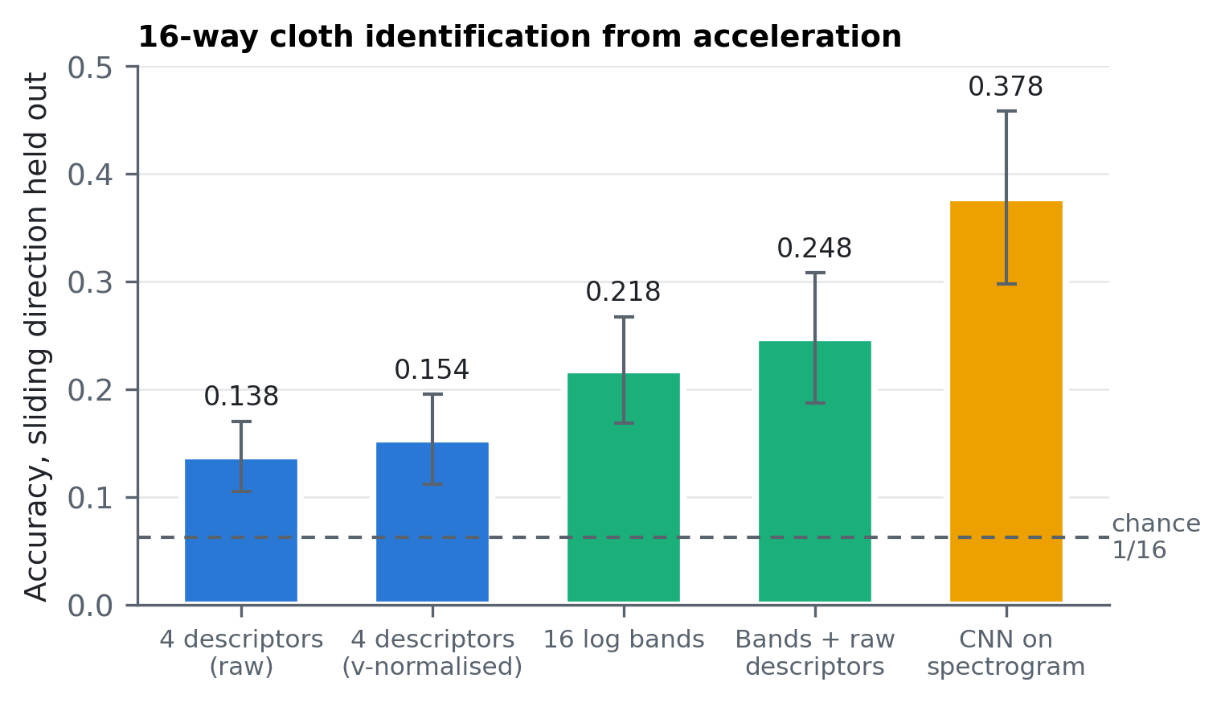
Fig. 4.3 Sixteen-way fabric identification from acceleration
4.4.2 Objective 2: image classifiers and the scan-to-photo gap
The MINC-2500 material model reaches 80.3% top-1 accuracy (macro F1 0.802) on 23 material classes [7]. The DTD texture models reach 69.2% on all 47 classes and 80.7% on the 12 textile classes (macro F1 0.806), mean over 10 folds with a spread of 1.9 points [8]. Fig. 4.4 shows the 12 textile classes over all 10 folds: braided (62%), fibrous (72%) and woven (73%) are the hardest; fibrous is most often mistaken for matted, and braided for woven.
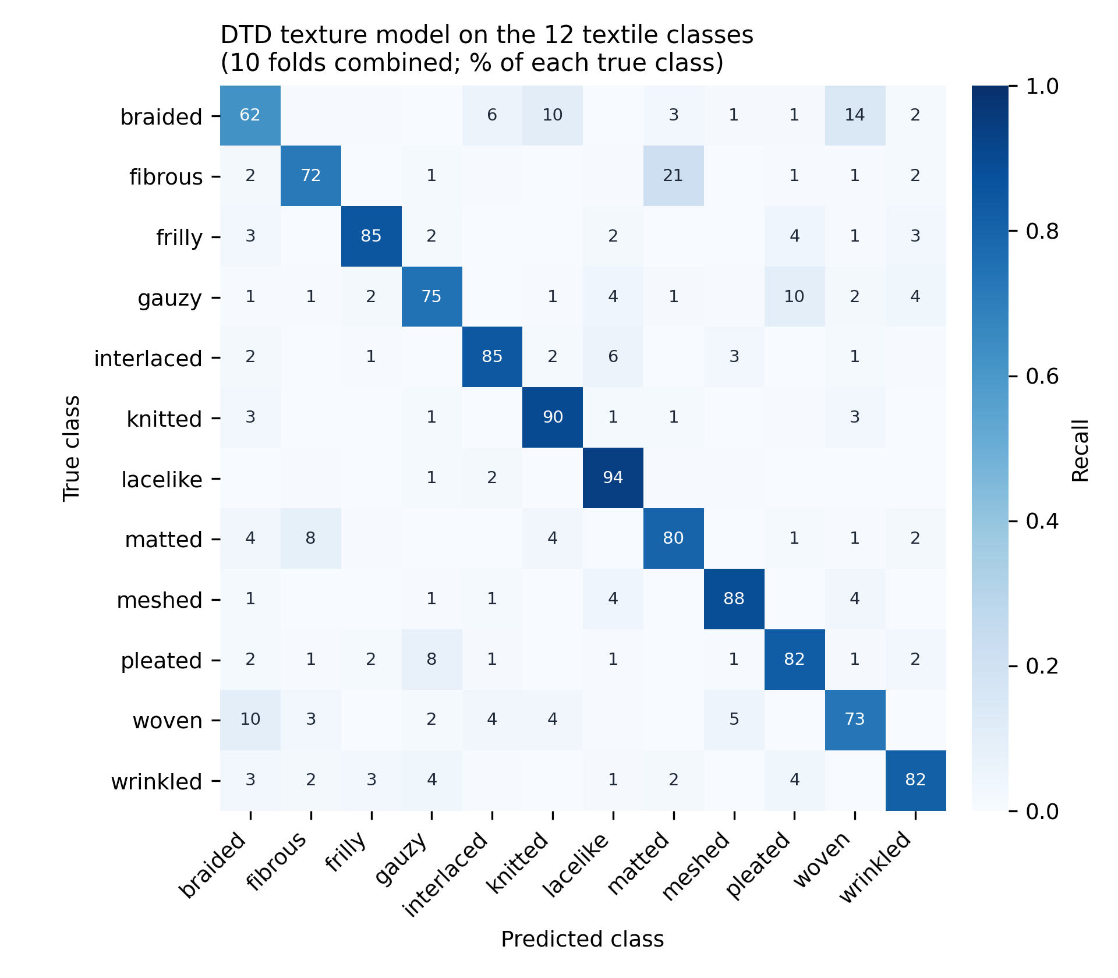
Fig. 4.4 Confusion matrix of the DTD texture classifier on the 12 textile classes
On the dataset's 300 dpi fabric scans the picture changes completely. The MINC model calls 75.6% of photographed fabric “fabric” but only 3.3% of the 1,600 scan crops, mostly “carpet” or “wallpaper” instead, and none of the 16 fabrics is called fabric by majority. Showing it a larger field of view does not help (Fig. 4.5).
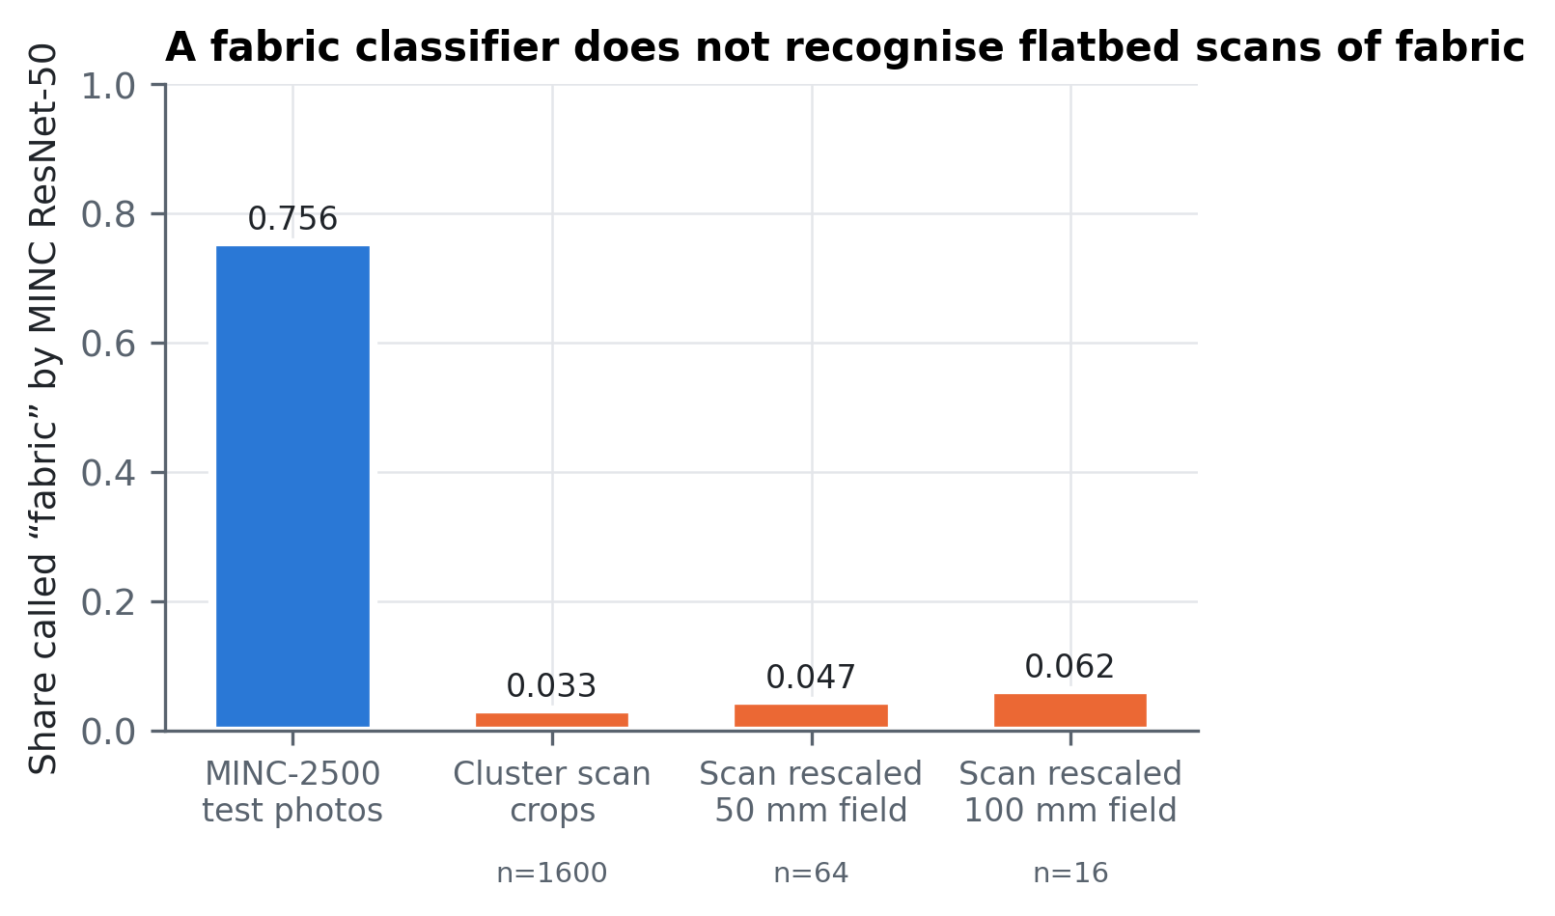
Fig. 4.5 A photo-trained classifier does not recognise flatbed scans of fabric
A first test in the other direction used DeepFashion-MultiModal product photographs [9] labelled cotton, chiffon or leather from their captions. A classifier trained on scans was perfect on scans (1.000) but scored 0.234 on the photographs, below the 0.333 chance level. A stricter re-test on unseen swatches gave 0.675 on scans against 0.287 on photographs (chance 0.5). CLIP [28], trained on web photographs, shows the mirror image: 0.635 on photographs but 0.460 on scans. The gap therefore runs both ways, and it is the headline result that Phase II will measure properly on a labelled set.
4.4.3 Objective 3: association and sliding velocity
Retrieval. Two strategies were compared for predicting a held-out fabric's descriptor from its image: class-pair lookup and cosine similarity of image features. Neither beat simply predicting the average descriptor, and class-pair lookup was significantly worse for intensity and duration (Holm p = 0.026). This follows from O1: when the descriptors barely differ between fabrics, choosing by appearance cannot beat the average. Across all 118 materials, looking similar predicts vibrating similarly only between categories (r = +0.154), not within them, and not among the 16 fabrics.
Velocity. On this rig the spectral centroid barely changes with sliding speed for any of the 118 materials: none is within 0.25 of the f = v/λ prediction, and every category sits at 240–270 Hz. Dividing by speed therefore makes descriptors worse. After removing the spectrum shared by all surfaces, however, cloth alone shifts upward with speed, by about a third of v/λ (median exponent 0.338, all 16 fabrics above zero; Fig. 4.6). This was found in exploratory analysis and then replicated on 2,240 held-out recordings.
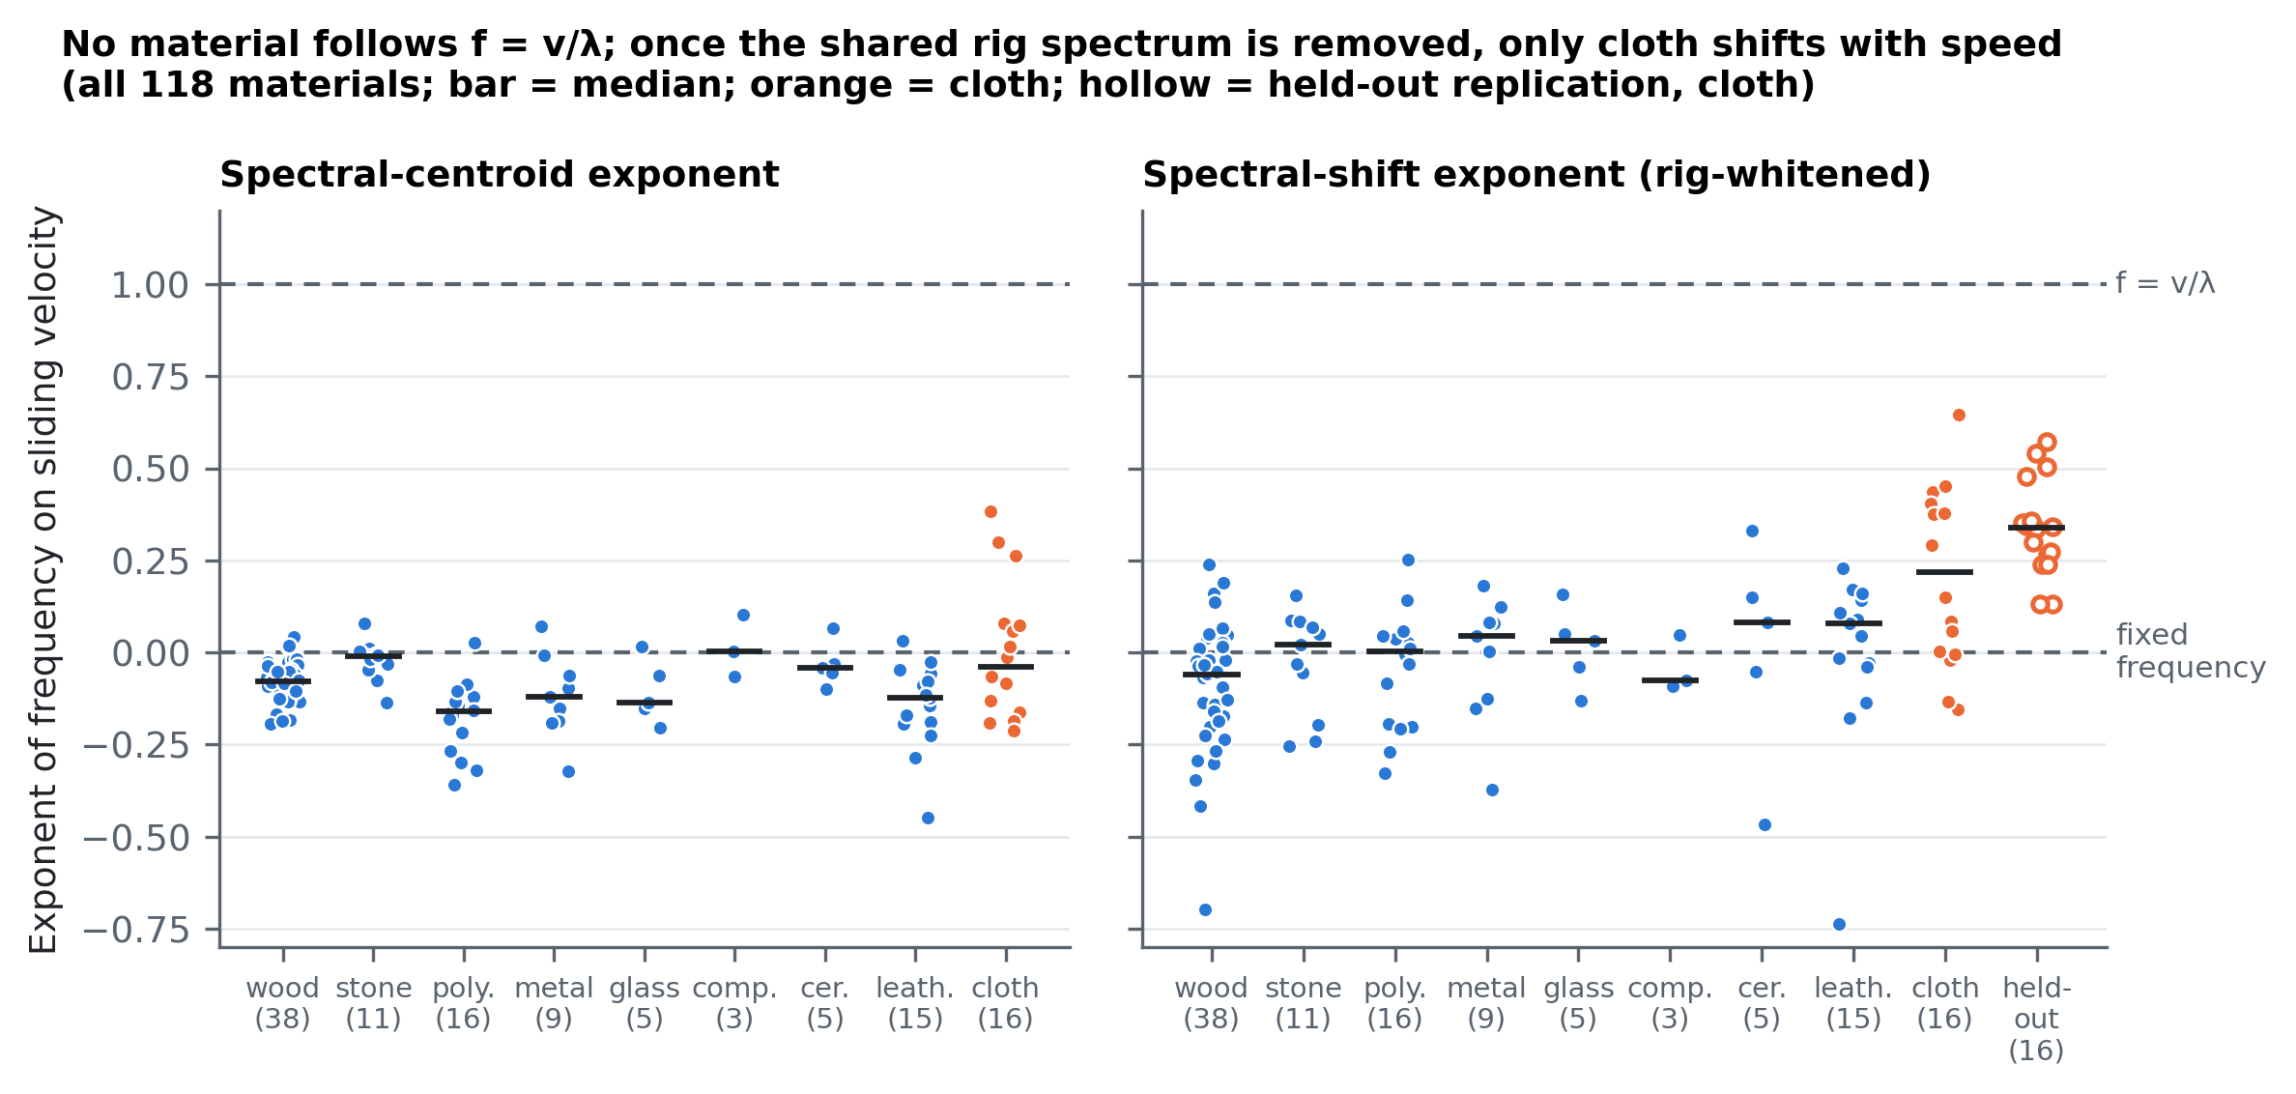
Fig. 4.6 Velocity exponents for all 118 materials
4.4.4 Objective 4: what survives the phone's on/off channel
Only 9 of 80 real vibration envelopes can be reproduced with a 10 ms tick, because most of their modulation is faster than 25 Hz. On those that can, the best scheme (B) differs from the intended envelope by 8.4 dB, but the random control (D) scores 7.5 dB, so this metric cannot tell them apart; that question needs people. Fabric identity does survive rendering partly: rendered patterns identify the fabric 9.9% of the time against 6.25% chance, while the intended patterns reach 11.8%.
4.4.5 Further registered analyses (rounds 2–6)
Sixteen more analyses (A–P) were registered and run on all 18,614 in-band recordings of the 118 materials. Table 4.7 lists every prediction and whether it held. Two results stand out. Contact sound carries far more identity than acceleration (72.0% against 37.8% for the 16 fabrics), but mostly above 1 kHz, which a phone motor cannot play. And removing the response that every surface shares (“whitening”) improves identification for both a linear model and the CNN, reaching 43.5% for the 16 fabrics, the best result from vibration alone.
Table 4.7 Registered predictions in rounds 2–6 and their outcomes
Analysis | Result | Outcome
A. Looks predict feel (118 materials) | r = +0.154 overall; none within category or within cloth | Held
B. Sound vs acceleration, 16 fabrics | 72.0% vs 37.8% (8/8 folds) | Held
C. Speed correction k = 0.338 vs none | 30.5% vs 27.9% at an unseen speed | Held
C. k = 0.338 vs full v/λ (k = 1) | 30.5% vs 28.4%, p = 0.064 | Not supported
E. Stroke direction structure | Perpendicular > opposite in 16/16; strongest in glass and metal (rig effect) | Held
F. Identity after on/off rendering | 9.9% vs 6.25% chance | Held
F. Intended beats rendered | 11.8% vs 9.9% | Held
H. Training on one force, testing on the other | 16 fabrics 32.4% → 22.4%; 118 materials 12.6% → 6.7% | Held
G. Scan model on product photos | 1.000 on scans vs 0.234 on photos | Held
I. Whitening, linear model | 16 fabrics 21.8% → 30.6%; 118 materials 7.8% → 13.3% | Held
J. Strict scan vs photo; CLIP | 0.675 vs 0.287; CLIP 0.635 on photos vs 0.460 on scans | Held
L. Category from image, then descriptor | Category 72.9% correct; only the centroid improves (1 of 4) | Partly held
M. Sound vs acceleration, 118 materials | 22.5% vs 7.8% (8/8 folds) | Held
N. Whitening rescues the O1 gate | Silhouette worsened, −0.07 → −0.15 | Failed
O. Speed dependence removed by whitening | 73% shared by all surfaces; cloth keeps the most | Held
P. Whitening, CNN | 16 fabrics 38.1% → 43.5%; 118 materials 20.2% → 31.4% | Held

Fig. 4.7 brings the identification results together. For both the 16 fabrics and all 118 materials, accuracy rises steadily from the four descriptors to the whitened CNN, and contact sound sits above vibration for the fabrics.
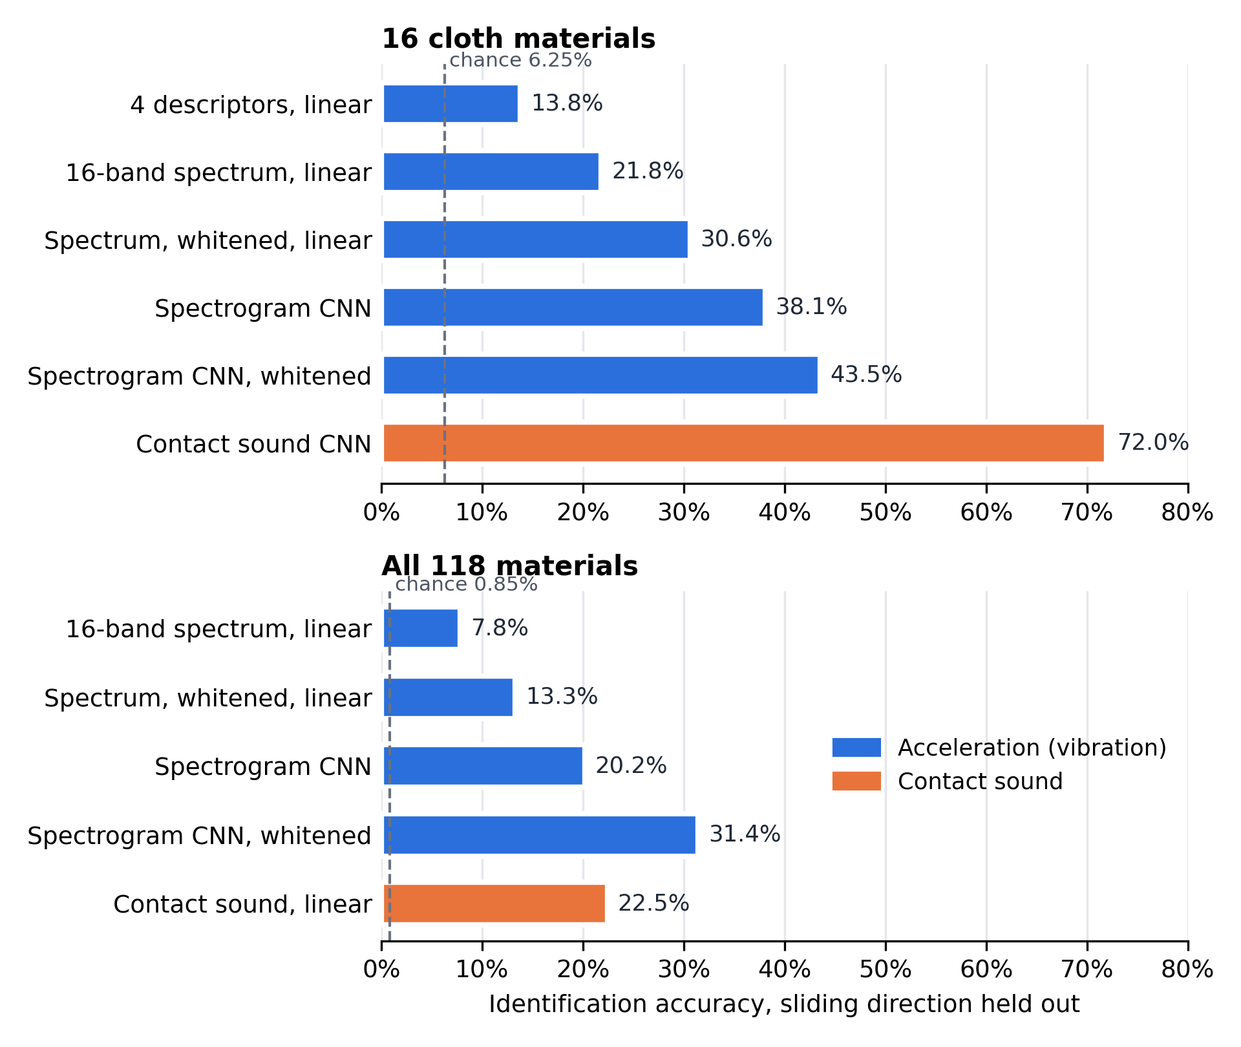
Fig. 4.7 Identification accuracy for every input and model tried in Phase I
Reporting failures matters as much as successes: the O1 gate, the weave group test, analysis N and half of C did not go as predicted, and they are reported as they came out, without changing thresholds afterwards.
4.5 Challenges and Decisions
- The descriptor gate failed. Following the registered plan, this is reported as a result, not tuned away; the richer spectrum and the CNN show where the information goes.
- Several standard measures misbehaved on real data and were replaced: spectral flatness was about zero for every fabric (replaced by spectral entropy), eta-squared is biased at small samples (replaced by omega-squared), and the envelope period was three times too long until the envelope was decimated.
- Coarse fabrics at slow speeds vibrate below the 20 Hz band; such recordings are flagged and excluded, not averaged in.
- An early velocity result was described as pre-registered although its prediction was committed after the run. It has been relabelled as a held-out replication; the numbers are unchanged.
- Some early results were produced from uncommitted code. All eight that this report quotes were re-run from committed code and reproduced exactly; every run now records a hash of its source.
- GPU time is limited, so every step that runs on a CPU was kept off the GPU; only CNN training used it.
- The product-photo set needs two independent human labellers, and the user study needs ethics clearance; both are planned for Phase II, and the main results do not depend on them.

CHAPTER 5
EXPECTED OUTCOMES AND PHASE–II PLAN
5.1 Expected Outcomes Linked to Objectives
Table 5.1 Expected outcomes
Objective | Expected outcome
O1 | Published negative result: compact descriptors do not separate fabrics, with the variance decomposition explaining why
O2 | The scan-to-photo accuracy gap per textile class on at least 50 labelled product photographs (headline result)
O3 | Velocity findings for all 118 materials and the cloth-specific shift; retrieval reported as a consequence of O1
O4 | Working Android web interface, with end-to-end latency measured on at least 3 phone models
O5 | Ratings of image–vibration match against mismatched controls, if ethics clearance arrives in time

5.2 Project Plan, Milestones and Timeline
Table 5.2 Phase II timeline (16 weeks)
Weeks | Track A – results and paper | Track B – user study
1 | Provenance fixes (done), phone vibration test | Submit ethics application
2–3 | Collect and label the product-photo set; run transfer | Prepare the rating instrument with real images
3–6 | Fix the draft's defects; write the paper | Wait for approval; pilot (about 10 people)
7–8 | Internal review; submit | Main study (40 recruited) if approved
9–12 | Revisions | Analysis
13–16 | Second submission if the study is complete | —

5.3 Work Planned for Phase II
- Run the 30-minute phone test to check whether the rendered patterns can be told apart on real Android phones; its outcome decides the study design.
- Collect at least 50 product photographs covering the textile classes, have two members label them independently, report their agreement, and measure the per-class accuracy gap.
- Connect the real O3 retrieval to the web interface and measure latency on at least three Android models.
- Submit the ethics application, run the pilot and the main study, and analyse the ratings.
- Write and submit the paper to a suitable venue (for example IEEE INDICON or a World Haptics work-in-progress track), after checking its indexing and deadline.
5.4 Conclusions from Phase I
Phase I built and tested the full pipeline on public data and produced clear, reproducible findings. Compact four-number descriptors cannot tell 16 fabrics apart, though the underlying signal carries more identity than they keep. A classifier trained on photographs does not recognise laboratory scans of fabric, and the reverse also fails, so the scan-to-photo gap is real and large. On this dataset the vibration's frequency does not follow sliding speed for any material, but cloth alone shows a speed-dependent shift once the shared response is removed. Phase II will measure the gap on labelled product photographs, complete the interface on real phones, run the user study if approved, and publish the results.
REFERENCES
[1] H. Culbertson, J. Unwin, and K. J. Kuchenbecker, “Modeling and rendering realistic textures from unconstrained tool-surface interactions,” IEEE Trans. Haptics, vol. 7, no. 3, pp. 381–393, 2014.
[2] S. J. Bensmaïa and M. Hollins, “The vibrations of texture,” Somatosensory & Motor Research, vol. 20, no. 1, pp. 33–43, 2003.
[3] W3C, “Vibration API,” W3C Recommendation. [Online]. Available: https://www.w3.org/TR/vibration/
[4] M. Eguchi, T. Hayase, Y. Hiroi, and T. Hiraki, “Cluster Haptic Texture Dataset: Haptic texture dataset with varied velocity-direction sliding contacts,” Scientific Data, vol. 13, no. 1, Art. no. 756, 2026, doi: 10.1038/s41597-026-06760-z. Data: doi: 10.6084/m9.figshare.29438288.
[5] J. Li, K. Cowan, A. Yazdanparast, and J. Ansell, “Vibrotactile feedback in m-commerce: Stimulating perceived control and perceived ownership to increase anticipated satisfaction,” Psychology & Marketing, vol. 41, no. 8, pp. 1748–1768, 2024, doi: 10.1002/mar.22008.
[6] M. Racat, R. Reynolds, and M. Obal, “Haptic feedback and the role of need for touch on augmented reality mobile shopping apps,” Int. J. Consumer Studies, vol. 50, no. 2, Art. no. e70189, 2026, doi: 10.1111/ijcs.70189.
[7] S. Bell, P. Upchurch, N. Snavely, and K. Bala, “Material recognition in the wild with the Materials in Context Database,” in Proc. IEEE Conf. Computer Vision and Pattern Recognition (CVPR), 2015, pp. 3479–3487.
[8] M. Cimpoi, S. Maji, I. Kokkinos, S. Mohamed, and A. Vedaldi, “Describing textures in the wild,” in Proc. IEEE Conf. Computer Vision and Pattern Recognition (CVPR), 2014, pp. 3606–3613.
[9] Y. Jiang, S. Yang, H. Qiu, W. Wu, C. C. Loy, and Z. Liu, “Text2Human: Text-driven controllable human image generation,” ACM Trans. Graphics, vol. 41, no. 4, Art. no. 162, 2022, doi: 10.1145/3528223.3530104.
[10] G. Cao, J. Jiang, D. Bollegala, M. Li, and S. Luo, “Multimodal zero-shot learning for tactile texture recognition,” Robotics and Autonomous Systems, vol. 176, Art. no. 104688, 2024, doi: 10.1016/j.robot.2024.104688.
[11] H.-T. Lee, J.-Y. Kim, K. Bak, K. Kim, S. Chun, and H.-J. Hwang, “Predicting human tactile smoothness/roughness perception from multidimensional mechanical properties of synthetic fibers using machine learning,” Scientific Reports, vol. 15, Art. no. 42345, 2025, doi: 10.1038/s41598-025-26294-5.
[12] A. Braune, C. Martin, and T. Le, “Haptic virtualisation of surfaces: Feeling textiles on your phone,” Communications in Development and Assembling of Textile Products, vol. 2, no. 1, pp. 80–90, 2021, doi: 10.25367/cdatp.2021.2.p80-90.
[13] B. Zandonati, R. Wang, R. Gao, and Y. Wu, “Investigating vision foundational models for tactile representation learning,” arXiv:2305.00596, 2023.
[14] S.-H. Park, S.-Y. Ahn, and S.-W. Lee, “Deep feature retention module network for texture classification,” Applied Sciences, vol. 14, no. 10, Art. no. 4011, 2024, doi: 10.3390/app14104011.
[15] Y. Ujitoko and Y. Ban, “Vibrotactile signal generation from texture images or attributes using generative adversarial network,” in Haptics: Science, Technology, and Applications (EuroHaptics 2018), LNCS vol. 10894. Cham: Springer, 2018, pp. 25–36, doi: 10.1007/978-3-319-93399-3_3.
[16] M. Zhang, S. Terui, Y. Makino, and H. Shinoda, “TexSenseGAN: A user-guided system for optimizing texture-related vibrotactile feedback using generative adversarial network,” arXiv:2407.11467, 2024 (to appear in IEEE Trans. Haptics).
[17] Y. Li and H. Seifi, “Sound2Hap: Learning audio-to-vibrotactile haptic generation from human ratings,” arXiv:2601.12245, 2026.
[18] N. Heravi, H. Culbertson, A. M. Okamura, and J. Bohg, “Development and evaluation of a learning-based model for real-time haptic texture rendering,” IEEE Trans. Haptics, vol. 17, no. 4, pp. 705–716, 2024, doi: 10.1109/TOH.2024.3382258.
[19] F. Yang et al., “Binding touch to everything: Learning unified multimodal tactile representations,” in Proc. IEEE/CVF Conf. Computer Vision and Pattern Recognition (CVPR), 2024, pp. 26340–26353.
[20] M. S. Rahman, S. M. E. Rabbi, and M. M. Rashid, “Optimizing domain-specific image retrieval: A benchmark of FAISS and Annoy with fine-tuned features,” arXiv:2412.01555, 2024.
[21] P. H. Lim and K. M. Yap, “Investigation of tactile texture simulation on online shopping experience,” in Proc. 6th Int. Conf. AsiaHaptics, 2024. arXiv:2411.05161.
[22] K. Yao et al., “A fully integrated breathable haptic textile,” Science Advances, vol. 10, no. 42, Art. no. eadq9575, 2024, doi: 10.1126/sciadv.adq9575.
[23] Y.-F. Tu, M.-Y. Kwan, and K.-L. Yick, “A systematic review of AI-driven prediction of fabric properties and handfeel,” Materials, vol. 17, no. 20, Art. no. 5009, 2024, doi: 10.3390/ma17205009.
[24] A. Majumdar, R. Bhattacharyya, and V. S. Yadav, “Deep learning applications in textile industry: A systematic review of current status and delineating future research agenda,” Archives of Computational Methods in Engineering, vol. 33, no. 2, pp. 2205–2227, 2026, doi: 10.1007/s11831-025-10366-w.
[25] L. Yu and D. Liu, “Recent progress in tactile sensing and machine learning for texture perception in humanoid robotics,” Interdisciplinary Materials, vol. 4, no. 2, pp. 235–248, 2025, doi: 10.1002/idm2.12233.
[26] K. He, X. Zhang, S. Ren, and J. Sun, “Deep residual learning for image recognition,” in Proc. IEEE Conf. Computer Vision and Pattern Recognition (CVPR), 2016, pp. 770–778.
[27] J. Deng, W. Dong, R. Socher, L.-J. Li, K. Li, and L. Fei-Fei, “ImageNet: A large-scale hierarchical image database,” in Proc. IEEE Conf. Computer Vision and Pattern Recognition (CVPR), 2009, pp. 248–255.
[28] A. Radford et al., “Learning transferable visual models from natural language supervision,” in Proc. Int. Conf. Machine Learning (ICML), 2021.
[29] S. Holm, “A simple sequentially rejective multiple test procedure,” Scandinavian J. Statistics, vol. 6, no. 2, pp. 65–70, 1979.
APPENDICES
Appendix A lists the contribution of each team member. Appendix B maps the project to the Sustainable Development Goals. Appendix C gives the core descriptor-extraction code and Appendix D lists the saved run behind each result. The UML diagram sources for StarUML are in the uml/ folder supplied with this report, and the run identifiers behind every number are in docs/RESULTS.md of the project repository.
APPENDIX A: CONTRIBUTION OF TEAM MEMBERS
Fill in each member's name and registration number. The roles below follow the objective ownership agreed at the start of the project; please confirm them with all members.
Table A.1 Contribution of team members
Member (Name, Regd. No.) | Role | Main responsibilities
Member 1 | O1 lead | Haptic descriptors, separability gate, statistics
Member 2 | O2 and O3 lead | Image classifiers, scan-to-photo transfer, association and velocity analysis
Member 3 | O4 lead | Web interface, vibration rendering, device testing
Member 4 | O5 lead | User study design, ethics application, rating instrument

All members took part in planning, reviewing results and preparing this report.
APPENDIX B: RELEVANCE TO SUSTAINABLE DEVELOPMENT GOALS (SDGs)
SDG 12 – Responsible Consumption and Production. Letting shoppers judge a fabric's feel before buying could reduce returns of clothing bought online and the transport and waste they cause. The project does not measure this effect; it is a possible benefit of the application.
SDG 9 – Industry, Innovation and Infrastructure. The project shows how public research data and existing phone hardware can add a new sense to online shopping without new devices.
APPENDIX C: DESCRIPTOR EXTRACTION CODE
The core of Objective 1 is the function below, from haptic/descriptor.py in the project repository. It turns one acceleration recording into the four descriptors (and auxiliary features) used throughout Chapter 4.
def extract(accel: np.ndarray, fs: float, *,
material_id: int = -1,
velocity_mm_s: float = float("nan"),
force_n: float = float("nan")) -> Descriptor:
"""Run the full pipeline on one recording.

Parameters
----------
accel : (N,) or (N, 3) acceleration samples
fs : sampling rate in Hz (Cluster acceleration is ~6000)
"""
x = to_magnitude(accel)
if len(x) < 64:
raise ValueError(f"recording too short: {len(x)} samples")

x = x - np.mean(x) # remove DC / gravity component
xb = bandpass(x, fs)
f, p = _welch(xb, fs)

centroid = spectral_centroid(f, p)
env = envelope(xb, fs)

return Descriptor(
material_id=material_id,
velocity_mm_s=velocity_mm_s,
force_n=force_n,
frequency_hz=centroid,
intensity=rms(xb),
pattern=spectral_entropy(f, p),
duration_ms=envelope_period_ms(env, fs),
spectral_rolloff_hz=spectral_rolloff(f, p),
spectral_bandwidth_hz=spectral_bandwidth(f, p, centroid),
zero_crossing_rate=zero_crossing_rate(xb, fs),
env_depth=envelope_depth(env),
flatness_db=spectral_flatness_db(f, p),
crest=spectral_crest(f, p),
)

APPENDIX D: SOURCE OF EVERY RESULT
Every number in Chapter 4 comes from a saved run in the repository's results/ folder. Each run stores its configuration, metrics, the Git commit and a hash of the source code. Table D.1 lists the run behind each result.
Table D.1 Saved runs behind the reported results
Result | Run name | Run ID
O1 gate (Table 4.6) | o1_gate | 20261108T113942_488140Z
Variance shares, group test, identification (Figs. 4.2, 4.3) | o1_real_analysis | 20261108T113952_427442Z
Spectrogram CNN baseline, 16 fabrics | o1_learned_baseline | 20261106T214141_196418Z
MINC-2500 and DTD classifiers (Fig. 4.4) | results/o2/ | minc2500_fold1_seed0, dtd_fold1–10_seed0
Scan crops and field of view (Fig. 4.5) | o2_cluster_scans / o2_cluster_scan_scale | 20261108T133149_279712Z / 20261108T113824_998654Z
Retrieval and velocity, cloth | o3_real | 20261108T114001_519385Z
On/off rendering fidelity | o4_fidelity_real | 20261108T114014_304295Z
Velocity, all 118 materials (Fig. 4.6) | velocity_all_materials | 20261108T114149_659895Z
Held-out velocity replication | velocity_confirm_cloth | 20261108T114348_515364Z
A. Looks predict feel | looks_feel | 20261107T082554_607613Z
B. Sound vs acceleration, 16 fabrics | audio_vs_accel | 20261107T110948_431117Z
C. Unseen velocity | velocity_warp | 20261107T111741_349222Z
D. 118-material benchmark | benchmark118_linear / benchmark118_cnn | 20261107T103411_132525Z / 20261107T125519_960150Z
E. Direction structure | direction_structure | 20261107T140954_426324Z
F. On/off channel | onoff_channel | 20261107T142357_330804Z
G. Scan to product photo | photo_transfer | 20261107T144009_695846Z
H. Force transfer | force_transfer | 20261107T140925_493108Z
I. Whitening, linear | rig_whitening | 20261107T152134_578254Z
J. Strict transfer and CLIP | photo_transfer_strict | 20261107T154450_969423Z
K. Repeatability | reliability | 20261107T152135_235452Z
L. Image to category to descriptor | image_to_descriptor | 20261107T153643_203552Z
M. Sound, 118 materials | audio118 | 20261107T171843_782790Z
N. Whitening and the gate | gate_whitened | 20261107T155735_142723Z
O. Velocity invariance | velocity_invariance | 20261107T155735_373772Z
P. Whitening, CNN | whitened_cnn | 20261107T194114_063058Z

