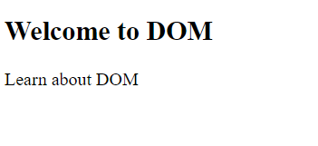

Browser supplies the definition of DOM objects and APIs to JS engine

Engine

paraObjRef

Through DOM API

JS code

Browser represents the structure of the entire HTML document/file along with the window where irt is being displayed in the browser, through a series of objects interlinked with each other (As parent-child or as sibling etc.), which is known as Document Object model (DOM).

The DOM is created so that from our code (JS/TS), we can manipulate the elements of the HTML document. Such as adding new elements dynamically, modifying existing elements dynamically etc.

Learn…

Welcome..