1. The application will be used to calculate and display salary of employees
2. Use the following diagram to create an application where a class, ‘Employee’ should be created

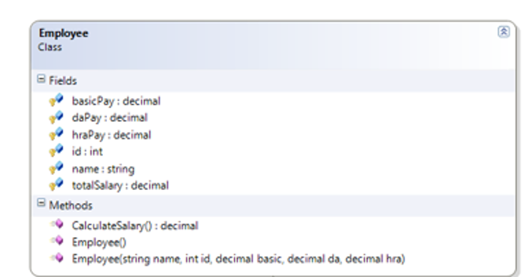

1. Create now two sample objects of employee class
2. Accept the employee information from user and pass those data to the parameterized constructor
3. Call the CalculateSalary() method on those two objects and print the salaries