1. The application will be used to calculate and display salary of employees
2. Use the following diagram to create an application where a class, ‘Employee’ should be created using separate class file

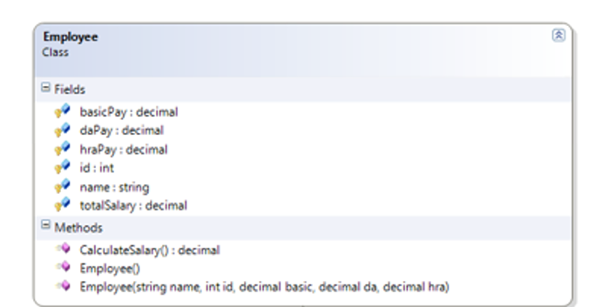

1. Create two child classes: Developer and Hr (using separate class files)
2. Developer:
   1. Will inherit form Employee
   2. Will have an extra attribute: incentive payment
   3. Will have the same calculate salary method, where you have to add basic, da, hra and incentive to generate total salary
3. Hr:
   1. Will inherit from Employee
   2. Will have an extra attribute: gratuity payment
   3. Will have the same calculate salary method, where you have to add basic, da, hra and gratuity to generate total salary
4. Create now two sample objects of Developer and Hr class
5. Accept the information from user and pass those data to the parameterized constructors of Hr and Developer class
6. Call the CalculateSalary() method on those objects and print the salaries