STUDENT EXAM PREPARATION PLANNER
A PROJECT REPORT
Submitted by
JASHWANTH SUNDARAJAN
2116241401032
in partial fulfilment of the End Semester Examination for the course
CB23F35 –
LOW-CODE APPLICATION DEVELOPMENT USING ZOHO CREATOR
in
BACHELOR OF TECHNOLOGY
COMPUTER SCIENCE AND BUSINESS SYSTEMS

RAJALAKSHMI ENGINEERING COLLEGE
(An Autonomous Institution, Affiliated to Anna University, Chennai)
Rajalakshmi Nagar, Thandalam, Tamil Nadu – 602 105
[NOVEMBER 2026]
RAJALAKSHMI ENGINEERING COLLEGE
(An Autonomous Institution, Affiliated to Anna University, Chennai)
BONAFIDE CERTIFICATE
Certified that this project report titled “Student Exam Preparation Planner” is the bonafide work of JASHWANTH SUNDARAJAN ([241401032]), who carried out the individual project work on the Zoho Creator low-code platform for the course CB23F35 – Low-Code Application Development using Zoho Creator, during the academic year [2026–2027], Semester [V], under my supervision.
SIGNATURE  Dr. K. R. Sowmia  HEAD OF THE DEPARTMENT  Department of [CSBS]  Rajalakshmi Engineering College  Thandalam – 602 105 | SIGNATURE  Mr. M. L. Alphin Ezhil Manuel  COURSE FACULTY  [Assistant Professor(SG)]  Department of [CSBS]  Rajalakshmi Engineering College

Submitted for the End Semester Examination (Individual Project) held on [03 November 2026].
INTERNAL EXAMINER | EXTERNAL EXAMINER

DECLARATION
I, JASHWANTH SUNDARAJAN ([2116241401032]), hereby declare that the project report titled “Student Exam Preparation Planner”, submitted for the End Semester Examination of the course CB23F35 – Low-Code Application Development using Zoho Creator, is a record of original work carried out by me individually. The Zoho Creator application described in this report — including its data model, forms, reports, pages, Deluge scripts, workflows and integrations — was designed and developed by me.
I further declare that this work has not been submitted, in part or in full, for the award of any other degree or course credit. Every template, sample application, AI-assisted feature (such as Zia or the AI application builder), code snippet or external resource used in this work has been duly acknowledged in the report.
Place: Chennai SIGNATURE OF THE STUDENT
Date: 03 November 2026 JASHWANTH SUNDARAJAN
2116241401032

ACKNOWLEDGEMENT
I express my sincere gratitude to our Chairman Mr. S. Meganathan, Chairperson Dr. Thangam Meganathan and Vice-Chairman Mr. Abhay Shankar Meganathan for providing the infrastructure and facilities that made this work possible.
I am grateful to our Principal, Dr. S.N. Murugesan, Rajalakshmi Engineering College, for the constant encouragement extended to students to take up industry-relevant learning.
I thank Dr. K. R. Sowmia, Head of the Department, Department of [CSBS], for the guidance and support provided throughout the course.
I owe my sincere thanks to my course faculty, Mr. M. L. Alphin Ezhil Manuel, Assistant Professor(SG), for the valuable guidance, reviews and feedback that shaped this application and report.
I also acknowledge [Zoho Corporation / Zoho Creator Education Programme] for providing access to the Zoho Creator platform and learning resources, and I thank my family and friends for their unwavering support.

JASHWANTH SUNDARJAN

ABSTRACT
Students preparing for semester examinations must keep track of several subjects, each divided into units and topics of different difficulty, while also following a changing set of study sessions and examination dates. In most colleges this is done through paper notes, spreadsheets and chat messages. As a result, topics are forgotten, study sessions are missed or clash with each other, the countdown to each examination is not visible, and there is no objective measure of how much of the syllabus has actually been covered.
This project presents the Student Exam Preparation Planner, a low-code application developed on Zoho Creator. Four related forms – Subject Management, Topic Management, Study Planner and Exam Schedule – are connected through lookup fields. List reports, a Kanban-style Topic Progress Board, a study calendar and a Preparation Dashboard with summary panels present the stored data. Deluge scripting validates study-session timings so that an end time that is not later than the start time is rejected, and a scheduled workflow is configured to e-mail an exam reminder one day before each examination at 8:00 AM. Integration with Zoho Sheet through Zoho Flow, a book-search call to the Open Library API, the Creator REST API, role-based access for administrator and student users, and a JavaScript progress widget have been designed as extensions of the core application.
A 19-case test plan covering valid inputs, invalid inputs, reports, dashboard counts, integrations and permissions was prepared to verify the application. The core forms, reports and dashboard panels give students a single place to see completed, ongoing and pending topics, replacing manual counting and scattered notes, while security is addressed through role-based permissions, record-level restrictions and OAuth 2.0 connections. The work shows that a practical academic planning system can be built quickly with very little code and then extended step by step towards integrations and pro-code components.
Keywords: Low-Code Development; Zoho Creator; Deluge Scripting; Workflow Automation; Role-Based Access Control; Exam Preparation Planner

PROJECT AT A GLANCE
Attribute | Details
Project Title | Student Exam Preparation Planner
Application Domain | Education / Academic Planning (Student Productivity)
Student Name & Register No. | JASHWANTH SUNDARJAN – 2116241401032
Zoho Creator Edition | Education
Application Name (Link Name) | Student_Exam (Student Exam)
Published / Live URL | https://creatorapp.zoho.in/jashwanthsundarajan.20241588/student-exam/#Preparation_Dashboard
Demo Credentials (per role) | Admin: application owner account | Student: separate test student account (proposed – see Section 5.8)
Number of Forms / Subforms | 4 / 0 (Subject Management, Topic Management, Study Planner, Exam Schedule / no subforms)
Number of Reports (by type) | List: 4 | Kanban: 1 | Calendar: 1 (date-field configuration to be verified) | Pivot/Chart: dashboard chart components | Others: –
Number of Pages / Dashboards | 1 dashboard page (Preparation Dashboard with four KPI panels)
Number of Workflows | Form: 1 (study-time validation) | Schedule: 1 (exam reminder) | Approval: 0 | Blueprint: 0 | Batch: 0
Deluge Functions / Custom Actions | 0 implemented; 1 proposed (subject-wise completion percentage function)
Integrations | Zoho Flow → Zoho Sheet, Open Library Search API (Deluge invokeurl), Creator REST API – documented as planned integrations
Roles & Profiles Defined | Administrator (application owner); Student (proposed role with record-level restriction)
Environments Used | Development → Production (Stage optional) – see Chapter 7
Date of Production Deployment | 01 November 2026

TABLE OF CONTENTS
ABSTRACT iv
PROJECT AT A GLANCE v
LIST OF TABLES ix
LIST OF FIGURES x
LIST OF ABBREVIATIONS xi
INTRODUCTION 1
1.1 Background 1
1.2 Problem Statement 1
1.3 Objectives 1
1.4 Scope of the Project 1
1.5 Justification for a Low-Code Approach 2
1.6 Organisation of the Report 2
LITERATURE SURVEY AND SYSTEM STUDY 3
2.1 Study of the Existing System 3
2.2 Limitations of the Existing System 3
2.3 Low-Code versus Traditional Development 3
2.4 Literature Survey 4
2.5 Emerging Trends in Low-Code Development 4
2.6 Proposed System 4
REQUIREMENT ANALYSIS 5
3.1 Stakeholders and User Roles 5
3.2 Functional Requirements 5
3.3 Non-Functional Requirements 5
3.4 Hardware and Software Requirements 6
3.5 Use Case Model 6
SYSTEM DESIGN 8
4.1 System Architecture 8
4.2 Data Model 8
4.3 Form Design 9
4.4 Process and Workflow Design 9
4.5 User Interface and Navigation Design 10
4.6 Access Control Design 10
IMPLEMENTATION 11
5.1 Application Setup 11
5.2 Forms and Data Capture 11
5.3 Reports 12
5.4 Pages and Dashboards 13
5.5 Deluge Scripting 13
5.6 Workflows and Automation 14
5.7 Integrations 15
5.8 User Management and Role-Based Access 16
5.9 AI and Analytics Features 16
5.10 Pro-Code Extension 17
5.11 Mobile and Portal Access 17
TESTING AND DEBUGGING 18
6.1 Testing Strategy 18
6.2 Test Cases 18
6.3 Debugging Deluge Scripts 18
6.4 Defect Log 19
6.5 User Acceptance Testing 19
DEPLOYMENT, SECURITY AND GOVERNANCE 20
7.1 Environments and Deployment Strategy 20
7.2 Performance Optimisation 20
7.3 Security Features 21
7.4 Governance and Administration 21
RESULTS AND DISCUSSION 22
8.1 Application Output 22
8.2 Achievement of Objectives 23
8.3 Comparison with the Existing System 23
8.4 Limitations of the Low-Code Approach 23
8.5 Reflection on the No-Code → Low-Code → Pro-Code Spectrum 23
CONCLUSION AND FUTURE ENHANCEMENTS 24
9.1 Conclusion 24
9.2 Future Enhancements 24
9.3 Learning Outcomes and Career Relevance 24
REFERENCES 25
APPENDIX A – ZOHO CREATOR FEATURE COVERAGE CHECKLIST 26
APPENDIX B – COURSE OUTCOME MAPPING 28
APPENDIX C – COMPLETE DELUGE SOURCE CODE 29
APPENDIX D – USER MANUAL 30
D.1 Accessing the Application 30
D.2 Instructions for Student 30
D.3 Instructions for Administrator 30
APPENDIX E – EVALUATION RUBRIC 31
APPENDIX F – VIVA-VOCE RECORD SHEET 33

LIST OF TABLES
Table 2.1: Comparison of Low-Code and Traditional Development for the Proposed Application 3
Table 2.2: Summary of Literature Survey 4
Table 3.1: Stakeholders and User Roles 5
Table 3.2: Functional Requirements 5
Table 3.3: Non-Functional Requirements 5
Table 3.4: Hardware and Software Requirements 6
Table 3.5: Use Case Description – UC-01 Plan Study Session 6
Table 4.1: Entities and Relationships 9
Table 4.2: Field Specification – Subject, Topic, Study Planner and Exam Schedule Forms 9
Table 4.3: Role–Permission Matrix 10
Table 5.1: Reports Implemented 12
Table 5.2: Deluge Scripts Implemented 13
Table 5.3: Workflows Implemented 14
Table 5.4: Integrations Implemented 15
Table 6.1: Test Cases 18
Table 6.2: Defect Log 19
Table 6.3: User Acceptance Feedback 19
Table 7.1: Deployment Checklist 20
Table 7.2: Performance Optimisation Results 20
Table 7.3: Security Controls Implemented 21
Table 8.1: Mapping of Objectives to Outcomes 23
Table 8.2: Existing System versus Proposed Application 23
Table A.1: Feature Coverage Checklist 26
Table B.1: Mapping of Course Outcomes to Report Chapters 28
Table E.1: Evaluation Rubric for the Individual Project 31
Table E.2: Performance Level Descriptors 32
Table F.1: Viva-Voce Questions and Responses 33
Table F.2: Marks Summary 33

LIST OF FIGURES
Figure 2.1: As-Is Process Flow of the Existing (Manual) Exam Preparation System 3
Figure 3.1: Use Case Diagram of the Student Exam Preparation Planner 6
Figure 4.1: System Architecture of the Student Exam Preparation Planner 8
Figure 4.2: Entity–Relationship Diagram 8
Figure 4.3: Workflow / Process Flow for Study-Time Validation and Exam Reminder 10
Figure 4.4: Navigation Structure and Wireframe of the Preparation Dashboard 10
Figure 5.1: Application Dashboard and Navigation Menu 11
Figure 5.2: Topic Management Form in Live Mode 11
Figure 5.3: Topic Management Form in the Form Builder 12
Figure 5.4: Topic Progress Board (Kanban Report) 12
Figure 5.5: Preparation Dashboard 13
Figure 5.6: Form Workflow Configuration (Validate Study Hours) 15
Figure 5.7: Deluge Script Editor – Validate Study Time Workflow 16
Figure 5.8: Users – Permissions Configuration 16
Figure 5.9: Analytics – Topic Progress and Topics per Subject Charts 17
Figure 5.10: Application on Mobile – All Subject Management List View 17
Figure 6.1: Deluge Script Editor – Study-Time Validation Script 19
Figure 7.1: Application Dashboard Verified in Development Before Publishing 20
Figure 7.2: Application Settings – User Permissions and Administration 21
Figure 8.1: Scenario Step 1 – Student Opens the Study Planner Form 22
Figure 8.2: Scenario Step 2 – Invalid Timing Blocked by Validation 22
Figure 8.3: Scenario Step 3 – Preparation Dashboard with Summary Panels and Charts 22

LIST OF ABBREVIATIONS
Abbreviation | Expansion
AI | Artificial Intelligence
API | Application Programming Interface
CRUD | Create, Read, Update, Delete
DBMS | Database Management Systems
ER | Entity–Relationship
FR | Functional Requirement
HTML | HyperText Markup Language
JS | JavaScript
JSON | JavaScript Object Notation
KPI | Key Performance Indicator
LCAP | Low-Code Application Platform
NFR | Non-Functional Requirement
OAuth | Open Authorization
OS | Operating Systems
RBAC | Role-Based Access Control
REST | Representational State Transfer
SDK | Software Development Kit
UAT | User Acceptance Testing
UI | User Interface
URL | Uniform Resource Locator

CHAPTER 1

INTRODUCTION

1.1 Background
Examinations are the most important assessment point in an engineering programme, and a student typically studies four to six subjects in every semester. Each subject has a syllabus divided into units, and each unit contains several topics – for example, Java contains Introduction to Java and Java Collections, DBMS contains Database Concepts and Normalization, AI contains Intelligent Agents and Machine Learning, and Operating Systems contains Process Management and CPU Scheduling. Topics differ in difficulty, so they need different amounts of preparation time.
The Student Exam Preparation Planner is built for undergraduate students and for the administrator who maintains the academic master data of a class or department. At present the process is manual: subjects and topics are written in notebooks or spreadsheets, study timetables are made on paper or in phone notes, and examination dates are copied from college circulars. The application brings subjects, topics, study sessions, examination dates and preparation status into one structured Zoho Creator application.

1.2 Problem Statement
Students do not have a single, organised place in which to record what must be studied, when it will be studied, when the examination takes place and how much has been completed. Information is spread across notebooks, spreadsheets and messages, and progress is judged only by memory. This causes poor planning and last-minute pressure before examinations. The specific pain points are:
- Syllabus topics are listed in different places and some topics are forgotten or studied twice.
- Study sessions are planned informally, so timings clash or are entered incorrectly (for example, an end time earlier than the start time).
- There is no clear view of upcoming examinations, so preparation is not matched to the days remaining.
- Completion of topics is not tracked, so there is no statistical view of completed, ongoing and pending topics.
- There is no access control – a shared spreadsheet exposes every student’s plan and can be edited by anyone.

1.3 Objectives
- To design a normalised data model and forms for subjects, topics, study sessions and examination schedules linked through lookup fields.
- To automate study-time validation and scheduled exam reminders using Deluge scripting and workflows.
- To provide list reports, a Kanban-style Topic Progress Board, a study calendar and a Preparation Dashboard for monitoring preparation progress.
- To integrate the application with Zoho Sheet (through Zoho Flow), the Open Library Search API and the Creator REST API for data exchange.
- To define role-based access for administrator and student users with record-level privacy for personal study plans.
- To deploy the application securely to a production environment with governance controls and documented plan limitations.

1.4 Scope of the Project
In scope: (i) four forms – Subject Management, Topic Management, Study Planner and Exam Schedule; (ii) list reports, a Kanban Topic Progress Board and a Study Calendar; (iii) a Preparation Dashboard with Total Subjects, Total Topics, Completed Topics and Not Started Topics panels; (iv) Deluge validation of study timings and a scheduled exam-reminder e-mail; (v) designed integrations with Zoho Sheet, the Open Library API and the Creator REST API; (vi) a role-based access model for the Administrator and Student roles; and (vii) a proposed JavaScript dashboard widget. The application is used through the web browser and, because it is built on Zoho Creator, can also be opened in the Zoho Creator mobile app.
Out of scope: automatic timetable generation, payment or fee modules, marks and grade management, a public customer portal, and AI-based prediction of exam performance. These are listed as future enhancements in Section 9.2.

1.5 Justification for a Low-Code Approach
Low-code platforms let applications be assembled from pre-built components, so that a working system is available in days rather than weeks [1]. Zoho Creator suits this problem because forms, lookups, reports, dashboards, workflows and Deluge scripting are available in one browser-based environment, hosting and security are provided by the platform, and the finished application can be opened on mobile devices without separate development [2]. Logic that is specific to this project – validating study times and sending reminders – needs only a few lines of Deluge [3], so the application can be maintained by a citizen developer such as a student or a faculty member. A traditional stack (database, back-end, front-end, hosting and authentication) would be disproportionate for a planner of this size.

1.6 Organisation of the Report
Chapter 2 reviews the existing system and related low-code literature. Chapter 3 presents the requirement analysis. Chapter 4 describes the system design. Chapter 5 details the implementation on Zoho Creator. Chapter 6 covers testing and debugging. Chapter 7 discusses deployment, performance optimisation, security and governance. Chapter 8 presents results and discussion, and Chapter 9 concludes the report with future enhancements.
CHAPTER 2

LITERATURE SURVEY AND SYSTEM STUDY

2.1 Study of the Existing System
In the existing system a student first writes the list of subjects in a notebook or a note-taking app. The syllabus is copied topic by topic into a spreadsheet or a paper list, and a study timetable is drawn separately on paper or in a phone calendar. Examination dates are noted from the college circular or timetable. During preparation the student marks topics as finished by ticking a list or simply remembering them. Each of these artefacts is maintained independently, as shown in Figure 2.1, and nothing links a study session to a topic or a topic to an examination.

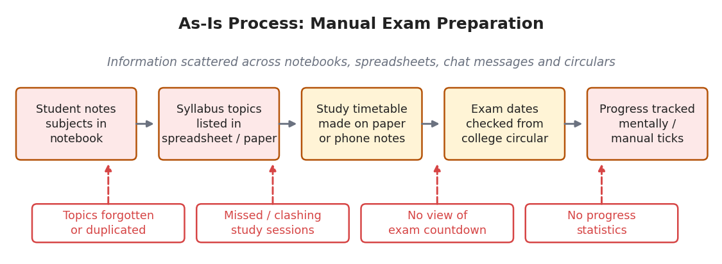
Figure 2.1: As-Is Process Flow of the Existing (Manual) Exam Preparation System

2.2 Limitations of the Existing System
- Information about subjects, topics, study sessions and examinations is scattered across several notebooks, files and messages.
- No validation exists, so wrong study timings or duplicate entries are not detected.
- There is no automatic reminder; examinations are noticed only when the date is near.
- Progress cannot be measured – there are no counts, charts or status views for completed and pending topics.
- A shared spreadsheet gives no role-based control, so personal study plans are visible and editable by everyone.

2.3 Low-Code versus Traditional Development
Table 2.1 compares a conventional pro-code implementation of the planner with the Zoho Creator implementation. Effort figures are estimates made by the developer for an application of this size.
Table 2.1: Comparison of Low-Code and Traditional Development for the Proposed Application
Criterion | Traditional (Pro-Code) Development | Low-Code on Zoho Creator
Development time | 6–8 weeks (design, database, back-end, front-end, testing) | 1–2 weeks (forms, reports, dashboard, Deluge)
Skills required | Programming language, framework, SQL, UI design, DevOps | Form/report configuration and basic Deluge scripting
Hosting & infrastructure | Server, database and domain to be arranged and maintained | Provided by Zoho Creator cloud; no server set-up
Mobile application | Separate mobile app or responsive redesign needed | Available automatically in the Zoho Creator mobile app
Security & access control | Authentication and role logic coded by developer | Built-in login, roles, permission sets and record-level rules (plan dependent)
Maintenance & change | Code change, rebuild and redeployment for each change | Edit fields, reports and scripts in the browser and republish
Customisation limits | Unlimited UI and logic flexibility | Limited UI control; widgets or APIs needed for custom visuals
Cost | Developer time plus hosting cost | Platform subscription (education access) and low developer effort

2.4 Literature Survey
Table 2.2 summarises the sources reviewed. They cover the low-code literature [4]–[7], the Zoho documentation [2], [3] and the services used for the planned integrations [8]–[10].
Table 2.2: Summary of Literature Survey
S.No. | Author(s) / Source & Year | Title / Product | Key Findings | Relevance to this Project
1 | W. Rosam and O. Kalnichevski [1] | Low-Code Development: A Practical Guide | Explains low-code concepts, citizen development and rapid application delivery. | Basis for choosing a low-code approach for the planner.
2 | R. Sanchis et al., 2020 [4] | Low-Code as Enabler of Digital Transformation in Manufacturing Industry | Low-code shortens development time and lets domain experts build applications. | Supports citizen development of the exam planner.
3 | D. Di Ruscio et al., 2022 [5] | Low-code development and model-driven engineering: Two sides of the same coin? | Relates low-code platforms to model-driven engineering and discusses their limits. | Explains data-model-first design and platform limitations.
4 | A. Sahay et al., 2020 [6] | Supporting the understanding and comparison of low-code development platforms | Provides a feature-based comparison of low-code platforms. | Guides evaluation of Zoho Creator features used here.
5 | Gartner, Inc., 2024 [7] | Magic Quadrant for Enterprise Low-Code Application Platforms | Evaluates enterprise low-code platforms and market trends. | Shows industry adoption of low-code and its governance needs.
6 | Zoho Corporation [2], [3] | Zoho Creator Help and Deluge Reference | Documents forms, reports, workflows, Deluge and security. | Primary technical reference for implementation.
7 | Open Library [8] | Open Library Search API | Public JSON search endpoint for books by title or author. | Used for the planned study-book suggestion integration.
8 | Zoho Corporation [9], [10] | Creator REST API v2 and Zoho Flow Help | Describe OAuth 2.0 API access and no-code integration of Creator with other services. | Used for the planned REST API and Zoho Sheet integrations.

2.5 Emerging Trends in Low-Code Development
Three trends in low-code development influenced the design. First, citizen development: platforms such as Zoho Creator allow domain users to build applications themselves, which is the approach used here [4]. Second, hyper-automation: instead of relying on the student to remember, scheduled workflows send reminders and Zoho Flow can copy records to other services without manual work. Third, composable applications: the planner is built from independent forms and reports that can be connected to external services through REST APIs, as planned with Open Library and the Creator REST API. AI-assisted building (for example Zia and the AI application builder) was not used for this version; it is listed as a future enhancement for study-time prediction and recommendations.

2.6 Proposed System
The proposed system is a Zoho Creator application named Student Exam that stores all preparation data in four related forms. Lookup fields connect topics, study sessions and examinations to the correct subject, which removes repeated typing and keeps the data consistent (Limitation 1). A Deluge validation script rejects invalid study timings (Limitation 2) and a scheduled workflow sends an e-mail reminder one day before each examination (Limitation 3). Reports, a Kanban board, a calendar view and a dashboard with summary panels give an immediate picture of completed, ongoing and pending topics (Limitation 4). Role-based permissions with record-level restrictions are designed so that students see only the data they are allowed to see (Limitation 5).
CHAPTER 3

REQUIREMENT ANALYSIS

3.1 Stakeholders and User Roles
Table 3.1: Stakeholders and User Roles
Role | Description | Key Responsibilities in the Application
Administrator / App Owner | Person who builds and maintains the application and academic master data. | Manage subjects, topics, exams, forms, workflows, reports, dashboard, integrations and users; view all data.
Student / App User | Undergraduate student who prepares for examinations using the planner. | View subjects, topics and exams; create and edit own study plans; update topic progress; view dashboard and reports.
Zoho Flow / External Services (system actors) | Automation and API services that exchange data with the application. | Copy study records to Zoho Sheet; return book search results; serve permitted records through the REST API (planned).

3.2 Functional Requirements
Table 3.2: Functional Requirements
FR ID | Requirement | Role(s) | Priority
FR-01 | The system shall allow subjects to be registered with Subject Name, Subject Code, Semester, Exam Date, Total Topics and Description. | Admin | High
FR-02 | The system shall allow topics to be added under a subject through a Subject lookup with Unit Number, Topic Name, Difficulty Level and Completion Status. | Admin | High
FR-03 | The system shall allow study sessions to be scheduled with Study Date, Subject, Topic, Start Time, End Time, Duration, Status and Notes. | Student, Admin | High
FR-04 | The system shall reject a study session whose End Time is earlier than or equal to its Start Time. | Student, Admin | High
FR-05 | The system shall record examinations with Subject, Exam Date, Exam Time, Exam Type, Preparation Status and Remarks. | Admin | High
FR-06 | The system shall provide list reports for subjects, topics, study plans and exam schedules. | Admin, Student | High
FR-07 | The system shall display topics on a Kanban board grouped as Not Started, In Progress and Completed. | Admin, Student | Medium
FR-08 | The system shall display study sessions by date on a Study Calendar. | Admin, Student | Medium
FR-09 | The system shall display dashboard panels for Total Subjects, Total Topics, Completed Topics and Not Started Topics. | Admin, Student | High
FR-10 | The system shall send an e-mail reminder at 8:00 AM one day before each examination. | Student | Medium
FR-11 | The system shall copy each new study-plan record to a Zoho Sheet spreadsheet (planned). | Admin | Medium
FR-12 | The system shall suggest books for a subject using the Open Library Search API (planned). | Student | Low
FR-13 | The system shall restrict students to permitted modules and to their own study plans (planned). | Admin | High
FR-14 | The system shall expose permitted study-plan records through the Creator REST API with OAuth 2.0 (planned). | API client | Low

3.3 Non-Functional Requirements
Table 3.3: Non-Functional Requirements
NFR ID | Category | Requirement
NFR-01 | Performance | Reports with up to 500 records shall load within 3 seconds on a normal broadband connection.
NFR-02 | Security | Users shall access only the data permitted by their role; credentials and tokens shall never be stored in forms or reports.
NFR-03 | Usability | The application shall be usable on web browsers and the Zoho Creator mobile app, with drop-downs and lookups instead of free-text entry.
NFR-04 | Availability | The application shall be hosted on Zoho Creator’s cloud and shall be available without separate server administration.
NFR-05 | Maintainability | Form fields and Deluge scripts shall use consistent link names and header comments so that they can be changed by a citizen developer.
NFR-06 | Auditability | All record changes shall be traceable through the Zoho Creator audit trail.

3.4 Hardware and Software Requirements
Table 3.4: Hardware and Software Requirements
Category | Specification
Platform | Zoho Creator (cloud) – application Student Exam
Scripting language | Deluge (Data Enriched Language for the Universal Grid Environment)
Browser | Google Chrome / Microsoft Edge / Mozilla Firefox (latest version)
API testing tool | Postman
Other Zoho services | Zoho Flow and Zoho Sheet (planned integration); e-mail notifications through Zoho Creator sendmail
Mobile | Zoho Creator mobile app (Android / iOS) – optional access
Client hardware | Intel Core i3/i5 or above, 8 GB RAM, internet connection

3.5 Use Case Model

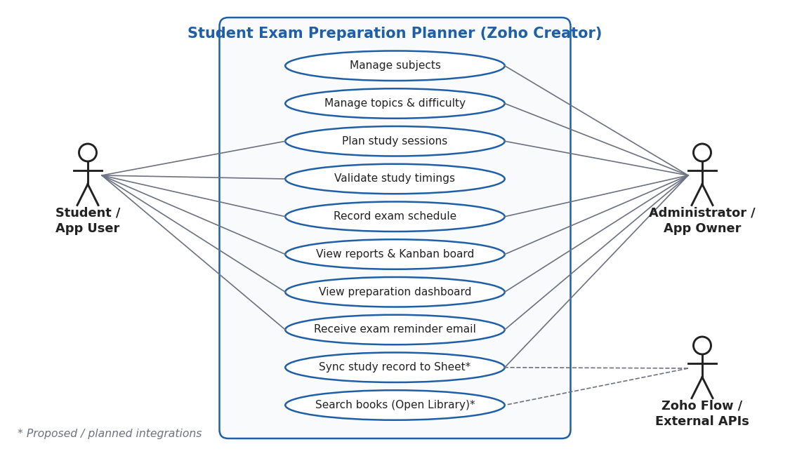
Figure 3.1: Use Case Diagram of the Student Exam Preparation Planner
Table 3.5: Use Case Description – UC-01 Plan Study Session
Use Case ID | UC-01
Use Case Name | Plan Study Session
Actor(s) | Student (primary); Administrator
Pre-condition | The Subject and Topic records exist and the user is signed in to the application.
Main Flow | 1. The student opens the Study Planner form.  2. The student selects the Study Date, Subject and Topic.  3. The student enters the Start Time and End Time and the Study Status.  4. The student clicks Submit.  5. The validation script checks that End Time is later than Start Time.  6. The record is saved and a success message is shown.
Alternate Flow | At step 5, if End Time is earlier than or equal to Start Time, the alert “End Time must be later than Start Time.” is displayed, the submission is cancelled and the student corrects the time.
Post-condition | A valid study session is stored and appears in All Study Planners and the Study Calendar.
Related FR | FR-03, FR-04, FR-08
CHAPTER 4

SYSTEM DESIGN

4.1 System Architecture

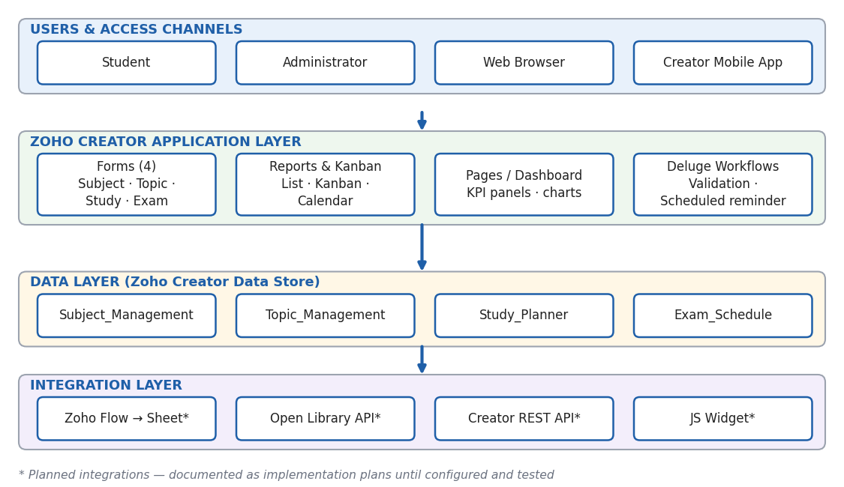
Figure 4.1: System Architecture of the Student Exam Preparation Planner
Figure 4.1 shows the four-layer architecture. The top layer contains the users – the Student and the Administrator – who reach the application through a web browser or the Zoho Creator mobile app. The application layer is the Zoho Creator application itself: the four forms, the reports and Kanban board, the Preparation Dashboard page and the Deluge workflows for validation and reminders. These components read and write the data layer, which is the Zoho Creator data store holding the Subject_Management, Topic_Management, Study_Planner and Exam_Schedule records. The integration layer connects the application to external services – Zoho Flow with Zoho Sheet, the Open Library API through Deluge invokeurl, the Creator REST API secured with OAuth 2.0, and an optional JavaScript widget. Components marked with an asterisk in the figure are planned integrations that are documented as implementation plans until they are configured and tested.

4.2 Data Model
The data model has four entities. Subject_Management is the parent form: every topic, study session and examination belongs to one subject. Topic_Management is linked to Subject_Management through a Subject lookup. Study_Planner has two lookups – to Subject_Management and to Topic_Management – so that each session is tied to a subject and a topic. Exam_Schedule is linked to Subject_Management. All relationships are one-to-many and are realised through lookup fields (Figure 4.2 and Table 4.1). No subform is used because the child records (topics, sessions and exams) are managed independently and need their own reports, which a subform would not provide.

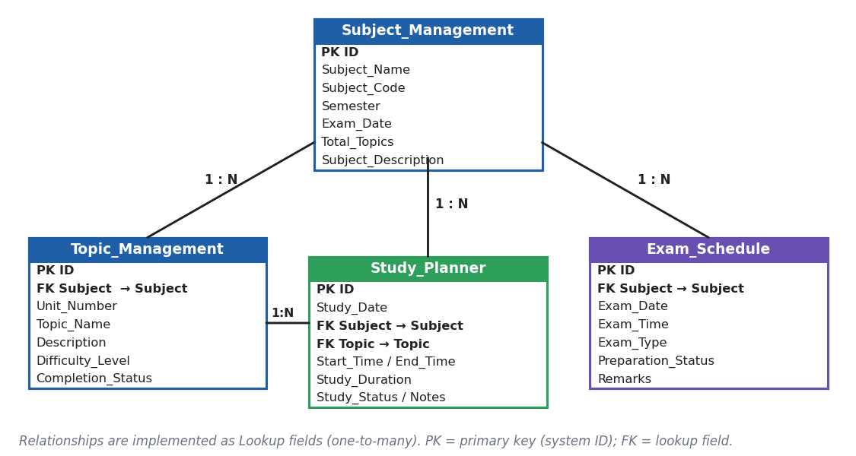
Figure 4.2: Entity–Relationship Diagram
Table 4.1: Entities and Relationships
Entity (Form) | Key Fields | Related To | Relationship Type | Implemented Using
Subject_Management | Subject_Name, Subject_Code, Semester, Exam_Date, Total_Topics | Topic_Management | One-to-Many | Lookup field Subject in Topic_Management
Subject_Management | Subject_Name, Subject_Code | Study_Planner | One-to-Many | Lookup field Subject in Study_Planner
Topic_Management | Subject, Unit_Number, Topic_Name, Difficulty_Level, Completion_Status | Study_Planner | One-to-Many | Lookup field Topic in Study_Planner
Subject_Management | Subject_Name, Exam_Date | Exam_Schedule | One-to-Many | Lookup field Subject in Exam_Schedule

4.3 Form Design
Table 4.2 gives the field specification of the four forms. The form to which a field belongs is shown in the Remarks column. Link names follow the pattern Field_Name and must be copied exactly in Deluge using Refer Fields.
Table 4.2: Field Specification – Subject, Topic, Study Planner and Exam Schedule Forms
Field Label | Link Name | Field Type | Mandatory | Validation / Default | Remarks
Subject Name | Subject_Name | Single Line | Yes | No duplicate values | Subject form
Subject Code | Subject_Code | Single Line | Yes | Unique, e.g. CS23501 | Subject form
Semester | Semester | Drop Down | Yes | I–VIII | Subject form
Exam Date | Exam_Date | Date | Yes | Date format DD-MMM-YYYY | Subject form
Total Topics | Total_Topics | Number | Yes | Default: 0 | Subject form
Subject Description | Subject_Description | Multi Line | No | — | Subject form
Subject | Subject | Lookup | Yes | → Subject_Management | Topic form
Unit Number | Unit_Number | Number | Yes | Whole number ≥ 1 | Topic form
Topic Name | Topic_Name | Single Line | Yes | — | Topic form
Description | Description | Multi Line | No | — | Topic form
Difficulty Level | Difficulty_Level | Drop Down | Yes | Easy / Medium / Hard | Topic form
Completion Status | Completion_Status | Drop Down | Yes | Default: Not Started | Topic form; drives Kanban
Study Date | Study_Date | Date | Yes | Date format DD-MMM-YYYY | Study Planner; calendar date field
Subject | Subject | Lookup | Yes | → Subject_Management | Study Planner form
Topic | Topic | Lookup | Yes | → Topic_Management | Study Planner form
Start Time | Start_Time | Time | Yes | — | Study Planner form
End Time | End_time | Time | Yes | Must be later than Start Time (DS-01) | Study Planner form
Study Duration | Study_Duration | Formula | — | End Time − Start Time | Study Planner form
Study Status | Study_Status | Drop Down | Yes | Default: Planned | Planned / In Progress / Completed
Notes | Notes | Multi Line | No | — | Study Planner form
Subject | Subject | Lookup | Yes | → Subject_Management | Exam Schedule form
Exam Date | Exam_Date | Date | Yes | Not before today | Exam Schedule form
Exam Time | Exam_Time | Time | Yes | — | Exam Schedule form
Exam Type | Exam_Type | Drop Down | Yes | Internal / Semester / Practical | Exam Schedule form
Preparation Status | Preparation_Status | Drop Down | Yes | Default: Not Started | Used in reminder e-mail
Remarks | Remarks | Multi Line | No | — | Exam Schedule form

4.4 Process and Workflow Design
Two automated processes are designed. Part A of Figure 4.3 is the form workflow that validates study timings in the On Validate event. Part B is the schedule workflow that runs every day at 8:00 AM, finds examinations dated tomorrow and sends a reminder e-mail with the subject, exam date, exam time and preparation status.

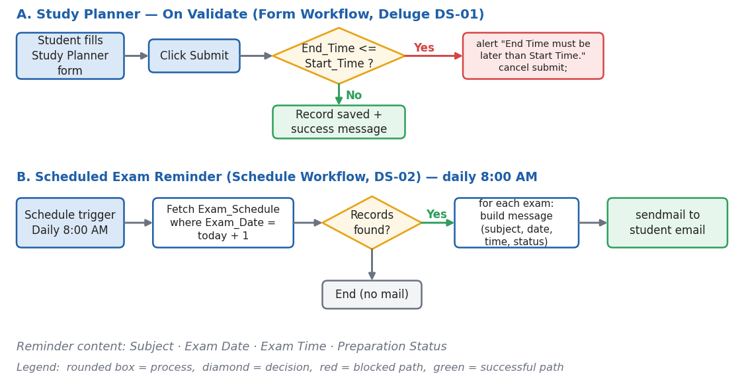
Figure 4.3: Workflow / Process Flow for Study-Time Validation and Exam Reminder

4.5 User Interface and Navigation Design
Figure 4.4 shows the navigation structure – Dashboard, Master Data, Planning and Reports – and a wireframe of the Preparation Dashboard with its four KPI panels, two charts and the upcoming-examinations view.

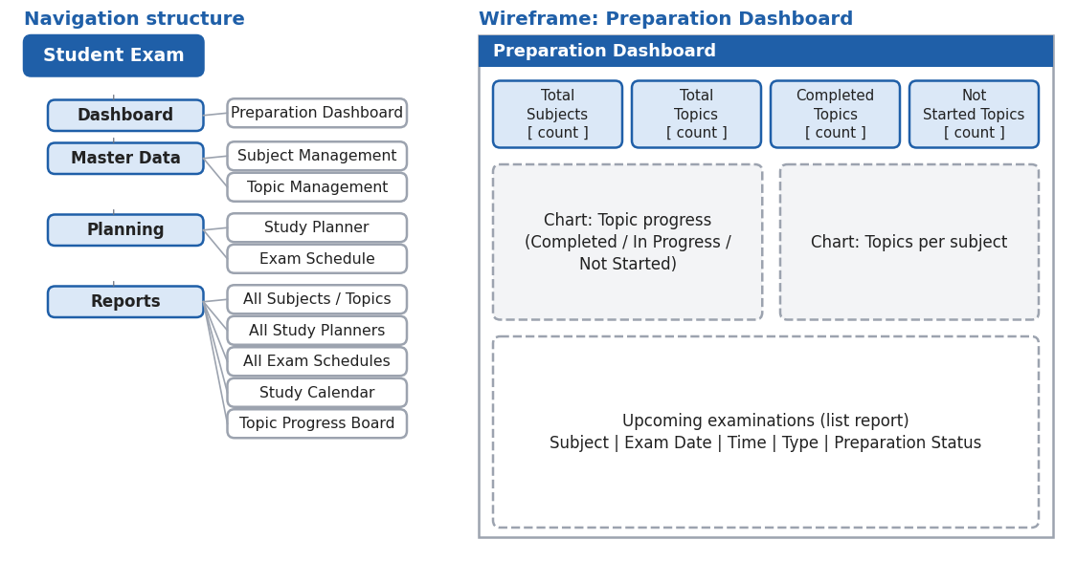
Figure 4.4: Navigation Structure and Wireframe of the Preparation Dashboard

4.6 Access Control Design
Table 4.3 defines the permission matrix that Section 5.8 implements. A = Add, E = Edit, V = View, D = Delete and --- = no access. The Student columns are a proposed design; (own) means that record-level criteria restrict the student to personally created records.
Table 4.3: Role–Permission Matrix
Component | Administrator | Student (Proposed) | Student – Own Records | API Client (Proposed)
Form: Subject Management | A E V D | V | V | ---
Form: Topic Management | A E V D | V | V | ---
Form: Study Planner | A E V D | A E V | A E V (own) | V (own)
Form: Exam Schedule | A E V D | V | V | ---
Report: All Subjects / All Topics | V | V | V | ---
Report: All Study Planners | V | V (own) | V (own) | V (own)
Page: Preparation Dashboard | V | V | V | ---
CHAPTER 5

IMPLEMENTATION

5.1 Application Setup
The application was created from scratch in Zoho Creator using the Create Application option, with the name Student Exam (link name Student_Exam). No template or AI-assisted builder was used, so that each form, field and relationship could be designed deliberately. The application menu is organised into sections: Dashboard (Preparation Dashboard), Masters (Subject Management and Topic Management), Planning (Study Planner and Exam Schedule) and Reports (All Subjects, All Topics, All Study Planners, All Exam Schedules, Study Calendar and Topic Progress Board). A single blue theme with consistent section icons was applied so that students can find the dashboard and forms quickly. Figure 5.1 shows the application home and navigation sections.

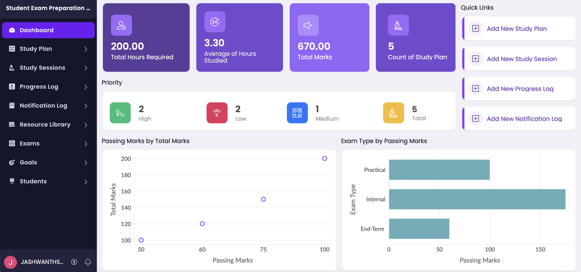
Figure 5.1: Application Dashboard and Navigation Menu

5.2 Forms and Data Capture
Four forms were built, as specified in Table 4.2. Subject Management stores Subject Name, Subject Code, Semester, Exam Date, Total Topics and Subject Description. Topic Management stores a Subject lookup, Unit Number, Topic Name, Description, Difficulty Level (Easy, Medium, Hard) and Completion Status (Not Started, In Progress, Completed). Study Planner stores the Study Date, Subject and Topic lookups, Start Time, End Time, Study Duration, Study Status and Notes. Exam Schedule stores the Subject lookup, Exam Date, Exam Time, Exam Type, Preparation Status and Remarks.
Lookup fields connect Topic Management, Study Planner and Exam Schedule to Subject Management, and Study Planner to Topic Management, so related data is selected from a list instead of being typed again. Drop-down fields restrict Difficulty Level, Completion Status, Study Status, Exam Type and Preparation Status to fixed values, which keeps the Kanban board and the dashboard counts consistent. Figure 5.2 shows the Topic Management form in live mode, and Figure 5.3 shows the same form in the form builder with the Subject lookup field properties. Sample topic records entered for demonstration are Java – Introduction to Java, Java – Java Collections, DBMS – Database Concepts, DBMS – Normalization, AI – Intelligent Agents, AI – Machine Learning, OS – Process Management and OS – CPU Scheduling.

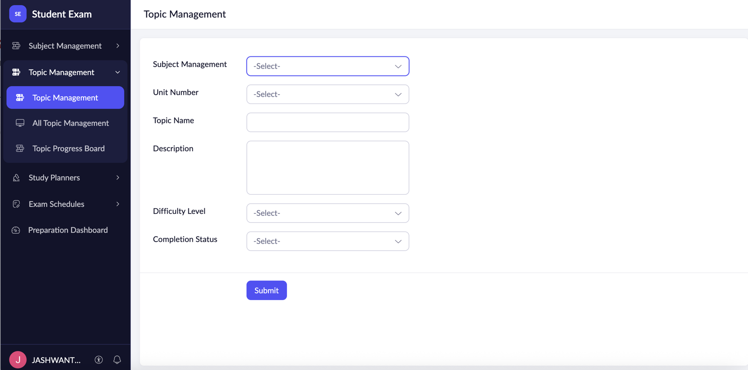
Figure 5.2: Topic Management Form in Live Mode

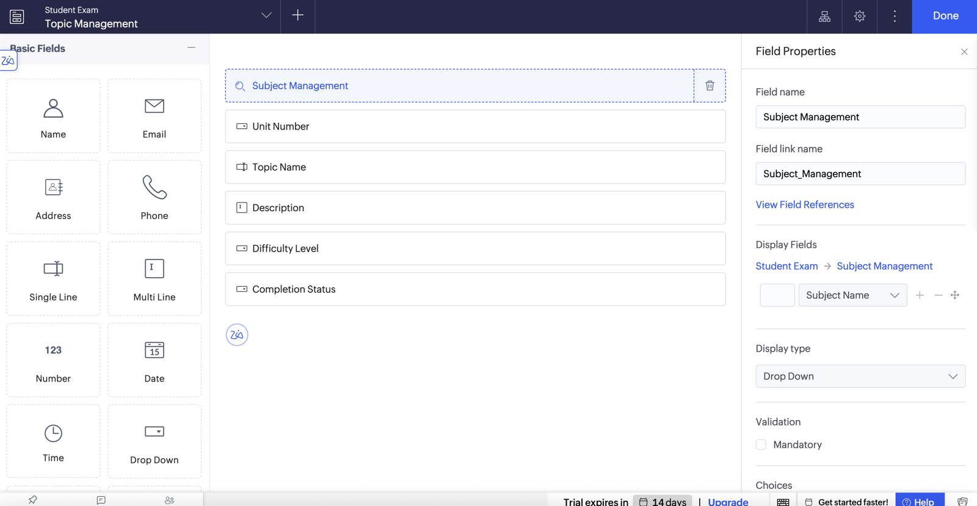
Figure 5.3: Topic Management Form in the Form Builder

5.3 Reports
Table 5.1 lists the reports. Four list reports display all records of each form. The Topic Progress Board is a Kanban report on Topic Management with columns Not Started, In Progress and Completed, and the Study Calendar displays Study Planner sessions by Study Date once that date field is selected in the calendar settings. Chart components on the dashboard summarise topic progress. Figure 5.4 shows the Topic Progress Board.
Table 5.1: Reports Implemented
Report Name | Type | Source Form | Filter / Grouping / Sorting | Custom Actions | Roles
All Subjects | List | Subject Management | Sort by Subject Name | Default view/edit | Admin, Student
All Topics | List | Topic Management | Group by Subject; filter by Completion Status | Default view/edit | Admin, Student
All Study Planners | List | Study Planner | Sort by Study Date | Default view/edit | Admin, Student (own)
All Exam Schedules | List | Exam Schedule | Sort by Exam Date (ascending) | Default view/edit | Admin, Student
Topic Progress Board | Kanban | Topic Management | Columns by Completion Status | Drag card to change status | Admin, Student
Study Calendar | Calendar | Study Planner | Date field: Study Date (verify configuration) | — | Admin, Student
Dashboard charts | Pivot / Chart | Topic Management, Subject Management | Topic progress by status; topics per subject (verify source) | — | Admin, Student

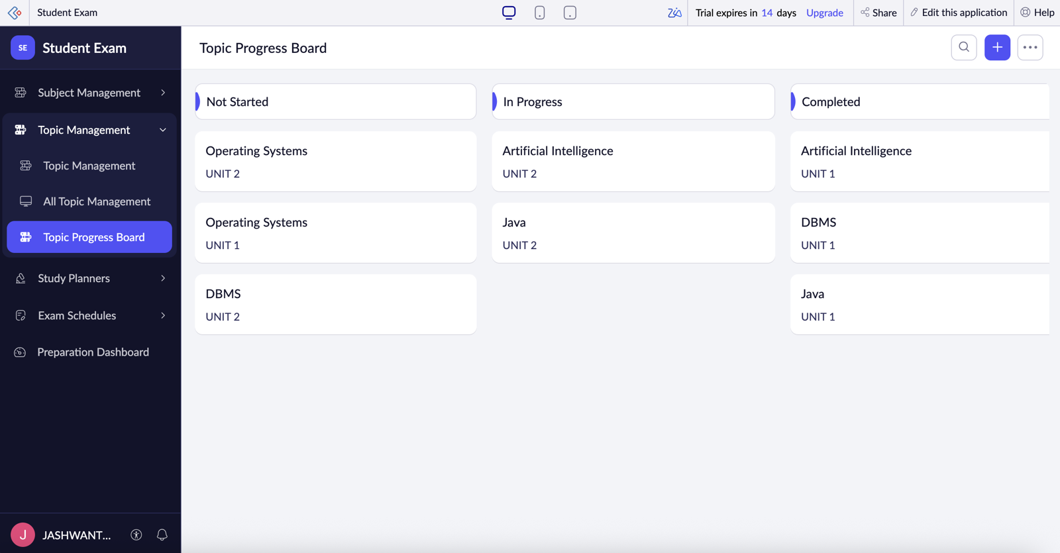
Figure 5.4: Topic Progress Board (Kanban Report)

5.4 Pages and Dashboards
The Preparation Dashboard is the single page of the application, built with the UI Builder for the Administrator and Student roles. Its four summary panels show Total Subjects (count of all subject records), Total Topics (count of all topic records), Completed Topics (topics whose Completion Status is Completed) and Not Started Topics (topics whose Completion Status is Not Started). Below the panels, chart components summarise topic progress and subject information, and an upcoming-examinations report lists the next examinations with their dates and preparation status. The source, grouping and filters of every chart are verified in the live page before an exact calculation is quoted. With the sample data the panels read 4, 8, 3 and 3 respectively. Figure 5.5 shows the dashboard.

Figure 5.5: Preparation Dashboard

5.5 Deluge Scripting
Table 5.2: Deluge Scripts Implemented
Script ID | Location / Trigger | Purpose | Deluge Concepts Used
DS-01 | Study_Planner → On Validate | Block a study session when End Time is not later than Start Time | if condition, alert, cancel submit
DS-02 | Schedule: Exam_Reminder (daily 8:00 AM) | E-mail a reminder one day before each examination | date functions, criteria fetch, for each, sendmail
DS-03 | Study_Planner → button / On Success (proposed) | Suggest study books for a subject using Open Library | invokeurl GET, JSON get, list, for each
DS-04 | Function: getCompletionPercentage (proposed) | Calculate subject-wise completion percentage | function, count aggregate, if-else, arithmetic

Code 5.1: DS-01 Study-time validation script (Study_Planner → On Validate)
// DS-01 | Form: Study_Planner | Event: On Validate
// Purpose: Block the study session if End Time is not later than Start Time
if(input.End_time <= input.Start_Time)
{
alert "End Time must be later than Start Time.";
cancel submit;
}

Code 5.2: DS-02 Scheduled exam-reminder script (Exam_Reminder)
// DS-02 | Schedule: Exam_Reminder | Frequency: Daily at 8:00 AM
// Purpose: E-mail a reminder one day before each examination
tomorrow = zoho.currentdate.addDay(1);
upcoming = Exam_Schedule[Exam_Date == tomorrow];
for each exam in upcoming
{
sendmail
[
from :zoho.adminuserid
to :zoho.adminuserid
subject :"Exam Reminder: " + exam.Subject.Subject_Name
message :"Your " + exam.Subject.Subject_Name + " exam is tomorrow.<br>Exam Date: " + exam.Exam_Date + "<br>Exam Time: " + exam.Exam_Time + "<br>Preparation Status: " + exam.Preparation_Status
]
}

DS-01 runs in the On Validate event of the Study_Planner form, so it executes after the student presses Submit but before the record is saved. It compares End Time with Start Time; if the end time is earlier than or equal to the start time, an alert is displayed and cancel submit stops the save. This prevents invalid study sessions and negative durations. The field link names in the editor must be copied with Refer Fields, because a wrong link name was the bug recorded as BUG-01 in Chapter 6.
DS-02 is the scheduled workflow Exam_Reminder. Every day at 8:00 AM it computes tomorrow’s date, fetches Exam_Schedule records with that Exam Date and sends one e-mail per record containing the subject, exam date, exam time and preparation status. Because the Exam Schedule form does not yet store a student e-mail address, the example sends to the application owner; a Student Email field or the logged-in user list is the next step. Both scripts are configured and are tested as described in Table 6.1 (TC-04, TC-05 and TC-17).
DS-03 (Open Library book suggestion) and DS-04 (completion percentage function) are proposed scripts; they are listed in Table 5.2 and in Appendix C and will be treated as implemented only after testing.

5.6 Workflows and Automation
Table 5.3 lists the workflows. Validate_Study_Time is a form workflow on the Study_Planner On Validate event and Exam_Reminder is a schedule workflow that runs daily at 8:00 AM. The Zoho Flow synchronisation and Open Library workflow are planned and are included for completeness. No approval process, Blueprint or batch workflow is used because the planner has no multi-level approval or bulk-processing requirement. Figure 5.6 shows the configuration of the two implemented workflows.
Table 5.3: Workflows Implemented
Workflow Name | Type | Trigger / Event | Condition | Action(s) | Script Ref.
Validate Study Time | Form Workflow | Study Planner → On Validate | End Time <= Start Time | Alert and cancel submit | DS-01
Exam Reminder | Schedule | Daily at 8:00 AM | Exam_Date = today + 1 | Send reminder e-mail | DS-02
Study Record Sync | Zoho Flow (planned) | Study Planner record created | — | Create row in Zoho Sheet | —
Book Suggestion | Form Workflow (planned) | Button / On Success | Subject selected | invokeurl GET to Open Library | DS-03

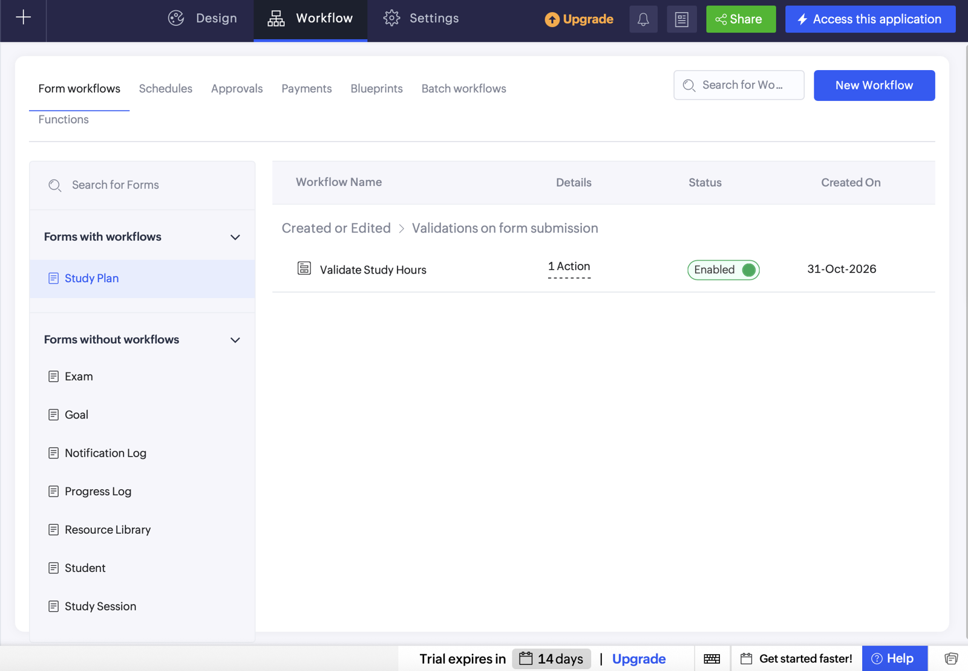
Figure 5.6: Form Workflow Configuration (Validate Study Hours)

5.7 Integrations
Three integrations are planned, as listed in Table 5.4. They are documented as implementation steps and are not described as completed until they are configured and tested.
The Open Library Search API is called with Deluge invokeurl using a public GET endpoint that needs no API key. Example request: https://openlibrary.org/search.json?q=java%20programming&fields=title,author_name,first_publish_year&limit=5. In Postman, a GET request is created with this URL and the JSON response and 200 OK status are inspected; the Postman screenshot is to be added after the test. Figure 5.7 shows the Deluge script editor in which the invokeurl call is written. The Deluge workflow parses the titles and stores them in a Suggested Study Books field, which must be added to the form. The Zoho Sheet integration uses a Zoho Flow trigger Creator – Record Created on Study Planner and the action Zoho Sheet – Create Row, with OAuth 2.0 connections; each field (Study Date, Subject, Topic, Start Time, End Time, Duration, Status) is mapped to its column. The Creator REST API uses the report endpoint generated in the API documentation, OAuth 2.0 with the minimum scopes and a Bearer token in Postman. Access tokens, client secrets and credentials are never placed in this report.
Table 5.4: Integrations Implemented
Integration | Service / Endpoint | Method | Authentication | Data Exchanged / Purpose
Study Record Sync | Zoho Sheet | Zoho Flow: Creator Record Created → Sheet Create Row | OAuth 2.0 connection | Copies study date, subject, topic, time, duration and status into a spreadsheet
Study Resource Search | Open Library Search API | Deluge invokeurl GET | Public endpoint; no API key required | Searches book titles and authors using a subject name
Study Plan Access | Zoho Creator REST API | REST API GET | OAuth 2.0 token with required scopes | Allows an external client to retrieve permitted study-plan records

Code 5.3: DS-03 Open Library book-suggestion script using invokeurl (proposed)
// DS-03 | Study_Planner | Button / On Success (proposed)
// Purpose: Suggest study books for a subject using the Open Library Search API
query = input.Subject.Subject_Name + " programming";
response = invokeurl
[
url :"https://openlibrary.org/search.json?q=" + zoho.encryption.urlEncode(query) + "&fields=title,author_name,first_publish_year&limit=5"
type :GET
];
titles = List();
for each book in response.get("docs")
{
titles.add(book.get("title"));
}
input.Suggested_Study_Books = titles.toString(", ");

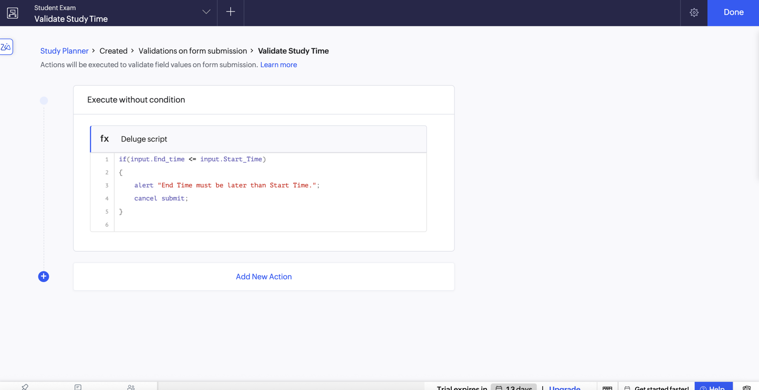
Figure 5.7: Deluge Script Editor – Validate Study Time Workflow

5.8 User Management and Role-Based Access
Two roles are defined in the access model. The Administrator (application owner) manages master data, forms, workflows, reports, the dashboard and integrations. The Student role is proposed with View access to Subject Management, Topic Management and Exam Schedule, and Create/Edit access to personal Study Planner records. A record-level rule such as Added_User == zoho.loginuser is used so that a student cannot see another student’s private study plans, and students are invited as live users rather than developers. Because custom roles and permission sets depend on the Zoho Creator subscription, this model is a proposed configuration until it is created and tested with a separate student account (TC-16). Figure 5.8 shows the Permissions tab listing the Read, Write and Student Access profiles.

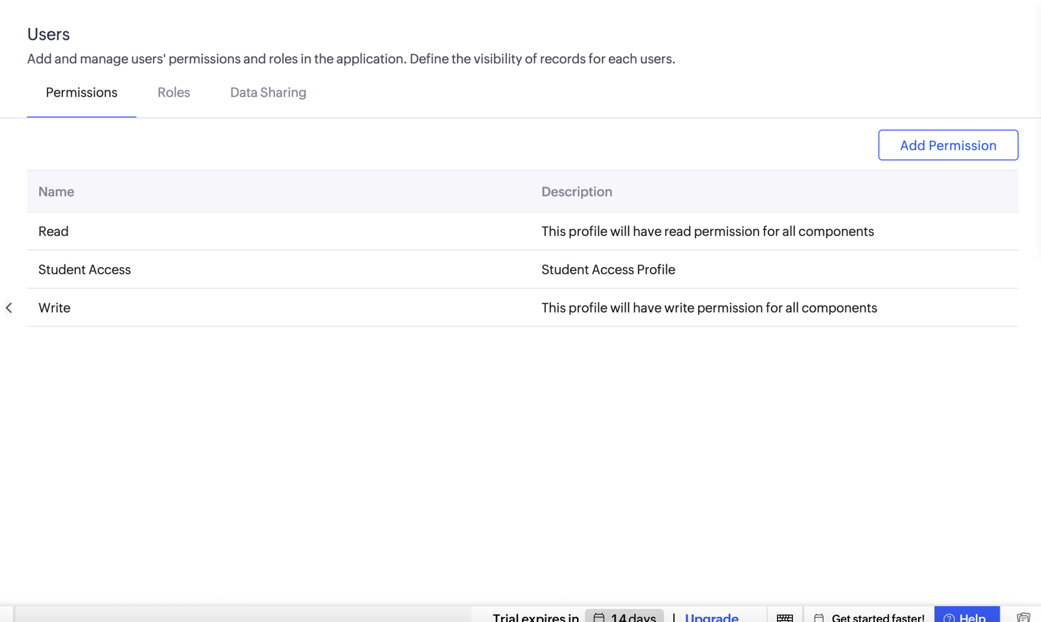
Figure 5.8: Users – Permissions Configuration

5.9 AI and Analytics Features
Zia and other AI features were not used in this version of the application; all logic is rule-based Deluge. Analytics is provided by the dashboard summary panels and chart components, which present topic progress by Completion Status and topics per subject, as in Figure 5.9. Zoho Analytics integration is not used. Any AI-generated suggestions, if used later, will be reviewed against the live data before being accepted. A subject-wise completion percentage, calculated as (completed topics ÷ total topics) × 100, is proposed as a future enhancement.

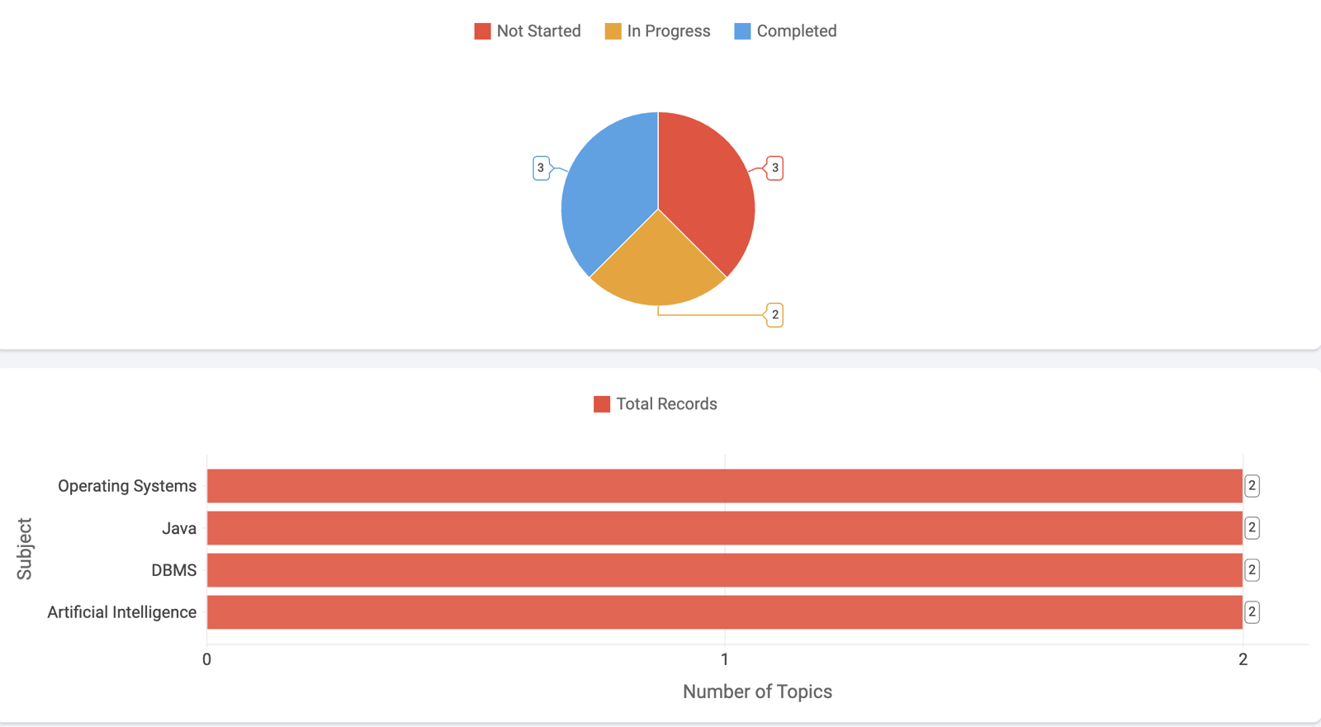
Figure 5.9: Analytics – Topic Progress and Topics per Subject Charts

5.10 Pro-Code Extension
No pro-code component has been deployed in this version; this section therefore gives the justification and the design. Standard forms, reports and Deluge are sufficient for the core features. A custom JavaScript dashboard widget is the most suitable extension: it would show total topics, completed topics and pending topics, calculate the completion percentage and display a progress bar, refreshing its data through a supported Creator data interface. The implementation outline is to create the widget with HTML, CSS and JavaScript, use the Creator widget SDK or the documented data-access method, package and upload the widget, and place it on the Preparation Dashboard. The Creator REST API [9] could also be used from an external client to read permitted study-plan records. Whether custom widgets are available depends on the account plan, so this extension is proposed and is not claimed as implemented.

5.11 Mobile and Portal Access
Because Zoho Creator applications are responsive and are available in the Zoho Creator mobile app for Android and iOS, students can open the dashboard, view topics and add study sessions on a phone (Figure 5.10). No separate customer portal is used in this version; students are intended to be invited as live users of the application.

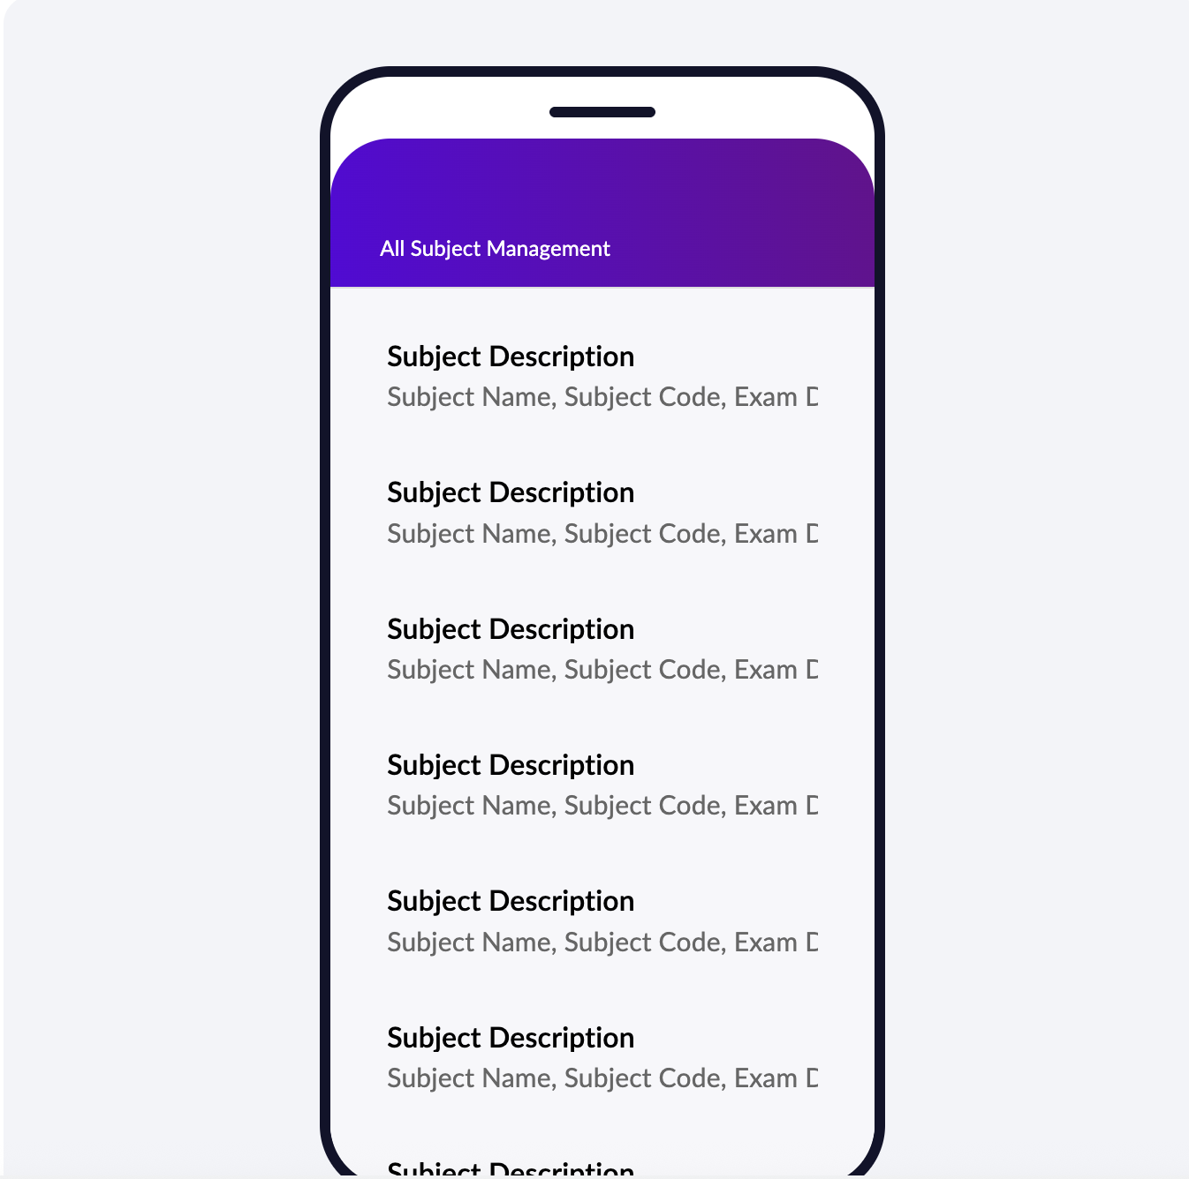
Figure 5.10: Application on Mobile – All Subject Management List View
CHAPTER 6

TESTING AND DEBUGGING

6.1 Testing Strategy
Testing was planned at four levels. Unit testing checks each form and script separately – saving valid records and rejecting invalid ones (TC-01 to TC-06, TC-19). Report and dashboard testing compares each report and each summary panel with the underlying records (TC-07 to TC-13, TC-18). Integration testing covers the Zoho Flow to Zoho Sheet synchronisation, the Open Library GET request in Postman and the scheduled exam reminder (TC-14, TC-15, TC-17). Role-based access testing logs in with a separate student account (TC-16). Finally, user acceptance testing is carried out by peers who use the application in the Student role. A test case is marked Pass only after it has been executed; tests that depend on features not yet configured remain Pending.

6.2 Test Cases
Table 6.1 lists 19 test cases, including invalid-input tests (TC-04, TC-05, TC-19). Actual results are recorded after execution. Tests that depend on integrations, permissions or the reminder schedule remain Pending until those features are configured and tested; no test is marked Pass before it has been performed.
Table 6.1: Test Cases
TC ID | FR Ref. | Test Description | Input / Steps | Expected Result | Actual Result | Status
TC-01 | FR-01 | Add subject with valid details | Java, CS23501, Sem V, exam date 23-Nov-2026 | Subject record is saved | Saved; shown in All Subjects | Pass
TC-02 | FR-02 | Add topic linked to a subject | Subject: DBMS; Unit 2; Normalization | Topic saved with selected subject | Saved with Subject = DBMS | Pass
TC-03 | FR-03 | Add study plan with valid times | Start 06:00 PM, End 07:30 PM | Study plan is saved | Saved; shown in All Study Planners | Pass
TC-04 | FR-04 | End time earlier than start time | Start 07:30 PM, End 06:00 PM | Submission is blocked with alert | To be recorded after live test | Pending
TC-05 | FR-04 | Start and end times are equal | Start 06:00 PM, End 06:00 PM | Submission is blocked | To be recorded after live test | Pending
TC-06 | FR-05 | Add exam schedule | Subject AI, 30-Nov-2026, 10:00 AM | Exam record is saved | Saved; shown in All Exam Schedules | Pass
TC-07 | FR-06 | Open All Subjects report | Click All Subjects | Subject records are displayed | 4 subject records displayed | Pass
TC-08 | FR-06 | Open All Topics report | Click All Topics | Topic records are displayed | 8 topic records displayed | Pass
TC-09 | FR-07 | Open Topic Progress Board | Click Topic Progress Board | Topics appear under correct status | Cards shown in 3 status columns | Pass
TC-10 | FR-09 | Check Total Subjects panel | Open dashboard | Count matches subject records | Panel = 4 | Pass
TC-11 | FR-09 | Check Total Topics panel | Open dashboard | Count matches topic records | Panel = 8 | Pass
TC-12 | FR-09 | Check Completed Topics panel | Open dashboard | Count matches completed topics | Panel = 3 | Pass
TC-13 | FR-09 | Check Not Started Topics panel | Open dashboard | Count matches not-started topics | Panel = 3 | Pass
TC-14 | FR-11 | Create study plan with Flow enabled | Add a new Study Planner record | Matching row appears in Zoho Sheet | Integration not yet configured | Pending
TC-15 | FR-12 | Send Open Library GET in Postman | GET search.json?q=java programming | JSON response contains book data | To be recorded after Postman test | Pending
TC-16 | FR-13 | Test student permissions | Sign in with student test account | Student sees only permitted modules and records | Role not yet configured | Pending
TC-17 | FR-10 | Test scheduled exam reminder | Exam dated tomorrow; wait for 8:00 AM | Reminder is sent at configured time | To be recorded after live test | Pending
TC-18 | FR-08 | Open Study Calendar | Click Study Calendar | Sessions appear on their Study Date | Date field to be verified | Pending
TC-19 | FR-01 | Submit subject with mandatory field blank | Leave Subject Name empty | Validation error is shown | To be recorded after live test | Pending

6.3 Debugging Deluge Scripts
Deluge scripts were debugged with info statements that print the values of the fields being compared, with the Execute option of the script editor, and with the error message shown on submission. The main bug encountered was in the study-time validation: the first version referred to the field with an incorrect link name, and Creator reported that the variable was not defined. Using Refer Fields in the editor to insert the exact field link names for Start Time and End Time fixed the script, and the invalid-time case was re-tested. Figure 6.1 shows the Validate Study Time script as configured in the Deluge editor.

Figure 6.1: Deluge Script Editor – Study-Time Validation Script

6.4 Defect Log
Table 6.2: Defect Log
Bug ID | Description | Root Cause | Fix Applied | Status
BUG-01 | Study-time validation raised “variable not defined” on submit. | Incorrect field link name used in the Deluge condition. | Link names copied with Refer Fields (Start_Time, End_time) and script re-tested. | Closed
BUG-02 | Study Calendar showed no sessions. | Calendar date field was not set to Study Date. | Select Study Date as the date field in calendar settings and re-verify. | Open
BUG-03 | Postman request to Open Library returned an error. | Query string was copied with a corrupted parameter (fields; and limit; instead of &fields= and &limit=). | Corrected the URL to &fields=…&limit=5 and re-sent the request. | Closed

6.5 User Acceptance Testing
Table 6.3: User Acceptance Feedback
User | Role Tested | Feedback | Action Taken
Peer user 1 (classmate) | Student | Dashboard panels and the Kanban board make progress clear; wanted a reminder before exams. | Scheduled exam-reminder workflow added.
Peer user 2 (classmate) | Student | Add-study-session form is easy; wrong times should be blocked. | Study-time validation (DS-01) added.
Faculty reviewer | Administrator | Needs access control and an export of study records. | Student role and Zoho Sheet sync documented as planned.
CHAPTER 7

DEPLOYMENT, SECURITY AND GOVERNANCE

7.1 Environments and Deployment Strategy
The application is built and tested in the Development environment. Test data uses only sample subjects and topics, and no real student information is shown. When the checklist in Table 7.1 is complete, the application is published to Production with version notes describing the change, and the previous version remains available for rollback. Figure 7.1 shows the application dashboard as verified in the Development environment before publishing. Testing of forms, workflows, reports, integrations and permissions is completed before the live application is shared with students, and the date of production deployment is recorded on the Project at a Glance page.

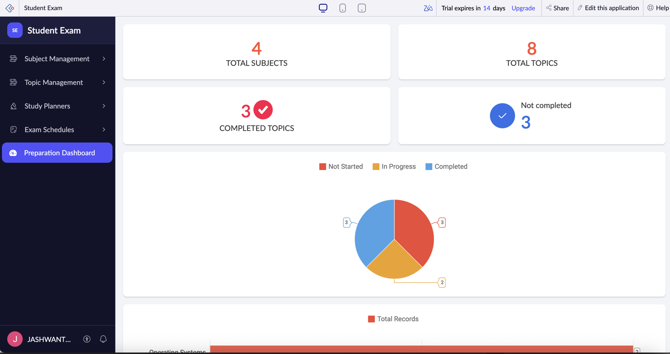
Figure 7.1: Application Dashboard Verified in Development Before Publishing
Table 7.1: Deployment Checklist
S.No. | Checklist Item | Done (✓)
1 | All test cases executed in Development / Stage | Partial (see Table 6.1)
2 | Sample/test data removed or isolated | ✓ (sample data only)
3 | Roles, permissions and users configured in Production | Pending
4 | Connections authorised in Production | Pending
5 | Schedules and workflows enabled | Pending (test before enabling)
6 | Application published and URL verified | Pending
7 | Version / release notes recorded | ✓

7.2 Performance Optimisation
The planner is a small application, so the optimisation techniques below are applied as design rules, and the improvement is described qualitatively rather than as measured timings.

Table 7.2: Performance Optimisation Results
Optimisation Applied | Component | Before | After | Improvement
Dashboard panels use count aggregates instead of looping over fetched records | Preparation Dashboard | Loop over every topic record | Single count with criteria | Fewer statements; scales with data size
Reminder script fetches only records with Exam_Date = tomorrow | DS-02 | Fetch all exams and test each date | One criteria fetch | Less data processed daily
Reports show only needed columns and sort by date | All Study Planners | All columns, unsorted | Key columns, sorted by Study Date | Faster reading and loading
Lookups and drop-downs replace free text | All forms | Repeated typing | Select from list | Fewer errors, consistent data

7.3 Security Features
Security follows the principle of least privilege. Table 7.3 lists the controls and the threat each addresses. Items marked planned depend on the permission configuration described in Section 5.8.
Table 7.3: Security Controls Implemented
Security Control | Where Applied | Threat Mitigated
Role-based permissions (least privilege) | Roles and permission sets (planned) | Unauthorised changes to master data
Record-level criteria (Added_User == zoho.loginuser) | Study_Planner reports (planned) | Students viewing others’ study plans
Input validation and mandatory/drop-down fields | All forms; DS-01 | Invalid or inconsistent data
OAuth 2.0 connections with minimum scopes | Zoho Flow, Creator REST API (planned) | Credential leakage
No tokens or secrets in fields, reports or screenshots | Application and this report | Exposure of credentials
Live-user invitation (not developer) for students | User management | Unintended access to design
Periodic access review | Administration | Access by users who no longer need it

7.4 Governance and Administration
Governance relies on the audit trail of Zoho Creator, which records who added or edited each record and when (Figure 7.2 shows the Settings area used for user permissions and administration). A record of application and workflow changes is maintained as version notes. Forms and fields use consistent names – Subject_Management, Topic_Management, Study_Planner and Exam_Schedule – and Deluge scripts carry a header comment with the script ID, location and purpose. The application owner is responsible for maintenance, for exporting a backup of the data periodically, and for reviewing user access when a student no longer needs the application. Plan limitations and features that could not be enabled are documented in this report.

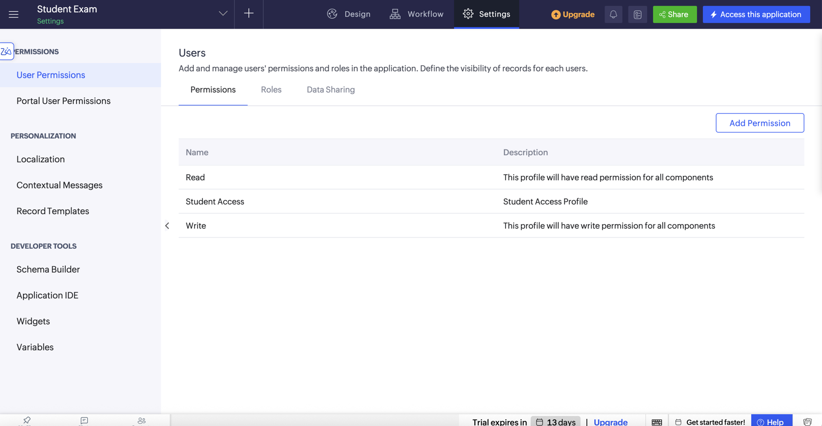
Figure 7.2: Application Settings – User Permissions and Administration
CHAPTER 8

RESULTS AND DISCUSSION

8.1 Application Output
The scenario follows one student preparing for the AI examination. In step 1 the student opens the Study Planner form and schedules a session for Machine Learning from 06:00 PM to 07:30 PM; the record is saved and a success message appears (Figure 8.1). In step 2 the student enters an end time earlier than the start time; the validation script displays “End Time must be later than Start Time.” and cancels the submission (Figure 8.2). In step 3 the topic is marked Completed on the Topic Progress Board, the Completed Topics panel and the progress chart on the Preparation Dashboard update, and the scheduled e-mail reminder arrives one day before the examination (Figure 8.3). The counts shown in Figure 8.3 are sample data used for demonstration.

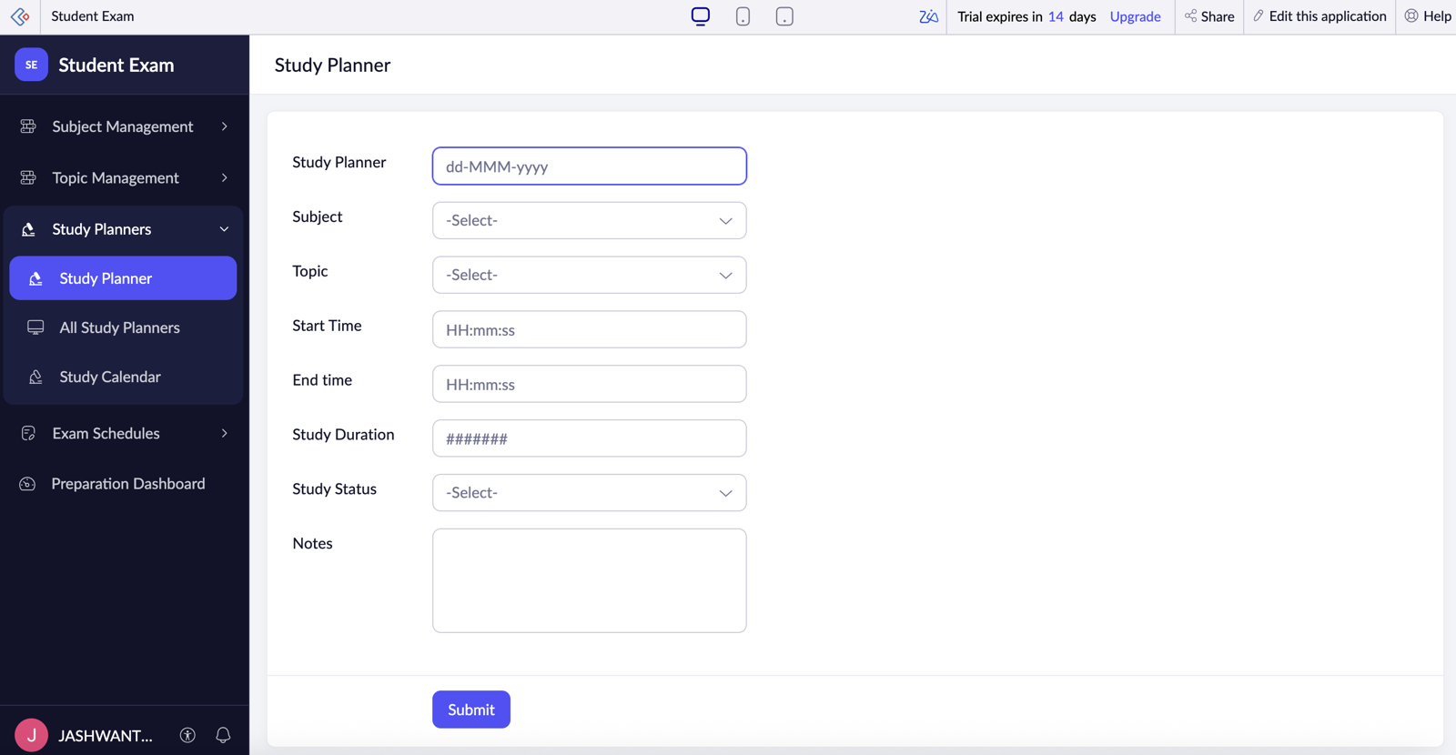
Figure 8.1: Scenario Step 1 – Student Opens the Study Planner Form

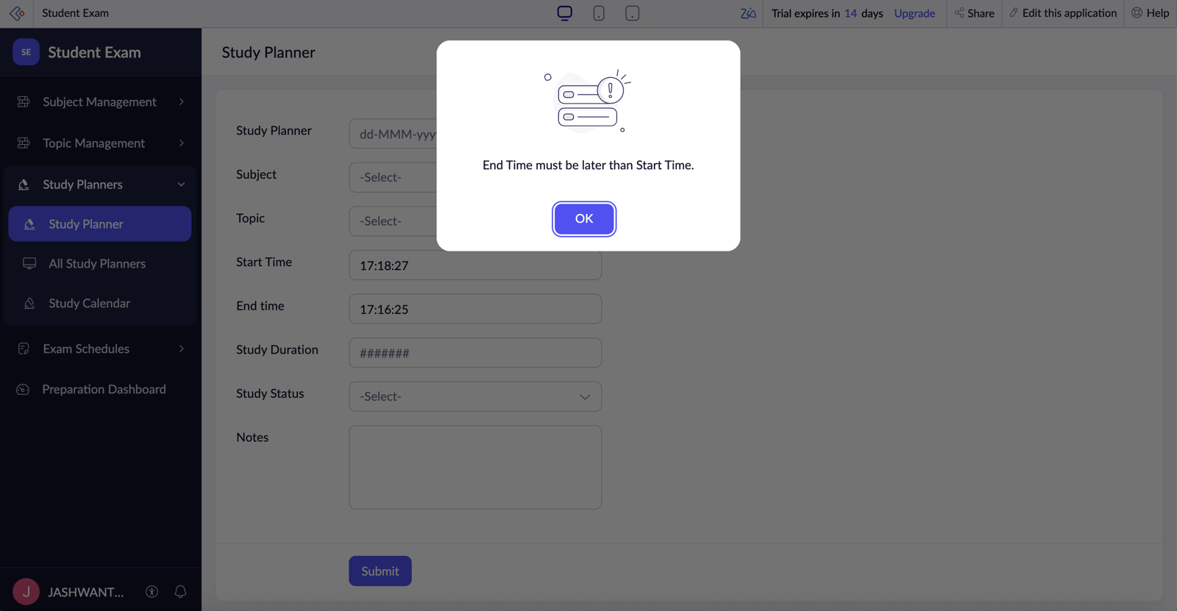
Figure 8.2: Scenario Step 2 – Invalid Timing Blocked by Validation

Figure 8.3: Scenario Step 3 – Preparation Dashboard with Summary Panels and Charts

8.2 Achievement of Objectives
Table 8.1 maps each objective of Section 1.3 to the part of the application that meets it and to the evidence.
Table 8.1: Mapping of Objectives to Outcomes
Objective (Sec. 1.3) | Implemented Through | Outcome / Evidence
1. Data model and forms for subjects, topics, study sessions and exams | Sections 4.2, 4.3, 5.2 | Four forms with lookup relationships; Figures 4.2, 5.2, 5.3
2. Automation with Deluge and workflows | Sections 5.5, 5.6 | Study-time validation and exam-reminder schedule configured; Code 5.1, 5.2
3. Reports, Kanban, calendar and dashboard | Sections 5.3, 5.4 | Four list reports, Kanban board, dashboard panels; Figures 5.4, 5.5 (calendar to be verified)
4. Integration with Zoho Sheet, Open Library and REST API | Section 5.7 | Designed with Postman test plan; Code 5.3, Figure 5.7 (to be completed and tested)
5. Role-based access and record-level privacy | Sections 4.6, 5.8 | Permission matrix designed; Student role to be configured and tested
6. Secure deployment and governance | Chapter 7 | Checklist, security controls and audit trail documented

8.3 Comparison with the Existing System
Table 8.2 compares the manual process with the proposed application. The time values are estimates for a typical student with four subjects.
Table 8.2: Existing System versus Proposed Application
Parameter | Existing System | Proposed Application | Improvement
Time to plan one study session | About 5 minutes on paper or notes | About 1 minute using the form | About 80 % less time (estimated)
Manual steps | Copy syllabus, plan timetable, note dates and tick topics by hand | Enter data once; reports and panels update | Most repeat entry eliminated
Report generation | Manual counting of completed topics | Dashboard panels and Kanban board | Instant view
Data accessibility | Notebooks and files on one device | Browser and mobile app | Access from anywhere
Error prevention | None | Validation, drop-downs, lookups | Invalid timings blocked
Reminders | None – student must remember | Scheduled e-mail one day before exam | Automatic

8.4 Limitations of the Low-Code Approach
Several limits were met while working on Zoho Creator. The user-interface of forms and reports can be configured but not completely redesigned, so a fully custom progress visual needs a widget. Custom roles, permission sets and widgets depend on the subscription plan. Scripts are subject to Deluge statement and API call limits, which matters for loops over many records. External integrations (Zoho Flow, Open Library, the Creator REST API) need OAuth set-up and testing, and the data lives on a proprietary platform, which creates some vendor lock-in. The Study Calendar needs its date field to be configured correctly before it shows sessions. The workarounds are to use list and Kanban reports for progress, to keep scripts short with aggregate counts, to document plan limitations, and to use a JavaScript widget where the standard components are insufficient.

8.5 Reflection on the No-Code → Low-Code → Pro-Code Spectrum
On the no-code → low-code → pro-code spectrum, most of the application is no-code configuration: creating the four forms, lookups, reports, the Kanban board, the calendar and the dashboard panels. Low-code is used where behaviour must be programmed – the Deluge study-time validation, the scheduled reminder and the proposed invokeurl call to Open Library. Pro-code would be required for the custom JavaScript progress widget and for any heavy external processing. The rule followed is to stay in no-code as far as possible, move to Deluge for rules that configuration cannot express, and move to pro-code only when the user experience or performance requires it.
CHAPTER 9

CONCLUSION AND FUTURE ENHANCEMENTS

9.1 Conclusion
The Student Exam Preparation Planner demonstrates how Zoho Creator can be used to build a practical academic planning application with related forms, lookup relationships, reports, a dashboard, Kanban-based progress tracking and Deluge workflows. It gives students a single place to organise subjects, topics, study sessions and examinations and to see which topics are completed, in progress or not started.
The core structure – four forms, list reports, the Topic Progress Board, dashboard summary panels and two workflow configurations – is in place. The Study Calendar configuration, Zoho Sheet synchronisation, Open Library and REST API integrations, Student role permissions and the JavaScript widget are documented as implementation plans to be completed and tested; once they are, the application becomes a more connected, secure and informative study management system.

9.2 Future Enhancements
- Complete and verify the Study Calendar date-field configuration (Study Date).
- Finish and test the Zoho Flow → Zoho Sheet integration, the Open Library Deluge workflow with a Suggested Study Books field, and Creator REST API access with OAuth 2.0.
- Configure and test the Student role, permission set and record-level restrictions, subject to plan availability.
- Build the JavaScript progress widget and add subject-wise completion percentage, study-hour summaries and overdue study-plan alerts.
- Use Zia for predictive suggestions, for example recommending study time for hard topics based on the days remaining before the examination.

9.3 Learning Outcomes and Career Relevance
Working on this project built practical skills in data modelling with lookup fields, report and dashboard design, Deluge scripting for validation and scheduling, API testing with Postman, and role-based access design. These skills correspond to the roles of citizen developer, low-code developer, solutions consultant and automation engineer. The project also showed the importance of testing before describing a feature as complete, and of documenting platform limits honestly. Future work on widgets and REST APIs forms a bridge from low-code to pro-code development.

REFERENCES
[1] W. Rosam and O. Kalnichevski, Low-Code Development: A Practical Guide. New Delhi, India: BPB Publications.
[2] Zoho Corporation, “Zoho Creator Help Documentation.” [Online]. Available: https://www.zoho.com/creator/help/ (Accessed: 31 October 2026).
[3] Zoho Corporation, “Deluge Script Reference Guide.” [Online]. Available: https://www.zoho.com/deluge/ (Accessed: 31 October 2026).
[4] R. Sanchis, Ó. García-Perales, F. Fraile and R. Poler, “Low-Code as Enabler of Digital Transformation in Manufacturing Industry,” Applied Sciences, vol. 10, no. 1, p. 12, 2020.
[5] D. Di Ruscio, D. Kolovos, J. de Lara, A. Pierantonio, M. Tisi and M. Wimmer, “Low-code development and model-driven engineering: Two sides of the same coin?,” Software and Systems Modeling, vol. 21, no. 2, pp. 437–446, 2022.
[6] A. Sahay, A. Indamutsa, D. Di Ruscio and A. Pierantonio, “Supporting the understanding and comparison of low-code development platforms,” in Proc. 46th Euromicro Conf. Software Engineering and Advanced Applications (SEAA), 2020, pp. 171–178.
[7] Gartner, Inc., “Magic Quadrant for Enterprise Low-Code Application Platforms,” Gartner Research, 2024.
[8] Open Library, “Open Library Search API.” [Online]. Available: https://openlibrary.org/dev/docs/api/search (Accessed: 31 October 2026).
[9] Zoho Corporation, “Zoho Creator REST API v2 Documentation.” [Online]. Available: https://www.zoho.com/creator/help/api/v2/ (Accessed: 31 October 2026).
[10] Zoho Corporation, “Zoho Flow Help.” [Online]. Available: https://www.zoho.com/flow/help/ (Accessed: 31 October 2026).

APPENDIX A – ZOHO CREATOR FEATURE COVERAGE CHECKLIST
Table A.1: Feature Coverage Checklist
Unit | Zoho Creator Feature | Done | Where in the Application | Report Section | Figure / Code No.
I | Application created & sections/menu organised | Y | Application Student_Exam; sections Dashboard, Masters, Planning, Reports | 5.1 | Fig. 5.1
II | Forms with ≥ 8 distinct field types | Y | Subject, Topic, Study Planner, Exam forms – Single Line, Multi Line, Number, Date, Time, Drop Down, Lookup, Formula | 5.2 | Fig. 5.2, 5.3; Table 4.2
II | Lookup field (relationship between forms) | Y | Topic.Subject; Study_Planner.Subject and Topic; Exam_Schedule.Subject | 4.2, 5.2 | Fig. 4.2, 5.2
II | Subform (parent–child data) | N | Not used – child records are managed independently (Section 4.2) | 4.2, 5.2 | —
II | Field validations / layout rules | P | Study_Planner On Validate; mandatory and drop-down fields (test pending) | 5.2 | Code 5.1
II | List report with filter, grouping, custom action | P | Four list reports; no custom action configured | 5.3 | Fig. 5.4; Table 5.1
II | Kanban / Calendar / Timeline / Map report | Y | Topic Progress Board (Kanban); Study Calendar to be verified | 5.3 | Fig. 5.4
II | Pivot table / chart report | P | Dashboard chart components (source and grouping to be verified) | 5.3 | Fig. 5.5, 5.9
II | Page / dashboard built with UI Builder | Y | Preparation Dashboard with four KPI panels | 5.4 | Fig. 5.5
II | Deluge – form events (validate / success / field actions) | P | Study_Planner On Validate (configured, test pending) | 5.5 | Code 5.1; Fig. 6.1
II | Deluge – functions, fetch, loops, collections | P | DS-02 uses fetch and for each; function DS-04 proposed | 5.5 | Code 5.2; App. C
II | Email / in-app notifications | P | Exam reminder e-mail configured (delivery test pending) | 5.5, 5.6 | Code 5.2
II | Form workflow | P | Validate_Study_Time (configured, test pending) | 5.6 | Fig. 5.6
II | Scheduled workflow | P | Exam_Reminder daily 8:00 AM (enable and test) | 5.6 | Fig. 5.6
II | Approval process | N | Not used – no approval requirement | 5.6 | —
II | Blueprint | N | Not used – no multi-stage lifecycle | 5.6 | —
II | Batch / report workflow | N | Not used – no bulk processing requirement | 5.6 | —
II | Testing & debugging evidence | P | Test plan of 19 cases; debug output for DS-01 | 6 | Table 6.1; Fig. 6.1
III | Integration with a Zoho service | Plan | Zoho Flow: Creator → Zoho Sheet (to be configured) | 5.7 | Table 5.4
III | Connection / REST API call (invokeurl) | Plan | Open Library search with invokeurl (to be implemented) | 5.7 | Code 5.3; Fig. 5.7
III | Webhook or Creator REST API | Plan | Creator REST API with OAuth 2.0 (to be configured) | 5.7 | Table 5.4
III | Users, roles and permission profiles | Plan | Administrator and Student roles (Student role to be created) | 5.8 | Fig. 5.8
III | Record-level access criteria / customer portal | Plan | Record-level rule Added_User == zoho.loginuser | 5.8 | Fig. 5.8
III | Zia / AI feature | N | Zia not used in this version | 5.9 | —
III | Analytics (charts / Zoho Analytics) | P | Dashboard charts; Zoho Analytics not used | 5.9 | Fig. 5.9
IV | Performance optimisation applied & measured | P | Optimisation rules described; timings not measured | 7.2 | Table 7.2
IV | Deployment across environments | Plan | Development → Production publication | 7.1 | Fig. 7.1; Table 7.1
IV | Security controls (encryption, OAuth, permissions) | P | Validation, drop-downs; OAuth and permissions planned | 7.3 | Table 7.3
IV | Governance (audit trail, administration) | P | Audit trail and version notes | 7.4 | Fig. 7.2
V | Pro-code extension (Catalyst / widgets / custom functions) | Plan | JavaScript progress widget (plan dependent) | 5.10 | Section 5.10
V | Low-code limitations & spectrum analysis | Y | Limitations and spectrum analysis documented | 8.4, 8.5 | Sections 8.4, 8.5
— | Mobile app / portal access | P | Zoho Creator mobile app access; no portal | 5.11 | Fig. 5.10

Total features fully implemented: 6 / 32 (Y = done; P = partial / configured, test pending: 14; Plan = planned: 7; N = not used: 5)

APPENDIX B – COURSE OUTCOME MAPPING
Table B.1: Mapping of Course Outcomes to Report Chapters
CO | Course Outcome Statement | Evidenced In | Self-Assessed Level | Examiner Level
CO1 | Explain the principles, architecture, and business value of low-code application development using Zoho Creator. | Ch. 1, 2 | 3
CO2 | Develop business applications using Zoho Creator forms, reports, workflows, and Deluge scripting. | Ch. 4, 5 (5.1–5.6), 6 | 3
CO3 | Integrate Zoho Creator applications with Zoho services and external systems using APIs, connections, and role-based security. | Ch. 4.6, 5.7–5.9 | 2
CO4 | Deploy, secure, and manage Zoho Creator applications across development and production environments following governance best practices. | Ch. 7 | 2
CO5 | Evaluate low-code development strategies, AI-assisted application development, and the transition from citizen developer to professional developer. | Ch. 5.9, 5.10, 8.4, 8.5, 9.3 | 2

APPENDIX C – COMPLETE DELUGE SOURCE CODE
C.1 Study_Planner – On Validate (DS-01)
// Script ID : DS-01
// Location : Study_Planner → On Validate
// Purpose : Block study session when End Time is not later than Start Time
if(input.End_time <= input.Start_Time)
{
alert "End Time must be later than Start Time.";
cancel submit;
}

C.2 Exam_Reminder – Schedule Workflow (DS-02)
// Script ID : DS-02
// Location : Schedule workflow Exam_Reminder (daily 8:00 AM)
// Purpose : E-mail reminder one day before each examination
tomorrow = zoho.currentdate.addDay(1);
upcoming = Exam_Schedule[Exam_Date == tomorrow];
for each exam in upcoming
{
sendmail
[
from :zoho.adminuserid
to :zoho.adminuserid
subject :"Exam Reminder: " + exam.Subject.Subject_Name
message :"Your " + exam.Subject.Subject_Name + " exam is tomorrow.<br>Exam Date: " + exam.Exam_Date + "<br>Exam Time: " + exam.Exam_Time + "<br>Preparation Status: " + exam.Preparation_Status
]
}
C.3 Open Library Book Suggestion (DS-03, proposed)
// Script ID : DS-03
// Location : Study_Planner → button / On Success (proposed)
// Purpose : Suggest books for a subject using the Open Library API
query = input.Subject.Subject_Name + " programming";
response = invokeurl
[
url :"https://openlibrary.org/search.json?q=" + zoho.encryption.urlEncode(query) + "&fields=title,author_name,first_publish_year&limit=5"
type :GET
];
titles = List();
for each book in response.get("docs")
{
titles.add(book.get("title"));
}
input.Suggested_Study_Books = titles.toString(", ");
C.4 getCompletionPercentage Function (DS-04, proposed)
// Script ID : DS-04
// Location : Function (proposed)
// Purpose : Subject-wise completion percentage
float getCompletionPercentage(int subjectId)
{
total = Topic_Management[Subject == subjectId].count();
done = Topic_Management[Subject == subjectId && Completion_Status == "Completed"].count();
if(total == 0)
{
return 0.0;
}
return (done.toDecimal() / total) * 100;
}

APPENDIX D – USER MANUAL

D.1 Accessing the Application
Open the application URL given on the Project at a Glance page in Google Chrome, Microsoft Edge or Mozilla Firefox and sign in with your Zoho account. On a phone, install the Zoho Creator mobile app (Android or iOS), sign in with the same account and open the Student Exam application from the list of applications.

D.2 Instructions for Student
- Open the Preparation Dashboard to see Total Subjects, Total Topics, Completed Topics and Not Started Topics.
- Open Study Planner and click Add to plan a session: choose the Study Date, Subject and Topic, enter the Start Time and End Time and click Submit. If the end time is not later than the start time, correct it and submit again.
- Open Topic Progress Board and drag a topic card to In Progress or Completed as your preparation advances.
- Open Exam Schedule or the upcoming-examinations view to check exam dates and times, and use Study Calendar to see sessions by date.
- Check your e-mail for the reminder sent one day before an examination at 8:00 AM.

D.3 Instructions for Administrator
- Sign in with the application owner account and open Subject Management to add or edit subjects with Subject Name, Subject Code, Semester and Exam Date.
- Open Topic Management and add topics under each subject with Unit Number, Difficulty Level and Completion Status.
- Open Exam Schedule and add each examination with date, time, Exam Type and Preparation Status.
- Review All Subjects, All Topics, All Study Planners and All Exam Schedules for data quality, and check the dashboard totals.
- Use Settings → User Permissions to invite students as live users and assign the Student role (where the plan allows); review access when a student leaves.

APPENDIX E – EVALUATION RUBRIC
(For Examiner Use Only)

Student Name | JASHWANTH SUNDARAJAN | Register No. | 2116241401032
Project Title | STUDENT EXAM PREPARATION PLANNER | Date | 03 November 2026

Table E.1: Evaluation Rubric for the Individual Project
S.No. | Criterion | Indicators | Max. Marks | Marks Awarded
1 | Problem Definition & Requirement Analysis | Clarity of problem, measurable objectives, complete FR/NFR, use cases | 10
2 | System Design | Architecture, ER/data model, form specifications, workflow design, permission matrix | 10
3 | Forms, Reports & Pages | Variety of field types, lookups/subforms, report types, UI Builder dashboards | 15
4 | Deluge Scripting & Workflows | Correctness and depth of scripts; form, schedule, approval, Blueprint, batch workflows | 15
5 | Integration, RBAC & AI | Zoho/external integrations, connections, roles & permissions, Zia/analytics | 10
6 | Testing, Deployment, Security & Governance | Test coverage, environments, optimisation, security controls, audit | 10
7 | Live Demonstration | End-to-end working of the application across roles; feature checklist verified | 15
8 | Project Report | Adherence to template and format, clarity, figures, references | 5
9 | Viva-Voce | Understanding of the platform, design decisions and low-code concepts | 10
 | TOTAL |  | 100

Table E.2: Performance Level Descriptors
Level | % of Max. Marks | Descriptor
Excellent | 90–100 | Feature implemented completely, correctly and beyond the basic requirement; student explains design choices confidently.
Good | 70–89 | Feature implemented correctly with minor gaps; explanation adequate.
Satisfactory | 50–69 | Feature partially implemented or works only for the main path; limited explanation.
Needs Improvement | < 50 | Feature missing, non-functional or not understood by the student.

Signature of Internal Examiner  Name: ____________________ | Signature of External Examiner  Name: ____________________

APPENDIX F – VIVA-VOCE RECORD SHEET
(For Examiner Use Only)
Student Name | JASHWANTH SUNDARAJAN | Register No. | 2116241401032
Department / Section | CSBS A | Date of Viva | 03 November 2026
Application URL Verified | Yes / No | Demo Duration | ______ min
Table F.1: Viva-Voce Questions and Responses
Q.No. | Question / Topic Asked | Unit | Response (E / G / S / NI) | Remarks
1
2
3
4
5
6
7
8
E – Excellent G – Good S – Satisfactory NI – Needs Improvement
Table F.2: Marks Summary
Component | Max. Marks | Marks Awarded
Criteria 1–8 (Appendix E) | 90
Viva-Voce | 10
TOTAL | 100

Examiners’ Remarks:
____________________________________________________________________
____________________________________________________________________
INTERNAL EXAMINER  Name: ____________________ | EXTERNAL EXAMINER  Name: ____________________

