Ex1a: Text Generation using N-gram Language model

Learning Objective:
Implement an N-Gram–based predictive text model using bigram and trigram probability distributions. This helps to understand how contextual probability influences next-word prediction.

Steps:
- Initialize the environment by installing and importing the Natural Language Toolkit (nltk). Download the Brown Corpus (for text data) and the Universal Tagset (for simplified Part-of-Speech tags).
- Extract raw sentences from the Brown Corpus using brown.sents().
- Tokenization: Convert all words to lowercase and flatten the nested list into a single list of tokens to verify the total volume of training data.
- Build an N-Gram Model for Bigram and Trigram.
- Predict Next Word and display Top-5 Suggestions
- Test Bigram & Trigram Prediction on certain words.

Program:
import nltk
from nltk.corpus import brown, stopwords
from nltk.util import ngrams
from collections import defaultdict, Counter
import string
nltk.download('brown')
sentences = brown.sents()

processed = []
for sent in sentences:
sent = ['<s>'] + [w.lower() for w in sent if w.isalpha()] + ['</s>']
processed.append(sent)

bigram_counts = defaultdict(Counter)
trigram_counts = defaultdict(Counter)

for sent in processed:
for w1, w2 in ngrams(sent, 2):
bigram_counts[w1][w2] += 1

for w1, w2, w3 in ngrams(sent, 3):
trigram_counts[(w1, w2)][w3] += 1

def predict_bigram_candidates(context, top_k=5):
words = context.lower().split()

if len(words) != 2:
return "Bigram input must contain exactly 2 words"

last_word = words[1]

if last_word not in bigram_counts:
return "No prediction found"
return bigram_counts[last_word].most_common(top_k)
def predict_trigram_candidates(context, top_k=5):
words = context.lower().split()

if len(words) != 3:
return "Trigram input must contain exactly 3 words"

key = (words[1], words[2])

if key not in trigram_counts:
return "No prediction found"

return trigram_counts[key].most_common(top_k)

choice = input("Enter model (bigram/trigram): ").strip().lower()

if choice == "bigram":
text = input("Enter 2-word context: ")
results = predict_bigram_candidates(text)

elif choice == "trigram":
text = input("Enter 3-word context: ")
results = predict_trigram_candidates(text)

else:
print("Invalid choice")
results = []

print("\nSuitable next words with counts:")
if isinstance(results, str):
print(results)
else:
for word, count in results:
print(f"{word} → {count}"

Output:
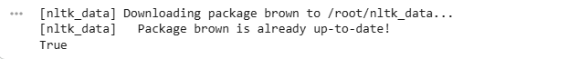
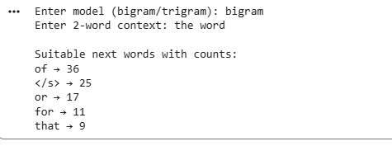

RESULT:
Thus the implementation of predictive text system using n-gram has been executed successfully.

