TIIA

First introducing you with the terminologies used in this advanced python project of TIIA

What is Computer Vision?

**Computer Vision** is the field of study that enables computers to see and identify digital images and videos as a human would. The challenges it faces largely follow from the limited understanding of biological vision. Computer Vision involves acquiring, processing, analysing, and understanding digital images to extract high-dimensional data from the real world in order to generate symbolic or numerical information which can then be used to make decisions. The process often includes practices like object recognition, video tracking, motion estimation, and image restoration.

What is OpenCV?

**OpenCV** is short for Open Source Computer Vision. Intuitively by the name, it is an open-source Computer Vision and Machine Learning library. This library is capable of processing real-time image and video while also boasting analytical capabilities. It supports the Deep Learning frameworks [***TensorFlow***](https://data-flair.training/blogs/tensorflow-tutorials-home/), Caffe, and PyTorch.

What is a CNN?

A [***Convolutional Neural Network***](https://data-flair.training/blogs/convolutional-neural-networks/) is a deep neural network (DNN) widely used for the purposes of image recognition and processing and [***NLP***](https://data-flair.training/blogs/nlp-natural-language-processing/). Also known as a ConvNet, a CNN has input and output layers, and multiple hidden layers, many of which are convolutional. In a way, CNNs are regularized multilayer perceptrons.

Gender and Age Detection Python Project- Objective

To build a gender and age detector that can approximately guess the gender and age of the person (face) in a picture using [***Deep Learning***](https://data-flair.training/blogs/deep-learning/) on the Adience dataset.

Gender and Age Detection – About the Project

In this Python Project, we will use Deep Learning to accurately identify the gender and age of a person from a single image of a face. We will use the models trained by [Tal Hassner and Gil Levi](https://talhassner.github.io/home/projects/Adience/Adience-data.html). The predicted gender may be one of ‘Male’ and ‘Female’, and the predicted age may be one of the following ranges- (0 – 2), (4 – 6), (8 – 12), (15 – 20), (25 – 32), (38 – 43), (48 – 53), (60 – 100) (8 nodes in the final softmax layer). It is very difficult to accurately guess an exact age from a single image because of factors like makeup, lighting, obstructions, and facial expressions. And so, we make this a classification problem instead of making it one of regression.

The CNN Architecture

The convolutional neural network for this python project has 3 convolutional layers:

* Convolutional layer; 96 nodes, kernel size 7
* Convolutional layer; 256 nodes, kernel size 5
* Convolutional layer; 384 nodes, kernel size 3

It has 2 fully connected layers, each with 512 nodes, and a final output layer of softmax type.

To go about the python project, we’ll:

* Detect faces
* Classify into Male/Female
* Classify into one of the 8 age ranges
* Put the results on the image and display it

The Dataset

For this python project, we’ll use the Audience dataset; the dataset is available in the public domain and you can find it [***here***](https://www.kaggle.com/ttungl/adience-benchmark-gender-and-age-classification). This dataset serves as a benchmark for face photos and is inclusive of various real-world imaging conditions like noise, lighting, pose, and appearance. The images have been collected from Flickr albums and distributed under the Creative Commons (CC) license. It has a total of 26,580 photos of 2,284 subjects in eight age ranges (as mentioned above) and is about 1GB in size. The models we will use have been trained on this dataset.

Admin panel Login

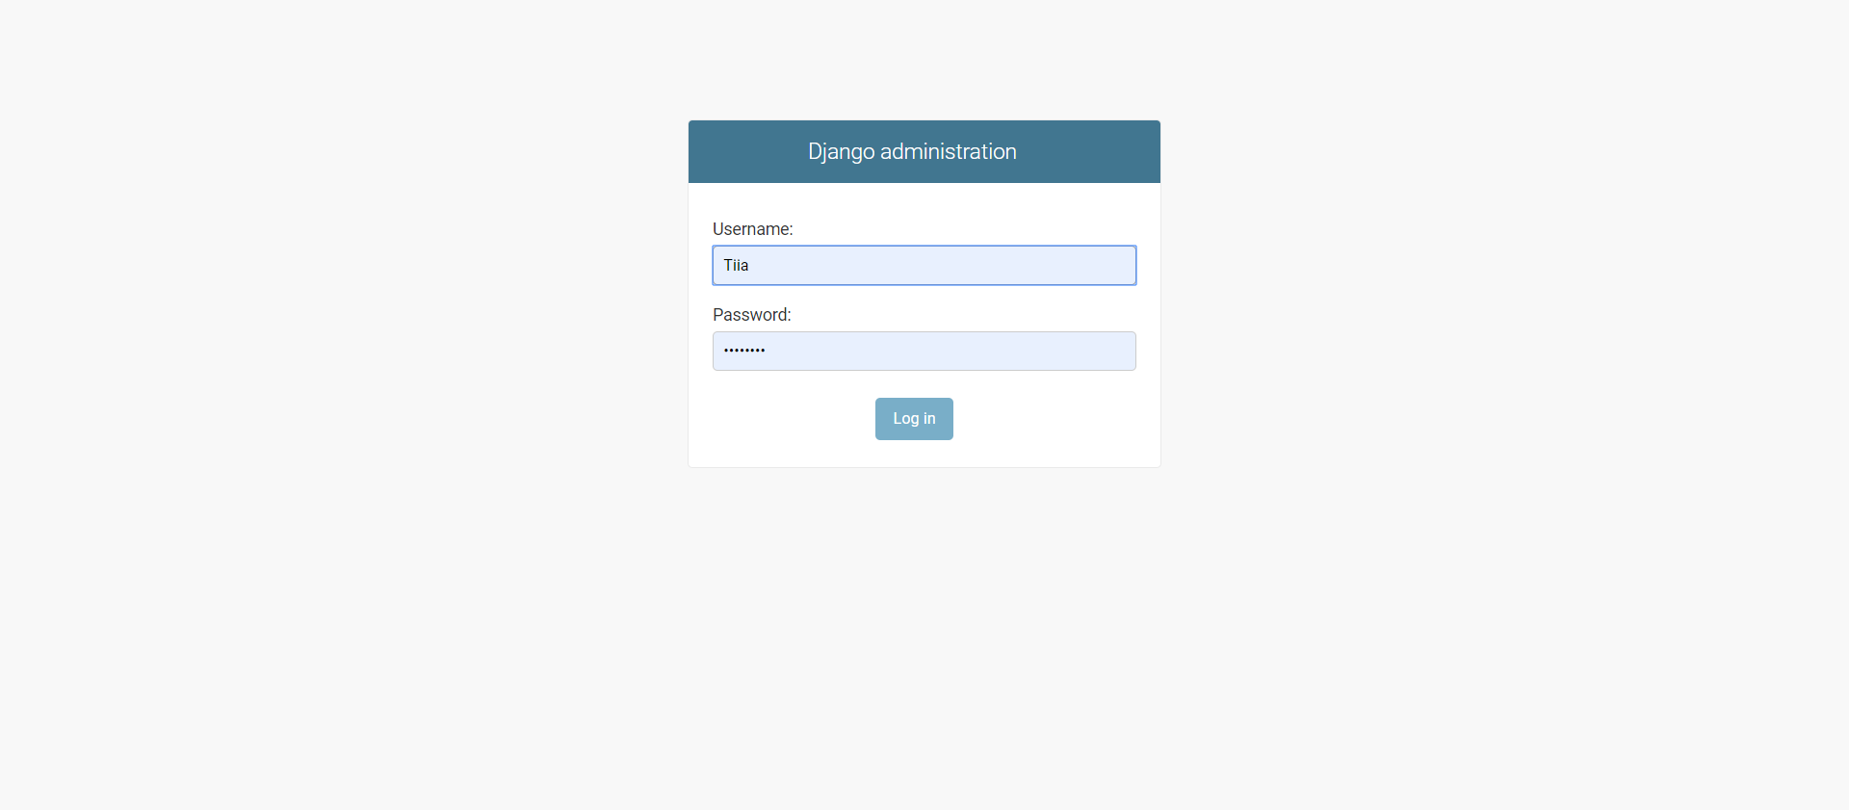

Home

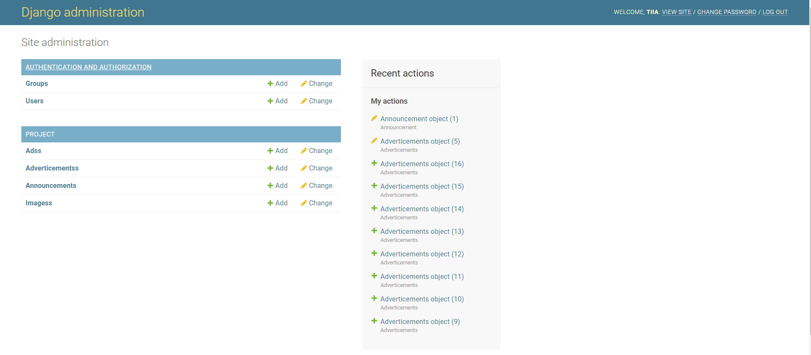

**database model**  
  
**Ads**

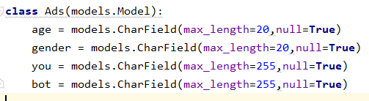

**Images**

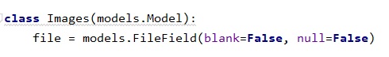

**Advertisements**

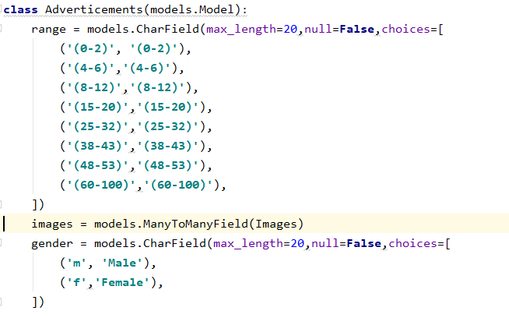

**Announcements**

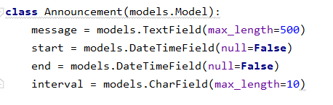

**'''  
Installataion  
------------------------------------  
1.Django  
2.DjangoRestFramework  
 pip install djangorestframework  
 pip install markdown  
 pip install django-filter   
3.OpenCv  
 pip install opencv-python  
4.SpeechRecognition  
 pip install SpeechRecognition  
5.pyttsx3  
 pip install pyttsx3  
6.pywin32  
 pip install pywin32  
  
----------------------------  
  
  
In terminal  
first> python manage.py runserver 0.0.0.0:8000  
then you get ip of your system in console, copy and replace it on config.py  
In second terminal   
second> python detect.py  
In third terminal   
third> python TextToSpeech.py  
then see the UI, its all done  
  
  
Admin  
u : Tiia  
p : tiiatiia  
'''**