## Front End Engineering-II

**Project Report**

Semester-IV (Batch-2022)

**Airbnb Clone**

­



**Supervised By:**

Dr. Baljit Kaur

**Submitted By:**

Jasjeet Kaur Saini (2210990442)

Kamaljeet Kaur (2210990470)

Kanchan Yadav (2210990471)

# 

# Department of Computer Science and Engineering

**Chitkara University Institute of Engineering & Technology, Chitkara University, Punjab**

**ABSTRACT**

This project report presents the development and implementation of an Airbnb clone website, aimed at replicating the functionality and user interface of the original platform. The website facilitates the process of finding and booking accommodations for traveller, mirroring the core features of Airbnb.

The primary purpose of this project was twofold: first, to gain proficiency in utilizing React, a popular JavaScript library for building user interfaces; and second, to hone our web development skills through practical application. By emulating the structure and functionality of Airbnb, we sought to deepen our understanding of front-end development concepts and best practices.

Throughout the development process, careful attention was paid to replicating the visual design, user experience, and functionality of the original Airbnb website. Leveraging React, we aimed to create a responsive and intuitive interface that enables users to seamlessly browse, search for, and book accommodations.

Key components of the project include the implementation of user authentication, search functionality, property listings, booking features, and a user-friendly interface. Challenges encountered during development were addressed through iterative design and problem-solving, contributing to a deeper understanding of React and web development principles.

In conclusion, this project served as a valuable learning experience, allowing us to apply theoretical knowledge to real-world development scenarios. Through the creation of an Airbnb clone, we have expanded our skills in React and web development, positioning ourselves for future projects and opportunities in the field of front-end development.

**Table of Contents**

|  |  |  |
| --- | --- | --- |
| **Sr.No** | **TITLE** | **Page no.** |
| 1 | Introduction   1. Background 2. Objective 3. Significance | 4-6 |
| 2 | Problem Definition and Requirement   1. Problem Statement 2. Solution Requirement 3. Software Requirements 4. Hardware requirements | 7-10 |
| 3 | Proposed Design/Methodology   1. Methodology 2. Algorithms Used | 11-12 |
| 4 | Results | 13-15 |
| 5 | References | 16 |

**INTRODUCTION**

In today's fast-paced, travel-oriented world, the ability to efficiently manage short-term rentals and accommodations is crucial for both property owners and traveler. Traditional methods of booking and listing properties are increasingly being replaced by digital solutions that offer greater convenience, accessibility, and reach. This project aims to develop a robust and user-friendly Airbnb Clone using ReactJS, HTML, CSS, and JavaScript. By leveraging the power of ReactJS, this application will provide an intuitive interface, dynamic property listings, and comprehensive booking management features. The goal is to create a seamless and efficient platform that enhances the rental experience for both hosts and guests, simplifying the process of listing, searching, and booking properties, ultimately supporting users in managing their short-term rentals and travel plans effectively.

1. **BACKGROUND:**

The evolution of property rental practices has been significantly influenced by advancements in technology, transitioning from traditional booking methods to sophisticated digital platforms. As the demand for flexible and accessible lodging options continues to grow, the need for effective and efficient rental management tools has become increasingly critical. This necessity is particularly evident in the travel and hospitality industry where organized and accessible booking systems are essential for productivity and success. ReactJS, a popular JavaScript library for building user interfaces, presents an opportunity to address these challenges effectively. Known for its component-based architecture, fast rendering capabilities, and ease of integration with other technologies, ReactJS enables the creation of highly dynamic and responsive web applications. Its virtual DOM ensures efficient updates, resulting in faster applications. By leveraging ReactJS along with HTML, CSS, and JavaScript, this project aims to develop a robust and user-friendly Airbnb Clone, providing an intuitive interface, real-time updates, dynamic property listings, and comprehensive booking management features. This platform enhances the rental experience for both hosts and guests, simplifying the process of listing, searching, and booking properties.

.

1. **OBJECTIVE:**

* Learn React: The primary objective of this project was to gain proficiency in React, a widely-used JavaScript library for building user interfaces. By undertaking the task of replicating Airbnb's website, we aimed to immerse ourselves in React's ecosystem, including its component-based architecture, state management, and virtual DOM rendering
* Practice Web Development: Beyond mastering React, we sought to refine our web development skills through practical application. This project provided an opportunity to work on a comprehensive web application from start to finish, encompassing various aspects such as UI design, front-end logic, and integration with backend services.
* Understand UX/UI Design Principles: Airbnb's success is attributed not only to its functional features but also to its exceptional user experience (UX) and user interface (UI) design. Through this project, we aimed to dissect and replicate the UX/UI patterns employed by Airbnb, gaining insights into effective design principles and best practices.

1. **SIGNIFICANCE:**

The Airbnb Clone holds significant value for both property owners and travelers by addressing key challenges in the short-term rental market. It enhances accessibility and convenience with an intuitive interface and real-time updates, making the rental process more efficient. Property owners benefit from improved rental management through comprehensive booking tools, while travelers enjoy a seamless and dynamic user experience thanks to ReactJS's fast rendering capabilities. The platform's secure user authentication ensures a reliable environment, and its scalable, component-based architecture allows for easy maintenance and growth. By offering a modern and efficient alternative to existing rental platforms, the Airbnb Clone can attract a broad user base and establish a competitive market presence, ultimately improving the efficiency, accessibility, and overall experience of short-term rental management.

**PROBLEM DEFINITION AND REQUIREMENT**

1. **PROBLEM STAEMENT**

The short-term rental market has experienced significant growth, driven by the increasing demand for flexible and accessible lodging options. However, many existing digital rental management platforms suffer from complex interfaces, slow performance, and inadequate organizational tools, making it difficult for property owners and travelers to manage rentals efficiently. Property owners face challenges in listing their properties, managing bookings, and communicating with guests, while travelers struggle with finding suitable accommodations and navigating cumbersome booking processes. There is a need for a user-friendly and efficient solution that addresses these issues, providing an intuitive interface and comprehensive booking management features. The development of a robust Airbnb Clone using ReactJS, HTML, CSS, and JavaScript aims to solve these problems by offering a seamless and efficient platform for property rental management, ultimately benefiting both property owners and travelers.

1. **SOLUTION STATEMENT**

In response to the challenges faced by property owners and travelers in the short-term rental market, we propose the development of a user-friendly and efficient solution: an Airbnb Clone built using ReactJS, HTML, CSS, and JavaScript.

Our solution aims to address the complexities and inefficiencies present in existing digital rental management platforms by offering a seamless and intuitive platform for property rental management. By leveraging the power of ReactJS and modern web technologies, we will create a robust and responsive interface that streamlines the process of listing properties, managing bookings, and facilitating communication between property owners and guests.

Key features of our solution include:

* **Intuitive Interface:** We will design a user-friendly interface that simplifies the process of listing properties and searching for accommodations, enhancing the overall user experience for both property owners and travelers.
* **Comprehensive Booking Management**: Our platform will provide comprehensive booking management tools, allowing property owners to easily manage reservations, update availability, and communicate with guests, thereby streamlining the rental management process.
* **Responsive Design:** With a focus on responsive design principles, our solution will ensure compatibility across various devices and screen sizes, enabling travelers to access and book accommodations seamlessly from desktops, tablets, and mobile devices.
* **Performance Optimization:** We will prioritize performance optimization to ensure fast loading times and smooth user interactions, eliminating the frustrations associated with slow and cumbersome platforms.
* **Scalability and Flexibility**: Our solution will be designed with scalability and flexibility in mind, allowing for easy integration of additional features and adaptability to evolving market demands.

1. **SOFTWARE REQUIREMENT**

* **React.js:** The project relies on React.js, a JavaScript library for building user interfaces, for front-end development. React's component-based architecture and efficient rendering make it suitable for creating dynamic and interactive web applications.
* **CSS (Cascading Style Sheets):** CSS is used for styling the user interface elements of the application, ensuring a visually appealing and cohesive design throughout the website.
* **React Router DOM:** React Router DOM is utilized for managing navigation and routing within the application. It enables the creation of multiple pages and routes, facilitating seamless navigation between different components of the website.
* **Git and GitHub:** Git version control system along with GitHub repository hosting platform are employed for collaborative development and version management. Git enables team members to work concurrently on the project while GitHub serves as a central repository for storing, sharing, and tracking changes to the codebase.
* **JSON Server:** JSON Server is utilized as a mock backend server to simulate a RESTful API for handling data requests and responses. It provides a simple and lightweight solution for prototyping and testing the application's functionality without the need for a full-fledged backend server.
* **Package Managers (npm or Yarn):** npm (Node Package Manager) or Yarn is used for managing project dependencies and packages. These package managers facilitate the installation, updating, and removal of libraries and tools required for the project.

1. **HARDWARE REQUIREMENT:**

Since the Airbnb Clone primarily runs in web browsers, the hardware requirements are minimal. Here are the hardware requirements for running the application:

* **Device**: Any device capable of running a modern web browser can access the application. This includes desktop computers, laptops, tablets, and smartphones.
* **Processor**: The processor should be capable of running the chosen web browser smoothly. Most modern processors, even those found in budget devices, meet this requirement.
* **Memory (RAM**): While there's no strict requirement, having at least 2GB of RAM is recommended for a smooth user experience, especially if running multiple browser tabs simultaneously.
* **Storage**: Since the application primarily runs in the browser and relies on cloud services for data storage (if applicable), local storage requirements are minimal.
* **Internet Connection**: A stable internet connection is necessary for real-time synchronization, accessing cloud services (if applicable), and initial loading of the application.

Overall, the hardware requirements for running the ReactJS Notes Making Application are minimal, making it accessible to users with a wide range of devices and computing capabilities

**PROPOSED DESIGN / METHODOLOGY**

1. **METHODOLOGY**

Our proposed methodology for developing the Airbnb Clone project involves a combination of iterative design, agile development practices, and utilization of modern web development technologies. The methodology encompasses the following key stages:

1. **Requirements Gathering:** The project initiation phase involves comprehensive requirements gathering to understand the objectives, functionality, and user expectations for the Airbnb Clone platform. This stage includes stakeholder consultations, user interviews, and analysis of existing rental management platforms to identify pain points and desired features.
2. **Design and Wireframing**: Following requirements gathering, the design phase begins with wireframing and prototyping of the user interface. We utilize tools like Figma or Adobe XD to create low-fidelity wireframes, allowing for rapid iteration and feedback from stakeholders. The design process focuses on creating an intuitive and visually appealing interface that aligns with the branding and usability goals of the project.
3. **Front-end Development:** The front-end development phase involves the implementation of the user interface design using ReactJS, HTML, CSS, and JavaScript. We adopt a component-based approach, leveraging the power of React's reusable components to build modular and maintainable UI elements. Throughout this phase, we prioritize responsiveness, accessibility, and cross-browser compatibility to ensure a seamless user experience across devices and platforms.
4. **Back-end Development (Mock API):** As part of the development process, we utilize JSON Server to create a mock RESTful API for handling data requests and responses. This allows us to simulate backend functionality such as property listings, user authentication, and booking management without the need for a full-fledged backend server. The mock API facilitates rapid development and testing of front-end features while providing a realistic data source for demonstration purposes.

.

1. **ALGORITHM USED**

While the Airbnb Clone project primarily focuses on front-end development and user interface design, there are several algorithms and data structures that play a role in implementing various features and functionalities.

* 1. **Search Algorithm:** The search functionality of the platform utilizes algorithms for filtering and ranking property listings based on user-defined criteria such as location, price, amenities, and availability. We employ techniques like binary search, sorting algorithms, and data structures like hash tables or trees to optimize search performance and deliver relevant results to users.
  2. **Sorting Algorithms:** Sorting algorithms are used to organize property listings and search results in a meaningful and user-friendly manner. We may employ algorithms like quicksort, mergesort, or bubble sort to efficiently sort listings based on different attributes such as price, rating, or proximity to user location.
  3. **Data Structures for State Management:** Within the React application, we leverage data structures like arrays, objects, and state hooks to manage application state and handle dynamic data updates. By efficiently managing state using appropriate data structures and algorithms, we ensure that the application remains responsive and performant, even as the user interacts with various features and components.

Overall, the design and development methodology outlined above, combined with the judicious use of algorithms and data structures, enable us to create a robust, user-friendly, and efficient Airbnb Clone platform that meets the needs of property owners and travelers in the short-term rental market.

**RESULTS**

After combining all the components we got a clone website that looks same like Airbnb with the following key features:

1. Our Airbnb clone boasts a user-friendly page featuring five distinct categories, each offering a curated selection of eight places to stay.
2. Integrated calendar functionality simplifies the booking process, allowing users to select check-in and check-out dates.
3. Leveraging JSON server, our website fetches data, ensuring up-to-date listing and information.
4. React Router DOM, navigation between categories and individual listing is smooth and intuitive, providing users with a seamless browsing experience.
5. Login and Signup functionality.

This is the main page that consists of 5 categories for the places to visit. The upper section includes profile logo where login and signup option are there. The check in and check out dates can be selected as calender functionality is used Number of guests can be selected from “WHO” section.

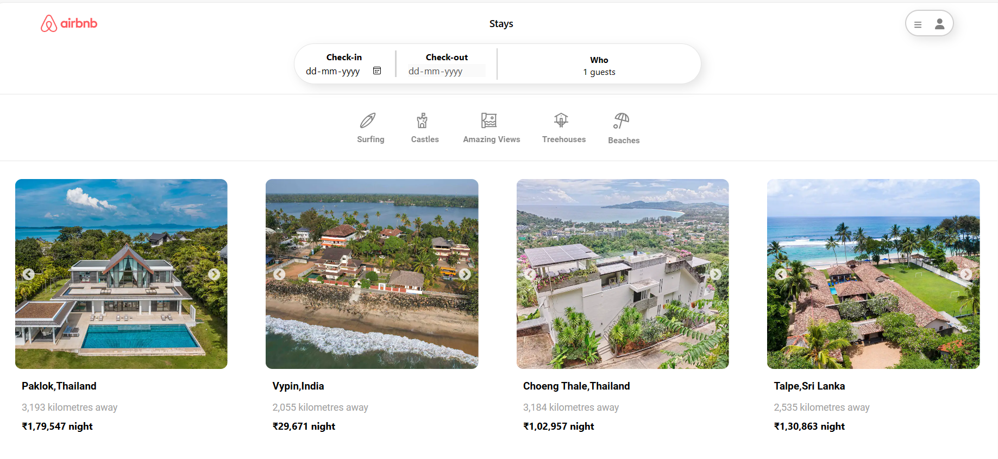

There are 8 place profiles for each category.

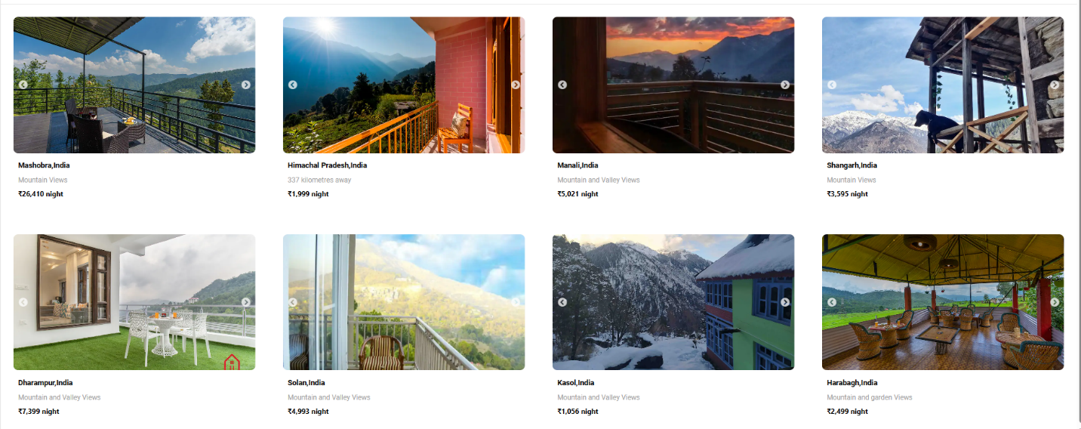

Each place profiles is having a detailed view consisting of 5 images , features information about the host, hosting experience and whether he/she is designated as a Superhost, highligts ratings and reliability and details about what that place offers . There is a short description about the place too. The place can be reserved after selecting check in and check out dates .

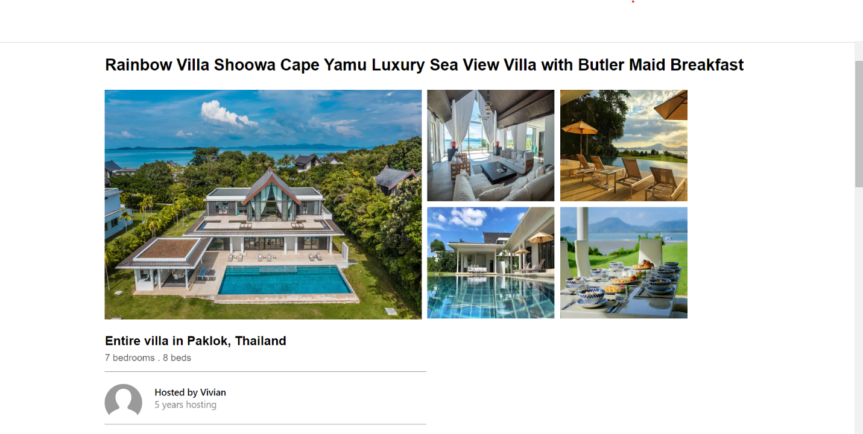

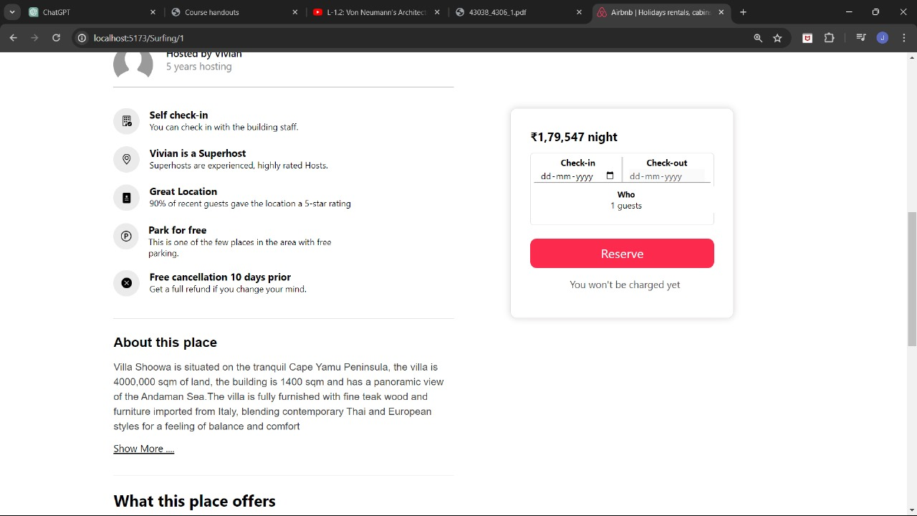

This section shows what each place offers

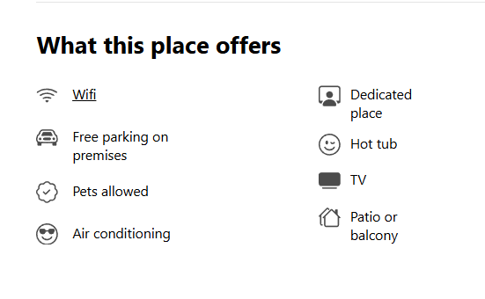­­

­­­­**REFERENCES**

1. AirBnB: [https://www.Airbnb.co.in](https://www.airbnb.co.in/)
2. Ant Design Library: [https://ant.design](https://ant.design/)
3. Material UI Library: <https://mui.com/material-ui>

­­­