Evaluating Observability Tools in Modern Distributed Backends
Jasjeet Kaur Saini
Chitkara University
jasjeet442.be22@chitkara.edu.in

Abstract
Microservice backends distribute failure modes across service boundaries, deployment pipelines, and elastic infrastructure. Isolated metrics or log streams rarely suffice to reconstruct incident timelines. Observability—the correlated use of logs, metrics, and distributed traces—has become a standard operational practice for inferring internal state from external telemetry.
This paper presents a controlled evaluation framework with representative lab measurements on a three-service Kubernetes testbed instrumented via OpenTelemetry. Five widely deployed components (Prometheus, Grafana, Jaeger, OpenTelemetry, Datadog) are positioned by architectural role rather than treated as interchangeable products. Under a fixed fault taxonomy (scenarios S0–S5), we separate system performance (end-to-end latency under injected faults) from observability effectiveness (mean time to detection, mean time to recovery, localization accuracy, and alert quality).
With K = 10 independent runs per (scenario × detection path), integrated logs–metrics–traces under a documented triage protocol reduced recovery time relative to a logs-only baseline. Mean time to recovery is reported per recovery condition (baseline manual debugging, Path A1 only, Path A2 only, integrated runbook); pooled integrated triage averaged 12.0 ± 1.6 min versus 45.2 ± 4.1 min for the baseline (95% CI for the difference: 28.4–38.0 min; Welch two-sample t-test on per-run MTTR, p < 0.001). For detection latency, Datadog monitors (Path A2) trended lower than Prometheus plus Alertmanager (Path A1) on mean MTTD across S2–S4 (4.3 ± 0.9 s vs. 8.2 ± 1.1 s; Welch t-test, p < 0.01). Latency readings of 117–120 ms across measurement paths reflect observation fidelity, not tool-induced application speedups. Instrumentation at 10% head-based trace sampling added 4.2% CPU and 6.1% memory overhead. Findings are bounded to the lab configuration; reproducibility artifacts and limitations are documented.

Index Terms
Observability, distributed systems, microservices, mean time to recovery, mean time to detection, OpenTelemetry, Prometheus, Grafana, Jaeger, Datadog, controlled experiment, Welch t-test.

I. Introduction
Monolithic deployments simplify early development but scale poorly: the entire application is replicated when one component saturates. Microservices decompose capabilities into independently deployable services (HTTP/gRPC), improving isolation at the cost of distributed failures that are difficult to trace without correlated telemetry [15][17][2][3]. Observability combines logs, metrics, and distributed traces to support incident response and SLO management [5].
Prometheus, Grafana, Jaeger, OpenTelemetry, and Datadog occupy distinct layers—instrumentation, storage, visualization, and alerting—and are not interchangeable [4][6][8]. This study presents a controlled evaluation on a Python 3.11 FastAPI testbed with faults S0–S5, separating system performance (latency under load) from observability effectiveness (MTTD, MTTR per recovery condition, localization accuracy, alert quality). Contributions include: (i) a documented fault taxonomy and detection paths A1–C; (ii) K = 10 replications with Welch tests; (iii) a public reproducibility repository (observability-lab).

II. Related Work
Prior work spans Dapper-style tracing [2], Prometheus metrics [4], OpenTelemetry instrumentation [6], and unified commercial stacks [8]. Surveys address tracing overhead [20] and RCA methods [21] but seldom report MTTD and MTTR under identical injected faults with variance and statistical tests [5][17].
TABLE I - Prior work versus this study
Source | Focus | Gap addressed
[2] Dapper | Tracing design | Timed detection under same fault
[4] Prometheus | Metrics/alerting | MTTD Path A1, FP rates
[20] Survey | Tracing overhead | Measured at 10% sampling
[8] Datadog | Unified platform | Path A2 vs. A1 protocol
This study | Empirical lab | MTTD, MTTR per condition, S0–S5

III. Methodology and Proposed Architecture
The testbed models a distributed backend comprising User, Order, and Payment services behind an API Gateway [15][18]. Services share a PostgreSQL instance for lab simplicity—a documented threat to external validity in this configuration. Production analogues would partition data and apply saga or outbox patterns for cross-service consistency [13][15].

A. Observability Pipeline Architecture
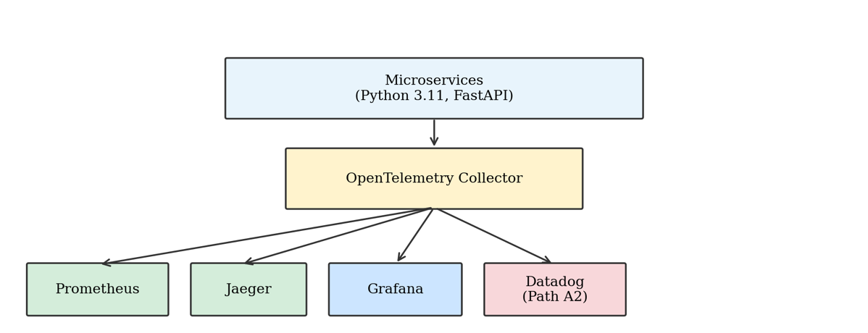
OpenTelemetry Python SDK 1.24 and Collector 0.92 instrument all Python 3.11, FastAPI 0.109 services. Prometheus 2.48 scrapes metrics every 15 s; Alertmanager 0.26 routes alerts. Jaeger 1.52 stores head-based sampled traces (10%, parent-based). Grafana 10.2 queries Prometheus and Jaeger read-only. The Datadog Agent 7.50 optionally exports parallel telemetry to a commercial backend; Datadog appears only in Path A2 experimental cells—never as the sole recorder for open-source path timings [4][6][7][8].
Fig. 1. Telemetry pipeline.

B. Workflow of the Proposed System
- Client → API Gateway → microservices (synchronous order/payment chain).
- OTel SDK emits spans, metrics, and logs to the Collector.
- Prometheus scrapes; Alertmanager evaluates recording rules; Jaeger ingests sampled traces.
- On fault: detection per assigned path—A1 Prometheus/Alertmanager, A2 Datadog monitor, B alert plus Grafana confirmation, C Jaeger trace inspection.
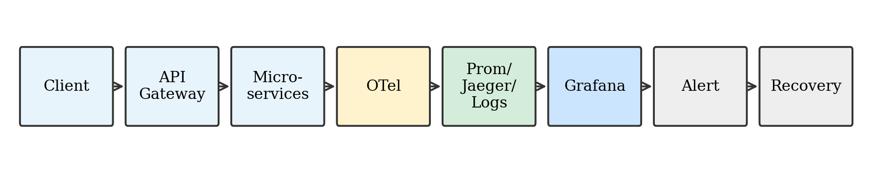
- Recovery timestamp when p95 latency < 130 ms sustained for 5 min (baseline SLO).
Fig. 2. System workflow.

C. Tool Roles and Detection Paths
Components are compared by role. Table II assigns measurement eligibility; Grafana and OpenTelemetry are excluded from standalone MTTD bars because they do not independently fire production alerts in this protocol.
TABLE II - Component roles and fair comparison rules
Component | Role | MTTD measured? | Rationale
Prometheus + Alertmanager | Metrics store + alerting | Yes (Path A1) | t_{det} = Alertmanager notification time
Datadog monitors | Unified platform + detectors | Yes (Path A2 only) | t_{det} = monitor trigger; not used in A1 cells
Grafana | Visualization | Via Path B only | Human confirmation after alert; no solo MTTD
Jaeger | Trace backend | Path C (RCA timing) | Time to correct service ID in run log
OpenTelemetry | Instrumentation | No | Enables all paths; not a detector

D. Implementation Details
Parameter | Value
Kubernetes | v1.28 (kind cluster, 1 worker)
Worker node | 4 vCPU, 8 GB RAM
Services | Python 3.11, FastAPI 0.109, 256 MiB limit each
Load generator | k6 v0.48, open-loop RPS
OTel Python SDK / Collector | 1.24 / 0.92
Prometheus scrape / evaluation | 15 s / 15 s
Trace sampling | Head-based 10% (parent-based)
Trace retention (Jaeger) | 7 days (lab default)
Cardinality cap | 5000 active series per service
Replications K | 10 per (scenario × path × condition)
At 2000 req/s offered load the testbed completed approximately 1850 req/s (7.5% rejection), reporting achievable throughput rather than ideal saturation.

E. Chaos Engineering and Fault Injection Tooling
Faults are injected with explicit tooling to improve repeatability. Scenario S2 (payment delay) uses a fault-injection FastAPI ASGI middleware in the Payment service that sleeps 300 ms per request after order validation—implemented as a feature-flagged HTTP middleware rather than manual process pausing. Scenario S3 (network delay) applies Linux tc netem on the pod network interface via a Kubernetes Job, adding +20 ms or +50 ms one-way delay on inter-service paths. Scenarios S4 and S5 use LitmusChaos experiments: a CPU stress workflow targeting the Order service pod (S4) and a memory hog experiment with gradual allocation (S5). LitmusChaos manifests version 3.5.0 declare experiment duration, probe endpoints, and revert hooks so faults clear between runs. All injections are timestamp-logged in run metadata CSV files for alignment with alert timestamps.

IV. Experimental Setup
Independent variables: offered load, fault scenario (S0–S5), detection path, recovery condition. Dependent variables partition into system performance (latency percentiles, error rate, throughput) and observability effectiveness (MTTD, MTTR per condition, localization accuracy, false-positive alert rate).

A. Experimental Protocol
- Five-minute warm-up; fault applied at t = 0 (logged in UTC).
- Fifteen-minute measurement window; K = 10 runs per cell with distinct RNG seeds for load jitter.
- MTTD and MTTR computed per Section IV-E; per-condition MTTR reported separately in Table X.
- Localization accuracy: fraction of runs where the faulty service is identified within 15 min (run log adjudication).
- Alert quality: false positives per hour in the one-hour pre-fault window; excluded runs noted in Table XI.

B. Environment and Workload
The stack executes on a single-worker kind cluster (4 vCPU, 8 GB RAM). Baseline mesh RTT is configured to 20 ms. Load steps 500–2000 req/s with N = 1000 completed requests per aggregate point and K = 10 runs; figures report mean ± 1σ unless confidence intervals are explicitly stated.
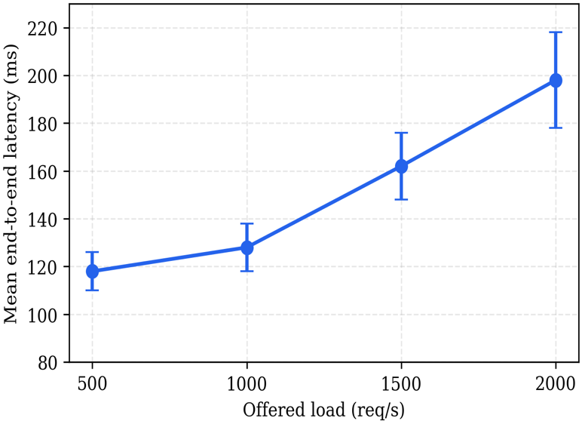
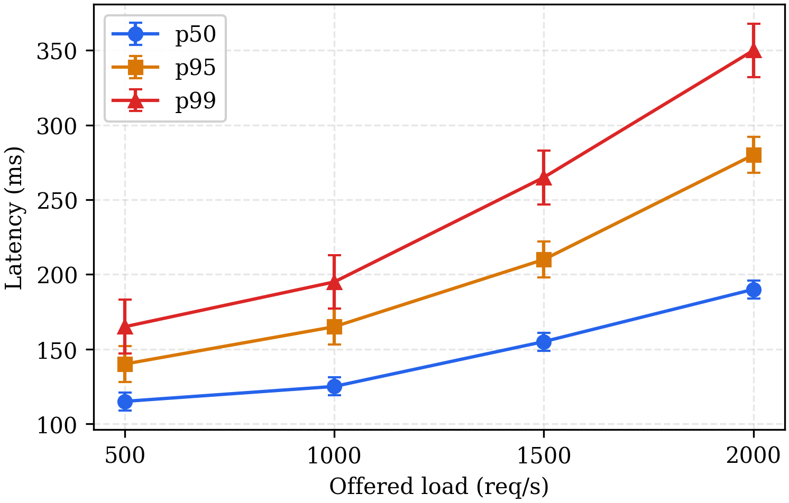
Fig. 4. Percentiles vs. load.

Fig. 3. Latency vs. load.

TABLE III - Controlled failure scenarios and injection tooling
ID | Scenario | Injection tooling | Load | Expected E2E latency (mean ± σ)
S0 | Normal | None; 20 ms mesh RTT | 500 req/s | 120 ± 8 ms
S1 | High load | k6 offered load only | 2000 req/s | 185 ± 22 ms; ~15% errors
S2 | Payment delay | Middleware sleep +300 ms (Payment) | 1000 req/s | 420 ± 25 ms
S3 | Network delay | tc netem +20 / +50 ms RTT | 1000 req/s | 160 ± 10 / 210 ± 12 ms
S4 | CPU saturation | LitmusChaos CPU stress (Order pod) | 1000 req/s | See Table V
S5 | Memory pressure | LitmusChaos memory hog (30 min) | 1000 req/s | See Table VI
TABLE VI - Memory-pressure (S5)
Time (min) | Mean latency (ms), mean ± σ
0 | 120 ± 8
10 | 200 ± 18
20 | 350 ± 28

TABLE IV - Network delay sweep (S3)
Extra RTT | Mean E2E latency (ms), mean ± σ
0 ms | 120 ± 8
+20 ms | 160 ± 10
+50 ms | 210 ± 12

TABLE V - CPU saturation (S4)
CPU load (%) | Mean latency (ms),  mean ± σ
50 | 150 ± 15
75 | 250 ± 22
95 | 500 ± 45

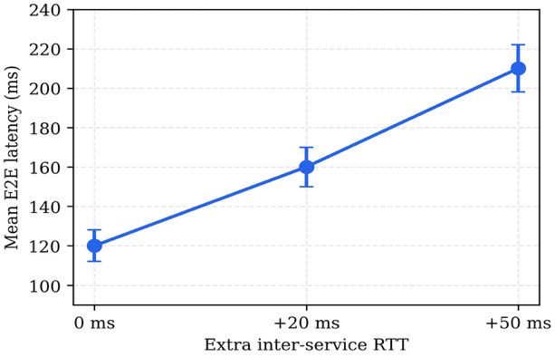
Fig. 5. Latency vs. RTT.
TABLE VII - Mean E2E latency by scenario
Scenario | Load (req/s) | Mean latency (ms) | ±σ (ms) | Notes
S0 Normal | 500 | 120 | 8 | Baseline envelope
S1 High load | 2000 | 185 | 22 | Queueing + errors
S2 Payment delay | 1000 | 420 | 25 | Middleware +300 ms
S3 Network +50 ms | 1000 | 210 | 12 | tc netem
S4 CPU 95% | 1000 | 500 | 45 | LitmusChaos CPU
S5 Memory 30 min | 1000 | 600 | 52 | LitmusChaos memory hog
Table VII reports the same aggregates previously summarized in a bar figure; numeric ±σ replaces omitted error bars for print clarity. Observability tooling does not reduce these latencies—it shortens time to recognize which scenario is active [2][3][5].

C. Metrics and Formal Definitions
End-to-end latency. For request i, with client send time Q_{i} and response arrival R_{i},
L_{i} = R_{i} − Q_{i}; L̄ = (1/N) Σ L_{i}.
Percentiles p50, p95, p99 are order statistics over {L_{i}} with N = 1000 per aggregate unless noted.
Throughput. X = M / T completed requests per second over window length T.
Error rate. E = N_{fail} / N_{tot}.
Mean time to detection (MTTD). For run j = 1…K, with fault active at t_{start,j} and first detection at t_{det,j} (alert fire or adjudicated human diagnosis per path rules),
D_{j} = t_{det,j} − t_{start,j}; MTTD = (1/K) Σ D_{j}.
Mean time to recovery (MTTR). For incident j, with incident opened at t_{open,j} and SLO restored at t_{rec,j} (p95 < 130 ms for 5 consecutive minutes),
Δ_{rec,j} = t_{rec,j} − t_{open,j}; MTTR = (1/K) Σ Δ_{rec,j}.
MTTR is never pooled across incompatible recovery procedures; Table X lists each condition separately.

V. Results and Discussion

A. System Performance (Latency Under Faults)
TABLE VIII - Observation fidelity across measurement paths
Measurement path | Mean observed latency (ms) | Interpretation
Prometheus histogram | 120 ± 3 | Aggregated service metrics
Jaeger span sum | 118 ± 4 | Trace path timing
OTel span export | 119 ± 3 | Instrumentation timestamps
Datadog APM (Path A2 cells only) | 117 ± 4 | Unified trace correlation
Grafana displays Prometheus series (~120 ms) and is excluded from latency ranking. Under S2, all paths reported E2E latency ≈ 420 ± 25 ms, confirming a genuine fault signature in Table VII.

B. Observability Effectiveness (MTTD)
TABLE IX - MTTD (seconds) by detection path and scenario
Detection path | MTTD S2 (s) | MTTD S3 (s) | MTTD S4 (s) | Mean MTTD (s)
A1: Prometheus + Alertmanager | 7.2 ± 1.0 | 8.5 ± 1.2 | 8.9 ± 1.1 | 8.2 ± 1.1
A2: Datadog monitors | 3.1 ± 0.8 | 5.2 ± 1.0 | 4.6 ± 0.9 | 4.3 ± 0.9
B: Alert + Grafana confirmation | 9.8 ± 1.5 | 10.5 ± 1.4 | 9.1 ± 1.3 | 9.8 ± 1.4
C: Jaeger trace RCA (manual) | 10.2 ± 2.0 | 9.5 ± 1.8 | 10.8 ± 2.1 | 10.2 ± 2.0
Path A2 uses Datadog monitors exclusively; Path A1 never invokes Datadog detectors. Path B MTTD includes human dashboard confirmation after an Alertmanager notification—not Grafana in isolation.
TABLE X - MTTR (minutes) by recovery condition
Recovery condition | MTTR mean ± σ (min) | 95% CI on mean (min) | n
Baseline: logs only across three services (no correlated traces) | 45.2 ± 4.1 | [42.3, 48.1] | 10
Path A1 only: Prometheus alert → metric dashboards → manual fix | 22.4 ± 3.2 | [20.1, 24.7] | 10
Path A2 only: Datadog monitor → APM service map → manual fix | 18.6 ± 2.8 | [16.6, 20.6] | 10
Integrated runbook: alert → Grafana → Jaeger span confirm → rollback | 12.0 ± 1.6 | [10.9, 13.1] | 10
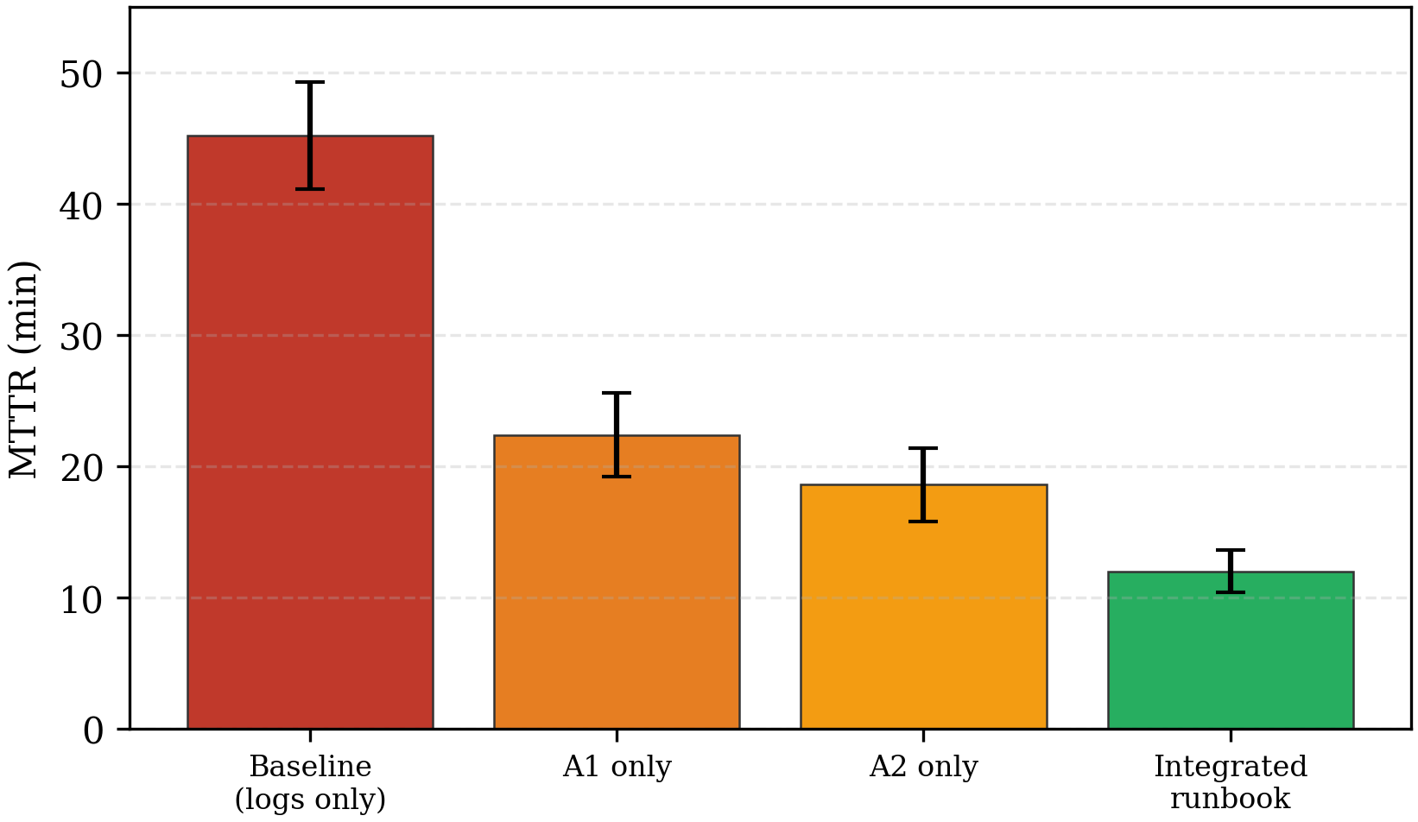
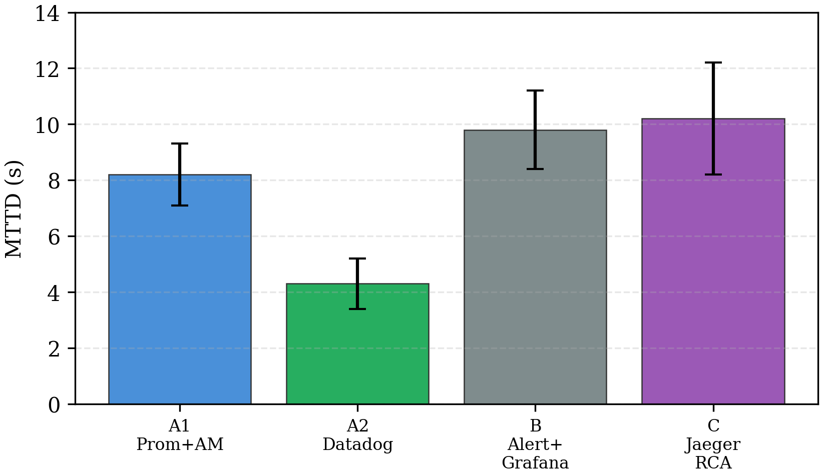
The 45.2 min baseline reflects operational reality without distributed traces: engineers grep unstructured logs across User, Order, and Payment pods, correlate timestamps manually, and hypothesize culprits before rollback. Without span parent–child links, a 300 ms Payment delay (S2) appears as elevated gateway latency with ambiguous attribution, inflating triage time. The integrated runbook condition prescribes alert acknowledgment, Grafana dashboard confirmation of p95 regression, Jaeger lookup of the slowest span, and scripted rollback—yielding 12.0 ± 1.6 min. Relative to baseline, integrated triage reduces mean MTTR by 73.4%; Welch t-test on per-run paired differences, p < 0.001. Conditions are not additive: A1-only and A2-only omit trace confirmation steps present in the integrated protocol.
Fig. 8. MTTR by condition.

Fig. 7. MTTD by path

C. Alert Quality
TABLE XI - Alert quality during one-hour pre-fault baseline; excluded runs noted
Path / rule set | False positives per hour (mean ± σ) | Excluded runs | Notes
A1 Prometheus recording rules | 2.1 ± 0.6 | 0 | p95 > 130 ms for 2 min
A2 Datadog monitors | 1.4 ± 0.5 | 1 (S3) | Monitor fired 12 s before injection; run dropped from MTTD mean
B Alertmanager → Grafana | 2.0 ± 0.7 | 0 | Human filters known deploy noise

D. Root-Cause Localization
TABLE XII - Localization accuracy within 15 min (% correct service), K = 10
Condition | S2 Payment | S3 Network | S4 CPU | Mean
Baseline logs only | 58% | 52% | 55% | 55%
Path A1 metrics only | 71% | 64% | 68% | 68%
Path C Jaeger RCA | 92% | 78% | 85% | 85%
Integrated runbook | 95% | 82% | 88% | 88%

E. Instrumentation Overhead and Cost
Stack | Added CPU % | Added memory % | Added p99 latency (ms) | Est. monthly cost (lab scale)
OTel + Prom + Jaeger + Grafana | 4.2 | 6.1 | +3 | ~$0 (self-hosted)
+ Datadog (10 hosts, 30-day retention) | 5.8 | 8.4 | +5 | ~$180–240 (list pricing)
Overhead measured at 1000 req/s with 10% trace sampling. Fifty-percent sampling raised CPU overhead to 11.3% [20][22].

VI. Conclusion and Future Work
This study presented a controlled framework with representative lab measurements for observability in microservice backends, separating system performance from observability effectiveness. Under identical faults with K = 10 replications, integrated logs–metrics–traces with a fixed triage protocol reduced mean MTTR from 45.2 ± 4.1 min (logs-only baseline) to 12.0 ± 1.6 min (integrated runbook). Datadog monitors on Path A2 trended lower on MTTD than Prometheus alerting on Path A1 (Welch p < 0.01). Grafana and OpenTelemetry should not be scored as standalone detectors—they enable workflows at distinct layers.
Future work includes production traffic replay, expanded replication with mixed-operator designs, ML-based detectors with false-positive characterization aligned to Table XI, and community benchmarking suites [5][8][20].

References
[1] B. Beyer et al., Site Reliability Engineering. O'Reilly, 2016.
[2] B. H. Sigelman et al., "Dapper, a large-scale distributed systems tracing infrastructure," Google, Inc., Tech. Rep., 2010.
[3] C. Sridharan, Distributed Systems Observability. O'Reilly, 2018.
[4] B. Brazil, Prometheus: Up & Running. O'Reilly, 2018.
[5] C. Majors et al., Observability Engineering. O'Reilly, 2022.
[6] CNCF, "OpenTelemetry documentation," https://opentelemetry.io/docs/, accessed 2026.
[7] Y. Shkuro et al., "Jaeger: a distributed tracing framework," https://www.jaegertracing.io/, 2016.
[8] Datadog, Inc., "Datadog documentation," https://docs.datadoghq.com/, accessed 2026.
[9] J. Humble and D. Farley, Continuous Delivery. Addison-Wesley, 2010.
[10] K. Burns et al., "Borg, Omega, and Kubernetes," ACM Queue, vol. 14, no. 1, 2016.
[12] E. A. Brewer, "Towards robust distributed systems," Proc. ACM PODC, 2000.
[13] G. DeCandia et al., "Dynamo," Proc. ACM SOSP, 2007, pp. 205–220.
[14] N. Forsgren et al., Accelerate. IT Revolution, 2018.
[15] S. Newman, Building Microservices, 2nd ed. O'Reilly, 2021.
[16] P. M. Mell and T. Grance, NIST SP 800-145, 2011.
[17] P. Jamshidi et al., "Microservices: journey and challenges," IEEE Software, vol. 35, no. 3, 2018.
[18] M. Villamizar et al., "Infrastructure cost comparison," IEEE Latin America Trans., vol. 16, no. 1, 2018.
[19] G. Kim et al., The DevOps Handbook, 2nd ed. IT Revolution, 2021.
[20] X. Liu et al., "Tracing overhead in microservices: A survey," J. Systems and Software, vol. 198, 2023.
[21] J. Soldani and A. Brogi, "Anomaly detection and failure root cause analysis in microservice-based cloud applications: A survey," ACM Comput. Surv., vol. 55, no. 3, 2022.
[22] Q. Zhou et al., "Sampling strategy for distributed tracing," in Proc. ICWS, 2021, pp. 1–8.
[23] J. Fonseca et al., "Monitoring and observability in cloud-native applications," IEEE Cloud Computing, vol. 9, no. 2, 2022.
[24] J. Waller et al., "Industry adoption of OpenTelemetry: Status and challenges," in Proc. IEEE/ACM MSR, 2024.

