Practical : Data Sniffing through wire sharks.

1.. Open kali terminal and type wireshark

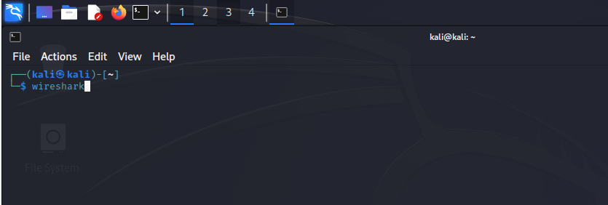

2.. You can see the wireshark tool GUI interface.

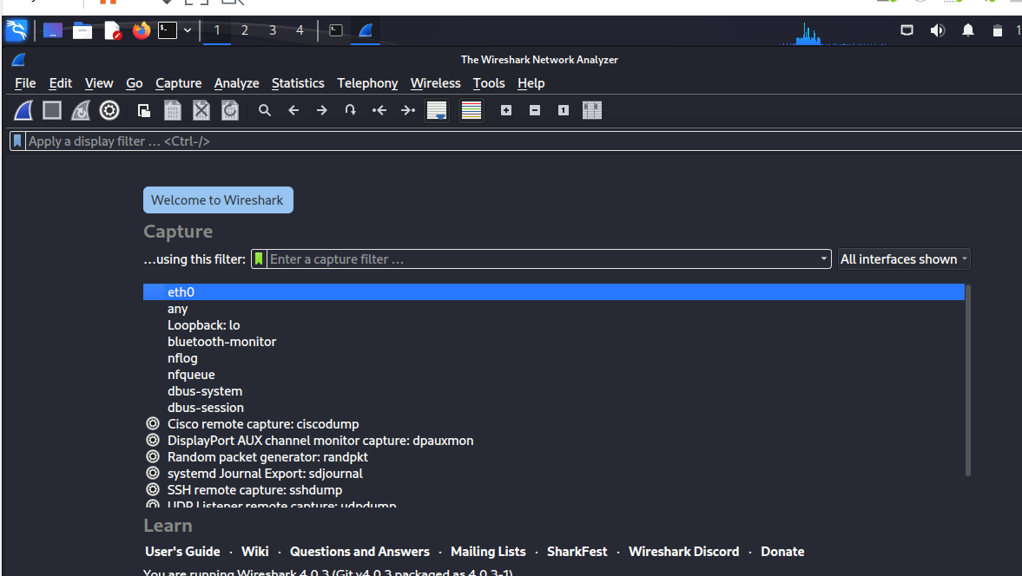

3.. Meanwhile, you need to open a website to capture and see the real time details.

And I used here one vulnerabilities website [www.vulnweb.com](http://www.vulnweb.com) ( for testing purpose.)

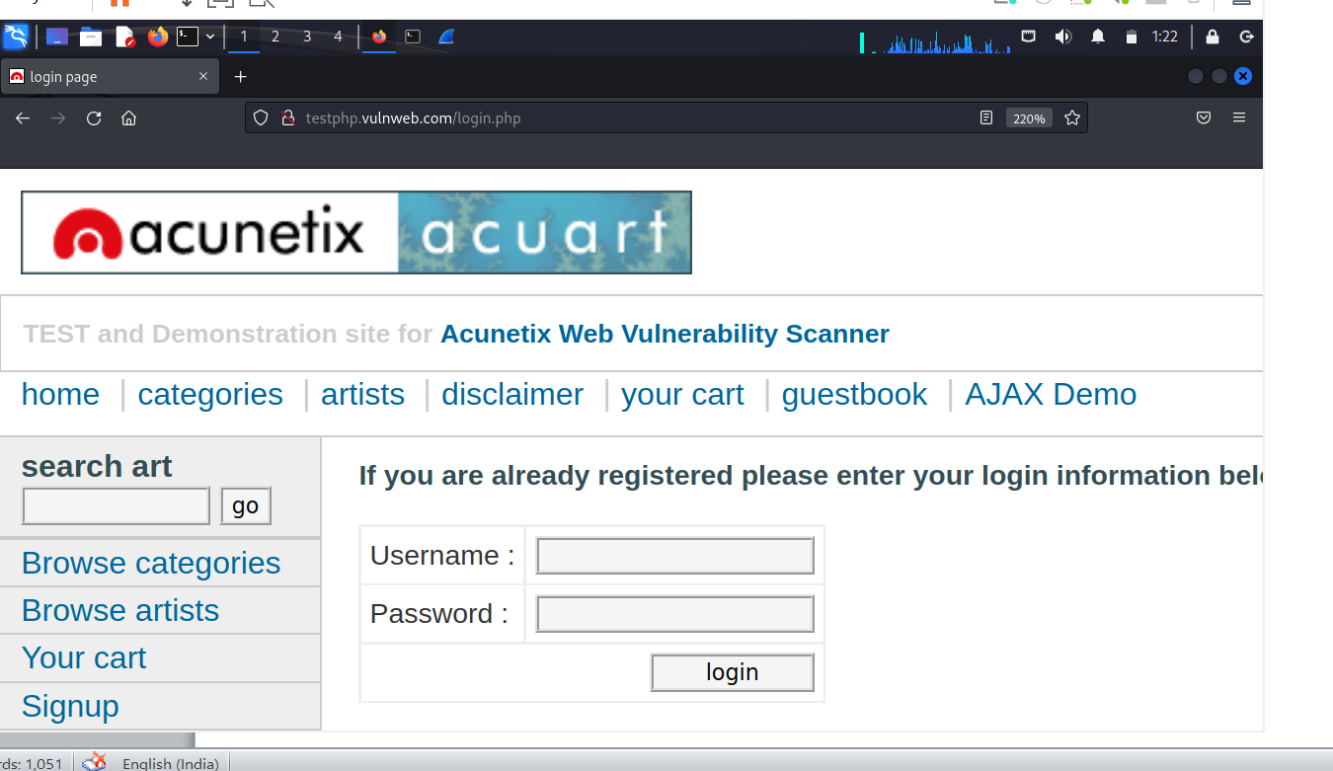

4.. Now, go to the wireshark and stop to capture packets from square sign and click on HTTP protocol of website (GET method and login.php page) the we open alongside it.

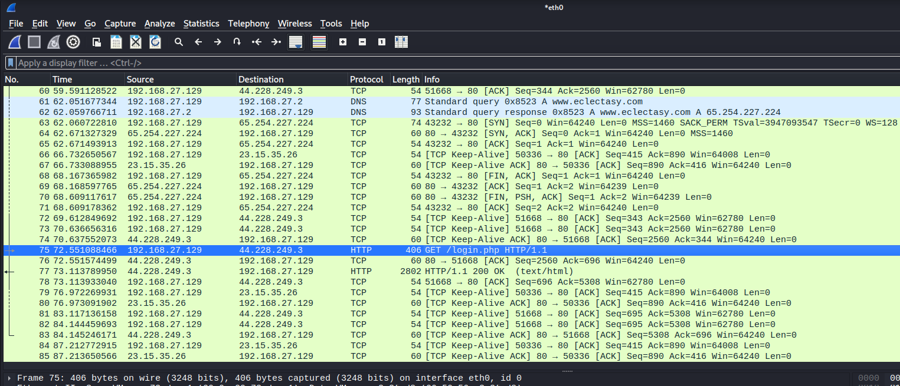

5.. You can see the result that what request is gone on server and other details like accurate time to access website, host time **and which language is used to make this site** and source code of site.

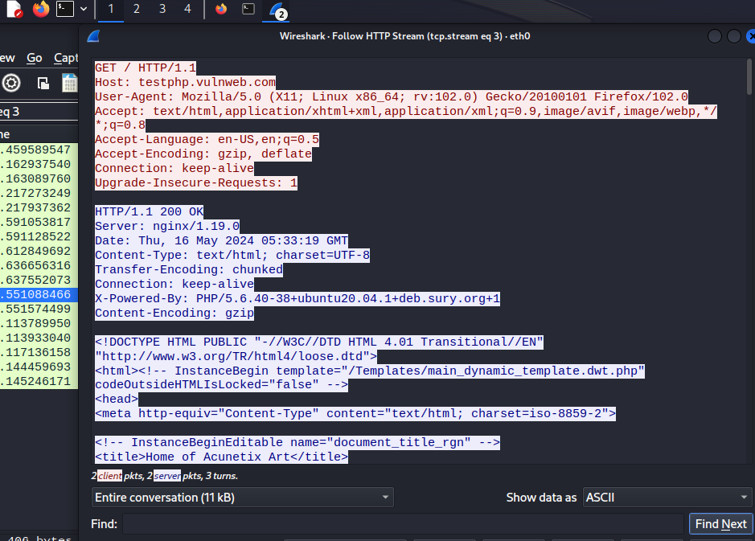

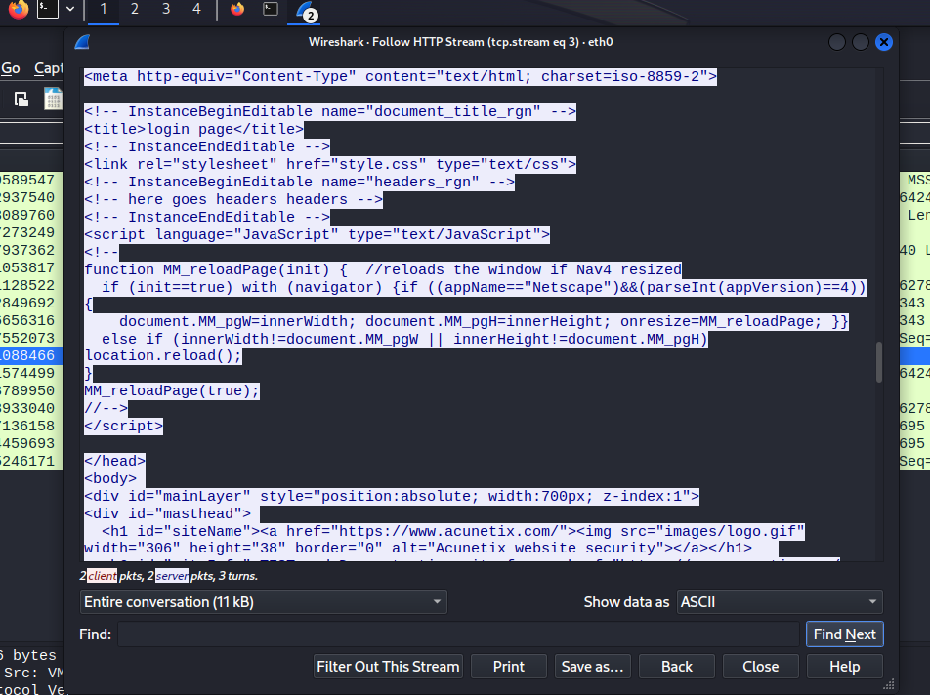

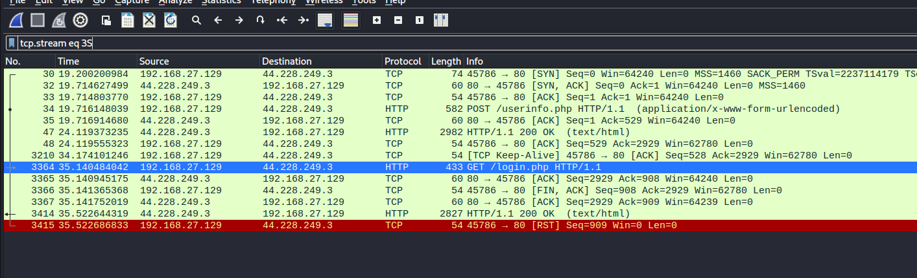

6.. At last you can see the username and password via wireshark to that is used to login in website.

