**ERD for a Restaurant**

* ERD stands for Entity Relationship diagram.
* To draw ERD, first we need to gather all the requirements. Basically, we need to understand how a restaurant works.
* After gathering all the requirements, then identify entities and its attributes. Here is the list of entities that a restaurant has: -

1. Customer
2. Reservation
3. Order
4. Food items
5. Employee
6. Restaurant
7. Dining tables
8. Bill
9. Payment

* After identifying, then draw a basic conceptual model for the restaurant.
* Then design a logical model for the same.
* Here, using forward engineering in MySQL Workbench, we have prepared final database/physical design for the restaurant.
* All the scripts generated during forward engineering has been attached in the zip file and also pushed on the git repository link mentioned above.

1. **Conceptual model for Restaurant:**

* After identifying entities and its attributes, we have to establish relationship b/w the entities and also cardinality of the relationship.
* Identify weak entities, partial key, multivalued attributes, primary key for the entities, participation level of relationship, derived attributes in the ER diagram.
* For e.g., for customer, customer id is the primary key, food item is a weak entity as to identify a food item order by a customer, we need order id. Also, quantity in order is a derived attribute as it is derived according to food items ordered.
* Also, name of food item is a partial key as it can’t uniquely identify the food ordered by a customer and need order id.
* Participation level is also decided according to the relationship between the entities. For e.g., for entities Restaurant and Employee, every restaurant has employees and similarly, every employee in the restaurant is working for the restaurant, be it server, chef, security guard or any other employee. Therefore, total participation exists between these two entities.
* Additionally, some attributes may be multivalued. Here, location attribute of restaurant is multi-valued.
* After identifying and analyzing, final conceptual diagram using Visual Paradigm tool has been drawn in Figure 1. Here, Chen’s model has been drawn.

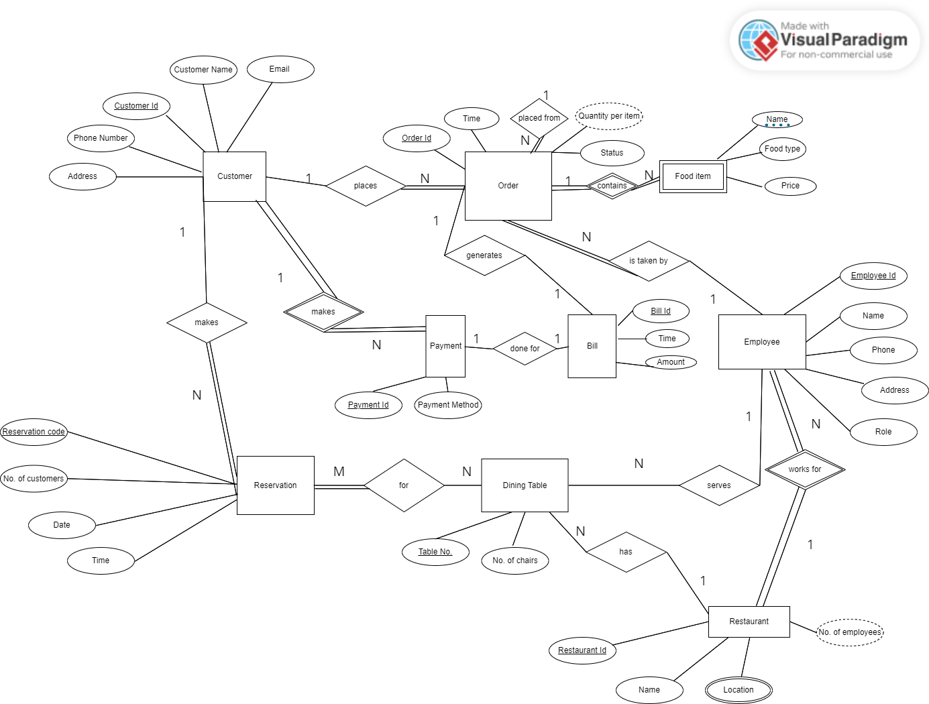

**Fig. 1 – Conceptual ERD for a restaurant**

1. **Logical model for Restaurant:**

* Logical model is the blueprint for the final physical design.
* Here, all the multi-valued relationships have been disintegrated to two 1: N relationship. Here, Reservation_dining_table has been introduced b/w Reservation and dining table.
* Also, multi-valued attribute has been drawn as a separate table, location has been drawn as a separate table.
* Final diagram has been drawn using Visual Paradigm tool as present in Fig. 2.

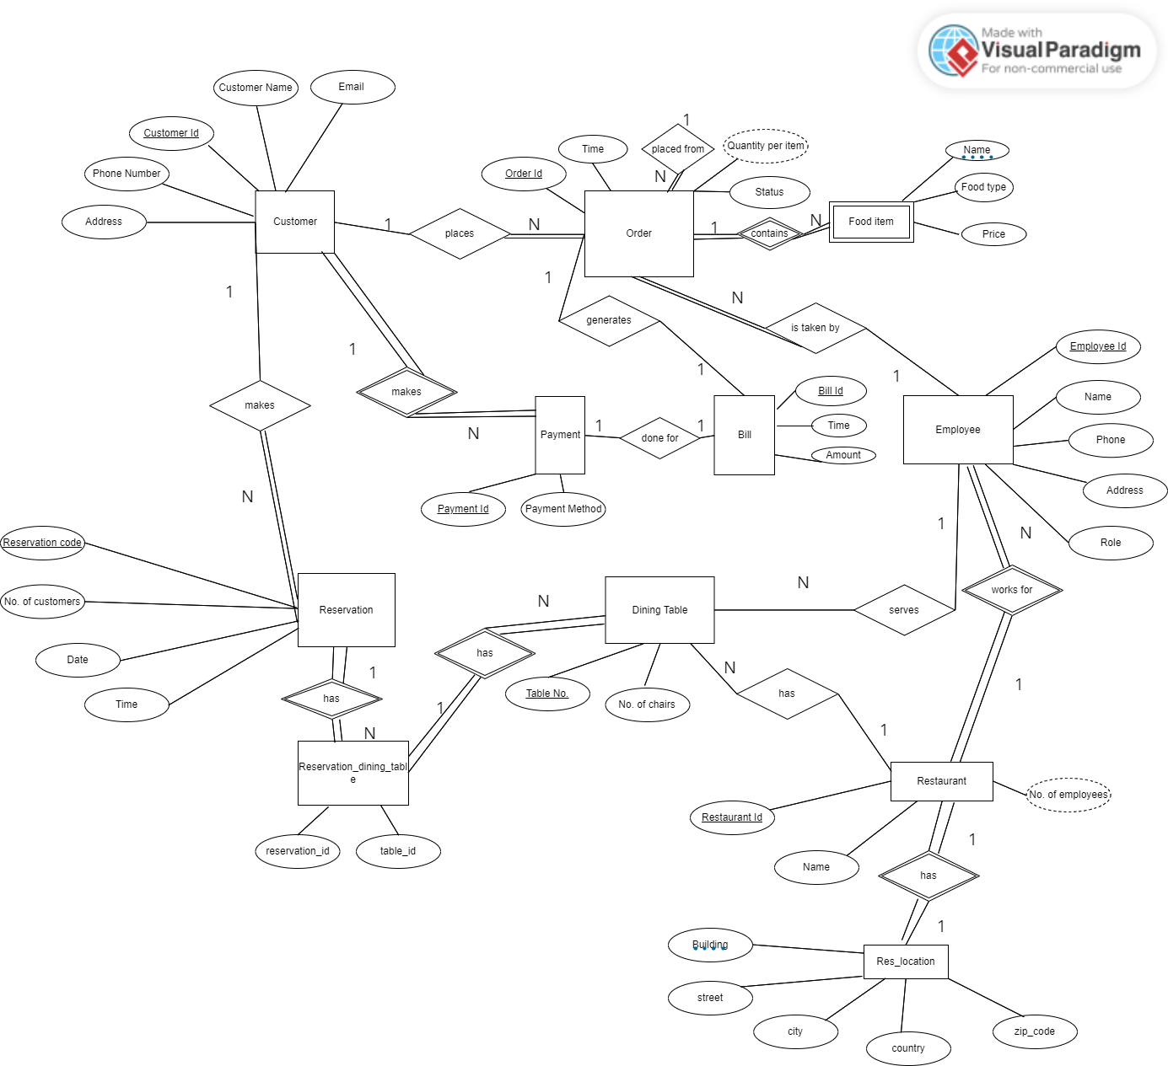

**Fig. 2 – Logical ERD for a restaurant**

1. **Physical model for Restaurant:**

* To draw physical model, I have used MySQL workbench.
* Go to File -> New Model, then name the schema as Restaurant as present in Fig. 3.
* Then, draw a EER diagram using tools present in workbench.
* Final diagram has been drawn as present in Fig. 4.
* After that, go to Database -> Forward Engineer.
* Then after configuring some database settings, workbench will provide us final SQL queries and also will create database and tables as shown in Fig. 5.
* SQL queries have been attached in the zip file and also on the git repository.

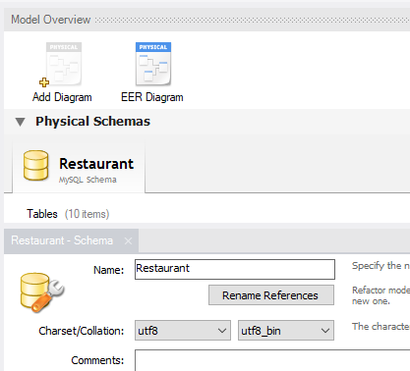

**Fig. 3 Creating new model in MySQL WorkBench**

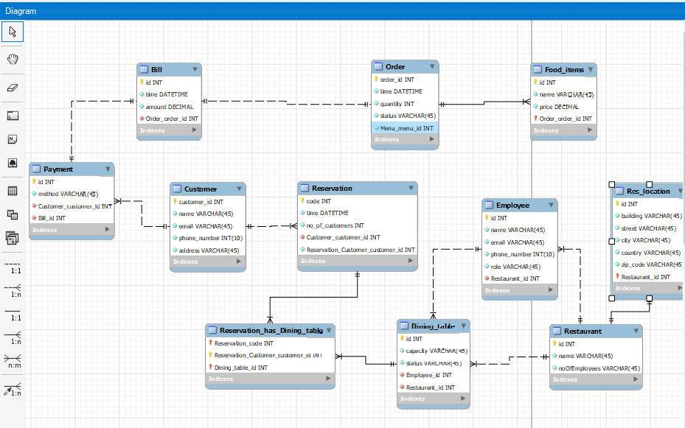

**Fig. 4 EER diagram in MySQL workbench (Forward engineering)**

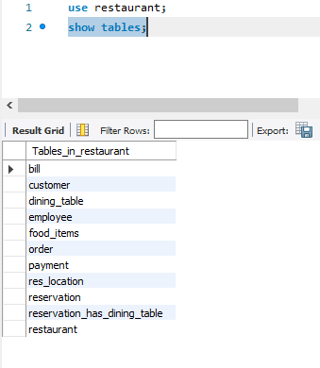

**Fig. 5 Final database and tables in MySQL workbench**