Lab 1: Jasper Savels en Victor Delbeke

Part 1: Connecting a physical network
- Create the following physical network by making the necessary connections. Work in a group of 2 or 3 or use your laptop and a computer if you prefer to work alone. Do not change any configuration on your computer or the switch yet.
  - How is everything connected? (schematic, photos, …)
    - Victor on C11 (PC0)
    - Jasper on C12 (PC1)
    - C11 en C12 in Catalyst 2960
  - What kind of cables did you use? What is the name of the connector that you used?
    - Cat 5 en Cat 5e
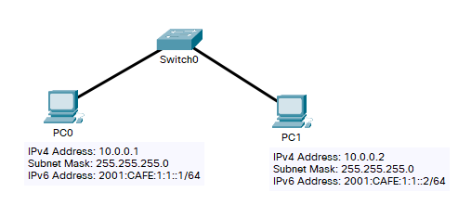
Figure 1: Basic network

- Test the network connectivity between the clients.
  - Which command did you use to test network connectivity?
    - ping
  - What is the response to this command?
    - PC0 -> PC1:
PS C:\Users\vicde> ping 10.0.0.2
Pinging 10.0.0.2 with 32 bytes of data:
Reply from 193.190.56.126: Destination net unreachable.
Reply from 193.190.56.126: Destination net unreachable.
Reply from 193.190.56.126: Destination net unreachable.
Reply from 193.190.56.126: Destination net unreachable.
Ping statistics for 10.0.0.2:
Packets: Sent = 4, Received = 4, Lost = 0 (0% loss),

    - PC1 -> PC0:
PS C:\Users\Jaske> ping 10.0.0.1
Pinging 10.0.0.1 with 32 bytes of data:
Reply from 10.67.46.153: Destination host unreachable.
Reply from 10.67.46.153: Destination host unreachable.
Reply from 10.67.46.153: Destination host unreachable.
Reply from 10.67.46.153: Destination host unreachable.
Ping statistics for 10.0.0.1:
Packets: Sent = 4, Received = 4, Lost = 0 (0% loss),
PS C:\Users\Jaske>
  - Do you understand why you got this response?
    - Yes, the network is not yet configured.
- Configure the wired network interfaces on both clients. Both the IPv4 and the IPv6 address (disable wifi)
  - Which settings did you change (screenshots)?
IP Version | PC0 (Victor) | PC1 (Jasper)
IPv4 | 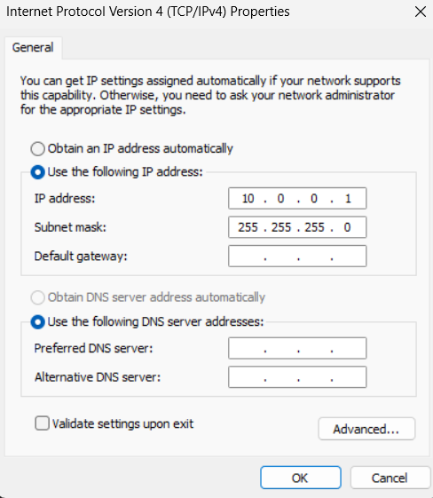 | 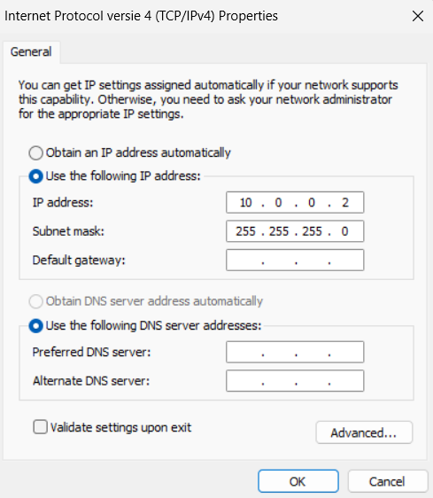
IPv6 | 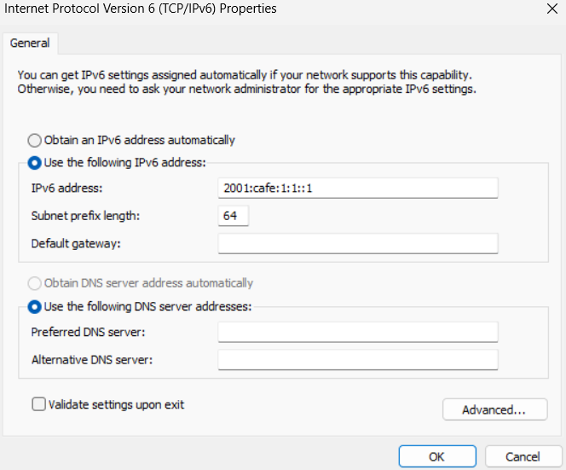 | 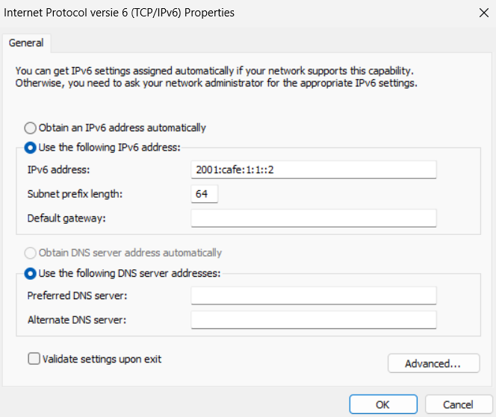

  - Which settings are required when filling in the ip address, which ones are optional?
- IP address and subnet mask

- Configure the firewalls on both clients to allow incoming echo requests. You can use Appendix A of the document Assignment 1 - Using Wireshark to View Network Traffic.pdf which you can find on Canvas.
  - Which steps did you take?
    - Control Panel -> System & Security -> Windows Defender Firewall -> Turn Windows Defender Firewall on or off
  - Which rules did you change?
    - Turn off Windows Defender Firewall for Public Network
  - Why did you need to enable these rules?
    - Windows blocks ping requests by default.
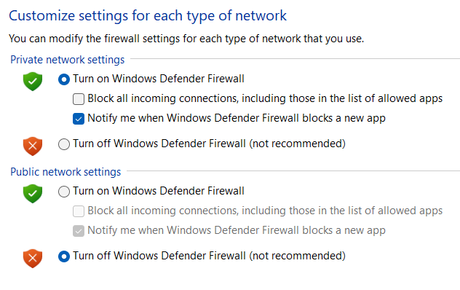 | 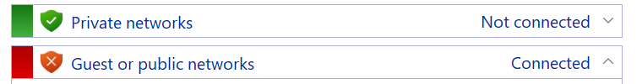

- Test the network connection in both directions (pc0 -> pc1, pc1 -> pc0). Both for IPv4 and IPv6
  - Which commands did you use?
    - ping
  - What was the result?
    - IPv4 (PC0 -> PC1)
PS C:\Users\vicde> ping 10.0.0.2
Pinging 10.0.0.2 with 32 bytes of data:
Reply from 10.0.0.2: bytes=32 time=4ms TTL=128
Reply from 10.0.0.2: bytes=32 time=5ms TTL=128
Reply from 10.0.0.2: bytes=32 time=5ms TTL=128
Reply from 10.0.0.2: bytes=32 time=4ms TTL=128
Ping statistics for 10.0.0.2:
Packets: Sent = 4, Received = 4, Lost = 0 (0% loss),
Approximate round trip times in milli-seconds:
Minimum = 4ms, Maximum = 5ms, Average = 4ms
    - IPv4 (PC1 -> PC0)
PS C:\Users\Jaske> ping 10.0.0.1
Pinging 10.0.0.1 with 32 bytes of data:
Reply from 10.0.0.1: bytes=32 time=4ms TTL=128
Reply from 10.0.0.1: bytes=32 time=4ms TTL=128
Reply from 10.0.0.1: bytes=32 time=4ms TTL=128
Reply from 10.0.0.1: bytes=32 time=3ms TTL=128
Ping statistics for 10.0.0.1:
Packets: Sent = 4, Received = 4, Lost = 0 (0% loss),
Approximate round trip times in milli-seconds:
Minimum = 3ms, Maximum = 4ms, Average = 3ms
    - IPv6 (PC0 -> PC1)
PS C:\Users\vicde> ping 2001:CAFE:1:1::2
Pinging 2001:cafe:1:1::2 with 32 bytes of data:
Reply from 2001:cafe:1:1::2: time=4ms
Reply from 2001:cafe:1:1::2: time=5ms
Reply from 2001:cafe:1:1::2: time=4ms
Reply from 2001:cafe:1:1::2: time=5ms
Ping statistics for 2001:cafe:1:1::2:
Packets: Sent = 4, Received = 4, Lost = 0 (0% loss),
Approximate round trip times in milli-seconds:
Minimum = 4ms, Maximum = 5ms, Average = 4ms
    - IPv6 (PC1 -> PC0)
PS C:\Users\Jaske> ping 2001:cafe:1:1::1
Pinging 2001:cafe:1:1::1 with 32 bytes of data:
Reply from 2001:cafe:1:1::1: time=3ms
Reply from 2001:cafe:1:1::1: time=5ms
Reply from 2001:cafe:1:1::1: time=3ms
Reply from 2001:cafe:1:1::1: time=4ms
Ping statistics for 2001:cafe:1:1::1:
Packets: Sent = 4, Received = 4, Lost = 0 (0% loss),
Approximate round trip times in milli-seconds:
Minimum = 3ms, Maximum = 5ms, Average = 3ms
PS C:\Users\Jaske>
  - How much time did it take for the reply to arrive?
    - About 4 ms average
  - What does that time represent regarding the datapacket?
    - It’s a very small datapacket, so it makes sense that it’s quite fast.
  - What other information can you find in the reply?
    - 4 packets sent, 4 arrived, no packet loss (something else?)
  - Did you have any problems? What did you do to resolve them?
    - We started too fast and didn’t read the questions yet oops.

Part 2: Examining network traffic
- Use document Assignment 1 - Using Wireshark to View Network Traffic.pdf which you can find on Canvas. This document explains how to install Wireshark and how to use it to examine network traffic.
  - Part1: Here you will install Wireshark
  - Part2: Here you will examine network traffic in the network you created previously
  - Part3: Here you will examine network traffic to the internet. You need to connect your computer to the internet (don’t forget to change your network settings to dynamic IP address)
- Using what you have learned in the Wireshark document, start monitoring- the network traffic.
- While Wireshark is monitoring, do a ping from PC0 to PC1 using both IPv4 and IPv6
- Stop monitoring. Using the filter “icmp”, you can filter all the ping packets.
  - How many packets do you see? Can you explain this number?
    - 20 packets with filter: “icmp || icmpv6”
      - 8 IPv4 ping packets
        - 4 requests
        - 4 replies
      - 8 IPv6 ping packets
        - 4 requests
        - 4 replies
      - 4 ICMPv6 packets for solicitation and advertisement
        - This is used for MAC to IPv6 binding

  - Can you find the IPv4, IPv6 and MAC addresses of both computers in this capture? Find the same information on your computer using the “ipconfig” (Windows) or “ip a” (Linux) command.
    - Yes we can. It’s in the Ethernet II frame:
    - For IPv4:
Ethernet II, Src: ASUSTekCOMPU_02:7b:82 (bc:fc:e7:02:7b:82), Dst: Dell_80:c5:a1 (fc:4c:ea:80:c5:a1)
Destination: Dell_80:c5:a1 (fc:4c:ea:80:c5:a1)
.... ..0. .... .... .... .... = LG bit: Globally unique address (factory default)
.... ...0 .... .... .... .... = IG bit: Individual address (unicast)
Source: ASUSTekCOMPU_02:7b:82 (bc:fc:e7:02:7b:82)
.... ..0. .... .... .... .... = LG bit: Globally unique address (factory default)
.... ...0 .... .... .... .... = IG bit: Individual address (unicast)
Type: IPv4 (0x0800)
[Stream index: 1]
    - For IPv6:
Ethernet II, Src: ASUSTekCOMPU_02:7b:82 (bc:fc:e7:02:7b:82), Dst: Dell_80:c5:a1 (fc:4c:ea:80:c5:a1)
Destination: Dell_80:c5:a1 (fc:4c:ea:80:c5:a1)
.... ..0. .... .... .... .... = LG bit: Globally unique address (factory default)
.... ...0 .... .... .... .... = IG bit: Individual address (unicast)
Source: ASUSTekCOMPU_02:7b:82 (bc:fc:e7:02:7b:82)
.... ..0. .... .... .... .... = LG bit: Globally unique address (factory default)
.... ...0 .... .... .... .... = IG bit: Individual address (unicast)
Type: IPv6 (0x86dd)
[Stream index: 1]

    - PC0 ipconfig
Ethernet adapter Ethernet:
Connection-specific DNS Suffix . :
IPv6 Address. . . . . . . . . . . : 2001:cafe:1:1::1
Link-local IPv6 Address . . . . . : fe80::60ff:967f:c0e:d4ef%9
IPv4 Address. . . . . . . . . . . : 10.0.0.1
Subnet Mask . . . . . . . . . . . : 255.255.255.0
Default Gateway . . . . . . . . . :
    - PC1 ipconfig
Ethernet adapter Ethernet:
Connection-specific DNS Suffix . :
IPv6 Address. . . . . . . . . . . : 2001:cafe:1:1::2
Link-local IPv6 Address . . . . . : fe80::26ee:e1be:ac9c:d22a%2
IPv4 Address. . . . . . . . . . . : 10.0.0.2
Subnet Mask . . . . . . . . . . . : 255.255.255.0
Default Gateway . . . . . . . . . :

Part 3: Virtual simulated network
- Install packet tracer on your computer and follow the introduction course on the Cisco website.
- Create the same network as shown in figure 1. Use the 2960 switch.
  - How did you configure the IP addresses of the clients?
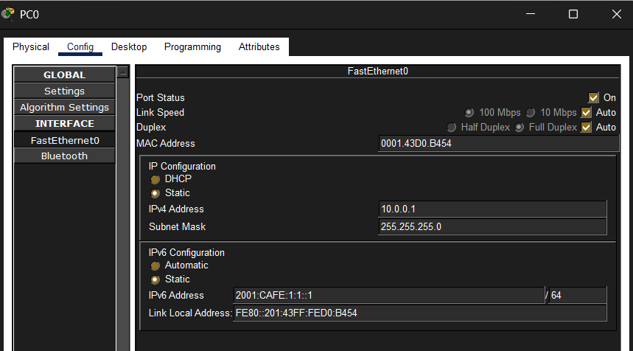 | 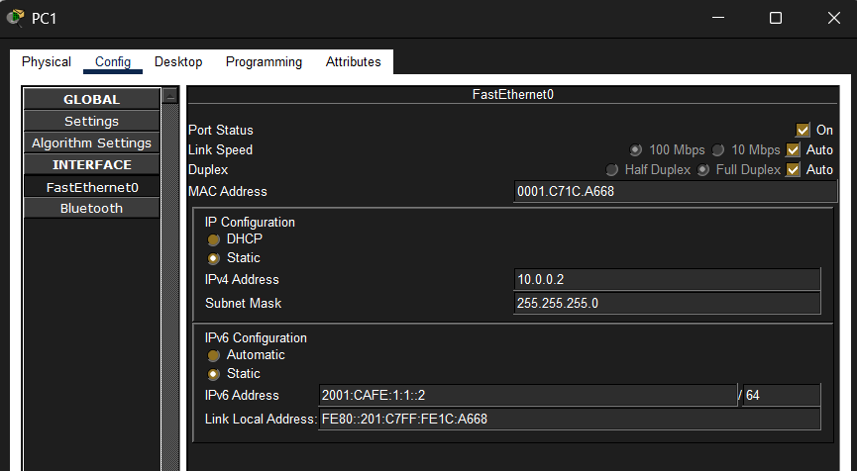

  - How did you test the network connectivity
    - We pinged from PC0 to PC1 and vice versa.
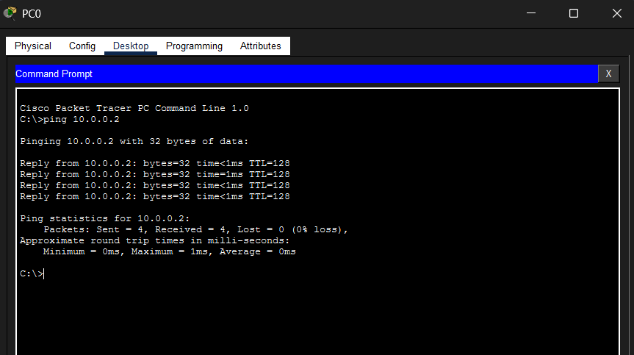 | 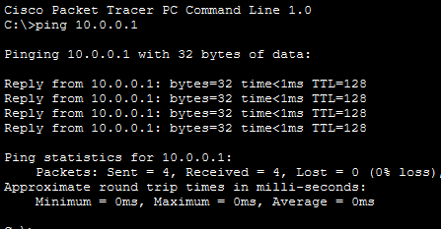

- View the ping packets flowing through the network in simulation mode
  - We did.
- Save your packet tracer network.
  - We did.

Demonstrate
After you did the lab, you should be able to demonstrate the following. Think about how you can demonstrate these achievements.
Part 1:
- Network connectivity between PC0 and PC1 over IPv4
- Network connectivity between PC0 and PC1 over IPv6
- Show network configuration on PC0 and PC1 using a command
Part 2:
- Show IP address and MAC address of PC0 and PC1 in a Wireshark capture and match it to your computer's information.
Part 3:
- Packet tracer: Network connectivity between PC0 and PC1
- Simulation mode

