Lab 3

Create and test a network cable

In this lab, you will make a network cable. You can make this cable alone (you will have to add both connections) or with another student (each student will make one connection on the cable)
You will need the following materials:
- 2 rj45 connectors
- 1m of CAT5e cable
- Rj45 crimping pliers
- Network cable tester

Use the following video as a guide to make your 1m network cable: https://www.youtube.com/watch?v=k4aL62ixJVc
Things to keep in mind:
- Make sure all the colored wires are all the way at the end of the connector before clamping it
- Make sure that the wires are still in the correct position after putting it in the connector before clamping it. Sometimes the wires change places while you put it in the connector.
- Make sure the insulation is inside the connector so it can also be clamped in the connector to strengthen the connection.
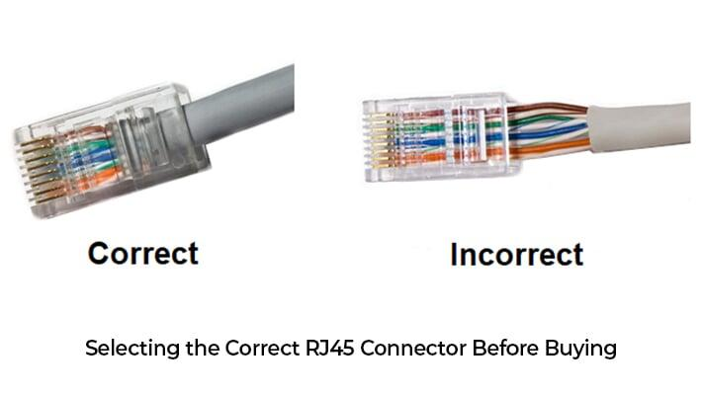

When your cable is done, write down your r-number on your end of the cable, or on both ends of the cable if you did them both.

Test your cable with cable tester
Use a cable tester to test if your cable is connected correctly.

Test your cable speed
Connect 2 computers with your network cable and give each computer a static IP address. Test the network connection (ping).
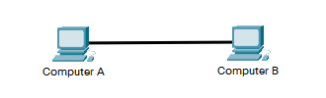

Option A: iperf
iperf is a command line tool to test the network quality between 2 systems. Use the tool to measure the Latency, Jitter, Data loss and Bandwidth.
The test is done between 2 devices connected to the same network, both running iperf.
Figure out how iperf works and how you can measure the required quantities.

Option B: LAN Speed test

Download the LAN speed test application on both computers: https://ping-tool.com/index.html#download
In the zip file, start the “Speedtest.exe” application. Start this application on both computers. The application will generate files that are used to test the network speed. The files are located in the folder specified in the “Speedtest Destination”.

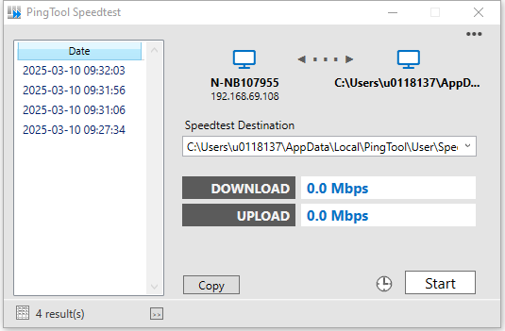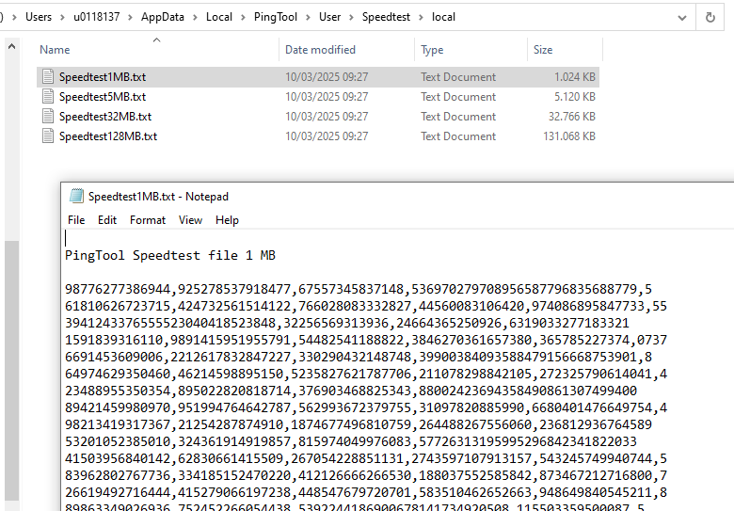

To test the local network speed the folder containing these files should be shared on one computer. The other computer can then set this shared folder as the “Speedtest Destination” folder. Check your firewall settings if this is not working.

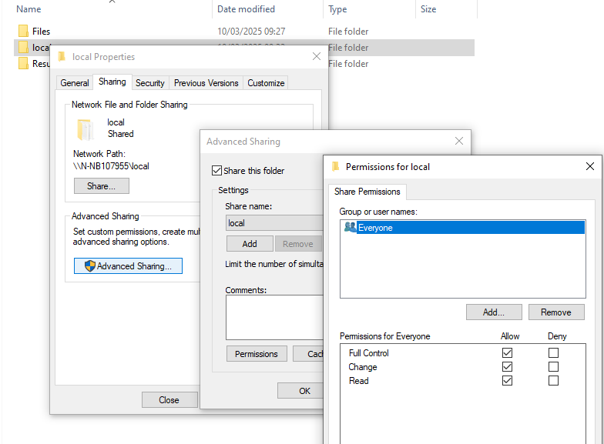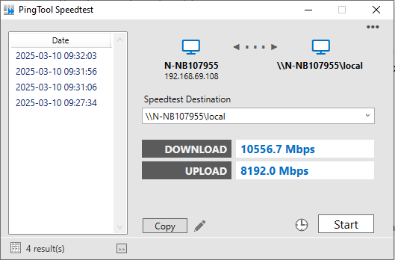
Share settings on computer A Speed test settings on computer B

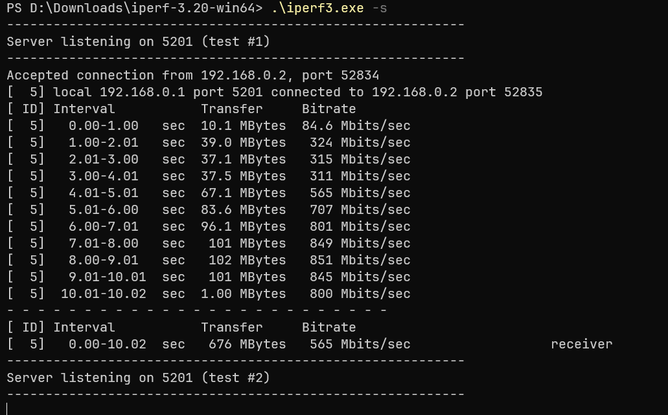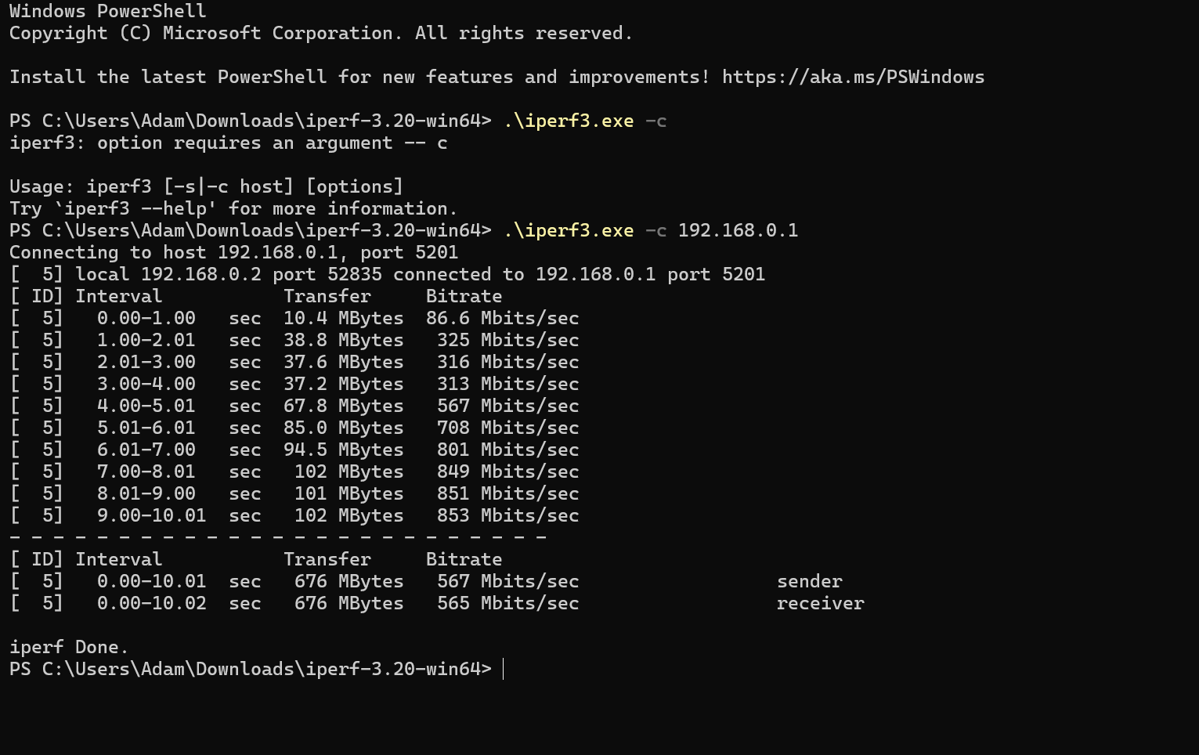

Monitor test with wireshark
Use Wireshark to monitor the speed test.
- Which application protocol, transport protocol and network protocol is used for this test?
  - Application protocol: iperf3 speed test
  - transport protocol: TCP
  - network protocol: IPv4
Demo
After you did the lab, you should be able to demonstrate the following. Think about how you can demonstrate these achievements.
- Show that your cable is created properly physically
- Show that your cable is working properly with the cable tester
- Show your speed test
- Show the Wireshark capture and explain

