**Project Report**

**on**

**Object Avoiding Robot**

in partial fulfilment for the award of the degree of

**BACHELOR OF ENGINEERING**

IN

**COMPUTER SCIENCE AND ENGINEERING WITH SPECIALIZATION IN AI AND ML**

**Submitted by:**

Aditya Bhatia (24BAI70084)

Jaskirat Singh (24BAI70110)

Adil Thakur (24BAI70464)

**Under the Guidance of**

Dr. Divneet

**ACADEMIC UNIT-I**



**Chandigarh University**

**April 2025**

**Index**

|  |  |  |
| --- | --- | --- |
| **S. No.** | **Content** | **Page No.** |
| 1 | Project Overview | 1 |
| 2 | Objective and Problem Statement | 2 |
| 3 | Proposed Solution & Methodology | 3 |
| 4 | Key Findings / Results | 4 |
| 5 | Conclusion & Learnings | 5 |
| 6 | References | 6 |
| 7 | Appendix | 7-8 |

## Project Overview

*-* **About:** Our project focuses on developing an Object Avoiding Robot, which autonomously detects and avoids obstacles in its path using sensors and programmed logic.

*-* **Importance:** Object avoidance is a critical capability for autonomous robots used in various industries, from warehouse automation to self-driving vehicles. This project enhances robotic mobility and intelligent navigation.

*-* **Brief background**: Obstacle avoidance is widely applied in modern robotics, utilizing sensor-based detection systems. Using ultrasonic and IR sensors, the robot analyzes its surroundings and makes real-time adjustments to avoid collisions.

## Objective and Problem Statement

*-* **Problem Statement:** Traditional wheeled robots lack autonomous navigation and obstacle detection, limiting their functionality. The goal is to build a self-navigating robot that avoids obstacles without human intervention. Implement sensor-based detection to make real-time movement decisions.

*-* **Objectives:** Design and program an autonomous robot for obstacle avoidance. Ensure seamless navigation using real-time adjustments to its path.

## Proposed Solution & Methodology

- **Solution Overview:** We propose using an Arduino-based platform with ultrasonic sensors, IR sensors, and DC motors to design an autonomous object-avoiding robot.

- **Tools/Software/Materials Used:**

**Hardware:** Arduino Uno, HC-SR04 ultrasonic sensors, motor driver (L293D), DC motors, wheels, and power supply.

**Software:** Arduino IDE for coding, C++ for control logic implementation.

## Key Findings / Results

**- Observations:** The ultrasonic sensor can accurately sense objects in a range of 2-300 cm.

The robot successfully alters its path upon encountering obstacles.

Real-time decision-making is achieved using programmed logic.

- **Circuit Diagram:**

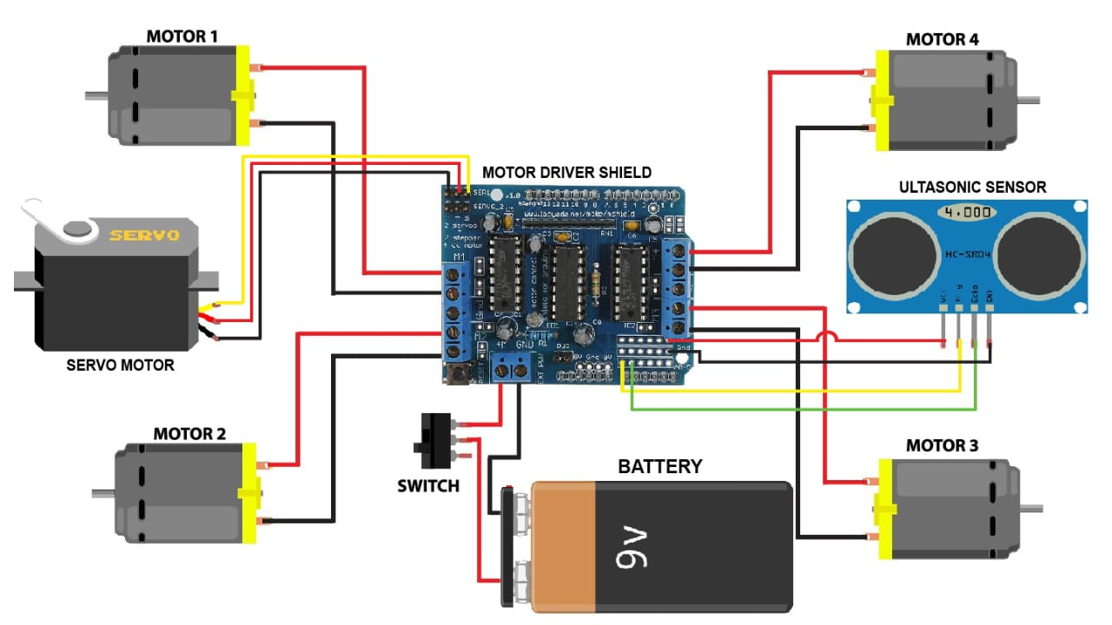

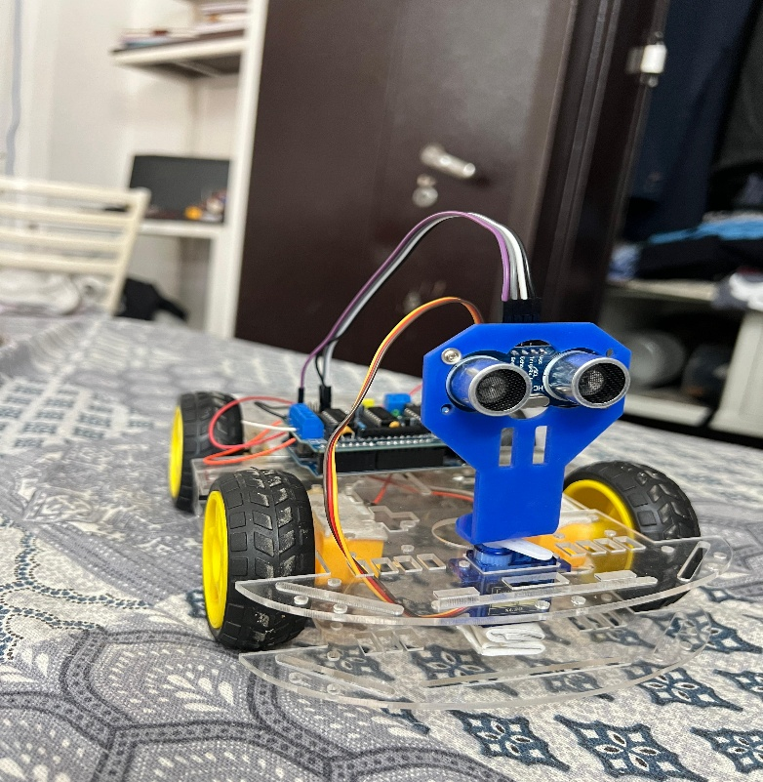

## Conclusion & Learnings

- **What did we learn?**

**Sensor Integration** plays an important role in real-time autonomous movement.

**Code Optimization** enhances response time and efficiency.

**Power Management** affects robot stability and operations.

**- Improvements And Next Steps:**

Implement **machine learning algorithms** for smarter obstacle detection.

Enhance mobility by using **servo motors** for improved rotation.

Develop **wireless control** for remote operations.

## References

1. **DIY Builder** YouTube channel.

2.Arduino Programming Guide **- Tech Robotics Publication.**

## Appendix

- **Code Snippet:**

#include <AFMotor.h>

#include <NewPing.h>

#include <Servo.h>

#define TRIG_PIN A0

#define ECHO_PIN A1

#define MAX_DISTANCE 200

#define MAX_SPEED 190 // sets speed of DC motors

#define MAX_SPEED_OFFSET 20

NewPing sonar(TRIG_PIN, ECHO_PIN, MAX_DISTANCE);

AF_DCMotor motor1(1, MOTOR12_1KHZ);

AF_DCMotor motor2(2, MOTOR12_1KHZ);

AF_DCMotor motor3(3, MOTOR34_1KHZ);

AF_DCMotor motor4(4, MOTOR34_1KHZ);

Servo myservo;

boolean goesForward=false;

int distance = 100;

int speedSet = 0;

void setup() {

myservo.attach(10);

myservo.write(115);

delay(2000);

distance = readPing();

delay(100);

distance = readPing();

delay(100);

distance = readPing();

delay(100);

distance = readPing();

delay(100);

}