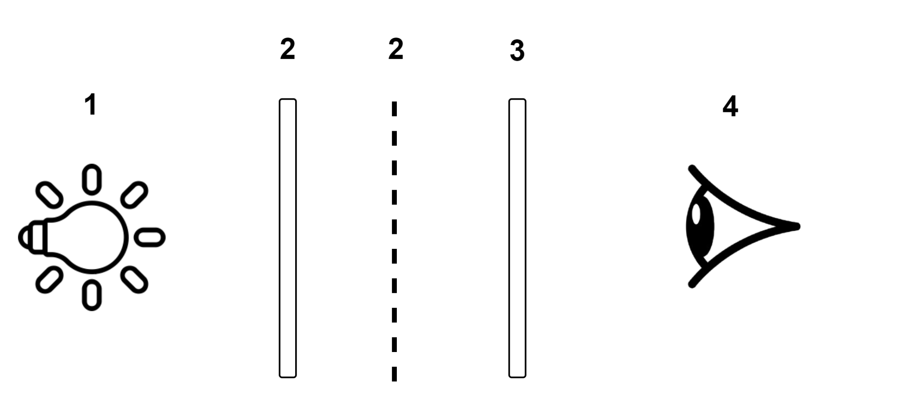

ELEMENTS

1.Light source

2.Transparent tape on top of Polarizer one

3.Polarizer two

4.Observer

According to the established concept, moving any of the elements 1, 2 or 3 changes the color or pattern that the observer(4) sees.

Depending on how the tape is placed on polarizer one, that shape or pattern stays the same but the color of that pattern changes depending on the movement of the elements (if you place the tape on the polarizer in a way that forms a cross shape, that shape stays the same as the other elements (1,3 or 4) move but the color of the cross changes)

This means when a custom pattern is created the shape and outliers stay the same but the color changes depending on movement of any of the elements.

Can we establish that in a control experiment,only our light source affects the color of the pattern and not ambient or external light.The color change of the pattern does not depend on any external light except ours.

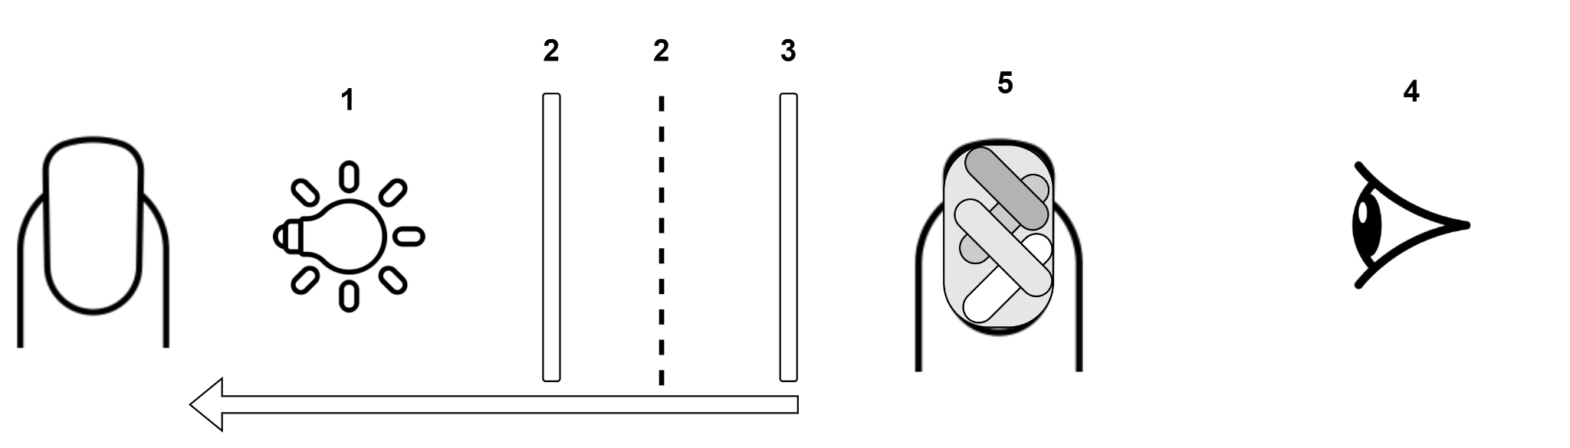

This is the intended setup:light source(nail polish that emits light) on the nail(1),transparent tape placed on the polarizer(2) to create a custom pattern,second polarizer(3) to enable the observer(4) see the pattern(5) created.

Can we also establish that when this is setup, all elements will be immobile except the observer.Moving the whole nail(5) or moving the observer(4) creates the same effect.

If the user is to use the phone’s front camera, the nail is placed in a static position facing the camera and the camera(or phone)is also static to perform the authentication.In that scenario,the shape of the pattern is static(as established earlier) and the color being observed also stays the same.

Now with that,if the phone is shifted or the nail is moved even slightly,the colors of the pattern might change but not the shape.Since the colors can change for a robust authentication system,we have to depend on the shape of the pattern created and not the colors.

Suggestions

1. I do not know if anyone has had breakthrough with the light source problem but so far we have the glow in the dark nail polish and I think we can start with that for the time being just to get things started.

Regardless of the light source, I think as part of our methodology we should create a control setup with a normal light and record our findings before transferring it to the nail.We can also say we did that to test our theory.

To Do:

Problems

Polarized nails

Ideas/ Modifications

Light source:

* Reflective nail polish where if you shine a light on it it shines back
* White Base on on nail or sheet
  + Make polarizer the nail and paint the polarizer white
  + Fake nail with white base and stack polarizer on top

Polarizer:

* Second polarized sheet will be on the phone rather than on the nail

Changed it to use authentication for single use at parties/events/concerts etc.