Exploratory Data Analysis of Factors Influencing Online News Engagement Using Data Science Techniques

Jasleen Kaur Bal
School of AI and Emerging Technologies
Lovely Professional University, Phagwara, Punjab, India
leenbal005@gmail.com
Veerpal Kaur
School of AI and Emerging Technologies
Lovely Professional University, Phagwara, Punjab, India
khaira.veerpal@gmail.com

Abstract- The rapid growth of digital news has increased the need to understand what drives audience engagement in the online media environment. This study presents an Exploratory Data Analysis (EDA) of the Online News Popularity dataset, which includes 39,644 articles published by Mashable, to identify the key factors influencing the social sharing behaviour of online news article. Using Python-based data analysis techniques such as statistical analysis, feature correlation, sentiment analysis, and topic related interpretation, the research examines 60 attributes related to content structure, the time of publication, the performance of specific keywords and text sentiment. The findings suggest that average keyword popularity, publishing channel, and weekend publication are among the strongest factors associated with higher engagement. Media articles specifically pertaining to social media and those that are published surrounding the weekends, tend to be shared more often while World News pieces have lower virality. The use of moderate subjectivity and a positive tone is found to improve shareability slightly as well according to the findings from sentiment analysis.
Statistical tests such as Welch’s t-test and one-way ANOVA also indicate statistically significant differences in engagement across publishing days and content categories. Overall, this research provides useful insight into online news virality and forms a meaningful foundation for future studies on predictive models of news popularity
Keywords: Online news popularity, exploratory data analysis, social media engagement, news virality, sentiment analysis, keyword analysis, LDA topic modelling,
- INTRODUCTION
The way people consume news has changed dramatically over the last ten years. Platforms like Facebook, Twitter and Instagram has become major source of information and online articles are no longer dependent only on editors to determine their visibility, as their reach is now largely influenced by how people choose to share them. This shift has created a biggest challenge in predicting the news popularity not only for news companies but also for advertisers, policy makers and content creators. Researches have already realized this earlier, Fernandes, Vinagre and Cortez [1] developed a system of predicting how popular a news article could be before publishing it. Using a dataset containing around 39,000 articles from Mashable, they found that keyword popularity, publishing day, and content category played an important role in predicting article popularity. Later on, studies on this topic get improved by applying more advanced machine learning techniques. For example, Tsai et al. [2] applied machine learning models such as Random Forest and XGBoost on the same dataset and reported high classification accuracy, while other studies using Gradient Boosting and AdaBoost reported accuracy levels between 73% and 79% [3].
Even though many studies have improved their prediction models, most of them focus directly on the machine learning instead of the inner pattern hidden in the data. Less attention has been given to what the dataset itself can reveal, such as which features are naturally linked with higher engagement, how the writing style of an article may affect its shareability, and whether publishing time or content category consistently influence article popularity. This is where Exploratory Data Analysis(EDA) plays a vital role. Therefore, instead of directly using features as input for a model, this study examined 39,644 articles in the Online News Popularity dataset through detailed statistical and visual analysis. By doing this, the study mainly aims to identify clear and easy to interpret insights about what makes online news more engaging which could be useful for both future prediction as well as decision making in digital journalism.
- LITERATURE REVIEW
Most of the researches have studied problem of online news popularity by using different data science and machine learning models. Most of these studies focused on predicting whether an article can become popular based on features such as performance of keyword, publication timing, article category, sentiment and content structure as well. A short summary of some related studies is presented in table

Table 1: Summary of Related Studies
Study | Method/Focus | Key Outcome/Gap
Fernandes et at.(2015) | Predictive modelling on Mashable dataset | Identified keyword popularity, publishing day and content category as important factors; limited focus on detailed exploratory interpretation
IEEE-based studies (2018) | Gradient Boosting and AdaBoost | Achieved moderate to high classification accuracy; limited explanation of feature influence
Tsai et al. (2022) | Random Forest, XGBoost and other ML models | Reported high prediction accuracy; more emphasis on model performance than data-level understanding
Sentiment-focused studies | Sentiment and text-based analysis | Suggested tone and subjectivity may affect sharing behaviour; often used mainly for prediction
Content virality studies | Statistical and feature-based analysis | Showed topic, timing and writing style can influence virality; less focus on EDA-based interpretation

- PROPOSED WORK
This study uses Exploratory Data Analysis(EDA) to understand the factors that affect how online news article got shared. Hence, instead of focusing directly on making prediction models this study first analyse data to find the patterns which are hidden and relationships. The main goal is to identify which features such as article content, timing, keywords and sentiments have a stronger impact on increasing the number of shares.
The proposed word uses Python based data science techniques in order to perform some steps like data cleaning, feature level exploration, statistical testing and visual analysis. Using this approach, this study aims to generate a better, clear and easy to interpret insights into how factors like publication timing , content category, keyword performance and sentiment characteristics can have an influence on the popularity of online news articles. The finding of this study can be useful for future predictive modelling as well as for practical decision making in digital news and strategies based on online content.
- DATA DESCRIPTION
The Online News Popularity dataset is used for this study. This dataset include a lot of information about news article from Mashable, a very popular digital media platform. The data was collected by Fernades, Vinagre and Cortez in 2015 which was available to public through UCI Machine Learning Repository[4]. It has information all about news article from January 2013 to January 2015 which is total of 39644 articles. This dataset is very useful as it does not have text of the articles and also it contains a lot of information of about each article like how it is written, when it was published and what it is about what keywords are used and how language make people to feel it.
The target variable which is used in this dataset shows the number of shares that individuals get on their social media platforms, which directly shows the level of involvement and popularity of the particular content. For example, on average each article receive 3395 shares; however, such information could be misleading due to uneven distribution of shares means some articles got viral while some receive very less engagement. Additionally, the minimum share value was equal to one while the maximum equals more than 843000 shares, that indicate the degree of unpredictability associated with the topic under discussion. Hence, all 60 independent variables are involved in this dataset that can be categorized in five groups including- content features (for example, number of words in the title and body, number of pictures, videos, and links in an article), keyword features(for example, average keyword popularity, number of keyword used), temporal features(i.e. the day when article was published, weekday/weekend variable), channel/category(i.e. whether article cover Technology,Business, Entertainment,Lifestyle, Social Media) and NLP-based Sentiment features(i.e. global sentiment polarity, subjectivityand rate of negative and positive words). Both give comprehensive picture of what an article looks like before it reaches audience – making this dataset ideal.
- METHODOLOGY
This study follow step by step approach to understand the Online News Popularity dataset using Python tools. Instead of directly jumping into prediction models, the main focus was to explore data and analyze it . This idea went from basic understanding to deep insights, therefore things become clear not confusing. For this, python libraries like pandas[5] and NumPy were used for data handling data, whereas Matplotlib[6] and seaborn helped in visualizing patterns, and SciPy was used in testing.
Firstly, the dataset was loaded and checked things like shape, data types, missing values and duplicates. It turned out dataset is already clean, with not missing values in 39644 records. Then , the target variable “shares” was analyzed. Its distribustion was highly rightly-skewed means most articles had less shares while other went very high, so far transformation was needed to understand it better.
After that, content related features like article length, number of images, videos, and links was explored using basic stats and plots. Some sentiment and language features also checked to see there shares using correlation. Then, time based patterns were studied by using comparison of shares across different days and categories. Keyword features were also considered to see their effect on engagement.
- RESULTS AND ANALYSIS
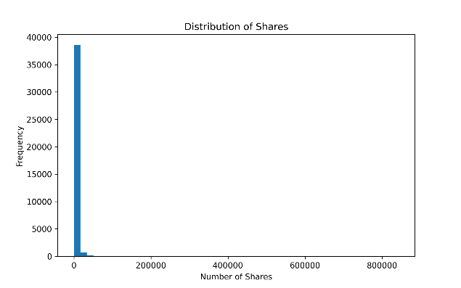
- Target Variable Analysis
Table 2: Distribution of Shares
Figure 1 Distribution of Shares
Fig. 1 shows that share distribution is not normal at all, it is rightly skewed. Basically, most of the articles get low engagement and few get higher in terms of popularity. The difference between mean and median also points towards this, as mean is around 3395 while median is only 1400 which shows some extreme values which are pulling average up.
- Content Feature Analysis
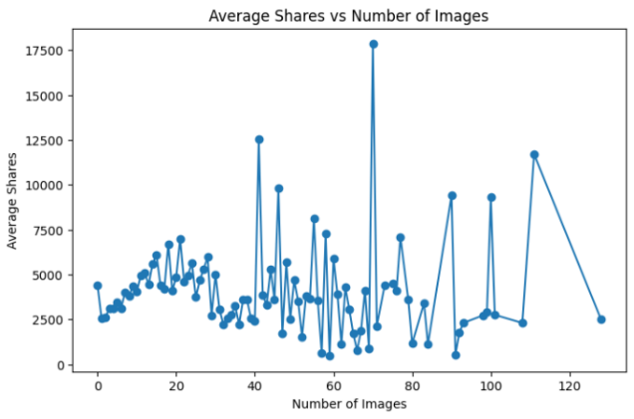
Figure 2. shows that articles published on weekends, particularly Saturday and Sunday, receive higher average shares compared to weekdays.
From this content side, the average title is almost 10 words and article length has cover near about 547 words.There is a big difference between sharing of images and articles as articles having more images (like 6-9) get around 1800 median shares whereas articles with no images stay near 1300. Therefore, images help in engagement.
Additionally, having some good amount of links and keywords improve in sharing which is not too much visible but still can be noticed. However, videos does not show proper pattern, sometimes they help not always. As video content takes more time to watch so people don’t like to share it.
C. Sentiment Analysis Results
By looking at sentiment features, most of the Mashable articles have positive tone. The average polarity is almost 0.119 and subjectivity is about 0.443 which is not too much. When it is compared with shares it shows that relationship is very weak. For example, subjectivity has small correlation(0.032), still statistically significant as emotional or opinion based content might get more shares.
Also, positive words are used instead of negatives words, with average of 0.682 vs 0.288. titles are mostly neutral but small changes in tone can affect how catchy they feel. Overall, sentiment does have impact on popularity of content.
- Temporal and Channel Analysis
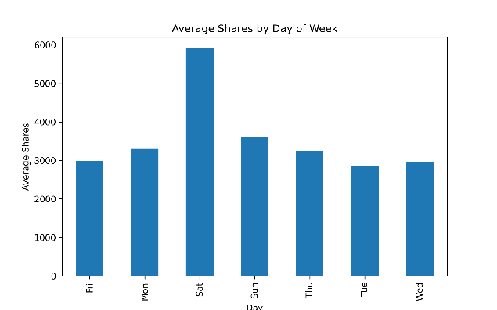
Figure 3. Average Shares by Day of Week
Publishing timing also affect news engagement. Articles pospted on weekends like on Saturdays and Sundays, get higher median shares around 2,000 and 1,900, whereas weekday articles stay between 1,300 and 1,500. It makes sense because people are more free on weekends.
The t-test also supports this, as tt=3.60 and p-value 0.0003, so this difference is not random. Looking at content, social media articles perform best like 2100 median share and Lifestyle and Technology about 1700. World news is lowest at 1100 maybe because it’s more serious.
- Keyword and Correlation Analysis
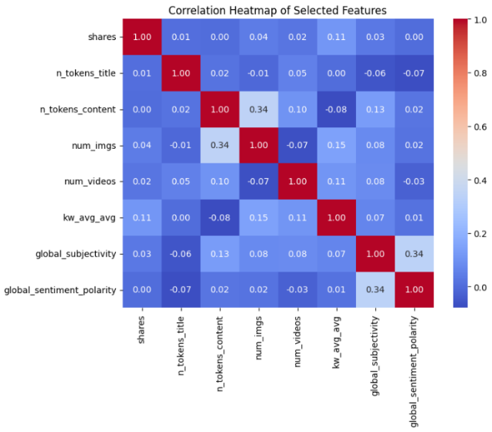
Figure 4. Correlation Heatmap of Selected Features
Among all features, the average keyword popularity score (kw_avg_avg) shows the strongest positive correlation with shares, with a Pearson r of 0.110 (p < 0.01). This means that articles built around keywords that are popular and get more shares.
Self-referencing features, it measures some moderate effect if an article connects with any Mashable articles, it performs better, as it stays in same content. From topic analysis, Topic 3 is positively linked with shares(0.084) while Topic 2 is negative(-0.059).Therefore, heatmap overall shows no single feature dominating, it’s mixture iof things like keyword, timing,content type and sentiment.
VII. DISCUSSION
The findings are somewhat similar to what earlier research has shown. For example, keyword importance (kw_avg_avg) again comes out as one of the stronger factors, which was also mentioned in Fernandes et al.[1]. Publishing time and content category also follow expected patterns, so nothing very surprising there. But instead of just focusing on model results, this study tries to actually understand the data step by step, which makes the insights a bit more practical.
Like the weekend effect — it’s not just statistically significant, it actually tells something useful. Posting on weekends can give better reach since people are more active and relaxed. Another thing is sentiment. Even though it shows significance, its actual impact is quite low. So just making content emotional doesn’t guarantee shares. It’s more about the overall mix — topic relevance, keywords, timing and type of content all together.
At the same time, there are some limitations too. The dataset is only from Mashable and from a limited time period, so results may not fully apply everywhere. Also, online trends keep changing, so what worked earlier may not always work the same now. Overall, news popularity doesn’t depend on one single factor, it’s more like multiple small things combined.
- CONCLUSION
This study was mainly done to understand what actually makes online news articles get more engagement, using the Mashable dataset with around 39,644 articles. By doing proper EDA — like basic stats, graphs, sentiment checking and some statistical tests — a few clear patterns came out. Articles with popular keywords, posted on weekends, and related to social media or lifestyle topics generally got more shares. Sentiment also had some effect, like slightly positive and a bit subjective content doing a little better. Topic analysis also showed that some topics naturally perform better than others.
The main point from all this is that virality is not dependent on just one thing. It’s more like a mix — content quality, keywords, timing and even emotional tone all together play a role. For future work, these insights can help in building better ML models, especially by focusing on features like keywords, day of publishing and category. Also, it’s useful for content creators or journalists, since it gives a rough idea of what works better instead of just guessing
IXREFERENCES
[1] K. Fernandes, P. Vinagre, and P. Cortez, “A proactive intelligent decision support system for predicting the popularity of online news,” in Proc. 17th EPIA Conference on Artificial Intelligence, Coimbra, Portugal, 2015, pp. 535–546.
[2] M. J. Tsai et al., “Predicting online news popularity based on machine learning,” Computers and Electrical Engineering, vol. 103, 2022, doi: 10.1016/j.compeleceng.2022.108319.
[3] IEEE, “News popularity prediction with ensemble methods of classification,” in Proc. IEEE International Conference, 2018, doi: 10.1109/ICOSC.2018.8494095.
[4] UCI Machine Learning Repository, “Online News Popularity Data Set,” University of California, Irvine. [Online]. Available: https://archive.ics.uci.edu/ml/datasets/Online+News+Popularity
[5] W. McKinney, “Data Structures for Statistical Computing in Python,” in Proc. 9th Python in Science Conference, 2010, pp. 51–56. (Pandas library)
[6] J. D. Hunter, “Matplotlib: A 2D graphics environment,” Computing in Science & Engineering, vol. 9, no. 3, pp. 90–95, 2007.

