GURU NANAK DEV ENGINEERING COLLEGE LUDHIANA

PROGRAMMING FOR PROBLEM SOLVING

PRACTICAL FILE



SUBMITTED TO SUBMITTED BY

RANJODH MAM JASLEEN KAUR

1905345

INFORMATION TECHNOLOGY

PROGRAM 1:

TO CONVERT TEMPERATURE FROM FAHRENHEIT TO CELSIUS

Codeing

#include<stdio.h>

int main()

{ float celsius,fahrenheit;

printf("\n enter temperature in fahrenheit:");

scanf("%f",&fahrenheit);

celsius=(fahrenheit-32)*5/9;

printf("\n temperature in celsius is %f",celsius);

return(0); }

output

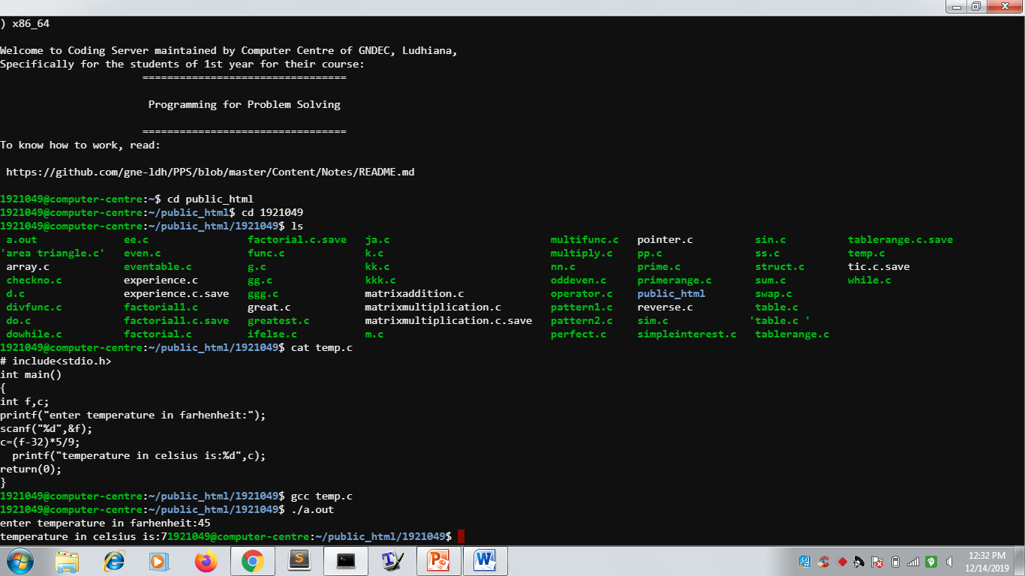

Program 2:

TO PRINT A TABLE BY USERS CHOICE

CODEING

|  |
| --- |
| #include<stdio.h> |
|  |
|  |  |
|  | int main() |
|  | { |
|  | int i,n; |
|  | printf("enter a number:"); |
|  | scanf("%d",&n); |
|  | for(i=1;i<=10;i++) |
|  | printf("%d X %d=%d \n",n, i, n*i); |
|  | return(0); |
|  | } |

OUTPUT

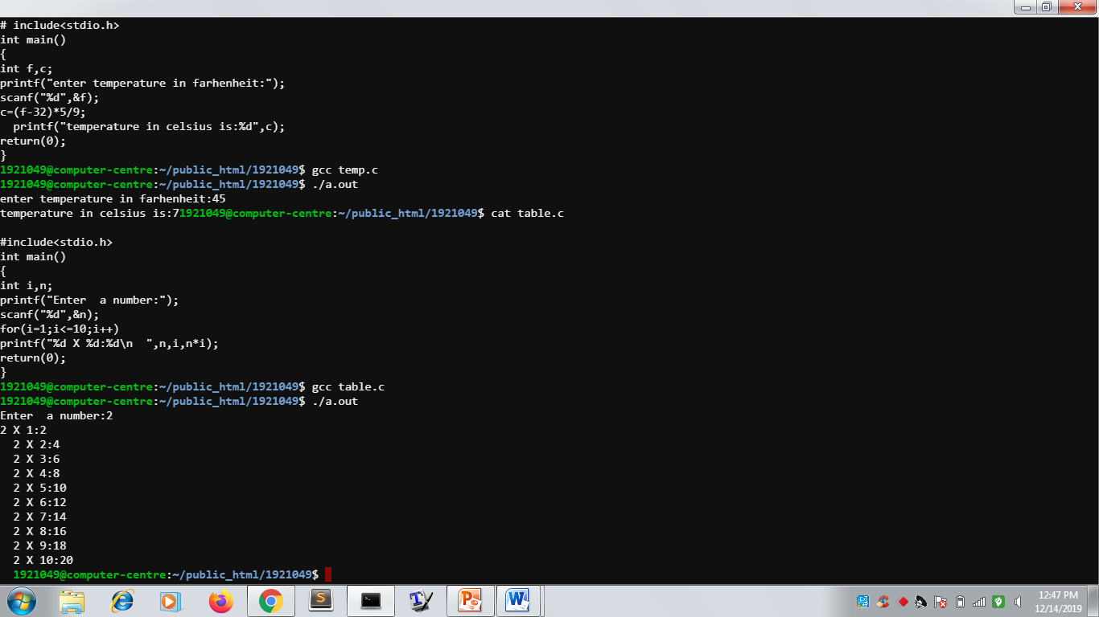

Program 3:

To choose different operators and perform different functions

Codeing

#include<stdio.h>

int main()

{

int a,b; char i;

printf("Enter value of a and b:");

scanf("%d%d", &a ,&b);

printf("Enter operator:");

scanf("%c", &i);

switch(i)

{

case '+':

printf("%d",a+b);

break;

case '-':

printf("%d",a-b);

break;

case '*':

printf("%d"a*b);

break;

case '/':

printf("%d",a/b);

break;

case '%':

printf("%d",a%b);

break;

default:

printf("Sorry wrong entry");

return(0);

}

OUTPUT

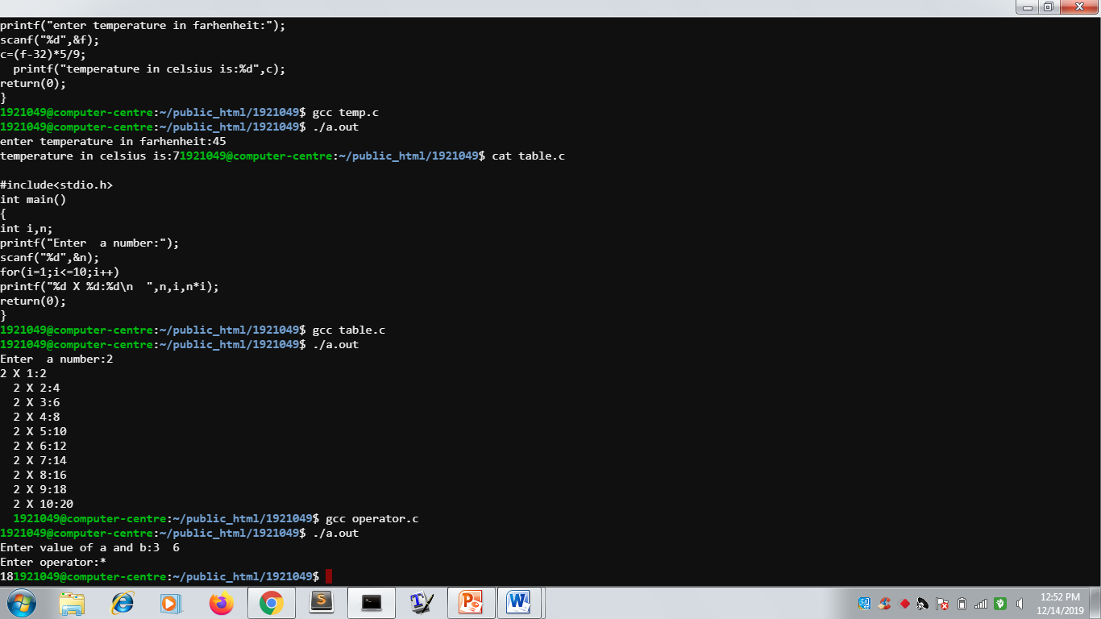

PROGRAM 4:

TO PRINT TABLE OF EVEN NUMBERS

CODEING

#include<stdio.h>

int main()

{

int i,n;

printf("Enter a number:");

scanf("%d",&n);

if(n%2==0);

{

for(i=1;i<=10;i++)

{

printf("%d X %d=%d\n",n,i,n*i);

}

}

else

printf("Not an even number");

return(0);

}

OUTPUT

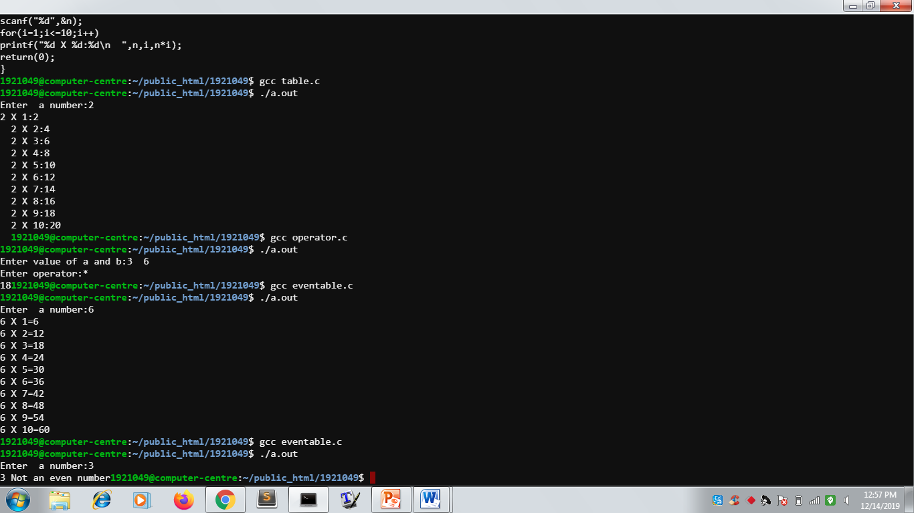

Program 5:

To check whether a number is positive or negative

Codeing

#include<stdio.h>

int main()

{

int n;

printf("Enter a number:");

scanf("%d",&n);

if(n>0)

printf("number is positive");

else

printf("number is negative");

return(0);

}

output

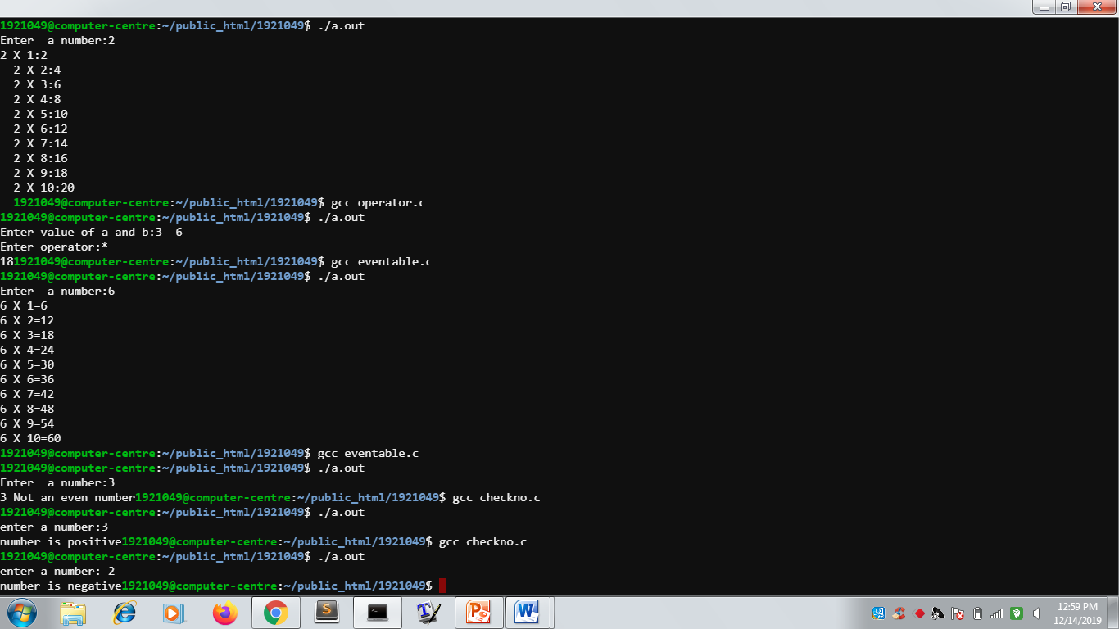

Program 6:

To check a number is even or odd

Codeing

#include<stdio.h>

int main()

{

int n;

printf("Enter a number");

scanf("%d",&n);

if(n%2==0);

printf("Number is even");

else

printf("Number is odd");

return(0);

}

Output

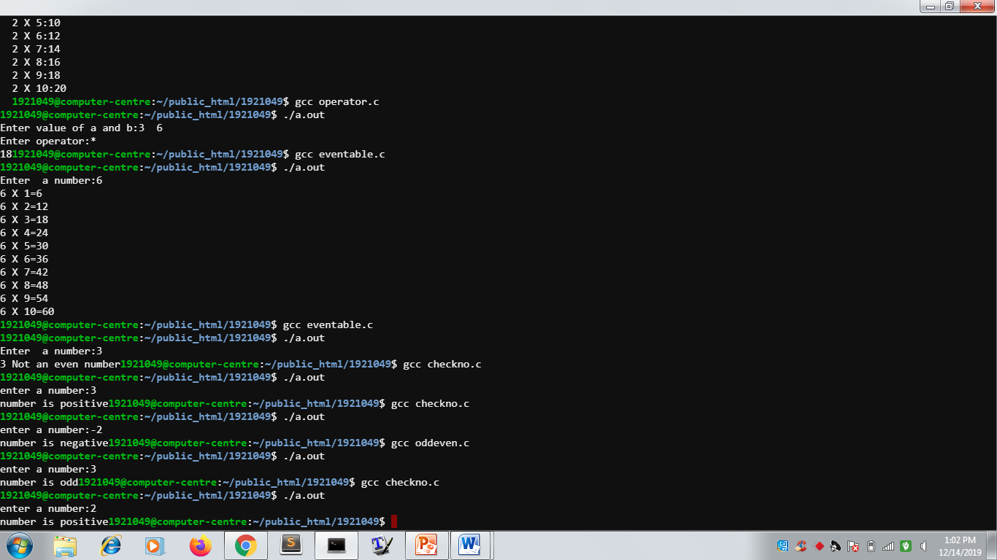

Program 7:

To find factorial of a number of user’s choice

Codeing

#include<stdio.h>

int main()

{

int n,i,fac=1;

printf("Enter a number:");

scanf("%d",&n);

{

for(i=1;i<=n;i++)

fac=fac*i;

printf("%d is factorial of %d",fac,n);

}

return(0);

}

Output

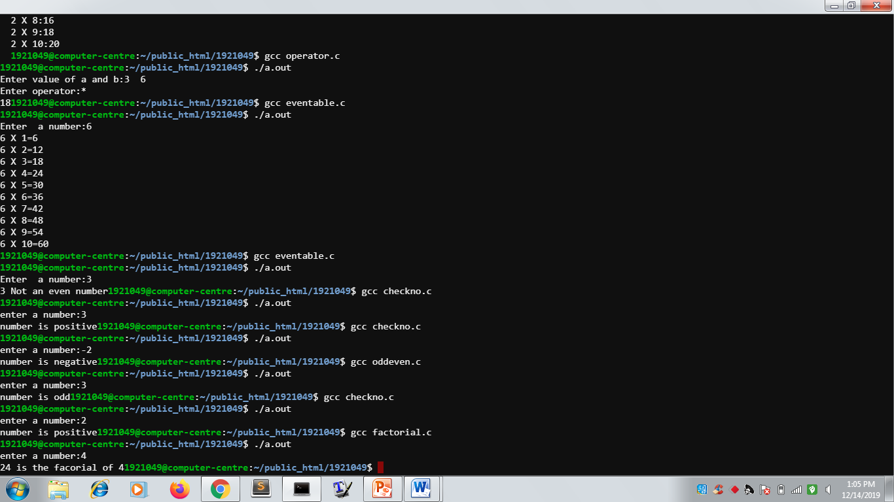

Program 8:

To find factorial of a number by recursion

Codeing

#include<stdio.h>

int multiplynumbers(int n)

int main()

{

int n;

printf("Enter a positive number:");

scanf("%d",&n);

printf("Factorial of %d=%d",n,multiplynumbers(n));

return(0);

}

int multiplynumbers(int n)

{

if(n>=1)

return n*multiplynumbers(n-1);

else

return 1;

}

Output

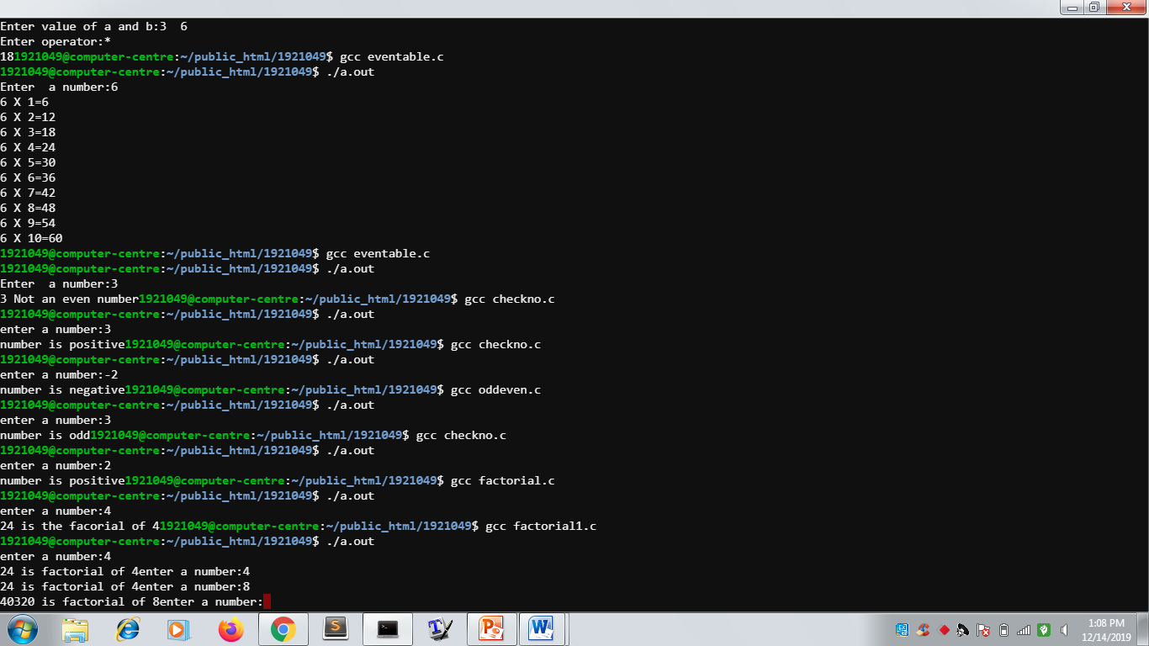

Program 9:

To check whether a number is prime or not

Codeing

#include<stdio.h>

int main()

{

int n,i,p;

printf("\n enter n value:");

scanf("%d",&n);

{

for(i=2;i<n;i++)

if(n%i==0)

p=1;

}

if(p==1)

printf("number is not prime");

else

printf("number is prime");

return(0);

}

Output

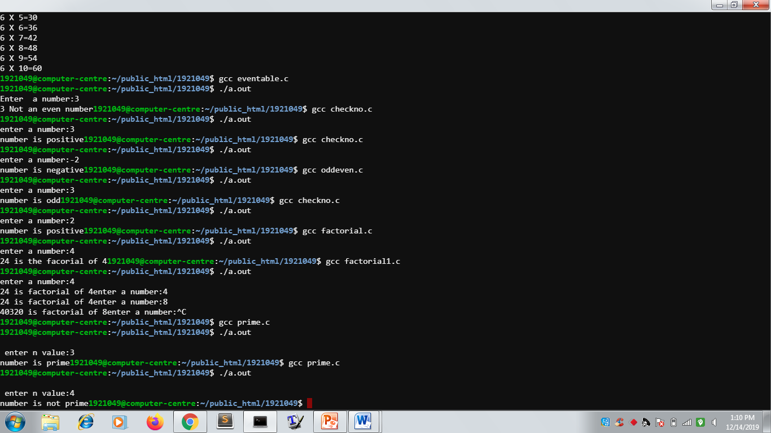

Program 10:

To check prime numbers in a given range

Codeing

#include<stdio.h>

int main()

{

int i,j,s,e,p;

printf("Enter a starting number:");

scanf("%d",&s);

printf("Enter ending number:");

scanf("%d”,&e);

for(i=s;i<=e;i++)

{

p=0;

for(j=2;j<i;j++)

{

if(i%j==0)

{

p=1;

}

}

if(p==1)

printf("\n %d are not prime",j);

else

printf("\n %d are prime",j);

}

return(0);

}

Output

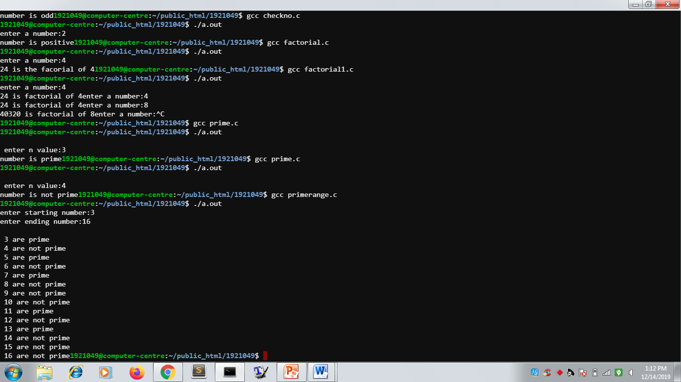

Program 11:

To add two matrices of users choice

Codeing

#include<stdio.h>

int main()

{

int m,n,c,d,first[10][10],second[10][10],sum[10][10];

printf('Enter a number of rows and columns of matrices:");

scanf("%d%d,&m&n);

printf("Enter elements of first matrix\n");

for(c=0;c<m;c++)

for(d=0;d<n;d++)

scanf("enter elements of second matrix\n");

for(c=0;c<m;c++);

for(d=0;d<n;d++);

scanf("%d",&second[c][d]);

printf("sum of entered matrices:\n);

for(c=0;c<m;c++)

{

for(d=0;d<n;d++)

{

sum[c][d]=first[c][d]+second[c][d]);

}

printf("\n");

return(0);

}

Output

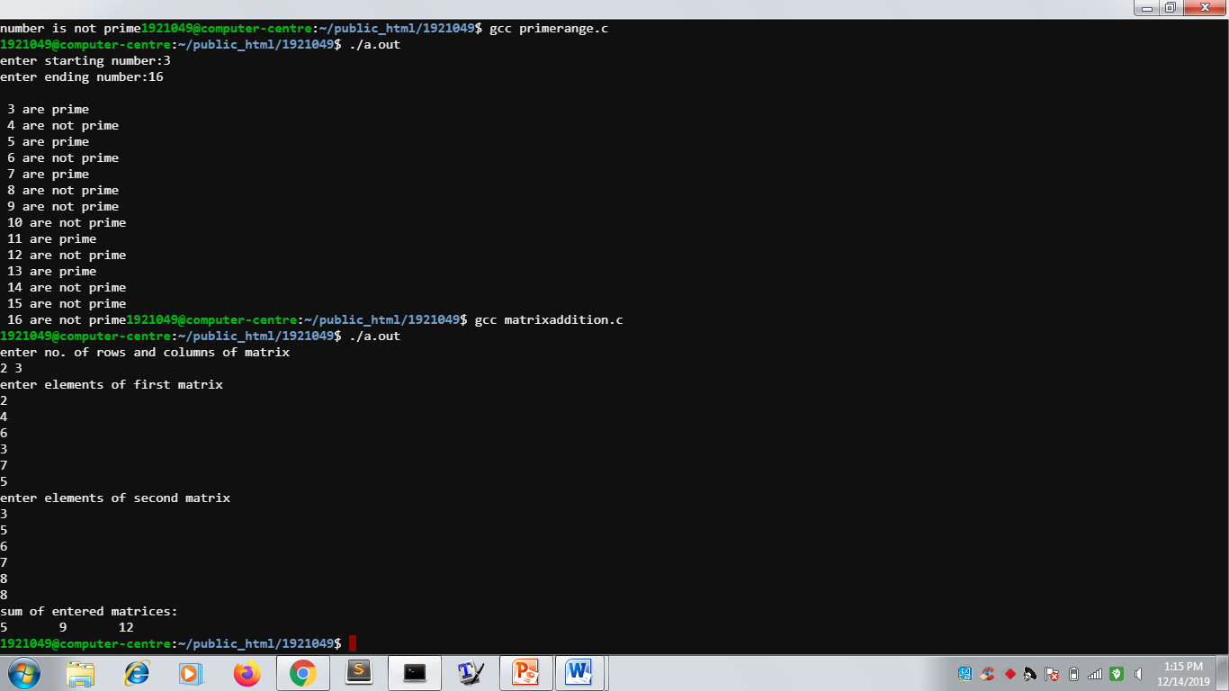

Program 12:

To multiply two matrices of users choice

Codeing

#include<stdio.h>

int main()

{

int matA[2][3], matB[3][4],matR[2][4];

int i,j,k;

printf("Enter elements of 1st matrix 2x3\n");

for(i=0;i<2;i++)

{

for(j=0;j<3;j++)

{

scanf("%d",&matA[i][j]);

}

}

printf("Enter elements of 2nd matrix 3x4\n");

for(i=0;i<3;i++)

{

for(j=0;j<4;j++)

{

scanf("%d",&matB[i][j]);

}

}

for(i=0;i<2;i++)

{

for(j=0;j<4;j++)

{

matR[i][j]=0;

}

}

for(i=0;i<2;i++)

{

for(j=0;j<4;j++)

{

for(k=0;k<3;k++)

matR[i][j]=matA[i][j]+matR[i][k]*matB[k][j];

}

}

}

printf("Matrix multiplication is \n");

for(i=0;i<2;i++)

{

for(j=0;j<4;j++)

{

printf("%d\t",matR[i][j]);

}

printf("\n");

}

return(0);

}

Output

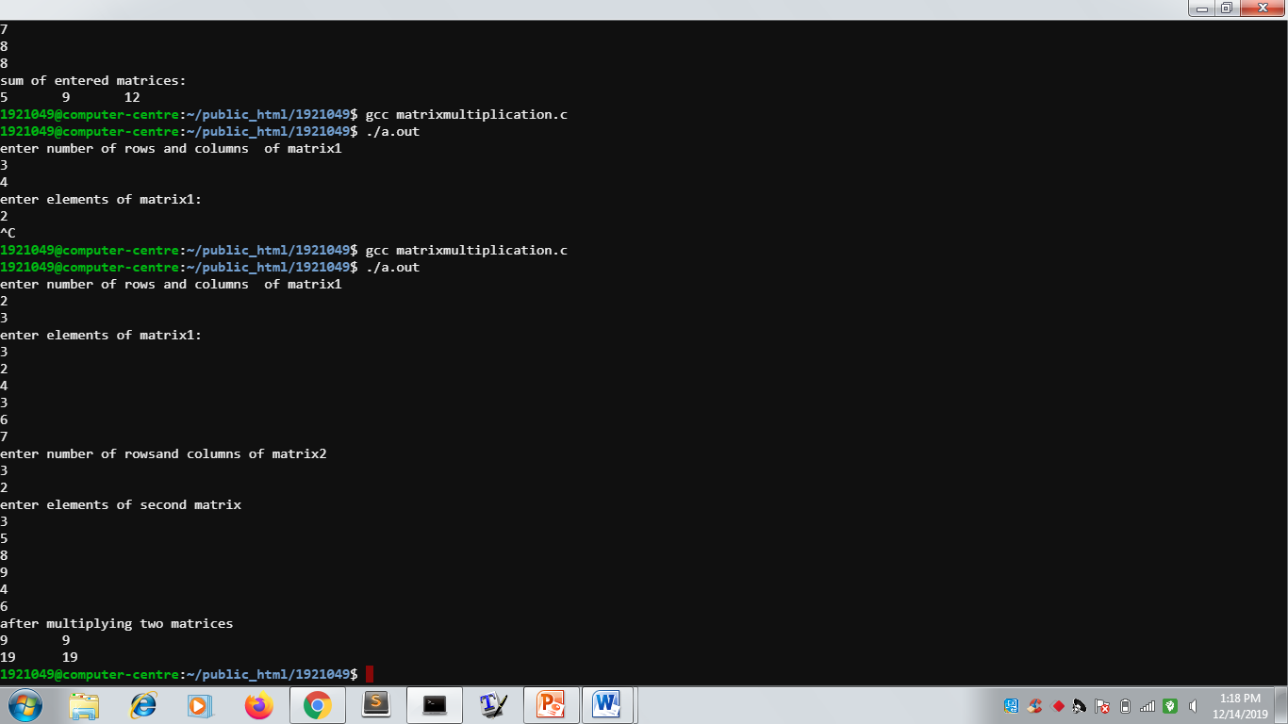

Program 13:

To reverse a given number by user

Codeing

#include<stdio.h>

int main()

{

int n, reversednumber=0,remainder;

printf("Enter an integer:");

scanf("%d",&n);

while(n!=0)

{

remainder=n%10;

reversednumber=reversednumber*10+remainder;

n/=10;

}

printf("Reversed number=%d",reversednumber');

return(0);

}

Output

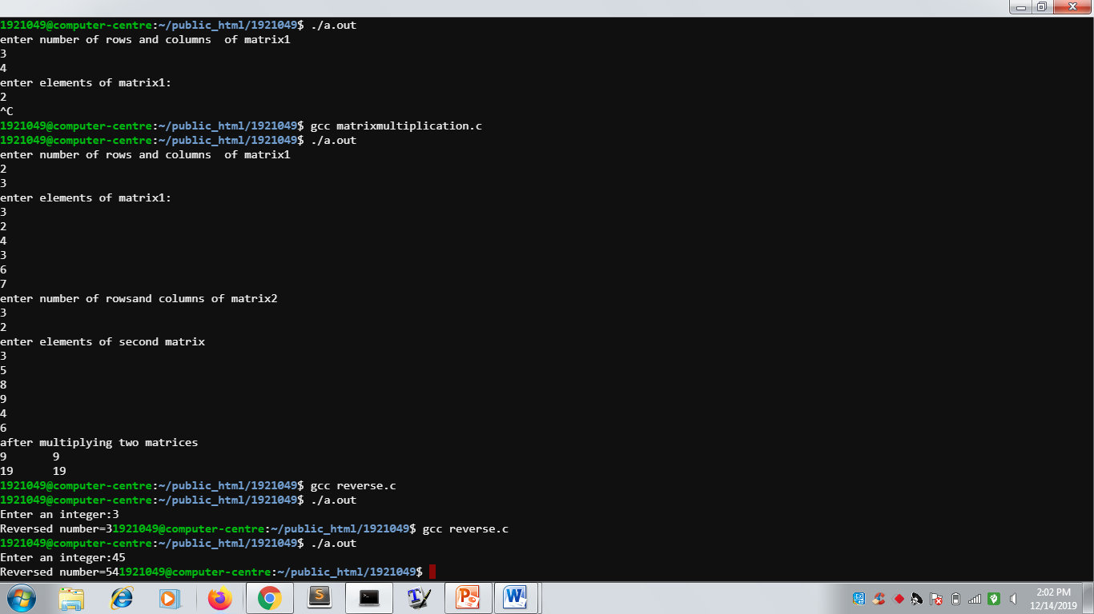

Program 14:

To swap two numbers given by user

Codeing

#include<stdio.h>

int main()

{

int a,b;

printf("\n enter value of a:");

scanf("%d",&a);

printf("\n enter value of b:");

scanf("%d",&b);

a=a-b;

b=a+b;

a=b-a;

printf("\n after swapping value of a:%d",a);

printf("\n after swapping value of b:%d",b);

return(0);

}

output

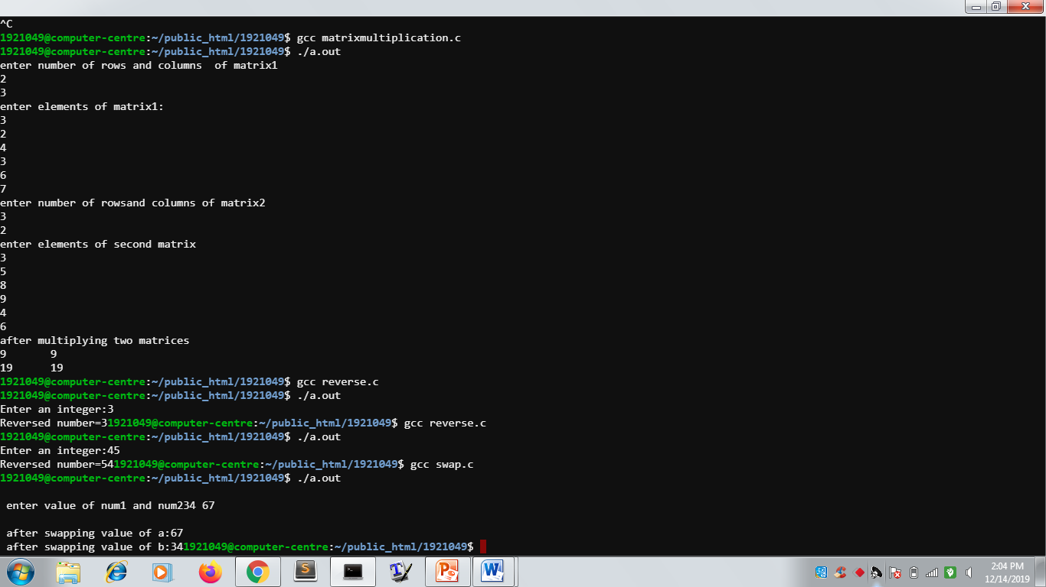

Program 15:

To check a number greatest in an array

Codeing

#include<stdio.h>

int main()

{

int a[10];

int i;

int greatest;

printf("Enter ten values:");

for(i=0;i<10;i++)

{

scanf("%d",&a[i]);

}

greatest=a[0];

for(i=0;i<10;i++)

{

if(a[i]>greatest)

{

greatest=a[i];

}

}

printf("Greatest of ten numbers is %d",greatest);

return(0);

}

output

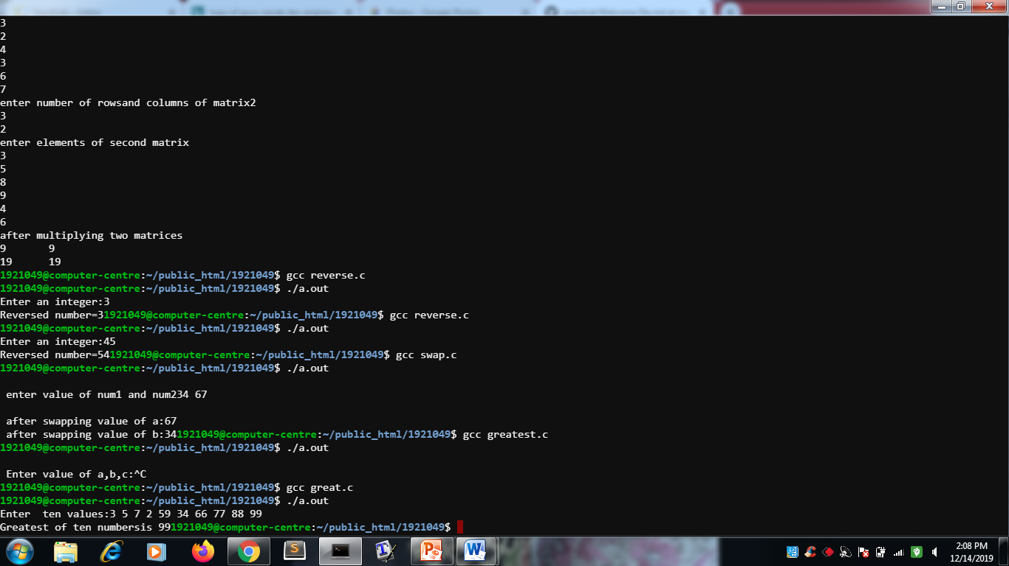

Program 16:

If –else statement example

codeing

#include<stdio.h>

int main()

{

int a=100;

if(a==10)

{

printf("value of a is 10\n");

}

else if(a==20)

{

printf("value of a is 20\n");

}

else

{

printf("none of the value matches\n");

}

printf("exavt vaue of a is:%d\n",a);

return(0);

}

Output

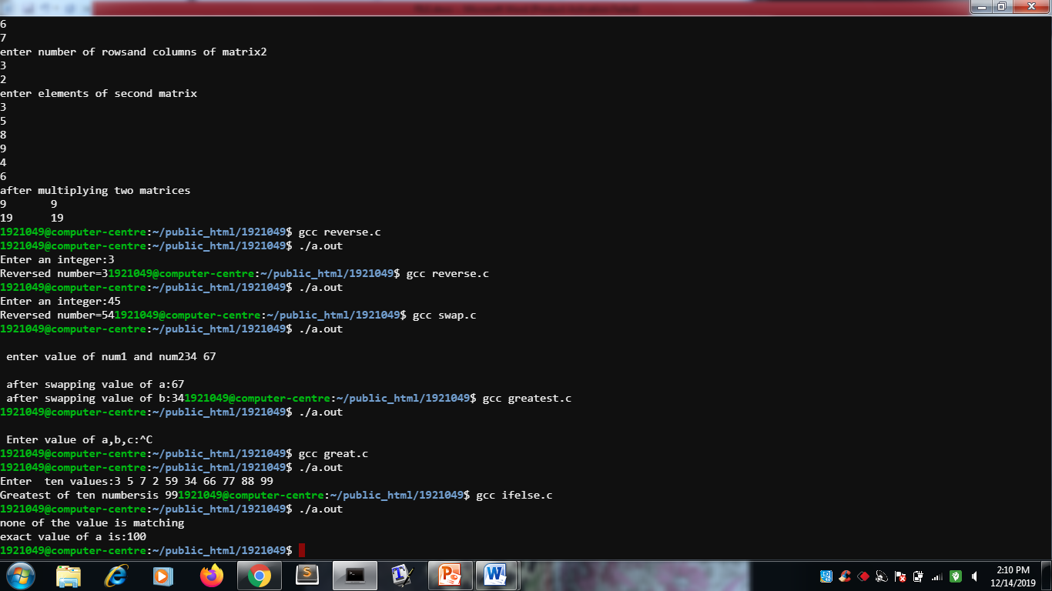

Program 17:

To examine experience of employees

Codeing

#include<stdio.h>

struct employee

{

char name[30];

int empid;

float salary;

};

int main()

{

struct employee emp;

printf("\n Enter details:");

printf("Name:");

gets(emp.name);

printf("id");

scanf("%d",&emp.empid);

printf("salary:");

scanf("%f,&emp.salary);

printf("\n Entered details is:");

printf("Name:%s", emp.name);

printf("id:%d", emp.empid);

printf("salary:%f\n",emp.salary);

return(0);

}

Output

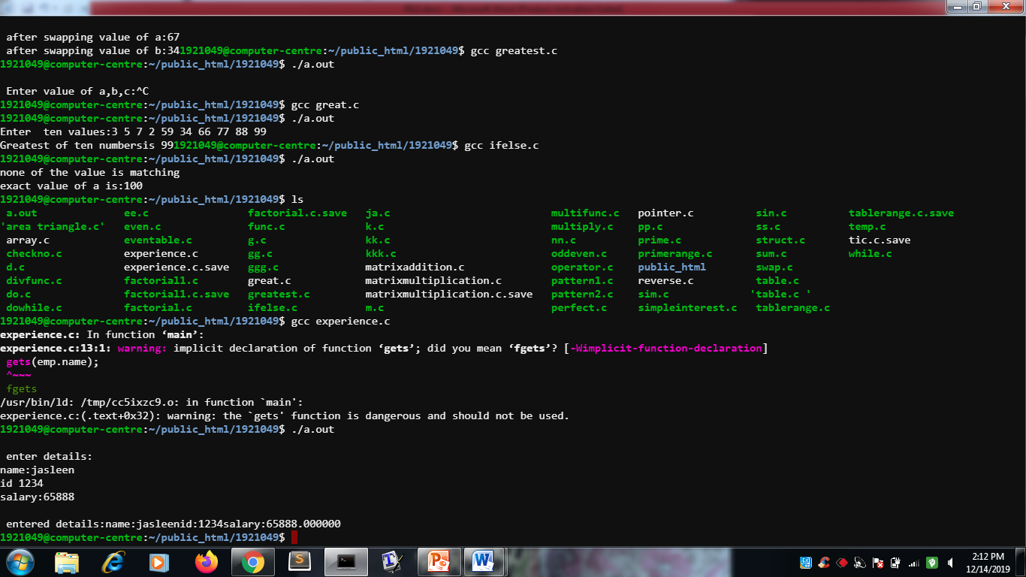

Program 18:

To print pattern

#include<stdio.h>

int main()

{

int i,j,rows;

printf("Enter number of rows:");

scanf("%d",&rows);

for(i=rows;i>=1;--i)

{

for(j=1;j<=i;++j)

{

printf("*");

}

printf("\n");

}

return(0);

}

Output

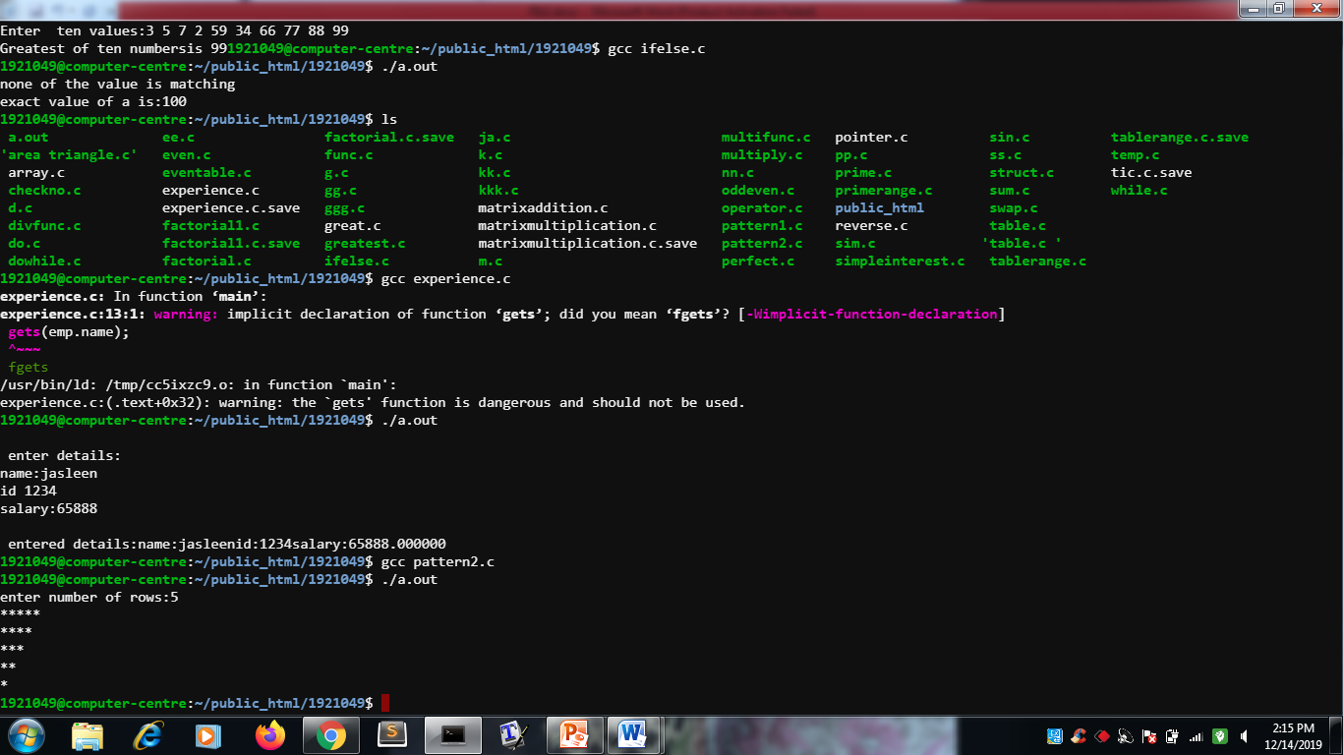

Program 19:

To print pattern

codeing

#include<stdio.h>

int main()

{

int i,j,rows;

printf("Enter no. of rows");

scanf("%d",&rows);

for(i=1;i<=rows;i++)

{

for(j=1;j<=i;j++)

{

printf("*");

}

printf("\n");

}

return(0);

}

Output

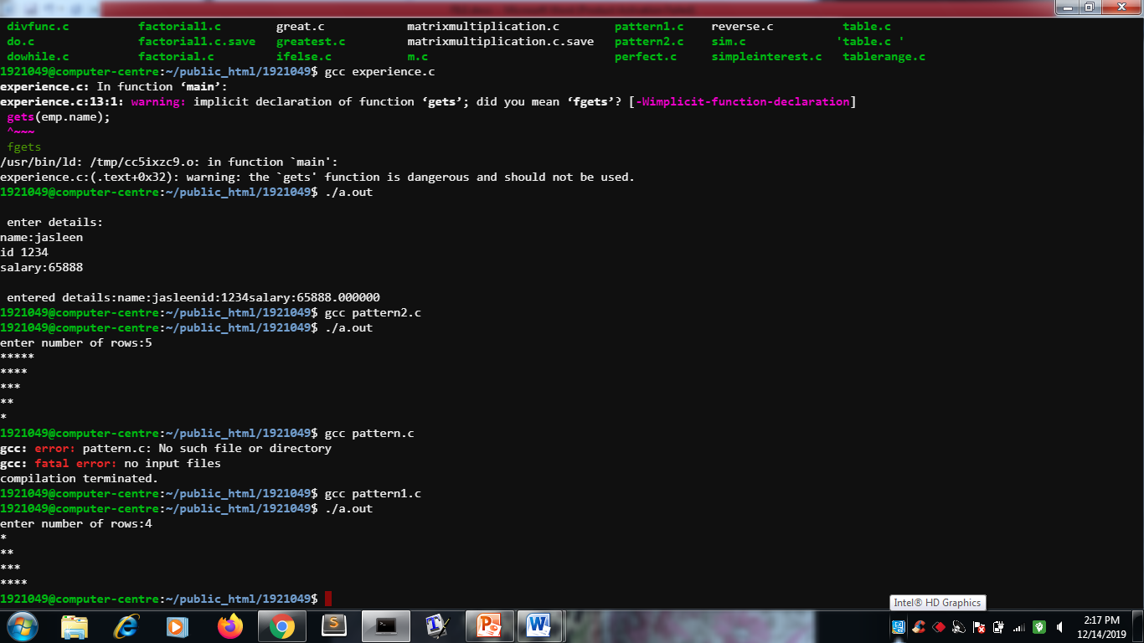

Program 20:

To separate even array and odd array

codeing

#include<stdio.h>

#define MAX_SIZE 1000

void printArray(int arr[],int len);

int main()

{

int arr[MAX-SIZE];

int even[MAX-SIZE],odd[MAX-SIZE];

int evencount, oddcount;

int i,size;

printf("Enter size of the array:");

scanf("%d",&size);

printf("Enter elements in the array:");

for(i=0;i<size;i++)

{

scanf("%d",&arr[i]);

}

evencount=0;

oddcount=0;

for(i=0;i<size;i++)

{

if(arr[i]&1)

{

odd[oddcount]=arr[i];

oddcount++;

}

else

{

even[evencount]=arr[i];

evencount++;

}

}

printf("\n Elements of even array:\n");

printArray(even,evencount);

printf("\n Elements of odd array:\n");

printArray(odd,oddcount);

return(0);

}

void printArray(int arr[],int len)

{

int i;

printf("Elements in the array:");

for(i=0;i<len;i++)

{

printf("%d",arr[i]);

}

printf("\n");

}

Output

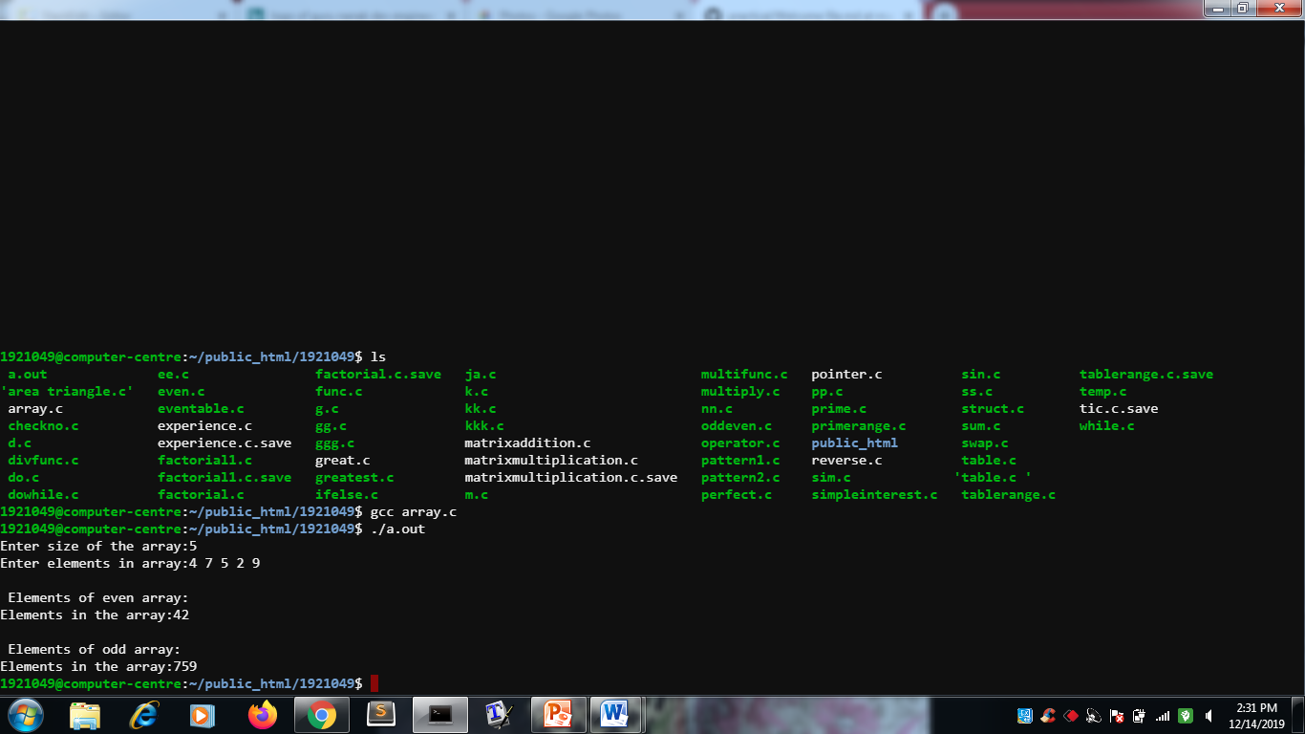

Program 21:

Program to print fibonnaci series by users choice

Codeing

#include<stdio.h>

int main()

{

int n,first=0,second=1,next,c;

printf("Enter value of n:");

scanf("%d",&n);

printf("first %d terms of fibanacci series:",n);

for(c=0;c<n;c++)

{

if(c<=1)

next=c;

else

next=first+second;

first=second;

second=next;

}

printf("%d",next);

return(0);

}

Output

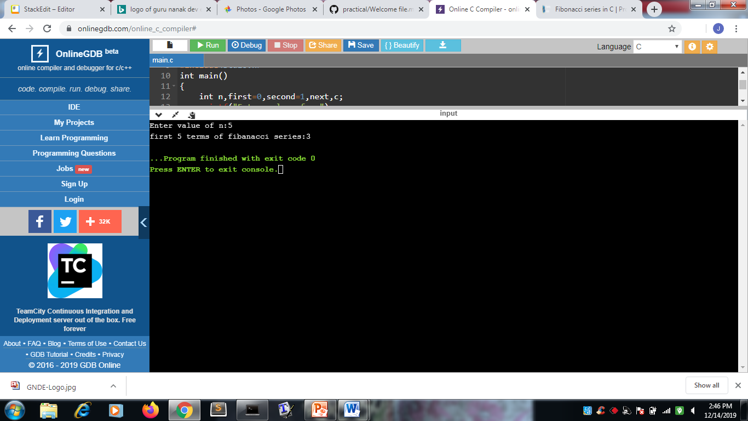

Program 22:

Program for finding Ackermann function

Codeing

#include<stdio.h>

int A(int m,int n);

void main()

{

int m,n;

printf("Enter two numbers:");

scanf("%d%d",&m,&n);

printf("\nOutput::%d\n",A(m,n));

}

int A(int m,int n)

{

if(m==0)

return n+1;

else if(n==0)

return A(m-1,1);

else

return A(m-1,A(m,n-1));

}

output

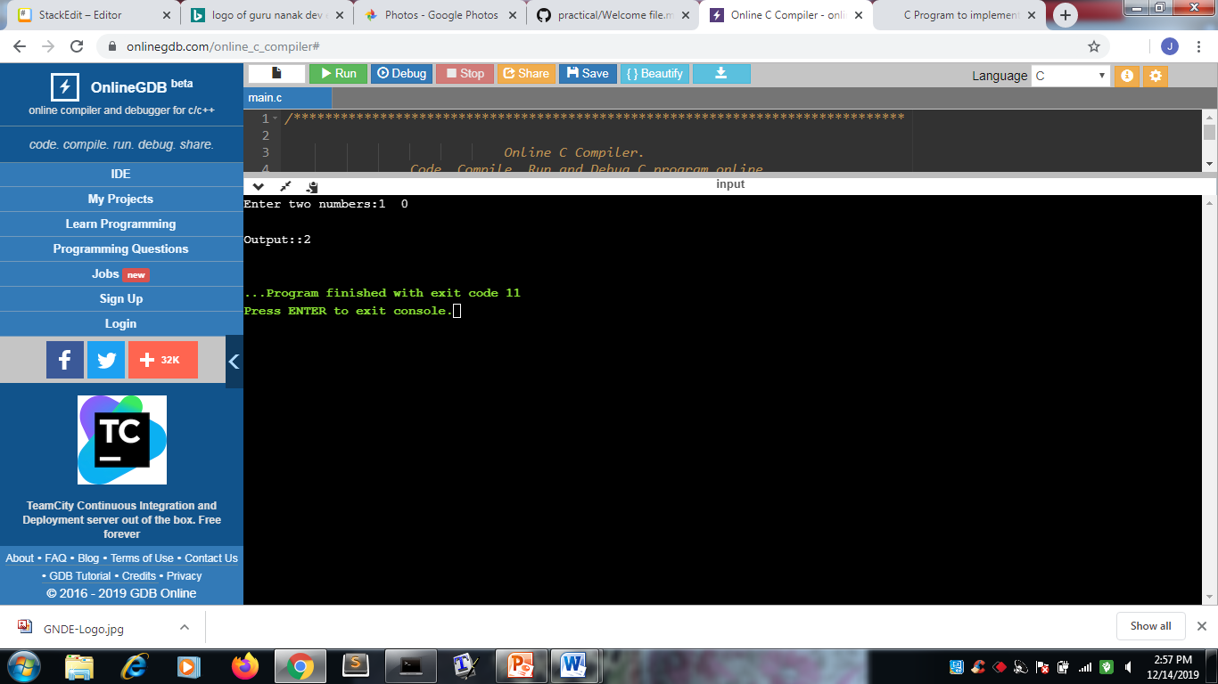

Program 23:

To print tables of numbers in a range by user

Codeing

#include<stdio.h>

int main()

{

int i,j,e,s,p;

printf("Enter starting number:");

scanf("%d",&s);

printf("Enter ending number:");

scanf("%d",&e);

for(i=s;i<=e;i++)

{

for(j=0;j<=10;j++)

printf("%d X %d=%d\n",i,j,i*j);

}

return(0);

}

Output

