Jasleen Kaur

Southern New Hampshire University

CS499

May 25, 2025

Software Design and Engineering

1. **Briefly describe the artifact. What is it? When was it created?**

This artifact is a full stack contact management system originally developed using a Node.js backend. It was created during my coursework in the computer science program. The system originally allowed for basic CRUD operation on contacts via API endpoints. For this milestone, I enhanced the artifact by adding a React-based user dashboard to improve usability and demonstrate front-end integration with the backend.

1. **Justify the inclusion of the artifact in your ePortfolio. Why did you select this item? What specific components of the artifact showcase your skills and abilities in software development? How was the artifact improve?**

The enhancement involved designing and implementing a user—facing React dashboard that allows users to interact with the contact system. Users can now:

* View contacts displayed in a sortable table
* Add need contacts
* Edit existing contacts
* Delete contacts

This dashboard replaced the previous method of interacting with the API solely through tools like HTTP requests, making the system more user-friendly and accessible/

Screenshots:

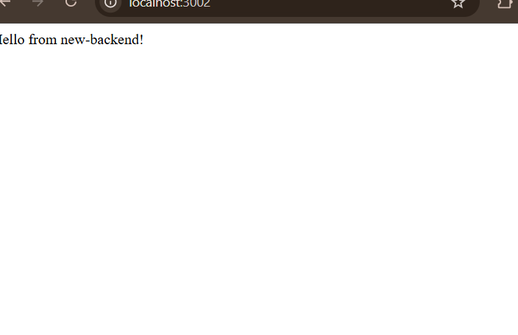

Project Organization:

The project is organized into two main folders:

Backend/ - contains the Node.js Express server and API logic

Frontend/ - contains the React application source code.

Each folder has its own package.json file and can be run into independently. All files are properly organized into folders- no file name includes folder paths or slashes.

How to Test the Application:

Perquisites:

* Node.js installed
* MongoDB installed and run locally or use a cloud MongoDB service

Steps:

1: Backend

* Open terminal and navigate to the backend folder
* Run npm install to install dependencies
* Run npm start to start the server on <http://localhost:3002>

2. Frontend

- open separate terminal and navigate to the frontend folder

Run npm install to install dependencies

Run npm start to launch the React app in the browser at <http://localhost:3000>

Verify that the React dashboard loads and correctly displays the contacts retrieved from the backend API.

**Did you meet the course outcomes you planned to meet with this enhancement in Module One? Do you have any updates to your outcome-coverage plans?**

* Software engineering / Design: Designed and built a React dashboard integrating with a Node.js backend API
* Computing Solutions: Created a user interface to address interaction challenges while balancing performance and usability.
* Communication : Produced well-documented, maintainable code and an intuitive user interface suitable for end users.

**Reflect on the process of enhancing and modifying the artifact. What did you learn as you were creating it and improving it? What challenges did you face?**

While building the React dashboard, I learned how to efficiently connect for tend interfaces with backend APIs using Axios and React hooks like useEffect and useState. I faced a lot of challenges in maintaining the UI responsiveness. Another challenge I experienced was getting my frontend and backend code to align with the overall goal. It was quite difficult. The improvement improved the system by making it user friendly and production ready. More importantly this is demonstrating my growth in learning full stack development.