EXPERIMENT 6
Dashboard and Scorecard Development using Microsoft Power BI

1. AIM:
To design and develop an interactive Executive Dashboard and Business Scorecard using Microsoft Power BI for monitoring organizational performance, supporting business decision-making, and communicating key performance indicators (KPIs) effectively.
2. OBJECTIVES:
• To identify key business metrics required for executive performance monitoring.
• To create KPI cards for Total Sales, Total Profit, Total Orders, and Profit Margin.
• To develop visualizations for regional, category-wise, monthly, customer-wise, and segment-wise performance.
• To add interactive slicers and verify that report visuals respond to selections.
• To create a business scorecard comparing actual performance with targets.
• To analyze dashboard findings and provide a data-driven business recommendation.
3. TOOLS / SOFTWARE REQUIRED:
• Microsoft Power BI Desktop
• Global Superstore Dataset.xlsx
• Power Query Editor (built into Power BI Desktop)
• DAX (Data Analysis Expressions)
4. DATASET USED:
Global Superstore Dataset.xlsx
Dataset Source: Global Superstore Dataset (Kaggle)
https://www.kaggle.com/datasets/apoorvaappz/global-super-store-dataset
5. THEORY:
A dashboard is a visual interface that presents important business metrics, trends, and performance indicators in a consolidated view. It helps executives and managers monitor organizational performance and make informed decisions.
A scorecard is a management tool used to compare actual performance against predefined targets. It helps organizations track progress toward strategic objectives using Key Performance Indicators (KPIs).
Microsoft Power BI provides visualization tools, KPI cards, charts, slicers, filters, and interactive features that can be used to build dashboards and scorecards. DAX measures can be used to calculate values such as sales, profit, order count, and profit margin.
Business Scenario: You are working as a Business Intelligence Analyst for Global Superstore. The executive management team requires a one-page dashboard and performance scorecard to monitor sales, profit, customer growth, and operational performance. The dashboard findings will be used to provide recommendations.
6. PROCEDURE:
Part A: Dashboard Planning
Step 1: Open Microsoft Power BI Desktop.
Launch Power BI Desktop. Open the Power BI project created in previous experiments, or start a new report if the project is not available.

Step 2: Load or verify the Global Superstore dataset.
If required, select Home > Get data > Excel workbook. Browse to Global Superstore Dataset.xlsx, select the required worksheet/table, and click Load. If the dataset is already present, verify that it is available in the Fields/Data pane.
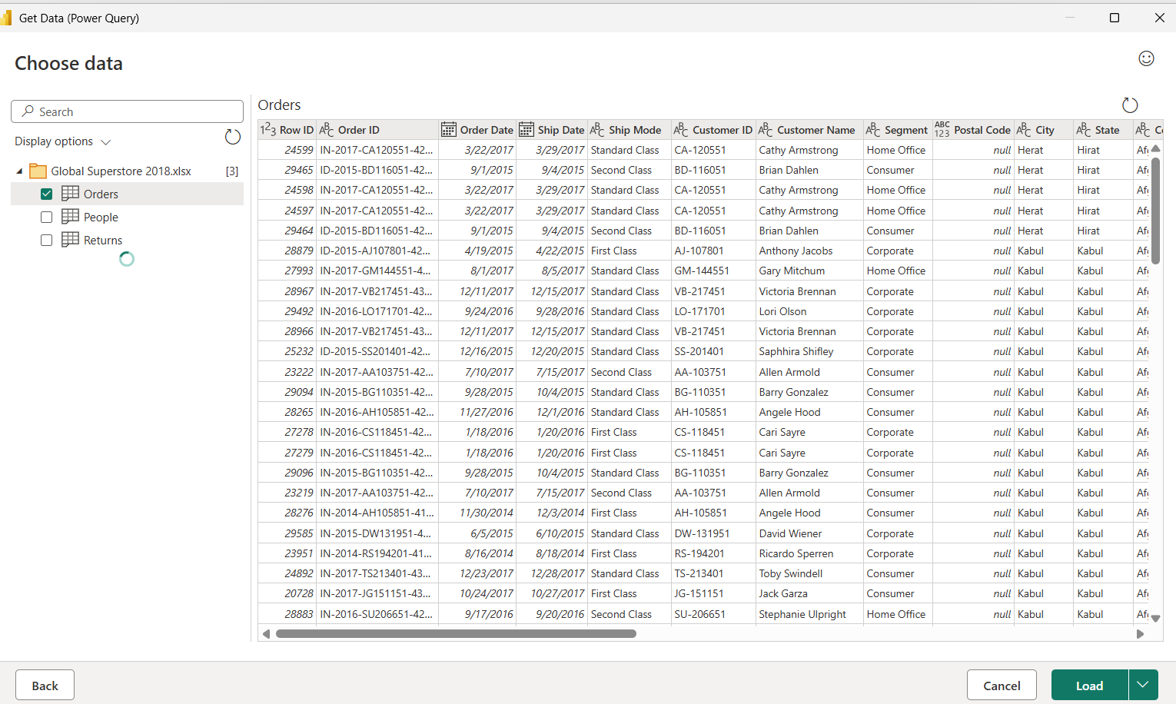
Step 3: Identify the key business metrics.
Confirm that fields such as Sales, Profit, Order ID, Customer Name, Category, Segment, Region, Order Date, and Year are available. These fields will be used to create the dashboard and scorecard.
Step 4: Plan the dashboard layout.
Arrange the page so that KPI cards appear near the top, charts occupy the main area, and slicers are placed along the top or side. Keep enough space for the scorecard and use consistent titles and formatting.
Part B: Create KPI Dashboard
Step 5: Create the Total Sales measure.
Select the table containing the sales records, choose Modeling > New measure, and enter: Total Sales = SUM(Orders[Sales]). Replace Orders with the actual table name if it differs. Press Enter.
Step 6: Create the Total Profit measure.
Choose Modeling > New measure and enter: Total Profit = SUM(Orders[Profit]). Press Enter. Use the actual table name if it differs.
Step 7: Create the Total Orders measure.
Create another measure: Total Orders = DISTINCTCOUNT(Orders[Order ID]). This counts unique orders rather than individual rows.
Step 8: Create the Profit Margin measure.
Create a measure using: Profit Margin = DIVIDE([Total Profit], [Total Sales], 0). Select the measure and format it as Percentage from the Measure tools/Modeling ribbon.
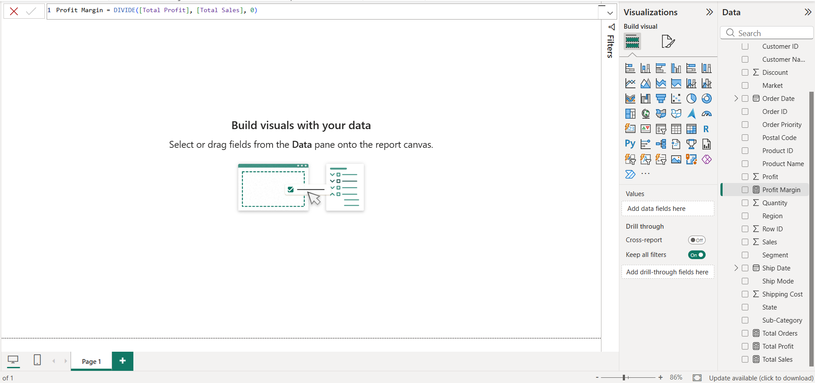

Step 9: Add KPI cards.
In the Report view, insert four Card visuals. Assign one measure to each card: Total Sales, Total Profit, Total Orders, and Profit Margin. Add clear titles, adjust number formatting, and align the cards consistently.
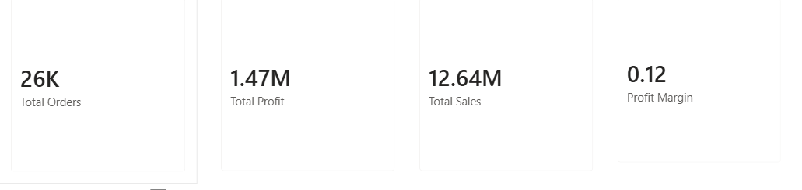
Step 10: Create Sales by Region and Sales by Category visuals.
Add a bar or column chart and place Region on the axis and Total Sales (or Sales) in Values. Add another chart with Category on the axis and Sales in Values. Give each chart a descriptive title.

Step 11: Create the Monthly Sales Trend.
Add a line chart. Place Order Date on the X-axis and Sales or the Total Sales measure in Values. Use the date hierarchy or a Month-Year field so that the trend is displayed over time. Sort the timeline chronologically.

Step 12: Create Top 10 Customers by Sales.
Add a bar chart with Customer Name on the axis and Sales in Values. In the Filters pane, select Customer Name, change the filter type to Top N, enter 10, use Sales as the “By value” field, and apply the filter. Sort by Sales in descending order.
Step 13: Create Profit by Segment and format the dashboard.
Add a bar or column chart with Segment on the axis and Profit in Values. Format titles, labels, colors, backgrounds, and number formats consistently. Arrange visuals neatly and avoid overcrowding the page.
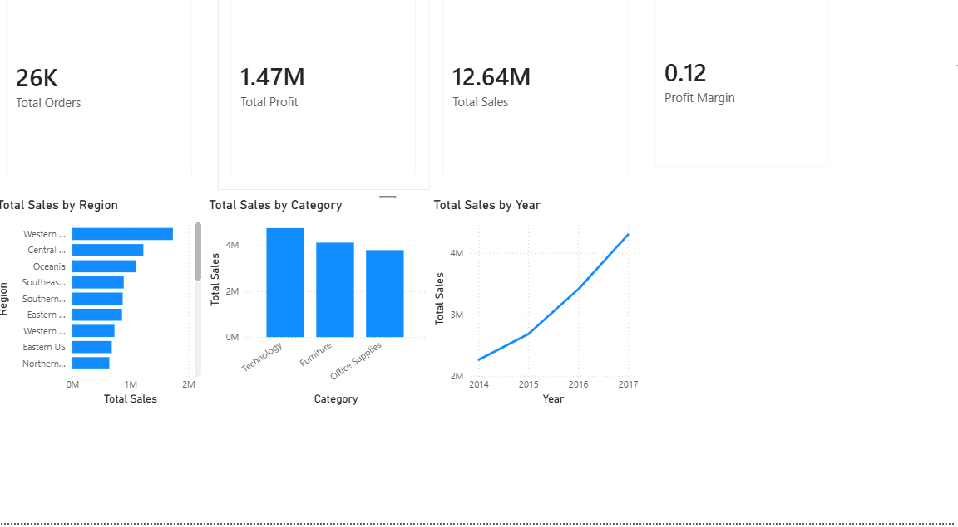

Part C: Add Interactive Features
Step 14: Add a Region slicer.
Insert a Slicer visual and add the Region field. Choose a list or dropdown style according to the available space.
Step 15: Add Category and Year slicers.
Insert two additional Slicer visuals. Add Category to one and Year (or the year level of Order Date) to the other. Ensure that the slicers are clearly labelled.
Step 16: Check visual interactions.
Select each slicer and choose Format > Edit interactions if necessary. Confirm that relevant charts and KPI cards are filtered by Region, Category, and Year. Change selections to test the response of the report.
Step 17: Test dashboard usability.
Clear the slicers and try several combinations. Verify that labels are readable, charts are not clipped, values update correctly, and users can return to an unfiltered view.
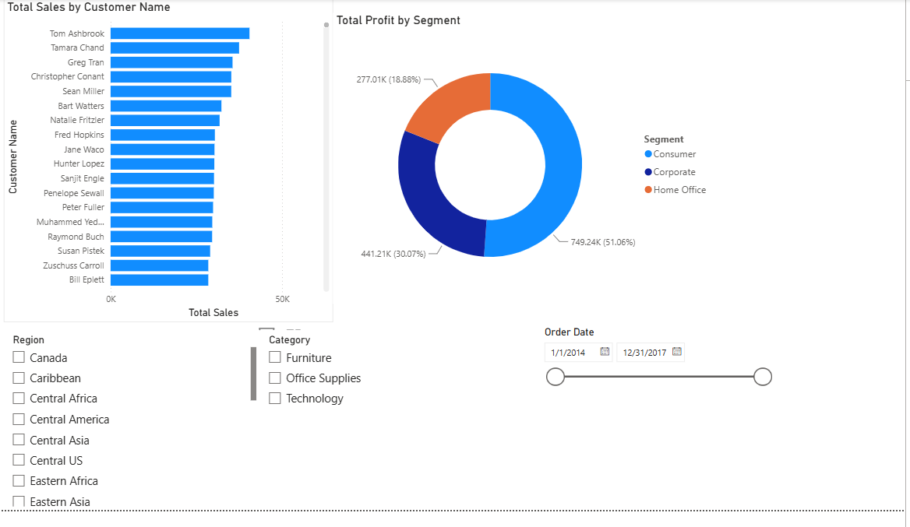
Part D: Create Business Scorecard
Step 18: Create or confirm performance target values.
Decide the target values for Sales, Profit, and Orders based on the lab instructions or a clearly stated business assumption. If no targets are provided, document the assumptions used; do not treat assumed targets as actual historical values.
Step 19: Create target and achievement measures.
Using Modeling > New measure, create target measures for Sales, Profit, and Orders, then create achievement measures by dividing each actual measure by its corresponding target. For example: Sales Achievement % = DIVIDE([Total Sales], [Sales Target], 0). Repeat for Profit and Orders using the corresponding measures.
Step 20: Build the scorecard visual.
Insert a Table or Matrix visual. Add rows/fields for Sales, Profit, and Orders and display each actual value, target value, and achievement percentage. Use suitable labels so the comparison is easy to understand.
Step 21: Apply conditional formatting and status indicators.
Select the scorecard visual and use conditional formatting on achievement percentages or status fields. Use a consistent rule such as Achieved for 100% or more, Partially Achieved for 80% to below 100%, and Not Achieved for below 80%, unless different thresholds are specified by your instructor. Use colors or icons consistently.
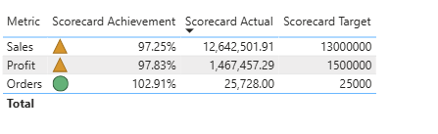
Part E: Business Analysis
Step 22: Identify the best and worst performing regions.
Compare Sales and Profit across regions in the dashboard. Record the region with the strongest performance and the region with the weakest performance, specifying whether the comparison is based on Sales, Profit, or both.
Step 23: Identify the most and least profitable categories.
Compare Profit by Category. Record the category with the highest profit and the category with the lowest profit. Use the displayed results rather than assuming which category performs best.

Step 24: Write one business recommendation.
Use the observed results to write one practical recommendation. For example, suggest investigating low-profit regions or categories, reviewing their costs and product mix, and applying lessons from better-performing areas. Adapt the recommendation to the actual dashboard findings.
Step 25: Save the Power BI report.
Save the report using File > Save As and choose a clear filename, such as Executive_Dashboard_Scorecard.pbix. Review the report page and scorecard before submission.
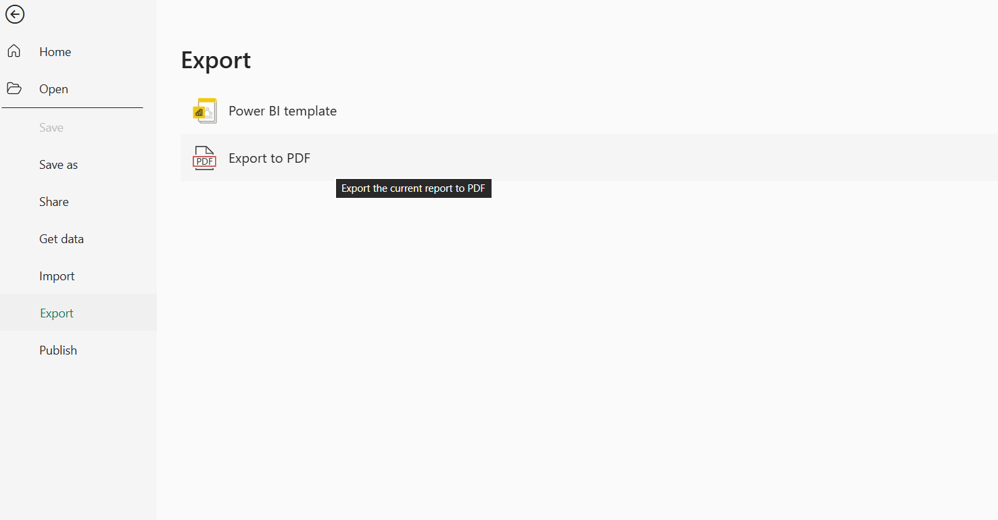
7. RESULT:
An Executive Dashboard and Business Scorecard were developed in Microsoft Power BI using the Global Superstore dataset. KPI cards, charts, slicers, and a scorecard were used to monitor performance and support business analysis. The findings were used to identify performance differences and formulate a business recommendation.
8. LEARNING OUTCOMES:
• Designed interactive dashboards using Power BI visualizations. (CO5-BT6)
• Created KPI-based scorecards for performance monitoring. (CO5-BT6)
• Applied visualization best practices in dashboard design. (CO3-BT3)
• Analyzed business performance using dashboard insights. (CO3-BT4)
• Developed recommendations based on data-driven findings. (CO5-BT6)

